LAZYSOFT

Developers: Htet Wai Yan, Zay Min Khant

Product Item Module

Project Plan

1. To use VS Code.
2. To use MS Team, Facebook Messenger to communicate each other.
3. To use GitHub for Source Code Collaboration.
4. To use MySQL database.
5. To write the service API with Nodejs.
6. To release beta version of “Product Item Module” in the first week.

Schedule

|  |  |  |  |  |  |  |  |
| --- | --- | --- | --- | --- | --- | --- | --- |
| Days / Developers | Oct-26 | Oct-27 | Oct-28 | Oct-29 | Oct-30 | Oct-31 | Nov-01 |
| Htet Wai Yan | Create UI design for login page and adding new product item. | Create UI design for searching product item and displaying product item list. | Create UI design for editing and deleting product item. | Writing source code for login and adding new product item. | Writing source code for searching product item and displaying product item list. | Writing source code for editing and deleting product item. | Checking source code to be smart. |
| Zay Min Khnat | Create a database for Product Item Module project. | Writing service API for login. | Writing service API for adding new product item. | Writing service API for editing new product item. | Writing service API for deleting product item. | Checking login function and adding new product item work properly or not. | Checking searching, displaying, editing and deleting product item work properly or not. |

Risk Plan

|  |  |
| --- | --- |
| Risk | Solace |
| Lack of cooperation negatively effects on the project. | Plan to encourage to each other and inspires to greater efforts. |
| Team may not meet the goal of the project timeline. | Plan to set a schedule and to follow up exactly. |

Test Plan

* Type of testing
  + Unit testing
  + Integration testing
  + API testing
* We will use Karma, Jasmine and Angular Mocks for testing.

High Level Design

User

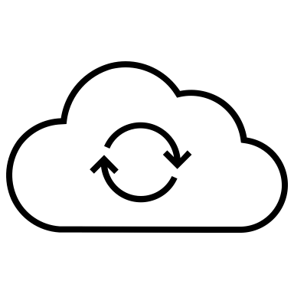

Web App

Service API

Web Server

Database

Software Layering Architecture

User

Database

Business Logic Layer

Response Object

REST Endpoints

REST Web Service

Response Object

Presentation Layer