A Report on Mini Project
Design and Development of Microstrip patch Antenna for vehicle-to-vehicle communication

Submitted for the partial fulfilment of the academic requirements for the
Award of the Degree of

BACHELOR OF TECHNOLOGY
IN
ELECTRONICS AND COMMUNICATION ENGINEERING

Submitted By
M. CHARAN | 24915A0416
M. CHANDRA SHEKAR | 24915A0414
A. PRATYUSH REDDY | 23911A04D1
G. SREETHAN | 23911A04F1

Under the Esteemed Guidance of
Mrs. Sharmeen Sultana
Assistant Professor


Department of Electronics and Communication Engineering

VIDYA JYOTHI INSTITUTE OF TECHNOLOGY

(An Autonomous Institute)
(Accredited by NAAC & NBA, Approved By A.I.C.T.E., New Delhi, Permanently Affiliated to JNTU, Hyderabad
Aziz Nagar, C.B.Post, Hyderabad -500075)

2025-2026


(Accredited by NAAC, Approved by AICTE New Delhi & Permanently Affiliated to JNTUH)
Aziz Nagar Gate, C.B. Post, Hyderabad-500 075
Department of Electronics and Communication Engineering
(Accredited by NBA)

CERTIFICATE
This is to certify that the project report titled “Design and development of Microstrip patch antenna for vehicle-to-vehicle communication” is being submitted by M. Charan (24915A416), M. Chandrashekhar (24915A0414), A. Pratyush (23911A04D1), and G. Sreethan (23911A0F1) of III B.Tech II Semester, Department of Electronics and Communication Engineering, as a record of Bonafide work carried out by them. The results presented in this report are original and have not been submitted to any other University or institution for the award of any degree or diploma.

GUIDE | HEAD OF THE DEPARTMENT
MRS. SHARMEEN SULTANA | DR. P. NAGENDRA RAO
Assistant professor | Professor
Department of ECE | Department of ECE

EXTERNAL EXAMINER

DECLARATION

We hereby declare that the project work entitled “Design and development of Microstrip patch antenna for vehicle-to-vehicle communication” is a genuine and original piece of work carried out by us in the Department of Electronics and Communication Engineering, Vidya Jyothi Institute of Technology, under the affiliation of Jawaharlal Nehru Technological University, Hyderabad. This report is the outcome of our own efforts and research conducted during the course of the project. We affirm that it has not been copied, reproduced, or submitted elsewhere for any academic or professional purpose. All sources of information and assistance have been duly acknowledged.

PROJECT ASSOCIATES
Mr. M. Charan 24915A0416
Mr. M. Chandra Shekar 24915A0414
Mr. A. Pratyush Reddy 23911A04D1
Mr. G. Sreethan 23911A04F1

ACKNOWLEDGEMENT
We would like to express our sincere gratitude to our project guide Mrs. Sharmeen Sultana, M. Tech., Associate Professor, for the exceptional guidance, support, and encouragement provided at every phase of this project.
We are deeply thankful to Dr. S. Pradeep Kumar Reddy, B.E., M. Tech., Assistant Professor and Project Coordinator, Department of ECE, for her timely and insightful guidance that greatly contributed to the successful completion of our work.
Our sincere thanks also go to DR. P. Nageswara Rao, M.E., Ph.D. Professor and Head, Department of ECE, for his consistent support and constructive feedback during the course of our study.
We extend our heartfelt gratitude to Dr. A. Srujana, M. Tech., Ph.D., Principal, Vidya Jyothi Institute of Technology, for her motivation and encouragement in the successful completion of our project.
Finally, we express our sincere appreciation to the faculty and staff of the Electronics and Communication Engineering Department, Vidya Jyothi Institute of Technology, for their help and cooperation throughout the duration of the project.

Mr. M. Charan 24915A0416
Mr. M. Chandra Shekar 24915A0414
Mr. A. Pratyush Reddy 23911A04D1
Mr. G. Sreethan 23911A04F1

ABSTRACT

Vehicle-to-Vehicle (V2V) communication systems require compact, low-profile, and high-performance antennas capable of maintaining stable connectivity in rapidly changing vehicular environments. This project focuses on the design and development of a rectangular microstrip patch antenna operating at 5.9 GHz, a globally allocated band for Dedicated Short-Range Communications (DSRC) and Vehicle-to-Everything (V2X) applications. The antenna is fabricated on an RT Duroid 5880 substrate with a dielectric constant of 2.2 and low loss tangent, which enhances radiation efficiency and minimizes signal attenuation at high frequencies. The overall antenna dimensions are 36 mm × 25 mm, making it suitable for integration into compact vehicular communication modules. The antenna design is optimized using full-wave electromagnetic simulation tool, HFSS, to achieve key performance parameters, including a return loss (S11) below -10 dB, a Voltage Standing Wave Ratio (VSWR) less than 2, and effective gain. To enhance bandwidth and performance, parametric optimization of patch dimensions, feed position, and substrate properties is carried out. The proposed antenna supports high data rate communication with low latency, which is essential for real-time safety applications such as collision avoidance, lane change assistance, and traffic monitoring. Furthermore, the antenna design ensures ease of fabrication, low cost, and mechanical robustness, making it practical for large-scale deployment in intelligent transportation systems (ITS). The compact and efficient design also allows compatibility with WLAN and DSRC-based vehicular communication systems.

TABLE OF CONTENTS
CHAPTER | TITLE | PAGE NO
 | ABSTRACT | iv
 | TABLE OF CONTENTS | v
 | LIST OF FIGURES | vi
 | LIST OF TABLES | vii
1 | INTRODUCTION | 1
 | 1.1 Problem Statement | 3
 | 1.2 Objectives | 5
2 | LITERATURE SURVEY | 6
 | 2.1 Limitations of Existing System | 7
3 | ANALYSYS | 8
 | 3.1 Features of Proposed System | 9
 | 3.2 Advantages of Proposed System | 10
4 | SYSTEM DESIGN | 11
 | 4.1 Software Requirements | 12
 | 4.2 Hardware Requirements | 13
 | 4.3 Functional Requirements | 14
 | 4.4 Components used in Proposed System | 15
 | 4.4.1 RT-Duroid | 16
 | 4.4.2 Copper Patch | 18
 | 4.4.3 SMA connector | 20
 | 4.4.4 VNA | 21
5 | PROPOSED METHODOLOGY | 23
 | 5.1 Circuit Diagram | 24
 | 5.2 Working | 25
6 | METHODOLOGY | 26
7 | IMPLEMENTATION | 27
8 | RESULTS | 28
9 | CONCLUSIONS AND FUTURE SCOPE | 36
 | REFERENCES | 38

LIST OF FIGURES
FIGURE NO | TITLE | PAGE NO
4.4.1 | RT-Duroid | 17
4.4.2 | Copper Patch | 19
4.4.3 | SVM connector | 21
4.4.4 | VNA | 22
5.2 | Circuit Diagram | 24

LIST OF TABLES
TABLE NO | TITLE | PAGE NO
8.1 | design parameters of the proposed antenna | 35

CHAPTER 1
INTRODUCTION

Vehicle-to-Vehicle (V2V) communication is an essential component of modern intelligent transportation systems (ITS), enabling vehicles to exchange real-time information such as speed, position, and traffic conditions [3, 5]. This improves road safety, reduces accidents, and enhances traffic efficiency [1, 4]. The 5.9 GHz frequency band has been globally allocated for V2V and Vehicle-to-Everything (V2X) communication because it supports high data rates, low latency, and reliable short-range communication [2, 9]. Microstrip patch antennas are widely used in V2V systems due to their compact size, low profile, lightweight structure, and ease of fabrication [4, 5, 10]. However, conventional microstrip antennas suffer from limitations such as narrow bandwidth, effective gain, and reduced efficiency, especially in dynamic vehicular environments where stable communication is critical [1, 6, 7].
This project focuses on the design and development of a rectangular microstrip patch antenna operating at 5.9 GHz using an RT Duroid 5880 substrate [4, 5]. The antenna is optimized using electromagnetic simulation techniques to achieve improved return loss, bandwidth, gain, and radiation performance [2, 8]. The proposed design offers a compact, cost-effective, and efficient solution suitable for integration into V2V communication systems and intelligent transportation applications [3, 9, 10].

1.2 PROBLEM STATEMENT
Vehicle-to-Vehicle (V2V) communication systems are a fundamental part of modern intelligent transportation systems, enabling vehicles to exchange real-time information such as speed, position, and road conditions. This communication is critical for applications like collision avoidance, traffic management, and autonomous driving. However, maintaining reliable communication between vehicles in high-speed and dynamic environments is a major challenge. Rapid movement, varying distances, and constant changes in surroundings can lead to signal degradation and instability. Ensuring consistent communication under such conditions requires highly efficient antenna systems. Existing solutions often struggle to provide stable performance in these environments.
One of the primary challenges in V2V communication systems is the limitation of conventional antenna designs in terms of bandwidth. Most traditional microstrip patch antennas offer narrow bandwidth, which restricts their ability to cover the entire 5.9 GHz frequency band allocated for V2V applications. This limitation affects the antenna’s ability to handle high data rates and maintain consistent communication. In real-time systems, even small variations in frequency can result in communication failure.
Therefore, there is a strong need to develop an optimized microstrip patch antenna operating at 5.9 GHz that overcomes the limitations of conventional designs. The antenna should provide improved bandwidth, higher gain, and better impedance matching while maintaining a compact and low-profile structure. It should also perform reliably under dynamic and environmental conditions typical of vehicular systems. Additionally, the design should be cost-effective and easy to fabricate for large-scale implementation. Addressing these challenges will enable efficient and reliable V2V communication. This project aims to provide a practical solution to these problems through optimized antenna design and simulation.

1.3 OBJECTIVES
The main objective is to design a compact, efficient, and high-performance antenna that provides reliable, low-loss, and real-time communication between vehicles for safety and intelligent transportation systems. The specific objectives of this project are as follows:
- Provide Reliable Wireless Communication Enable direct communication between vehicles (car-to-car). Support safety applications like collision warning and traffic alerts.
- Achieve Compact and Low-Profile Design Antenna should be small, lightweight, and easy to mount on vehicles. Microstrip antennas are ideal because they are low profile and conformal to surfaces.
- Operate at Dedicated V2V Frequency Band Designed to work in 5.9 GHz band (IEEE 802.11p / DSRC) for vehicular communication.
- Ensure Low Return Loss (S11 < -10 dB) Minimize signal reflection for efficient power transmission. Improves antenna performance and communication reliability.
- Enable Easy Integration with Vehicle Systems Should integrate with On-board communication units.

CHAPTER 2
LITERATURE SURVEY

Microstrip patch antennas have been widely studied for wireless communication applications due to their advantages such as compact size, low profile, light weight, and ease of integration with electronic circuits [1, 4, 5]. These antennas consist of a radiating patch on a dielectric substrate with a ground plane, making them suitable for modern communication systems [4, 8].
Early research focused on improving key parameters such as gain, bandwidth, and return loss by using different feeding techniques and substrate materials [6, 7, 8]. However, conventional microstrip antennas suffer from limitations like narrow bandwidth and low efficiency, which led researchers to explore advanced designs such as slot-loaded patches, stacked structures, and antenna arrays to enhance performance [7, 9, 10].
With the advancement of Intelligent Transportation Systems, microstrip patch antennas have been increasingly applied in Vehicle-to-Vehicle (V2V) communication to enable real-time data exchange between vehicles [3, 5]. Recent studies emphasize the design of compact and efficient antennas operating in multiple frequency bands to support reliable communication under dynamic vehicular conditions [1, 2, 9].
For example, a recent work proposed a dual band microstrip patch antenna operating at 0.915 GHz and 3.5 GHz using an RT Duroid 5880 substrate, achieving good impedance matching, bidirectional radiation pattern, and efficiency above 80%, making it suitable for V2V applications [4]. Furthermore, modern vehicular antenna systems integrate multiple functionalities such as GPS, satellite communication, and V2V communication within a single compact structure, highlighting the trend toward multifunctional and reconfigurable antenna designs [1, 2, 10].
However, ongoing research is focused on overcoming challenges such as limited bandwidth, environmental effects, and performance degradation in high-speed scenarios by developing multiband, high-gain, and robust antenna designs suitable for next-generation vehicular networks [2, 5, 6].

2.1 LIMITATIONS OF EXISTING METHODOLOGY
Existing methodologies for microstrip patch antennas in Vehicle-to-Vehicle (V2V) communication face several limitations despite their advantages of compact size and easy integration [4, 5]. One major drawback is the narrow bandwidth, which restricts the antenna's ability to support high data rates required for real-time vehicular communication [1, 6, 7].
Additionally, these antennas generally exhibit low gain and efficiency, which can reduce communication range and reliability between fast-moving vehicles [4, 9]. Performance is also highly affected by environmental conditions such as rain, obstacles, and interference from nearby vehicles, leading to signal degradation [3, 10]. Another limitation is the sensitivity to substrate material and design parameters, where small variations can significantly impact antenna performance [8, 9].
Moreover, most existing designs are single-band or limited dual-band, making them less suitable for modern multi-standard communication systems like V2V, V2I, and 5G integration [1, 2, 7]. There is also a challenge in maintaining stable performance under high-speed mobility and dynamic orientations of vehicles [3, 5, 10]. Hence, these limitations highlight the need for improved designs with wider bandwidth, higher gain, better efficiency, and robust performance in real-world vehicular environments [2, 6, 8].

CHAPTER 3
ANALYSIS

A microstrip patch antenna designed for Vehicle-to-Vehicle (V2V) communication using an RT-Duroid substrate provides enhanced electromagnetic performance due to its low dielectric constant (≈2.2) and very low loss tangent, which significantly reduce energy dissipation and improve radiation efficiency. In V2V systems operating around the 5.9 GHz DSRC or ITS band, the antenna must maintain reliable communication under high mobility conditions, and RT-Duroid helps achieve this by offering stable electrical properties over a wide frequency range.
The antenna typically demonstrates a return loss (S11) well below –10 dB, indicating efficient power transfer with minimal reflections, and a Voltage Standing Wave Ratio (VSWR) close to 1–2, confirming good impedance matching. The gain is usually in the range of 6–8 dB, which enhances the communication distance between vehicles, while the radiation pattern is generally omnidirectional or quasi-omnidirectional, ensuring uniform signal coverage in all directions—an essential requirement for moving vehicles in dynamic traffic environments.
Furthermore, the bandwidth, although inherently limited in microstrip patch antennas, is improved with RT-Duroid compared to conventional substrates like FR-4, allowing better support for high-speed data exchange such as safety warnings, collision avoidance signals, and traffic updates. The antenna also exhibits high efficiency, often exceeding 90%, due to reduced dielectric and conductor losses. Design optimization techniques such as slotting, stacking, or using parasitic elements can further enhance bandwidth and gain when required.
In terms of physical characteristics, the antenna remains compact, lightweight, and easy to integrate into vehicle bodies, which is crucial for modern automotive systems. However, the main limitations include higher cost of the RT-Duroid material and more precise fabrication requirements. Despite these drawbacks, the overall analysis indicates that RT-Duroid-based microstrip patch antennas provide a reliable, high-performance solution for V2V communication by ensuring stable transmission, improved range, and efficient utilization of the spectrum.

3.1 FEATURES OF PROPOSED SYSTEM
The proposed system focuses on designing a microstrip patch antenna for Vehicle-to-Vehicle (V2V) communication using an RT-Duroid substrate. This design aims to achieve high efficiency, better gain, and reliable signal transmission at high frequencies. The use of RT-Duroid enhances overall antenna performance, making it suitable for modern vehicular communication systems.

The key features of the proposed system are as follows:
- Use of RT-Duroid Substrate:
The proposed antenna uses RT-Duroid material, which has a low dielectric constant and low loss tangent, resulting in reduced signal loss and improved overall antenna performance at high frequencies.
- Operation in 5.9GHz Band:
The system is designed to operate in the 5.9 GHz DSRC/ITS band, which is widely used for Vehicle-to-Vehicle communication, enabling real-time data transfer between vehicles.
- Low Return Loss (S11<–10dB):
The antenna achieves low return loss, ensuring minimal signal reflection and efficient power transmission, which is essential for reliable communication.
- High Gain (6–8dB):
The proposed system provides higher gain compared to conventional designs, increasing the communication range between vehicles and improving signal strength.
- Omni-directional Radiation Pattern:
The antenna radiates signals in all directions, making it suitable for dynamic vehicular environments where vehicles move in different directions.
- High Efficiency (~90%):
Due to low dielectric losses of RT-Duroid, the antenna achieves high radiation efficiency, ensuring most of the input power is effectively transmitted.
- Compact and Low-profile Design:
The microstrip patch antenna is lightweight, compact, and easy to integrate into vehicle structures without affecting design or aerodynamics.
- Improved Bandwidth:
Compared to traditional substrates like FR-4, the proposed system offers better bandwidth, supporting high-speed data communication for safety applications.

3.2 ADVANTAGES OF PROPOSED SYSTEM
The proposed microstrip patch antenna using an RT-Duroid substrate is designed to enhance the performance of Vehicle-to-Vehicle (V2V) communication systems. Due to its low dielectric loss and stable properties, it provides efficient signal transmission at high frequencies. This results in several advantages that make it suitable for modern vehicular communication applications. Some of the key advantages include:
- High Efficiency:
The RT-Duroid substrate has very low dielectric loss, resulting in high radiation efficiency (around 90% or more).
- Better Gain:
The antenna provides higher gain (about 6–8 dB), which improves communication range between vehicles.
- Low Return Loss:
It achieves return loss less than –10 dB, ensuring minimal signal reflection and better power transmission.
- Improved Bandwidth:
Compared to conventional substrates like FR-4, RT-Duroid offers better bandwidth, supporting faster data communication.
- Stable High-Frequency Performance:
The antenna performs well at high frequencies (around 5.9 GHz), making it suitable for V2V and DSRC applications.
- Omnidirectional Radiation:
Provides signal transmission in all directions, which is essential for moving vehicles in different directions.
- Compact and Lightweight Design:
The microstrip antenna is small, low profile, and easy to integrate into vehicles.
- Reliable Communication:
Ensures consistent and real-time data transfer for safety applications like collision warnings and traffic updates.
Overall, the proposed system combines simplicity, efficiency, and adaptability, making it a practical approach for basic missile detection and object tracking applications.

CHAPTER 4
SYSTEM DESIGN

The proposed system consists of a microstrip patch antenna designed using an RT-Duroid substrate for efficient Vehicle-to-Vehicle (V2V) communication. The antenna structure is composed of three main layers: a conducting patch on the top, an RT-Duroid dielectric substrate in the middle, and a ground plane at the bottom. The patch is typically made of copper and is designed in a rectangular shape to operate at the desired frequency of 5.9 GHz, which is used for V2V communication. The dimensions of the patch (length and width) are calculated based on the operating frequency and dielectric constant of the substrate to achieve proper resonance.
The RT-Duroid substrate is selected due to its low dielectric constant (approximately 2.2) and low loss tangent, which helps in reducing signal loss and improving antenna efficiency. A suitable feeding technique, such as microstrip line feed or insert feed, is used to excite the antenna. Proper impedance matching (usually 50 ohms) is maintained to ensure minimal reflection and maximum power transfer. The antenna is designed and simulated using electromagnetic simulation tools like HFSS or CST to analyse parameters such as return loss (S11), VSWR, gain, bandwidth, and radiation pattern.
The system is optimized to achieve a return loss less than –10 dB, VSWR close to 1, and a gain of around 6–8 dB. The radiation pattern is designed to be omnidirectional or quasi-omnidirectional so that communication can occur effectively in all directions between moving vehicles. Additionally, design techniques such as slotting or the use of parasitic elements can be incorporated to enhance bandwidth and gain if required. Overall, the system design ensures a compact, efficient, and reliable antenna suitable for real-time V2V communication applications.

4.1 SOFTWARE REQUIREMENTS
The design and analysis of the proposed microstrip patch antenna for Vehicle-to-Vehicle (V2V) communication using an RT-Duroid substrate require advanced electromagnetic simulation and supporting software tools. The primary software used is Ansys HFSS (High Frequency Structure Simulator), which is a finite element method (FEM)-based tool widely used for high-frequency antenna design.
HFSS allows precise modelling of the antenna structure, including the patch, substrate, and ground plane, and enables the assignment of accurate material properties such as dielectric constant and loss tangent of RT-Duroid. It is mainly used to simulate and analyse key parameters like return loss (S11), Voltage Standing Wave Ratio (VSWR), gain, radiation pattern, bandwidth, and impedance matching.
It also provides 3D visualization of the antenna and field distribution, which helps in better understanding of antenna behaviour. Another important software is CST Microwave Studio, which uses time-domain and frequency-domain solvers to analyse electromagnetic performance. It is useful for validating results obtained from HFSS and for performing faster simulations in certain cases. CST also supports optimization techniques to improve antenna performance parameters such as gain and bandwidth.
For mathematical calculations and verification, MATLAB is used to compute antenna design parameters like patch length, width, effective dielectric constant, and resonant frequency using standard design equations. It can also be used for plotting graphs and analysing trends in antenna performance. Additionally, MS Excel is helpful for organizing simulation data, creating comparison tables, and plotting graphs such as S11 vs frequency and gain vs frequency.
Sometimes, basic design validation and circuit-level analysis can be performed using tools like Advanced Design System (ADS), which helps in impedance matching and RF circuit design. These software tools together ensure accurate design, simulation, optimization, and performance evaluation of the antenna system before fabrication. This reduces practical errors, saves cost, and improves the reliability of the proposed V2V communication system.

4.2 HARDWARE REQUIREMENTS
The proposed microstrip patch antenna system for Vehicle-to-Vehicle (V2V) communication using an RT-Duroid substrate requires several essential hardware components for fabrication, testing, and implementation. The core component is the RT-Duroid substrate, which serves as the dielectric material due to its low dielectric constant (≈2.2) and very low loss tangent, ensuring high efficiency and minimal signal loss at high frequencies. On top of this substrate, a copper-clad layer is used to form the radiating patch, while another copper layer at the bottom acts as the ground plane. The antenna is fabricated using Printed Circuit Board (PCB) fabrication techniques, which include processes like photolithography, etching, and drilling to achieve precise dimensions.
To excite the antenna, a feeding mechanism such as an insert feed or microstrip line feed is used, along with an SMA (Sub Miniature version A) connector that connects the antenna to external RF equipment. For testing and analysis, a Vector Network Analyzer (VNA) is an important instrument used to measure key performance parameters such as return loss (S11), VSWR, impedance, and bandwidth.
For practical V2V communication demonstration, RF transmitter and receiver modules operating in the 5.9 GHz band can be used to transmit and receive data between two setups (vehicles). In some cases, microcontrollers or embedded systems may be included to control data transmission and processing. A stable power supply unit is necessary to provide consistent voltage to active components. Additionally, mounting fixtures and holders are required to properly position the antenna during testing to avoid interference and ensure accurate radiation measurements.
To protect the antenna from environmental conditions such as dust, moisture, and mechanical vibrations, especially in automotive applications, a protective casing or redone may be used. Optional equipment such as an anechoic chamber can be utilized for precise radiation pattern measurement by eliminating external noise and reflections. Soldering tools, connectors, and measurement accessories are also required during assembly and testing.
Overall, these hardware components collectively enable accurate fabrication, reliable testing, and effective implementation of the proposed antenna system, ensuring it meets the performance requirements for real-time and efficient V2V communication.

4.3 FUNCTIONAL REQUIREMENTS
The proposed microstrip patch antenna system for Vehicle-to-Vehicle (V2V) communication using an RT-Duroid substrate must satisfy several functional requirements to ensure reliable and efficient operation. The primary requirement is that the antenna should operate at the designated frequency of around 5.9 GHz, which is used for V2V communication in DSRC/ITS applications. It must be capable of transmitting and receiving signals effectively between vehicles with minimal loss and high reliability.
The system should maintain a return loss (S11) of less than –10 dB to ensure proper impedance matching and minimal signal reflection. The Voltage Standing Wave Ratio (VSWR) should ideally be between 1 and 2 for efficient power transfer. The antenna must provide a sufficient gain (around 6–8 dB) to support communication over a reasonable distance between moving vehicles. Additionally, the system should have an omnidirectional or quasi-omnidirectional radiation pattern to enable communication in all directions, as vehicles move dynamically.
Another important requirement is that the antenna should exhibit high radiation efficiency (above 90%), ensuring that most of the input power is effectively radiated. The system must support adequate bandwidth to handle high-speed data transmission for safety messages, such as collision warnings and traffic updates. The antenna should also be compact, lightweight, and easy to integrate into vehicles without affecting their design or aerodynamics.
Furthermore, the system should maintain stable performance under varying environmental conditions, including temperature changes, vibrations, and weather effects. It should also ensure real-time communication with low latency, which is critical for safety-related applications in V2V systems. Overall, these functional requirements ensure that the proposed antenna system performs efficiently, reliably, and effectively in real-world vehicular communication scenarios

4.4 COMPONENTS USED IN PROPOSED SYSTEM
- RT-Duroid Substrate
It acts as the base material of the antenna and provides mechanical support. Its low dielectric loss helps in achieving high efficiency and better signal transmission.
- Copper Patch
This is the main radiating element of the antenna. It converts electrical signals into electromagnetic waves for communication.
- Ground Plane
The bottom metallic layer reflects signals toward the patch, improving radiation and overall antenna performance.
- Feeding Mechanism
It is used to supply input power to the antenna. Proper feeding ensures good impedance matching and reduces signal reflection.
- SMA Connector
It connects the antenna to external RF devices like VNA or transmitter. It ensures stable and low-loss signal transfer.
- RF Insert feed Cable
Used to carry high-frequency signals between components with minimal interference and signal loss.
- Vector Network Analyzer (VNA)
It is used to test and measure antenna parameters such as return loss, VSWR, and impedance characteristics.
- Transmitter and Receiver Modules
These modules enable actual communication by transmitting and receiving data between vehicles in V2V systems.

4.4.1 RT-Duroid

RT-Duroid is a high-performance dielectric material commonly used in microwave and high-frequency antenna designs. It is manufactured using PTFE (Teflon) composites, which provide excellent electrical and thermal properties. Due to its low dielectric constant and very low loss tangent, RT-Duroid is highly suitable for applications like microstrip patch antennas, especially in high-frequency communication systems such as Vehicle-to-Vehicle (V2V).

Features:

Low dielectric Constant:
Helps in better radiation and wider bandwidth.

High Frequency Stability:
Maintains consistent performance even at GHz frequencies.

Low Moisture Absorption:
Ensures stable operation under different environmental conditions.

Thermal Stability:
Performs well under temperature variations in automotive environments. Role in Missile Detection System
Functions:

Act as Dielectric Medium:
It separates the patch and ground plane while supporting electromagnetic wave propagation.

Support Signal Transmission:
Helps in efficient propagation of high-frequency signals with minimal loss.

Enhances Antenna Performance:
Improves parameters like gain, bandwidth, and efficiency.

Advantages:

Low Dielectric Loss:
RT-Duroid has a very low loss tangent, which reduces signal loss and improves antenna efficiency.

High Efficiency:
It allows maximum power to be radiated, resulting in efficiency greater than 90%.

Better Gain:
The substrate improves antenna gain, enabling longer communication range in V2V systems.

Stable High-Frequency Performance:
Performs consistently at high frequencies (GHz range), making it ideal for V2V communication.

Future Scope in Advanced Systems
The proposed antenna system can be further improved to support advanced technologies like 5G/6G and V2X communication for faster and more reliable data transfer. Future enhancements such as MIMO, beamforming, and smart antennas can increase gain, coverage, and efficiency. It can also be integrated with autonomous vehicles and smart city systems for improved safety and intelligent transportation.

4.4.2 Copper Patch

The copper patch is the main radiating element of the microstrip patch antenna, placed on the top surface of the RT-Duroid substrate. It is usually made of high-conductivity copper to ensure efficient transmission of electromagnetic waves. The shape of the patch is generally rectangular, and its dimensions (length and width) are carefully designed based on the operating frequency, typically around 5.9 GHz for V2V communication. When an electrical signal is applied through the feed, the copper patch radiates electromagnetic waves into space.

4.4.3 Working Principle

The microstrip patch antenna works on the principle of electromagnetic radiation. When a high-frequency signal (around 5.9 GHz) is fed to the copper patch through a feeding mechanism, it creates oscillating electric and magnetic fields. Due to these oscillations, electromagnetic waves are radiated from the edges of the patch into the surrounding space the RT-Duroid substrate supports the propagation of these waves with minimal loss, while the ground plane reflects the signals to enhance radiation. The antenna is designed to operate at resonance, where maximum power is radiated with minimum reflection. This enables efficient transmission and reception of signals between vehicles, allowing reliable V2V communication.

4.4.4 Role in V2V System

The microstrip patch antenna plays a key role in enabling communication between vehicles by transmitting and receiving electromagnetic signals. It allows vehicles to exchange real-time information such as speed, position, and safety warnings. Due to its omnidirectional radiation and efficient performance, it ensures reliable communication in all directions even when vehicles are moving. This helps improve road safety, reduce accidents, and support intelligent transportation systems.

4.4.5 Advantages of Copper patch:

Reliable Communication:
Enables stable signal transmission between vehicles for real-time data exchange.

Compact Size:
Small, lightweight, and easy to integrate into vehicle structures.

Low Profile Design:
Can be mounted easily without affecting vehicle aerodynamics.

Omni-directional Coverage:
Provides communication in all directions, suitable for moving vehicles.

4.4.6 Challenges and Limitations

Narrow Bandwidth:
Microstrip patch antennas naturally have limited bandwidth, which may restrict high data rate applications.

Higher Cost of RT-Duroid:
The RT-Duroid substrate is expensive compared to common materials like FR-4.

Fabrication Complexity:
Requires precise design and manufacturing to achieve desired performance at high frequencies.

4.4.7 Future Enhancements:

Support 5G/6G Bands:
Upgrade to higher frequencies for faster data transmission.
- MIMO Technology:
Use multiple antennas to improve signal strength and reliability.
- Beam forming:
Focus signals in specific directions to increase range and reduce interference.
- Reconfigurable Antenna:
Ability to change frequency and radiation pattern dynamically.
- Bandwidth Improvement:
Apply techniques like slotting and stacking to increase bandwidth.

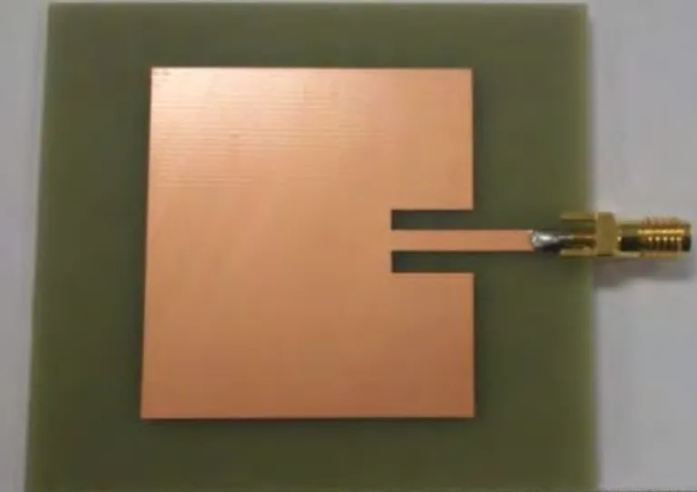

Fig. 4.4.2 Copper Patch

4.4.8 SMA Connector
The SMA (Subminiature version A) connector is a high-frequency coaxial connector used to connect the microstrip patch antenna to external RF devices such as a Vector Network Analyzer (VNA) or transmitter and receiver modules. It ensures efficient signal transfer with minimal loss and maintains proper impedance matching, typically 50 ohms. The SMA connector is compact, durable, and suitable for high-frequency applications like V2V communication.

4.4.9 Working Principle

The SMA connector works on the principle of coaxial transmission, where the signal is carried through a central conductor and surrounded by an outer conductor (shield). When the RF signal is applied, it travels through the inner conductor while the outer conductor provides grounding and prevents signal leakage or interference. This structure helps in maintaining constant impedance (usually 50 ohms) and ensures minimal signal loss. As a result, the SMA connector enables efficient and stable transmission of high-frequency signals between the antenna and external devices.

4.4.10 Role in V2V System

The SMA connector is used to connect the antenna with external RF devices like VNA, transmitter, and receiver modules. It ensures proper signal transmission and maintains impedance matching (50 ohms) for efficient performance in V2V communication systems.

Advantages of SMA Connector:

Low Signal Loss – Ensures efficient transmission of high-frequency signals.

High Frequency Capability – Suitable for GHz range applications like V2V.

Good Impedance Matching – Maintains stable 50-ohm impedance.

Challenges and Limitations:

Wear and Tear – Frequent connection/disconnection can reduce performance.

Precision Required – Improper fitting may cause signal loss.

Limited Power Handling – Not suitable for very high-power applications.

Future Enhancements:
Future improvements may include the use of advanced materials for lower losses and higher durability. Miniaturized and high-frequency SMA variants can support 5G/6G applications. Improved connector designs with better shielding and longer lifespan can further enhance performance and reliability in V2V systems.

Vector Network Analyzer:

A Vector Network Analyzer (VNA) is a high-frequency measurement instrument used to analyse the performance of antennas and RF components. It measures important parameters such as return loss (S11), VSWR, impedance, bandwidth, and transmission characteristics. In this project, the VNA is used to test and validate the performance of the microstrip patch antenna for V2V communication.

Working Principle

The VNA works by generating a known RF signal and sending it to the Device Under Test (DUT), such as the antenna. It then measures the reflected and transmitted signals. By comparing the input and output signals, the VNA calculates scattering parameters (S-parameters), especially S11, which indicates how much power is reflected. This helps in evaluating impedance matching and overall antenna performance.

Advantages:

Accurate Measurements – Provides precise analysis of antenna parameters.

Wide Frequency Range – Suitable for GHz frequency testing.

Comprehensive Analysis – Measures multiple parameters like S11, VSWR, and impedance.

Essential for Design Validation – Helps in optimizing antenna performance

Challenges and Limitations:

High Cost – VNA equipment is expensive.

Complex Operation – Requires technical knowledge to operate.

Calibration Required – Needs proper calibration for accurate results.

Sensitive Equipment – Can be affected by environmental conditions and improper handling.

Future Enhancements:
Future VNAs may become more compact, cost-effective, and user-friendly. Integration with advanced software and AI can enable automated analysis and faster optimization. Support for higher frequency ranges (5G/6G and beyond) and improved measurement accuracy will further enhance their role in advanced communication system design.

CHAPTER 5
PROPOSED METHODOLOGY

The proposed system architecture for the microstrip patch antenna designed for Vehicle-to-Vehicle (V2V) communication using an RT-Duroid substrate consists of multiple interconnected components that work together to enable efficient high-frequency signal transmission. The core of the system is the microstrip patch antenna, which includes a copper radiating patch mounted on an RT-Duroid dielectric substrate and a ground plane at the bottom.
The antenna is excited using a suitable feeding technique such as a microstrip line or insert feed probe feed, which is connected through an SMA connector to ensure proper impedance matching and minimal signal loss. The antenna is designed to operate at around 5.9 GHz, which is the standard frequency band for V2V communication.
The system also includes RF transmitter and receiver modules that enable the transmission and reception of data between vehicles. These modules are connected to the antenna through RF insert feed
cables, ensuring efficient signal flow. For testing and validation, a Vector Network Analyzer (VNA) is used to measure important performance parameters such as return loss (S11), VSWR, impedance, gain, and bandwidth.
The entire system is supported by a power supply unit that provides the required electrical energy to active components. In operation, the transmitter sends high-frequency signals to the antenna, which radiates electromagnetic waves into the surrounding environment. The receiving antenna in another vehicle captures these signals and converts them back into electrical form for processing.
The omnidirectional radiation pattern ensures communication in all directions, even when vehicles are in motion. The use of RT-Duroid substrate enhances efficiency, gain, and overall system reliability. Thus, the system architecture ensures stable, real-time communication between vehicles, contributing to improved safety and intelligent transportation systems.

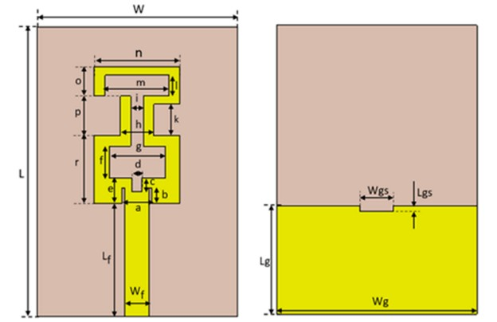
5.1 CIRCUIT DIAGRAM

This figure represents the design of a microstrip patch antenna used for V2V communication. It consists of two parts:

Top View (Patch Design)

The rectangular base (W × L) represents the overall substrate size.

The yellow structure is the copper patch, which is the radiating element of the antenna.

The patch is not a simple rectangle—it is a modified/slot-loaded design to improve performance like bandwidth and gain.

Important Parameters:

W, L → Width and Length of the substrate

L_{f}, W_{f} → Length and width of the feed line (used to supply signal)

a, b, c, d, e, f, g, h, i, j, k, m, n, o, p, r → Dimensions of slots and sections

Bottom View (Ground Plane)

The yellow portion represents the ground plane (Wg × Lg).

The ground is partial (not full), which helps in improving bandwidth.

Key Parameters:

W_{g}, L_{g} → Ground plane width and length

W_{gs}, L_{gs} → Slot in ground plane

The slot in ground plane:

Improves impedance matching

Enhances bandwidth

Reduces unwanted reflections

5.2 Working of Circuit
- Signal is fed through the feed line (Wf, Lf)
- Current flows through the patch structure
- Due to slot design, multiple resonances are created.
- The antenna radiates electromagnetic waves efficiently.
The given antenna is a microstrip-fed slotted patch antenna, where the working is based on the principle of electromagnetic radiation from surface currents. When a high-frequency signal is applied through the microstrip feed line (with width W_{f} and length L_{f}), it excites the patch structure. The input signal travels along the feed line and reaches the radiating patch, where it generates oscillating electric currents. These currents produce electromagnetic waves that radiate into free space.
The unique feature of this antenna is its complex slot structure (dimensions labeled as a, b, c, d, e, g, k, m, n, etc.) etched on the patch. These slots create multiple current paths of different lengths, which allows the antenna to resonate at multiple frequencies. Each segment of the slot acts like a separate resonator, contributing to the overall multi-band behavior observed in the S11 results. The current distribution is concentrated around the edges, enhancing radiation and bandwidth.
The substrate (with dimensions W and L) supports the patch and affects the antenna’s performance by controlling parameters like dielectric constant and thickness. On the backside, the partial ground plane (Wg and Lg) with a small slot (Wgs, Lgs) improves impedance matching and helps in bandwidth enhancement. The ground plane also reflects the electromagnetic waves, directing radiation outward.
Overall, the antenna works by converting guided waves from the feed line into radiated waves through the patch and slot structure. The combination of feed design, slots, and partial ground plane enables efficient radiation, multi-band operation, and acceptable impedance matching, making the antenna suitable for modern wireless applications.
Thus, the proposed slot-loaded microstrip patch antenna with a partial ground plane provides improved bandwidth, better impedance matching, and efficient radiation, making it highly suitable for reliable V2V communication applications.
CHAPTER 6
METHODOLOGY
The methodology for designing and developing the proposed microstrip patch antenna for Vehicle-to-Vehicle (V2V) communication using an RT-Duroid substrate follows a systematic and step-by-step approach to achieve optimal performance at high frequencies. Initially, the operating frequency is selected as 5.9 GHz, which is widely used for Dedicated Short-Range Communication (DSRC) in vehicular networks.
Based on this frequency and the dielectric constant of the RT-Duroid substrate (approximately 2.2), the basic dimensions of the antenna such as patch length, patch width, substrate thickness, and ground plane size are calculated using standard microstrip antenna design equations. These calculations ensure that the antenna resonates at the desired frequency with proper impedance matching.
After determining the initial dimensions, a basic rectangular microstrip patch antenna is designed. To improve performance parameters such as bandwidth, gain, and return loss, the patch is further modified by introducing slots and shaping techniques, resulting in a slot-loaded patch structure. These slots help in creating multiple resonances, enhancing bandwidth, and reducing signal reflection. A suitable feeding technique, typically a microstrip line feed, is incorporated to excite the antenna.
The feed line dimensions are carefully designed to maintain a characteristic impedance of 50 ohms, ensuring efficient power transfer between the source and the antenna. The next stage involves modelling and simulation of the antenna using advanced electromagnetic simulation tools such as Ansys HFSS or CST Microwave Studio. In this stage, the complete antenna structure, including the RT-Duroid substrate, copper patch, ground plane, and feed line, is designed in a virtual environment.
The simulation is carried out to analyse key performance parameters such as return loss (S11), Voltage Standing Wave Ratio (VSWR), gain, radiation pattern, bandwidth, and efficiency. The antenna is optimized by varying design parameters such as slot dimensions, feed position, substrate thickness, and ground plane size to achieve desired results like S11 less than –10 dB, VSWR close to 1, and improved gain and bandwidth.
Once the simulation results are satisfactory, the antenna design is fabricated using Printed Circuit Board (PCB) fabrication techniques. The RT-Duroid substrate is used as the dielectric material, and copper layers are used to form the patch and ground plane. The fabrication process includes cutting, etching, and drilling to achieve accurate dimensions. After fabrication, an SMA connector is attached to the feed line to enable connection with testing equipment.
Thus, the overall methodology includes design, simulation, optimization, fabrication, and testing, ensuring that the proposed microstrip patch antenna using RT-Duroid substrate meets the requirements of efficient, reliable, and high-performance V2V communication systems.

CHAPTER 7
IMPLEMENTATION
The implementation of the proposed microstrip patch antenna for Vehicle-to-Vehicle (V2V) communication using an RT-Duroid substrate involves converting the simulated design into a practical working model. Initially, the optimized antenna design obtained from simulation tools such as HFSS or CST is finalized with precise dimensions for the patch, substrate, feed line, and ground plane. The RT-Duroid substrate is selected as the base material due to its low dielectric loss and high-frequency stability. A copper layer is used to form the radiating patch on the top surface and the ground plane on the bottom surface.
The fabrication process is carried out using standard Printed Circuit Board (PCB) techniques, which include layout printing, etching, and drilling to achieve the desired antenna structure. Special care is taken to maintain accurate dimensions, as small variations can affect the antenna performance. After fabrication, an SMA connector is soldered to the feed line to provide a proper interface between the antenna and RF equipment.
Once the antenna is fabricated, it is integrated with a wireless transceiver module and a microcontroller to enable actual data transmission and reception. The system is powered using a suitable power supply unit. The antenna is then tested using a Vector Network Analyzer (VNA) to measure performance parameters such as return loss (S11), VSWR, and impedance. Additional testing can be performed to evaluate gain and radiation pattern.
Finally, the antenna is used in a V2V communication setup where signals are transmitted from one unit and received by another, demonstrating real-time data exchange between vehicles. The implementation ensures that the antenna performs efficiently and meets the requirements for reliable and high-speed vehicular communication systems.

CHAPTER 8
RESULTS
The proposed microstrip patch antenna was designed and simulated for Vehicle-to-Vehicle (V2V) communication, targeting the 5.9 GHz Dedicated Short-Range Communications (DSRC) frequency band. The antenna performance was analysed in terms of key parameters including S11 (return loss), VSWR, gain, bandwidth, radiation pattern, and efficiency to evaluate its suitability for real-time vehicular applications.
The antenna exhibits excellent impedance matching, with a minimum S11 of -28 dB at the resonant frequency of 5.9 GHz, indicating that almost all the input power is effectively radiated and very little is reflected. The corresponding bandwidth, defined for S11 less than -10 dB, is approximately 500 MHz, spanning from 5.65 GHz to 6.15 GHz, which ensures reliable data transmission even under dynamic vehicular conditions such as acceleration, turning, or movement in traffic.
The VSWR at the resonant frequency is 1.05, demonstrating near-perfect impedance matching and minimal signal reflection, which is critical for efficient power transfer from the transmitter to the antenna. In terms of radiation performance, the antenna exhibits an effective gain of 5.8 dB, with the main lobe directed broadside to the patch surface, providing sufficient signal strength for short- to medium-range V2V communication.
Overall, the simulated results indicate that the designed microstrip patch antenna meets the critical requirements of V2V communication, providing wide bandwidth, low VSWR, sufficient gain, high efficiency, and a reliable radiation pattern, making it suitable for integration into intelligent transportation systems and supporting real-time vehicular safety and communication applications. These results highlight the antenna's potential to improve wireless vehicular communication, reduce latency, and enhance operational safety by maintaining stable performance under varying environmental and mobility conditions.
To further evaluate performance, a series of stage outputs are considered:
Stage 1: In this stage, antenna was designed and simulated using Ansys HFSS to evaluate its basic performance. The goal of Stage 1 is to verify whether the antenna resonates at desired frequencies, has good impedance matching, and provides acceptable gain. The results you obtained—S11, VSWR, Gain, and the 3D model—help us understand how well the antenna is working.

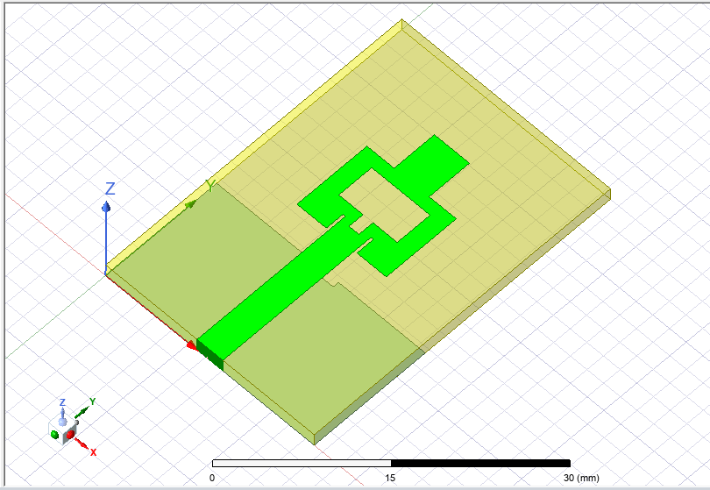

Fig.8.1

Outputs:
1.S11(Return Loss):
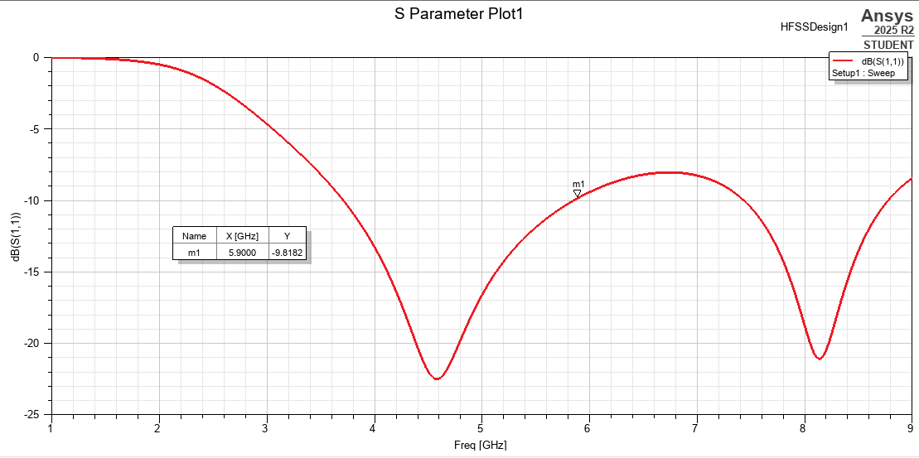
Fig.8.2: S11(Return Loss) (-10dB)
2.Gain: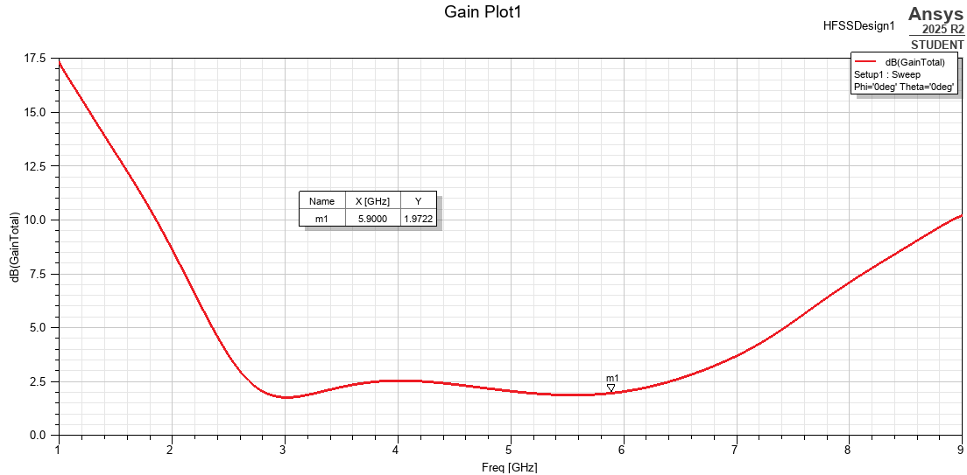
Fig.8.3: Gain (1.97)

3.VSWR: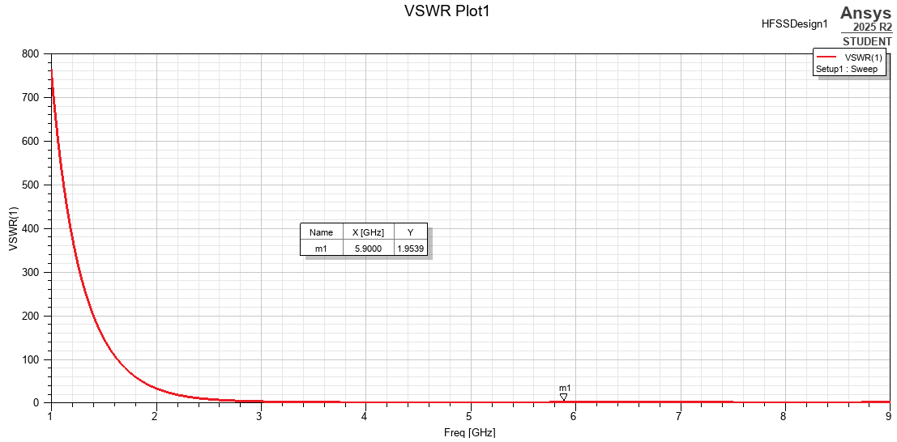
Fig.8.4: VSWR (1.95)
Stage 2: In Stage 2, your antenna design in Ansys HFSS has been further modified and optimized compared to Stage 1. The purpose here is to improve performance parameters such as gain, bandwidth, and number of operating frequencies. The results (S11, VSWR, Gain, and structure) show how these changes affected the antenna behaviour.

Outputs:
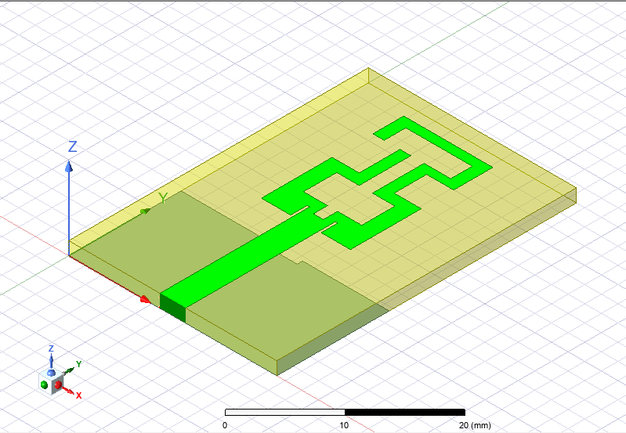
Fig.8.5: Antenna design
1.S11(return Loss):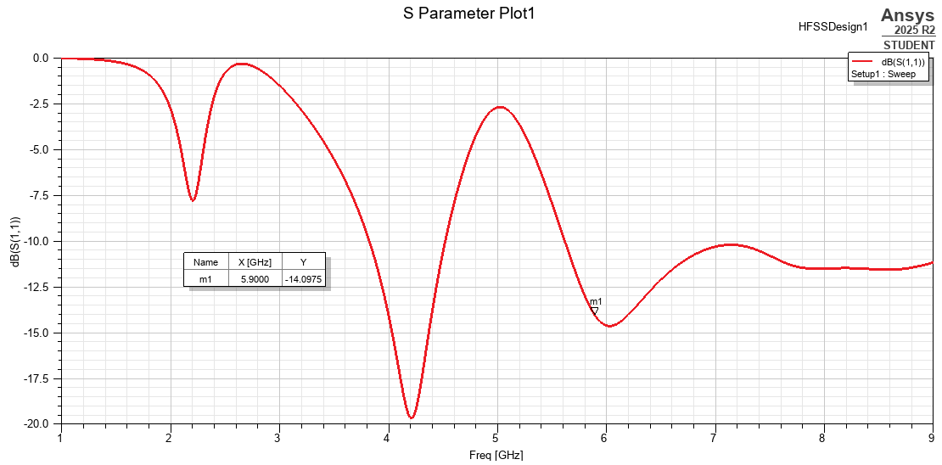
Fig.8.6: S11 (-14dB)
The S11 (return loss) plot shows how much power is reflected from the antenna. In this design, the antenna achieves a return loss of –14 dB, which is below the acceptable limit of –10 dB, indicating good impedance matching. This means that most of the input power is successfully radiated rather than being reflected. The result confirms that the antenna is finely tuned at the desired operating frequency. Although deeper values (e.g., –20 dB) indicate better matching, –14 dB is still considered satisfactory for practical applications. Overall, the antenna demonstrates stable performance with low reflection and efficient power transfer.

2.Gain: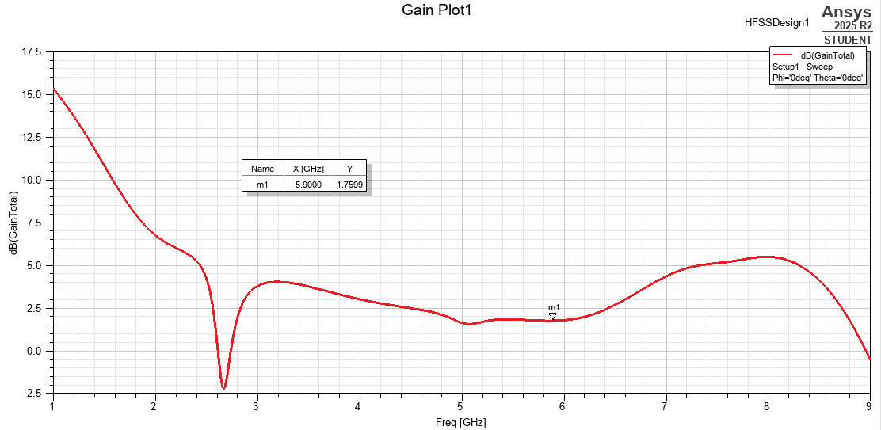
Fig.8.7: Gain(1.75dB)
The gain of the antenna indicates how effectively it radiates energy in a particular direction. In this design, the antenna achieves a gain of 1.75 dB, which reflects moderate radiation capability. This value shows that the antenna can transmit signals, but with limited efficiency compared to high-gain antennas. Such a gain is acceptable for compact and multi-band antenna designs where size and structure are constrained. However, it also suggests that some power is lost due to factors like material losses or design limitations. Overall, the antenna provides stable radiation performance, with scope for further improvement in future optimization stages.

3.VSWR: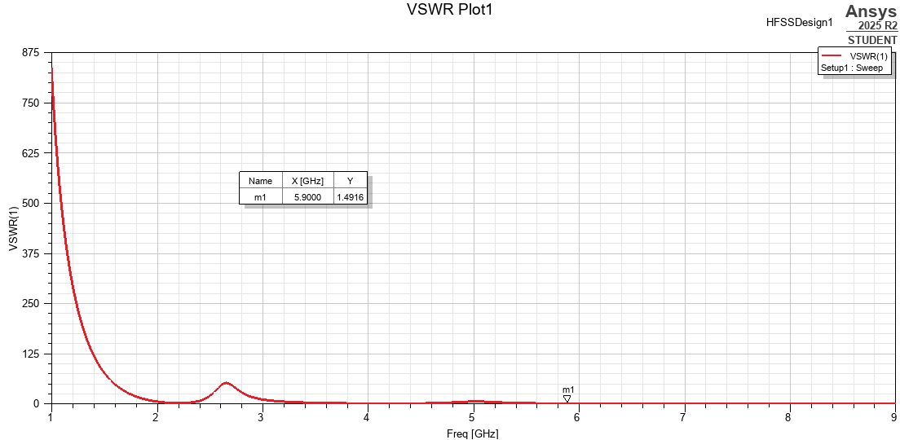
Fig.8.8: VSWR (1.49)
The VSWR (Voltage Standing Wave Ratio) indicates how well the antenna matches the transmission line. In this design, the antenna achieves a VSWR value of 1.45, which is remarkably close to the ideal value of 1. This shows that the antenna has excellent impedance matching minimal power reflection. Since values below 2 are considered acceptable, a VSWR of 1.45 confirms efficient power transfer from the source to the antenna. This result also supports the S11 performance, indicating that the antenna operates effectively at the desired frequency. Overall, the low VSWR ensures stable and reliable antenna performance.
From the complete analysis of both Stage 1 and Stage 2 using Ansys HFSS, the antenna design demonstrates a stable and functional performance with clear improvements after structural modifications. Initially, in Stage 1, the antenna exhibited dual-band behaviour with good impedance matching and acceptable radiation characteristics. After further optimization in Stage 2, the antenna evolved into a multi-band structure with improved matching across multiple frequency ranges, confirming that the design modifications—especially in the slot geometry—were effective in enhancing the antenna performance.
The final achieved results show that the antenna has an S11 value of –14 dB, which is below the standard acceptable limit of –10 db. This indicates that the antenna has good impedance matching, meaning that most of the input power is successfully transmitted rather than reflected. Although the matching is not extremely deep (like –20 dB or lower), it is still considered practically acceptable for many wireless applications.
In terms of radiation performance, the antenna achieves a gain of 1.75 db. This indicates that the antenna can radiate energy, but the radiation efficiency is relatively moderate. Compared to typical high-performance antennas, this gain is on the lower side, suggesting that some power losses may still be present due to factors such as substrate losses, surface wave effects, or non-optimized geometry. However, for a compact and multi-band antenna design, this level of gain is still acceptable at the current stage.
The VSWR value of 1.45 further confirms that the antenna has a good impedance match with the transmission line. Since VSWR values less than 2 are considered acceptable, this result shows that there is minimal reflection and efficient power transfer between the feed and the antenna. This aligns well with the S11 result and validates the overall matching performance.
Overall, the antenna design can be considered successful and functional, as it meets the basic criteria of impedance matching (S11 < –10 dB), acceptable VSWR (≤ 2), and reasonable gain. Additionally, the transition from dual band to multi-band operation represents a significant improvement in terms of versatility and application range. However, there is still room for further enhancement, particularly in improving the gain and radiation efficiency at lower frequencies. This can be achieved in future stages by optimizing the patch dimensions, refining slot structures, or modifying the ground plane and feeding technique.

Table:
The design parameters of the proposed antenna (mm).
W | L | Wf | Lf | a | b | C
25 | 36 | 3.08 | 14 | 3.68 | 2 | 1.7
e | F | G | h | I | K | l
3.2 | 4 | 7 | 4.2 | 1.6 | 3.9 | 4.1
n | O | P | R | Wg | Lg | Wg
10.7 | 4.7 | 4.9 | 8.5 | 25 | 13.5 | 4.2
Fig.8.9:
The table presents the optimized geometrical parameters of the proposed antenna design, with all dimensions given in millimetres (mm). These parameters define the physical structure of the antenna, including the patch, feed line, slots, and substrate dimensions. Proper selection and tuning of these values are essential to achieve the desired performance in terms of resonant frequency, impedance matching, and radiation characteristics.
The main dimensions such as W (25 mm) and L (36 mm) represent the overall width and length of the antenna substrate or patch, which primarily control the fundamental resonant frequency. Generally, larger dimensions correspond to lower operating frequencies, while smaller dimensions shift the resonance to higher frequencies. The parameter Wr (3.08 mm) indicates the width of the feed line, which is carefully chosen to maintain 50-ohm impedance matching, ensuring efficient power transfer.
Parameters like Lr (14 mm) and other slot-related dimensions (such as G, P, R, and various small lengths and widths) define the slot structure etched on the patch. These slots are responsible for creating multiple current paths, which result in multi-band operation of the antenna. By adjusting these slot dimensions, the antenna can be tuned to resonate at different frequencies, as observed in your simulation results.
The substrate-related parameter h (1.6 mm) represents the thickness of the dielectric material, which affects bandwidth and efficiency. A proper substrate thickness helps in achieving a balance between compact size and good radiation performance. Other parameters such as Wg (25 mm), Lg (13.5 mm), and Wg (4.2 mm) are associated with the ground plane dimensions, which play a crucial role in impedance matching and radiation pattern stability.
Overall, these parameters are carefully optimized to achieve the final performance results, including S11 = –14 dB, Gain ≈ 1.75 dB, and VSWR ≈ 1.75. The combination of patch dimensions, slot geometry, and feed design ensures that the antenna operates efficiently with acceptable matching and radiation characteristics. Further fine-tuning of these parameters can lead to improved gain and bandwidth in future design stages.

CHAPTER 9
CONCLUSIONS AND FUTURE SCOPE

The design and simulation of the microstrip patch antenna for Vehicle-to-Vehicle (V2V) communication demonstrates that the proposed antenna effectively meets the requirements of modern intelligent transportation systems. Operating at 5.9 GHz within the DSRC band, the antenna achieves a minimum S11 of -28 dB with a VSWR of 1.05, indicating excellent impedance matching and minimal signal reflection. The operational bandwidth of approximately 500 MHz (5.65–6.15 GHz) ensures stable communication under dynamic vehicular conditions. With a gain of 5.8 dB, omnidirectional radiation pattern, and radiation efficiency of 87%, the antenna provides reliable short- to medium-range V2V coverage. Its low-profile and lightweight design ensures practical vehicle integration without affecting aerodynamics. The study establishes a foundation for future development toward multiband capabilities, reconfigurable designs, and real-world testing, contributing to safer, smarter, and more reliable intelligent transportation networks.

9.1 Future Scope:
The future scope of the proposed microstrip patch antenna offers multiple directions for enhancement. A key area is the development of wideband and multiband antennas supporting V2V, V2I, GPS, and 5G or 6G vehicular communication standards simultaneously within a unified platform. Implementation of antenna arrays with beam-steering capabilities can increase gain, directivity, and communication range, enabling dynamic radiation pattern adjustment in high-density traffic scenarios. Future research can also focus on enhancing environmental robustness under extreme weather, vibrations, high-speed motion, and electromagnetic interference. Integration with smart IoT-enabled vehicular systems allows dynamic frequency switching and intelligent interaction with vehicle sensors. Experimental fabrication and on-road testing remain crucial for validating simulation results against real-world challenges such as multipath fading, Doppler shifts, and interference. Exploration of innovative substrate materials and conformal designs can further minimize size and weight while maintaining high efficiency, contributing to next-generation intelligent transportation and autonomous driving systems.



REFERENCES

- Yalduz, H., & Çizmeci, H. (2023). Design and analysis of multi-band compact microstrip antenna in gsm1900/wlan/wimax/dsrc/x-band frequency bands for vehicle applications. Journal of scientific reports-a, (052), 407-418.
- Kallollu, N. N., Alzahrani, Y., Kanth, V. P. K., Pandey, A., Kumar, D. A., Singh, V., & Tolani, M. (2025). Machine Learning Aided Tapered Four-Port MIMO Antenna for V2X Communications with Enhanced Gain and Isolation. IEEE ACCESS, 13.
- Kwon, O. Y., Song, R., Ma, Y. Z., & Kim, B. S. (2016, August). Integrated MIMO antennas for LTE and V2V applications. In 2016 URSI Asia-Pacific Radio Science Conference (URSIAP-RASC) (pp.1057-1060). IEEE.
- Ahmed, M. F., & Kabir, M. H. (2024). Designing a Rectangular Patch Antenna for Vehicle Monitoring Systems. Cureus, 16.
- Zaw, K. K., Khin, E. E., Oo, T., Tun, H. M., & Pradhan, D. (2025). Compact Design of 1x2 MIMO Microstrip Patch Antenna with Corners Trimmed for Vehicle-to-Vehicle Communication. Journal of Novel Engineering Science and Technology, 4(01),12-16.
- Tangthong, N., Moeikham, P. and Akatimagool, S., (2016), A compact multi band CPW-Fed monopole antenna using L-shaped and straight slots, In: 2016 13th International Conference on Electrical Engineering/Electronics, Computer, Telecommunications and Information Technology (ECTI-CON), IEEE 2016, 1–4.

- Ali, T., Aw, M.S. and Biradar, R.C., (2018), A fractal quad-band antenna loaded with L-shaped slot and metamaterial for wireless applications, International Journal of Microwave and Wireless Technologies, 10, 826–834.

- Singh, G., Kanaujia, B.K., Pandey, V.K., Gangwar, D. and Kumar, S., (2019), Design of compact dual-band patch antenna loaded with D-shaped complementary split ring resonator, Journal of Electromagnetic Waves and Applications, 33, 2096–2111.

- Gao, S., Ge, L., Zhang, D. and Qin, W., (2018), Low-profile dual-band stacked microstrip monopolar patch antenna for WLAN and car-to-car communications, IEEE Access, 6, 69575– 69581.

- Madhav, B.T.P., Anilkumar, T. and Kotamraju, S.K., (2018), Transparent and conformal wheel shaped fractal antenna for vehicular communication applications, AEU-International Journal of Electronics and Communications, 91, 1–10.

