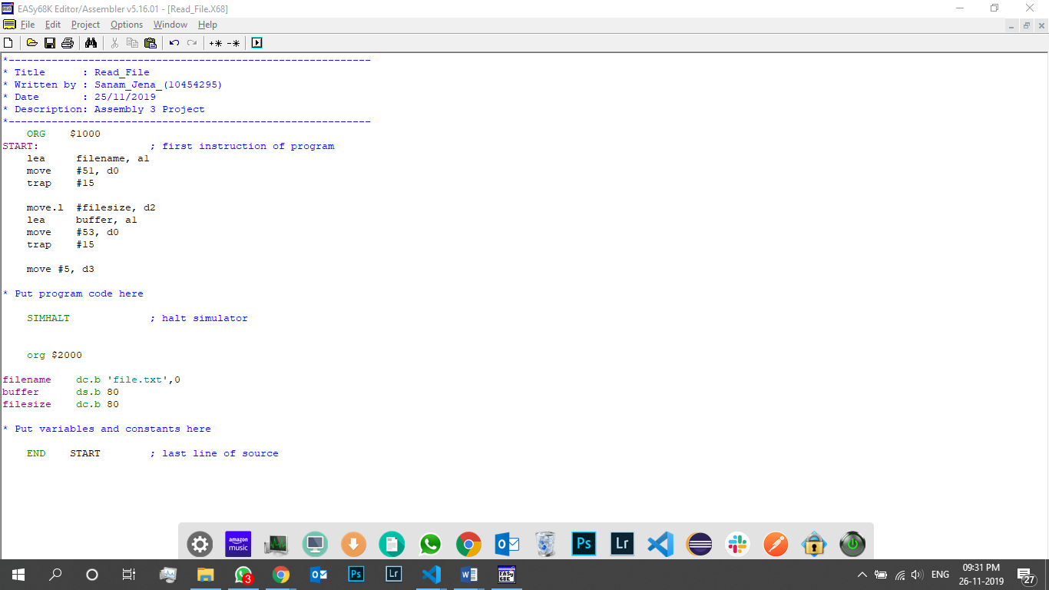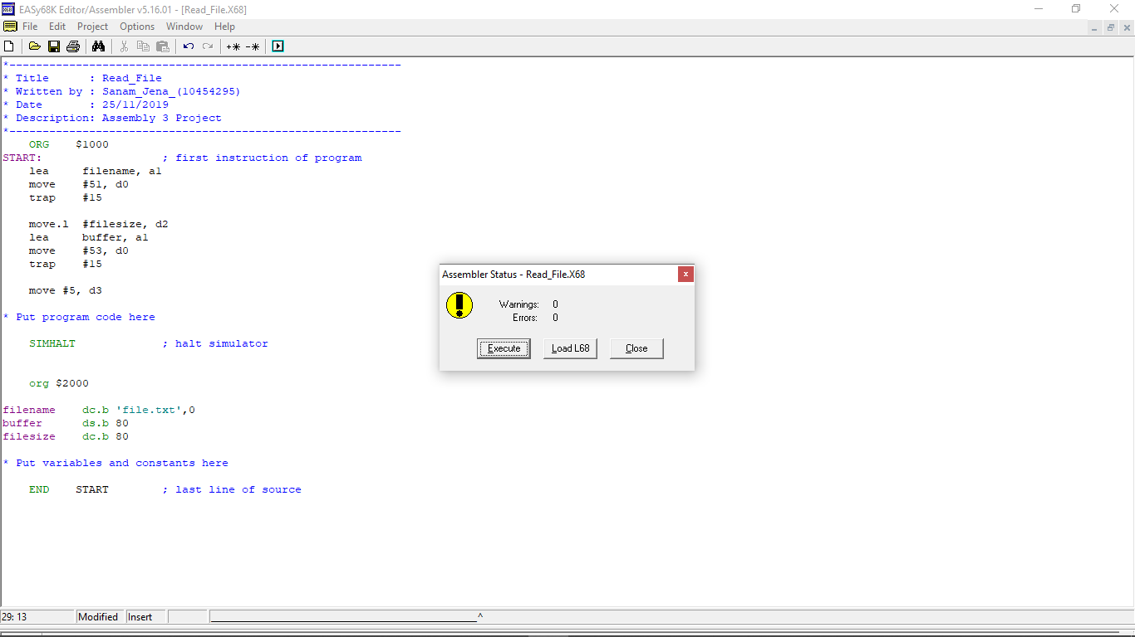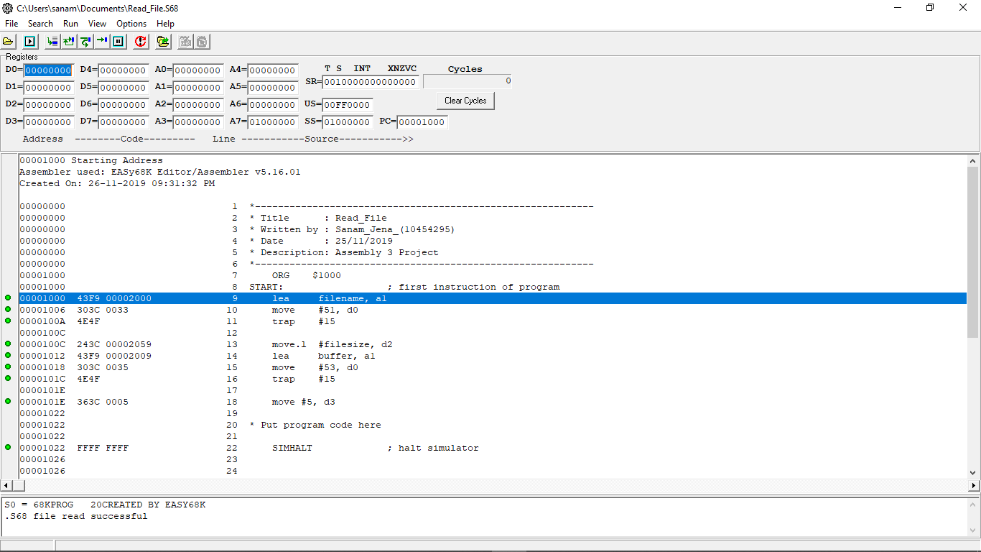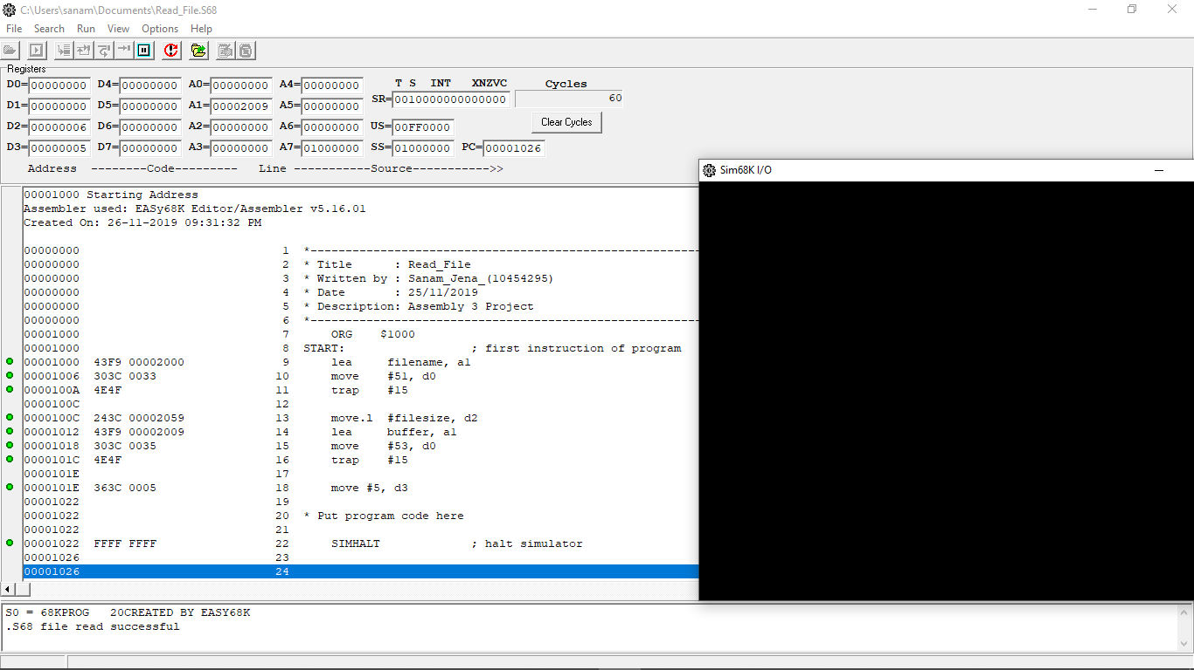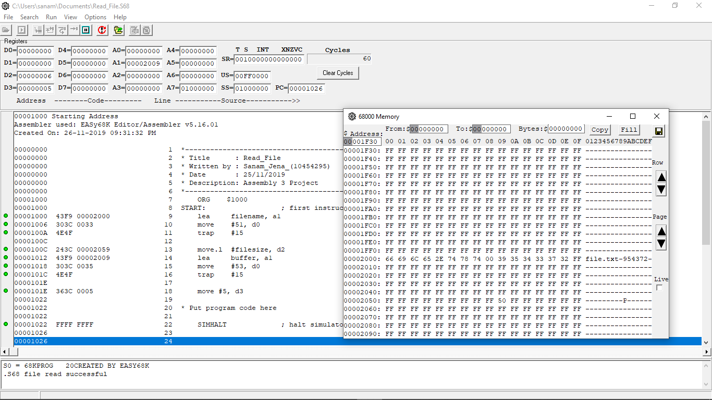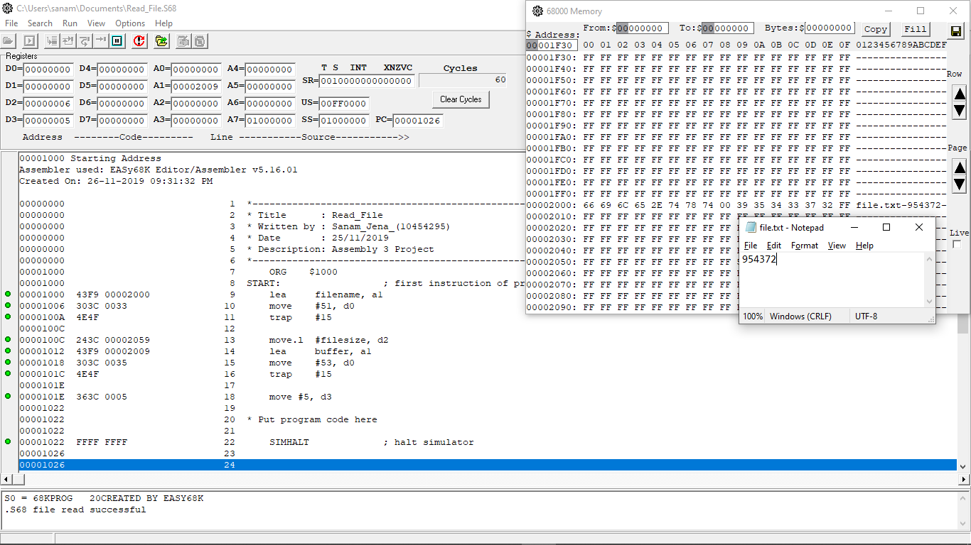

1. **Please explain how to transform an assembly language program into a binary executable file using basic reference tables.**

Answer: Assembly is a low level language that requires an assembler to convert the written code into a binary executable file which can be understood by the computer to follow the instructions. Compiler is used to convert the human readable language into something that a machine can understand. For assembly an assembler is used as a compiler to convert the assembly code into a binary executable. An assembler works from top to bottom in a sequential manner executing the instructions specified by the programmer. The operations table which is used to determine the type of instruction, the number of operands, and other information that is required to translate the instruction. The operations table is built right into the assembler. There is also a symbol table which is specific to a particular program, and it is used during the final translation to look up any symbols that are not located in the operations table. There are then object files that are converted to binary executable files as the final result.

1. **Please explain the formats of the different types of data (image, video, audio and alphanumerical, integers, floating point numbers).**

Answer:

**Image**

I. TIFF [Tagged Image File Format]: This type of images consumes more memory space to store because they are uncompressed and carry a large amount of data of the image.

Use: Photo software, Page layout software

II. JPEG [Joint Photographic Experts Group]: This types of images are compressed to carry a large amount of data in the small size of the file. Sometimes it loses the detail of the image while compressing.

Use: Digital camera, online photographs

III. GIF [Graphics Interchange Format]: GIF format type of images are also compressed files but not same as “JPEG”. Images are not losing their data while compressing and that’s why they have a larger size of the file than JPEG.

Use: for creating an animations

**Video**

I. FLV [Flash Video]: On each platform, each browser supports flash videos because they carry both progressive as well as streaming downloads. It is encoded by Adobe Flash software.

II. AVI [Audio Video Interleave]: This is the oldest format and produced by Microsoft. Mostly all popular web browser supports AVI videos.

III. MP4 [Moving Picture Experts Group]: They become more popular than the FLV because it can save online audio and visual streams. It provides high quality with a small size of the file.

**Audio and Alphanumerical**

I. PCM [Pulse Code Modulation]: Firstly, the existence of an analog sounds is in a waveform, later it transfers into digital bits. It stores data without any compression.

Use: In CD and DVD

II. MP3 [MPEG Audio Layer 3]: Nowadays the most popular audio format is MP3. The best thing of this format is it breaks down the sound data which are outside the limit of hearing of people and very efficiently compresses the rest of the sound data.

Use: In PCs, Macs, Smart TVs

III. AIFF [Audio Interchange File Format]: As WAV created by Windows and IBM, Apple created AIFF format for MAC in 1988. It is also a compressed version. It contains PCM formats data in an uncompressed form and acts as a wrapper for PCM encoding to make compressed data.

**Integers**: They are whole numbers contains positive, negative and zero value. There are different types of integers as follows,

byte contains 8 bits [example: “56”], char contains 16 bits [example: ‘B’], short contains 16 bits [example: “56”], int contains 32 bits [example: “56”], long contains 64 bits [example: “56L”].

**Floating point numbers**: It is a fractional number with a decimal point, not a whole number. There are two types as follows,

Float contains 32 bits [example: “65f”] and double contains 64 bits [example: “65.50”].

**Reference:**

* Caroline. (2010, May 14). The 5 Types of Digital Image Files: TIFF, JPEG, GIF, PNG, and Raw Image Files, and When to Use Each One.

Retrieved from <https://www.ivanexpert.com/blog/2010/05/the-5-types-of-digital-image-files-tiff-jpeg-gif-png-and-raw-image-files-and-when-to-use-each-one/>

* Brown, Liza. (2018, October 16). What is The Best Video Format to Choose for YouTube/Editing/TV?

Retrieved from <https://filmora.wondershare.com/video-editing-tips/video-formats.html>

* Lee, Joel. (2016, May 16). 10 Common Audio Formats Compared: Which One Should You Use?

Retrieved from <https://www.makeuseof.com/tag/audio-file-format-right-needs/>

* Skinner, Thomas P. (1988). ASSEMBLY LANGUAGE PROGRAMMING FOR TNE 68000 FAMILY.