**Splunk LAB In a Box (draft)**

9/19/2016

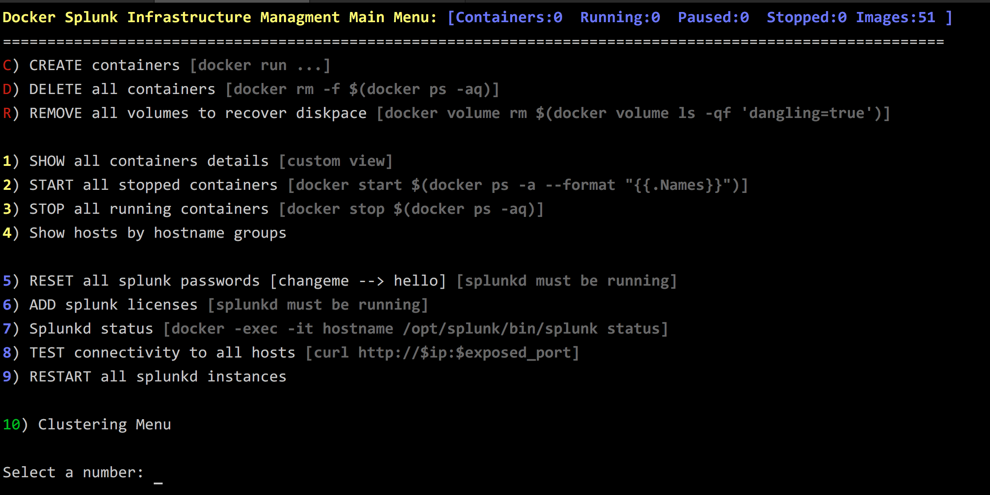

**Cluster-building menu:**

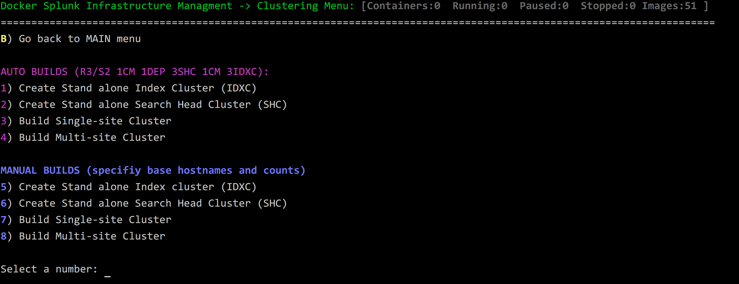

**Sample list of all hosts created:**

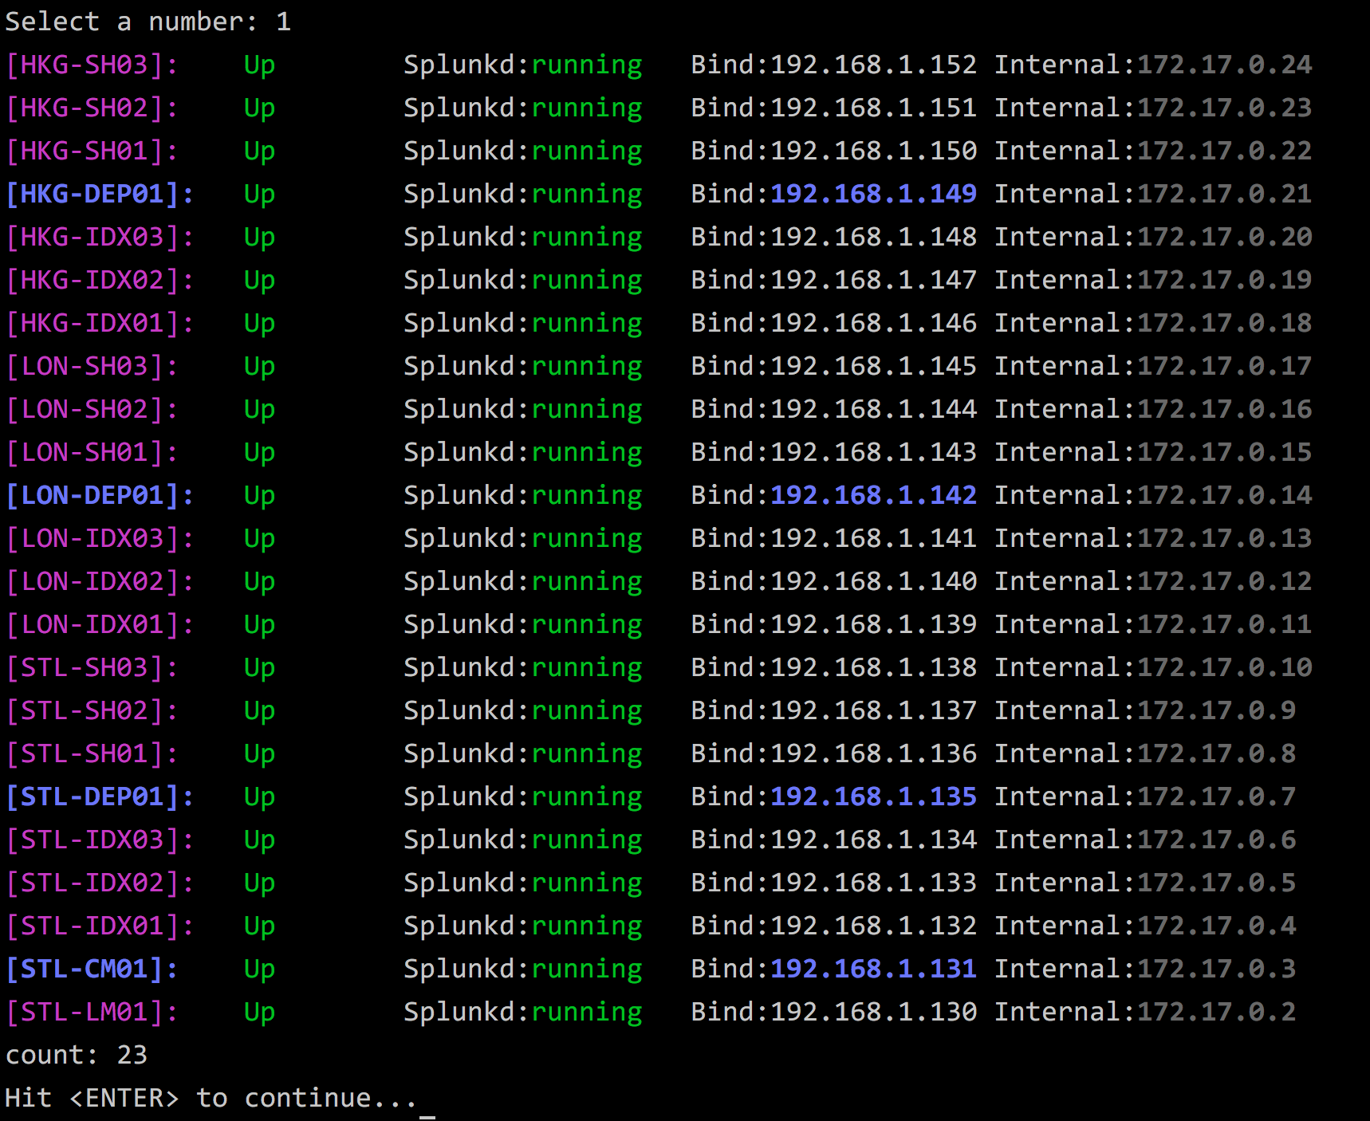

**Sample execution (log level 3):**

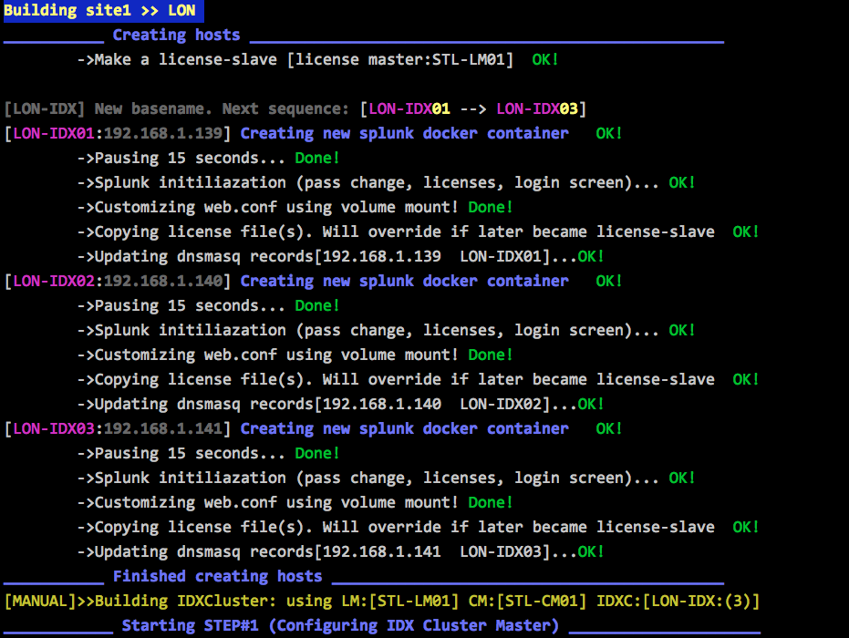

**Sample login screen:**

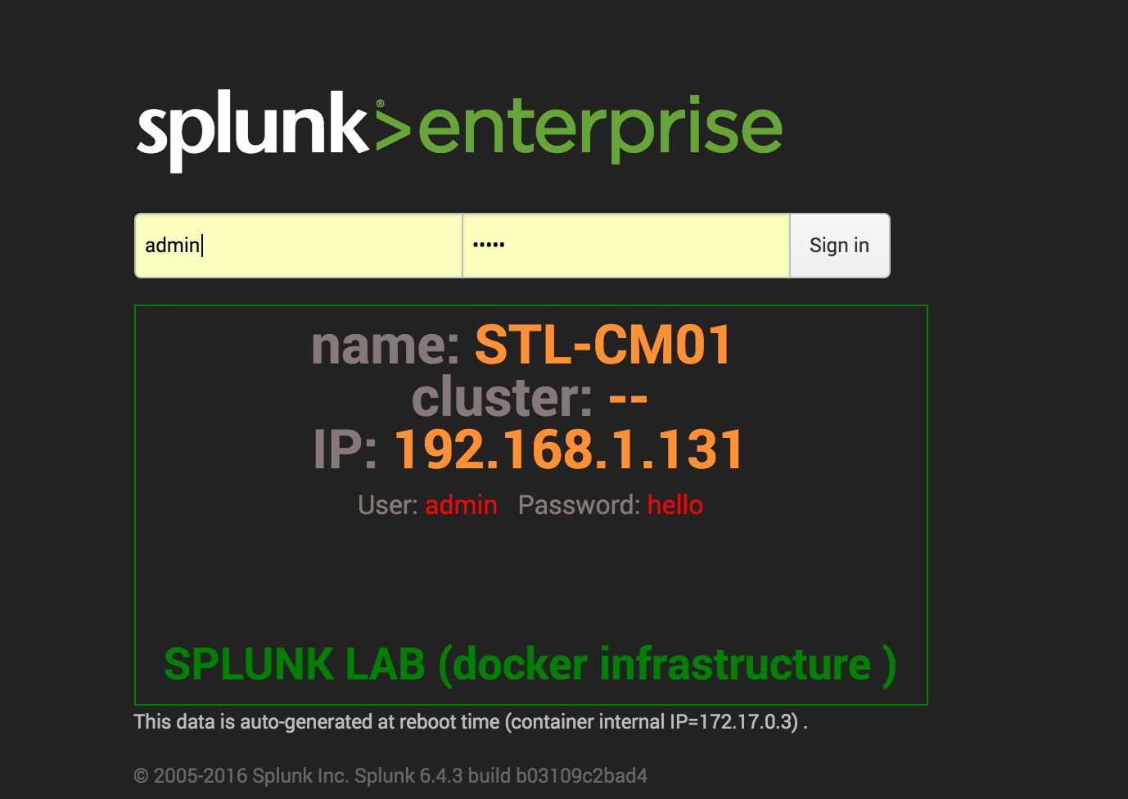

Sample showing three sites site-2-site cluster:

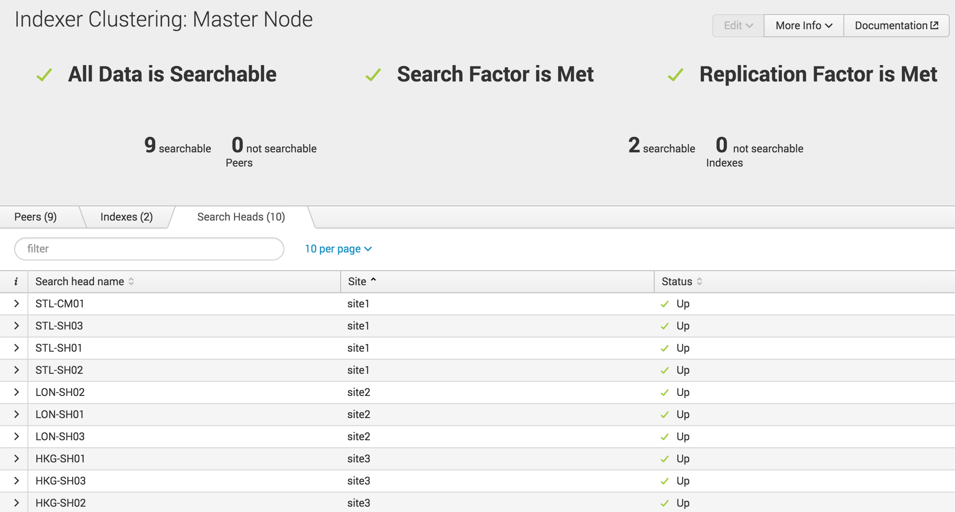



**Additional screenshots (4 sites each location 3 SH, 20 IDX) running on NUC Skull (32GB ram, 8 core)**

