ASEZA Databank & Dashboard Phase 2 Project

Azure Data Platform

Submission Date: NOV 02, 2026
IDIQ No.: 72027821D00003
Task Order No.: 72027822F0001
Period of Performance: April 26, 2026, to September 30, 2026
Contracting Officer’s Representative: Ruba Abu Hussein

Submitted by: Tracy Shanks, Chief of Party
Chemonics International
1275 New Jersey Avenue SE, Suite 200
Washington, DC 20003
Email: tshanks@JordanERA.org
This document was produced for the review and approval of the United States Embassy Amman as part of support provided to Jordan by the United States Government. The contents are the responsibility of its authors and do not necessarily reflect the views of the United States Government.

User and Administrator Guides

Document Information

Field | Details
Project | ASEZA Databank and Dashboard - Phase 2
Document Type | user and administrator guides
Version | V1.0
Prepared By | DataHub Analytics
Client | Aqaba Special Economic Zone Authority (ASEZA)
Contract / Reference | ERA-058
Period | April 26, 2026 - September 30, 2026
Update Basis | Platform state as deployed in November 2026

Table of Contents
Table of Contents 3
How to Use This Guide 5
1. System Overview 6
1.1 Platform Components 6
1.2 The Four Warehouse Layers 7
1.3 Environments and Endpoints 7
1.4 Refresh Schedule 8
1.5 Glossary 8
2. User Guide 10
2.1 Accessing the Dashboards 10
2.2 Navigating a Report 10
2.3 Reading the Figures 11
2.4 Exporting and Sharing 11
2.5 Submitting Data in the Forms Application 12
2.6 Data Freshness 12
2.7 When Something Looks Wrong 13
2.8 Requesting Access 13
3. Administrator Guide 15
3.1 Access and Permissions 15
3.2 Synapse Studio Orientation 15
3.3 Pipeline Inventory 16
3.4 Control Tables and Watermarks 17
3.5 Linked Services, Integration Runtimes and Credentials 18
3.6 Monitoring Pipeline Runs 18
3.7 Alerts and the Error Log 19
3.8 The SQL Pool 19
3.9 Power BI Administration 20
3.10 Purview and the Data Catalogue 20
3.11 Forms Application Administration 21
4. Standard Operating Procedures 22
5. Disaster Recovery Runbooks 33
5.1 Recovery Objectives 33
5.2 What Is Backed Up 33
5.3 Selecting a Runbook 34
5.4 Runbook A. Restore the SQL Pool from a Restore Point 35
5.5 Runbook B. Rebuild the Warehouse from DDL and Reload 35
5.6 Runbook C. Recover a Single Table or Pipeline 37
5.7 Runbook D. Recover from a Source Change or Outage 37
5.8 Runbook E. Restore Lost or Rotated Credentials 39
5.9 Post-Incident Verification 40
Appendix A. Pipeline and Object Reference 41
Appendix B. SOP Quick Reference 43
Appendix C. Common Failures 44

How to Use This Guide
This guide explains how to operate and maintain the ASEZA Databank and Dashboard platform. It is written for two audiences and is organized so that each audience can work from its own part without reading the other.
Reader | Read | Purpose
Report users in the directorates | Part 2 | Open and read the dashboards, understand the figures, submit form data
ASEZA IT, the five platform administrators | Parts 3, 4 and 5 | Operate the pipelines, run the daily procedures, recover from failure
Delivery Unit and management | Part 1 and Part 2 | Understand what the platform does and how to read the reports
Anyone new to the platform | Part 1 | System overview before anything else

Conventions used in this guide
- Procedures are written as numbered steps. Each step is a single action with an observable result.
- Object names, schemas, pipelines and file paths are written in a distinct typeface, for example dwh.vw_transport_form.
- Every procedure ends with a verification step. A procedure is not complete until its verification passes.
Related documents
Document | Covers
Data Connection Framework and Catalogue | How each source connects, linked services, datasets, alerts and the data catalogue
Data Warehouse Blueprint and Structure | The Gold data model, design standards and the complete deployed DDL
Co-Development Sessions Documentation | The training sessions delivered to the ASEZA team and their recordings

NOTE: This guide does not repeat the connection details or the data model. Where a procedure depends on them, it points to the document above rather than restating content that would then need maintaining in two places.

1. System Overview
The platform collects data from several source systems, stores it in a layered warehouse inside Azure Synapse Analytics, and publishes it through Power BI dashboards used by the ASEZA directorates and the Delivery Unit.

1.1 Platform Components
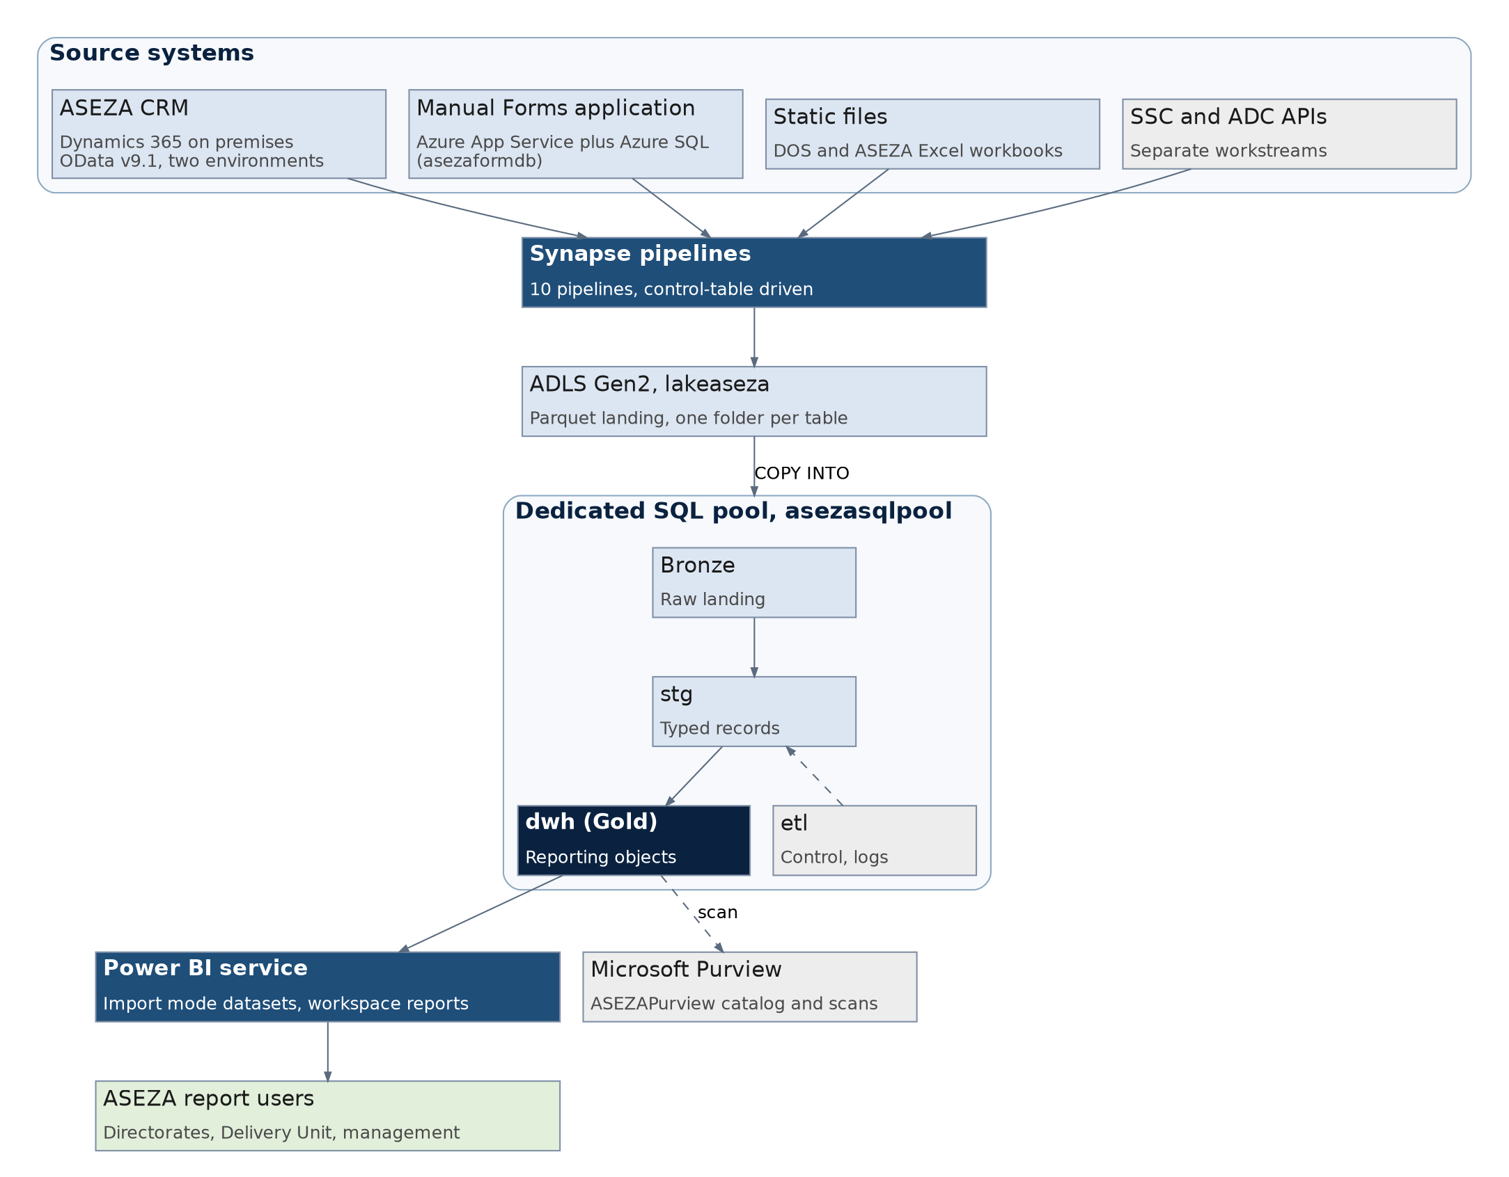
Figure 1. Platform components and the path data takes from source to report
Component | Service | Responsibility
Source systems | Dynamics 365 CRM, Manual Forms application, Excel files | Where the data originates
Orchestration | Synapse pipelines (Azure Data Factory) | Moves data on a schedule, calls the load procedures
Data lake | ADLS Gen2, lakeaseza | Holds a Parquet copy of every extract, one folder per table
Warehouse | Synapse dedicated SQL pool, asezasqlpool | Stores and models the data across the Bronze, stg, etl and dwh schemas
Reporting | Power BI service | Hosts the datasets and the reports the directorates open
Governance | Microsoft Purview, ASEZAPurview | Catalogues the warehouse objects and classifies sensitive data
Secrets | Azure Key Vault | Holds source credentials referenced by the linked services

1.2 The Four Warehouse Layers
Data always moves forward through the layers. Nothing writes backwards, which is what makes a failure recoverable: any layer can be rebuilt from the one before it.
Layer | Schema | What it holds | Can be rebuilt from
Landing | ADLS Gen2 | Parquet extract files per table and run | The source system
Bronze | Bronze | Raw rows, all columns text typed | The landing files
Silver | stg | Typed, de-duplicated records | Bronze
Gold | dwh | Dimensions, fact views, form views, KPI star, statistical tables | stg
Control | etl | Control tables, watermarks, option-set metadata, error logs | Not derived, this is configuration and must be backed up

1.3 Environments and Endpoints
Item | Value
Synapse workspace | asezaws
Dedicated SQL pool | asezasqlpool, always active, not paused on a schedule
SQL endpoint | asezaws.sql.azuresynapse.net
Data lake account | lakeaseza
Production containers | crm-api-data, manual-forms, and the raw and staging areas for static files
Test container | test-container
CRM endpoints | crm.aseza.jo/LicensingAndRegistrationProd/api/data/v9.1 and crm.aseza.jo/LaborAndResidencyProd/api/data/v9.1
Manual Forms database | asezaformdb (Azure SQL Database), behind the forms Azure App Service
Purview account | ASEZAPurview
Test schema | TEST, inside the same pool, with layer prefixes on the object names

NOTE: The test objects live in the same SQL pool as production. A statement run without a schema prefix runs against production. Always qualify object names with their schema.

1.4 Refresh Schedule
Data | Pipeline | Frequency
CRM entity data | CRM_API_DATA | Daily, off hours
CRM reference metadata | CRM_API_DIMS | Weekly or on demand after a CRM configuration change
Manual Forms submissions | PL_Manual_Forms | Daily, full reload
Strategic Plan KPIs | Pl_Load_StrategicPlan | Daily
Static statistics (DOS, ASEZA) | PL_ETL_Excel_Ingest | Annually, or when a new release is received
Power BI datasets | Power BI scheduled refresh | After the warehouse loads complete

1.5 Glossary
Term | Meaning
ADLS Gen2 | Azure Data Lake Storage. File storage holding the Parquet copies of each extract.
Bronze, stg, dwh | The warehouse layers. Raw, typed, and reporting ready, in that order.
CCI | Clustered columnstore index. The compressed, column oriented storage used for larger tables.
Control table | A table in the etl schema that drives a pipeline, for example which tables to load and which columns to select.
Dedicated SQL pool | The provisioned Synapse warehouse compute that hosts the database asezasqlpool.
DWU | Data Warehouse Unit. The unit of compute capacity assigned to the dedicated SQL pool.
Full reload | A load pattern that empties the target and loads the source in full on every run.
Gold view | A view in the dwh schema that Power BI reads. It presents data, it does not store it.
Import mode | A Power BI storage mode where data is copied into the dataset on refresh, rather than queried live.
Integration runtime | The compute that runs a pipeline activity. Auto resolve is Azure hosted, self hosted runs on a VM.
Linked service | A stored connection definition to a source or destination system.
Option set | A list of coded values in Dynamics 365, for example a status or a sector, decoded into labels in the warehouse.
Restore point | A point in time snapshot of the SQL pool that a restore can be made from.
SHIR | Self hosted integration runtime. Used where a source requires a fixed, whitelisted outbound IP address.
Watermark | The stored marker of how far an incremental load has progressed, used to retrieve only newer records.

2. User Guide
Part 2 is for the directorate staff and the Delivery Unit. It covers opening the dashboards, reading them correctly, submitting form data, and what to do when something looks wrong.

2.1 Accessing the Dashboards
Reports are published to a Power BI workspace. Access is granted by ASEZA IT and uses the ASEZA account already used for email, so there is no separate password.
1. Open a browser and go to app.powerbi.com.
2. Sign in with the ASEZA account, for example name@aseza.jo.
3. Select Workspaces in the left navigation, then the ASEZA workspace.
4. Select the report to open it. Reports and datasets are listed separately; open the item of type Report.
5. Select the star icon next to a report to add it to Favourites, which places it in the left navigation for later.

2.2 Navigating a Report
Every report follows the same layout: page tabs along the bottom, filters and slicers on the page, and visuals showing the measures.
Element | What it does | How to use it
Page tabs | Separate subject areas within one report | Select a tab along the bottom of the report
Slicer | Restricts the page to selected values, for example a year or a directorate | Select a value. Hold Ctrl to select several
Filter pane | Applies a filter to a visual, a page or the whole report | Expand Filters on the right, then set the condition
Field parameter selector | Switches which measure or which dimension a chart displays | Select an option in the selector next to the chart
Cross highlighting | Selecting a bar or slice filters the other visuals on the page | Select the element, select it again to clear
Focus mode | Enlarges one visual to the full canvas | Select the expand icon in the visual header
Reset to default | Removes every selection made in the session | Select Reset to default in the report toolbar

2.3 Reading the Figures
Three points decide whether a number is being read correctly.
The reporting date, not the submission date
Form data carries both. The reporting date is the period the figure describes. The submission date is when it was entered. A figure entered in November for the third quarter appears under the third quarter. Visuals are built on the reporting date unless their title says otherwise.
Sparse and irregular submission
Forms are not submitted on a fixed monthly cycle. A measure labelled as the latest value shows the most recent submission on or before the selected period, not necessarily a value from that period. An empty point on a trend line means no submission was received, not a zero.
Arabic and English labels
Dimension labels are held in both languages. Visuals use the Arabic label where the source provides it and the English label elsewhere, so a single report can show both. The underlying code is the same in either case.
If a figure looks wrong | Check first
A period shows no value | Whether a submission exists for that reporting date, see 2.6
A total differs from the source | Whether a slicer or filter is still applied, and whether the report refreshed after the latest load
A percentage looks impossible | Whether the visual sums components or averages ratios. Occupancy style measures sum the components
A name appears twice with different spellings | Whether the source holds two spellings. The warehouse presents the source value as it is
A figure changed since yesterday | Whether the source record was corrected. Form loads are a full reload, so corrections overwrite

2.4 Exporting and Sharing
Task | Steps
Export the data behind a visual | Select the visual, select the three dots, Export data, then choose summarized or underlying data
Export the page to PDF | Select Export in the report toolbar, then PDF
Export to PowerPoint | Select Export, then PowerPoint. Current selections are preserved
Share a report | Select Share. The recipient needs their own access, sharing does not grant it
Subscribe to a page by email | Select Subscribe to this report, set the frequency and the time

NOTE: An exported file is a snapshot and does not update. Treat exported figures as valid only for the date they were taken, and state that date whenever the file is circulated.

2.5 Submitting Data in the Forms Application
KPI figures that do not come from a system are entered by directorate staff in the Manual Forms application. Each user can open only the forms assigned to them.
TO BE COMPLETED: Developers Team
This subsection covers the forms application built on Azure App Service with an Azure SQL database. The following must be supplied by the team that built it:
1. The application URL and how a user signs in.
2. How a user selects a form, a reporting period and a frequency, and how a draft is saved before submission.
3. The meaning of each submission status and who approves a submission, if approval applies.
4. How a submitted value is corrected after submission, and whether a correction creates a new record or overwrites the previous one.
5. How table style KPIs with several rows are entered.
6. Any validation applied on entry, for example numeric only or required fields.
7. Screenshots of the login page, the form list, a completed form and the submission confirmation.
8. Who administers user and form assignments, and how a new form or a new user is added.

2.6 Data Freshness
Every form view carries the submission timestamp, and the reports carry the dataset refresh time, so the age of any figure can be established without asking ASEZA IT.
1. Open the report and select the information icon or the footer text showing the last refresh time, where the page provides it.
2. In the Power BI service, select the workspace, then the dataset. The Refreshed column shows the date and time of the last successful refresh.
3. For a specific figure, add the submission date field to a table visual, or export the underlying data of the visual, to see when that value was entered.
Verification
The refresh time is on or after the expected daily load time. If it is older than two days, raise it with ASEZA IT as described in 2.7.
Sequence | Typical timing
Source systems updated by users | Throughout the working day
Pipelines load the warehouse | Overnight, scheduled in UTC
Power BI datasets refresh | After the loads complete
Reports show the new data | From the next working morning

2.7 When Something Looks Wrong
Report users are the first to notice a bad figure, so what is reported and how it is reported decides how quickly it can be traced.
Before reporting it
- Select Reset to default to clear any filter or slicer left from earlier.
- Check the refresh time as described in 2.6. A figure missing from a report refreshed before the source was updated is expected.
- Check whether the figure is missing or wrong. Missing usually means no submission, wrong usually means a source value or a calculation.
What to include in the report to ASEZA IT
Item | Example
Report and page name | Transport and Logistics, Fleet page
Visual | Vehicles by type, bar chart
Filters applied | Year 2026, Directorate Transport
Expected and observed value | Expected 1,240 taxis, report shows 860
Source of the expected value | Directorate register as at 1 November 2026
Refresh time shown | 2 November 2026, 01:20
Screenshot | Full page, so the filter state is visible

2.8 Requesting Access
Access has three separate parts, and a request should state which is needed: the Power BI workspace for reports, the forms application for data entry, and the Synapse workspace for administrators.
1. Send the request to ASEZA IT with the user name, the ASEZA email address, the directorate, and which of the three parts is required.
2. For report access, state whether the user needs to view reports only or to build new reports from the datasets.
3. For form access, state which form the user is responsible for.
4. ASEZA IT grants the access as described in 3.1 and confirms by email.
5. The user signs in and confirms the report or form opens.

3. Administrator Guide
Part 3 is for the five ASEZA IT platform administrators. It assumes an Azure portal account with the assigned roles and familiarity with SQL, but no prior Synapse experience.

3.1 Access and Permissions
Access is granted in four independent places. A user can hold one and still be blocked by another, which is the most common cause of an access problem on this platform.
Layer | Granted in | Typical role | Controls
Azure RBAC | Azure portal, the resource or resource group, Access control (IAM) | Reader, or Contributor for administrators | Whether the resource is visible and manageable in Azure
Synapse RBAC | Synapse Studio, Manage, Access control | Synapse Artifact User, Synapse Contributor | Whether pipelines and notebooks can be opened and run
SQL pool permissions | T-SQL in asezasqlpool | db_datareader, or a custom role | Whether a user can query the schemas
Power BI | Power BI service, workspace access | Viewer, Contributor, Member | Whether reports and datasets can be opened or edited

NOTE: Azure RBAC and Synapse RBAC are separate systems. Granting Contributor in Azure does not grant the right to open a pipeline in Synapse Studio. Both must be assigned.
Granting SQL read access to a user
CREATE USER [name@aseza.jo] FROM EXTERNAL PROVIDER;
ALTER ROLE db_datareader ADD MEMBER [name@aseza.jo];
Checking what a user currently holds
SELECT dp.name AS principal_name, dp.type_desc, r.name AS role_name
FROM sys.database_role_members rm
JOIN sys.database_principals r ON r.principal_id = rm.role_principal_id
JOIN sys.database_principals dp ON dp.principal_id = rm.member_principal_id
ORDER BY dp.name;

3.2 Synapse Studio Orientation
Hub | Used for
Home | Entry point and recent items
Data | Browsing the SQL pool schemas, the lake containers and the file contents
Develop | SQL scripts and stored procedure definitions
Integrate | The pipelines, their activities and their triggers
Monitor | Pipeline runs, trigger runs, activity detail and SQL requests
Manage | Linked services, integration runtimes, triggers, access control and the SQL pool itself

The two hubs used daily are Monitor, to confirm the overnight loads, and Integrate, to rerun a pipeline. Everything in Part 4 happens in one of those two.

3.3 Pipeline Inventory
Ten pipelines exist in the workspace. Seven serve production, three are test clones that write to the TEST schema and the test container.
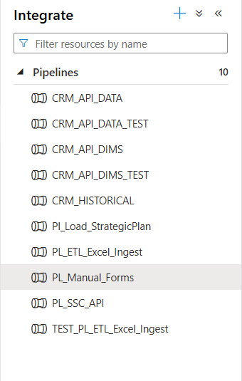
Figure 4. The pipeline list in Synapse Studio, Integrate hub
Pipeline | Loads | Path | Frequency | Environment
CRM_API_DATA | ASEZA CRM entity data | OData v9.1 to ADLS to Bronze to stg | Daily | Production
CRM_API_DIMS | CRM option-set and reference metadata | OData metadata endpoints to stg.OptionSetLabels to dwh dimensions | Weekly or on demand | Production
CRM_HISTORICAL | CRM historical backfill | Paginated JSON to ADLS to COPY INTO to OPENJSON to Bronze | On demand | Production
PL_Manual_Forms | Manual Forms submissions | asezaformdb to ADLS to Bronze to stg, full reload | Daily | Production
Pl_Load_StrategicPlan | Strategic Plan KPI framework | Loads the KPI dimensions, bridge and fact tables | Daily | Production
PL_ETL_Excel_Ingest | Static Excel files (DOS and ASEZA) | Excel in the raw area to Parquet in staging to stc_ tables | Annually or on release | Production
PL_SSC_API | SSC G2G API | REST API to ADLS, pending connectivity | Not scheduled | Pending
CRM_API_DATA_TEST | Test clone of CRM_API_DATA | Writes to the TEST schema and test-container | On demand | Test
CRM_API_DIMS_TEST | Test clone of CRM_API_DIMS | Writes to the TEST schema | On demand | Test
TEST_PL_ETL_Excel_Ingest | Test clone of the Excel ingest | Writes to the TEST schema | On demand | Test

NOTE: The test pipelines are near copies of the production ones. Before running one, confirm in its Sink settings that it writes to test-container and to the TEST schema, because a copied pipeline that still points at the production container will overwrite production files.

3.4 Control Tables and Watermarks
The pipelines are configuration driven. Which tables load, which columns are selected and how far an incremental load has progressed are all held in the etl schema rather than inside the pipeline definitions, so a scope change is a row change rather than a pipeline change.
Object | Purpose | Changed when
etl.ApiIngestConfig | CRM tables, selected columns and mappings for the API ingest | A table or column is added to or removed from the CRM scope
etl.ExcelIngestConfig | Workbook, sheet and target table mapping for the static files | A new annual release arrives or a sheet is renamed
Watermark columns | The last loaded modification timestamp per CRM table | Reset only to force a reload of a table
etl.pipeline_run_log | Start, success with row count, and failure with message per run | Written by the pipelines, read when investigating
etl.<Source>_ErrorLog | Captured error detail per source | Written by the load procedures on failure

Reading the most recent runs
SELECT TOP 50 *
FROM etl.pipeline_run_log
ORDER BY 1 DESC;
NOTE: Manual Forms is a full reload and holds no watermark. CRM is incremental and does. Resetting a CRM watermark causes the next run to reload that table from the chosen point, which is the supported way to repair a partial load.

3.5 Linked Services, Integration Runtimes and Credentials
Item | Detail
Linked services | Defined per source, listed with their configuration in the Data Connection Framework and Catalogue
Auto resolve integration runtime | Azure hosted, used for sources that do not require IP whitelisting
Self hosted integration runtime | Runs on a VM with a static public IP, required where a source whitelists the caller address
Key Vault | Holds source credentials. Linked services reference the secret rather than storing the value
Managed identity | The Synapse workspace system assigned identity is enabled and used for lake access

Two standing risks are recorded in the Catalogue and repeated here because they affect recovery. CRM credentials are currently held inline in the linked service rather than in Key Vault, so a credential change requires a linked service edit. The SSC source cannot be reached through the auto resolve runtime because its gateway whitelists caller addresses, which is why the self hosted runtime exists.

3.6 Monitoring Pipeline Runs
1. Open Synapse Studio and select the Monitor hub.
2. Select Pipeline runs. Set the time range to the last 24 hours.
3. Read the Status column. Succeeded, Failed, In progress and Cancelled are the states that matter.
4. Select a run name to open its activity list, which shows which activity failed rather than only that the pipeline failed.
5. Select the error icon on the failed activity to read the message, and the input and output icons to see the parameters it ran with.
6. For a load procedure failure, cross check against the error log table described in 3.7.

3.7 The SQL Pool
The dedicated SQL pool is always active. It is not paused on a schedule, so the warehouse is queryable at any time and no resume step is needed before a load.
Task | Where | Notes
Check the current service level | Azure portal, the SQL pool overview, or Synapse Studio, Manage | The DWU level determines concurrency and memory per query
Scale up or down | Azure portal, Scale, select the level and apply | Queries are cancelled during a scale operation. Plan it outside load windows
Pause or resume | Azure portal, Pause or Resume | Not used here. Pausing makes the warehouse and every report refresh unavailable
Monitor active queries | sys.dm_pdw_exec_requests in the pool | Used when a load is slow rather than failed

Who may scale or pause
Scaling and pausing change cost and availability for every user, so they are restricted to the ASEZA IT administrators and should be agreed with the Delivery Unit before they are applied in working hours.
Current queries and their state
SELECT request_id, status, submit_time, total_elapsed_time, [label], command
FROM sys.dm_pdw_exec_requests
WHERE status NOT IN ('Completed','Failed','Cancelled')
ORDER BY submit_time;

3.8 Power BI Administration
Task | Steps
Check a dataset refresh | Workspace, the dataset, Refresh history. Read the status and the duration
Trigger a manual refresh | Workspace, the dataset, Refresh now
Change the refresh schedule | Dataset settings, Scheduled refresh, set the times. Keep them after the warehouse loads complete
Update data source credentials | Dataset settings, Data source credentials, sign in again
Check the gateway | Dataset settings, Gateway connection. Required only for sources not reachable from the service

NOTE: All ASEZA reports use Import mode. A report shows data as of the last successful dataset refresh, not live warehouse content, so a successful pipeline run does not by itself update a report.

3.9 Purview and the Data Catalogue
Purview holds the catalogue of the warehouse objects and the sensitivity classification. Scans are scheduled against the registered sources and the results are reviewed as part of the quarterly tasks.
Task | Where
Confirm the last scan status | Purview portal, Data map, the registered source, Scans
Run a scan on demand | Data map, the source, Scans, Run now
Review classifications | Data catalogue, browse by asset, then the Classifications tab
Check which assets are uncatalogued | Data catalogue, Insights

3.10 Forms Application Administration
TO BE COMPLETED: Developers Team
The Manual Forms application is built on Azure App Service with an Azure SQL database. The administrator content for it must be supplied by the team that built it:
1. The App Service name, resource group, region and the plan it runs on.
2. The database name, server, tier, and how backups and point in time restore are configured.
3. How a new form, a new KPI or a new field is defined, and whether that is a configuration change or a deployment.
4. How users and form assignments are administered, including adding and removing a user.
5. How the application is deployed and rolled back, and where the source code is held.
6. Application logging and monitoring, and where an error is read.
7. The recovery procedure for the application and its database, with the recovery steps and any dependency on ASEZA IT.
8. Whether the application is handed over to ASEZA IT or remains operated by Datahub, and from what date.

4. Standard Operating Procedures
Part 4 holds one procedure per recurring task. Each is written in the same shape: purpose, frequency, owner, prerequisites, numbered steps, verification and escalation. A procedure is complete only when its verification passes.
SOP | Task | Frequency
SOP 1 | Daily Load Verification | Daily, each working morning
SOP 2 | Rerunning a Failed Pipeline | On failure
SOP 3 | Manual Forms Full Reload | On demand, and after a correction in the source
SOP 4 | CRM Historical Backfill | On demand
SOP 5 | Adding a Source Table or Column | On request
SOP 6 | Adding a New Form | On request
SOP 7 | Option Set Dimension Refresh | Weekly, and after any CRM configuration change
SOP 8 | Power BI Dataset Refresh Failure | On failure
SOP 9 | User Onboarding and Offboarding | On request
SOP 10 | Monthly Housekeeping | Monthly
SOP 11 | Source Reconciliation | Monthly, and after any backfill
SOP 12 | Annual Static File Load | Annually, on release

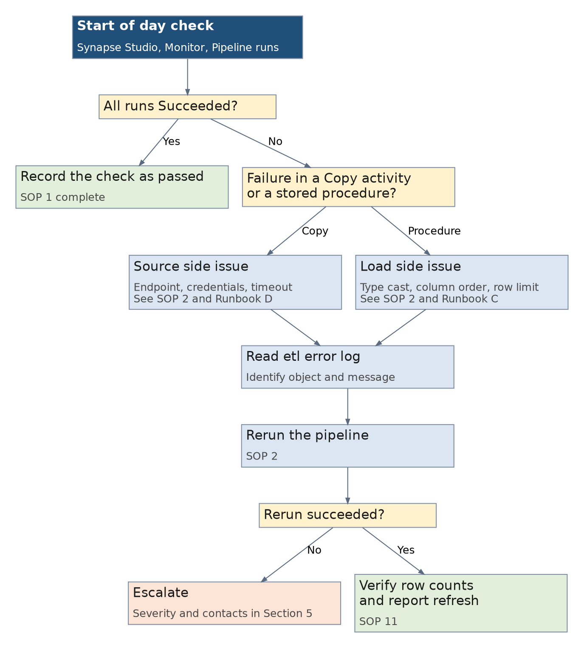
Figure 6. Daily verification and triage flow, SOP 1 and SOP 2

SOP 1. Daily Load Verification
Field | Value
Purpose | Confirm that every scheduled load completed overnight and that the reports are serving current data.
Frequency | Daily, each working morning
Owner | ASEZA IT

Prerequisites
- Synapse Studio access with the Synapse Artifact User role.
- Read access to the etl schema in asezasqlpool.
- Viewer access to the Power BI workspace.
Procedure
1. Open Synapse Studio, Monitor hub, Pipeline runs, and set the range to the last 24 hours.
2. Confirm CRM_API_DATA, PL_Manual_Forms and Pl_Load_StrategicPlan show Succeeded.
3. Confirm CRM_API_DIMS ran if this is its scheduled day.
4. Open the run log and compare the row counts with the previous two days.
5. Open the Power BI workspace and confirm each dataset shows a refresh time after the loads completed.
6. Record the result in the daily check log, including any pipeline that did not run.
Verification
All expected pipelines show Succeeded, row counts are within the normal range, and every dataset refreshed after its source load.
Escalation
Any Failed pipeline goes to SOP 2. A dataset that did not refresh goes to SOP 8. Row counts far outside the normal range go to SOP 11 before any rerun.

SOP 2. Rerunning a Failed Pipeline
Field | Value
Purpose | Restore a failed load without duplicating or losing data.
Frequency | On failure
Owner | ASEZA IT

Prerequisites
- The failure message and the failed activity name from the Monitor hub.
- Confirmation that the source system is available.
Procedure
1. Open the failed run in Monitor and identify the failed activity and its error message.
2. Classify the failure: a Copy activity points to the source or the connection, a stored procedure points to the load.
3. Check the matching error log table in the etl schema for the detail behind a procedure failure.
4. Confirm the source is reachable. For CRM, confirm the endpoint responds. For Manual Forms, confirm asezaformdb is online.
5. Select Rerun on the failed run. Use Rerun from failed activity where the earlier activities succeeded and wrote their output.
6. Watch the run to completion rather than leaving it, so a second failure is caught in the same session.
7. Verify as below, then record the incident with the cause and the action taken.
Verification
The rerun shows Succeeded and the row count for the affected tables is consistent with the previous successful run.

SOP 3. Manual Forms Full Reload
Field | Value
Purpose | Reload the Manual Forms data in full so that the warehouse matches the forms database exactly.
Frequency | On demand, and after a correction in the source
Owner | ASEZA IT

Prerequisites
- No other Manual Forms run in progress.
- A quiet window, since the reload truncates the staging tables.
Procedure
1. Confirm in Monitor that no PL_Manual_Forms run is in progress.
2. Open the Integrate hub and select PL_Manual_Forms.
3. Select Add trigger, then Trigger now, and confirm.
4. Follow the run in Monitor until every activity reports Succeeded.
5. Query the row counts in the stg forms tables and compare them with the source.
6. Refresh the affected Power BI datasets as described in SOP 8.
Verification
Row counts match the source, and the form views return the corrected values.
Escalation
A truncate that succeeds followed by a failed load leaves the staging tables empty. Do not leave this state. Rerun immediately, and if the second attempt fails, follow Runbook C.

SOP 4. CRM Historical Backfill
Field | Value
Purpose | Load historical CRM records for a table beyond the window covered by the incremental load.
Frequency | On demand
Owner | Datahub with ASEZA IT

Prerequisites
- Agreement on the table and the date range.
- A window outside the daily load schedule.
- The paginated extract pattern already configured for that table.
Procedure
1. Confirm the target table and the date range, and record them before starting.
2. Check the current watermark for the table so it can be restored if the backfill is abandoned.
3. Open the Integrate hub and select CRM_HISTORICAL.
4. Select Trigger now and supply the table and date range parameters the pipeline expects.
5. Follow the run. The pipeline pages through the API, lands JSON in the lake, loads it with COPY INTO, then flattens it into Bronze.
6. Confirm the Bronze row count for the period, then run the stg upsert for that table.
7. Verify as below, then confirm the watermark is correct for the next incremental run.
Verification
The record count for the period matches the source, no duplicate record ids exist in stg, and the next daily run loads only newer records.
Escalation
A partial page set in the lake with no way to tell complete from partial is a stop condition. Clear the landing folder for that run and start again rather than loading a partial set.

SOP 5. Adding a Source Table or Column
Field | Value
Purpose | Extend the CRM ingest scope without editing pipeline definitions.
Frequency | On request
Owner | Datahub with ASEZA IT approval

Prerequisites
- The entity and column names as they exist in CRM.
- Confirmation of the business need and the owner of the data.
Procedure
1. Confirm the entity and column names in CRM, including the exact spelling and the data type.
2. Add or update the row in the ingest control table for that entity, including the selected columns.
3. Add the matching columns to the Bronze and stg table definitions, in the same order as the source query, because the load maps by position and not by name.
4. Update the stg load procedure for the new columns.
5. Run the pipeline for that entity only and confirm the new columns populate.
6. Extend the Gold view or dimension if the new column is to be reported.
7. Update the Blueprint and the Catalogue so the documented model matches what is deployed.
Verification
The new column holds source values in stg, the Gold object exposes it where required, and the daily run completes unchanged.
Escalation
A truncation or type cast error after the change almost always means the column order no longer matches. Correct the order rather than widening the column.

SOP 6. Adding a New Form
Field | Value
Purpose | Bring a new Manual Form into the warehouse and the reports.
Frequency | On request
Owner | Datahub with the forms application team

Prerequisites
- The form is defined and in use in the forms application.
- The FormId, the KPI codes and the field keys.
- Agreement on which directorate owns it and which report will consume it.
Procedure
1. Obtain the FormId, the KPI codes and the field keys from the forms application team.
2. Confirm whether the form uses the shared KPI table or needs its own core and attributes tables, which depends on how many form specific columns it carries.
3. Create the staging objects if a split is required, keeping the core at the same shape as the shared table.
4. Extend the Manual Forms pipeline to load the new tables.
5. Create the Gold view following one of the two documented patterns, a filtered projection or a core plus attributes unpivot.
6. Confirm the selection column used matches the platform standard rather than introducing a third variant.
7. Add the view to the Power BI model and build the visuals.
8. Update the Blueprint with the new objects.
Verification
The view returns one row per submitted value or per populated measure, counts match the source, and the report shows the new KPI.
Escalation
If the new form requires a selection column that differs from the existing standard, stop and agree the standard before building, so the inconsistency does not grow.

SOP 7. Option Set Dimension Refresh
Field | Value
Purpose | Keep the decoded labels in the warehouse aligned with the option sets configured in CRM.
Frequency | Weekly, and after any CRM configuration change
Owner | ASEZA IT

Prerequisites
- CRM_API_DIMS is available.
- Knowledge of whether CRM configuration changed since the last run.
Procedure
1. Confirm with the CRM administrator whether picklist or status values changed since the last run.
2. Open the Integrate hub and run CRM_API_DIMS.
3. Confirm the metadata load succeeded and the label staging table is populated.
4. Refresh the Gold dimension snapshots so the new labels reach the reporting layer.
5. Query for codes present in the fact views with no matching dimension row.
6. Refresh the affected Power BI datasets.
Verification
No reported code is missing a label, and no dimension returns zero rows.
Escalation
A new code with no label, or a dimension returning zero rows, goes to the CRM administrator because the cause is upstream configuration rather than the pipeline.

SOP 8. Power BI Dataset Refresh Failure
Field | Value
Purpose | Restore a report to current data after a dataset refresh fails.
Frequency | On failure
Owner | ASEZA IT

Prerequisites
- Contributor access to the Power BI workspace.
- Confirmation that the warehouse loads succeeded.
Procedure
1. Open the workspace, select the dataset, then Refresh history, and read the failure message.
2. Confirm the warehouse load for that data succeeded. A refresh against a mid load warehouse can fail or load partial data.
3. For a credential message, open Dataset settings and sign in again under Data source credentials.
4. For a timeout, check whether the pool was under load at that time and reschedule the refresh later in the window.
5. Select Refresh now and wait for it to complete.
6. Open the report and confirm the figures and the refresh time.
Verification
Refresh history shows a successful refresh, and the report shows the current period.
Escalation
Repeated timeouts point at the pool service level or the refresh window rather than at Power BI. Raise with the Datahub contact before scaling.

SOP 9. User Onboarding and Offboarding
Field | Value
Purpose | Grant or remove platform access consistently across all four access layers.
Frequency | On request
Owner | ASEZA IT

Prerequisites
- An approved request naming the user, the directorate and the access required.
Procedure
1. Confirm the request and which of the three parts applies: reports, forms, or administration.
2. For report access, add the user to the Power BI workspace with the Viewer role, or Contributor where they must build reports.
3. For form access, pass the request to the forms application administrator with the form name.
4. For administrator access, assign both the Azure RBAC role and the Synapse RBAC role, then create the SQL user and grant the read role.
5. For an external user, confirm the guest account exists in the ASEZA tenant first.
6. Confirm with the user that they can open what was granted.
7. On offboarding, remove the access in every layer on the same day, and record the removal.
Verification
The user can open exactly what was approved and nothing further. For offboarding, sign in fails and no workspace or schema is listed.
Escalation
A user who can sign in but sees nothing is almost always missing Synapse RBAC or workspace access rather than Azure RBAC. Check that before raising it.

SOP 10. Monthly Housekeeping
Field | Value
Purpose | Keep the operational tables, statistics and logs in a healthy state.
Frequency | Monthly
Owner | ASEZA IT

Prerequisites
- A window outside the daily load schedule.
Procedure
1. Run the error log purge procedure for each source to trim resolved entries.
2. Review the run log for repeated warnings that did not cause a failure.
3. Confirm that table statistics exist on the columns used for joins and filters on the largest tables, and update them where they are stale.
4. Review the pool service level against the observed query durations.
5. Confirm the restore point history shows automatic restore points for the period.
6. Confirm that the user access list still matches the approved list from SOP 9.
Verification
Logs are trimmed, statistics are current, restore points are present, and the access list matches the approved list.
Escalation
A missing restore point history is a recovery risk, not a housekeeping item. Raise it the same day.

SOP 11. Source Reconciliation
Field | Value
Purpose | Confirm the warehouse still agrees with the source systems.
Frequency | Monthly, and after any backfill
Owner | ASEZA IT with Datahub

Prerequisites
- Read access to the warehouse.
- An agreed record count or control total from each source owner.
Procedure
1. Obtain the record count or control total from the source owner for the agreed period.
2. Run the equivalent count in stg for the same period and the same filter.
3. Compare and record both figures, with the date of the comparison.
4. Investigate any difference: a missing watermark advance, a failed run never rerun, or a source side correction are the usual causes.
5. Where the source corrected a record, confirm the warehouse reflects the correction.
6. Record the reconciliation result for the monthly report.
Verification
Counts agree, or every difference has a recorded and accepted explanation.
Escalation
A difference that cannot be explained by a known load event goes to the Datahub contact before any reload, because a reload can mask the cause.

SOP 12. Annual Static File Load
Field | Value
Purpose | Load a new annual release of a DOS or ASEZA statistical workbook.
Frequency | Annually, on release
Owner | ASEZA IT with Datahub

Prerequisites
- The workbook as released by the source.
- The previous release for comparison.
Procedure
1. Compare the new workbook with the previous release, sheet by sheet, for renamed sheets, moved columns or new breakdowns.
2. Update the Excel ingest control table where a sheet or column changed.
3. Place the workbook in the raw area of the lake in the expected folder.
4. Run PL_ETL_Excel_Ingest and confirm the Parquet output appears in the staging area.
5. Load the target stc_ tables and compare the row counts with the workbook.
6. Spot check several published figures against the workbook.
7. Update the Blueprint if a new table was added.
Verification
Each stc_ table holds the published series for the new release, and the spot checked figures match the workbook.
Escalation
A silently empty load almost always means a renamed sheet. Check the control table mapping before anything else.

5. Disaster Recovery Runbooks
Part 5 covers recovery from failure. The runbooks are ordered from the broadest recovery to the narrowest, but the decision tree below should be used to select one rather than working through them in order.

5.1 Recovery Objectives

5.2 What Is Backed Up
Asset | Protection | Recovery route
Dedicated SQL pool | Automatic restore points are enabled, and geo backup is on | Runbook A, restore to a new pool
Warehouse structure | The complete DDL is held in the Data Warehouse Blueprint and Structure | Runbook B, recreate and reload
Lake files | Azure Storage redundancy, with the Parquet extract per table and run | Reload Bronze from the retained files
Pipelines and linked services | Held in the Synapse workspace | See the note below
etl configuration | Held in the pool, so covered by its restore points only | Runbook A, or manual re-entry in Runbook B
Power BI reports | Published to the workspace, with the source files held by Datahub | Republish from the source file
Forms application and database | Managed by the forms application team | See 3.11, content pending

NOTE: The pipelines exist only in the Synapse workspace. There is no Git repository connected, so a deleted pipeline cannot be recovered from source control and must be rebuilt by hand. Connecting the workspace to Git is the single most valuable improvement available to the recovery position and is recommended before the next release.

5.3 Selecting a Runbook
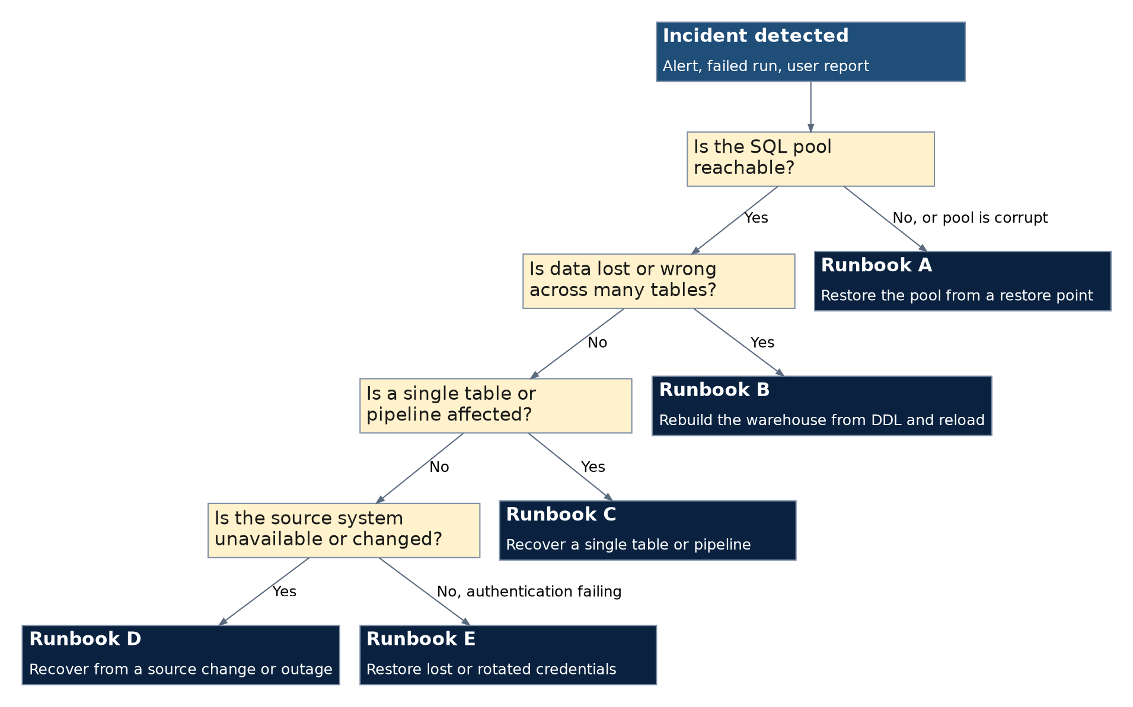
Figure 7. Runbook selection by incident type
Runbook | Use when | Typical duration
A | The pool is unavailable or broadly wrong, and a restore point exists | Hours
B | The structure is lost and no restore point serves | Days, driven by the historical reload
C | One table or pipeline is affected | Under an hour in most cases
D | A source changed or is unreachable | Driven by the source owner
E | Authentication is failing after a credential change | Under an hour

5.4 Runbook A. Restore the SQL Pool from a Restore Point
Field | Value
Use when | The pool is unavailable, or data across many objects is wrong or lost, and the cause is inside the pool.
Impact while running | The pool is unavailable during the restore. All reports continue to serve their last refresh, since they are Import mode.

Procedure
1. Record the time the incident was detected and the last known good state.
2. Stop the triggers in Synapse Studio, Manage, Triggers, so no load writes into a pool that is being restored.
3. In the Azure portal, open the dedicated SQL pool and select Restore.
4. Choose Automatic restore points and select the most recent point before the incident. Geo backup is available if the regional points are not usable.
5. Restore to a new pool name rather than over the existing one, so the current state is preserved for investigation.
6. Wait for the restore to complete, then query the restored pool and confirm the data is correct at that point.
7. Repoint the Power BI datasets and any direct consumers at the restored pool, or rename the pools once the restored one is confirmed good.
8. Restart the triggers and run the pipelines for the period between the restore point and now, following SOP 2 and SOP 3.
9. Complete the post incident checklist in 5.8.
Verification
The restored pool returns correct data for the period before the incident, the gap period has been reloaded, and the reports refresh successfully against it.

5.5 Runbook B. Rebuild the Warehouse from DDL and Reload
Field | Value
Use when | The structure itself is lost or corrupt and no usable restore point exists, or the pool must be recreated in a new region or subscription.
Impact while running | Full outage of the warehouse until the reload completes. Duration depends on the volume of history being reloaded.

Procedure
1. Confirm with the Datahub contact that no restore point can serve, since Runbook A is faster wherever it applies.
2. Create the pool, then run the schema creation script for Bronze, stg, etl and dwh.
3. Run the table and view DDL from Appendix A of the Data Warehouse Blueprint and Structure, in its documented order: schemas, tables, then views.
4. Restore the etl configuration: the ingest control tables, the Excel ingest mapping and the watermark values. Without these the pipelines have nothing to drive them.
5. Load the reference metadata first by running CRM_API_DIMS, so the dimensions exist before the facts.
6. Reload the CRM history by running CRM_HISTORICAL for each table and period, following SOP 4.
7. Run PL_Manual_Forms, which reloads in full and therefore needs no history handling.
8. Run PL_ETL_Excel_Ingest to reload the static statistical tables.
9. Run Pl_Load_StrategicPlan to rebuild the KPI framework.
10. Reconcile against the sources following SOP 11, then refresh every Power BI dataset.
11. Complete the post incident checklist in 5.8.
Verification
Every object listed in the Blueprint catalogue exists, the reconciliation in SOP 11 passes for each source, and every dataset refreshes successfully.

5.6 Runbook C. Recover a Single Table or Pipeline
Field | Value
Use when | One table is empty, partially loaded or wrong, and the rest of the warehouse is healthy. This is the most common recovery.
Impact while running | Limited to the reports that read the affected table.

Procedure
1. Identify the affected object and whether the problem is missing rows, duplicated rows or wrong values.
2. Read the error log and the run log entries for that object to establish when it last loaded correctly.
3. For a CRM table, reset the watermark to the last known good point so the next run reloads the affected period.
4. For a Manual Forms table, run the full reload in SOP 3, which replaces the content entirely.
5. For a statistical table, reload from the workbook following SOP 12.
6. Run the pipeline for that object only, rather than the whole pipeline, where the pipeline supports a table parameter.
7. Confirm the row count and spot check values against the source.
8. Refresh the dependent Power BI datasets.
Verification
The object holds the expected rows with no duplicate record ids, and the dependent reports show the corrected figures.

5.7 Runbook D. Recover from a Source Change or Outage
Field | Value
Use when | A source system is unreachable, its endpoint changed, or its schema changed, and loads fail at the Copy activity.
Impact while running | No new data for that source until the source is restored. Existing warehouse data stays intact and reports continue to serve it.

Procedure
1. Confirm the source is genuinely unavailable rather than the connection being misconfigured, by testing the endpoint independently.
2. Check whether the endpoint or the authentication changed. The CRM environments were renamed and moved from v8.2 to v9.1 in October 2026, which is the pattern to expect.
3. For an endpoint change, update the control table and the linked service to the new address, and confirm the API version in the path.
4. For a schema change, compare the source columns with the Bronze and stg definitions and apply SOP 5 before reloading.
5. For an outage, suspend the trigger for that source so failure alerts do not mask other problems, and record the suspension.
6. When the source returns, run the pipeline and confirm the gap period loaded, extending the window where the incremental watermark would otherwise skip it.
7. Restart the suspended trigger and confirm the next scheduled run succeeds.
Verification
The pipeline succeeds against the current endpoint, the gap period is present in stg, and the trigger is running again.

5.8 Runbook E. Restore Lost or Rotated Credentials
Field | Value
Use when | Loads fail with an authentication or authorization message after a password change, a secret rotation or an account expiry.
Impact while running | Every pipeline using that credential fails until it is restored. Warehouse content is unaffected.

Procedure
1. Identify which linked service the failing activity uses, and therefore which credential is involved.
2. Confirm with the source owner whether the account password or key was changed or expired.
3. For a credential held in Key Vault, update the secret value and confirm the linked service references the current version.
4. For a credential held inline in a linked service, which is currently the case for CRM, edit the linked service and update it there.
5. Test the connection from the linked service before running the pipeline.
6. Run the failed pipeline following SOP 2 and confirm the gap period loaded.
7. Record the change, and raise moving the credential into Key Vault if it was inline.
Verification
The linked service test connection succeeds and the pipeline completes with the expected row counts.

5.9 Post-Incident Verification
Run this checklist after any runbook, before declaring the platform recovered.
Check | Passes when
Object inventory | Every object in the Blueprint catalogue exists in the pool
Row counts | Counts for the main tables are consistent with the last known good figures
Gap period | Every load between the recovery point and now has been run and succeeded
Duplicates | No duplicate record ids exist in the reloaded stg tables
Triggers | Every trigger that was stopped has been restarted and its next run succeeded
Reports | Each dataset refreshed successfully and the reports show the current period
Access | Users can sign in and open what they could before the incident
Record | The incident, the cause, the runbook used and the outcome are written up

Appendix A. Pipeline and Object Reference
A quick reference to the objects an administrator touches. The authoritative and complete inventory is in the Data Warehouse Blueprint and Structure, and the connection detail is in the Data Connection Framework and Catalogue.
Pipelines
Pipeline | Frequency | Environment
CRM_API_DATA | Daily | Production
CRM_API_DIMS | Weekly or on demand | Production
CRM_HISTORICAL | On demand | Production
PL_Manual_Forms | Daily | Production
Pl_Load_StrategicPlan | Daily | Production
PL_ETL_Excel_Ingest | Annually or on release | Production
PL_SSC_API | Not scheduled | Pending
CRM_API_DATA_TEST | On demand | Test
CRM_API_DIMS_TEST | On demand | Test
TEST_PL_ETL_Excel_Ingest | On demand | Test

Schemas
Schema | Contents
Bronze | Raw landing tables, one per source table, all columns text typed
stg | Typed tables, CRM upserted and forms fully reloaded
dwh | Dimensions, fact views, Manual Forms views, the KPI framework and the statistical tables
etl | Control tables, watermarks, option-set metadata and the error logs
TEST | Test clone of the CRM objects, with layer prefixes on the names

Objects read most often during operations
Object | Used for
etl.pipeline_run_log | Start, success and failure of each run, with row counts
etl.<Source>_ErrorLog | The error detail behind a load failure
etl.ApiIngestConfig | Which CRM tables and columns are in scope
etl.ExcelIngestConfig | Workbook and sheet mapping for the static files
sys.dm_pdw_exec_requests | Queries currently running in the pool
stg.OptionSetLabels | The decoded CRM labels the dimensions are built from

Appendix B. SOP Quick Reference
One line per procedure, for use at the screen. The full procedure is in Part 4.
SOP | Task | Trigger | First step
SOP 1 | Daily Load Verification | Daily, each working morning | Open Synapse Studio, Monitor hub, Pipeline runs, and set the range to
SOP 2 | Rerunning a Failed Pipeline | On failure | Open the failed run in Monitor and identify the failed activity and it
SOP 3 | Manual Forms Full Reload | On demand, and after a correction in the source | Confirm in Monitor that no PL_Manual_Forms run is in progress.
SOP 4 | CRM Historical Backfill | On demand | Confirm the target table and the date range, and record them before st
SOP 5 | Adding a Source Table or Column | On request | Confirm the entity and column names in CRM, including the exact spelli
SOP 6 | Adding a New Form | On request | Obtain the FormId, the KPI codes and the field keys from the forms app
SOP 7 | Option Set Dimension Refresh | Weekly, and after any CRM configuration change | Confirm with the CRM administrator whether picklist or status values c
SOP 8 | Power BI Dataset Refresh Failure | On failure | Open the workspace, select the dataset, then Refresh history, and read
SOP 9 | User Onboarding and Offboarding | On request | Confirm the request and which of the three parts applies: reports, for
SOP 10 | Monthly Housekeeping | Monthly | Run the error log purge procedure for each source to trim resolved ent
SOP 11 | Source Reconciliation | Monthly, and after any backfill | Obtain the record count or control total from the source owner for the
SOP 12 | Annual Static File Load | Annually, on release | Compare the new workbook with the previous release, sheet by sheet, fo

Appendix C. Common Failures
The failures seen on this platform, their cause and the first action. Each points to the procedure that resolves it.
Symptom | Likely cause | Action
Copy activity fails with HTTP 501 or a not implemented message | The CRM endpoint or API version changed | Runbook D, then update the control table and linked service
Load fails with a string or binary data would be truncated message | Column order in the source query no longer matches the target DDL, because the load maps by position | SOP 5, correct the order rather than widening the column
A load succeeds but returns zero rows for Arabic values | A missing N prefix on an Arabic string literal, which fails silently | Correct the literal, then rerun
A table shows a partial load with no error | The watermark advanced past a failed load | Runbook C, reset the watermark and reload the period
A statistical table loads empty after a new release | A renamed or removed sheet broke the control table mapping | SOP 12, correct the mapping first
A source API call times out from the auto resolve runtime | The source whitelists caller addresses and the Azure egress IP is not static | Use the self hosted runtime, see 3.5
A report shows old data after a successful load | The dataset did not refresh | SOP 8
A user signs in but sees no workspace or no schema | Missing Synapse RBAC or workspace access, not Azure RBAC | SOP 9
A pipeline fails with an authentication message | A rotated or expired credential | Runbook E
A Power BI Desktop connection to the pool fails on sign in | SQL Authentication is reading the email address as a server name | Clear cached credentials and sign in with the Microsoft account option

