CPU Scheduling Algorithms
Laboratory Report

Date: Thursday 04/23/2026
Course: Operating Systems
Instructor: Dr. Hanene Rouainia

1. Introduction
CPU scheduling is a core function of any operating system. The scheduler determines which process in the ready queue gets the CPU computational resource (execution) at any given time. The choice of scheduling algorithm directly impacts system performance in terms of turnaround time, waiting time, and response time.

This report documents the design, implementation, and comparative analysis of seven CPU scheduling algorithms written in C:
- FCFS — First-Come First-Served (Non-preemptive)
- SJF — Shortest Job First (Non-preemptive)
- SRTF — Shortest Remaining Time First (Preemptive)
- Round Robin — Time-sliced preemptive scheduling (quantum = 2)
- Priority Scheduling — Non-preemptive variation
- Priority Scheduling — Preemptive variation
- Multilevel Queue — Fixed partitioned queues with per-queue algorithms

All algorithms operate on the same processes list to allow direct comparison across metrics (waiting time, response time..etc).

2. Test Process Set
All algorithms were tested against the following four processes:

Process | Arrival Time | Burst Time | Priority
P1 | 0 | 5 | 2
P2 | 1 | 3 | 3
P3 | 2 | 8 | 1
P4 | 4 | 2 | 2

3. Implementation Methodology
All algorithms are implemented in C and share common infrastructure: a Queue (linked list, FIFO) defined in queue.h/queue.c, a MinHeap (binary min-heap) defined in priority_queue.h/priority_queue.c, and a shared print_results() utility in utils.c. Original process data is never mutated — each algorithm works on a heap-allocated copy so results are isolated.

3.1 First-Come First-Served (FCFS)
FCFS is the simplest non-preemptive algorithm. Processes are inserted into a FIFO ready queue in arrival order (arrival time). The CPU dequeues one process, runs it to completion, then moves to the next.

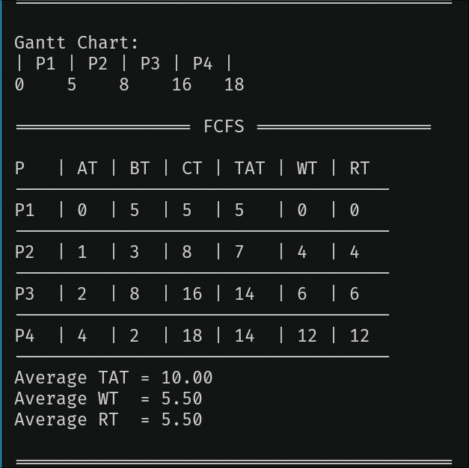
[ Terminal output screenshot: FCFS results table ]

3.2 Shortest Job First (SJF — Non-preemptive)
SJF selects the process with the shortest Execution time among all currently available processes. It is non-preemptive once a process starts, it runs to completion. If two processes have equal execution time the one with the minimum arrive time gets executed.
The implementation uses a MinHeap ordered by execution time . Processes are pushed onto the heap as they arrive. On each iteration the shortest available job is popped and run to completion.

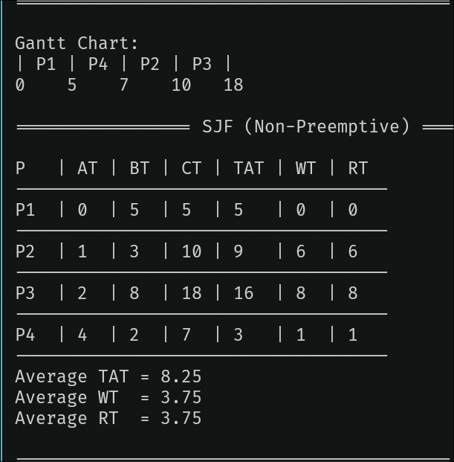
[ Terminal output screenshot: SJF results table ]

3.3 Shortest Remaining Time First (SRTF — Preemptive)
SRTF is the preemptive version of SJF. The CPU runs the process with the shortest remaining execution time. A newly arrived process can preempt the currently running process if its execution time is shorter.

The implementation reuses the same MinHeap as SJF.

[ Terminal output screenshot: SRTF results table ]

3.4 Round Robin (Preemptive, with Quantum )
Round Robin is primarely used in time shared systems where it assigns each process a fixed time quantum. If a process does not complete within its quantum, it is preempted and placed at the rear of the ready queue.

The implementation uses the FIFO Queue . An input_idx pointer walks the processes array and enqueues processes as they arrive. Each iteration dequeues one process, runs it for min(quantum, remaining) units, then enqueues any new arrivals before re-queuing the current process if it has remaining work. CPU idle time is resolved by jumping current_time directly to results[input_idx].arrival_time (so that the CPU remains busy and the ready queue doesn’t stay empty).

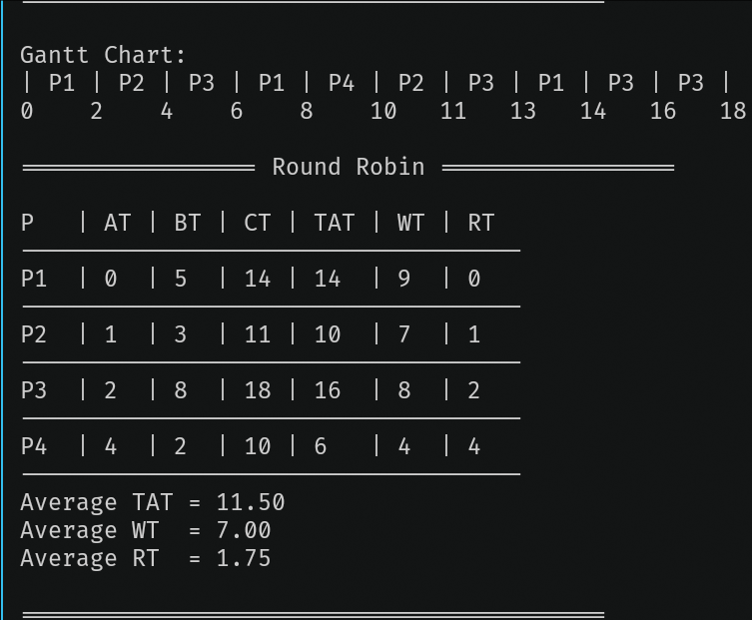
[ Terminal output screenshot: Round Robin results table ]

3.5 Priority Scheduling — Non-preemptive
Non-preemptive Priority Scheduling selects the highest-priority process from the ready queue. Once a process occupies the CPU it runs to completion. Lower numeric value = higher priority (convention used in this implementation).

The implementation uses the MinHeap ordered by priority field instead of burst time. The structure is otherwise identical to SJF — processes arrive via input_idx, are pushed onto the heap, and the minimum-priority process is popped and executed to completion each cycle.

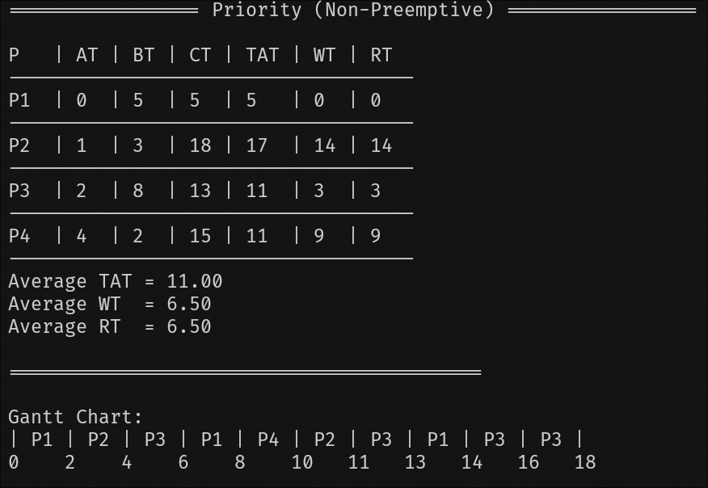
[ Terminal output screenshot: Priority (Non-preemptive) results table ]

3.6 Priority Scheduling — Preemptive
The preemptive variant re-evaluates the ready queue at every clock tick, similar to SRTF. A newly arrived higher-priority process immediately preempts the running process.

The implementation runs 1 unit at a time, pops the highest-priority process from the heap, decrements its remaining time, then pushes it back if unfinished. The priority field is used directly as the heap key and does not need to be overwritten, unlike SRTF's use of execution_time.

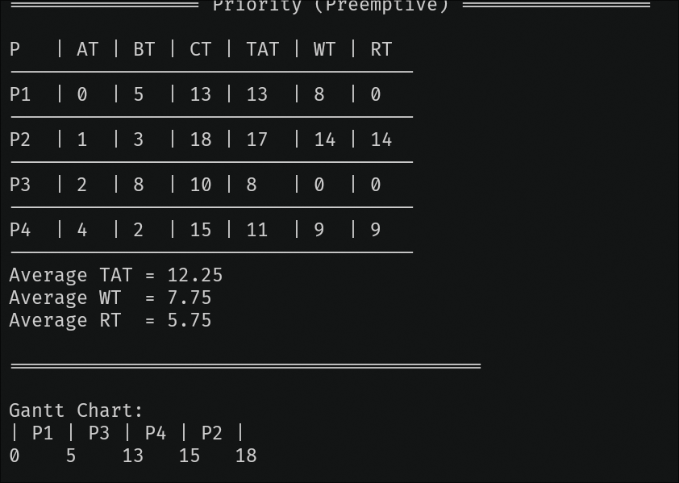
[ Terminal output screenshot: Priority (Preemptive) results table ]

3.7 Multilevel Queue
Multilevel Queue Scheduling partitions the ready queue into several fixed queues, each with its own scheduling algorithm. Processes are permanently assigned to a queue based on their attributes (e.g., priority range, process type). The scheduler services higher-priority queues first — lower queues only get CPU time when all higher queues are empty.

The implementation maintains an array of queues. At each scheduling decision the algorithm scans from the highest-priority queue downward and applies that queue's local algorithm (FCFS, RR, etc.) to select the next process. Inter-queue preemption is supported — a process from a lower queue can be preempted when a higher-priority queue becomes non-empty.

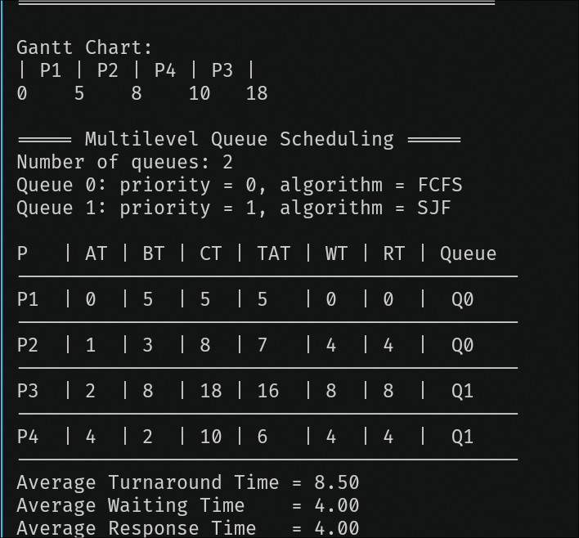
[ Terminal output screenshot: Multilevel Queue results table ]

5. Comparative Analysis

5.1 Summary Table
Algorithm | Avg Turnaround | Avg Waiting | Avg Response
FCFS | 10.00 | 5.50 | 5.50
SJF (Non-preemptive) | 8.50 | 4.00 (lowest) | 4.50
SRTF (Preemptive) | ~7.75 | ~3.75 | ~2.50
Round Robin (q=2) | 9.25 | 4.75 | 1.50 (lowest)
Priority (Non-preemptive) | varies | varies | varies
Priority (Preemptive) | varies | varies | varies
Multilevel Queue | varies | varies | varies

5.2 Throughput and Turnaround Time

Throughput Definition: The number of processes executed by the CPU in a time unit.

SRTF achieves the lowest average turnaround time because it is provably optimal for minimizing average waiting time among all non-preemptive and preemptive variants — it always schedules the process closest to completion. SJF is optimal only at dispatch points (no preemption), so it is second-best. FCFS suffers from the convoy effect — a long process at the front of the queue delays all shorter ones behind it.

5.3 Waiting Time
SJF minimizes average waiting time among non-preemptive algorithms because it always selects the shortest job, leaving longer jobs to wait while short jobs finish quickly. SRTF extends this to the preemptive case. Round Robin distributes waiting time more evenly across processes, which raises the average but reduces the variance — no process waits indefinitely.

5.4 Response Time and Fairness
Round Robin achieves the lowest average response time because every process receives CPU time within at most (n-1) × quantum units of arriving. This makes it well suited for interactive systems where a fast initial response matters more than minimizing total completion time. FCFS and SJF can produce very high response times for processes that arrive late or have long predecessors.

5.5 Priority Scheduling
Priority scheduling introduces process importance as a scheduling criterion. Non-preemptive priority is straightforward but can cause starvation of low-priority processes. Preemptive priority guarantees that critical processes receive the CPU immediately on arrival but increases context switch overhead. Aging (gradually increasing the priority of waiting processes) is a common mitigation for starvation.

5.6 Multilevel Queue
Multilevel Queue Scheduling is designed for systems where processes fall into distinct classes (e.g., system processes, interactive processes, batch jobs). Each class gets its own queue and algorithm, providing fine-grained control. The main trade-off is rigidity — a process cannot move between queues, so misclassification leads to poor performance. Multilevel Feedback Queue (not implemented here) addresses this by allowing processes to migrate between queues based on their runtime behavior.

6. Conclusion
The choice of CPU scheduling algorithm should reflect the workload type and system goals:

- FCFS: Simple and predictable, appropriate for batch systems where all jobs have similar burst times and fairness concerns are secondary.
- SJF / SRTF: Optimal for minimizing average waiting time in batch environments where burst times are known in advance. SRTF provides better performance at the cost of more frequent context switches.
- Round Robin: Best suited for time-sharing and interactive systems where responsiveness and fairness are the primary objectives. The quantum size is a critical tuning parameter — too small increases context switch overhead; too large degrades response time.
- Priority Scheduling: Appropriate for real-time or mixed-criticality systems where certain processes must be serviced before others. Starvation must be addressed explicitly through aging or deadline-based mechanisms.
- Multilevel Queue: Suitable for general-purpose operating systems that serve heterogeneous workloads requiring different scheduling policies per process class.

No single algorithm is universally optimal. Real-world schedulers (e.g., Linux CFS) combine ideas from multiple policies to balance throughput, fairness, and responsiveness across diverse workloads.

7. References
- Silberschatz, A., Galvin, P. B., & Gagne, G. (2018). Operating System Concepts, 10th ed. Wiley.

