|  |  |  |  |
| --- | --- | --- | --- |
| **American International University- Bangladesh (AIUB) Faculty of Engineering** | | | |
| **Course Name:** | Data Communication | **Course Code:** | COE 3201 |
| **Semester:** | Fall 2022 | **Term:** | Mid |
| **Total Marks:** | 30 | **Submission Date:** | 31-10-2022 |
| **Faculty Name:** | Mr. Abrar Fahim Liaf | **Assignment:** | 01/OBE |

Course Outcome Mapping with Questions

|  |  |  |  |  |  |  |  |
| --- | --- | --- | --- | --- | --- | --- | --- |
| **Item** | **COs** | **POIs** | **K** | **P** | **A** | **Marks** | **Obtained**  **Marks** |
| **Q1** | **CO4** | **P.c.3.C5** | **K5** | **P1, P2, P6** |  | **15** |  |
| **Q2** | **CO4** | **P.c.3.C5** | **K5** | **P1, P2, P6** |  | **15** |  |
| **Total:** | | | | | | **30** |  |

Student Information:

**Student Name:** Ricky Shahinur Islam

**Student ID :** 18-38861-3

**Section:** J

**Department:** CSE

Marking Rubrics (to be filled by Faculty):

|  |  |  |  |  |  |  |  |
| --- | --- | --- | --- | --- | --- | --- | --- |
| **Problem** | **Excellent [5]** | **Proficient [4]** | **Good [3]** | **Acceptable [2]** | **Unacceptable [1]** | **No Response [0]** | **Secured Marks** |
| Detailed unique response explaining the concept properly and  answer is correct with all  works clearly shown. | Response with no apparent errors and the answer is  correct, but explanation is not adequate/uniqu e. | Response shows understanding of the problem, but the final answer may not be correct | Partial problem is solved; response indicates part of the problem was not understood clearly. | Unable to  clarify the understanding of the  problem and method of the problem solving was not correct | No Response/(Copie d/identical submissions will be graded as 0 for all parties concerned) |
| **1** |  |  |  |  |  |  |  |
| **2** |  |  |  |  |  |  |  |
| **3** |  |  |  |  |  |  |  |
| **Comment** |  | | | | | Total marks (30) |  |

1. ***Assess*** the effect of communication networks on environment and obtain the 8-bit data stream for eachcase depicted in Figure 1.

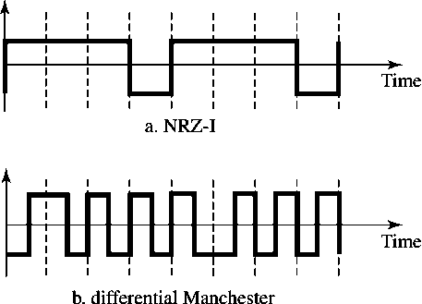

**Figure 1:** Graph for problem 1.

1. ***Evaluate*** the data streams **00110011** and **01010101** by graphically representing them by using thefollowing schemes below. Assume that the last signal level has been positive.
   * **NRZ-L**
   * **Manchester.**
   * **2B1Q**

