**Here I simulate “log in ,sign up system” , to let new customers enter their data If they are new .**

This is a list of the products { Books} with their details

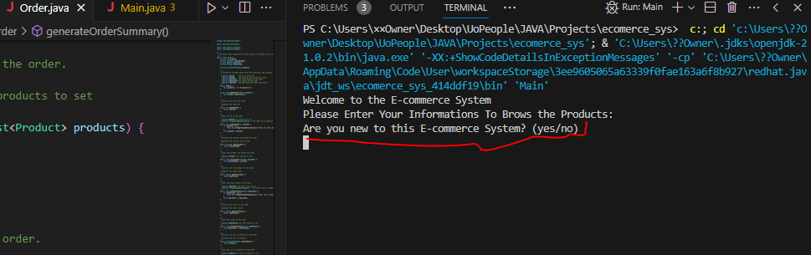



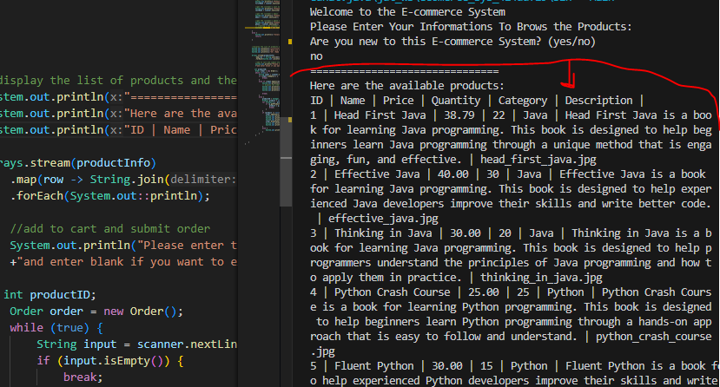

1. Adding to cart functionality.
2. Summary of cart content

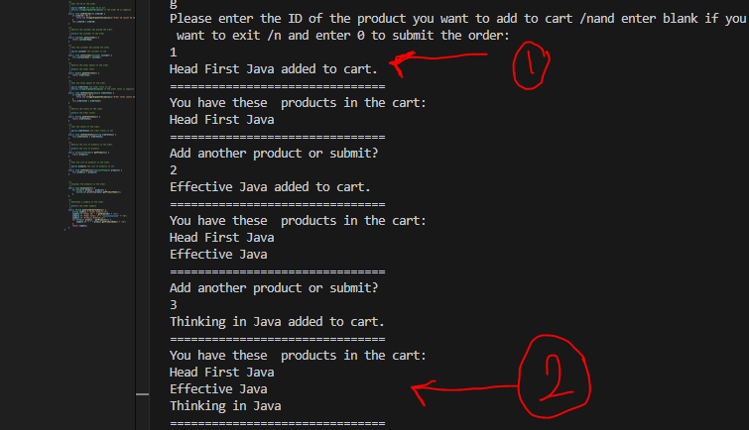

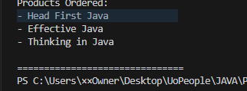

The order Summary :