BANK RISK INTELLIGENCE RESULTS(SCREENSHOTS)
Customer Loan Exposure
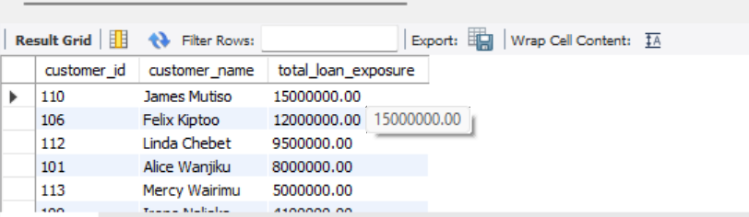

Under-Collateralised Loans
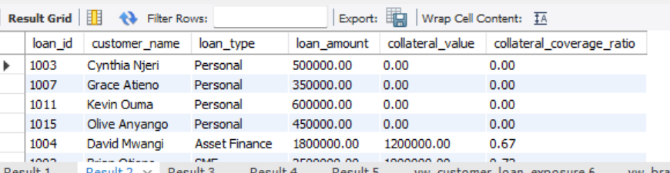

Branch Default Exposure
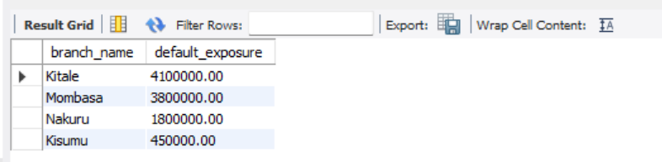

Suspicious Transaction Monitoring
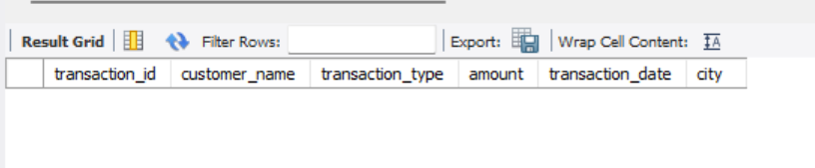
Customer Risk Flagging
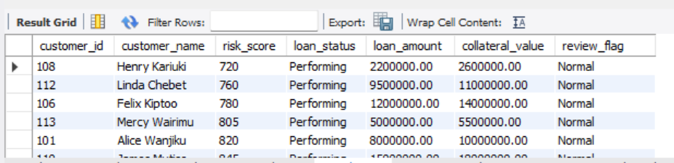

vw_customer_loan_exposure
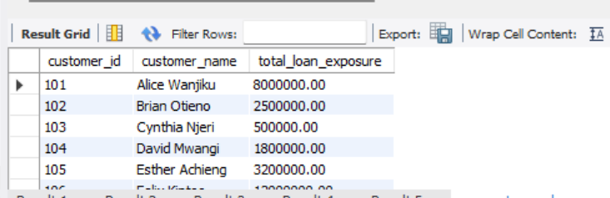

vw_branch_risk_exposure
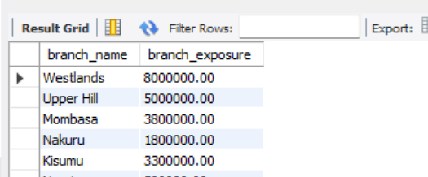

vw_collateral_coverage
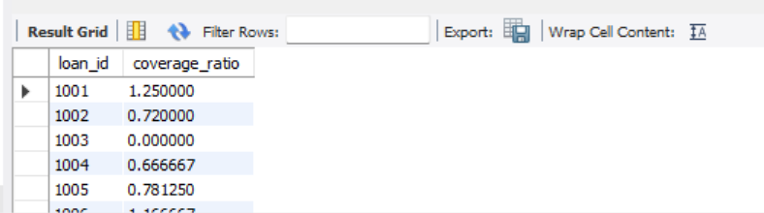

vw_high_value_transactions
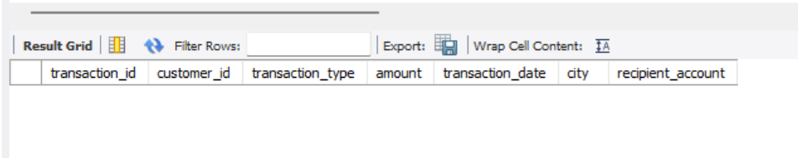

vw_customer_risk_monitoring
