FRAUD DETECTION SYSTEM RESULTS(SCREENSHOTS)
High-Value Transaction Detection
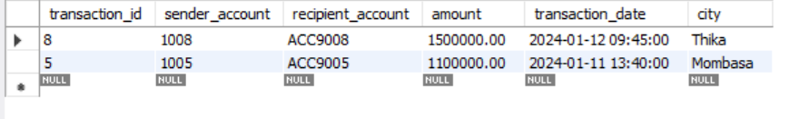
Rapid Transfer Activity Detection
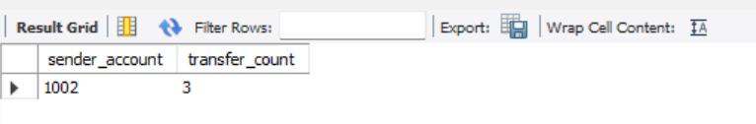
Distributed Recipient Pattern Analysis
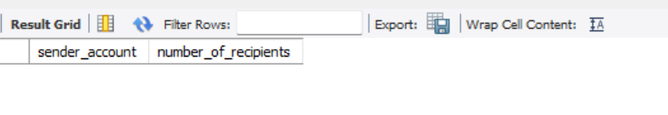
High-Risk Customer Transaction Monitoring
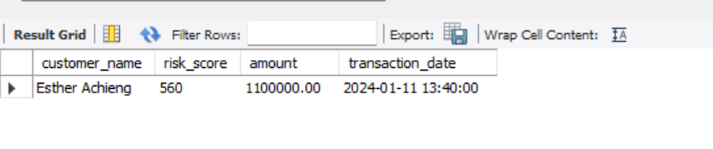
Geographic Transaction Hotspot Analysis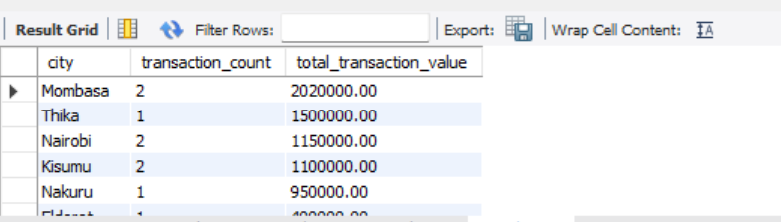

vw_suspicious_transactions
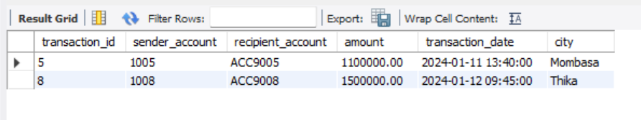

vw_rapid_transfers
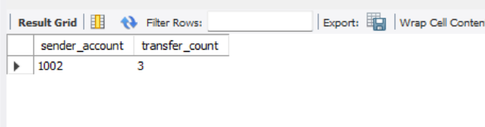
vw_high_risk_transactions
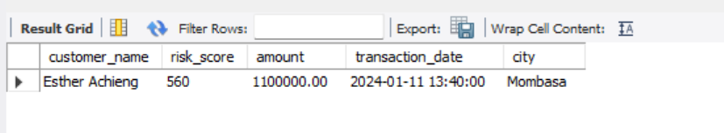
vw_transaction_hotspots
