

JustTech

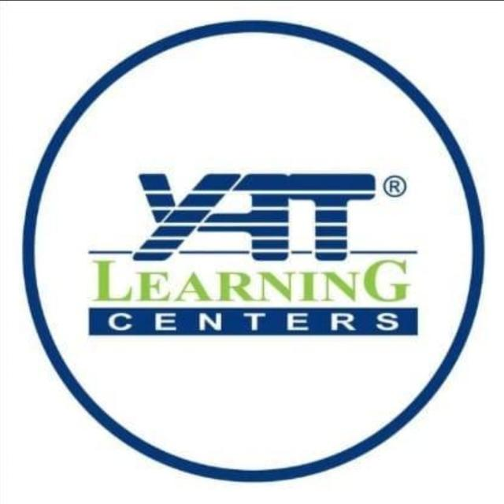

Team names
- Abdullah Khaled Ahmed
- Mira Makram Nassif
- Mohamed sameh Mohamed
- Mohamed Adel Mohamed
- Nardeen Hesham Ismail
- Rahaf Emad Saeed

Index

# | Section | Page
1 | Stakeholders | 5
2 | Target Users | 6
3 | Functional Requirements | 7
3.1 | Authentication & Authorization | 7
3.2 | Student Management | 8
3.3 | Instructor Management | 8
3.4 | Course Management | 9
3.5 | Round Management | 9
3.6 | Enrollment Management | 10
3.7 | Lecture Management | 10
3.8 | Material Management | 11
3.9 | Progress Tracking | 11
3.10 | Assignment Management | 12
3.11 | Submission Management | 12
3.12 | Certificate Management | 13
4 | Non-Functional Requirements | 14
5 | System Scope | 15
5.1 | In Scope | 16
5.2 | Out of Scope | 17
5.3 | Technical Scope | 17
6 | System Constraints | 17
7 | Use Cases | 18
8 | Class Diagram | 19,20
9 | ERD | 21
10 | Design Patterns Used | 22
11 | Key Design Decisions | 23
12 | API Endpoints Summary | 24
13 | Technologies Used | 25,26
14 | Project Structure | 27

1. Stakeholders
Stakeholder | Role | Interest
Students | End users | Learn courses, track progress, earn certificates
Instructors | Content creators | Create courses, upload materials, grade assignments
Administrators | System managers | Manage users, monitor platform, handle issues
Investors | Financial backers | ROI, user growth, platform scalability
Project Manager | Team coordinator | Timeline, budget, resource allocation
Development Team | Implementers | Build and maintain the system
QA Team | Testers | Ensure quality and reliability
UI/UX Designers | Designers | Create user-friendly interface
Database Administrator | Data manager | Maintain database performance and security
System Architect | Technical lead | Design system infrastructure
Legal Team | Compliance | Ensure data privacy (GDPR, etc.)
Customer Support | Support | Handle user issues and feedback
Marketing Team | Promotion | Attract new users and courses
Content Reviewer | Quality control | Verify course quality before publishing

2. Target Users
User Type | Description | Primary Actions
Student | Individuals who want to learn new skills | • Browse/search courses  • Enroll in rounds  • Watch lectures  • Complete assignments  • Track progress  • Download certificates
Instructor | Subject matter experts who create courses | • Create/manage courses  • Create rounds and lectures  • Upload materials  • Create assignments  • Grade submissions  • Monitor student progress
Admin | Platform managers | • Manage all users  • Approve/reject courses  • Monitor platform health  • Generate reports  • Handle disputes

3. Functional Requirements

3.1 Authentication & Authorization
ID | Requirement
FR-AUTH-01 | Users can register with name, email, and password
FR-AUTH-02 | Users can login with email and password
FR-AUTH-03 | System returns JWT token upon successful login
FR-AUTH-04 | Users can change password with current password verification
FR-AUTH-05 | Passwords must be hashed using BCrypt
FR-AUTH-06 | JWT token expires after 24 hours

3.2 Student Management
ID | Requirement
FR-STD-01 | Admins can create, read, update, delete student accounts
FR-STD-02 | Students can view their own profile
FR-STD-03 | Students can update their profile information
FR-STD-04 | Students can upload profile image
FR-STD-05 | System tracks student registration date
FR-STD-06 | Students can filter by status (student/graduate)
FR-STD-07 | Admins can search students by email, name, or city

3.3 Instructor Management
ID | Requirement
FR-INS-01 | Admins can create, read, update, delete instructor accounts
FR-INS-02 | Instructors can view their own profile
FR-INS-03 | Instructors can update their profile information
FR-INS-04 | System tracks instructor's courses and rounds
FR-INS-05 | Admins can filter instructors by profession or city

3.4 Course Management
ID | Requirement
FR-CRS-01 | Instructors/Admins can create courses
FR-CRS-02 | Instructors/Admins can update course details
FR-CRS-03 | Instructors/Admins can delete courses (soft delete)
FR-CRS-04 | Students can view all available courses
FR-CRS-05 | Students can search courses by name
FR-CRS-06 | Each course has name, description, and course plan
FR-CRS-07 | System displays created and updated timestamp

3.5 Round Management
ID | Requirement
FR-RND-01 | Instructors can create rounds for a course
FR-RND-02 | Each round has name, start date, end date, and status
FR-RND-03 | Round status: "in progress", "completed", "cancelled", "delayed"
FR-RND-04 | Instructors can update round details
FR-RND-05 | Instructors can delete rounds (soft delete)
FR-RND-06 | Students can view rounds by course
FR-RND-07 | Only "in progress" rounds allow enrollment

3.6 Enrollment Management
ID | Requirement
FR-ENR-01 | Students can enroll in available rounds
FR-ENR-02 | System prevents duplicate enrollment
FR-ENR-03 | Enrollment status: "active", "inactive"
FR-ENR-04 | Students can view their enrolled rounds
FR-ENR-05 | Instructors can view enrolled students per round
FR-ENR-06 | System records enrollment date
FR-ENR-07 | Admins can update enrollment status
FR-ENR-08 | Students cannot enroll in completed/cancelled rounds

3.7 Lecture Management
ID | Requirement
FR-LEC-01 | Instructors can create lectures for a round
FR-LEC-02 | Lectures have title and description
FR-LEC-03 | Instructors can update lecture details
FR-LEC-04 | Instructors can delete lectures (soft delete)
FR-LEC-05 | Students can view lectures by round
FR-LEC-06 | Lectures are ordered by creation date

3.8 Material Management
ID | Requirement
FR-MAT-01 | Instructors can upload materials (video, PDF, document)
FR-MAT-02 | Materials have URL and type
FR-MAT-03 | Instructors can update material URL
FR-MAT-04 | Instructors can delete materials
FR-MAT-05 | Students can view materials by lecture

3.9 Progress Tracking
ID | Requirement
FR-PRG-01 | System tracks when student watches a lecture
FR-PRG-02 | Students can mark lectures as completed
FR-PRG-03 | System records completion timestamp
FR-PRG-04 | Students can view their progress percentage per round
FR-PRG-05 | System calculates progress = (completed lectures / total lectures) × 100
FR-PRG-06 | Students can view all completed lectures
FR-PRG-07 | Instructors can view student progress
FR-PRG-08 | System prevents duplicate progress records

3.10 Assignment Management
ID | Requirement
FR-ASN-01 | Instructors can create assignments for a round
FR-ASN-02 | Assignments have title, description, and due date
FR-ASN-03 | Instructors can update assignment details
FR-ASN-04 | Instructors can delete assignments
FR-ASN-05 | Students can view assignments by round

3.11 Submission Management
ID | Requirement
FR-SUB-01 | Students can submit assignments with answer URL
FR-SUB-02 | Students can update their submission
FR-SUB-03 | System marks submission as "late" if after due date
FR-SUB-04 | Instructors can grade submissions (0-100)
FR-SUB-05 | Students can view their grades
FR-SUB-06 | System prevents multiple submissions per assignment
FR-SUB-07 | Submission status: "submitted", "not submitted", "late"

3.12 Certificate Management
ID | Requirement
FR-CRT-01 | System auto-generates certificate when round progress = 100%
FR-CRT-02 | Certificate includes student name, course name, and issue date
FR-CRT-03 | Students can view their certificates
FR-CRT-04 | Students can download certificates via URL
FR-CRT-05 | System prevents duplicate certificates
FR-CRT-06 | Admins can manually generate certificates

4. Non-Functional Requirements
ID | Category | Requirement | Target
NFR-01 | Performance | API response time | < 200ms for 95% of requests
NFR-02 | Performance | Concurrent users support | 1000+ simultaneous users
NFR-03 | Performance | Database query time | < 100ms
NFR-04 | Security | Password storage | BCrypt hashing (no plain text)
NFR-05 | Security | Authentication | JWT with 24-hour expiration
NFR-06 | Security | Data encryption | HTTPS only
NFR-07 | Security | SQL injection protection | Entity Framework Core parameterized queries
NFR-08 | Security | XSS protection | Input sanitization
NFR-09 | Availability | System uptime | 99.9%
NFR-10 | Scalability | Horizontal scaling | Support for multiple server instances
NFR-11 | Maintainability | Code architecture | Clean Architecture (separated layers)
NFR-12 | Maintainability | Coding standards | Consistent naming conventions
NFR-13 | Reliability | Data persistence | ACID compliance
NFR-14 | Reliability | Error handling | Graceful degradation with meaningful messages
NFR-15 | Usability | API documentation | Swagger/OpenAPI
NFR-16 | Usability | Error messages | Clear, user-friendly JSON responses
NFR-17 | Compliance | Data privacy | GDPR compliant (right to delete)
NFR-18 | Compliance | Audit trail | Soft delete with timestamp

5. System Scope

5.1 In Scope
Category | Included Features
User Management | Student registration, login, profile management, password change
Instructor Management | Admin creation, profile management, course assignment
Course Management | Create, read, update, delete courses
Round Management | Create rounds per course with status tracking
Lecture Management | Create lectures per round with materials
Material Management | Upload video/PDF materials with type classification
Enrollment | Student enrollment in rounds with duplicate prevention
Progress Tracking | Track lecture completion and calculate round progress
Assignments | Create assignments with due dates
Submissions | Student submissions with grading
Certificates | Auto-generation at 100% completion
Authentication | JWT-based secure authentication
Authorization | Role-based access (Student, Instructor, Admin)
Reporting | Student progress, enrollment counts, completion rates

5.2 Out of Scope (Future Releases)
Category | Excluded Features
Payment | Course payments, subscriptions, discounts
Live Sessions | Real-time video conferencing, live chat
Mobile App | Native iOS/Android applications
Social Features | Student forums, comments, ratings
Email Notifications | Automated email for reminders
Analytics Dashboard | Advanced analytics and insights
Third-party Integrations | Zoom, Stripe, Google Classroom
AI Features | Personalized recommendations, auto-grading
Offline Access | Download lectures for offline viewing
Multiple Languages | Internationalization (i18n)

5.3 Technical Scope
Aspect | Technology/Approach
Backend Framework | ASP.NET Core 10
Database | Microsoft SQL Server
ORM | Entity Framework Core
Authentication | JWT Bearer
API Style | RESTful
Architecture | Clean Architecture (separated layers)
Documentation | Swagger/OpenAPI
Password Hashing | BCrypt.Net-Next
Mapping | AutoMapper

6. System Constraints
Constraint | Description
Authentication | All endpoints except register/login require JWT token
Soft Delete | No physical deletion - all deletes set DeletedAt timestamp
Unique Constraints | Email (Student/Instructor), Enrollment (Student+Round), Submission (Assignment+Student), Certificate (Student+Round)
Progress Calculation | Certificate only generated at exactly 100% progress
Round Status | Only "in progress" rounds accept new enrollments

. Use Cases
Use Case | Actor | Description
Register | Student | Create new account with name, email, password
Login | Student | Authenticate and receive JWT token
Change Password | Student | Update password with current password verification
Browse Courses | Student | View all available courses
View Course Rounds | Student | See all rounds for a specific course
Enroll in Round | Student | Enroll in a round to access lectures
Watch Lecture | Student | View lecture materials and track progress
Mark Lecture Complete | Student | Mark lecture as completed (updates progress %)
Submit Assignment | Student | Submit assignment answer URL
View Grade | Student | See grade for submitted assignments
View Certificate | Student | Download certificate after 100% completion
Manage Courses | Instructor/Admin | CRUD operations on courses
Manage Rounds | Instructor/Admin | CRUD operations on rounds
Manage Lectures | Instructor/Admin | CRUD operations on lectures
Manage Materials | Instructor/Admin | Upload/update lecture materials (videos, PDFs)
Grade Submissions | Instructor | Grade student assignments
View Student Progress | Instructor | See student completion percentages

Class Diagram:
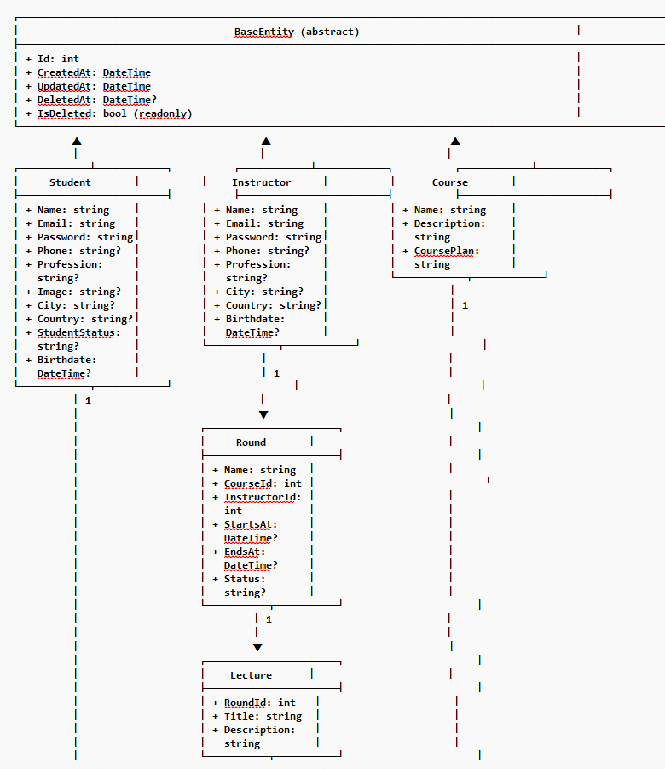

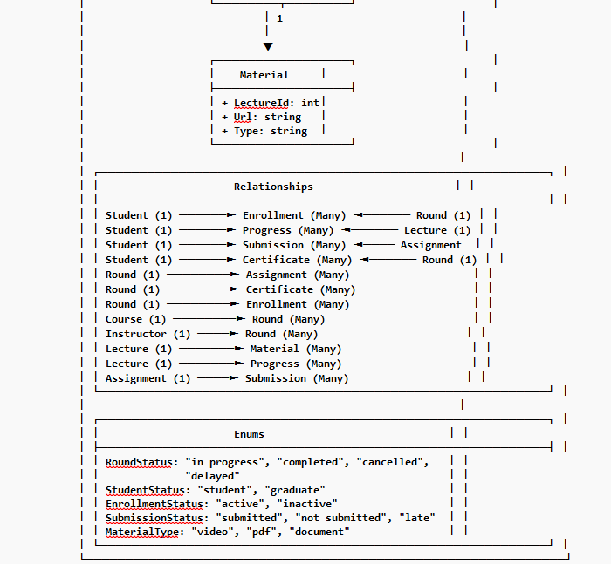

ERD:
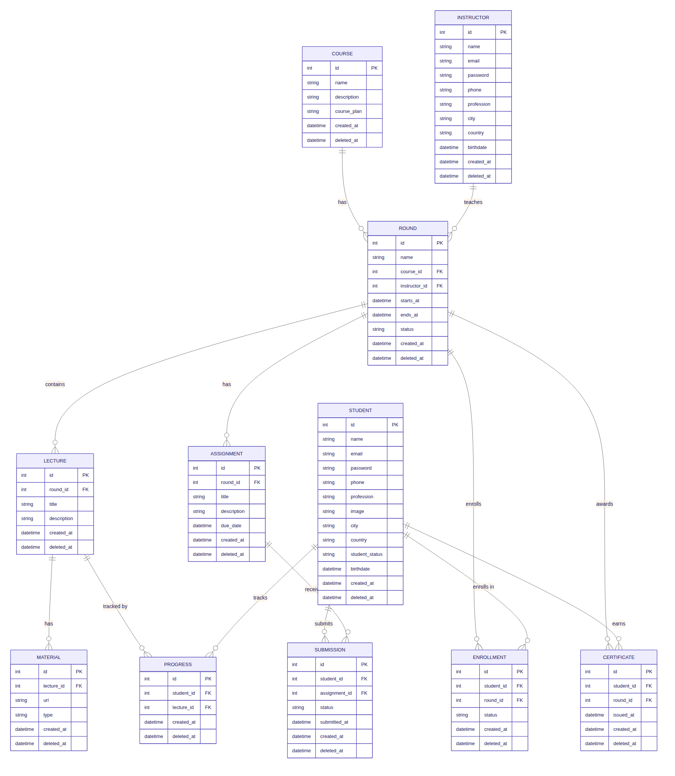

2. Design Patterns Used
Pattern | Layer | Purpose | Example
Repository | Infrastructure | Encapsulates data access logic | CourseRepository, StudentRepository
Generic Repository | Infrastructure | Reusable base CRUD operations | Repository<T>
Unit of Work | Infrastructure | Groups multiple operations into one transaction | UnitOfWork
Dependency Injection | All layers | Decouples object creation from usage | IService → Service in Program.cs
Service Layer | Business | Contains business logic | CourseService, AuthService
DTO Pattern | Core | Transfers data between layers | CourseDto, CreateCourseDto
AutoMapper | Business | Maps Entities ↔ DTOs | CourseProfile
Result Pattern | Business/API | Returns null + Controller handles NotFound | Service returns null, Controller returns NotFound()

5. Key Design Decisions
Decision | Reason
Clean Architecture | Testability, maintainability, separation of concerns
Generic Repository | Eliminates duplicate CRUD code
Unit of Work | Ensures atomic transactions (all changes succeed or fail together)
DTO Pattern | Prevents over-posting, hides sensitive data (password)
Service Layer | Centralizes business logic, keeps controllers thin
Soft Delete | Data recovery, audit trail, referential integrity
BCrypt Hashing | Industry standard for password security
JWT Authentication | Stateless, scalable, works with any frontend
Async/Await | Scalable, non-blocking I/O operations
NotFound Pattern | Proper HTTP status codes, frontend-friendly responses

API Endpoints - Summary for Your Colleague

What I Built:
Feature | CRUD Operations | Endpoint
Authentication | Register, Login, Change Password | /api/auth
Course Management | Create, Read, Update, Delete | /api/courses
Round Management | Create, Read, Update, Delete | /api/rounds
Student Management | Create, Read, Update, Delete | /api/students
Instructor Management | Create, Read, Update, Delete | /api/instructors
Enrollment | Enroll, View, Update Status, Remove | /api/enrollments
Lecture Management | Create, Read, Update, Delete | /api/lectures
Material Management | Create, Read, Update, Delete | /api/materials
Progress Tracking | Track, Complete, View Percentage | /api/progress
Assignment Management | Create, Read, Update, Delete | /api/assignments
Submission | Submit, Update, Grade | /api/submissions
Certificate | Generate, View, Download | /api/certificates

Key Points:
- Total Endpoints: ~50+ RESTful endpoints
- Authentication: JWT token required (except register/login)
- Response Pattern: Returns proper HTTP status codes (200, 201, 400, 401, 404)
- Error Handling: Returns user-friendly JSON messages
- Backend Framework
Technology | Version | Purpose
.NET | 8.0 / 10.0 | Application framework
ASP.NET Core | 8.0 / 10.0 | Web API development
- Database & ORM
Technology | Purpose
Microsoft SQL Server | Database
Entity Framework Core | ORM (Object-Relational Mapping)
Entity Framework Core Tools | Migrations
Library | Purpose
Microsoft.AspNetCore.Authentication.JwtBearer | JWT token validation
System.IdentityModel.Tokens.Jwt | JWT token generation
BCrypt.Net-Next | Password hashing
- Authentication & Security
- API Documentation
Library | Purpose
Swashbuckle.AspNetCore | Swagger UI for API testing

Mapping & Validation
Library | Purpose
AutoMapper | Object-to-object mapping (Entity ↔ DTO)
- Development Tools
Tool | Purpose
Visual Studio 2022 | IDE
SQL Server Management Studio (SSMS) | Database management
Git / GitHub | Version control
Postman | API testing
- Architecture Pattern
Pattern | Purpose
Clean Architecture | Separation of concerns
Repository Pattern | Data access abstraction
Unit of Work | Transaction management
Dependency Injection | Loose coupling

Project Structure
Project | Role
JustTech.Api | API endpoints (Controllers)
JustTech.Business | Business logic (Services)
JustTech.Core | Entities, DTOs, Interfaces
JustTech.Infrastructure | Database, Repositories, Migrations

