Description: the application includes main menu for starting contain four required options

In start game: 2 choices for playing game2x2 or game 5x5 then choosing vs computer or 2 players

the game loop include grid in top left of screen change with lines The information

updates after every play in the top right of screen. After each game,If the winner is

between top scorers, The list will change .Vs computer game: AI chooses the most

suitable line to play.

In load game: the user chooses saved file to continue a uncompleted game from three files available.

In top scorers: this item in the list displays the top scorers from firing the game.

Features: start list, vs list and the size of game list used to choose the required choice by up and down

Button of keyboard.

Assumptions:

1- if a player entered a name with space the game teat with the part of name that is before the space.

2-the history of undoes and redoes will not be saved and loaded.

User Manual: when you start a game, choose game 2x2 or 5x5 then choosing vs computer or 2 players

After selecting required choices, for starting game and time enter your names and enter

1 and then enter row1 ,row2,col1,col2 of desired line. After entering the inputs, the line

coloured by red if player1 and coloured by blue if player2. if you close a box, your score

Increase by one and increase by two if you close two boxes. In addition that, the box

you close will be coloured by your colour. Before every played line, choose the desired

choice from four [1]continue [2]undo [3]redo [4]save game….you can return to first line

played or redo to Played game. You and your competitor continue until the grid is filled

and the game Ended with winner and loser or draw in score.

Data structure: we used [1]struct for storing name , score in game loop ,number of moves

[2]some arrays: grid for storing the grid.

Score_4 and score_4_name for checking completed boxes continuously

Undo : two dimensional array for storing each played line

Important functions used:[1]scan_valid_integer.. used to make the user enter a valid integer

[2]game_loop_vs_player ..used with parameter size for generalizing for any size

[3]computer.. used to make the AI choose the most suitable line to play.

[4]gotoxy..used to go to any line desired in console.

Headers:[1] game_loop_and_AI..store prototypes of game loop functions and fn of computer.

[2]save_load_top_scores..store prototypes of all functions of saving and loading and scores.

[3]menu..store functions of main list , vs list , size list , colours.

Start menu:

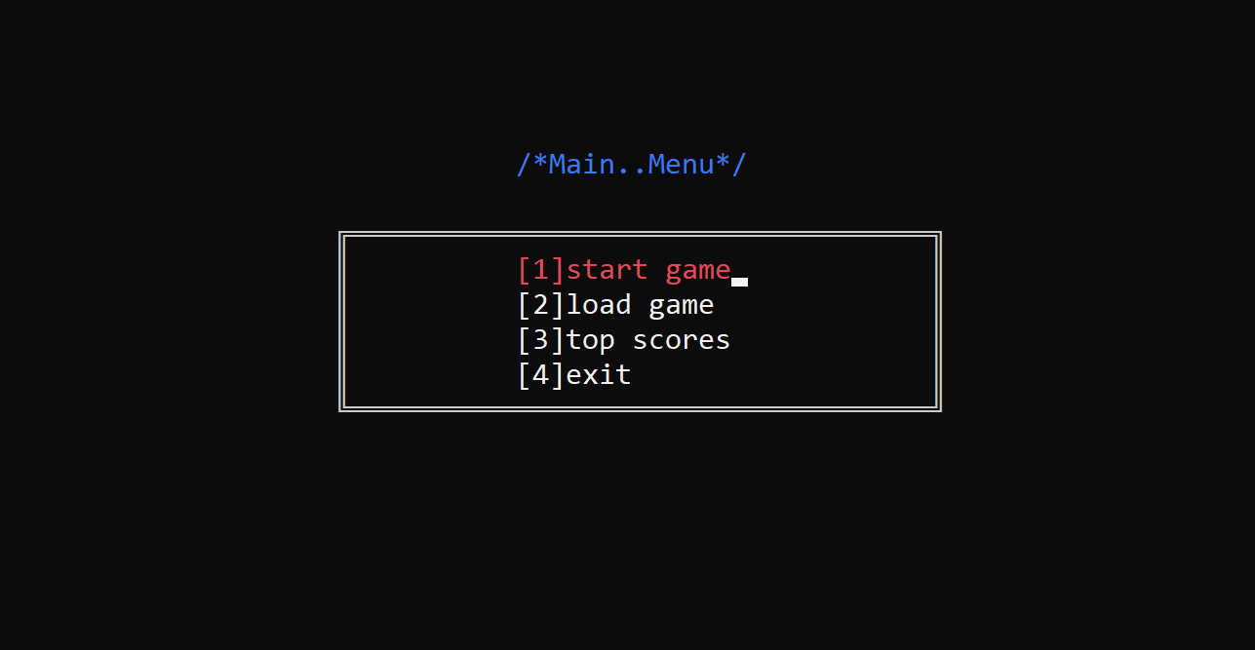

Level menu:

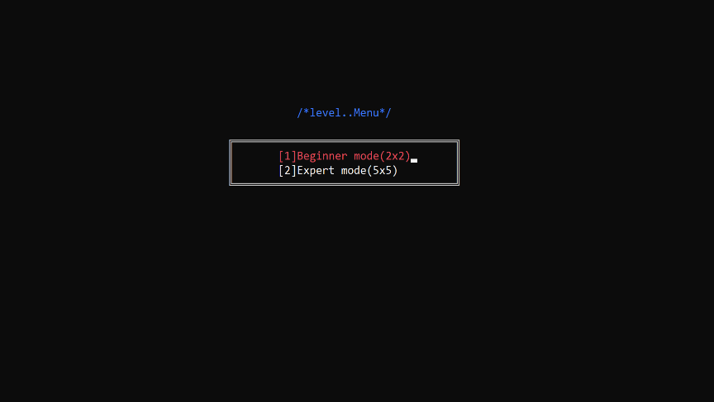

Vs menu:

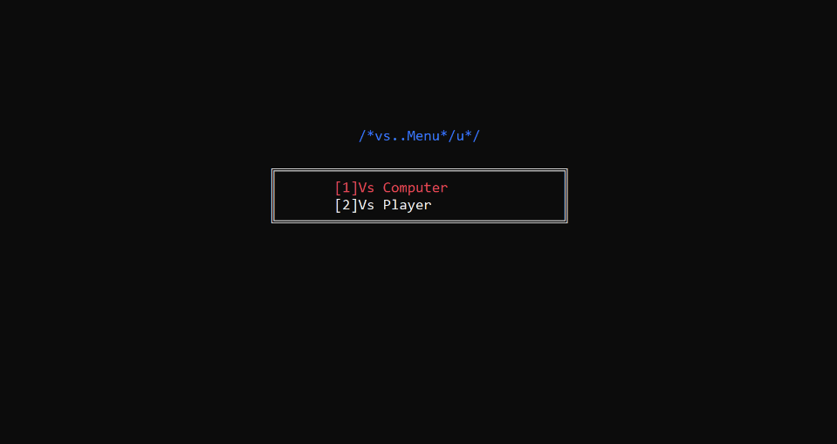

Game start:

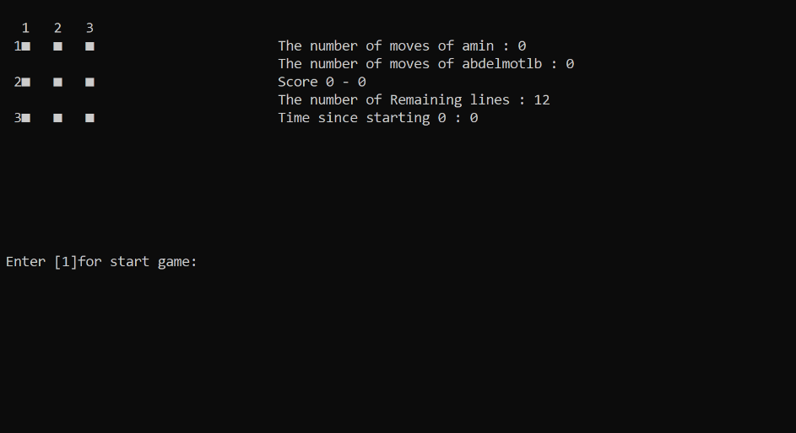

Play row1 , row2 , col1 , col2:

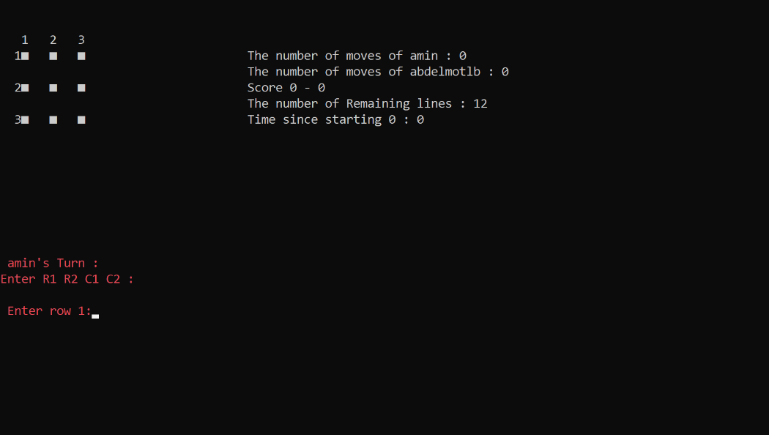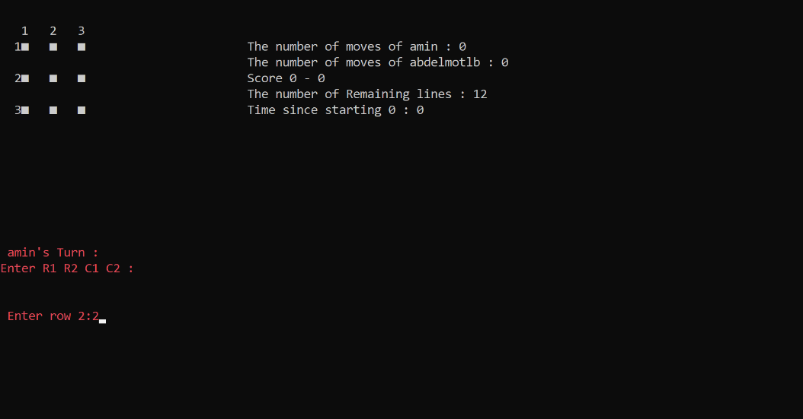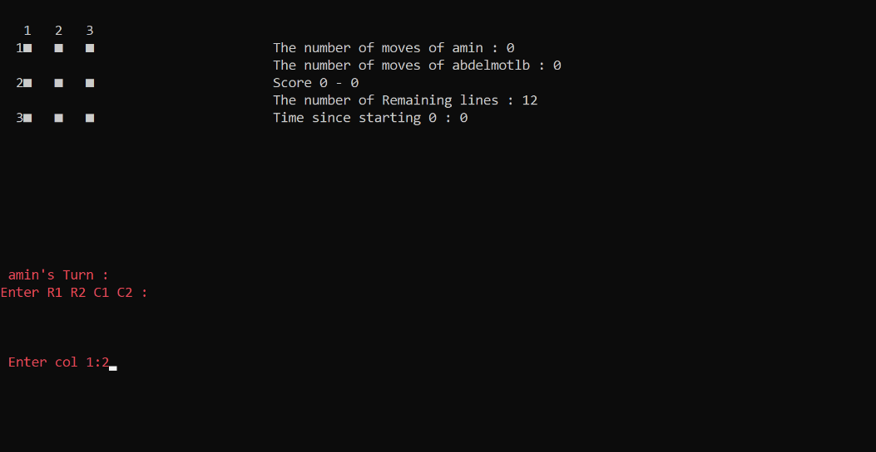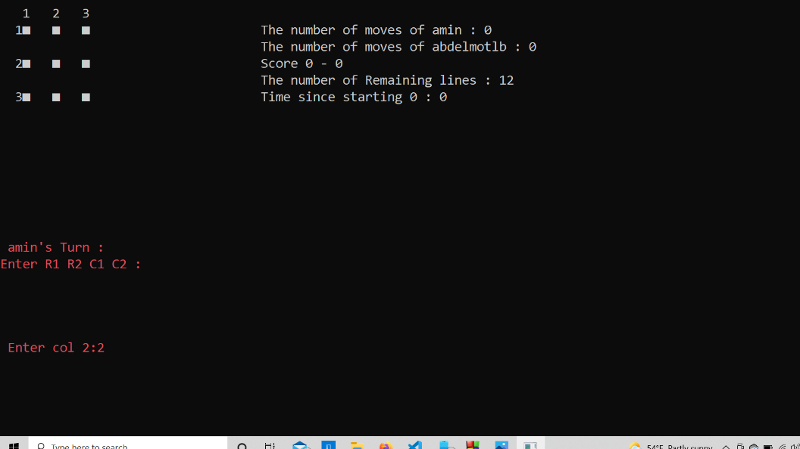b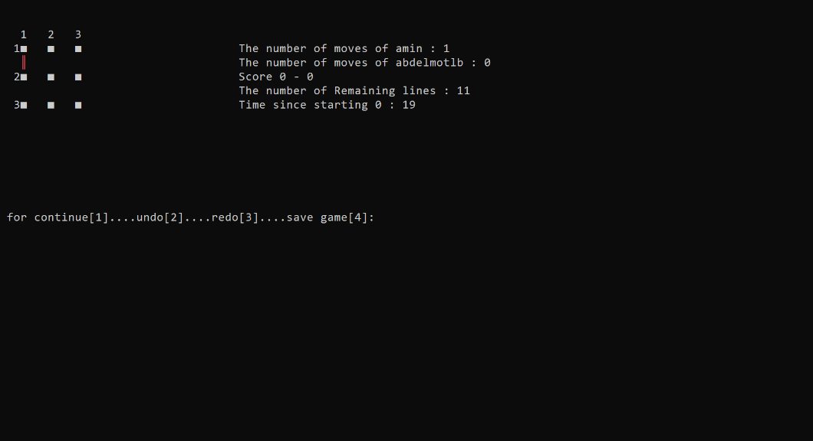

Playing some roles:

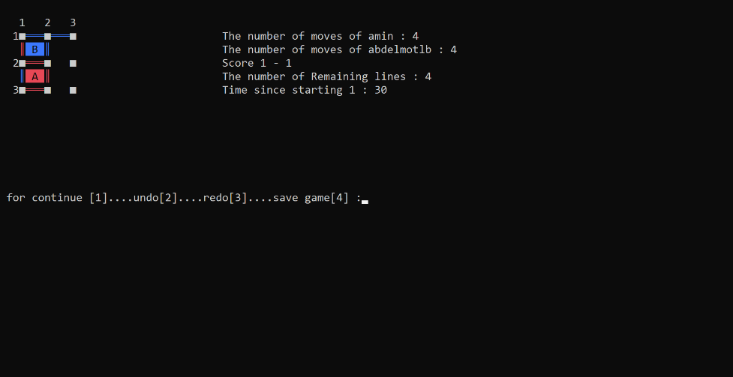

Entering undo for some times:

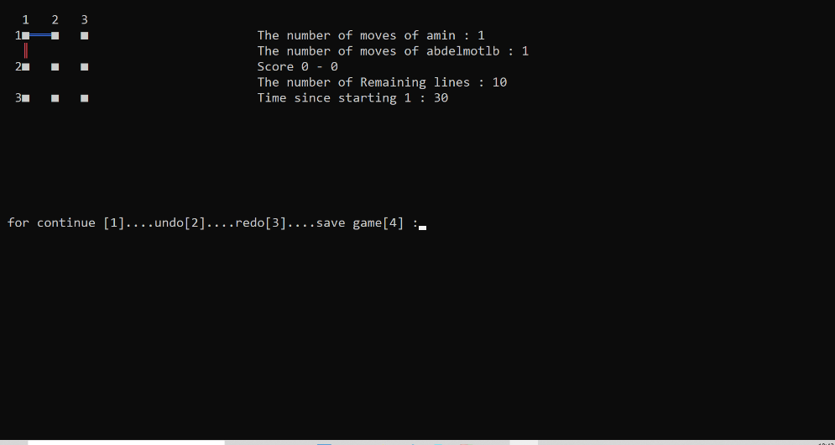

Entering some redos:

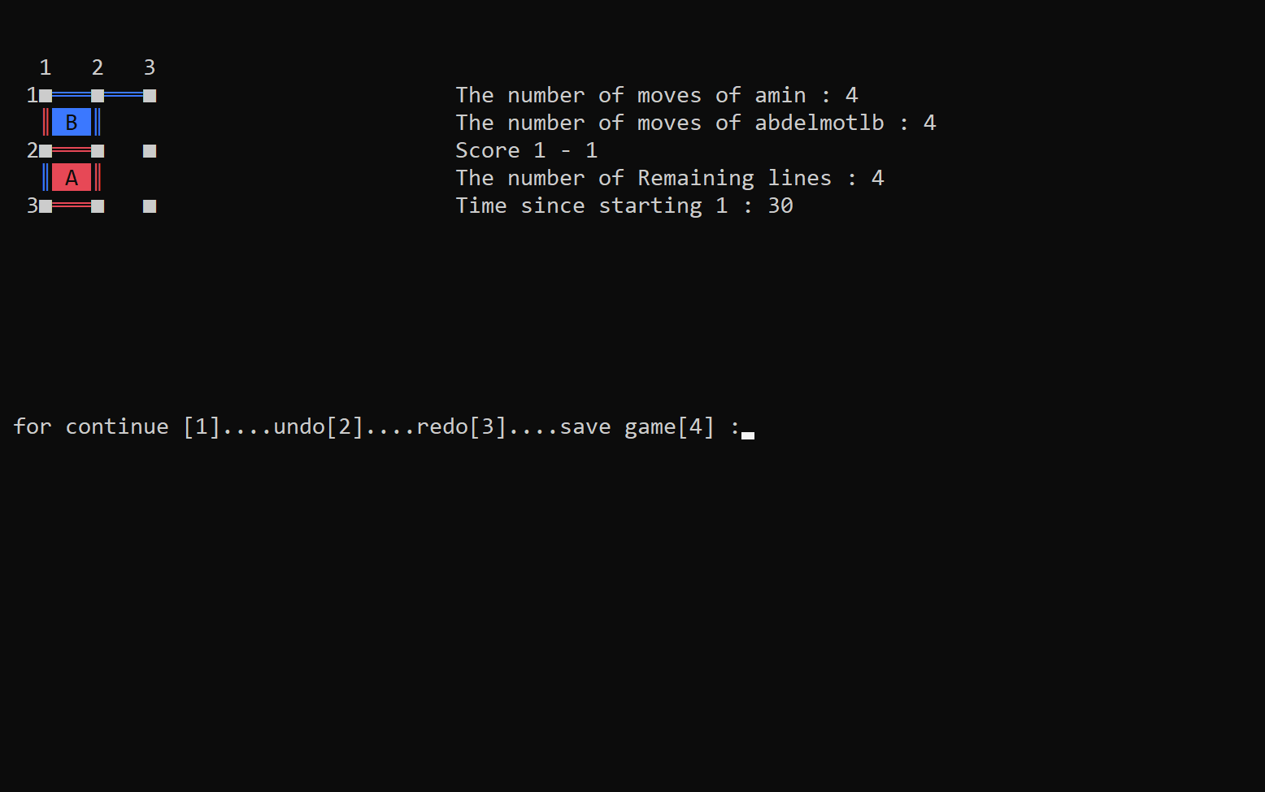

Playing complete game:

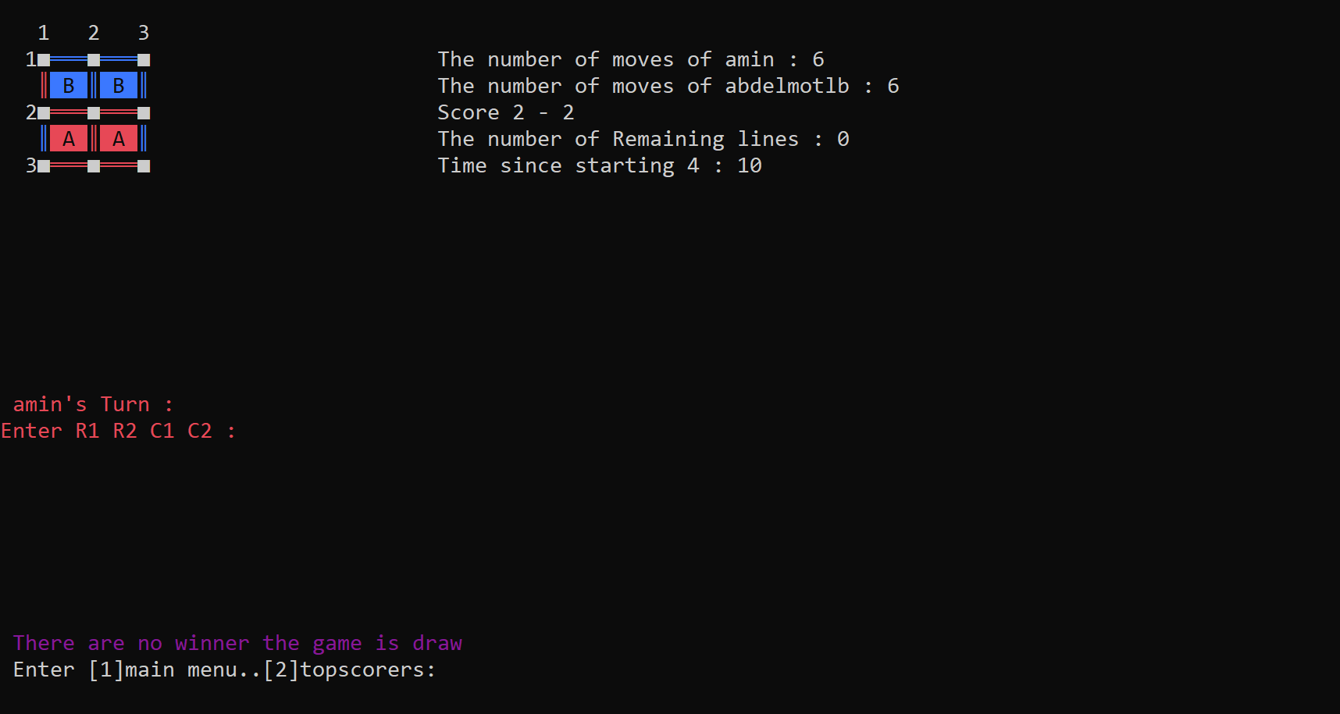

After entering 1 for main menu & 2 for top scorers:

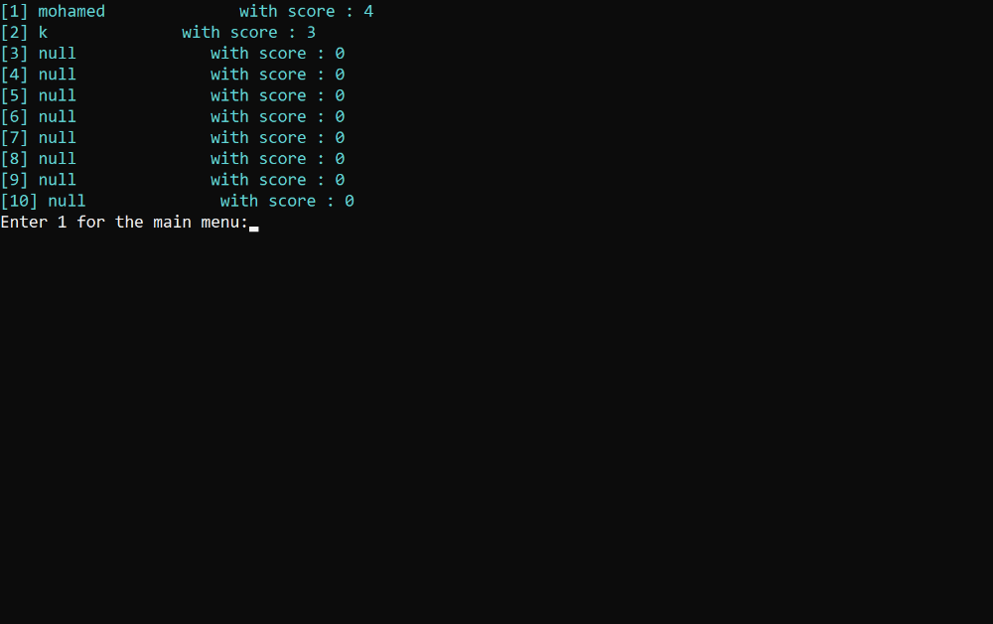

For saving in a game:

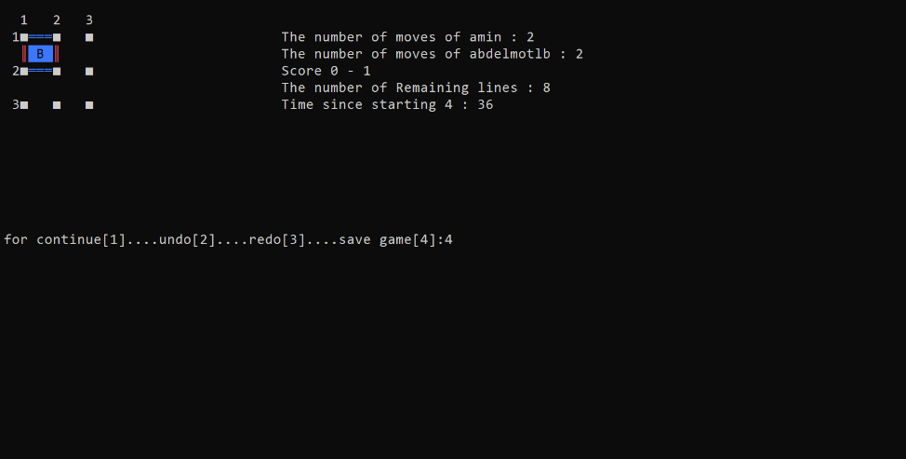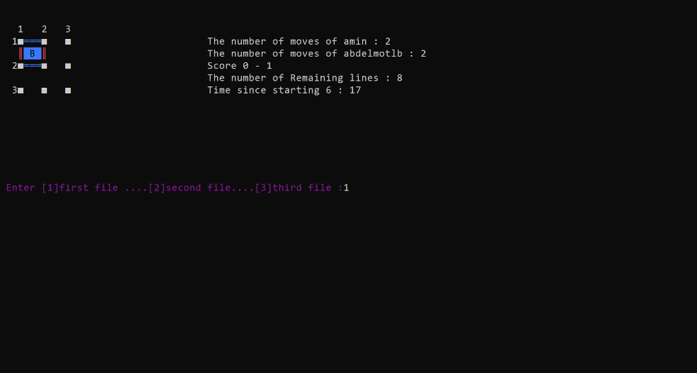

For loading the game:

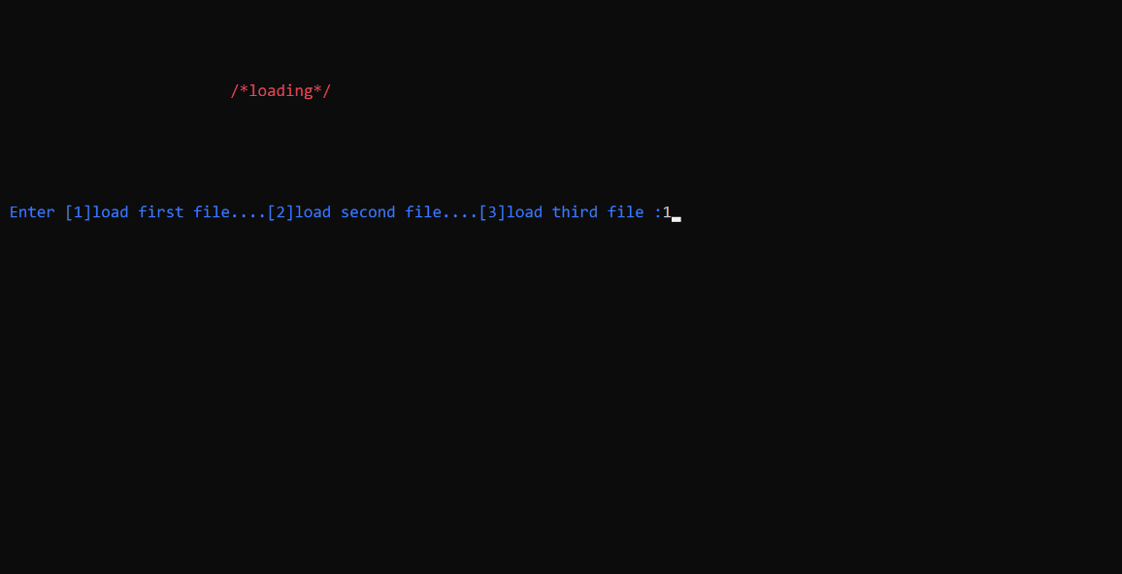

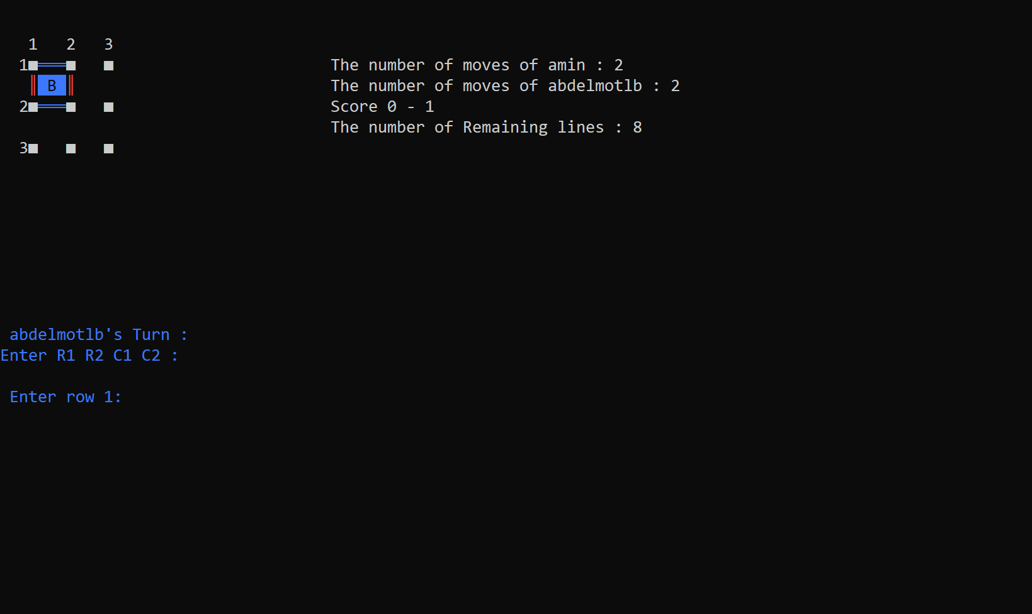

For top scorers:

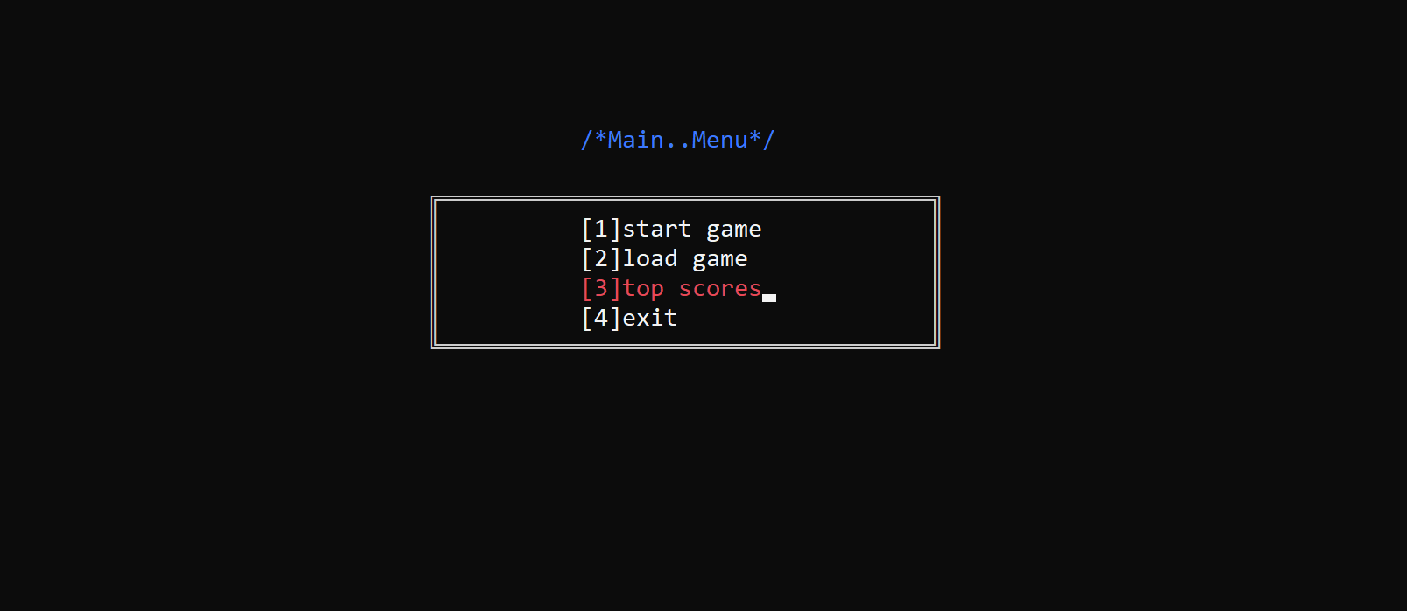

Different games:

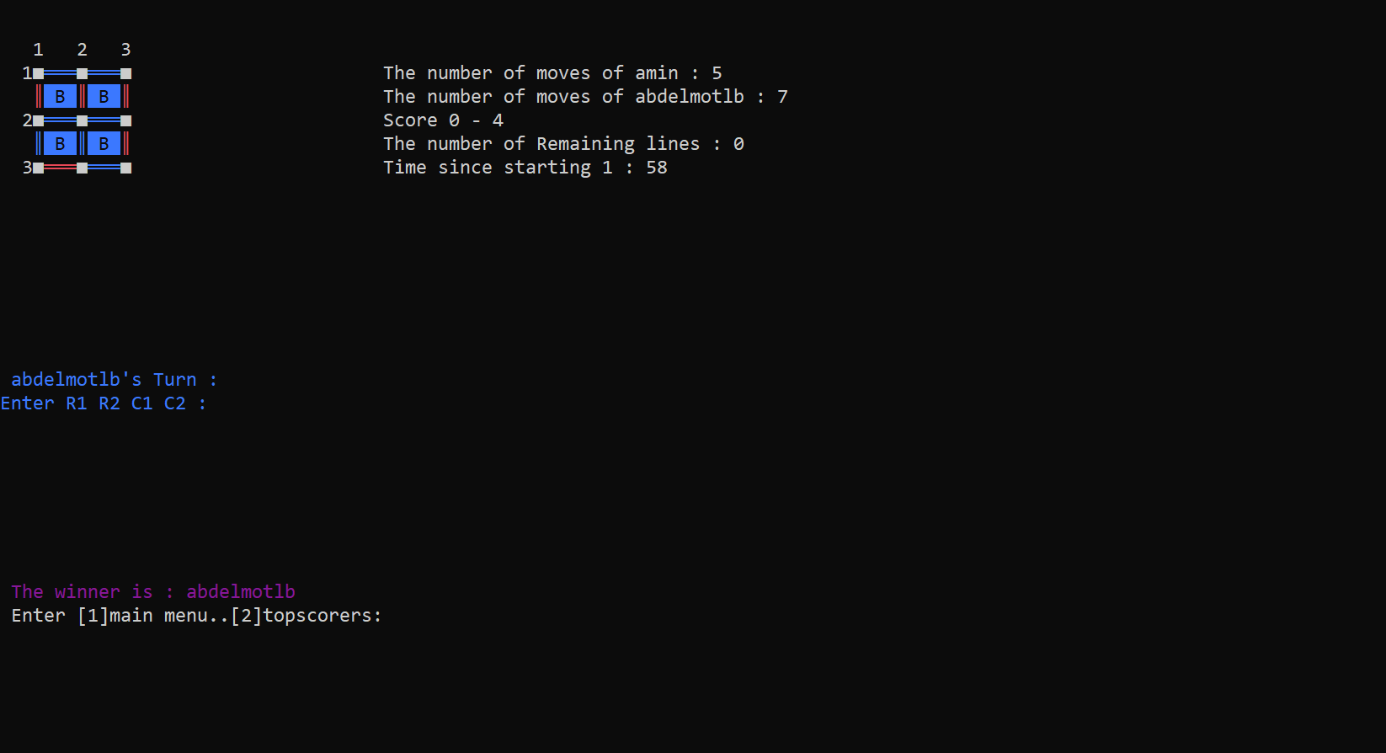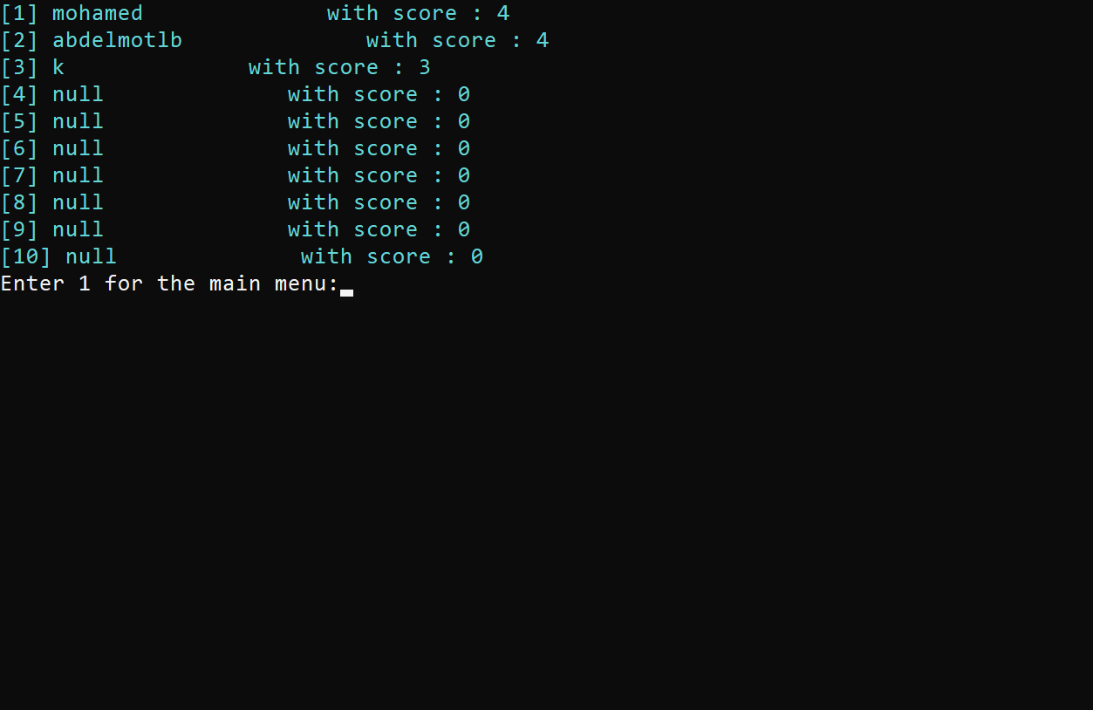

Game 5x5:

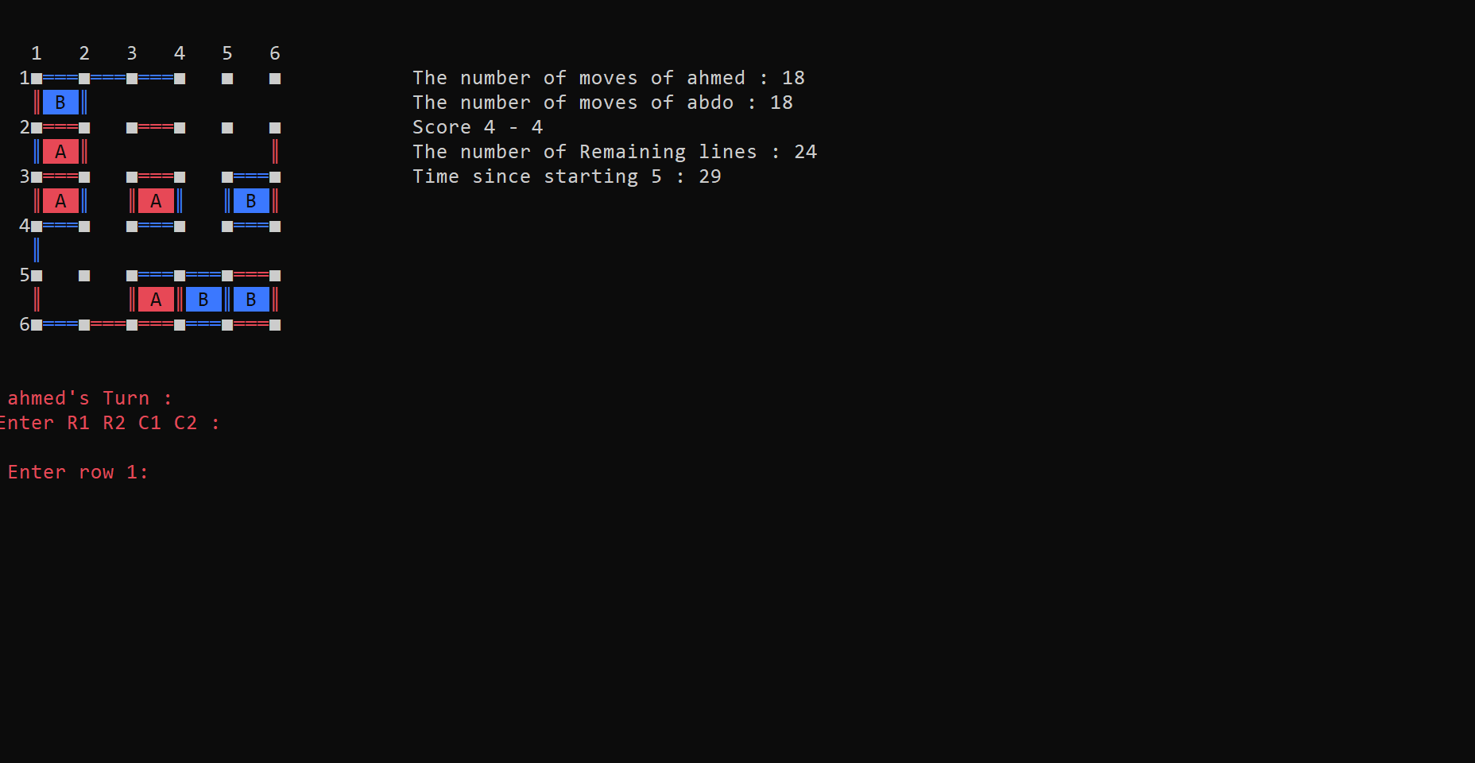

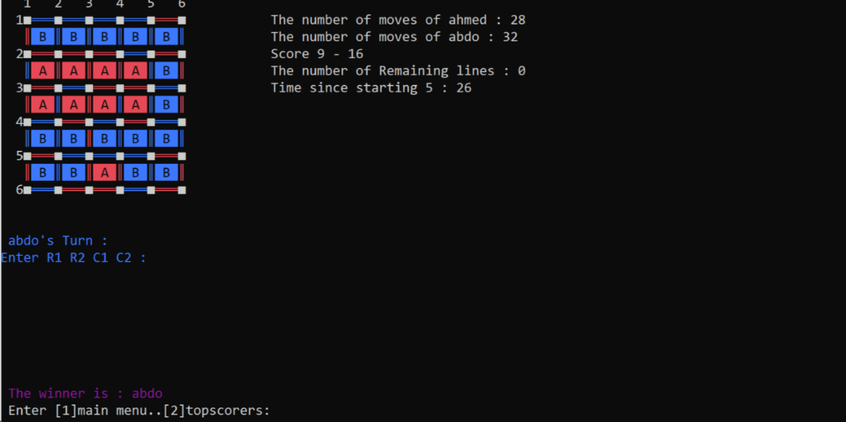

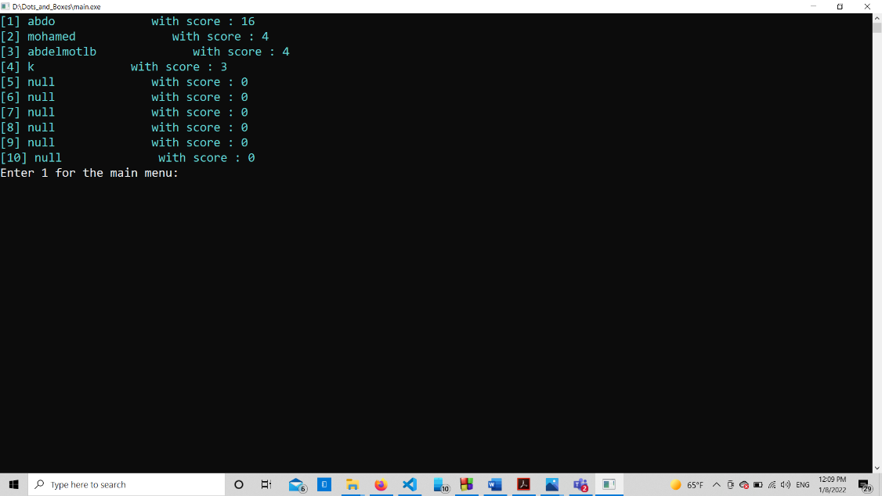

Game vs computer 2x2:

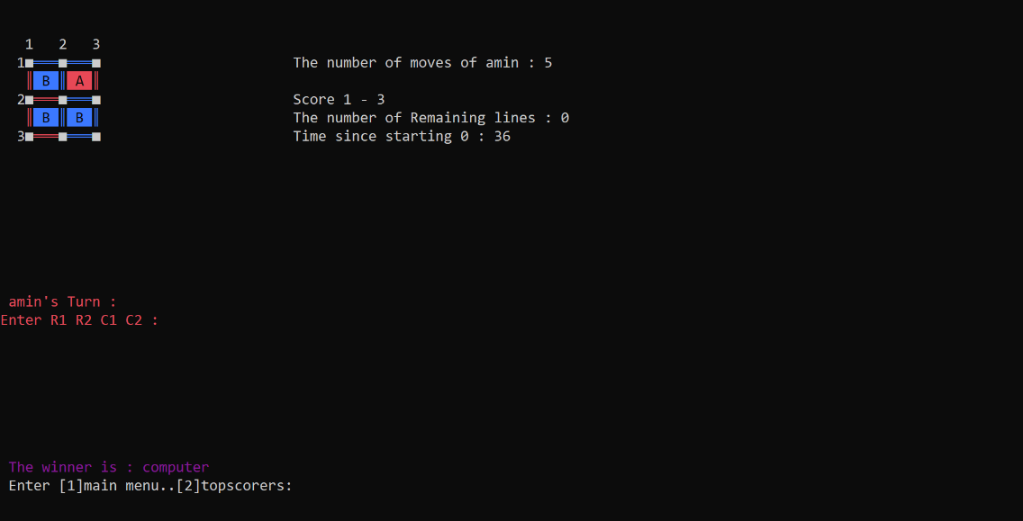

Vs computer 5x5:

