Vanier College

Computer Science Department

  - User Manual

Daiyan Abrar Samin, Mohamed Amine Hamidouch
420-331-VA : Application Development (Sec-02, 03)
Teacher: Syed Naseem Afzal
Monday, December 08, 2025
Table of Contents
Introduction: 3
Open the project: 3
Login Form: 3
Main Menu Form: 5
User Form: 6
Exception Handling: 7
Exporting Records as UserView.txt: 8
Open Viewer Button to CsvUserRecordViewer Form: 9
Exception handling: 10
User Records View: 10
Transaction Form: 11
About: 12
Change Theme: 12
Application execution problem fix: 13

Introduction:
Smart Expense Tracker is an application that aims to solve this issue by offering an easy-to-use Windows Forms application. The program provides two table views of User Information and Expense Records. Each program record gives CRUD (Create, Retrieve, Update, Delete) operations to manipulate data in the database. This user manual will guide through all the features and functionalities of this program.

Open the project:
First open Visual Studio 2022. Click Open a project or solution and choose AppDevProject.sln. Alternatively, you can go to the project folder and click the solution file to open the project in Visual Studio 2022. Once the project opens, it will build and prepare the application to run.

Login Form:
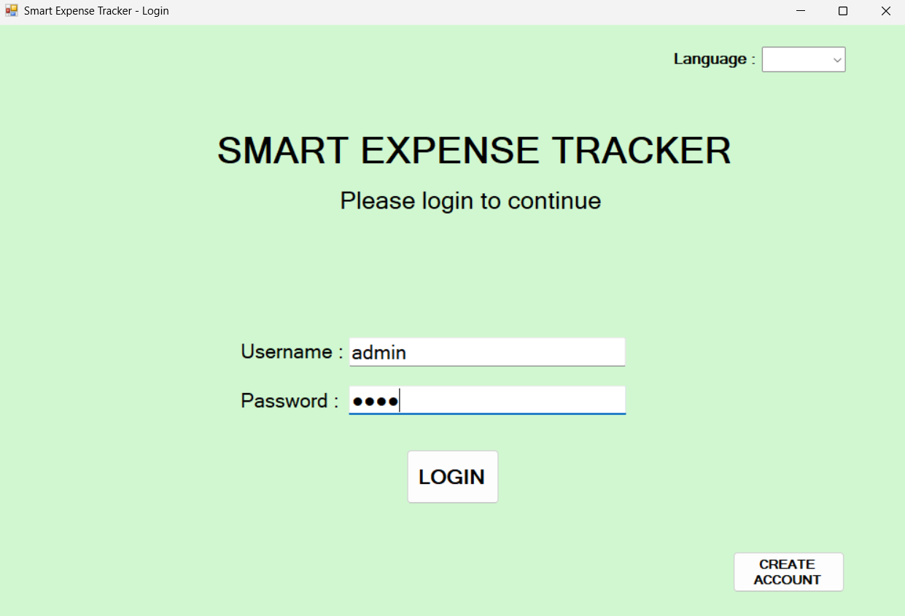
When the application starts, it prompts user to Login page. We already stored Username and password in the program.
- Username: admin
- Password: 1234
Once user enters the login credentials in Login screen, the application gives access to Main Menu form.
Successful Login:
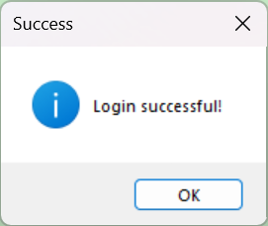
With a successful login, the application shows this message on the user screen.

If a user try to create a new account, it will take them to the following form
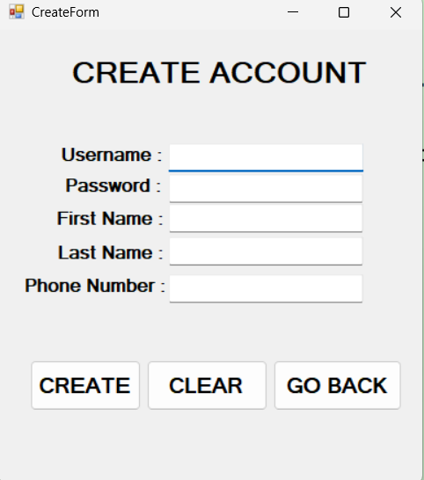
From here, they can enter their information and it will save it to the database once the press on the create button.

Main Menu Form:
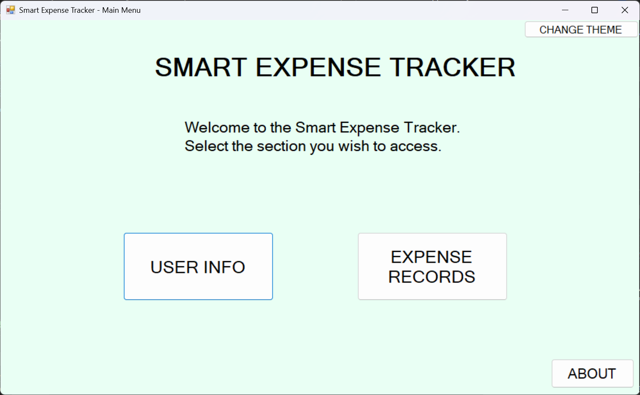
This is the Main Menu window where there are two main buttons User Info and Expense Records. Each button gives user access to different database table records. Main Menu windows also show the application title and description of user choices.

User Form:
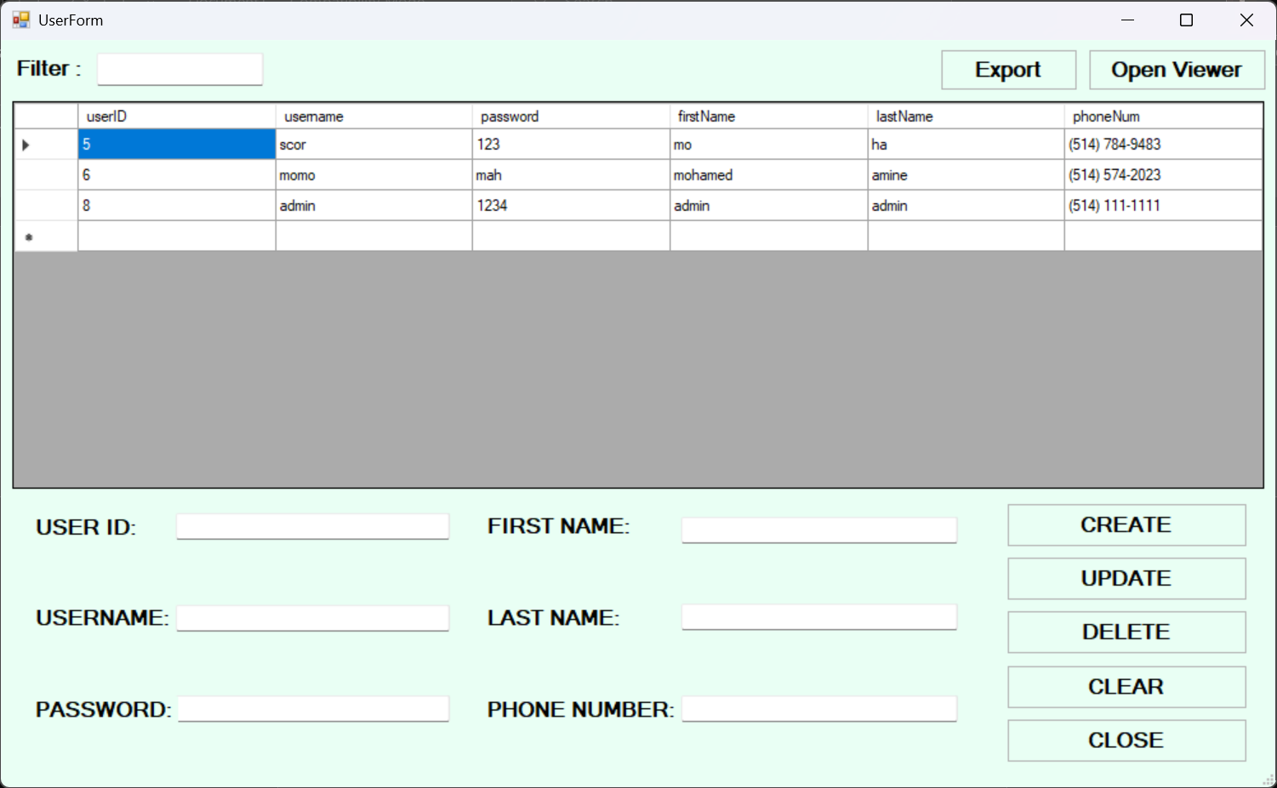
User window shows User data from the database. It has a filter operation which filters the table based user input of username, firstName and lastName. It has Create, Update and Delete operations to manipulate data on the users table in the database. Clear buttons clear texts from all the textboxes which was primarily added by user clicking a record cell from UserGridView. Close button closes User Form.

Exception Handling:
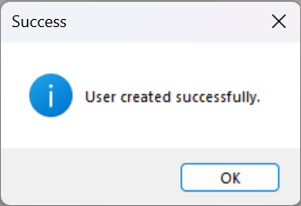
It shows this message when user creation is successful.
Popup message when user information has been successfully updated.
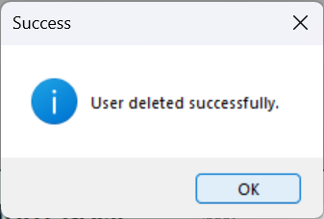
When user has been deleted, this message pops on user screen.

Exporting Records as UserView.txt:
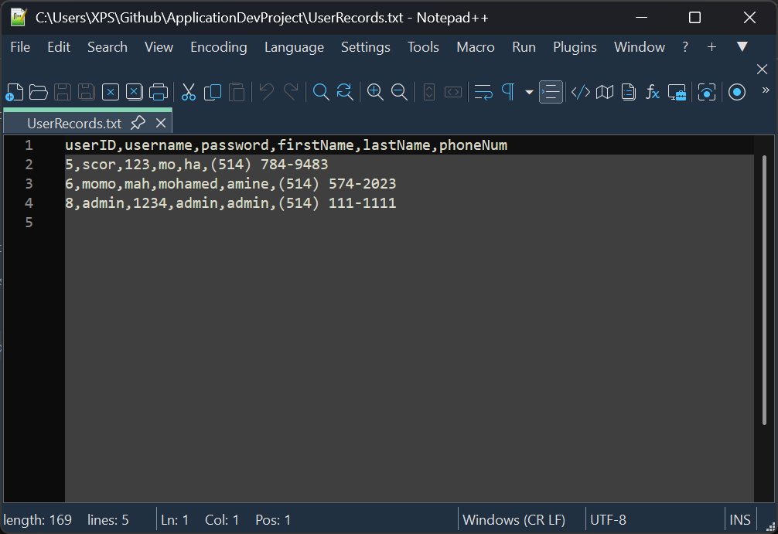
When user clicks on the Export button, the application shows a Dialog Box to allow saving the user records and column headers in UserView.txt as CSV (Comma-Separated Value) format.

Open Viewer Button to CsvUserRecordViewer Form:
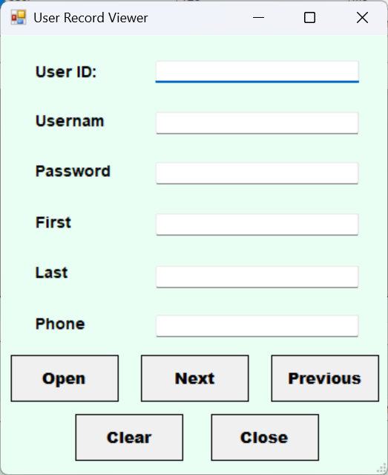
Open Viewer button opens a new CsvUserRecordViewer Form where user can view the user records from the UserView.txt. As user clicks Open button, it shows a Dialog Box where user can selects the UserView.txt to shows the user records from.

Exception handling:
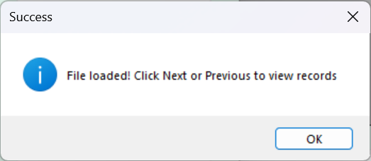
Successful file load to show user records.

User Records View:
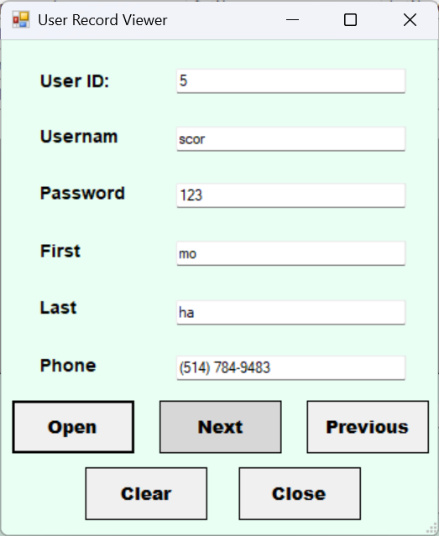
As successfully file loaded, user can use Next and Previous buttons to see all the records forward and backward. Clear buttons clear all the texts from textboxes. Close button exit form.

Transaction Form:
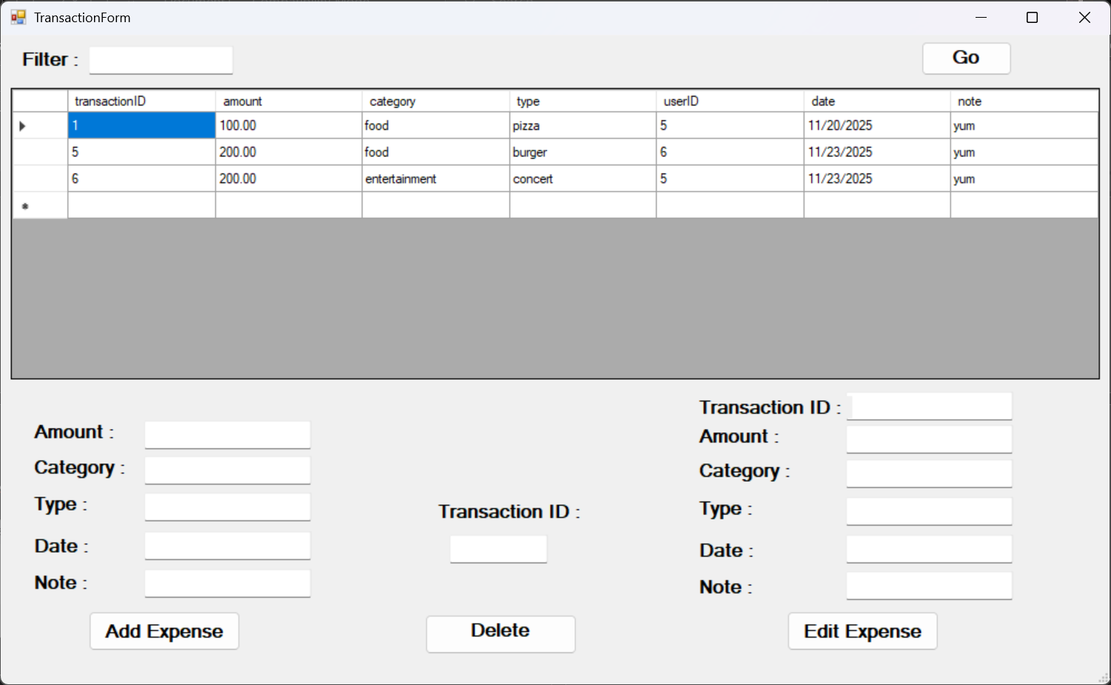
Transaction Form shows Expense records in a DataGridView with 7 different columns. It has similar filter and CRUD operations. Go button hides this window to get user back to Main Menu window.

About:
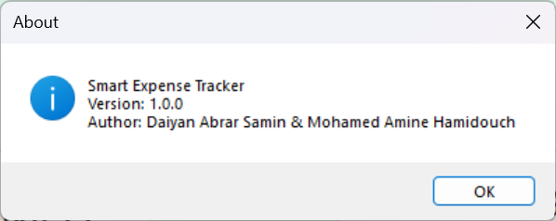
About button shows information of the application as it shows application name, current software version and authors’ info.

Change Theme:
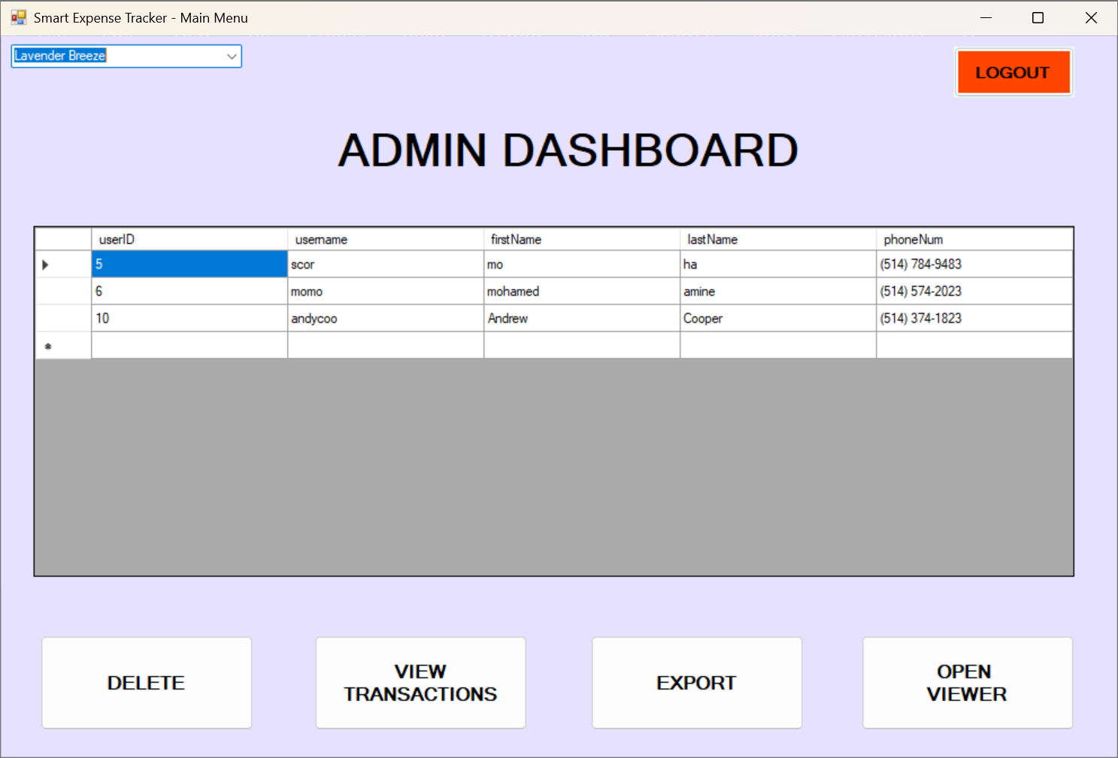
Change Theme combo box has 5 different color options to change the Admin Dashboard Form background theme.

Application execution problem fix:
If any problem is found during app execution, you have to go Task Manager>AppDevProject>End Task. Then build the solution in Visual Studio. After that, you will be able to run the application with no error.

