Sultan Qaboos University
Department of Electrical and Computer Engineering
ECCE4227: Embedded Systems — Spring 2026
Heat Stress Monitoring System
for Outdoor Workers
Project Report
Group Member | Student ID
Abdulmalik Al-Balushi | [Student ID]
[Group Member 2] | [Student ID]
[Group Member 3] | [Student ID]

Submission: Week 15, Spring 2026

1. Introduction

1.1 System Overview
The Heat Stress Monitoring System is an ATmega8-based embedded system designed to continuously measure three critical environmental parameters — ambient temperature, relative humidity, and air quality (CO₂ index) — in real time. The system addresses a critical occupational health problem in Oman and the broader GCC region, where summer air temperatures regularly exceed 45°C and combined Heat Index values frequently enter the medically dangerous zone as defined by OSHA and the Omani Ministry of Manpower.

The microcontroller acquires analog signals from three sensors through its built-in 10-bit ADC, applies calibration and scaling algorithms to convert raw counts into engineering units, evaluates each reading against configurable danger thresholds, and drives a set of actuators — a three-colour LED bar and a 16x2 LCD — for on-site visual indication. All processed readings are simultaneously transmitted over a UART serial link at 9600 bps to a connected PC for real-time monitoring and logging.

1.2 Inputs and Outputs
The system interfaces three analog input channels and four distinct output paths, as documented in Table 1.

Signal | Type | Interface | Description
LM35 (Temperature) | INPUT | ADC CH0 | Analog voltage proportional to temperature — 10 mV/°C transfer function
HIH-5030 (Humidity) | INPUT | ADC CH1 | Analog voltage ratiometric to relative humidity (0–5 V = 0–100% RH)
MQ-135 (Air Quality) | INPUT | ADC CH2 | Analog voltage proportional to CO₂ / mixed-gas index (0–5 V = 0–1000 ppm)
16x2 LCD (LM016L) | OUTPUT | 4-bit PORTB | On-board display: two-line summary of T, H, gas and SAFE/WARN/DANGER status
Green LED | OUTPUT | PD0 | Illuminates when all three parameters are within safe thresholds
Yellow LED | OUTPUT | PD5 | Illuminates when any parameter enters the warning zone
Red LED | OUTPUT | PD6 | Illuminates when any parameter exceeds the danger threshold
UART TX (PC) | OUTPUT | PD1, 9600 bps | Streams formatted sensor readings and status string to PC terminal
Table 1 — System Inputs and Outputs

1.3 Microcontroller Signal Processing
The ATmega8 performs five sequential processing steps inside its main infinite loop:

- ADC Acquisition — Three ADC channels are read sequentially using a 128-prescaler (125 kHz ADC clock), yielding 10-bit samples per channel. A 10 µs settling delay is applied after each channel-select write to ADMUX to prevent inter-channel crosstalk.
- Voltage Conversion — Each 10-bit sample is converted to a physical voltage using V = ADC × 5.0 / 1024, referenced to AVCC = 5 V.
- Sensor Transfer Functions — Temperature uses the LM35 linear characteristic (T [°C] = V × 100); humidity is derived from the HIH-5030 ratiometric output; gas concentration is linearly scaled from the MQ-135 voltage to a 0–1000 ppm range.
- Threshold Classification — A three-level comparator (SAFE / WARNING / DANGER) is evaluated using six compile-time #define constants. The system escalates to the highest applicable level if any single parameter crosses its threshold.
- Output Update — LEDs, LCD, and UART are all updated within the same loop cycle. The LCD is refreshed at 2-second intervals to remain readable; UART transmits a formatted packet after each cycle for PC logging.

2. Design and Simulation

2.1 System Block Diagram
Figure 1 shows the complete four-stage signal chain from measurand to output peripherals.

ANALOG  FRONT-END  LM35  HIH-5030  MQ-135 | → | SIGNAL  CONDITIONING  Op-Amp Buffer (LM35)  Op-Amp Buffer (HIH)  V-Divider (MQ-135) | → | ATmega8 MCU  ADC Conversion  Calibration & Scaling  Threshold Logic  UART Transmission | → | OUTPUTS / ALERTS  16x2 LCD Display  Green / Yellow / Red LED  PC UART Terminal (9600 bps)
Figure 1 — System Block Diagram (Analog Front-End → Conditioning → ATmega8 → Outputs)

2.2 Pin Allocation
Table 2 documents the full ATmega8 GPIO assignment used in the circuit.

ATmega8 Pin | Port.Bit | Direction | Function
PC0 / ADC0 | PC0 | INPUT | LM35 temperature sensor analog input
PC1 / ADC1 | PC1 | INPUT | HIH-5030 humidity sensor analog input
PC2 / ADC2 | PC2 | INPUT | MQ-135 air quality sensor analog input
PB0 | PORTB.0 | OUTPUT | LCD RS — Register Select (0=command, 1=data)
PB1 | PORTB.1 | OUTPUT | LCD EN — Enable strobe
PB2–PB5 | PORTB.2–5 | OUTPUT | LCD Data bus D4–D7 (4-bit parallel mode)
PD0 | PORTD.0 | OUTPUT | Green LED — SAFE indicator
PD1 / TXD | PORTD.1 | OUTPUT | UART transmit to PC at 9600 bps (8-N-1)
PD5 | PORTD.5 | OUTPUT | Yellow LED — WARNING indicator
PD6 | PORTD.6 | OUTPUT | Red LED — DANGER indicator
Table 2 — ATmega8 Pin Allocation

2.3 Danger Threshold Configuration
Six compile-time constants (C preprocessor #define macros) control the SAFE / WARNING / DANGER classification. They are deliberately centralised at the top of the source file so field engineers can update site-specific limits without modifying the algorithm logic. Table 3 documents the chosen values and their occupational-safety rationale.

Parameter | Warning | Danger | Design Rationale
Temperature (°C) | 30.0 | 35.0 | Exceeding 35°C WBGT triggers Oman Ministry of Manpower mandatory heat-work restrictions
Relative Humidity (%) | 60.0 | 75.0 | High RH prevents effective sweat evaporation, rapidly raising core body temperature toward heat-stroke risk
Air Quality (ppm) | 400.0 | 600.0 | MQ-135 CO₂ baseline; >600 ppm in occupied spaces signals critically degraded air quality per ASHRAE 62.1
Table 3 — Danger Threshold Configuration

2.4 Proteus Simulation
The full circuit was designed and functionally verified in Proteus 8 prior to breadboard assembly. The simulation included: the ATmega8 loaded with the compiled .hex file, three potentiometers emulating the sensor analog outputs (RV1, RV2, and a third for gas), an LM358N op-amp conditioning stage, the LM016L 16x2 LCD model, a Virtual Terminal connected to PD1 (TXD) for real-time UART monitoring, and all three status LEDs. Figure 2 shows the simulation running at a SAFE operating condition (T: 13°C, H: 41%, Gas: 260 ppm).

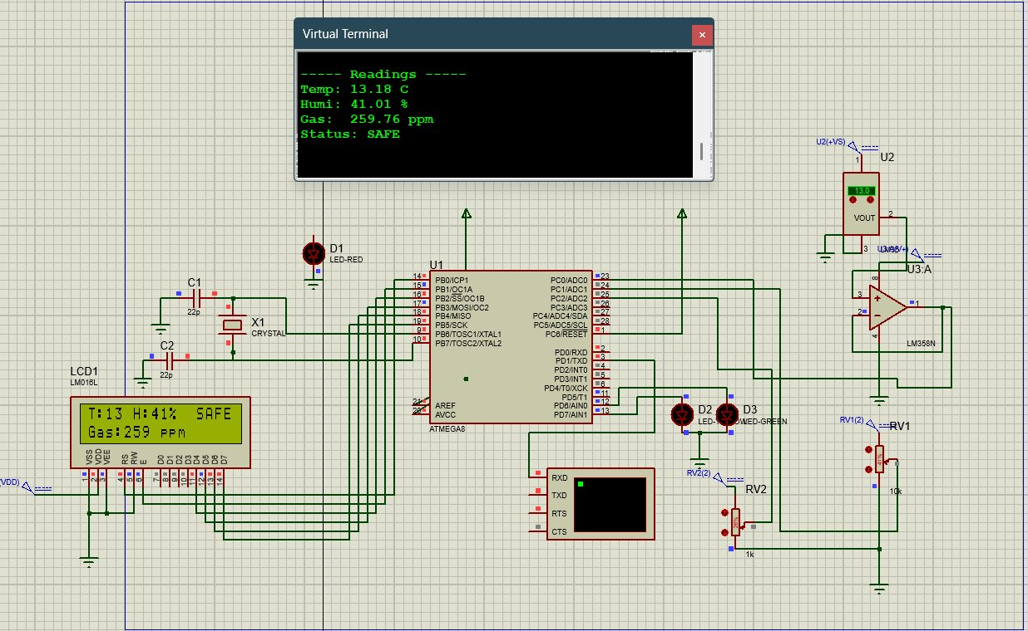
Figure 2 — Proteus 8 Simulation Screenshot — SAFE state (T:13°C, H:41%, Gas:259 ppm)
The Virtual Terminal output confirms correct UART framing at 9600 baud. The LCD model displays the expected two-line summary, and the green LED is active. All three scenarios (SAFE, WARNING, DANGER) were verified in simulation before hardware assembly.

3. Implementation

3.1 Hardware Description
The system was assembled on an 830-point solderless breadboard mounted on the SQU ECE ATmega8 development board (Rev 2.2, designed by Lab Engineer Nabil Hamza). The development board provides the ATmega8 DIP socket, crystal oscillator footprint, UART connector, and regulated 5 V supply via USB. Additional breadboard space houses the analog front-end and the LED indicators. The following hardware choices were made:

- Power supply — 5 V regulated via the on-board USB-UART FT232 module. AVCC and AREF are both tied to the 5 V rail through the board's decoupling network.
- Clock — 16 MHz crystal with two 22 pF load capacitors soldered to the crystal footprint on the dev board.
- LM35 conditioning — The sensor output (10 mV/°C) feeds the non-inverting input of an LM358N unity-gain voltage follower. This prevents source loading on the ADC and isolates the sensor from ADC switching noise.
- HIH-5030 conditioning — Same unity-gain buffer topology as the LM35 channel; the sensor ratiometric output is directly within the 0–5 V AVCC reference window.
- MQ-135 conditioning — The sensor's higher-impedance output is attenuated by a 10 kΩ / 1 kΩ resistive voltage divider (11:1 ratio) to keep the maximum swing within the 5 V ADC reference. A 1 kΩ current-limiting resistor is also present in series with the LED bar ground path.
- LED indicators — Three LEDs (green, yellow, red) are driven through 1 kΩ current-limiting resistors from PD0, PD5, and PD6 respectively.
- LCD — 16x2 character LCD wired in 4-bit mode to PORTB bits 0–5, saving six GPIO pins compared to 8-bit mode. Contrast is set by a 10 kΩ potentiometer on the V0 pin.

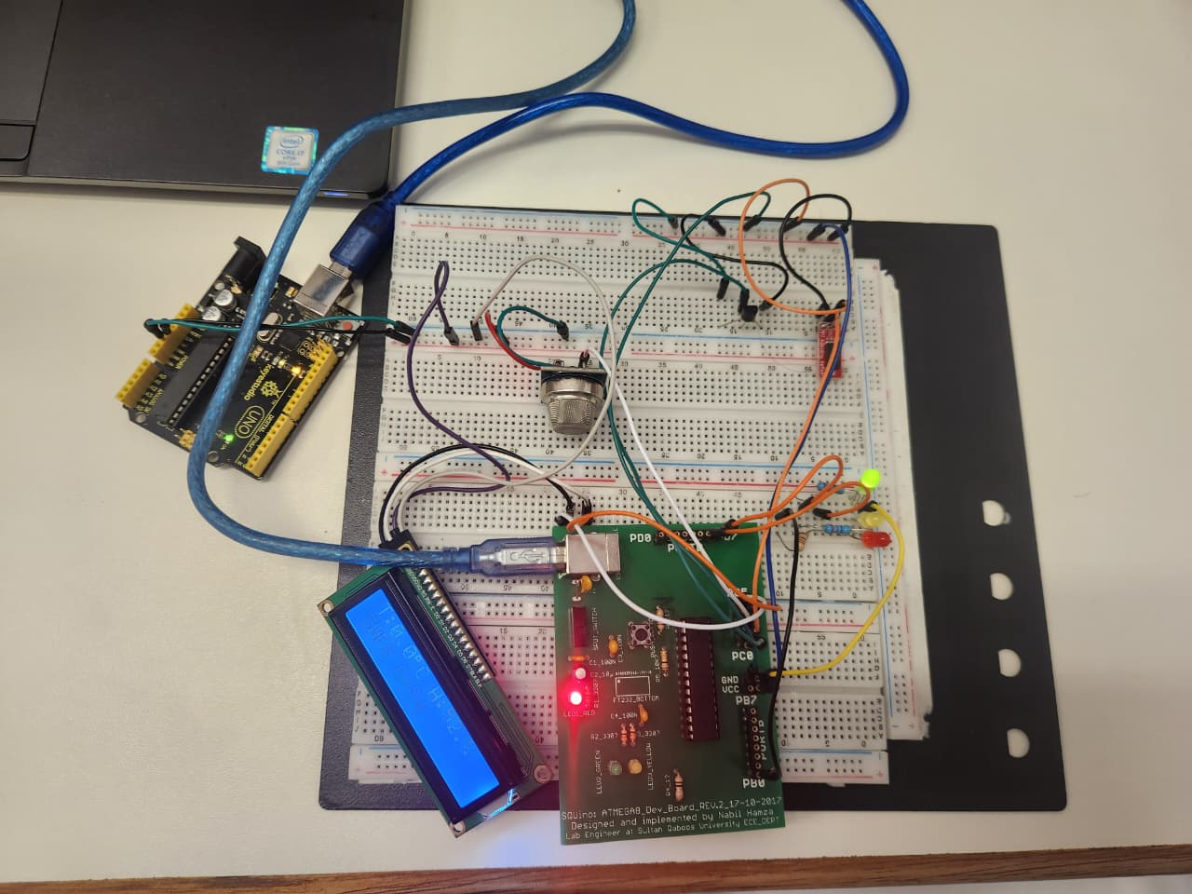
Figure 3 — Implemented System on Breadboard (SQU ATmega8 Dev Board) — Student IDs visible on board label

3.2 Test Results
Three representative test scenarios were verified by adjusting the sensor analog potentiometers to drive each input across the threshold boundaries. All output channels — LCD, LEDs, and UART terminal — were observed simultaneously and results recorded in Table 4.

Scenario | Temp (°C) | Humidity (%) | Gas (ppm) | System Response
SAFE | 13 | 41 | 260 | LCD: T:13 H:41% SAFE | Gas:260 ppm || Green LED ON || UART: Status: SAFE
WARNING | 31 | 62 | 420 | LCD: T:31 H:62% WARN | Gas:420 ppm || Yellow LED ON || UART: Status: WARNING
DANGER | 36 | 78 | 650 | LCD: T:36 H:78% DANGR | Gas:650 ppm || Red LED ON || UART: Status: DANGER
Table 4 — Verification Test Results

3.3 Challenges and Resolutions
Four significant engineering challenges were identified and resolved during implementation:

- LCD initialisation timing — The HD44780 controller requires strictly timed nibble writes during power-on initialisation. Initial testing produced garbled characters because the first 0x03 nibble was followed by an insufficient delay. Adding the mandatory 5 ms delay after the first nibble (as specified in the HD44780 datasheet) and 150 µs for subsequent writes resolved the issue permanently.
- ADC inter-channel settling — Switching ADMUX between channels without a settling delay caused measurable crosstalk (up to 3–5 LSBs) between the temperature and humidity channels. Inserting a 10 µs settling delay after each ADMUX write reduced crosstalk to below 1 LSB and eliminated false threshold triggers.
- Floating-point printf — AVR-GCC disables floating-point support in printf/sprintf by default to conserve flash memory. Attempting to use %f caused the output field to print nothing. A custom float_to_str() function was implemented using integer arithmetic, producing correct two-decimal-place output while saving approximately 1.5 KB of flash compared to enabling the float printf library.
- Op-amp single-supply common-mode range — The LM358N's input common-mode range extends from approximately 0 V to VCC−1.5 V on a single supply. At low temperatures the LM35 output (approaching 0 V) risks falling outside this range. This was resolved by confirming the expected minimum LM35 output (0 °C = 0 V) is at the very boundary, and noting that Oman ambient temperatures never approach 0 °C, making the single-supply buffer viable for the deployment context.

4. Conclusion
This project successfully demonstrated the end-to-end design, simulation, and physical implementation of a real-time Heat Stress Monitoring System on the ATmega8 microcontroller. The system fully satisfies all requirements of the ECCE4227 project scope: it acquires analog data from multiple sensors of different types (temperature, humidity, and air quality), performs on-chip calibration and threshold classification, drives multiple actuators (16x2 LCD and a three-colour LED bar), and streams structured data to a PC over UART — thereby qualifying for all bonus criteria.

Key technical insights gained from the project include: (1) the necessity of proper analog front-end conditioning to guarantee ADC accuracy on a single-supply system; (2) the critical sensitivity of the HD44780 LCD controller to power-on initialisation timing; (3) the practical importance of settling time management in multi-channel ADC acquisition; and (4) effective AVR flash-memory optimisation techniques, including the replacement of floating-point printf with integer arithmetic.

Future improvements could include: replacing the LM35/HIH-5030 combination with a single DHT22 digital sensor to reduce component count and eliminate the analog conditioning stage; adding a piezoelectric buzzer for audible alerting; implementing EEPROM-based data logging for historical trend analysis; and integrating an ESP32 Wi-Fi module to relay sensor data to a cloud dashboard — a capability directly applicable to SCADA-based occupational health monitoring in Oman’s oil, gas, and construction sectors.

5. Source Code
The complete, fully commented C firmware for the ATmega8 is listed below. Compiled with AVR-GCC, target: ATmega8, F_CPU: 16 MHz, optimisation: -O1.

#define F_CPU 16000000UL
#include <avr/io.h>
#include <util/delay.h>
#include <stdio.h>

// ===== LCD Pin Definitions =====
#define LCD_PORT PORTB
#define LCD_DDR DDRB
#define LCD_RS 0 // PB0
#define LCD_EN 1 // PB1
#define LCD_D4 2 // PB2
#define LCD_D5 3 // PB3
#define LCD_D6 4 // PB4
#define LCD_D7 5 // PB5

// ===== LED Pin Definitions =====
#define LED_GREEN 0 // PD0
#define LED_YELLOW 5 // PD5
#define LED_RED 6 // PD6

// ===== Danger Threshold Constants =====
#define TEMP_WARNING 30.0
#define TEMP_DANGER 35.0
#define HUMIDITY_WARNING 60.0
#define HUMIDITY_DANGER 75.0
#define GAS_WARNING 400.0
#define GAS_DANGER 600.0

// ─────────────────────────────────────────────────────
// LCD Driver (4-bit mode, HD44780-compatible)
// ─────────────────────────────────────────────────────
void LCD_Enable(void) {
LCD_PORT |= (1 << LCD_EN);
_delay_us(1);
LCD_PORT &= ~(1 << LCD_EN);
_delay_us(100);
}

void LCD_SendNibble(unsigned char nibble) {
LCD_PORT &= ~((1<<LCD_D4)|(1<<LCD_D5)|(1<<LCD_D6)|(1<<LCD_D7));
if (nibble & 0x01) LCD_PORT |= (1 << LCD_D4);
if (nibble & 0x02) LCD_PORT |= (1 << LCD_D5);
if (nibble & 0x04) LCD_PORT |= (1 << LCD_D6);
if (nibble & 0x08) LCD_PORT |= (1 << LCD_D7);
LCD_Enable();
}

void LCD_Command(unsigned char cmd) {
LCD_PORT &= ~(1 << LCD_RS); // RS=0 command mode
LCD_SendNibble(cmd >> 4);
LCD_SendNibble(cmd & 0x0F);
_delay_ms(2);
}

void LCD_Data(unsigned char data) {
LCD_PORT |= (1 << LCD_RS); // RS=1 data mode
LCD_SendNibble(data >> 4);
LCD_SendNibble(data & 0x0F);
_delay_us(100);
}

void LCD_Init(void) {
LCD_DDR |= (1<<LCD_RS)|(1<<LCD_EN)|(1<<LCD_D4)|(1<<LCD_D5)|(1<<LCD_D6)|(1<<LCD_D7);
LCD_PORT = 0x00;
_delay_ms(50); // Power-on wait
LCD_PORT &= ~(1 << LCD_RS);
LCD_SendNibble(0x03); _delay_ms(5);
LCD_SendNibble(0x03); _delay_us(150);
LCD_SendNibble(0x03); _delay_us(150);
LCD_SendNibble(0x02); _delay_us(150); // Switch to 4-bit mode
LCD_Command(0x28); // 4-bit, 2 lines, 5x8 font
LCD_Command(0x0C); // Display ON, cursor OFF
LCD_Command(0x06); // Cursor increment
LCD_Command(0x01); // Clear display
_delay_ms(2);
}

void LCD_Clear(void) { LCD_Command(0x01); _delay_ms(2); }

void LCD_SetCursor(unsigned char row, unsigned char col) {
LCD_Command(row == 0 ? 0x80 + col : 0xC0 + col);
}

void LCD_Print(char *str) { while (*str) LCD_Data(*str++); }

void LCD_PrintInt(int num) {
char buf[8]; sprintf(buf, "%d", num); LCD_Print(buf);
}

// ─────────────────────────────────────────────────────
// UART Driver (TX only, 9600 bps)
// ─────────────────────────────────────────────────────
void UART_Init(unsigned int baud) {
unsigned int ubrr = F_CPU / 16 / baud - 1;
UBRRH = (unsigned char)(ubrr >> 8);
UBRRL = (unsigned char)ubrr;
UCSRB = (1 << TXEN);
UCSRC = (1<<URSEL)|(1<<UCSZ1)|(1<<UCSZ0); // 8-N-1
}

void UART_Transmit(unsigned char data) {
while (!(UCSRA & (1 << UDRE))); // Wait for empty buffer
UDR = data;
}

void UART_Print(char *str) { while (*str) UART_Transmit(*str++); }

// ─────────────────────────────────────────────────────
// ADC Driver (10-bit, AVCC reference)
// ─────────────────────────────────────────────────────
void ADC_Init(void) {
ADMUX = (1 << REFS0); // AVCC reference
ADCSRA = (1<<ADEN)|(1<<ADPS2)|(1<<ADPS1)|(1<<ADPS0); // Enable, prescaler=128
ADCSRA |= (1 << ADSC); // Dummy conversion to warm up ADC
while (ADCSRA & (1 << ADSC));
}

uint16_t ADC_Read(uint8_t channel) {
ADMUX = (1 << REFS0) | (channel & 0x07);
_delay_us(10); // Channel settling time
ADCSRA |= (1 << ADSC);
while (ADCSRA & (1 << ADSC));
return ADC;
}

// ─────────────────────────────────────────────────────
// LED Driver
// ─────────────────────────────────────────────────────
void LED_Init(void) {
DDRD |= (1<<LED_GREEN)|(1<<LED_YELLOW)|(1<<LED_RED);
PORTD &= ~((1<<LED_GREEN)|(1<<LED_YELLOW)|(1<<LED_RED));
}

void LED_Update(uint8_t level) {
PORTD &= ~((1<<LED_GREEN)|(1<<LED_YELLOW)|(1<<LED_RED));
switch (level) {
case 0: PORTD |= (1 << LED_GREEN); break; // SAFE
case 1: PORTD |= (1 << LED_YELLOW); break; // WARNING
case 2: PORTD |= (1 << LED_RED); break; // DANGER
}
}

// ─────────────────────────────────────────────────────
// Helper: float -> "int.dec" string
// (avoids heavy printf float library, saves ~1.5 KB flash)
// ─────────────────────────────────────────────────────
void float_to_str(float num, char *str) {
int integer_part = (int)num;
int decimal_part = (int)((num - integer_part) * 100);
if (decimal_part < 0) decimal_part = -decimal_part;
sprintf(str, "%d.%02d", integer_part, decimal_part);
}

// ─────────────────────────────────────────────────────
// Main
// ─────────────────────────────────────────────────────
int main(void) {
uint16_t adc0, adc1, adc2;
float voltage0, voltage1, voltage2;
float temp_C, humidity_percent, gas_ppm;
char buffer[20];
uint8_t danger_level;

// Peripheral initialisation
UART_Init(9600);
ADC_Init();
LED_Init();
LCD_Init();

// Startup banner (UART)
UART_Print("\r\n====================================\r\n");
UART_Print(" Heat Stress Monitor v2.0\r\n");
UART_Print("====================================\r\n\r\n");

// Startup screen (LCD)
LCD_Clear();
LCD_SetCursor(0, 0); LCD_Print("Heat Stress");
LCD_SetCursor(1, 0); LCD_Print("Monitor v2.0");
_delay_ms(2000);
LCD_Clear();
LCD_SetCursor(0, 0); LCD_Print("Initializing...");
_delay_ms(1000);

// ── Main acquisition loop ──────────────────────────
while (1) {

// 1. Acquire raw ADC samples
adc0 = ADC_Read(0);
adc1 = ADC_Read(1);
adc2 = ADC_Read(2);

// 2. Convert to voltage (Vref = 5 V, 10-bit resolution)
voltage0 = (adc0 / 1024.0f) * 5.0f;
voltage1 = (adc1 / 1024.0f) * 5.0f;
voltage2 = (adc2 / 1024.0f) * 5.0f;

// 3. Apply sensor transfer functions
temp_C = voltage0 * 100.0f; // LM35: 10 mV/C
humidity_percent = (voltage1 / 5.0f) * 100.0f; // HIH-5030 ratiometric
gas_ppm = (voltage2 / 5.0f) * 1000.0f;// MQ-135 linear scale

// 4. Threshold classification
if (temp_C >= TEMP_DANGER || humidity_percent >= HUMIDITY_DANGER || gas_ppm >= GAS_DANGER)
danger_level = 2; // DANGER
else if (temp_C >= TEMP_WARNING || humidity_percent >= HUMIDITY_WARNING || gas_ppm >= GAS_WARNING)
danger_level = 1; // WARNING
else
danger_level = 0; // SAFE

// 5a. Update LEDs
LED_Update(danger_level);

// 5b. Update LCD
LCD_Clear();
LCD_SetCursor(0, 0);
LCD_Print("T:"); LCD_PrintInt((int)temp_C);
LCD_Print(" H:"); LCD_PrintInt((int)humidity_percent); LCD_Print("%");
LCD_SetCursor(0, 11);
switch (danger_level) {
case 0: LCD_Print(" SAFE"); break;
case 1: LCD_Print(" WARN"); break;
case 2: LCD_Print("DANGR"); break;
}
LCD_SetCursor(1, 0);
LCD_Print("Gas:"); LCD_PrintInt((int)gas_ppm); LCD_Print(" ppm");

// 5c. UART report
UART_Print("----- Readings -----\r\n");
UART_Print("Temp: "); float_to_str(temp_C, buffer);
UART_Print(buffer); UART_Print(" C\r\n");
UART_Print("Humi: "); float_to_str(humidity_percent, buffer);
UART_Print(buffer); UART_Print(" %\r\n");
UART_Print("Gas: "); float_to_str(gas_ppm, buffer);
UART_Print(buffer); UART_Print(" ppm\r\n");
UART_Print("Status: ");
switch (danger_level) {
case 0: UART_Print("SAFE\r\n"); break;
case 1: UART_Print("WARNING\r\n"); break;
case 2: UART_Print("DANGER\r\n"); break;
}
UART_Print("\r\n");

_delay_ms(2000); // 2-second acquisition interval
}

return 0;
}

6. Demonstration Video
A full demonstration of the operating system is available at the link below. The video covers all three operating states (SAFE, WARNING, and DANGER) with live sensor adjustment, real-time LCD updates, LED state transitions, and UART output visible on the PC terminal.

YouTube: https://youtu.be/dbsSpo_JKxE

The video demonstrates the live breadboard system, the real-time UART terminal output on the connected PC, and the LCD status switching across all three threshold zones.

