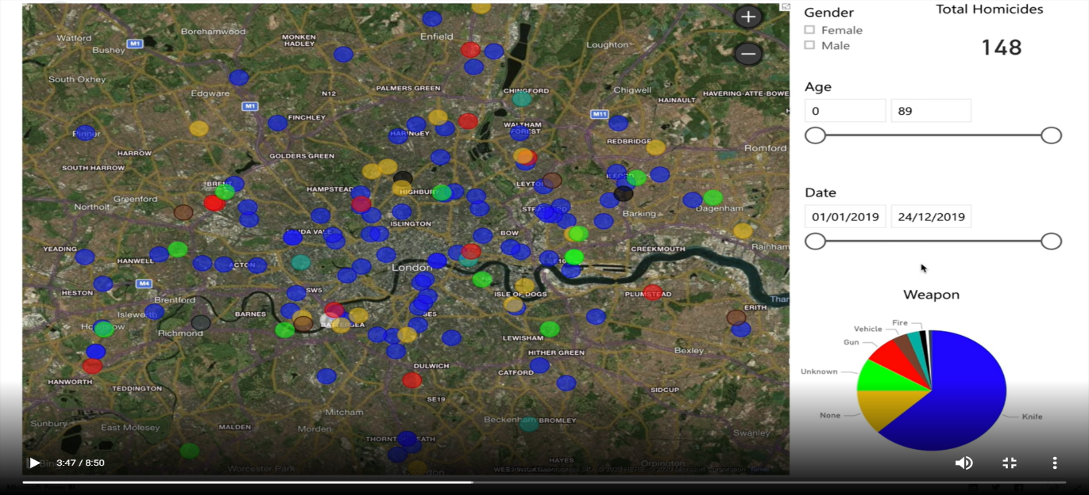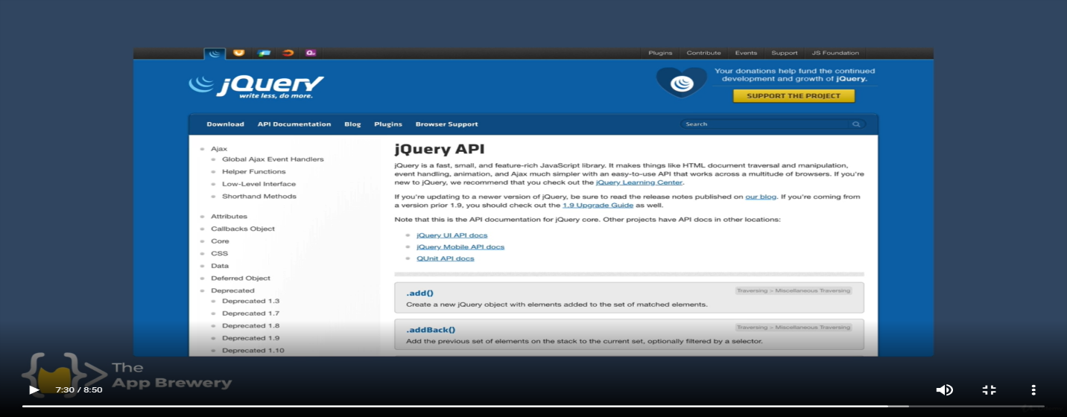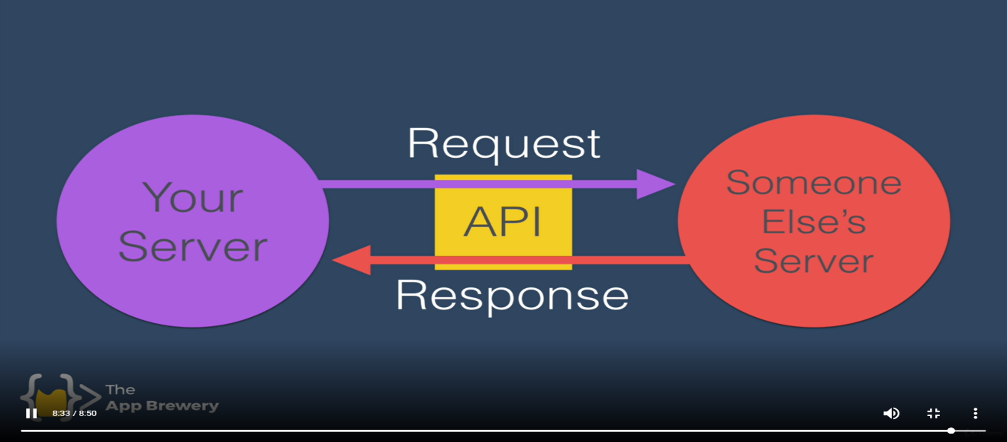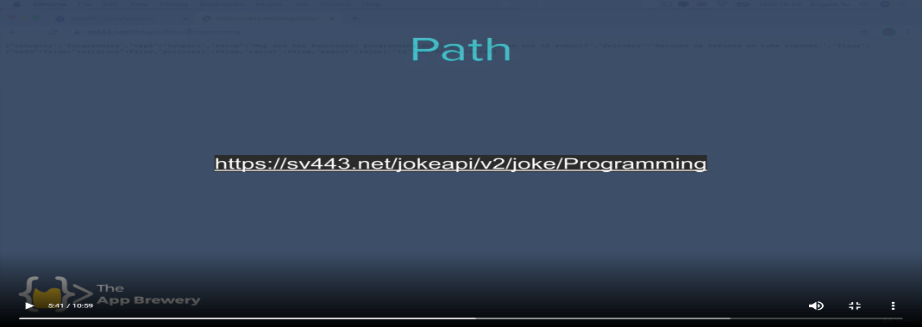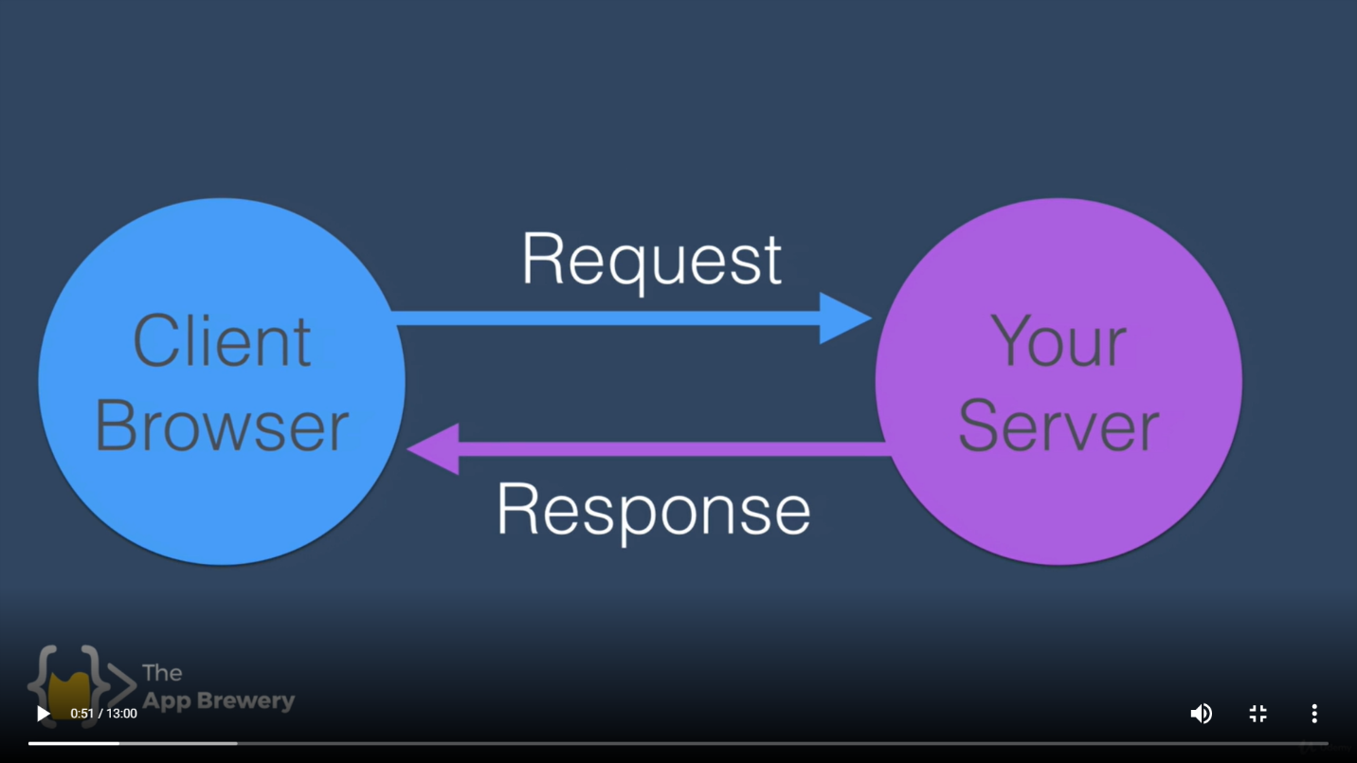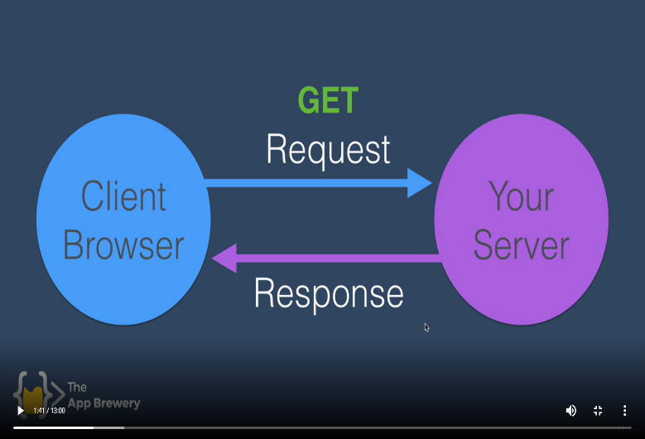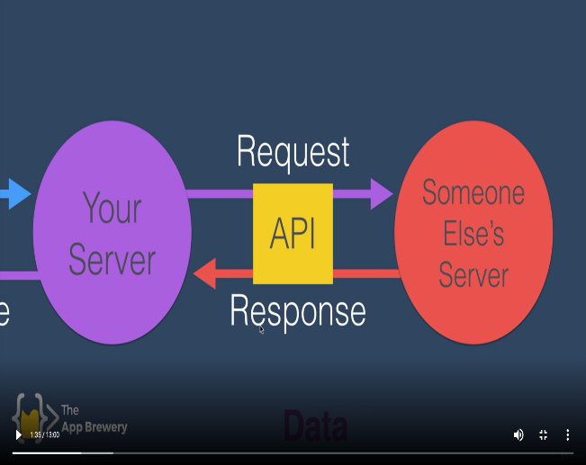

To use api in your website-

const express=require("express");

const app=express();

const https=require("https");

app.get("/",function(req,res)

{

 res.send("Hey!! server started");

 const url="https://api.openweathermap.org/data/2.5/weather?q=Allahabad&appid=dea259ae24c989df7d1a44ab49af6027&units=metric";

 https.get(url,(response)=>

 {

    console.log(response);

 })

})

app.listen("3000",()=>

{

    console.log("Server port 3000 has started");

})

To parse json-

app.get("/",function(req,res)

{

 const url="https://api.openweathermap.org/data/2.5/weather?q=California&appid=dea259ae24c989df7d1a44ab49af6027&units=metric";

 var weatherData,temp,City;

 https.get(url,(response)=>

 {

    response.on("data",(data)=>{

    var weatherData,temp,City,wDiscription,icon;

    weatherData=JSON.parse(data);

    temp=weatherData.main.temp;

    City=weatherData.name;

    wDiscription=weatherData.weather[0].description;

    icon="http://openweathermap.org/img/wn/"+weatherData.weather[0].icon+"@2x.png";

    console.log("Current Temperature in "+City+" is "+temp);

    res.write("<p>The weather Discription is "+wDiscription+"</p>");

    res.write("<h1>Current Temperature in "+City+" is "+temp+" *C </h1>");

    res.write('<img src='+icon+' alt="icon">');

    res.send();

});

 })

})

To get data from api use-

**response.on(“data”,(d)=>{**

d is in hexadecimal form .

to convert it to json form use –

weatherData=JSON.parse(d);

**…………………………})**

To send multiple resonse use res.write() and then res.send().