1. npm i ejs
2. see documentation to use (github).
3. Use app.set() just below defining app.
4. Create view folder and index.ejs file

const app=express();

app.set("view engine","ejs");

5)Create html template in a file say “list.ejs” and add <%=var-name%> in file-

<body>

    <h1>It's a <%=typeOfDay%></h1>

</body>

In app.js use res.render(“ejs-file-name”,{key:value});

const express=require("express");

const bodyParser=require("body-parser");

const app=express();

app.set("view engine","ejs");

app.get("/",(req,res)=>{

    var today = new Date();

    var currentDay=today.getDay();

    var day="";

    if(currentDay==0||currentDay==6)

    day="Weekend baby!!";

    else

    day="Workday :("

    res.render("list",{typeOfDay:day});

})

app.listen("3000",()=>{

    console.log("Server is running on port 3000");

})

To run .ejs file use res.render(…) to again refresh the root use res.redirect(“/”)..

const express=require("express");

const bodyParser=require("body-parser");

const app=express();

var items=[];

app.set("view engine","ejs");

app.use(bodyParser.urlencoded({extended:true}));

app.get("/",(req,res)=>{

    var today = new Date();

    var dateString=today.toLocaleDateString('en-us',{ weekday:"long", day:"numeric",month:"long"});

    res.render("list",{typeOfDay:dateString,newItems:items});

})

app.post("/",(req,res)=>{

    items.push(req.body.item);

    console.log(req.body.item);

    res.redirect("/");

})

app.listen("3000",()=>{

    console.log("Server is running on port 3000");

})

Running code inside ejs template use <%................jscode………of every line………%>

const express=require("express");

const bodyParser=require("body-parser");

const app=express();

app.set("view engine","ejs");

app.get("/",(req,res)=>{

    var today = new Date();

    var currentDay=today.getDay();

    var day="";

    switch (currentDay) {

        case 0:

            day="Sonstag";

            break;

        case 1:

            day="Monstag";

            break;

        case 2:

            day="Deinstag";

            break;

        case 3:

            day="Mittwoch";

            break;

        case 4:

            day="Donnerstag";

            break;

        case 5:

            day="Frietag";

            break;

        case 6:

            day="Samstag";

            break;

        default:

            console.log("Error :Current Day="+currentDay)

            break;

    }

    res.render("list",{typeOfDay:day});

})

app.listen("3000",()=>{

    console.log("Server is running on port 3000");

})

Ejs file-

<!DOCTYPE html>

<html lang="en">

<head>

    <meta charset="UTF-8">

    <meta http-equiv="X-UA-Compatible" content="IE=edge">

    <title>Todo Lost</title>

</head>

<body>

    <%if(typeOfDay==="Samstag"||typeOfDay=="Sonstag"){%>

        <h1 style="color: blueviolet;">It's a <%=typeOfDay%></h1>

    <%}else{%>

        <h1 style="color: red;">It's a <%=typeOfDay%></h1>

    <%}%>

</body>

</html>

**Diff btwn scope of var, const and let-**

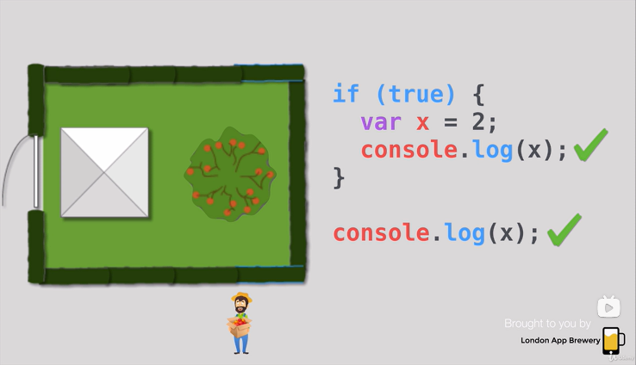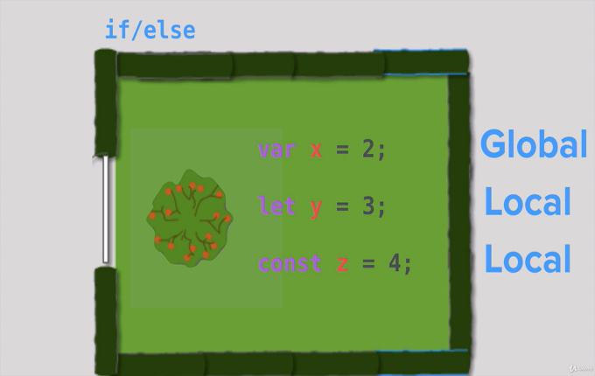

**It’s is recommended to use let instead of var. Use var vey rarely.**

**We can can tell express to serve- the files which are in public folder (eq,css files,etc.)-**

app.use(express.static("public"));