**For responsive design -**

**1)** <div class="row">

<div class="col lg-3 col md-4 col-sm-2">fdgd</div>

<div class="col lg-3 col md-4 col-sm-2">fdgd</div>

</div>

12 ->100%

md-tab,lg-desktop,sm-mobile.

md-3-->al sizes greater than md will have(12/3)4 columns

**2)bootstrap class-**

container->center

container-fluid-> full width

**3)**

**font awesome** is used to add icons

first inlude font awesome in your html and then copy code(<i>is like span</i>)

can change color and size of icon.

**4)bootstrap carousel**

**5)bootsnip**-for various diff elements

**6)bootstrap-cards**

**7)z-index**=1/-1/...(default is 0),but the element should be positioned means it's position should not be static.

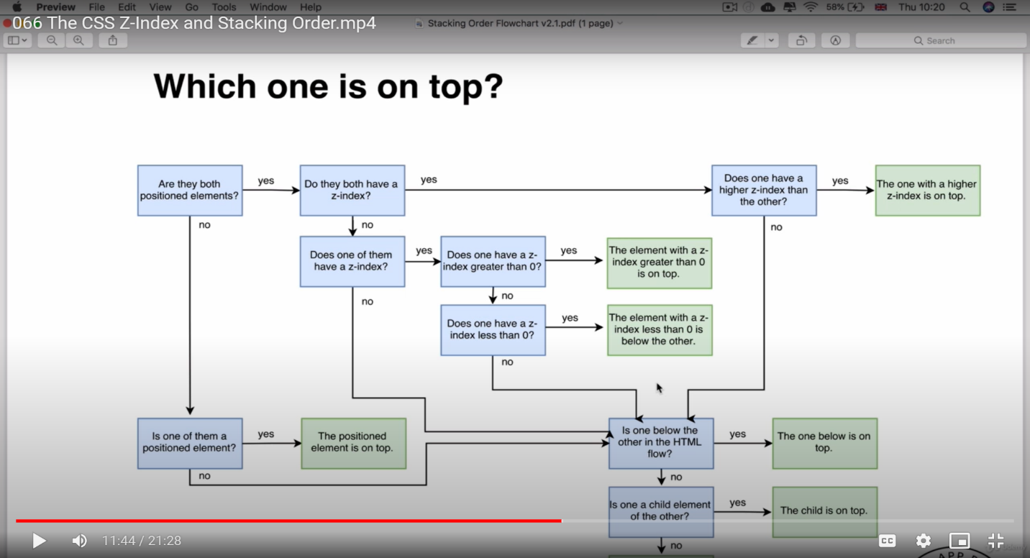

**8)To make fine responsiveness use media query-**

@media print{

On printing}

@media speech{

On reading}

@media (max-width: 1250px)

{ width less than 1250px will follow this}

@media (min-width:value)

{ width more than ‘value’ will follow this}

**9)id>class>element(priority)**

**10)**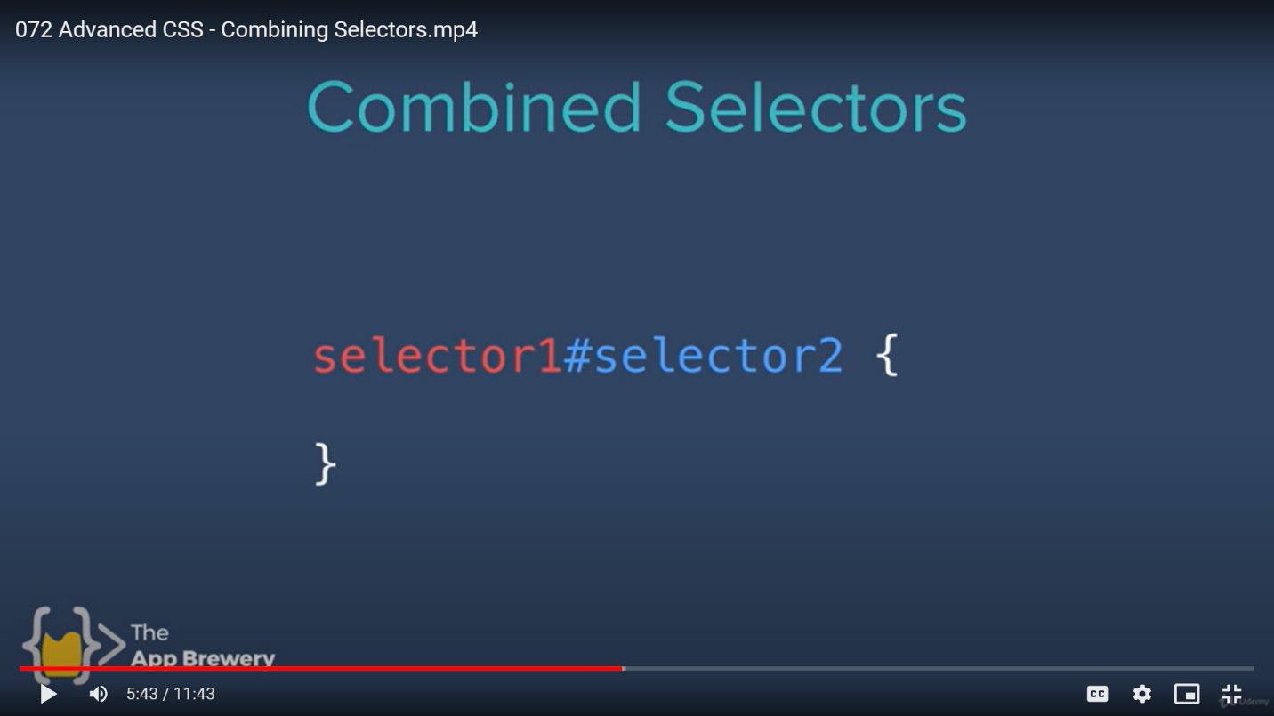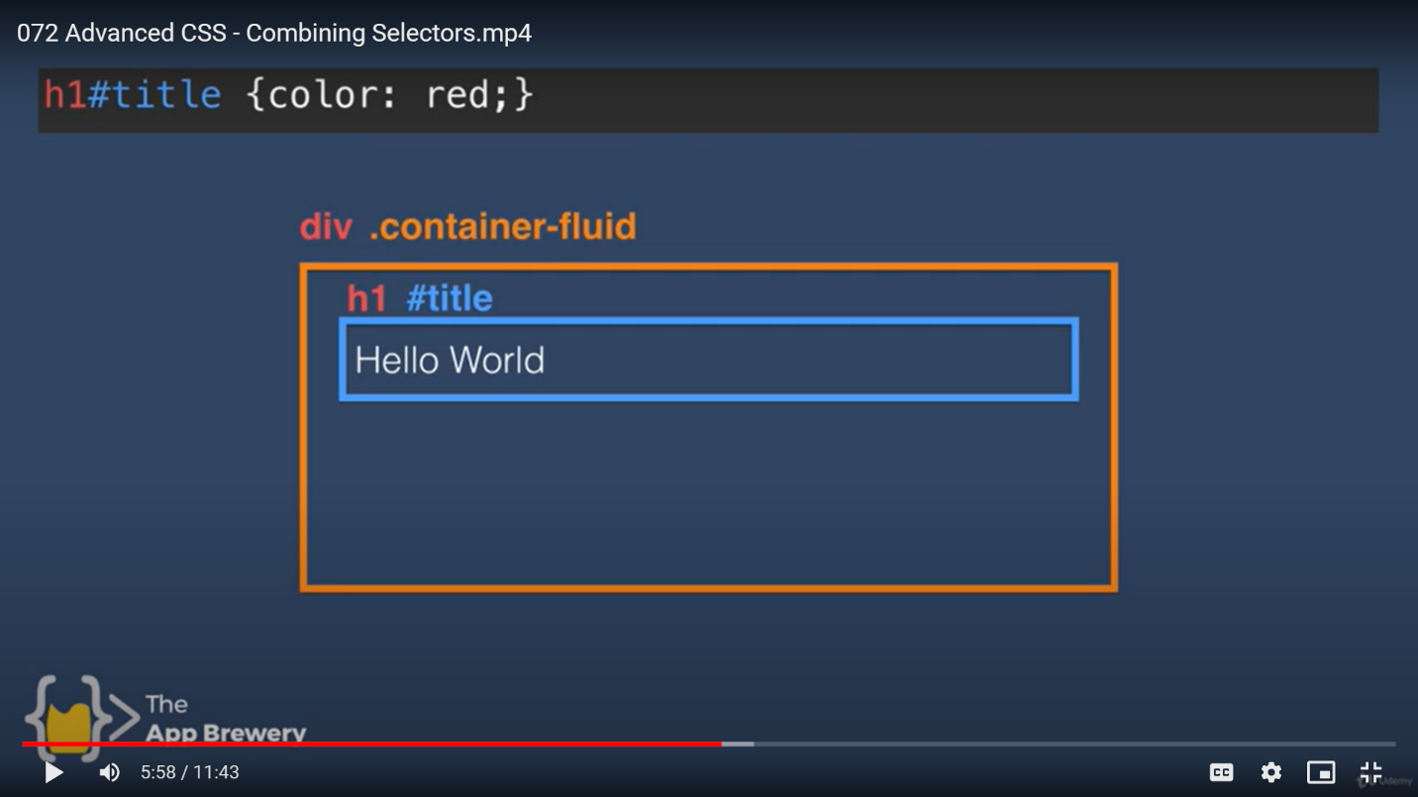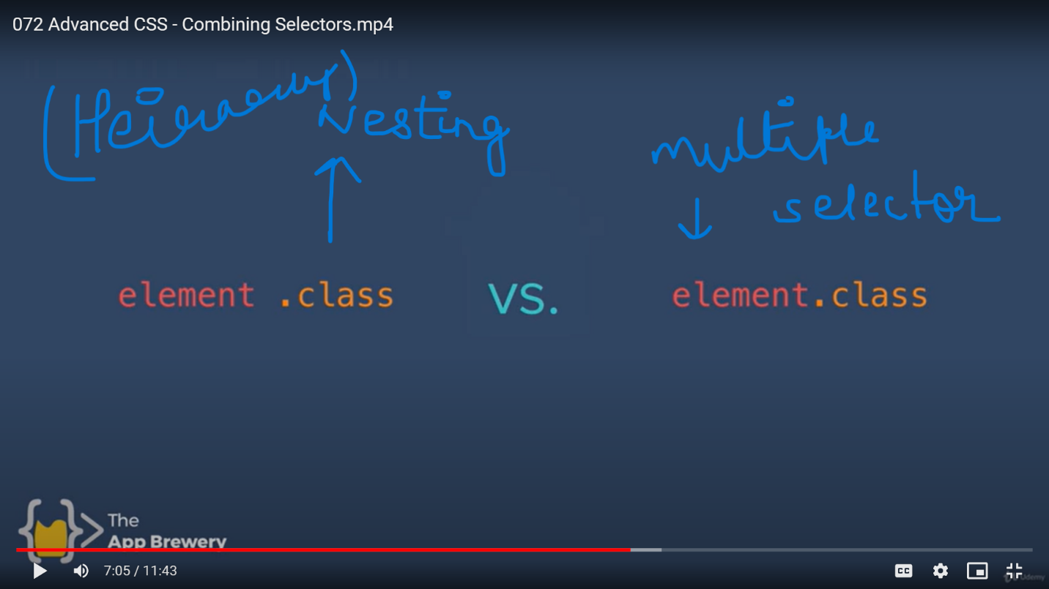

**12)Good practice-**

Use ids rarely ,avoid using multiple class, never use inline css.