November 17, 2021
Smart Solar Inverter
Proposal : a smart solar inverter system that enables AI and Data science for performance optimization

Introduction
With the growing effort to reduce carbon emissions and environmental footprint, we have seen the acceleration of green energy industry and research as well as an increase of demand on clean sustainable energy systems in the market. Wind ad solar are the fastest growing energy sources due to their low cost and high availability compared to the contemporary sources for electricity such as gas, oil and coal. The field is still growing, and it faces many challenges in terms of efficiency, maintenance, storage, mobility, and scalability.
This document is a proposal for a system that is a foothold and potentially a contribution into the energy industry, specifically solar energy.

Goals/expectations

Solar energy system
Solar energy is a renewable energy source, and it can be used to meet the electricity requirements for domestic and industrial applications. The essential component in solar energy system is photovoltaic or solar cell, by which sunlight energy is converted into electric current.
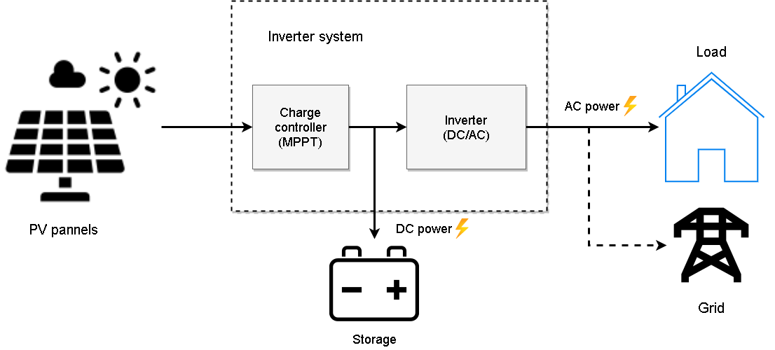
This diagram shows a typical solar system, the PV panels produce a DC current that goes into a charge controller, the function of the charge controller is to regulate the battery (storage) charging and maintain an optimal power transfer by using a Maximum Power Point Tracking (MPPT) algorithm, additional functions might include DC voltage boosting. The inverter transforms the DC signal from the storage into an AC signal and boosts it to the grid voltage. Commercial inverters contain the charge controller and the AC/DC inverter and other additional functions such as monitor and control and other services.

Problems
- Battery lifespan:
A problem that rises often in practice with solar system is the degradation of battery life span due to the unpredictability and poor management of the supply and load.
The cycle life of the battery is the amount of charge/discharge cycles that a battery can perform before losing its performance. The cycle life degradation is non-linear and it depends on the depth of discharge DOD which is the amount of battery’s storage capacity that is utilized.
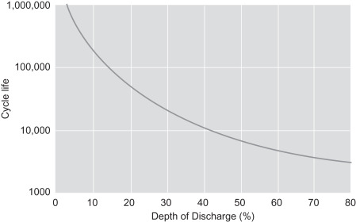
Reasons that increase the DOD in practice include high temperature, insufficient charging that keeps the batteries in partial state of charge (PSOC), bad sizing that results high load what keeps draining the available energy, absence of synchronized charging or awareness for excess energy during light load periods, and many other reasons.

PV cells efficiency:
The efficiency of photovoltaic cells is dependent on the semiconductor that is used, and the highest efficiency that is achieved with commercial multicrystalline silicon cells is around 14-19%, and other materials such as gallium arsenide could reach 30%.
The efficiency is constantly a research topic for institutions leading in semiconductor technology, as it will have a large impact on the cost and sizing of the solar systems.

PV panels orientation:
The most surface is exposed to direct sunlight, the higher energy a PV panel will produce. Usually, the solar system is stationary as it is mounted on fixed objects, unlike the sun rays that is changing direction constantly. To get the optimal amount of energy from a fixed orientation, companies and energy consultants run through extensive simulations which result in suggested panels orientation that gives the most throughout the year.
Some solutions consist of a sunflower or sun tracking approach where the PV panels are motorized in order to follow the sun ray, but an important flow in this approach is the cost and scalability, as individual panels have to rotate in 3 degrees of freedom while not interfering and shading other panels.

Dust:
Since a huge investment in solar systems is targeting desert areas, a problem has risen that is a constant accumulation of dust that causes shading.
Right now, it is manually dealt with by cleaning the panels on daily basis or by installing water hoses that are connected to a control room.

Heating
The peak performance of PV cells is around 25°C of temperature, but in real case scenarios the exposure to sunlight increases this temperature and therefore lowers the efficiency.
Many solutions are being suggested in this regard and they mainly consist of local solution depending on the place where the system is mounted.

Proposal
The inverter is very central in the solar system for the reason that it connects all the parts, and therefore it is an important source of information. Hence, the proposed work will be focused on the DC/AC inverters.
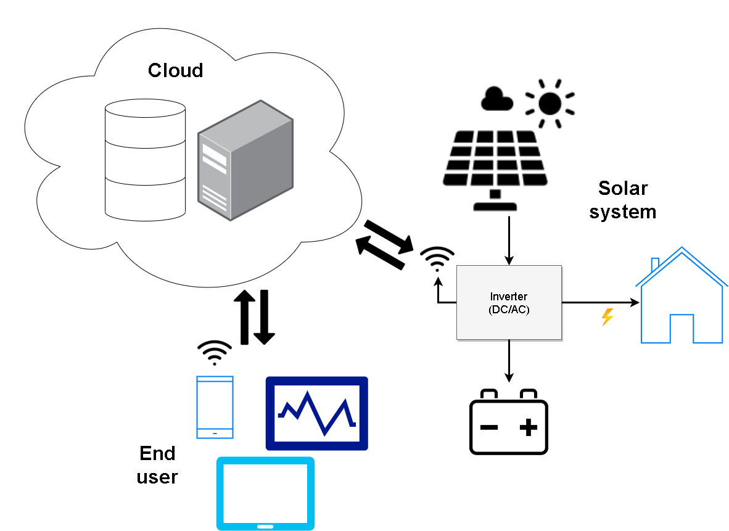
The system consists of a state-of-art inverter (on-grid or off-grid) with integrated measuring points, sensors, and an RF communication module. Variables that will be measured in real time are key to study the performance of the system along with the conditions surrounding it, and they include the connected load, PV panels available power, panels temperature, solar irradiance, battery SOD and DOD, states of the machine.

The collected data will be sent to the cloud server in a secured manner through WIFI, GSM or a suitable communication technology for the installation. The end user will be able to have a control on the system through a mobile application that provides a monitor to check variables of interest, perform tasks and benefit from services.
In the other hand, the collected data will be a backbone that we rely on to improve the operation, identify new opportunities, perform faster and better decisions, and apply machine learning algorithms for forecasting and problem identification. This will also open opportunities for collaboration with data science and research institutions.
In the first stage, the available services for the end user will be monitoring and control until enough data is available to enable artificial intelligence and therefore introducing additional functions. An example could be the prediction of battery lifetime using machine learning, while also giving suggestions for the user etc. Various algorithms are suggested by researches and can be implemented by gathering the right type of data.

The system needs to meet certain important criteria:
- Low cost
- High security
- Long lifetime
- Fast operation
- High efficiency
- Low energy footprint
- Ease of installation/portability
- Scalability
The system needs to meet or get close to these criteria in order to make its way to the market and be a consumer’s choice, especially that different consumers will prioritize and value some criteria compared to the others.

Follow up/Future work
After establishing a solid identity in the first stage, later stages would be scaling up in different directions that could include the following:
- Investing further into inverters and this will include three phase inverter that are needed nowadays especially in relatively low power, or microinverters and such applications.
- PV cells solutions for efficiency, temperature, orientation, cleaning, mobility etc.…
- Investigating in different forms of energy (solar, thermal ...)
- Working on solutions for low power applications.
- Working for smart grid solution.
- Collaboration with other local and international institutes for joint projects.

