

Faculty of Engineering and Technology

Department of Electrical and Computer Engineering

Digital Electronics and Computer Organization Lab

Report 1

Encoders, Decoders, Multiplexers, and Demultiplexers

Prepared by:

Mohammad Rjoub 1220929

Partners:

Zaid Musa 1221833

Abd Al-Rahman Salhab 1220192

Instructor: Dr. Jamal Seyam

Assistant: Eng. Haleema Hmedan

Section: 9

Date: 21/03/2024

# **Abstract**

The aim of this experiment is to explore the fundamental principles and construction techniques of Encoders/Decoders and Multiplexers/Demultiplexers using basic gates and integrated circuits (ICs). Additionally, this hands-on experience will provide insight into the design and optimization of digital circuits.

# **Tables**

## Table of Content

**I.** **Abstract** I

**II.** **Tables** II

A. Table of Content II

B. Table of Figures III

C. List of Tables IV

**III.** **Theory** 5

A. Decoder 5

B. Encoder 5

C. Multiplexers 6

D. Demultiplexer 6

**IV.** **Procedure** 8

A. Encoder Circuit 8

1. 4-to-2 Encoder with Basic Gates 8

2. 9-to-4-Line Encoder with TTL IC 10

B. Decoder Circuits. 12

1. 2-to-4 Line Decoder with Basic Gates 12

2. 4-to-10 Line Decoder with TTL IC 14

C. Multiplexer Circuit. 16

1. 2-to-1-Line Multiplexer with basic Gates 16

2. 8-to-1 Line Multiplexer with IC 17

3. Multiplexer to implement a Logic Function 19

A. Demultiplexer Circuit. 20

1. 1-to-2 Line Demultiplexer with Basic Logic Gates 20

2. 1-to-8 Line Demultiplexer with CMOS IC 21

**V.** **Conclusion** 23

**VI.** **References** 24

## Table of Figures

Figure 1: N to 2N line decoder 5

Figure 2: 2N to N Encoder 5

Figure 3: 2N to N Mux block diagram 6

Figure 4: 2N to N De-Mux block diagram 7

Figure 5:wiring diagram of 4-to-2-line Encoder. 8

Figure 6:wiring connection of 4-to-2-line Encoder 9

Figure 7: 74147 BCD Priority Encoder. 10

Figure 8:wiring connection of 74147 BCD Priority Encoder. 11

Figure 9: 2-to-4 Decoder. 12

Figure 10:wiring connection of 2-to-4 Line Decoder 13

Figure 11: 4-to-10-line Decoder. 14

Figure 12:wiring connection of 4-to-10 Line Decoder 15

Figure 13:2-to-1 Multiplexer 16

Figure 14:wiring connection of 2-to-1 Multiplexer 16

Figure 15: 8-to-1 MUX 17

Figure 16:wiring connection of 8-to-1 Multiplexer 18

Figure 17:Function implementation 19

Figure 18:1-to-2 Line Demultiplexer 20

Figure 19:wiring connection of 1-to-2 Demultiplexer 20

Figure 20:1-to-8 Demultiplexer 21

Figure 21:wiring connection of 1-to-8 Demultiplexer 22

## List of Tables

Table 1:2 to 4 decoder truth table 5

Table 2:4 to 2 encoder truth table 6

Table 3:4 to 2 MUX truth table 6

Table 4: Truth table of 1 to 4 De-Multiplexer 7

Table 5:Data for 4-to-2 Encoder with Basic Gates 10

Table 6:Data for 74147 BCD Priority Encoder. 11

Table 7:Data for 2-to-4 Decoder. 13

Table 8:Data for 4-to-10-line Decoder. 15

Table 9:Data for 2-to-1 Multiplexer. 17

Table 10:Data for 8-to-1 Multiplexer 18

Table 11:Function truth table. 19

Table 12:Data for 1-to-2 Demultiplexer 21

Table 13:Data for 1-to-8-Line Demultiplexer 22

# **Theory**

## Decoder

Decoders are a combinational circuit that changes the N binary information into 2N output lines. At a time, only one input line is activated for simplicity, each output line corresponds to one of the possible min-terms of the (N) input variables‎[1].

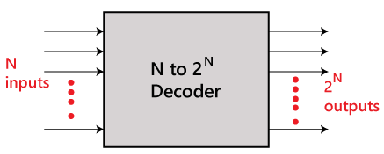‎[2]

|  |  |  |  |  |  |
| --- | --- | --- | --- | --- | --- |
| Inputs | | Outputs | | | |
| I1 | I0 | O3 | O2 | O1 | O0 |
| 0 | 0 | 0 | 0 | 0 | 1 |
| 0 | 1 | 0 | 0 | 1 | 0 |
| 1 | 0 | 0 | 1 | 0 | 0 |
| 1 | 1 | 1 | 0 | 0 | 0 |

Figure 1: N to 2N line decoder

Table 1:2 to 4 decoder truth table

## Encoder

**Encoders** are a combinational circuit that change the binary information in the form of 2N into N output lines. In simple words, the **Encoder** performs the reverse operation of the **Decoder**. At a time, only one input line is activated for simplicity‎[3].

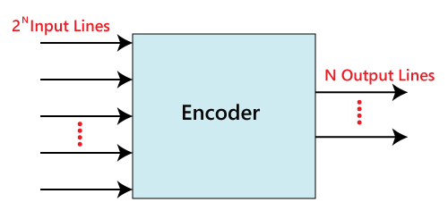‎[4]

Figure 2: 2N to N Encoder

|  |  |  |  |  |  |
| --- | --- | --- | --- | --- | --- |
| Inputs | | | | Outputs | |
| Y3 | Y2 | Y1 | Y0 | A1 | A0 |
| 0 | 0 | 0 | 1 | 0 | 0 |
| 0 | 0 | 1 | 0 | 0 | 1 |
| 0 | 1 | 0 | 0 | 1 | 0 |
| 1 | 0 | 0 | 0 | 1 | 1 |

Table 2:4 to 2 encoder truth table

## Multiplexers

Multiplexer, or Mux, is a combinational circuit that selects one of several input signals and forwards the selected input into a single line. A multiplexer of 2N inputs has N select lines, which are used to select which input line to send to the output‎[5].

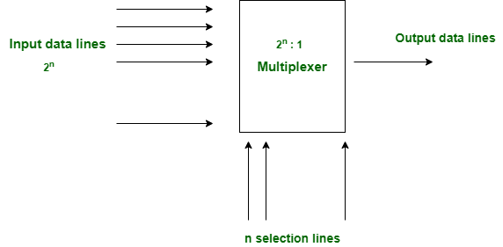‎[6]

Figure 3: 2N to N Mux block diagram

|  |  |  |
| --- | --- | --- |
| S1 | S0 | Output |
| 0 | 0 | I0 |
| 0 | 1 | I1 |
| 1 | 0 | I2 |
| 1 | 1 | I3 |

Table 3:4 to 2 MUX truth table

## Demultiplexer

D**emultiplexer**, or De-Mux is a digital circuit that takes a single input signal and chooses one of 2N output lines based on a set of N control signals (data selectors which are used to select which output line to send to the input signal to it). It essentially serves the opposite purpose from a multiplexer‎[7].

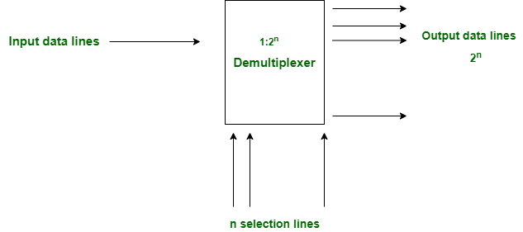‎[8]

Figure 4: 2N to N De-Mux block diagram

|  |  |  |  |  |  |
| --- | --- | --- | --- | --- | --- |
| Selections | | Outputs | | | |
| S1 | S0 | O0 | O1 | O2 | O3 |
| 0 | 0 | I | 0 | 0 | 0 |
| 0 | 1 | 0 | I | 0 | 0 |
| 1 | 0 | 0 | 0 | I | 0 |
| 1 | 1 | 0 | 0 | 0 | I |

Table 4: Truth table of 1 to 4 De-Multiplexer

# **Procedure**

## Encoder Circuit

### 4-to-2 Encoder with Basic Gates

The circuit can be constructed using the Module IT-3004 block Encoder 1 circuit. From the 4-to-2 Encoder circuit, it will have 4 inputs and 2 outputs. The first input A will be connected to A1 and to Switch 0, input B also connected to B1 and to Switch 1, input C connected to C1 and to Switch 2, input D to Switch 3, and the outputs F8 and F9 to Logic Indicator L0 and L1. Also, we Connect +5V of module IT-3004 to the +5V output of fixed power supply section of IT-3000. The figure below shows it clearly.

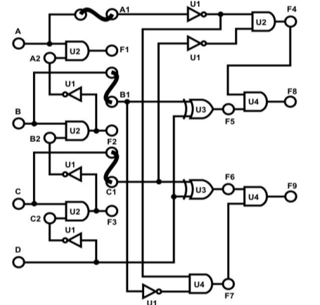

Figure 5:wiring diagram of 4-to-2-line Encoder.

Below we find figure for the circuit connection of 4 to 2 Encoder in the lab.

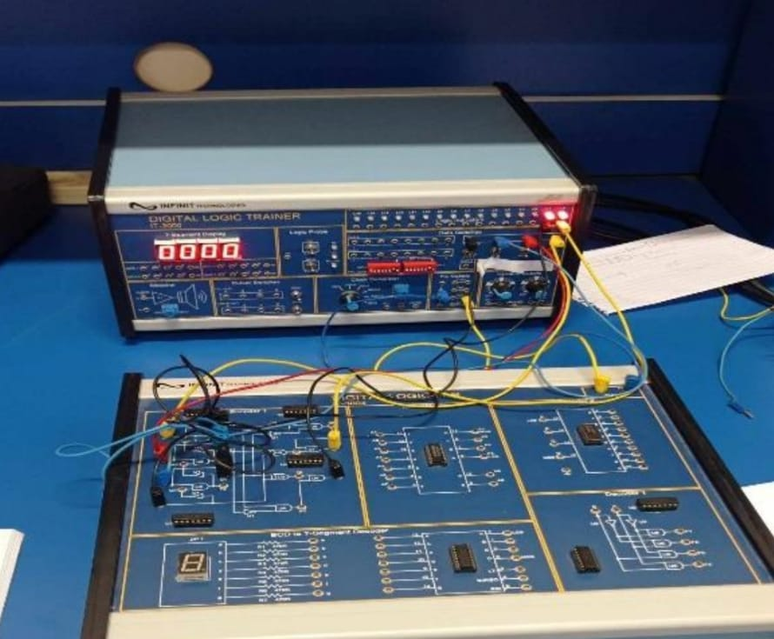

Figure 6:wiring connection of 4-to-2-line Encoder

|  |  |  |  |  |  |
| --- | --- | --- | --- | --- | --- |
| Inputs | | | | Outputs | |
| D | C | B | A | F9 | F8 |
| 0 | 0 | 0 | 0 | 0 | 0 |
| 0 | 0 | 0 | 1 | 0 | 0 |
| 0 | 0 | 1 | 0 | 0 | 1 |
| 0 | 0 | 1 | 1 | 0 | 0 |
| 0 | 1 | 0 | 0 | 1 | 0 |
| 0 | 1 | 0 | 1 | 0 | 0 |
| 0 | 1 | 1 | 0 | 0 | 0 |
| 0 | 1 | 1 | 1 | 0 | 0 |
| 1 | 0 | 0 | 0 | 1 | 1 |
| 1 | 0 | 0 | 1 | 0 | 0 |
| 1 | 0 | 1 | 0 | 0 | 0 |
| 1 | 0 | 1 | 1 | 0 | 0 |
| 1 | 1 | 0 | 0 | 0 | 0 |
| 1 | 1 | 0 | 1 | 0 | 0 |
| 1 | 1 | 1 | 0 | 0 | 0 |
| 1 | 1 | 1 | 1 | 0 | 0 |

Table 5:Data for 4-to-2 Encoder with Basic Gates

After testing the 4 to 2 encoder, and collect this data we verify that for each unique input, the encoder produces the correct binary output, and same as encoder truth table. Otherwise, the output is wrong.

### 9-to-4-Line Encoder with TTL IC

In this part we will use 74147 (U5) block Encoder 2 of module IT-3004. First, we need to connect +5V of the module the +5V output of the fixed power supply, then we will connect the inputs of the IC A1-A8 to the DIP Switches 1.1-1.8 and A9 to 2.1. after that we connect outputs F1-F4 to Logic indicators L1-L4. Finally, we Follow the input sequences given in Table 6 and record output states. Below figure of the IC inputs and outputs.

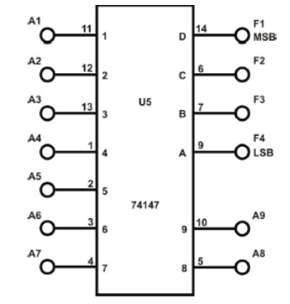

Figure 7: 74147 BCD Priority Encoder.

Here we find figure for the circuit connection in the lab.

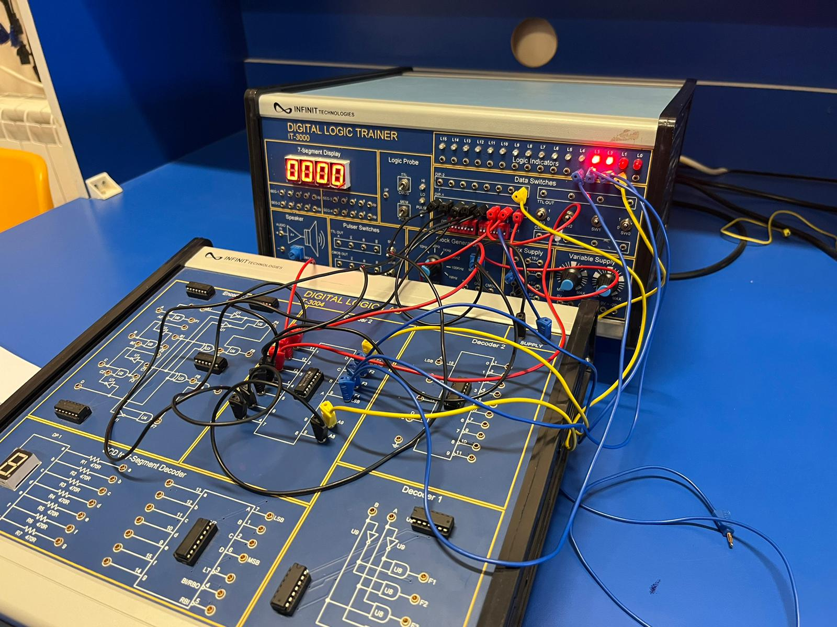

Figure 8:wiring connection of 74147 BCD Priority Encoder.

|  |  |  |  |  |  |  |  |  |  |  |  |  |
| --- | --- | --- | --- | --- | --- | --- | --- | --- | --- | --- | --- | --- |
| Inputs | | | | | | | | | Outputs | | | |
| A9 | A8 | A7 | A6 | A5 | A4 | A3 | A2 | A1 | F4 | F3 | F2 | F1 |
| 0 | 1 | 1 | 1 | 1 | 1 | 1 | 1 | 1 | 0 | 1 | 1 | 0 |
| 0 | 0 | 1 | 1 | 1 | 1 | 1 | 1 | 1 | 0 | 1 | 1 | 0 |
| 1 | 1 | 1 | 1 | 1 | 1 | 1 | 1 | 0 | 0 | 1 | 1 | 1 |
| 1 | 1 | 1 | 1 | 1 | 1 | 1 | 0 | 0 | 1 | 0 | 1 | 1 |
| 1 | 1 | 1 | 1 | 1 | 1 | 0 | 1 | 1 | 0 | 0 | 1 | 1 |
| 1 | 1 | 1 | 1 | 1 | 0 | 0 | 0 | 0 | 1 | 1 | 0 | 1 |
| 1 | 1 | 1 | 1 | 0 | 1 | 1 | 1 | 1 | 0 | 1 | 0 | 1 |
| 1 | 1 | 1 | 1 | 0 | 0 | 0 | 1 | 1 | 0 | 1 | 0 | 1 |
| 1 | 1 | 1 | 0 | 1 | 1 | 1 | 0 | 0 | 1 | 0 | 0 | 1 |
| 1 | 1 | 0 | 1 | 1 | 0 | 1 | 1 | 0 | 0 | 0 | 0 | 1 |
| 1 | 1 | 0 | 0 | 0 | 1 | 1 | 1 | 1 | 0 | 0 | 0 | 1 |
| 1 | 0 | 0 | 0 | 0 | 1 | 1 | 1 | 1 | 1 | 1 | 1 | 0 |

Table 6:Data for 74147 BCD Priority Encoder.

The table lists various combinations of inputs, In the operation of the IC, when multiple inputs are active, it gives priority to the highest numbered active input. And the data we collect equal to the IC truth data, so that’s mean the circuit done correctly.

## Decoder Circuits.

### 2-to-4 Line Decoder with Basic Gates

In this section of the experiment, we will be use Decoder 1 Block of module IT-3004. So first we need to connect +5V of the module to the +5V output of the fixed power supply, and inputs A, B to Data Switches SW0 and SW1, second, we connect outputs F1-F4 to Logic Indicators L0-L3. Finally, we follow the input sequences for A and B that given table 7 and record output states. Below figure of the Decoder diagram inputs and outputs.

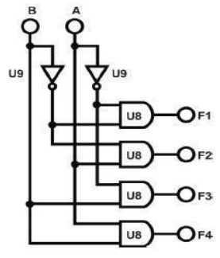

Figure 9: 2-to-4 Decoder.

Here we find figure for the circuit connection in the lab.



Figure 10:wiring connection of 2-to-4 Line Decoder

|  |  |  |  |  |  |
| --- | --- | --- | --- | --- | --- |
| Inputs | | Outputs | | | |
| B | A | F1 | F2 | F3 | F4 |
| 0 | 0 | 1 | 0 | 0 | 0 |
| 0 | 1 | 0 | 1 | 0 | 0 |
| 1 | 0 | 0 | 0 | 1 | 0 |
| 1 | 1 | 0 | 0 | 0 | 1 |

Table 7:Data for 2-to-4 Decoder.

From the collected table the 2 to 4 decoder activates only one output for each input combination, ensuring a distinct output for every possible input pair. And this is what actually the decoder does.

### 4-to-10 Line Decoder with TTL IC

In this part we will use 74147 (U5) on block Decoder 2 of module IT-3004, 7442 is a BCD-to-Decimal decoder IC. First, we need to connect +5V of the module the +5V output of the fixed power supply, Then, connect inputs A, B, C and D to the Data Switches SW0, SW1, SW2 and SW3, respectively. And connect the 10 outputs to corresponding Indicators L0-L9. Finally, we follow the input sequences for A, B, C and D that given table 8 and record output states. Below figure of the Decoder IC inputs and outputs.

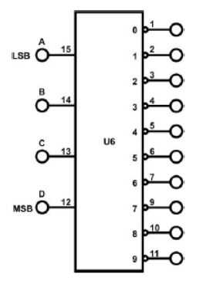

Figure 11: 4-to-10-line Decoder.

Here we find figure for the circuit connection in the lab.

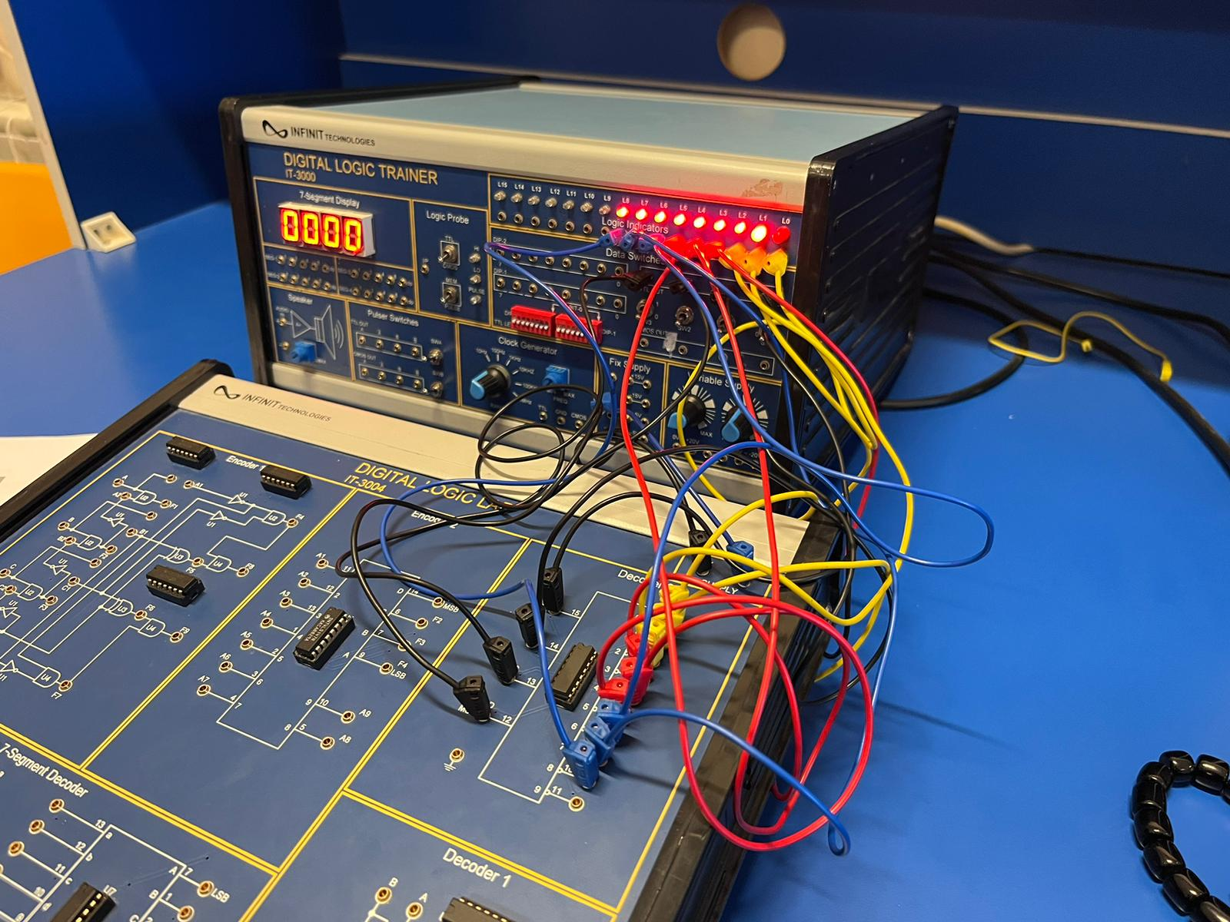

Figure 12:wiring connection of 4-to-10 Line Decoder

|  |  |  |  |  |  |  |  |  |  |  |  |  |  |  |
| --- | --- | --- | --- | --- | --- | --- | --- | --- | --- | --- | --- | --- | --- | --- |
|  | Inputs | | | | Outputs | | | | | | | | | |
|  | D | C | B | A | 0 | 1 | 2 | 3 | 4 | 5 | 6 | 7 | 8 | 9 |
| 0 | 0 | 0 | 0 | 0 | 0 | 1 | 1 | 1 | 1 | 1 | 1 | 1 | 1 | 1 |
| 1 | 0 | 0 | 0 | 1 | 1 | 0 | 1 | 1 | 1 | 1 | 1 | 1 | 1 | 1 |
| 2 | 0 | 0 | 1 | 0 | 1 | 1 | 0 | 1 | 1 | 1 | 1 | 1 | 1 | 1 |
| 3 | 0 | 0 | 1 | 1 | 1 | 1 | 1 | 0 | 1 | 1 | 1 | 1 | 1 | 1 |
| 4 | 0 | 1 | 0 | 0 | 1 | 1 | 1 | 1 | 0 | 1 | 1 | 1 | 1 | 1 |
| 5 | 0 | 1 | 0 | 1 | 1 | 1 | 1 | 1 | 1 | 0 | 1 | 1 | 1 | 1 |
| 6 | 0 | 1 | 1 | 0 | 1 | 1 | 1 | 1 | 1 | 1 | 0 | 1 | 1 | 1 |
| 7 | 0 | 1 | 1 | 1 | 1 | 1 | 1 | 1 | 1 | 1 | 1 | 0 | 1 | 1 |
| 8 | 1 | 0 | 0 | 0 | 1 | 1 | 1 | 1 | 1 | 1 | 1 | 1 | 0 | 1 |
| 9 | 1 | 0 | 0 | 1 | 1 | 1 | 1 | 1 | 1 | 1 | 1 | 1 | 1 | 0 |

Table 8:Data for 4-to-10-line Decoder.

From the collected table, the 4 to 10 decoder activates only one output for each input combination, ensuring a distinct output for every possible input pair. And this is what actually the decoder does.

## Multiplexer Circuit.

### 2-to-1-Line Multiplexer with basic Gates

In this section of the experiment, we will be use Multiplexer 1 Block of module IT-3005 as a 2-to-1 MUX1. So first we need to connect +5V of the module to the +5V output of the fixed power supply, and inputs A, B, Selector C to Data Switches SW0, SW1, and SW2, second, we connect output F3 to Logic Indicators L0. Finally, we follow the input sequences that given table 9 and record output states. Below figure of the Multiplexer diagram inputs and outputs.

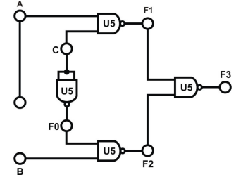

Figure 13:2-to-1 Multiplexer

Here we find figure for the circuit connection in the lab.

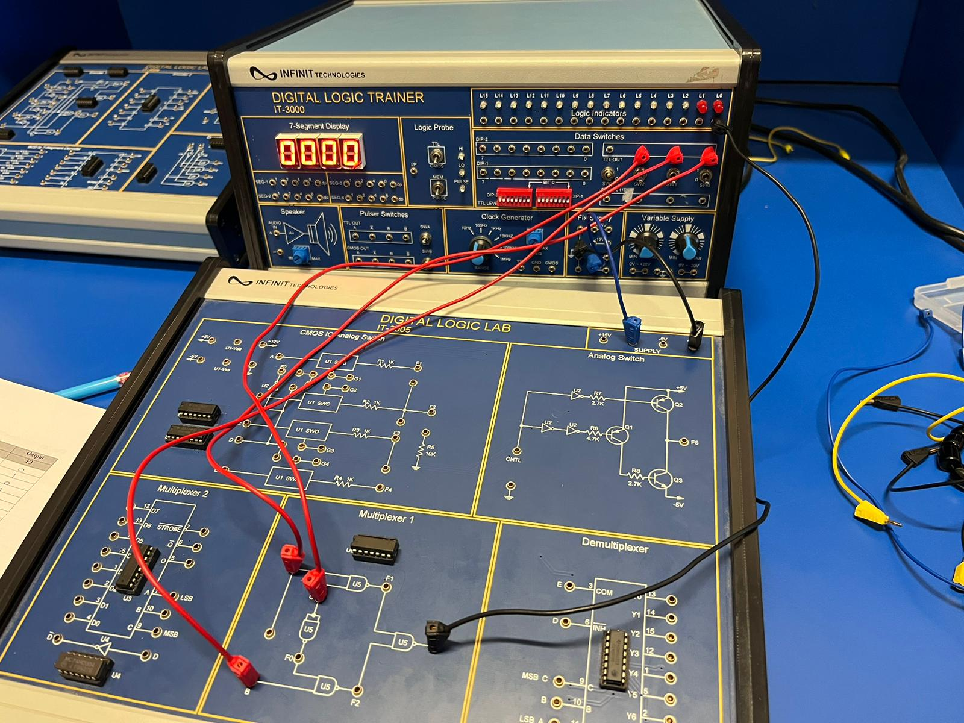

Figure 14:wiring connection of 2-to-1 Multiplexer

|  |  |  |  |
| --- | --- | --- | --- |
| Inputs | | | Outputs |
| C | A | B | F3 |
| 0 | 0 | 0 | 0 |
| 0 | 0 | 1 | 1 |
| 0 | 1 | 0 | 0 |
| 0 | 1 | 1 | 1 |
| 1 | 0 | 0 | 0 |
| 1 | 0 | 1 | 0 |
| 1 | 1 | 0 | 1 |
| 1 | 1 | 1 | 1 |

Table 9:Data for 2-to-1 Multiplexer.

From the collected table, the circuit acts as 2-to-1 Multiplexer.

### 8-to-1 Line Multiplexer with IC

In this part we will use U3 (74LS151) on block Multiplexer 2 of module IT- 3005. First, we need to connect +5V of the module the +5V output of the fixed power supply, Then, connect inputs D0-D7 to DIP Switch 1.0-1.7, and inputs C, B, A to Data Switches SW2, SW1, SW0, STROBE to “0”. And connect the output Q to Indicator L0. Finally, we follow the input sequences for A, B, C that given table 10 and record output states. Below figure of the Multiplexer IC inputs and outputs.

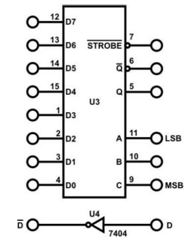

Figure 15: 8-to-1 MUX

Here we find figure for the circuit connection in the lab.

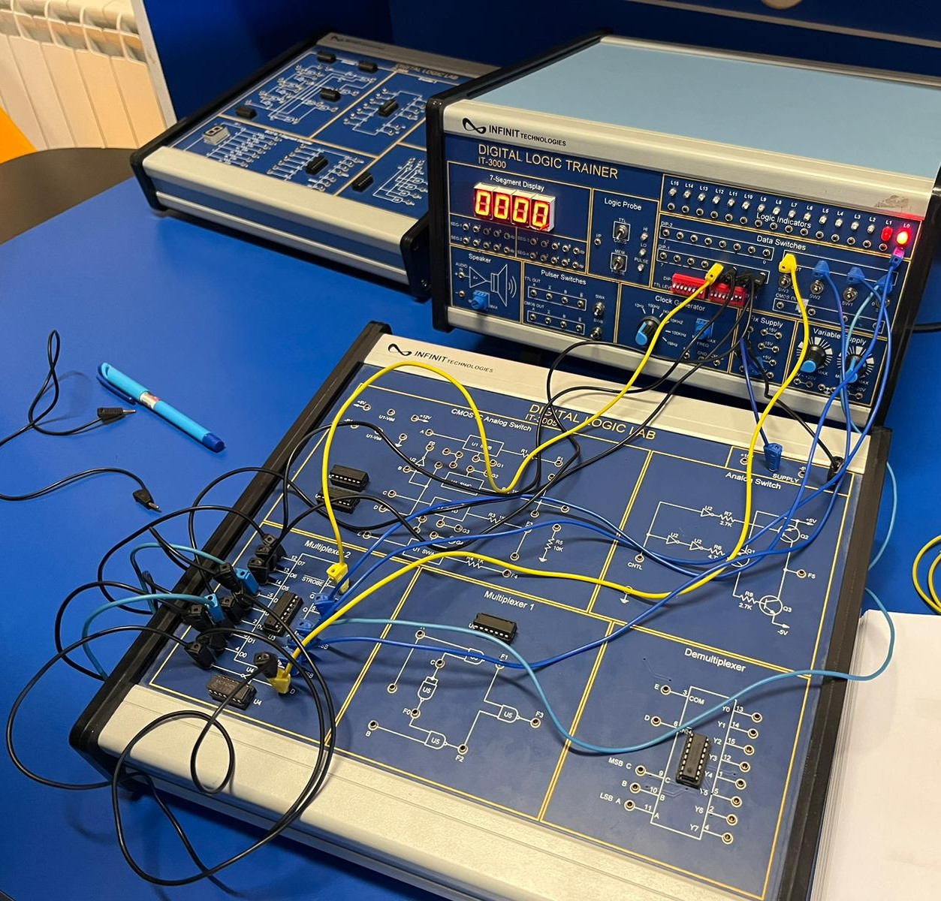

Figure 16:wiring connection of 8-to-1 Multiplexer

|  |  |  |  |
| --- | --- | --- | --- |
| Inputs | | | Outputs |
| C | B | A | Q |
| 0 | 0 | 0 | D0 |
| 0 | 1 | 0 | D2 |
| 0 | 0 | 1 | D1 |
| 0 | 1 | 1 | D3 |
| 1 | 0 | 0 | D4 |
| 1 | 1 | 0 | D6 |
| 1 | 0 | 1 | D5 |
| 1 | 1 | 1 | D7 |

Table 10:Data for 8-to-1 Multiplexer

The table lists various combinations of inputs, In the operation of the Multiplexer IC, And the data we collect equal to the IC truth data, so that’s mean the circuit done correctly.

### Multiplexer to implement a Logic Function

In this part we will use U3 (74LS151) on block Multiplexer 2 of module IT- 3005 to implement the function F (A, B, C, D) =∑ (0,2,4,5,7,8,10,11,15). First, we need to connect +5V of the module the +5V output of the fixed power supply, Then, connect input D, C, B, A to Data Switches SW3, SW2, SW1, SW0, STROBE to “0”, D0, D1, D4 to ~D, D2, D5 to “1”, D3, D7 to D, D6 to “0”, And output Q to L0. This connection come from the truth table of the function shown below.

|  |  |  |  |  |  |
| --- | --- | --- | --- | --- | --- |
| Inputs | | | | Outputs |  |
| A | B | C | D | Y |  |
| 0 | 0 | 0 | 0 | 1 | ~D |
| 0 | 0 | 0 | 1 | 0 |
| 0 | 0 | 1 | 0 | 1 | ~D |
| 0 | 0 | 1 | 1 | 0 |
| 0 | 1 | 0 | 0 | 1 | 1 |
| 0 | 1 | 0 | 1 | 1 |
| 0 | 1 | 1 | 0 | 0 | D |
| 0 | 1 | 1 | 1 | 1 |
| 1 | 0 | 0 | 0 | 1 | ~D |
| 1 | 0 | 0 | 1 | 0 |
| 1 | 0 | 1 | 0 | 1 | 1 |
| 1 | 0 | 1 | 1 | 1 |
| 1 | 1 | 0 | 0 | 0 | 0 |
| 1 | 1 | 0 | 1 | 0 |
| 1 | 1 | 1 | 0 | 0 | D |
| 1 | 1 | 1 | 1 | 1 |

Table 11:Function truth table.

Here we find figure for the circuit connection in the lab.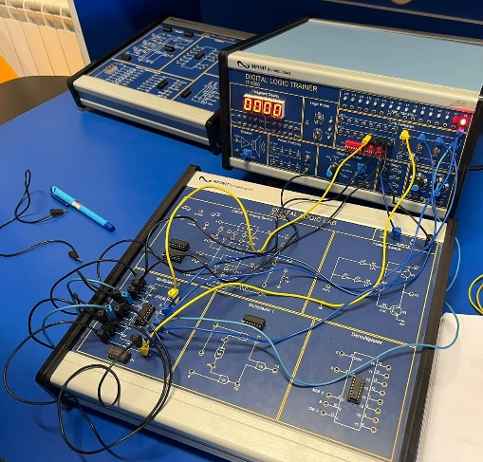

Figure 17:Function implementation

## Demultiplexer Circuit.

### 1-to-2 Line Demultiplexer with Basic Logic Gates

In this section of the experiment, we will be use Multiplexer 1 Block of module IT-3005 as a 2-to-1 MUX1. So first we need to connect +5V of the module to the +5V output of the fixed power supply, and inputs A, C to Data Switches SW0, SW3, and B to A, second, we connect output F1, F2 to Logic Indicators L1, L2. Finally, we follow the input sequences that given table 12 and record output states. Below figure of the Demultiplexer diagram inputs and outputs.

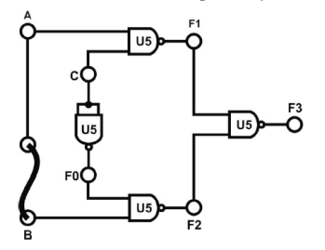

Figure 18:1-to-2 Line Demultiplexer

Here we find figure for the circuit connection in the lab.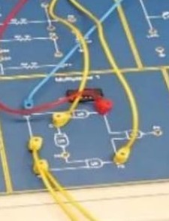

Figure 19:wiring connection of 1-to-2 Demultiplexer

|  |  |  |  |
| --- | --- | --- | --- |
| Inputs | | Outputs | |
| C | A | F1 | F2 |
| 0 | 0 | 0 | 0 |
| 0 | 1 | 1 | 0 |
| 1 | 0 | 0 | 0 |
| 1 | 1 | 0 | 1 |

Table 12:Data for 1-to-2 Demultiplexer

From the collected table, the circuit acts as 1-to-2 Demultiplexer.

### 1-to-8 Line Demultiplexer with CMOS IC

In this part we will use U6 (4051) on block Demultiplexer of module IT- 3005. First, we need to connect +5V of the module the +5V output of the fixed power supply, Then, connect E to DIP1.0; D to DIP1.1; A to SW0; B to SW1; C to SW2; outputs Y0-Y7 to Logic Indicators L0-L7 respectively. Finally, we follow the input sequences for A, B, C that given table 13 and record output states. Below figure of the Multiplexer IC inputs and outputs.

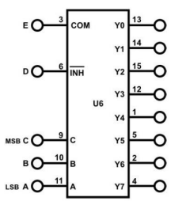

Figure 20:1-to-8 Demultiplexer

Here we find figure for the circuit connection in the lab.

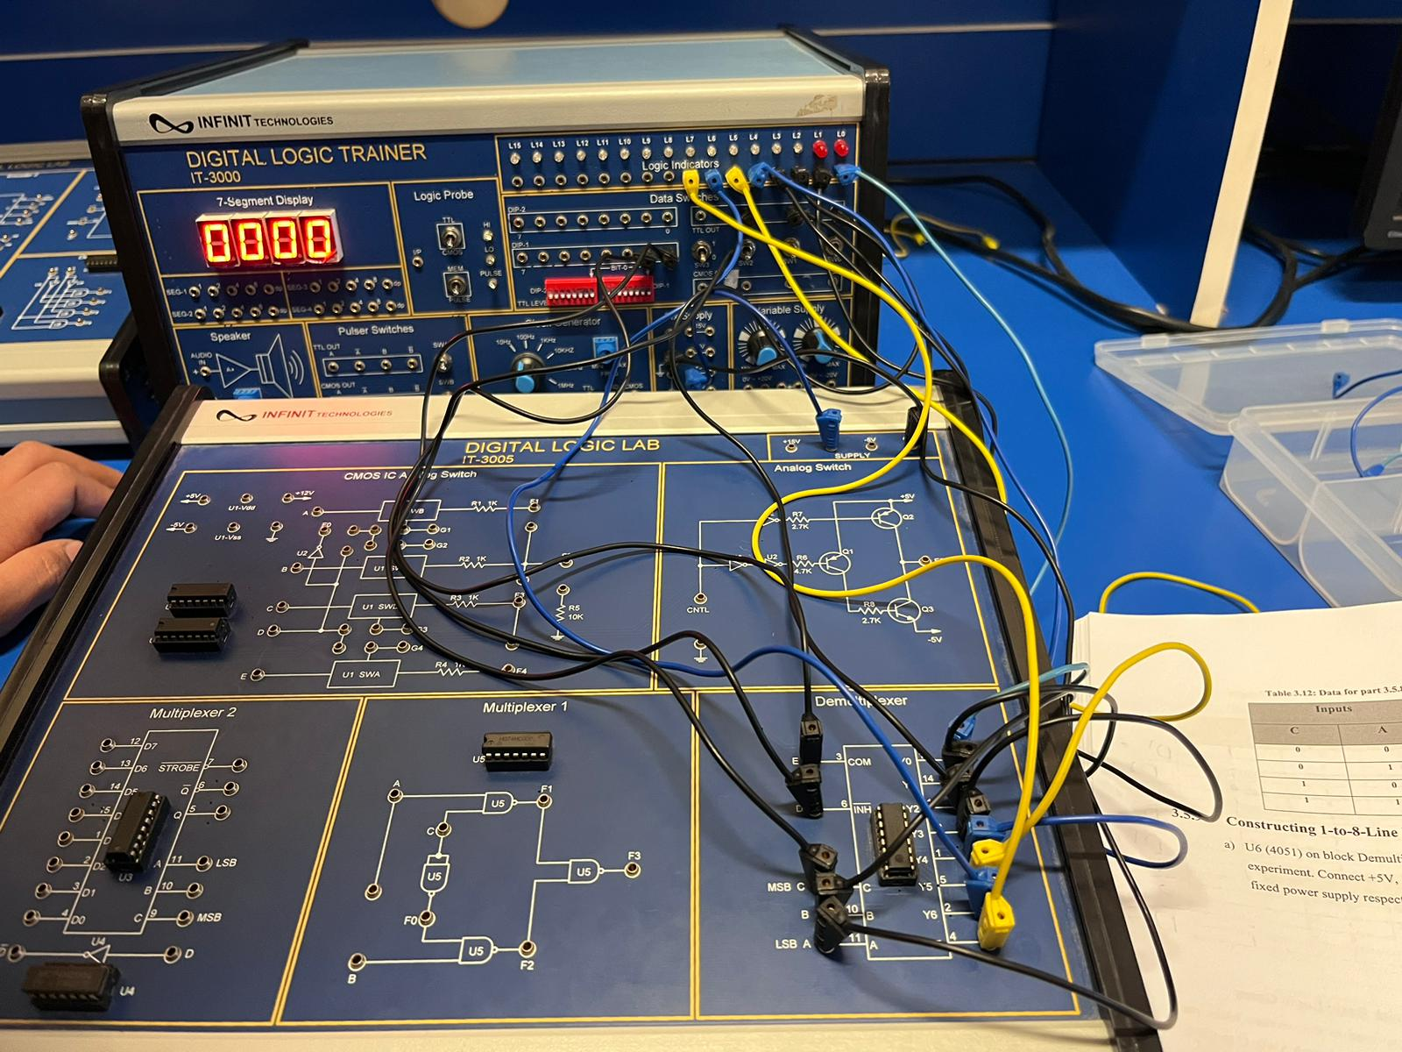

Figure 21:wiring connection of 1-to-8 Demultiplexer

|  |  |  |  |  |  |  |  |  |  |  |
| --- | --- | --- | --- | --- | --- | --- | --- | --- | --- | --- |
| Inputs | | | Outputs | | | | | | | |
| C | A | B | Y0 | Y1 | Y2 | Y3 | Y4 | Y5 | Y6 | Y7 |
| 0 | 0 | 0 | 1 | 0 | 0 | 0 | 0 | 0 | 0 | 0 |
| 0 | 0 | 1 | 0 | 1 | 0 | 0 | 0 | 0 | 0 | 0 |
| 0 | 1 | 0 | 0 | 0 | 1 | 0 | 0 | 0 | 0 | 0 |
| 0 | 1 | 1 | 0 | 0 | 0 | 1 | 0 | 0 | 0 | 0 |
| 1 | 0 | 0 | 0 | 0 | 0 | 0 | 1 | 0 | 0 | 0 |
| 1 | 0 | 1 | 0 | 0 | 0 | 0 | 0 | 1 | 0 | 0 |
| 1 | 1 | 0 | 0 | 0 | 0 | 0 | 0 | 0 | 1 | 0 |
| 1 | 1 | 1 | 0 | 0 | 0 | 0 | 0 | 0 | 0 | 1 |

Table 13:Data for 1-to-8-Line Demultiplexer

The table lists various combinations of inputs, In the operation of the Demultiplexer IC, And the data we collect equal to the IC truth data, so that’s mean the circuit done correctly.

# **Conclusion**

In conclusion the experiment went smoothly with no complications, everything was giving the same answers as the theoretical datasheets. This proved that everything was correct. This experiment was simply to understand how encoders, decoders, multiplexers, and demultiplexers work and how to implement each one. The construction of each design was done through basic gates and IC’s. It was also found that any function can be implemented using multiplexers and other circuits properly.

# **References**

1. :<https://www.tutorialspoint.com/digital_circuits/digital_circuits_decoders.htm>[Accessed 21 March 2024,22:28]
2. : <https://www.javatpoint.com/decoder-digital-electronics> [Accessed 21 March 2024,22:35]
3. : <https://www.javatpoint.com/encoders-digital-electronics> [Accessed 22 March 2024,4:34]
4. : <https://www.javatpoint.com/encoders-digital-electronics> [Accessed 22 March 2024,4:41]
5. : <https://www.javatpoint.com/multiplexer-digital-electronics> [Accessed 22 March 2024,5:25]
6. : <https://www.geeksforgeeks.org/difference-between-multiplexer-and-demultiplexer/> [Accessed 22 March 2024,5:25]
7. : <https://www.prepbytes.com/blog/digital-electronics/what-is-demultiplexer/> [Accessed 22 March 2024,7:03]
8. : <https://www.geeksforgeeks.org/difference-between-multiplexer-and-demultiplexer/> [Accessed 22 March 2024,7:10]