

Faculty of Engineering and Technology

Department of Electrical and Computer Engineering

Digital Electronics and Computer Organization Lab

Report 3

A Simple Security System Using FPGA

Prepared by:

Mohammad Rjoub 1220929

Partners:

Zaid Musa 1221833

Abd Al-Rahman Salhab 1220192

Instructor: Dr. Jamal Seyam

Assistant: Eng. Haleema Hmedan

Section: 9

Date: 18/05/2024

# **Abstract**

The aim of this experiment is to practice building different digital components using Quartus either by building a Verilog codes or Block diagrams, learning how to merge various digital component to build useful systems, become more familiar with FPGA programming, and in this experiment, we will build a simple security system using Altera Quartus software.

# **Tables**

## Table of Content

**I.** **Abstract** I

**II.** **Tables** II

A. Table of Content II

B. Table of Figures III

C. List of Tables IV

**III.** **Theory** 5

A. 4x2 Priority Encoder 5

B. Enable Port 5

C. Segment display driver 6

D. Memory System 6

E. Comparator 7

F. 2-input AND gate 7

**IV.** **Procedure** 8

A. Design a 4 x 2 priority encoder 8

B. 7-segment display driver. 9

C. D- Flip Flop 10

D. 2x1 MUX 11

E. Memory System 13

F. Comparator 14

G. Security System 15

**V.** **Conclusion** 17

**VI.** **References** 18

## Table of Figures

Figure 1:block diagram of 4x2 Priority Encoder 5

Figure 2:7 -segment decoder. 6

Figure 3:Memory System 6

Figure 4:4 x 2 priority Block Diagram 8

Figure 5: 4 x 2 Priority Encoder Verilog Code. 8

Figure 6: simulation for 4 x 2 priority encoder 9

Figure 7:7-segment display driver block diagram 9

Figure 8:7-Segment Display Driver Verilog Code. 9

Figure 9:7-segment display driver. 10

Figure 10:D Flip Flop Block Diagram 10

Figure 11:D Flip Flop Verilog Code. 11

Figure 12:D Flip Flop simulation 11

Figure 13: 2x1 MUX Block Diagram 11

Figure 14:2x1 MUX Verilog Code. 12

Figure 15:2x1 MUX simulation 12

Figure 16: Memory System Block Diagram 13

Figure 17: Comparator Block Diagram 14

Figure 18: Comparator Verilog Code. 14

Figure 19:Comparator simulation. 14

Figure 20:The Security System Final Block Diagram. 15

Figure 21:FPGA board 16

## List of Tables

Table 1: 4x2 Priority Encoder truth table. 5

# **Theory**

## 4x2 Priority Encoder

The priority encoder is a combinational logic circuit that contains 2^n input lines and n output lines and represents the highest priority input among all the input lines. When multiple input lines are active high at the same time, then the input that has the highest priority is considered first to generate the output‎[1].

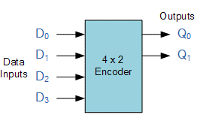‎[2]

Figure 1:block diagram of 4x2 Priority Encoder

|  |  |  |  |  |  |
| --- | --- | --- | --- | --- | --- |
| D3 | D2 | D1 | D0 | Q1 | Q0 |
| 1 | X | X | X | 1 | 1 |
| 0 | 1 | x | X | 1 | 0 |
| 0 | 0 | 1 | X | 0 | 1 |
| 0 | 0 | 0 | X | 0 | 0 |

Table 1: 4x2 Priority Encoder truth table.

## Enable Port

The purpose of this port is to allow the user to select which memory system is active, and hence which 7- segment display to use, for example, if SW4 is high then the En pin of the first memory system is enabled and ready to read the user input on the 4x2 priority encoder ‎[3].

## Segment display driver

A Flip-Flop is a better memory element for synchronous circuits, it solves the problem of latches in synchronous sequential circuits, A latch is sensitive to the level of the clock, but flip-flop is sensitive to the edge of the clock, it called an edge-triggered memory element, because it changes it output value at the edge of the clock‎[4].

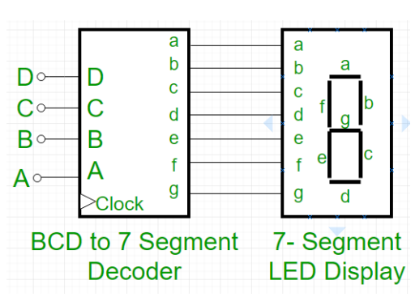‎[3]

Figure 2:7 -segment decoder.

## Memory System

The purpose of such system is to ensure that the value selected by the user to display on a certain 7- segment is kept there when the user switches to select another 7-segment. Each memory system consists of seven D- flip-flops and 2x1 MUXs as shown in Figure 3. When the enable pin equals 0, the output of each DFF becomes its input at every clock cycle. On the other hand, when the Enable pin becomes 1, the data coming from the 7-segment driver is stored in the each DFF. The output of each DFF is sent on a data bus to a 7-segment display‎[3].

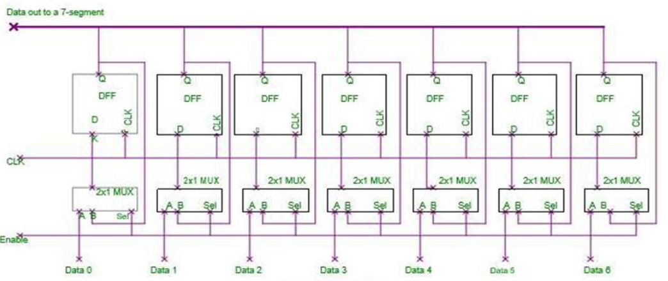‎[3]

Figure 3:Memory System

## Comparator

The input of each 7-segment display is connected also to a comparator. every comparator has a built-in value (reference) which is compared with the value of the 7-segment display. If both values are equal, then the output of the comparator is 1, and it is 0, otherwise. For example, if one of the comparators has a reference value equals 5, then its output will be 1 if and only if the input is equal to=7'b0100100 (which is the value of 5 in the 7-segment display). The purpose of the comparator is to lock/unlock the security system‎[3].

## 2-input AND gate

This AND gate will make sure that the two 7-segment displays have the correct combination. In other words, if each comparator output is “1”, then the AND gate output will be “1”, and the green light is ON. Otherwise, the red light will be always ON‎[3].

# **Procedure**

## Design a 4 x 2 priority encoder

In this part the 4 x 2 priority encoder module has been designed by writing and simulating the Verilog code shown in figure 5.

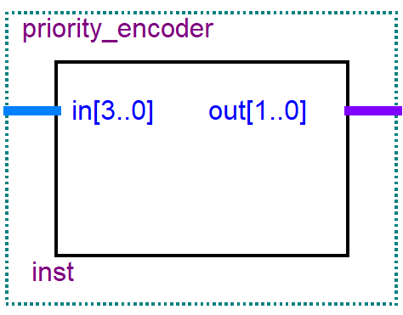

Figure 4:4 x 2 priority Block Diagram

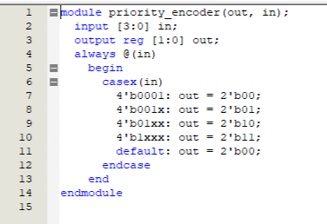

Figure 5: 4 x 2 Priority Encoder Verilog Code.

First defines a 4-bit input 'in', and 2-bit output 'out', then whenever 'in' changes the case block executes as follows If 'in' is 0001, 'out' will be 00, If 'in' is 001x, 'out' will be 01, If 'in' is 01xx, 'out' will be 10, If 'in' is 1xxx, 'out' will be 11, and default case if none previous match.

Below we find figure for the simulation.

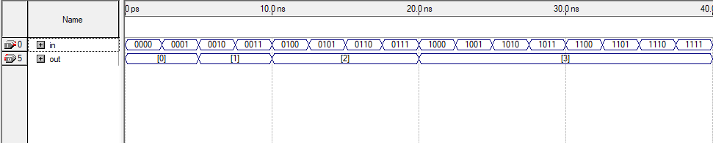

Figure 6: simulation for 4 x 2 priority encoder

After testing the 4 x 2 priority, and collect this simulation data we verify that if multiple input lines are active, the output code will correspond to the input line with the highest priority and same as 4 x 2 priority truth table.

## 7-segment display driver.

In this part the 7-segment display driver module has been designed by writing and simulating the Verilog code shown in figure 8.

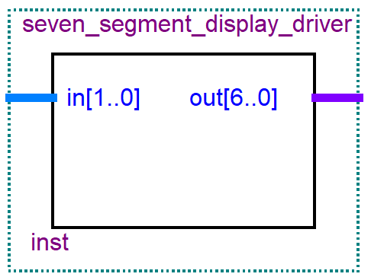

Figure 7:7-segment display driver block diagram

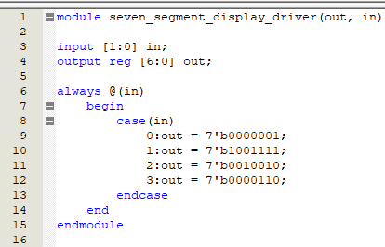

Figure 8:7-Segment Display Driver Verilog Code.

First defines a 2-bit input 'in', and 7-bit output 'out', then whenever 'in' changes the case block executes as follows If 'in' is 0, 'out' will be 0000001, If 'in' is 1, 'out' will be 1001111, If 'in' is 2, 'out' will be 0010010, and if 'in' is 3, 'out' will be 0000110.

Below we find figure for the simulation.

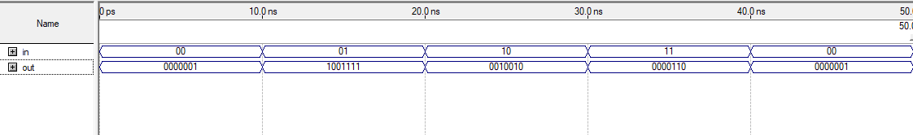

Figure 9:7-segment display driver.

After testing the 7-segment display driver, and collect this simulation data we verify that if any correct input enters, the output code will be the correct code for 7-segment LED display.

## D- Flip Flop

In this part the D- Flip Flop module has been designed by writing and simulating the Verilog code shown in figure 11.

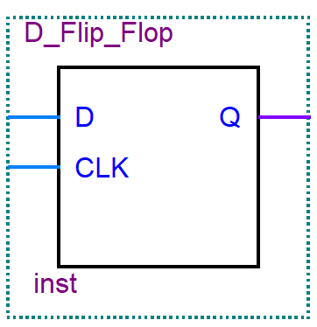

Figure 10:D Flip Flop Block Diagram

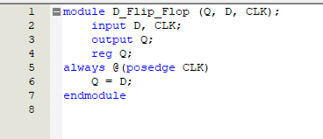

Figure 11:D Flip Flop Verilog Code.

First defines 'D' as data input, 'CLK' as clock input, and 'Q' as the output, then declares 'Q' as a register to hold the state, and when the clock on the rising edge the always block executes to assigns the value of 'D' to 'Q'.

Below we find figure for the simulation.

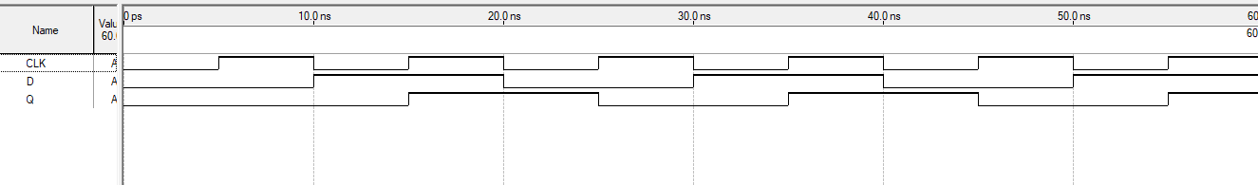

Figure 12:D Flip Flop simulation

After testing the D Flip Flop, and collect this simulation data we verify that the D Flip Flop captures and holds the input value at the moment of a clock signal’s rising edge.

## 2x1 MUX

In this part the 2x1 MUX module has been designed by writing and simulating the Verilog code shown in figure 14.

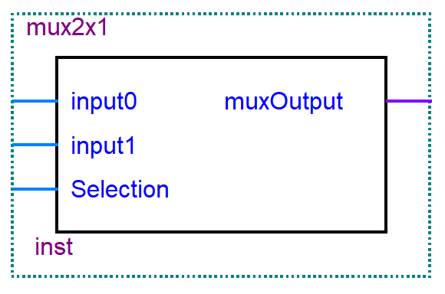

Figure 13: 2x1 MUX Block Diagram

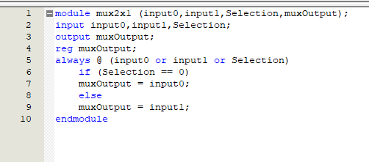

Figure 14:2x1 MUX Verilog Code.

First defines 'input0' and 'input1' as inputs, 'Selection' as the select line, 'muxOutput' as the output, and declares 'muxOutput' as a register to hold the state, then whenever any of the inputs change the always block executes as follows If 'Selection' is 0, 'muxOutput' will be 'input0' else if 'Selection' is not 0, 'muxOutput' will be 'input1'.

Below we find figure for the simulation.

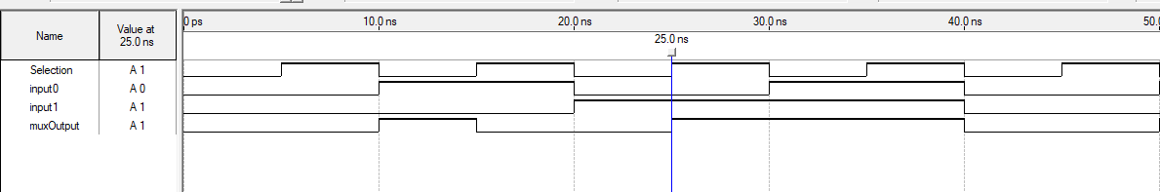

Figure 15:2x1 MUX simulation

After testing the 2x1 MUX, and collect this simulation data we verify that the MUX allows one of two inputs to be passed to the output based on a selection signal.

## Memory System

In this part the Memory System Block has been designed using seven of D- flip-flops and 2x1 MUXs as shown in Figure 12.

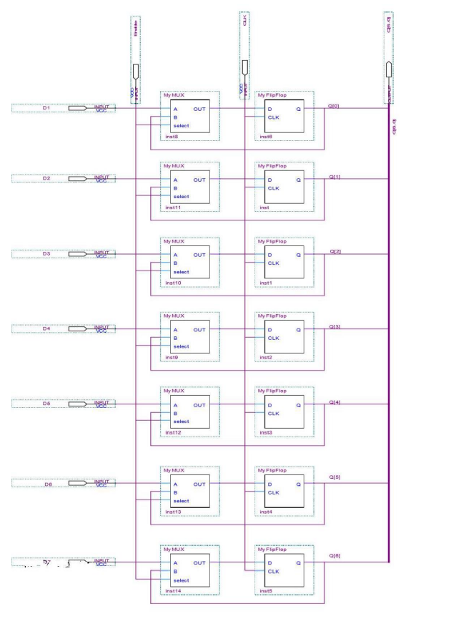

Figure 16: Memory System Block Diagram

## Comparator

In this part the Comparator module has been designed by writing and simulating the Verilog code shown in figure 18.

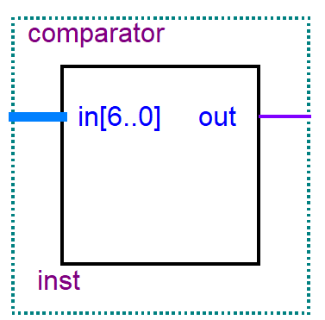

Figure 17: Comparator Block Diagram

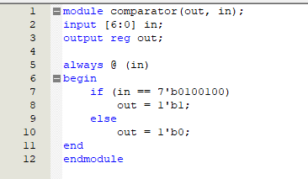

Figure 18: Comparator Verilog Code.

First defines a 7-bit input 'in', and a 1-bit output 'out', then whenever 'in' changes the always block executes as follows Checks if 'in' is equal to the binary number 0100100 If true, sets 'out' to 1, else if false, sets 'out' to 0.

Below we find figure for the simulation.

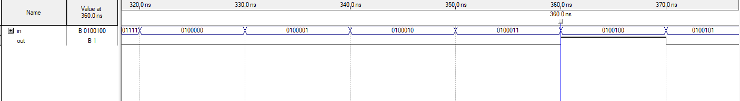

Figure 19:Comparator simulation.

## Security System

In this part the final block of the security system has been designed using the components that built in the previous steps as shown in the figure below. Then Assign pins values to the security system design, and download the system on the FPGA board.

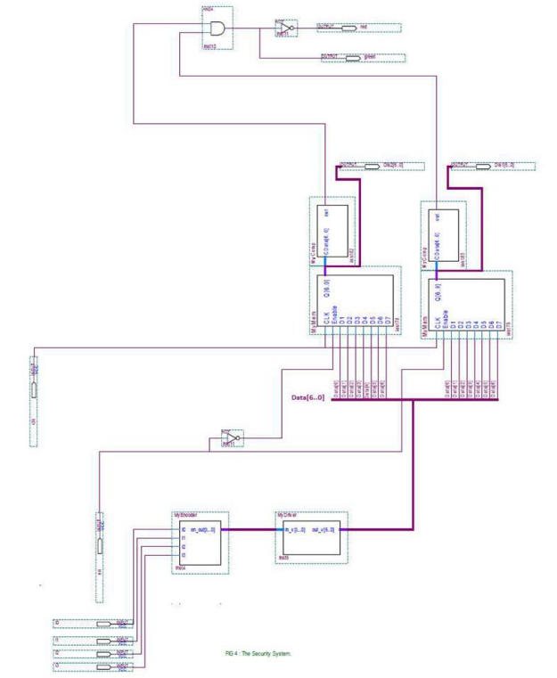

Figure 20:The Security System Final Block Diagram.

Here we can find a picture of the block in the lab.

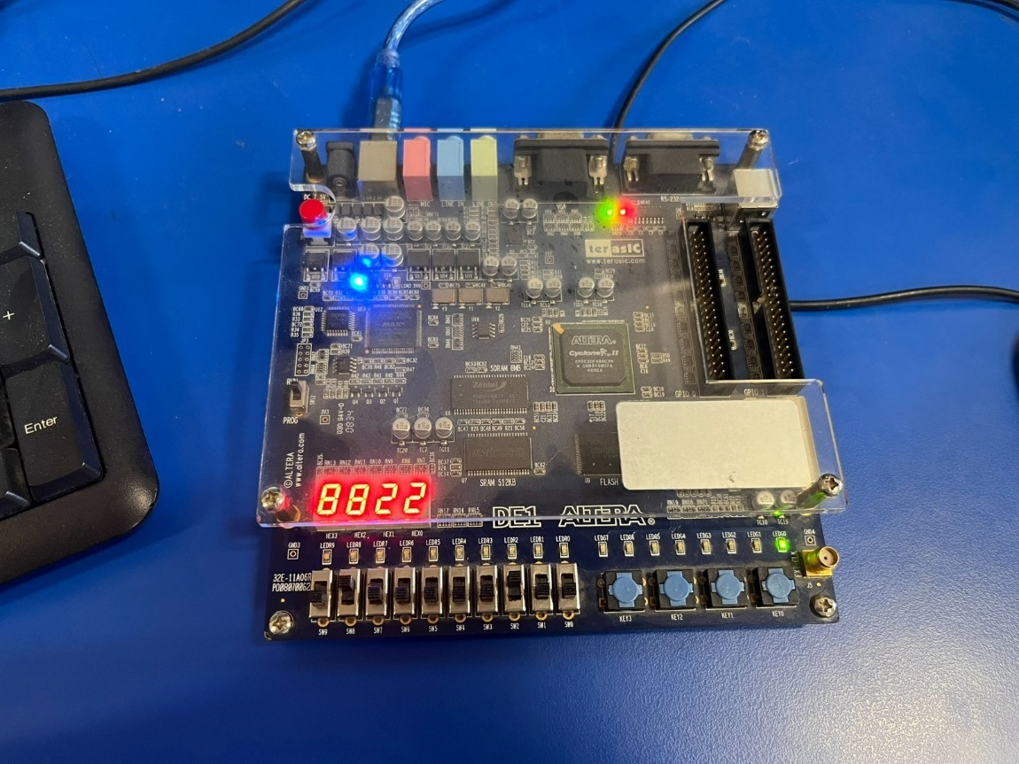

Figure 21:FPGA board

After download the system on the board which can be programmed after manufacturing to perform a wide variety of digital functions, and test it, we verify that if the user enters the correct password the green led turn on otherwise the red led still on, indicates that the security system works fine and correctly.

# **Conclusion**

In conclusion the experiment went smoothly with some complications at first but then it was fine, everything was giving the same answers as the theoretical datasheets. This experiment was simply to understand how comparators, flip flops, Priority Encoders, and 7- segment displays work and how to implement each one. The implementation of each design was done through Quartus either by building a Verilog codes or Block diagrams.

# **References**

1. : <https://www.elprocus.com/priority-encoder/> [Accessed 18 May 2024,17:28]
2. : <https://www.electronics-tutorials.ws/combination/comb_4.html> [Accessed 18 May 2024,17:43]
3. : Manual for Digital Electronics and Computer Organization Lab.
4. : <https://www.electronics-tutorials.ws/blog/7-segment-display-tutorial.html> [Accessed 13 April 2024,1:00]