

Faculty of Engineering and Technology

Department of Electrical and Computer Engineering

ENCS 2110

Digital Electronics and Computer Organization Lab

Experiment No. 1 - Combinational Logic Circuits

Mohammad Rjoub

1220929

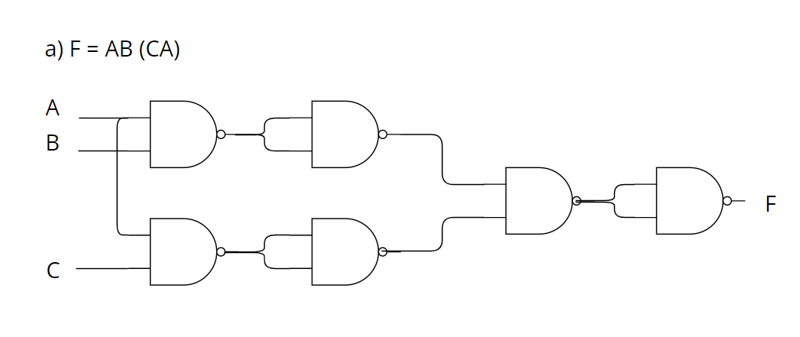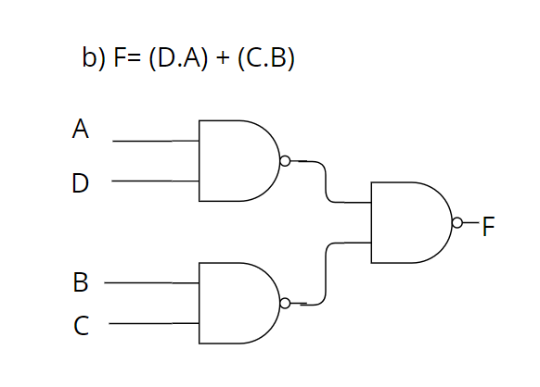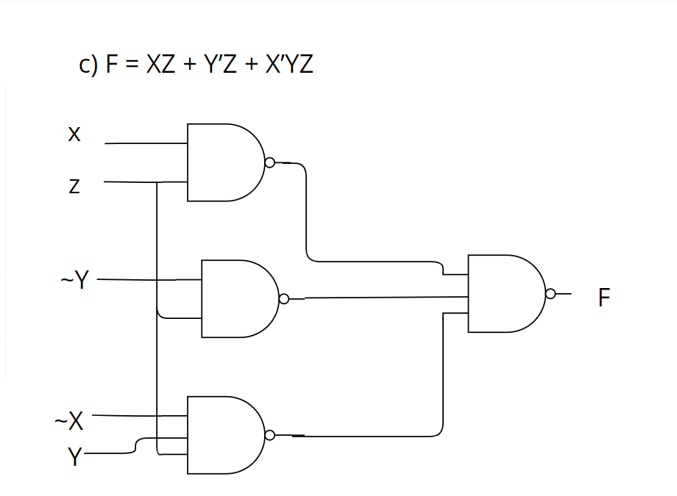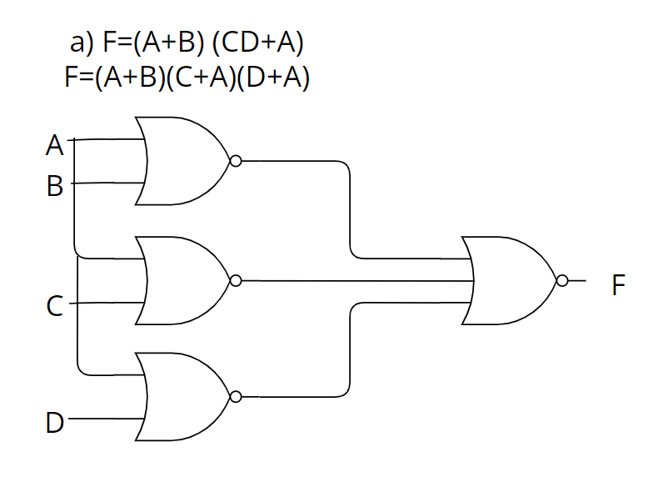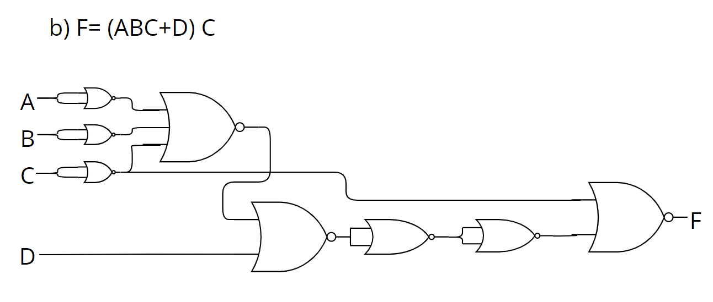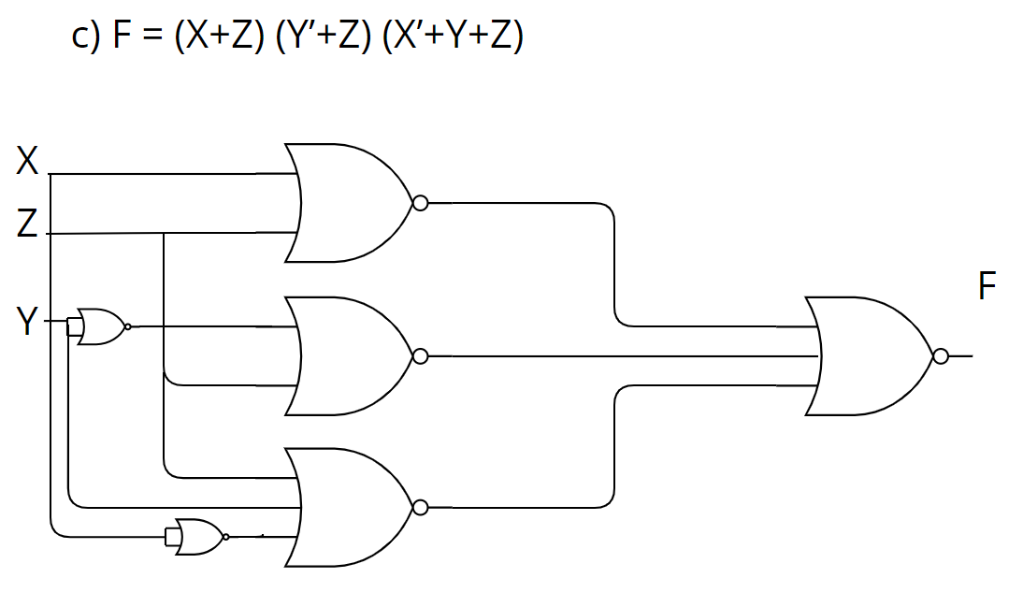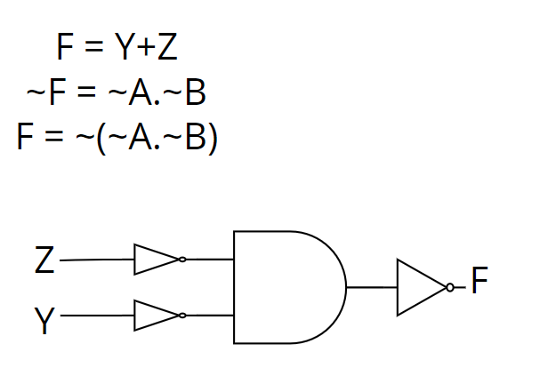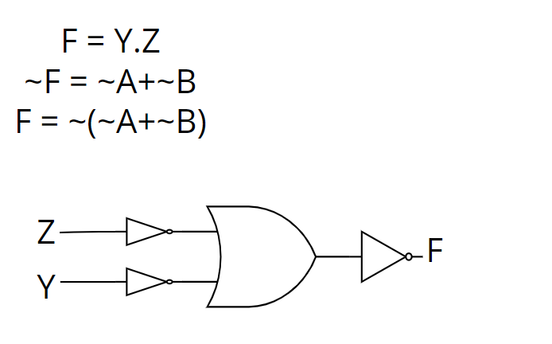

Prove that the equality operation F1 =AB+A’B’ is the inverse of exclusive OR operation F2=AB’+A’B (use Demerger’s theorem).

F1 = AB+A’B’

F1`=(A`+B`)(A+B)

=A`A+A`B+B`A+B`B

=0+A`B+AB`+0

=AB` + A`B = F2

Show how is it possible to reduce Boolean expressions using the Karnaugh map:

1. F1 = A’B’C + ABC’ + A’BC’ + AB’C

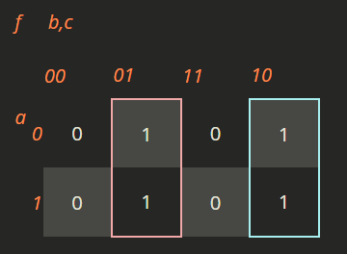

F1 = B'C + BC'

1. F2=A’D+A’C+BD+AB’D’

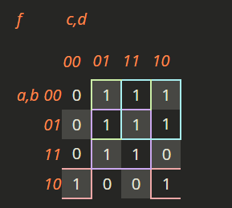

F2 = = A'D + A'C + AB'D' + BD

1. F3= A'BCD + ABCD' + A'BCD' + ABCD'

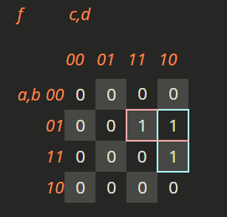

F = A'BC + BCD'

1. F4= A'B'C'D' + AB'CD' + A'B'CD' + A'BC'D'

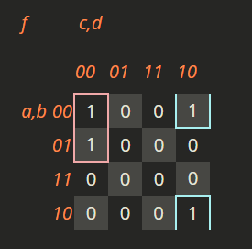

F = A'C'D' + B'CD'