

Faculty of Engineering and Technology

Department of Electrical and Computer Engineering

ENCS 2110

Digital Electronics and Computer Organization Lab

Experiment No. 2 - Comparators, Adders, and Subtractors

Mohammad Rjoub

1220929

1.Design 8-bit BCD adder.

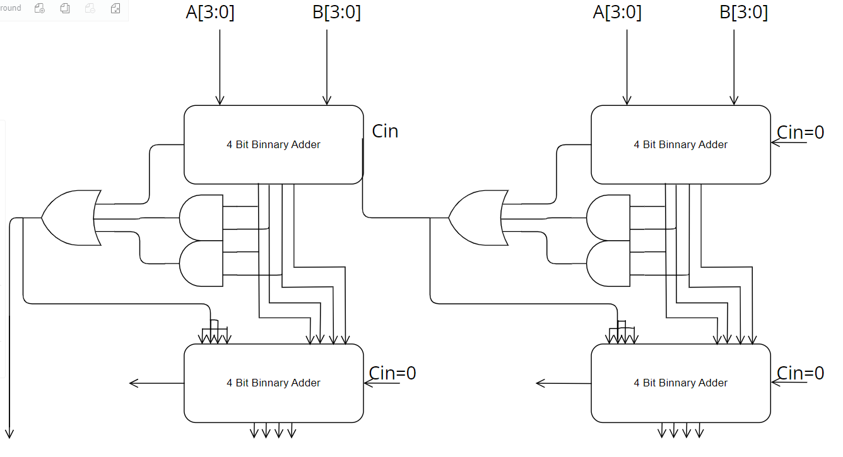

2.Design 8-bit comparator using 2 of 4-bit comparator.

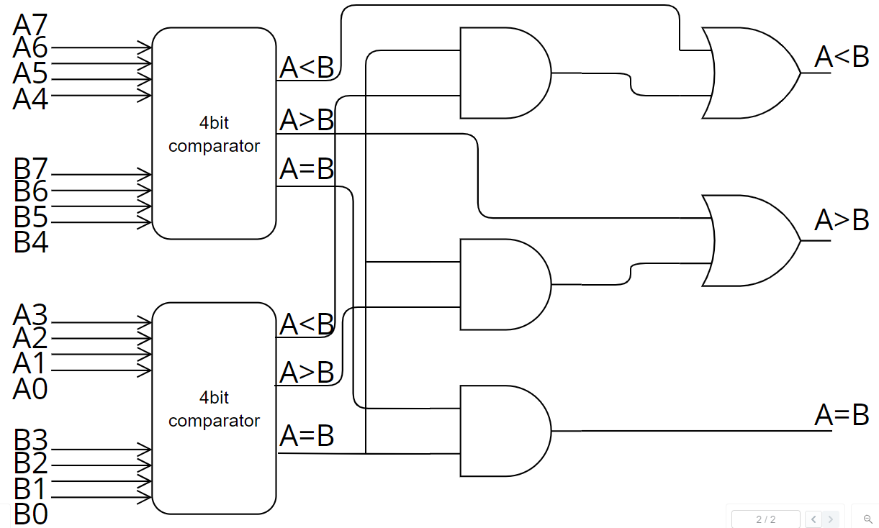

3.A 4-inputs, 3-outputs circuit that compares 2-bit unsigned numbers and outputs a ‘1’ on one of three output lines according to whether the first number is greater than, equal to, or less than the other number. You can only use two 4×1 multiplexer.

