

Faculty of Engineering and Technology

Department of Electrical and Computer Engineering

ENCS 2110

Digital Electronics and Computer Organization Lab

Experiment No. 2 Pre Lab

Mohammad Rjoub

1220929

Build half adder using basic gates.

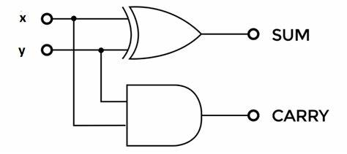

Build the above circuit using universal gates

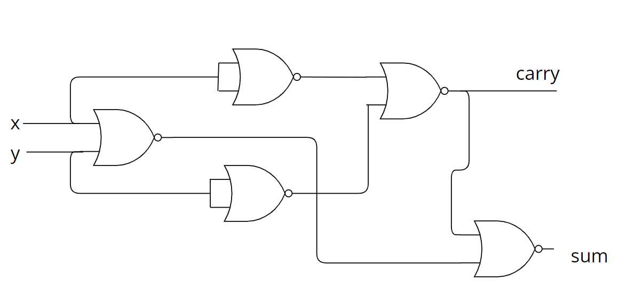Build a full adder using basic gates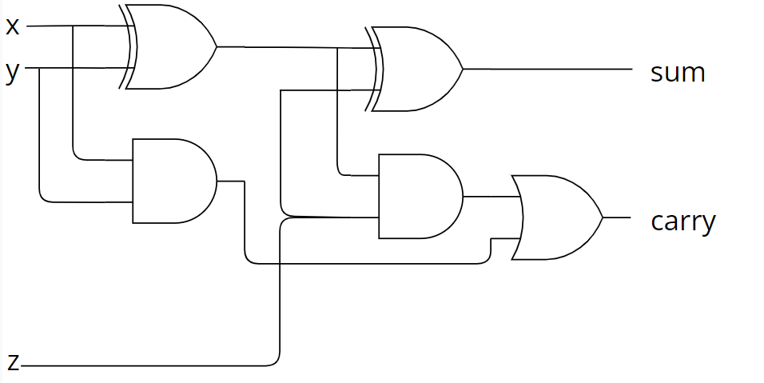

Build a full adder using half adder and another gate

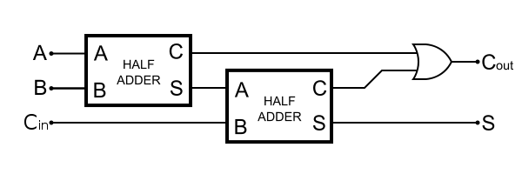

Build a 4-bit adder using a full adder.

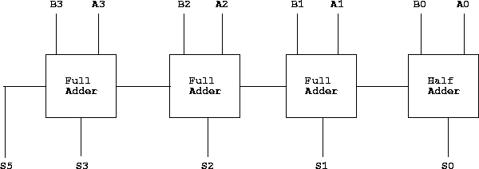

Build a 4-bit subtractor using basic gates

