

Faculty of Engineering and Technology

Department of Electrical and Computer Engineering

ENCS 2110

Digital Electronics and Computer Organization Lab

Experiment No. 3 Post Lab

Mohammad Rjoub

1220929

1. Implement 8x1 Multiplexer using lower order Multiplexers Show how to solve it. 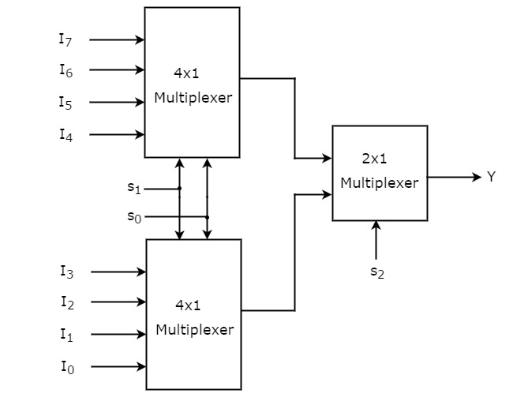
2. Design a Majority Circuit; a circuit that takes 4 inputs A, B, C, D and 1 output Y. Its output equals 1 when 3 or 4 of the inputs are 1. You can only use two 4×1 multiplexers.

