

Faculty of Engineering and Technology

Department of Electrical and Computer Engineering

ENCS 2110

Digital Electronics and Computer Organization Lab

Experiment No. 3 Pre Lab

Mohammad Rjoub

1220929

3.3 Pre Lab

1) Design a circuit which uses an SN74151 to implement a sum-of-products expression, as follows:

a) Convert the following expression into summation form (i.e., F (A, B, C) =∑ (…)):

𝑌 = 𝑓(𝐴,𝐵, 𝐶) = 𝐴~𝐵 + ~𝐵𝐶

Y = ∑(1,5,6,7)

b) Sketch on Figure 3.1 the input connections necessary to implement the function in part (a). Observe that the inputs are connected to 0 or 1 depending on the value of the function for that min term.

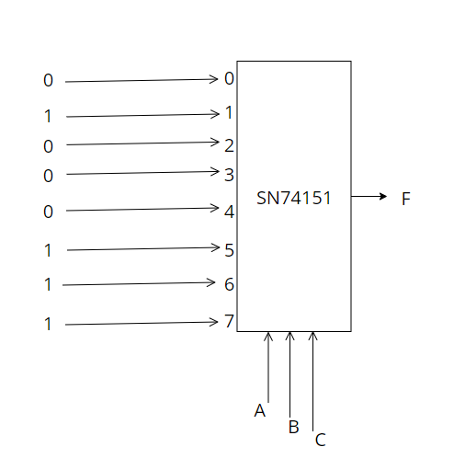

2) Design a circuit which uses an SN74138 Demultiplexer to implement a sum- of-products expression, as follows: a) Convert the following expression into summation (Sum of Products –SOP-) form (i.e. F(A,B,C)=∑(…)):

𝑌 = 𝑓(𝐴,𝐵, 𝐶) = ~𝐴𝐵𝐶 + 𝐵~C

Y = ∑(2,3,6)

