

Faculty of Engineering and Technology

Department of Electrical and Computer Engineering

ENCS 2110

Digital Electronics and Computer Organization Lab

Experiment No. 4 Post Lab

Mohammad Rjoub

1220929

3. Use the just constructed 4x1 multiplexer to design a three inputs network that gives 1 if the majority of its inputs are 1 and outputs a zero otherwise (Design Only using chips in Figure 1).

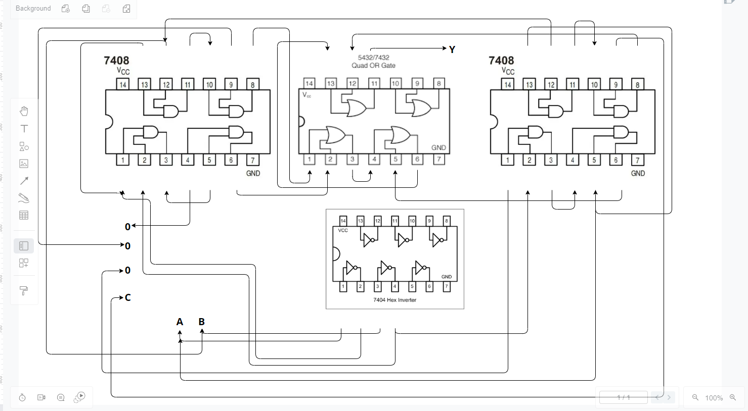

4. Implement f(x, y, z) = m(0, 1, 4, 6, 7), using 4x1 MUX using chips in Figure 1.

