

Faculty of Engineering and Technology

Department of Electrical and Computer Engineering

ENCS 2110

Digital Electronics and Computer Organization Lab

Experiment No. 4 Pre Lab

Mohammad Rjoub

1220929

3)Design and implement the following circuit using the gates on the chips as shown in Figure (Your final circuit must include the IC’s, their pin numbers, and the connections between the pins.)

a) Build Full Adder using basic gates.

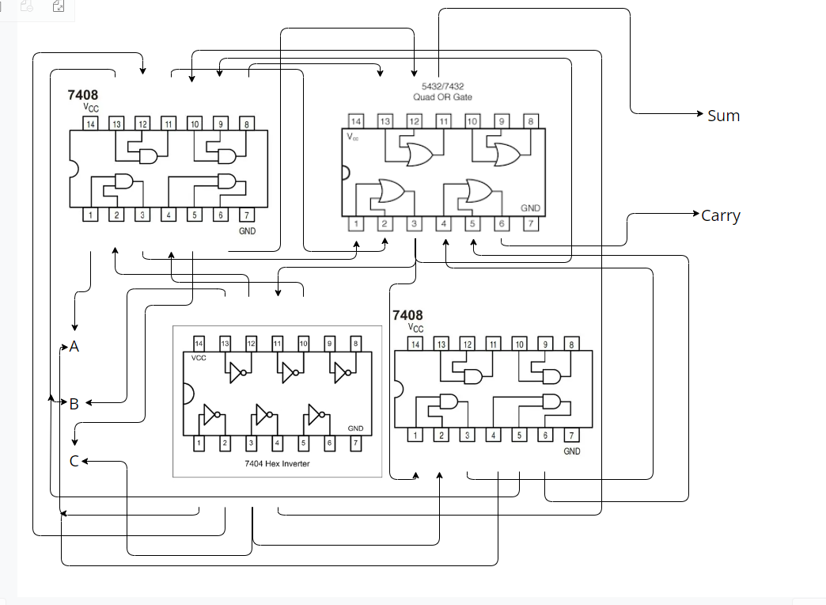

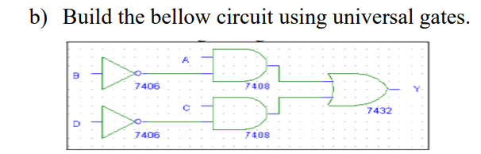

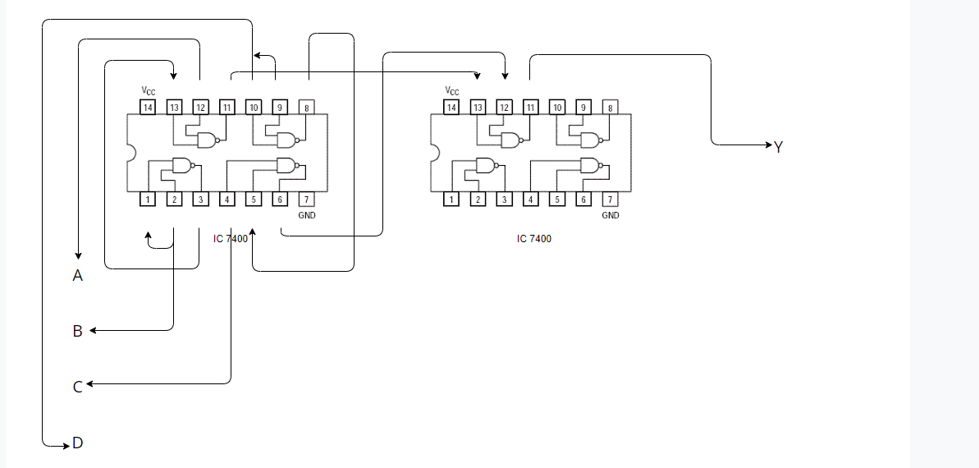

e) Use the just constructed 4x1 multiplexer to design a three inputs network that gives 1 if the majority of its inputs are 1 and outputs a zero otherwise.

