

Faculty of Engineering and Technology

Department of Electrical and Computer Engineering

ENCS 2110

Digital Electronics and Computer Organization Lab

Experiment No. 5

Pre Lab

Mohammad Rjoub

1220929

Design the Logic Diagram, function table of the SR latch using NOR gates, and explain how it works.

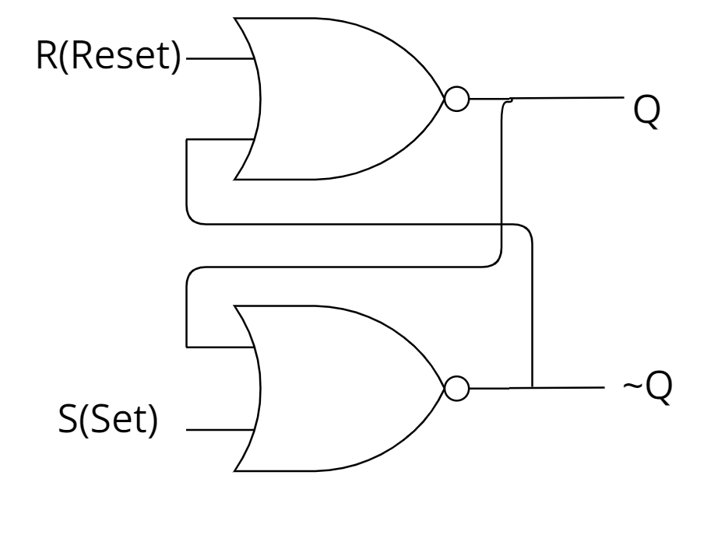

|  |  |  |  |  |
| --- | --- | --- | --- | --- |
| **S** | **R** | **Q** | **~Q** | **State** |
| 1 | 0 | 1 | 0 | Set State |
| 0 | 0 | 1 | 0 |
| 0 | 1 | 0 | 1 | Reset State |
| 0 | 0 | 0 | 1 |
| 1 | 1 | 0 | 0 | Undefined |

SR latch with NOR gate Truth table.

# how it works?

❖ Two inputs: 𝑆 (Set) and 𝑅 (Reset)

❖ Two outputs: 𝑄 and ~𝑄

If 𝑆 = 1 and 𝑅 = 0 then Set (𝑄 = 1, ~𝑄 = 0)

If 𝑆 = 0 and 𝑅 = 1 then Reset (𝑄 = 0, ~𝑄 = 1)

When 𝑆 = 𝑅 = 0, 𝑄 and ~𝑄 are unchanged

When 𝑆 = 𝑅 = 1, 𝑄 and ~𝑄 are undefined (should never be used)