

Faculty of Engineering and Technology

Department of Electrical and Computer Engineering

ENCS 2110

Digital Electronics and Computer Organization Lab

Experiment No. 7 Post Lab

Mohammad Rjoub

1220929

1. Design a 4x16 RAM using four 4x4 RAMS.

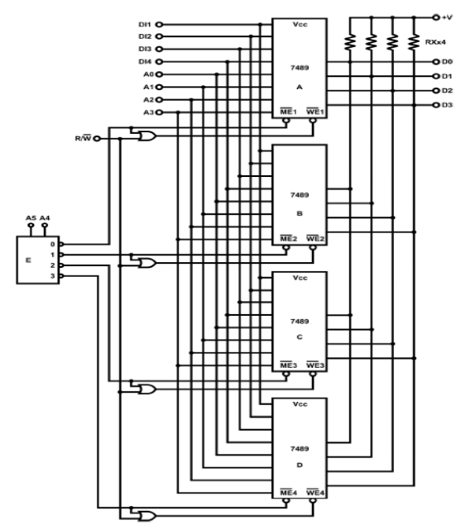

1. Although D latches are useful for storing binary information, they are not used in RAM circuit design, why?

D latches are not clocked which means they are level triggered, they have high instability, a lot of power consumption, time delays, and could even cause it to lose information. Also, they don't allow the quick access time that's required to the RAM, and integrating these circuits using Flip-flops is easier and more practical.