

Faculty of Engineering and Technology

Department of Electrical and Computer Engineering

ENCS 2110

Digital Electronics and Computer Organization Lab

Experiment No. 5

Pre Lab

Mohammad Rjoub

1220929

Task 1: The circuit subtract two 4-bit number and determine its Overflow, Negative, Zero Flags.

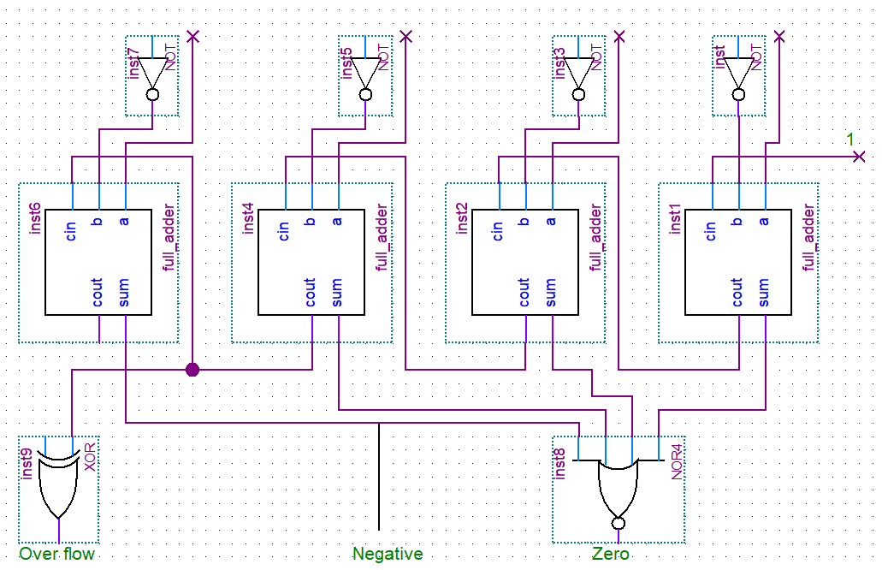

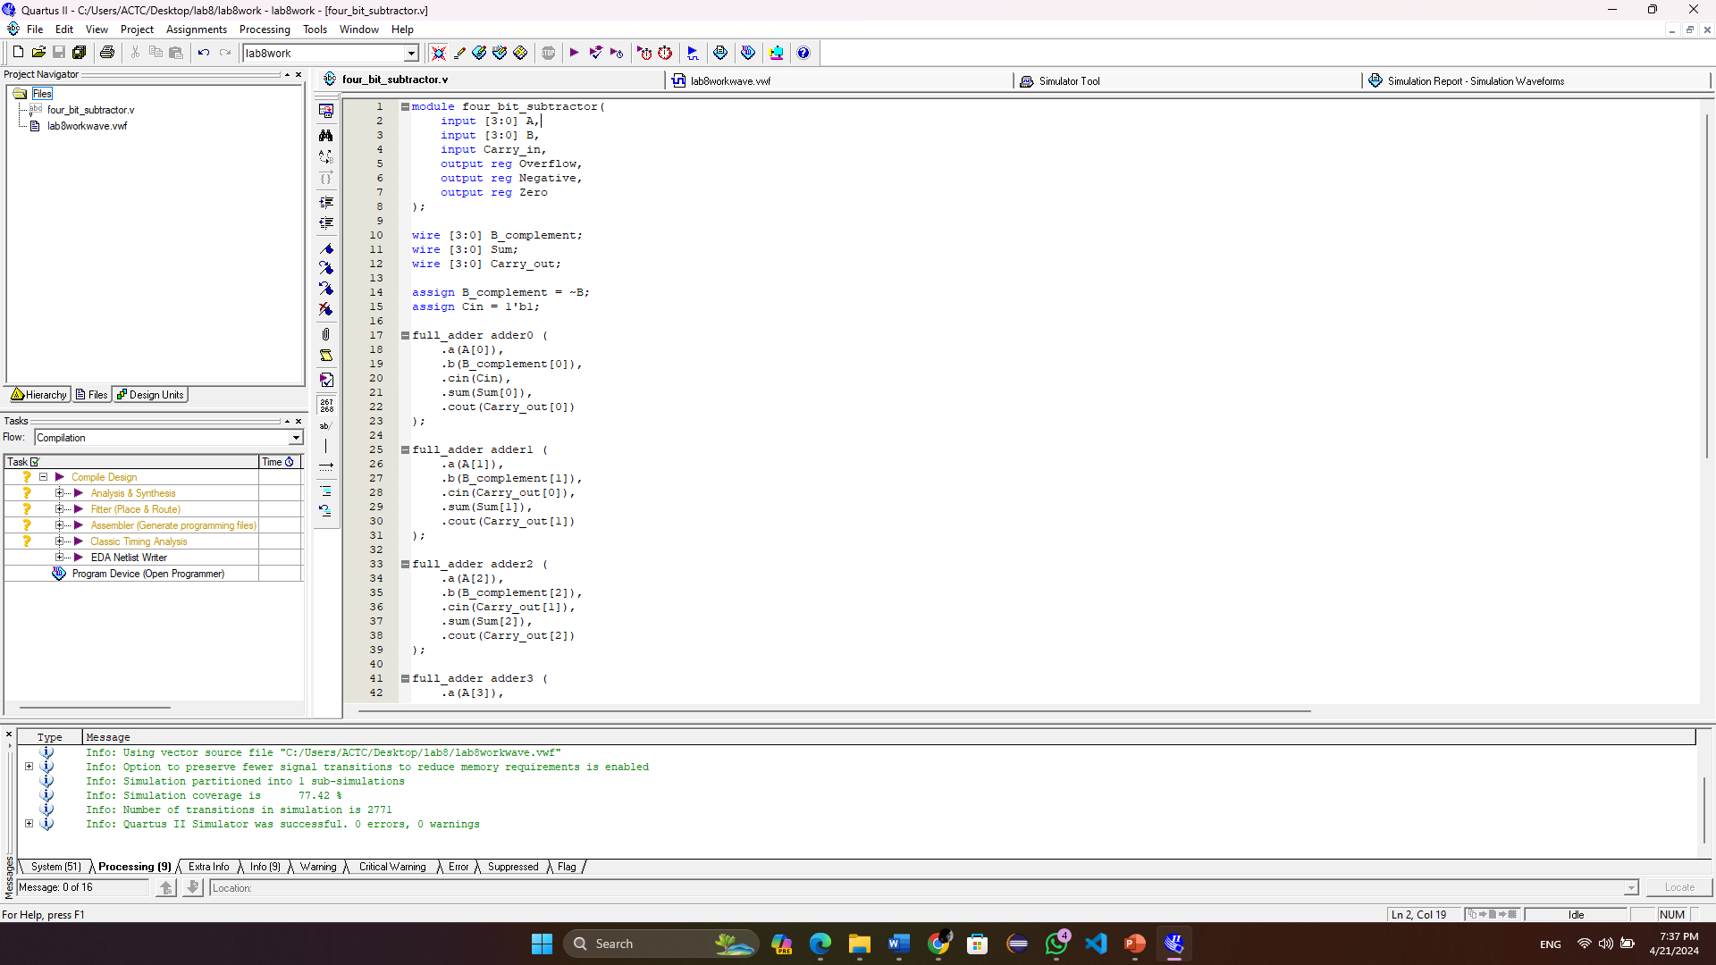

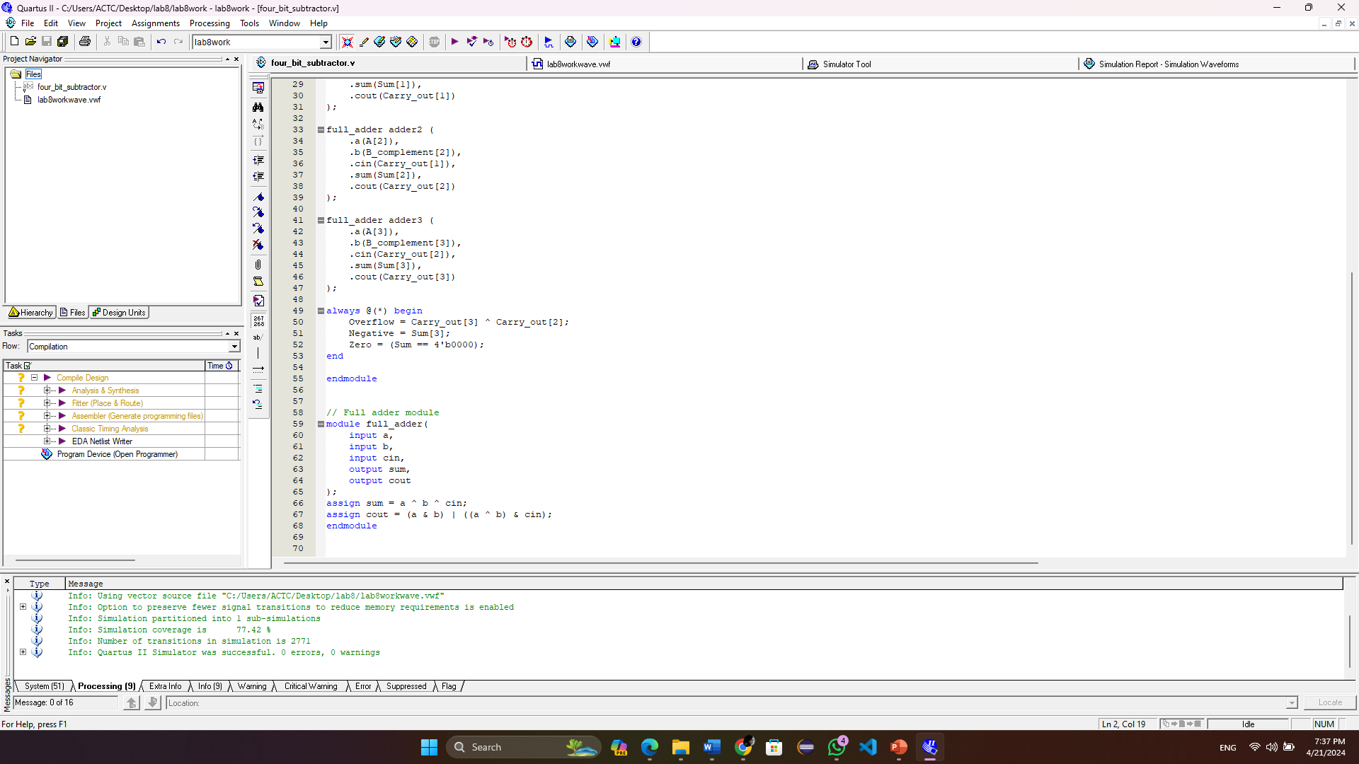

Waveform:

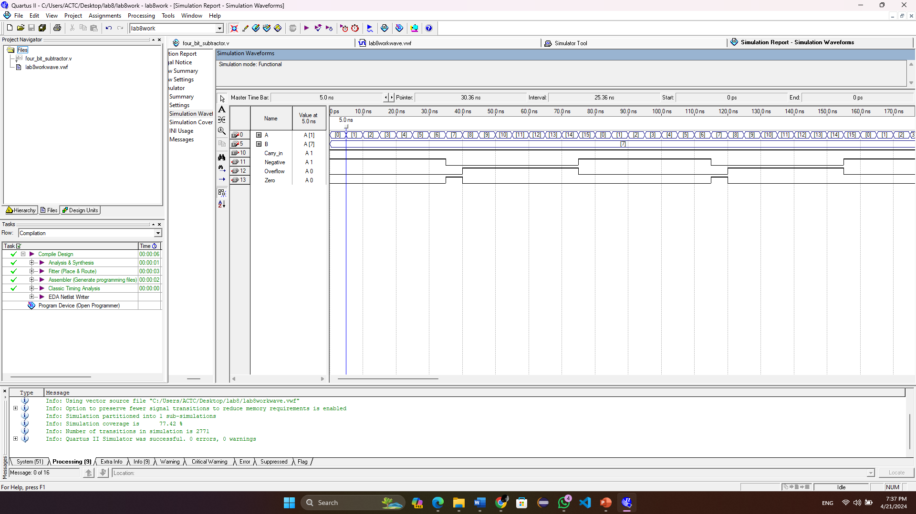

Task 2:

Code:

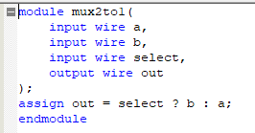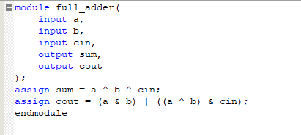

Waveform: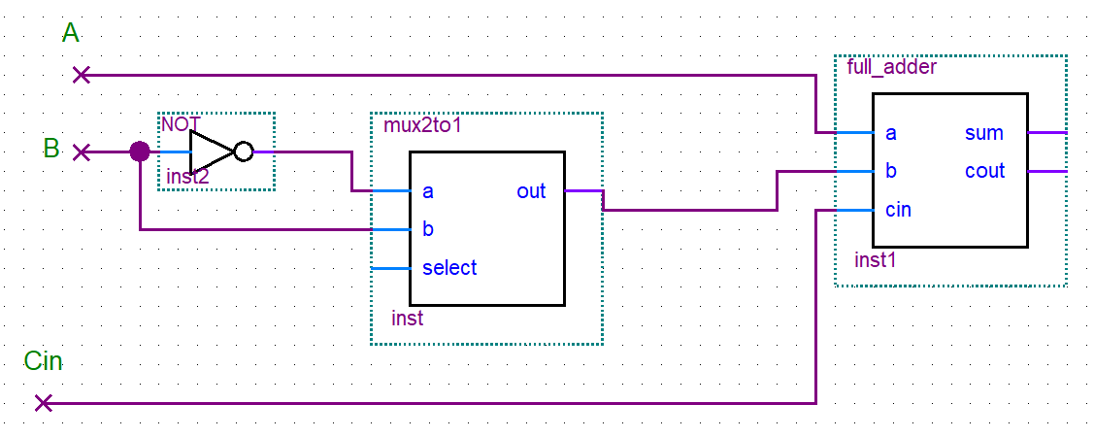

Task3:

Code:

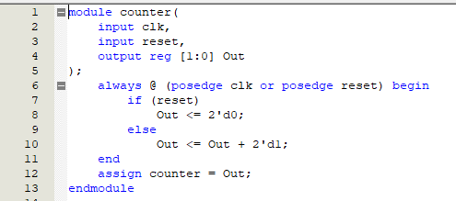 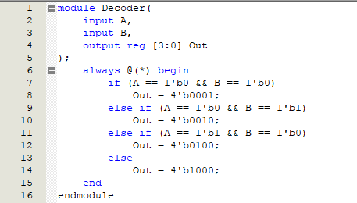 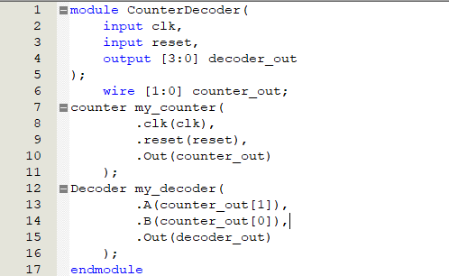

Waveform:

