Readme file

1. Download the trace files
   1. Simple
   2. 200000 branch instructions
   3. High transition trace
   4. Low transition trace
2. Change the path as in figure 1

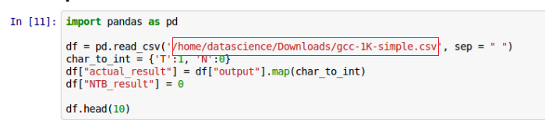

Figure : change the path of the trace

1. Change the parameter for each predictor as in figure 2



Figure : Change the parameter values