AOSAV – Mohamed Khalifa Abdalla finale Project

XML for ui,
Kotlin.
Java.

https://developer.android.com/reference/android/app/ActivityManager

STAR
S:
make it 50% has to be done by the end of the semester.

T:
Take courses on the PL you're gonna implement on the project,
1: SDLC,
Real-world application
The effect of the finale project on your marks
Can I become a lecturer in the college
Make the social network.
Build rapport with doctors.

1: Intorduction to software engineering IBM, Coursera.

https://www.youtube.com/watch?v=M6extgmQQNw

System Server: the node used to access system services using API.

Context. GetSystemService(Service_Name)

Context: access to resources, interaction between the app and the android system - filesystem

Behavoir based- Signiture Based.
XML for UI

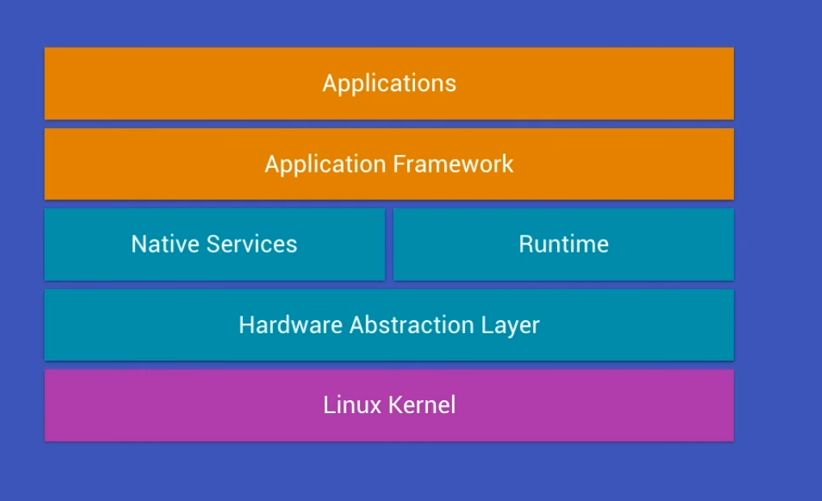
1: SDLC
Meet the requirement -
Define the phases of the development.

Questions for The Supervisor
What approach should be taken in the presentation
A: Explain the project to them with a PPTX as if they were potential investors or clients
B: explain only the technical side of the project an
C: Demonstrate the Skills applied to the project making and go back to the achievements I've accomplished
D: Should I ask them for questions.
E: The expectations of the supervisors
F: Should the project be applied in a real world situation, tested.
G: what kind of features should be added, RSA, Login portal Admin page, domain name, VPS (cloud) for management. mgmt portal.
H: the expectations in the %50 run end of semester 9.
I: How deep should I dive into the system calls
J: the use of OSS

The Projects Proposed:
Choice: Android based Anti-Virus
1: Processor architectures for
2: SYS calls
3: Inline-Assembly when a low level language interacts with a high level lang to achieve a syscall
4: Linux kernel and the AOSP
5: Java,
6:

1: ARM Based: android devices.
2: System calls
3:inlin-Assembly real world example

Guidelines

Phase Planning:
Gather, analys, document, priorities: consider Users, purpose. I/O, complince, Risk ID, QA, Schedule, money labor. time, teams.

SRS Specification:

make archeticutre - Prototyping demo - Design document.

Phase Desing:

Phase Development :

Phase Testing:

Phase Deployment:

Phase Maintainance:

vs add hok, waterfall Method:

