PART 1

Question1:

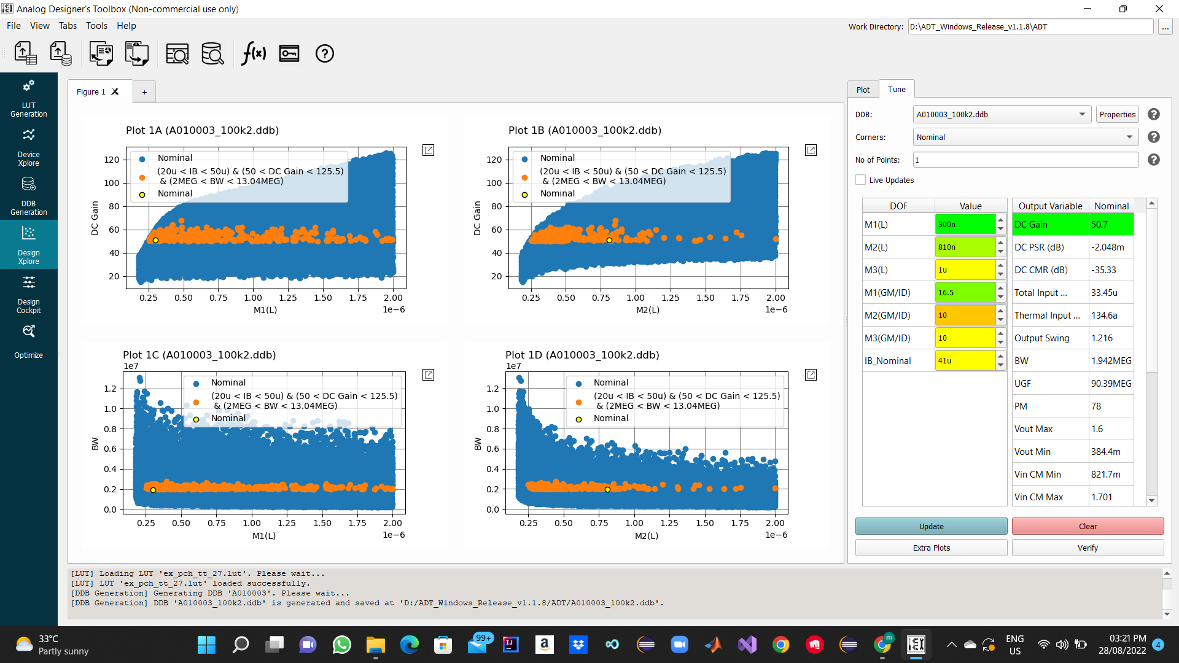

Question2:

Verifying Results

GBW=100Mega , Avdc=34db

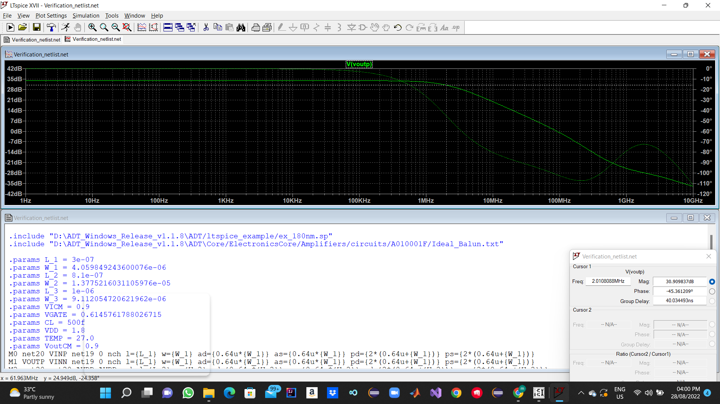

Question3:

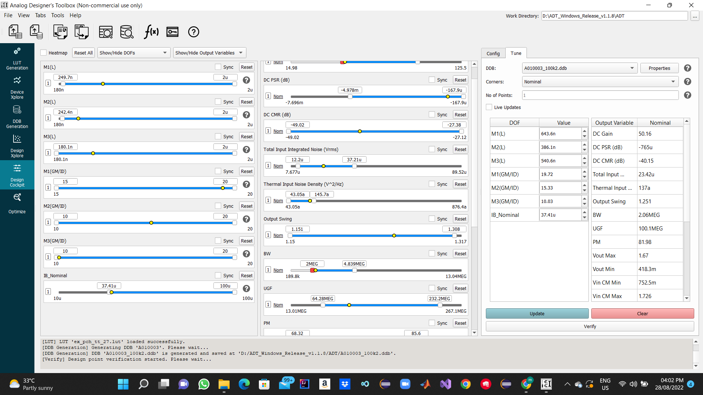

Question4:

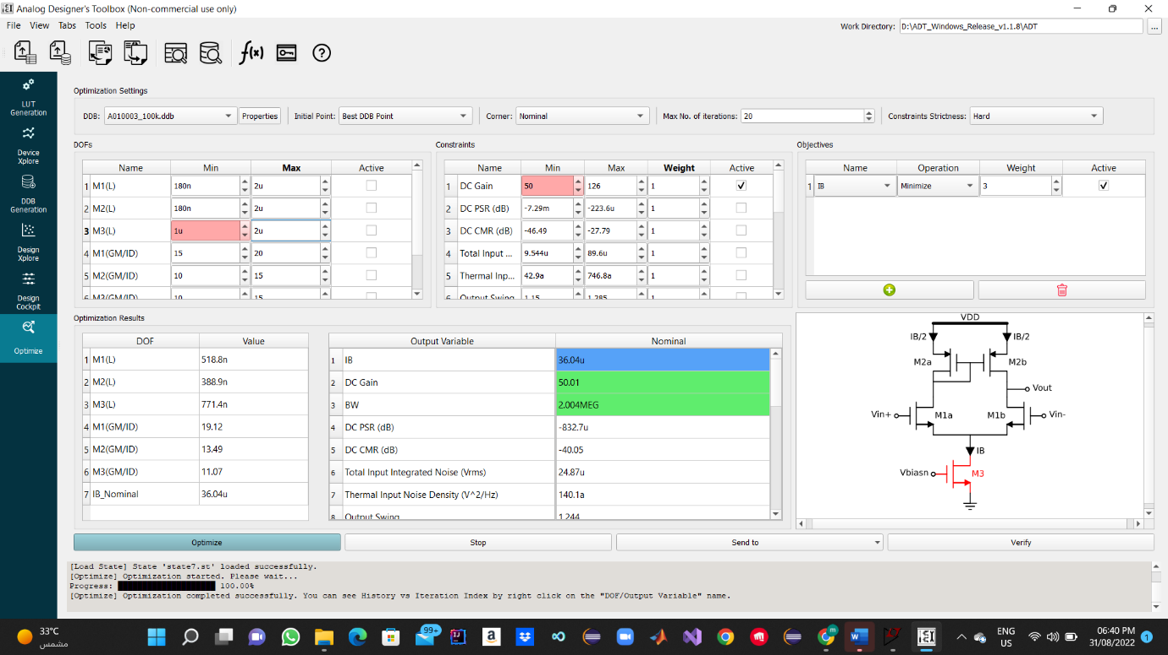

Question5:

Figure 1 Results .

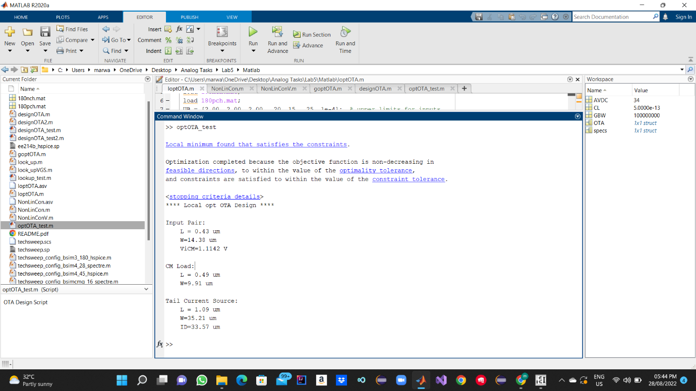

Figure 2 lopt function . 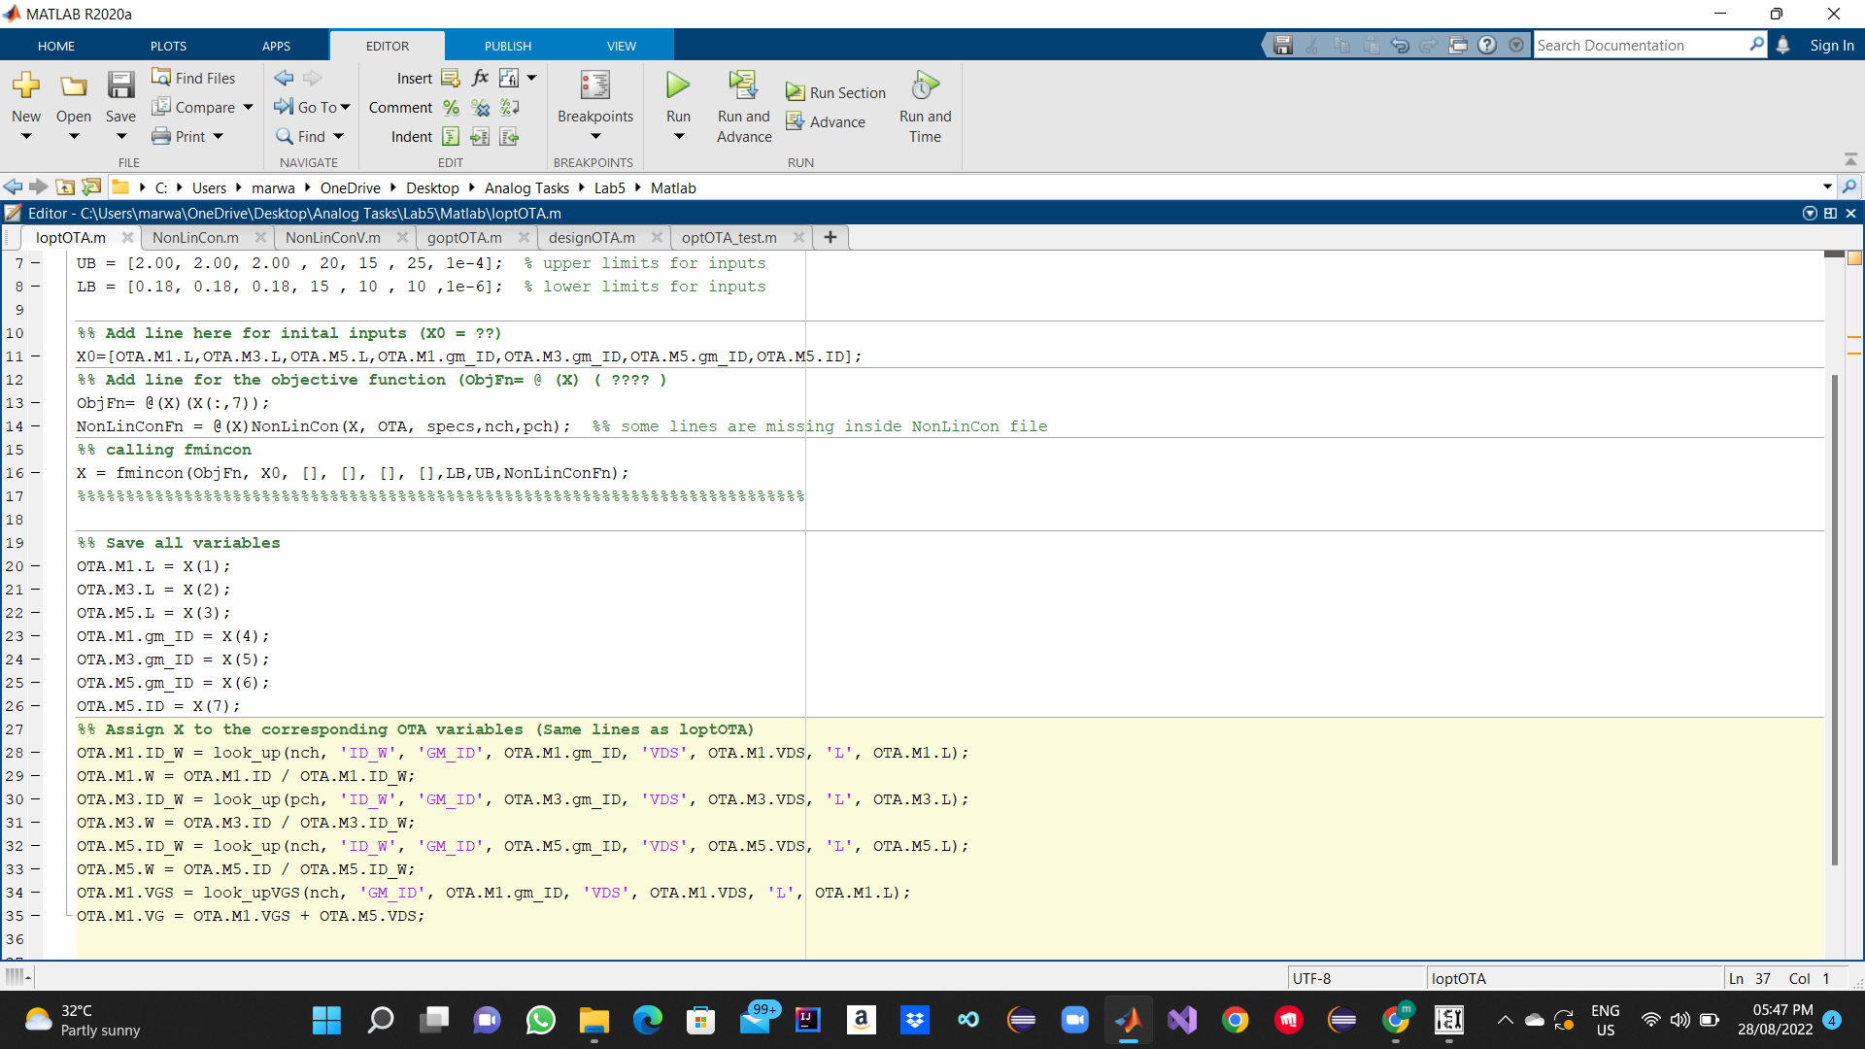

Figure 3 Nonlincon function .

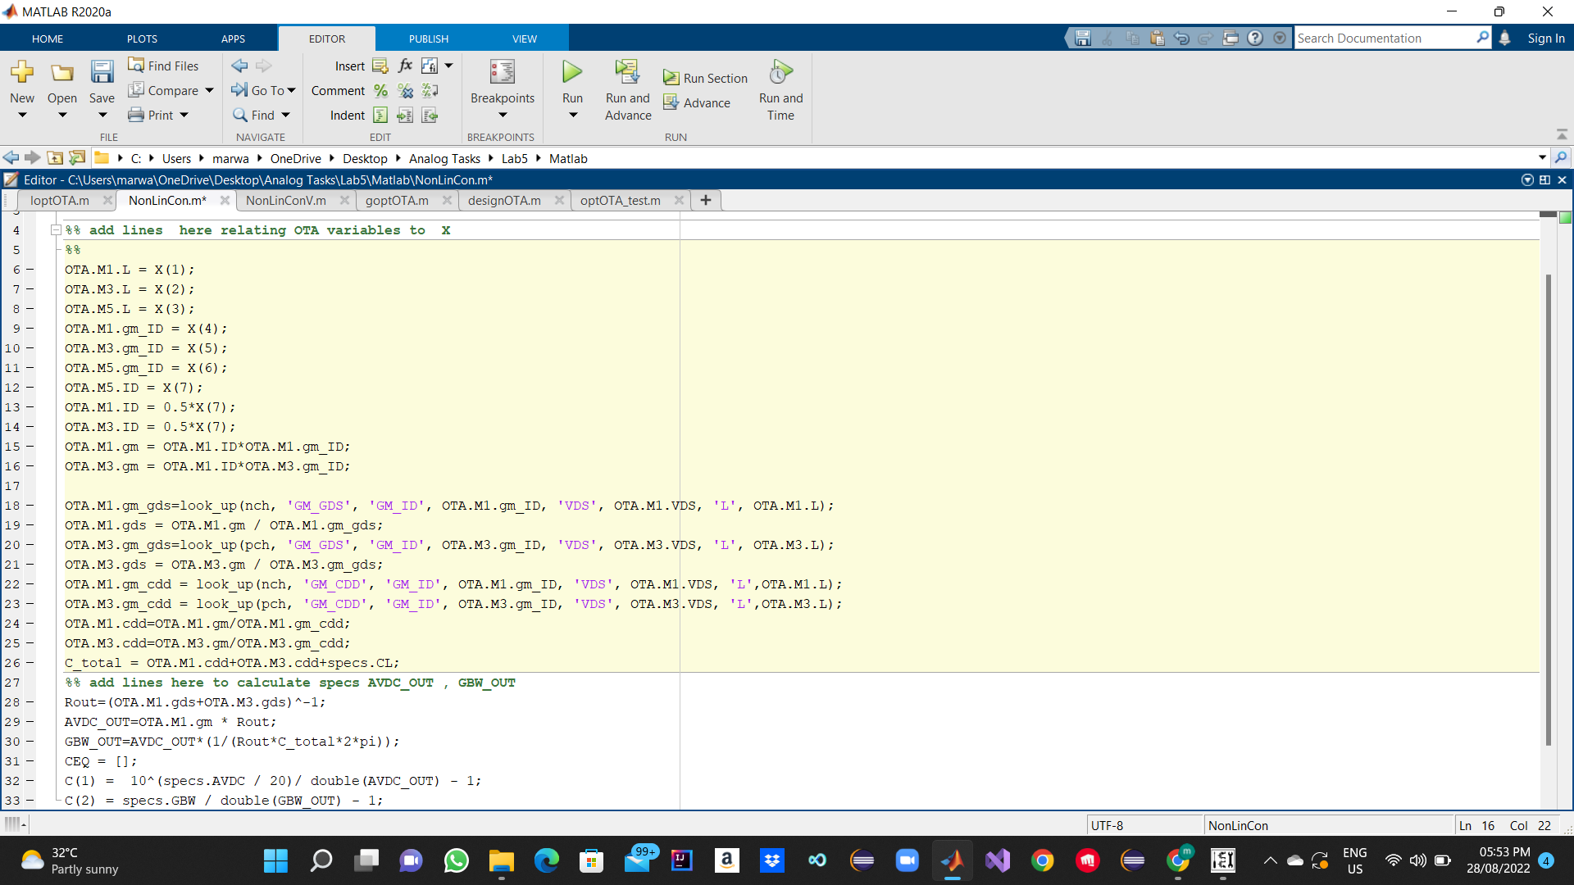

Question6:

Global Optimizer

Note : This Result isn’t Correct but I can’t find the bug in my code .

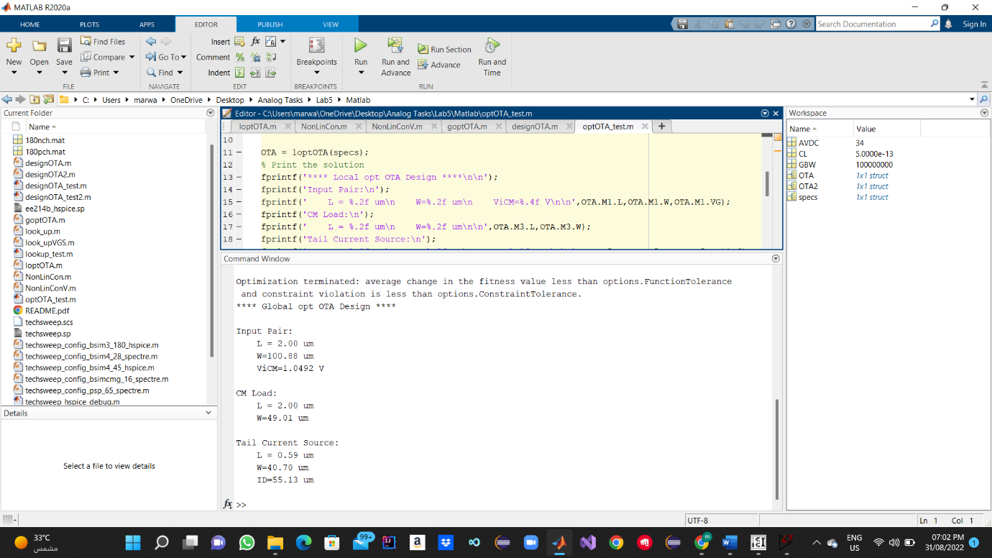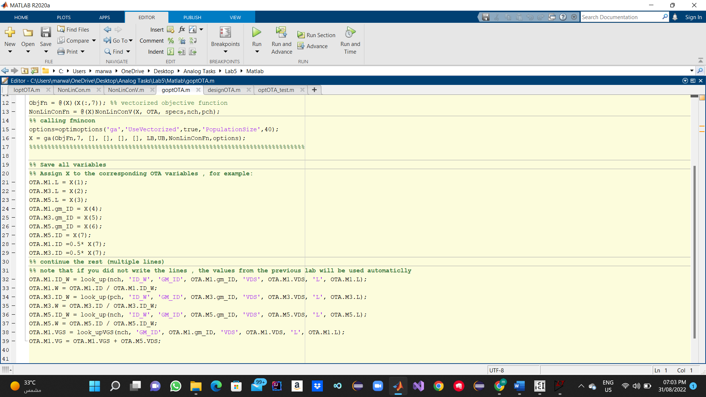

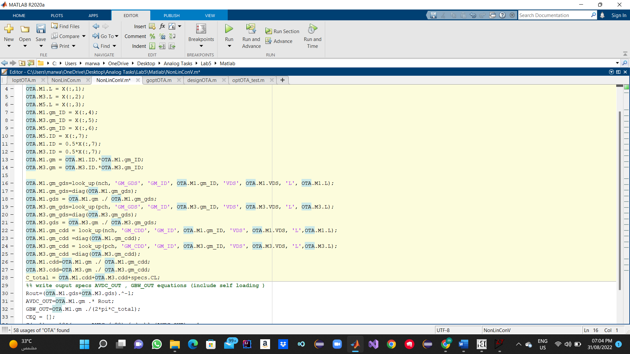

Question7:

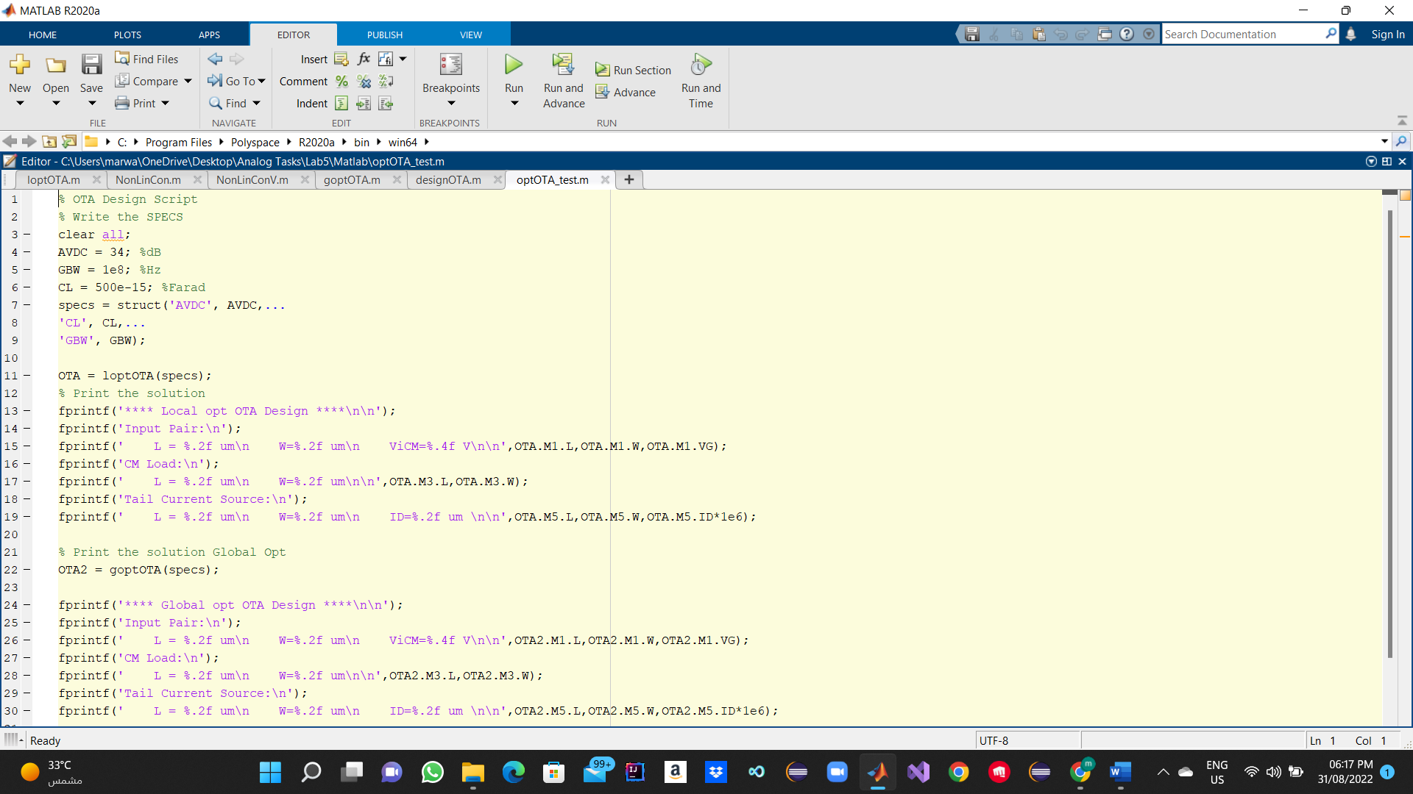

|  |  |
| --- | --- |
| ADT | Matlab |
| Input Pair:  W= 11.286 u L=518.8n  Current Mirror Load :  W= 10.2069u L=389n  Tail Current Source :  W=7.4689u L=771.4n  IB=36.04u | Input Pair:  W= 14.38u L=0.43u  Current Mirror Load :  W= 35.21u L=0.49u  Tail Current Source :  W=9.598u L=1u  IB=33.57u |

Comment :

The Sizing Difference due to the added constrain in ADT for GBW = 100 mega , where added DCgain constrain and BW Constrain.

Question8:

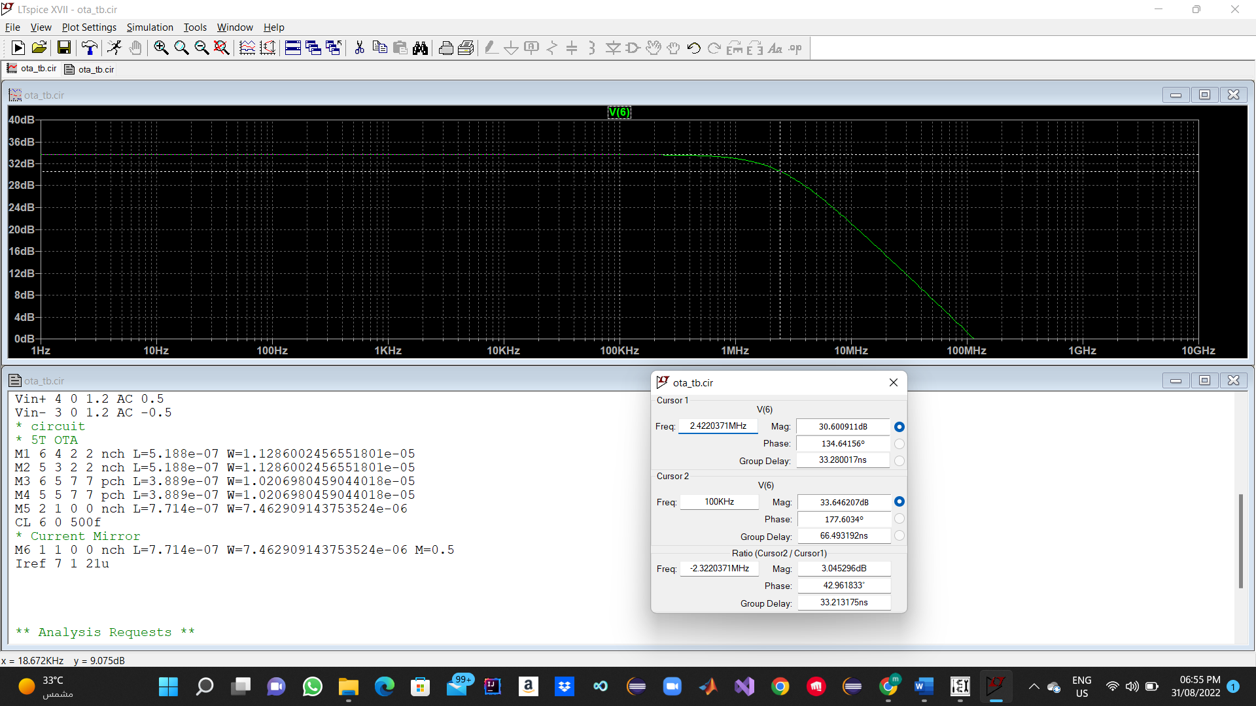

PART2:

Question 1:

C1 is +10% C2 is -10%

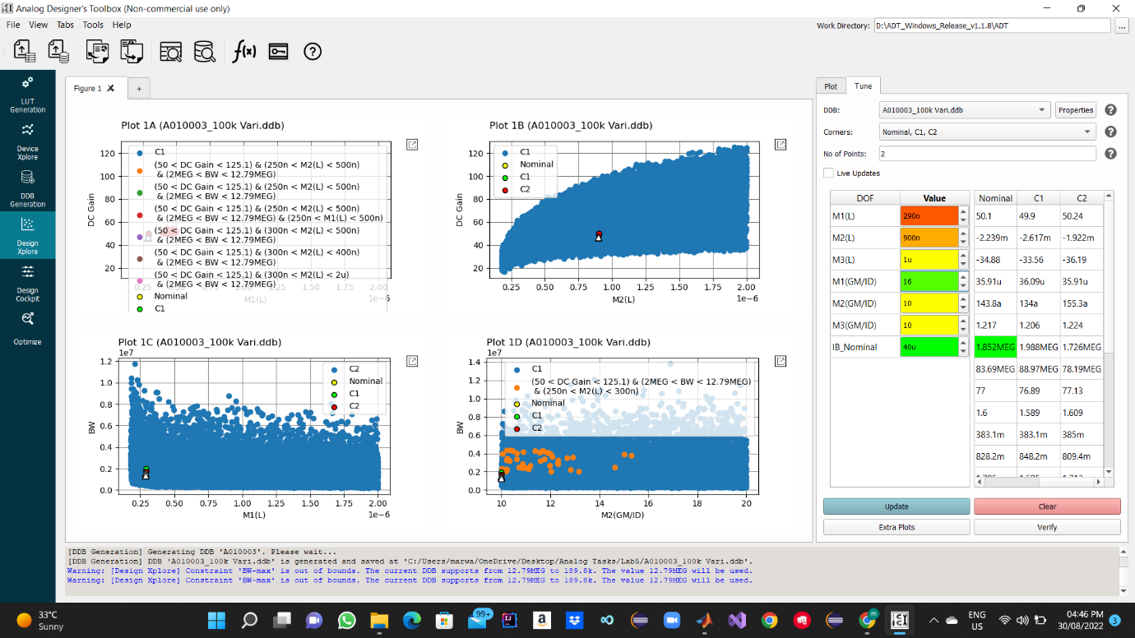

Question 2:

C1 is +10% C2 is -10%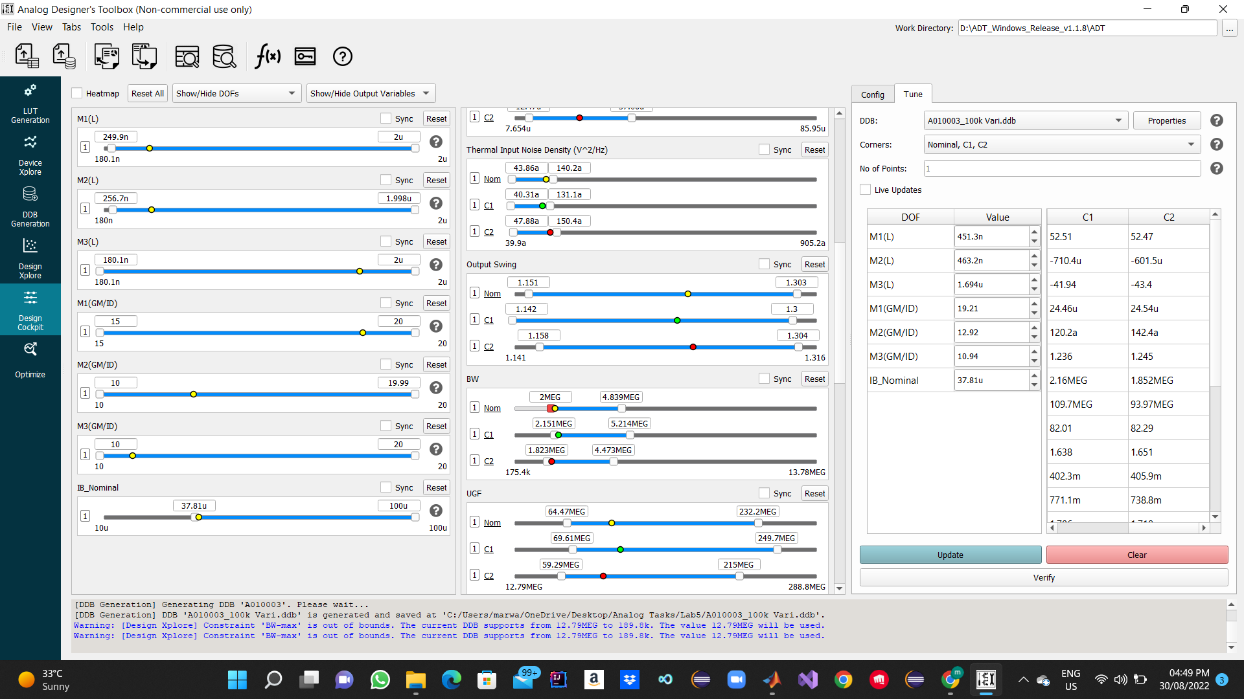

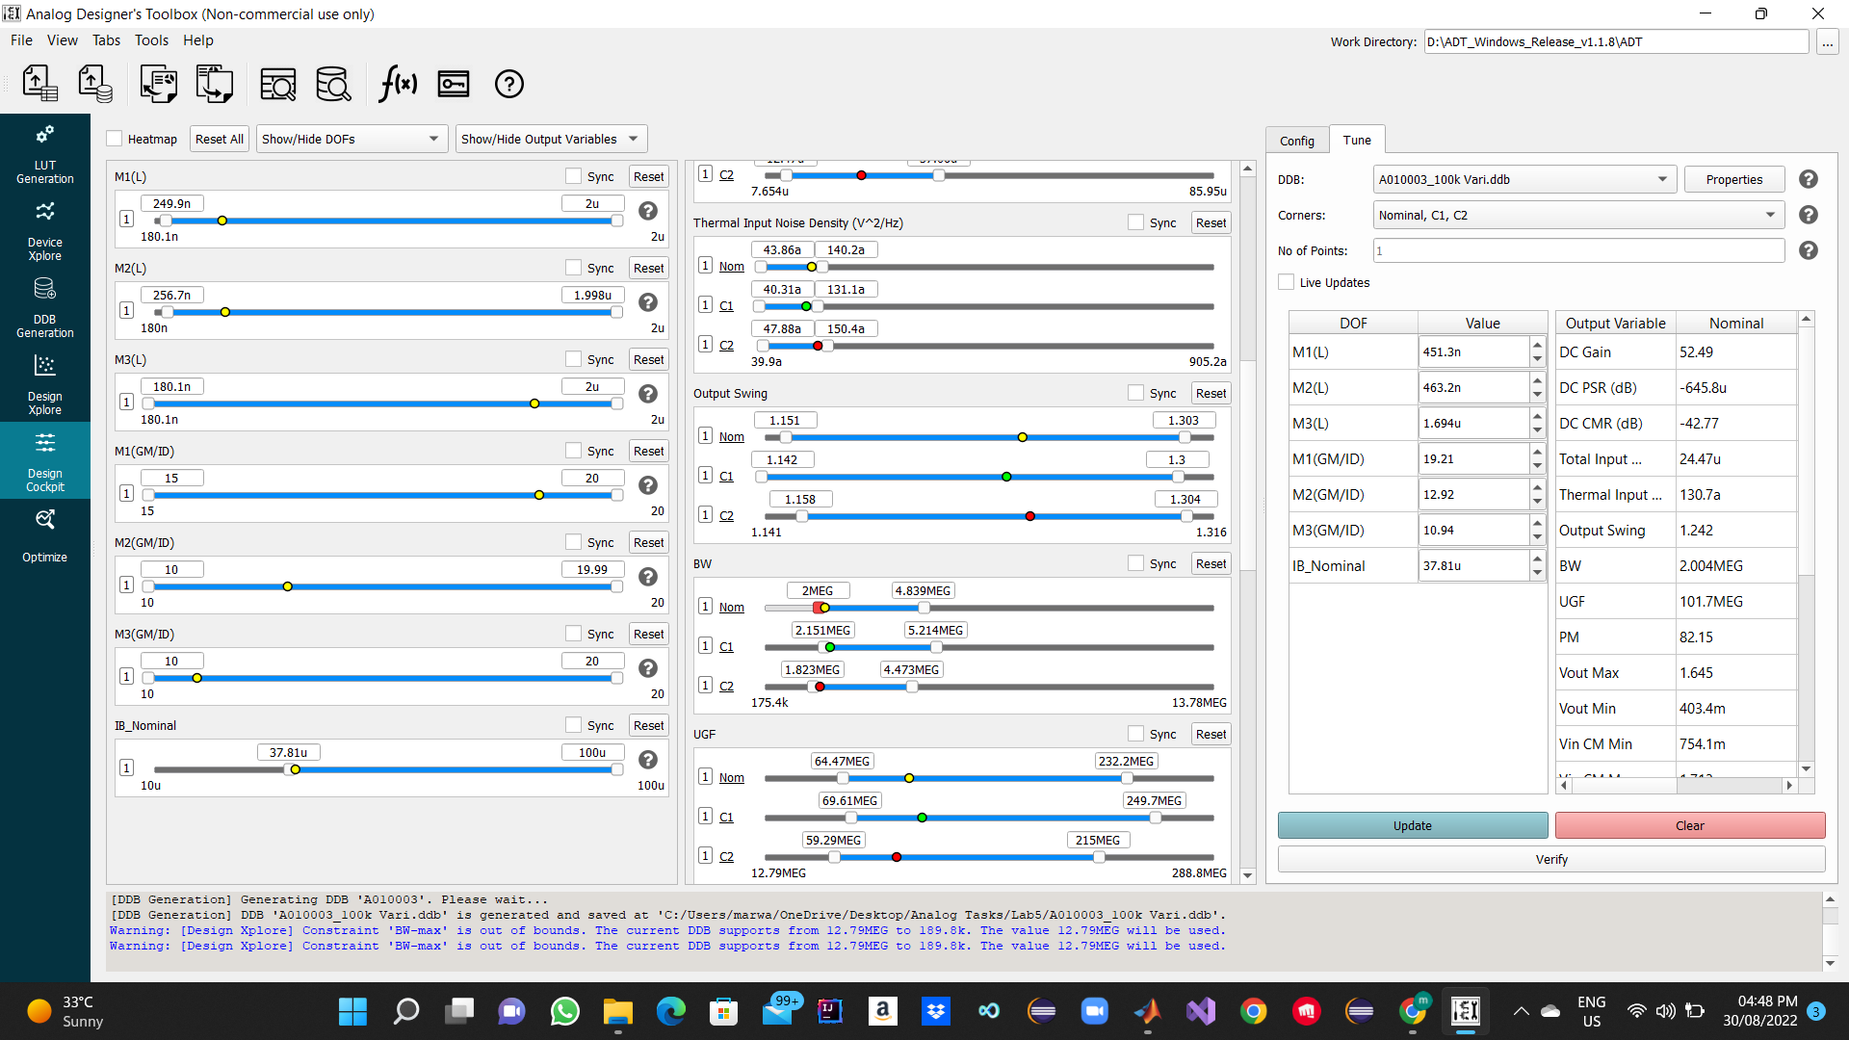

Question 3:

C1 is +10% C2 is -10%

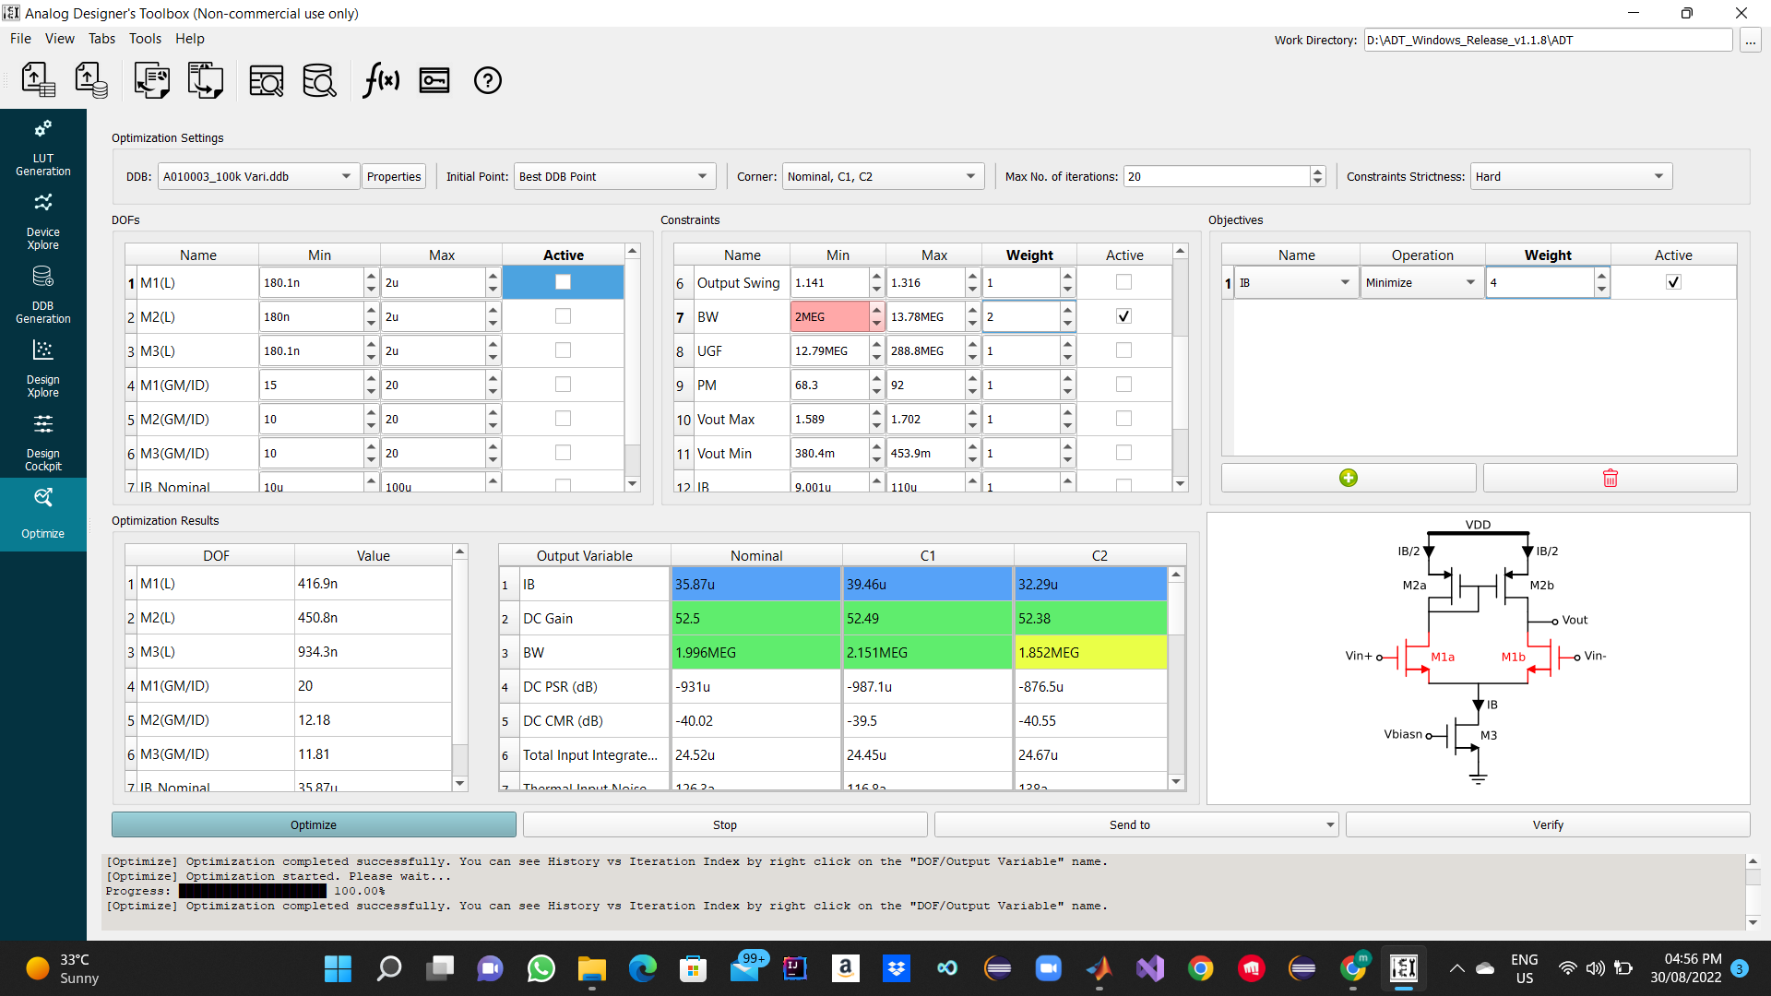

Question 4:

