***Report***

**1)SkLearn:**

A)By using text classification using gaussianNB and countvectorizer (BOW) and the accuracy of program on sample dataset (10000 from training set &2000 from test)

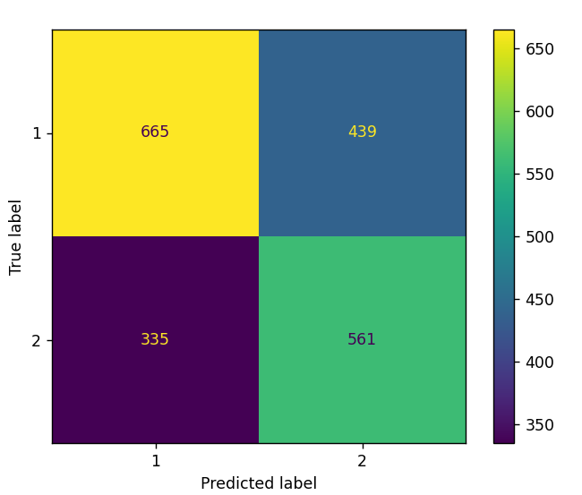

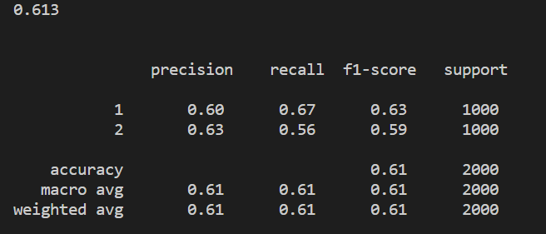

B) By using text classification using gaussianNB and tfidfvectorizer(TF-IDF) and the accuracy of program on sample dataset (10000 from training set &2000 from test)

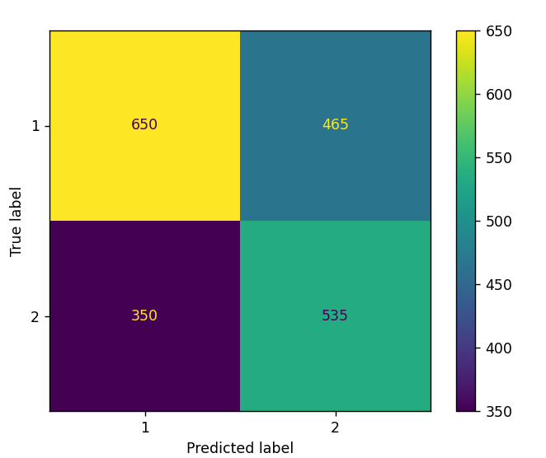

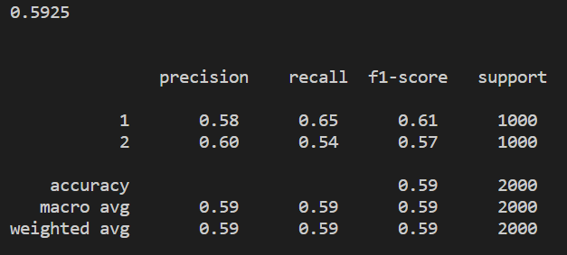

2)By using NLTK we make train test automatically because it’s a training model already

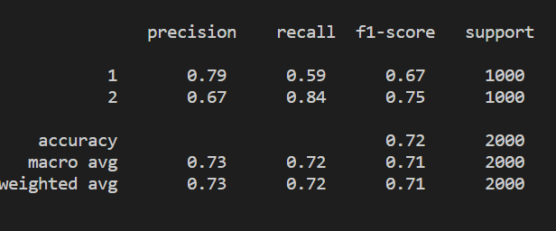

3)By using spacytextblob we make train test automatically because it’s a training model already

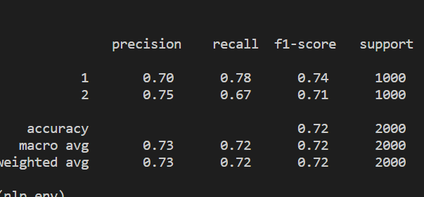

***TABLE OF ACCURACY***

|  |  |  |  |  |
| --- | --- | --- | --- | --- |
|  | **Using Naïve Bayes** |  | **SIA** | **spacytextblob** |
|  | **BOW** | **TF-IDF** | **NLTK** | **Spacy** |
| **Accuracy** | **0.61** | **0.59** | **0.72** | **0.72** |

**After testing on a real data from Amazon using scraping using beautifulsoup on 9 records using SIA model we reach to an accuracy 100% as in the fig.**

