**Component specifications**

**Fuel cell**

Voltage at 0 Amp: 253.5 V

Voltage at 1 Amp: 242.8 V

Nominal Operating point: 136 A & 221.9 V

Maximum Operating Point: 272 A & 206 V

Number of Cells: 235 cells

Nominal Stack Efficiency: 80.38 %

Operating Temperature: 80 °C

Nominal Air Flow Rate: 0.90989 lpm / 0.0026499 kg/s

Nominal Fuel Supply Pressure: 8 bar

Nominal Air Supply Pressure: 8 bar

Nominal Composition: ??????

**Motor**

<https://www.torqeedo.com/us/en-us/products/outboards/deep-blue/deep-blue-80-r/M-3201-00.html>

<http://www.aquawatt.at/data/download/download_1/pricelist_ab_motor_vk_1_2016_71.pdf>

**Photo Voltaic**

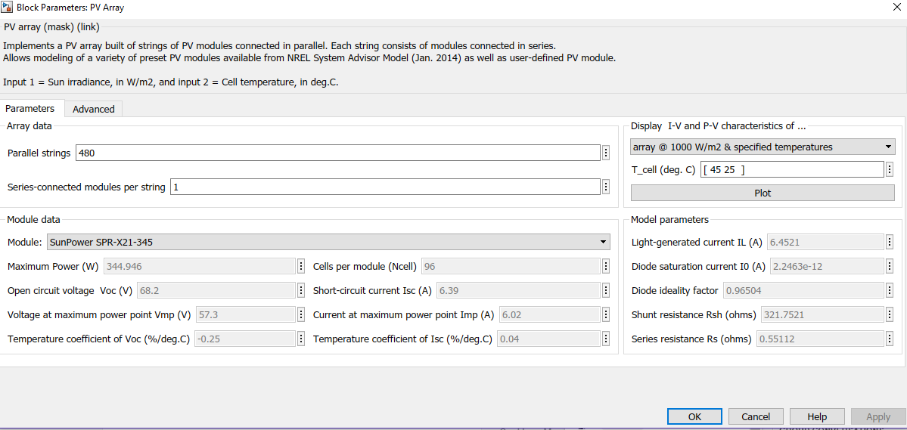

**Battery**

Links

<https://www.alibaba.com/product-detail/high-quality-12v-200ah-solar-battery_1807662936.html?spm=a2700.7735675.2017115.1.GNungZ&s=p>

<https://www.lithiumion-batteries.com/products/24-volt-lithium-batteries/>