

**AMERICAN INTERNATIONAL UNIVERSITY-BANGLADESH**

**Faculty of Science and Technology (FST) SOFTWARE QUALITY AND TESTING [B]**

**2021-2022, Summer *Mid-Term Assignment***

**Submitted To:**

**COURSE TEACHER:** ABHIJIT BHOWMIK

Associate Professor & Special Assistant [OSA], Computer Science

**Group Members:**

|  |  |
| --- | --- |
| **Name** | **ID** |
| 1. Linta, Sahara khan | 19-39864-1 |
| 2. Mahdi Md Mohaimenul Islam | 19-39845-1 |
| 3. Islam, Tajul | 19-39847-1 |

*Table of Contents*

**Part-I: Installation Process of Selenium Webdriver for Web Application Automation Testing.** ............................................................................................... **Error! Bookmark not defined.**

**Flowchart of Installation Process** .................................... **Error! Bookmark not defined.**

Visual Representation and Description of Each Step of the Flowchart**Error! Bookmark not defined.**

Download and Install Java Development Kit (JDK)... **Error! Bookmark not defined.** Configure Environment Variables for JDK ................... **Error! Bookmark not defined.** Download and Install Eclipse IDE for Java Developers**Error! Bookmark not defined.** Download Selenium .............................................................. **Error! Bookmark not defined.** Download Chromedriver for the Chrome Browser .. **Error! Bookmark not defined.** Configure Selenium on the Eclipse.................................. **Error! Bookmark not defined.**

**Part-II: Test a Web Application Module Using Selenium Webdriver.Error! Bookmark not defined.**

**Flowchart of Testing Process** ............................................. **Error! Bookmark not defined.**

Visual Representation and Description of Each Step of the Flowchart 21

Create a New Project in Eclipse IDE 21

Select a Web Application Module Which Will be Tested 21

Prepare a Test Case 22

Write Required Code 23

Run and Observe the Outcomes ....................................... **Error! Bookmark not defined.**

**About Selenium:**

Selenium is basically used to automate the testing across various web browsers. It supports various browsers like Chrome, Mozilla, Firefox, Safari, and IE, and we can very easily automate browser testing across these browsers using Selenium WebDriver.

**Part-I: Installation Process of Selenium Webdriver for Web Application Automation Testing.**

**Required software’s along with selenium :**

Java IDE

Selenium

Elicpse

**Flowchart for installation process**

Download and Install JDK

Configure Environment

Variable for JDK

Download and install Eclipse

IDE for JAVA devolopers

Download Selenium

Download Chromedriver for

Chrome Browser

Configure Selenium on

Eclipse

# Visual Representation and Description of each step of the Flowchart

**Downloading process of JAVA Development Kit(JDK) :**

**Step 1:** For downloading the java development kit you need to search with “JDK download” or

click on the link (https:[//w](http://www.oracle.com/java/technologies/java-se-glance.html))ww[.oracle.com/java/technologies/java-se-glance.html)](http://www.oracle.com/java/technologies/java-se-glance.html)) follow the Arrows in picture for more precise understanding

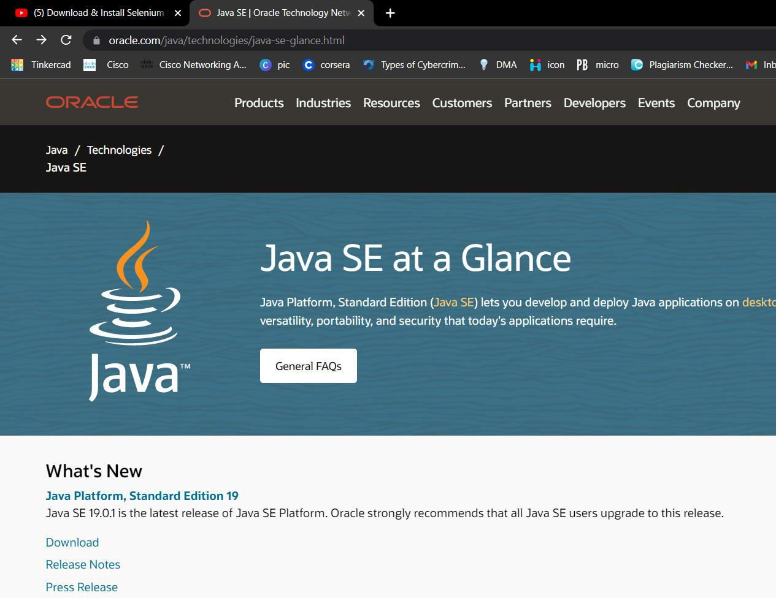

**Step 2:** After clicking on the latest version of JDK you will end up in the page bellow, where you can download the file according to your devices operating system I am downloading the windows versions.

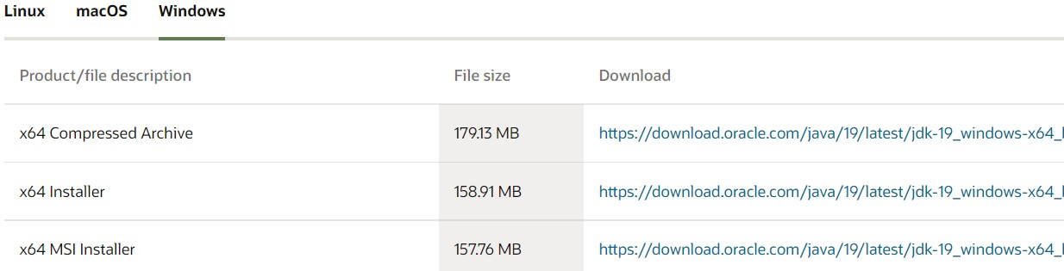

After downloading exe file will look like this in your downloads folder



**Installation process of JAVA Development Kit(JDK) :**

**Step 1:** After successful downloading ,double click or open the JDK file .The following screen will appear. Click on Next option every time.

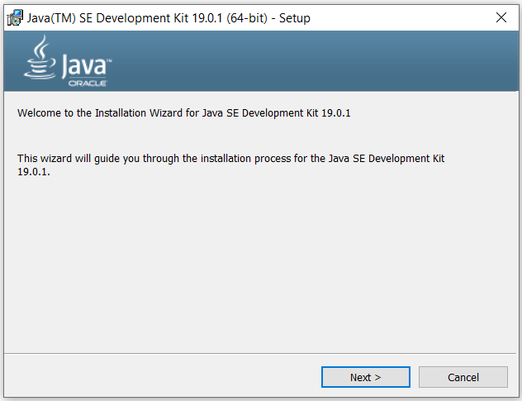

**Step 2:** After clicking next a window may appear which will give you option to change the location of the files which will be installing . If you want to change the location then Click on Change and select preferable folder otherwise click next.

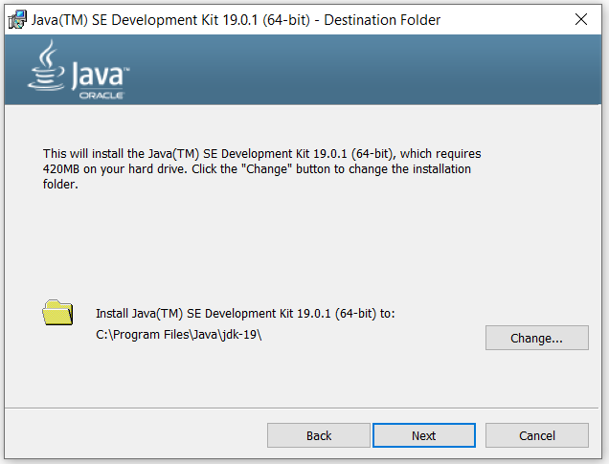

**Step 3:** Wait for few minutes until the whole bar turns green.

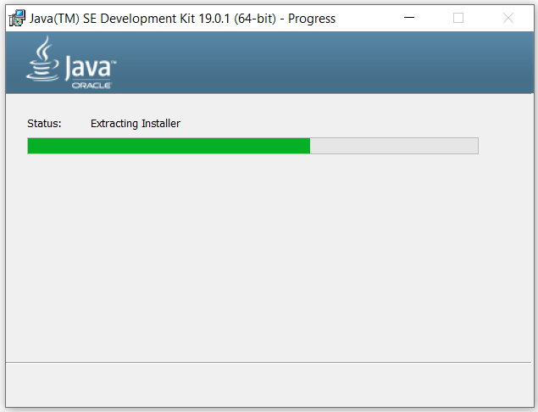

**Step 3:** This window denotes that your installation process is complete . Now click on close .

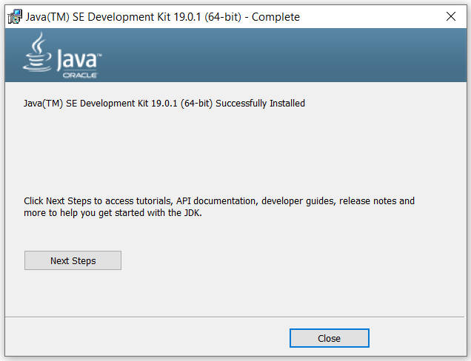

**Optional step** to check whether our JDK has been installed correctly or not ?

Open command prompt and type **java -version** -> press enter ->and the versions will appear else you couldn’t install the JDK so try to uninstall the file and again follow the installation process

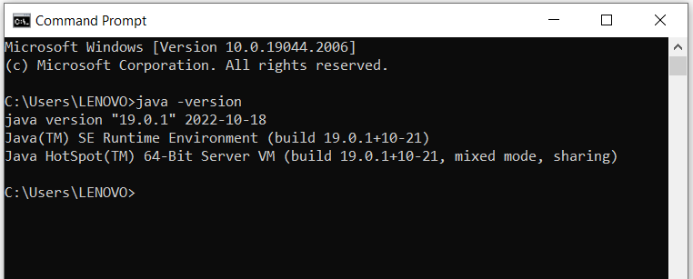

**Configure environment variable for JDK**

Search with Environment variable in the windows search bar picture 1 window will appear the follow the arrow which indicates **Environment Variables** button click on it picture 2 will appear click on path .

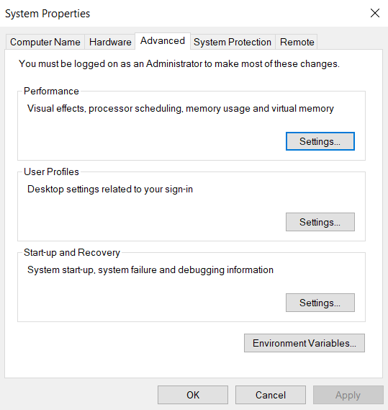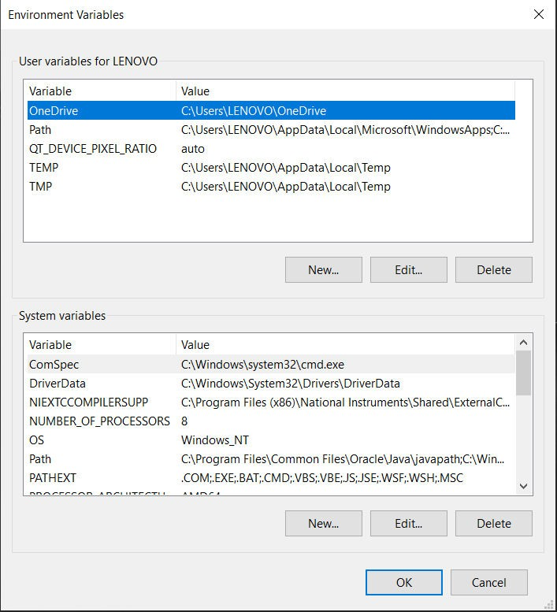

Picture 1

Picture 2

After clicking on Path the window will appear which is showing bellow . click on New then copy the path of your folder where JDK files has been saved ,paste the path click on OK. This is how you set the environment for JDK.

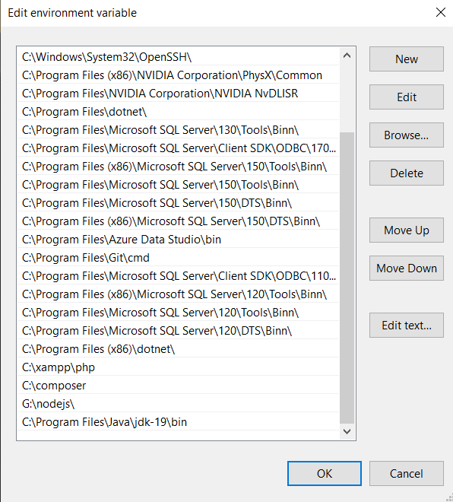

**Eclips:**

Eclipse is an integrated development environment (IDE) for developing applications using the Java programming language and other programming languages such as C/C++, Python, PERL, Ruby etc. Developed using Java, the Eclipse platform can be used to develop rich client applications, integrated development environments and other tools. Eclipse can be used as an IDE for any programming language for which a plug-in is available.

**Downloading process of Eclips:**

**Step1:** For downloading the java development kit you need to search with “Eclips for enterprice addition” or click on the link (https://www.eclipse.org/downloads/download.php?file=/oomph/epp/2022-06/R/eclipse- inst-jre-win64.exe)

The following screen will appear Click on Download button pointed with the arrow

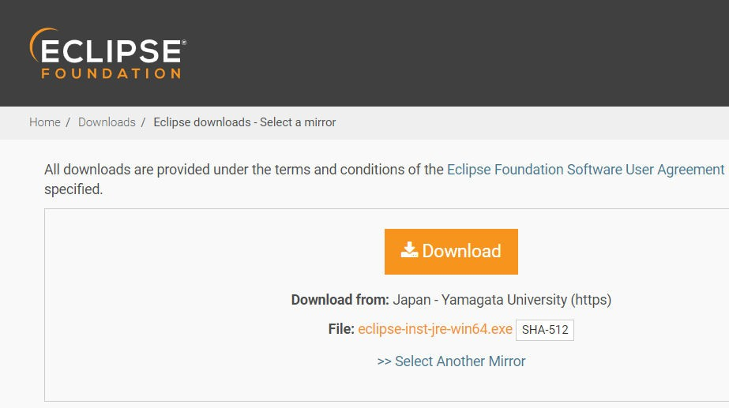

**Installing process of Eclipse:**

**Step 1** : click on eclipse IDE file , eclipse installer window will appear like the picture shown bellow .click on the first option if you want to use it for java development .

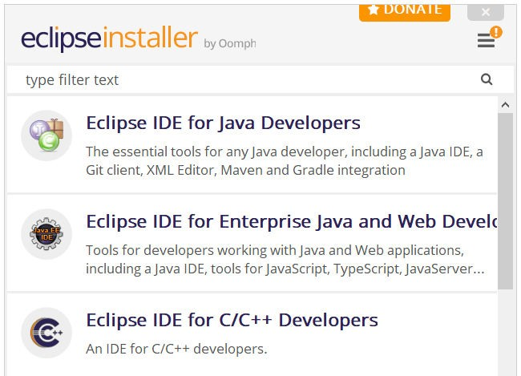

**step 2 :** Click on install for continuing the installation process. Meanwhile check those two buttons

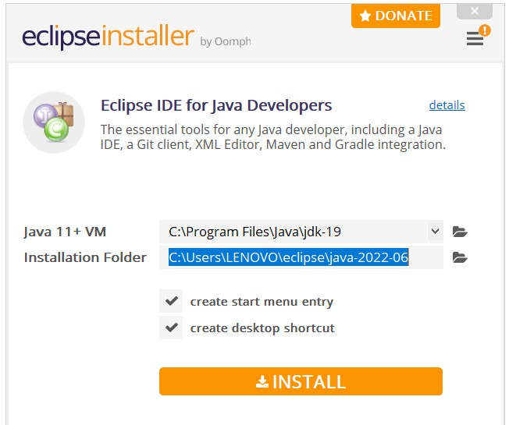

In between installation process a agreement window may appear you need to accept them by clicking it by Accept now

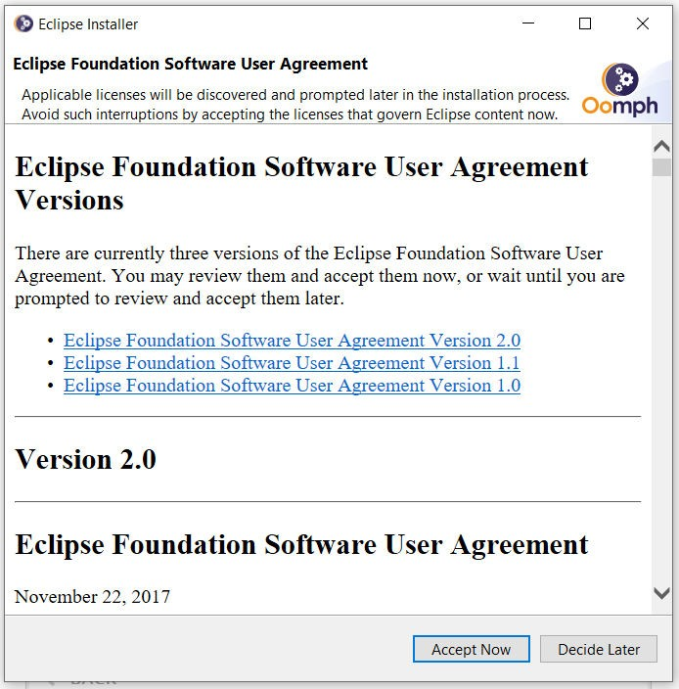

**step 3 :** Click on Launch option.

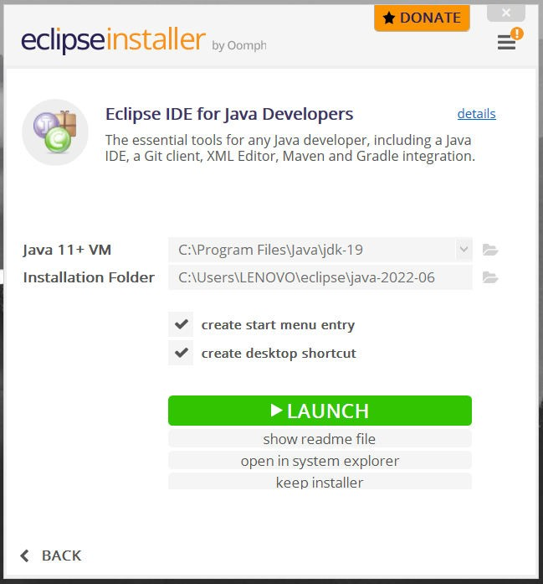

**step 4 :** After successful installation this window will appear where you can create new project.

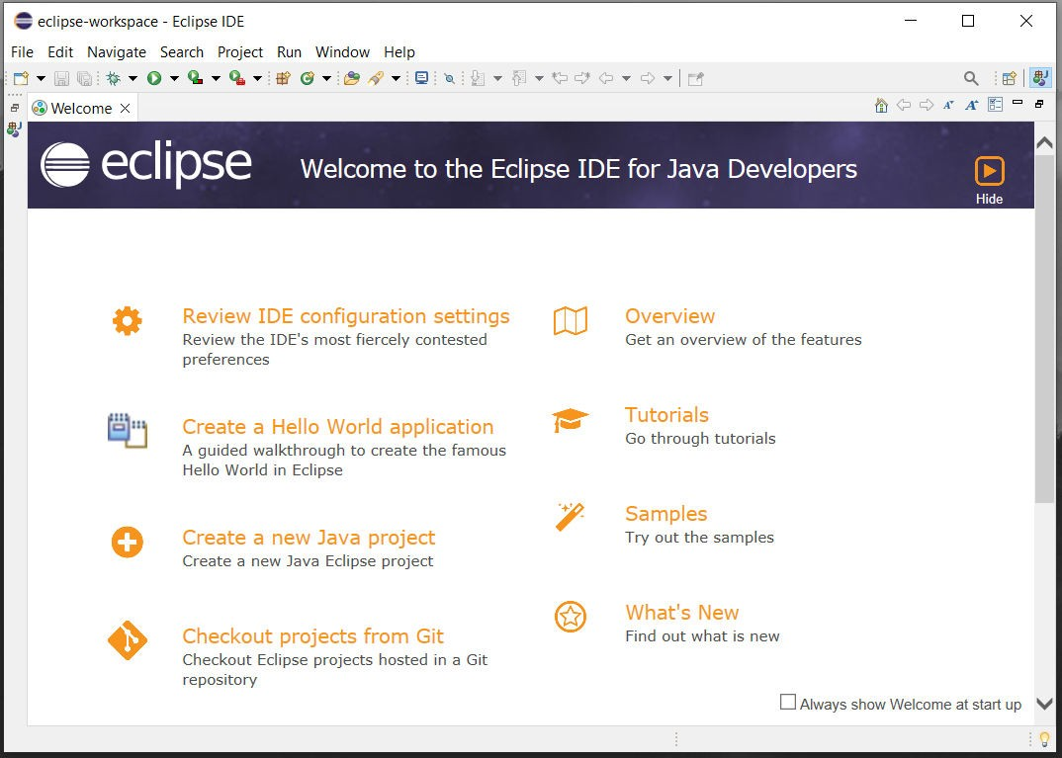

**Downloading process of** selenium**:**

**Step 1:** For downloading the selenium you need to search with “selenium org” or click on the link (https:[//w](http://www.selenium.dev/))ww[.selenium.dev/)](http://www.selenium.dev/))

This screen will appear. Click on the download option.

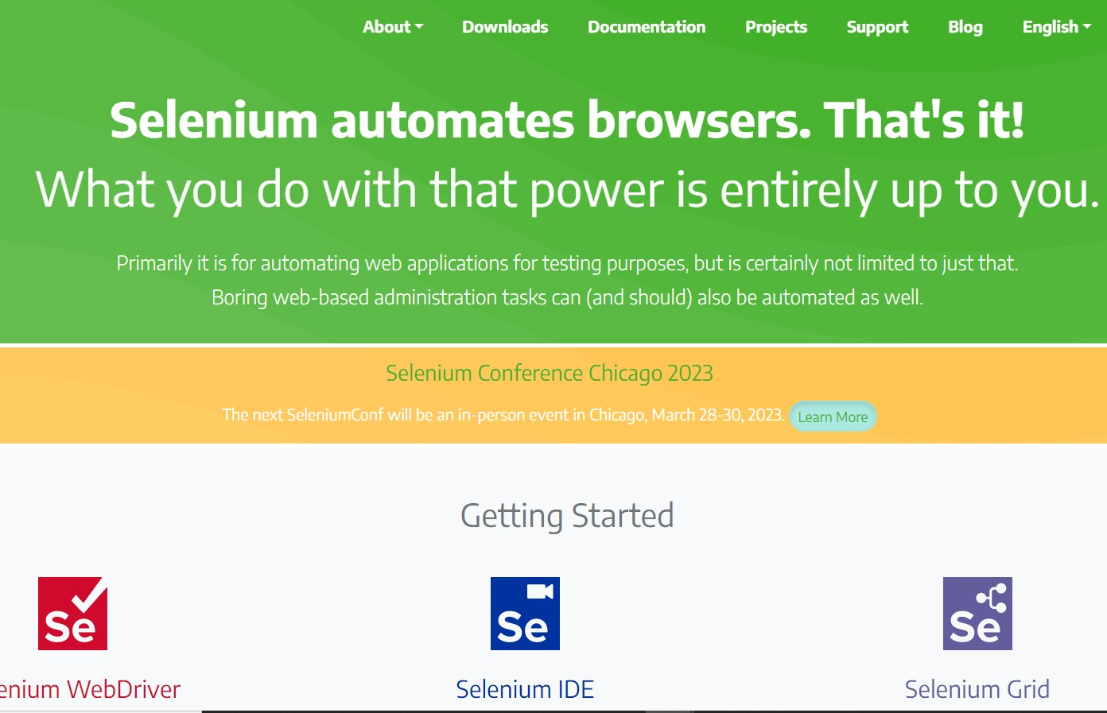

**Step 2:** Click on the selenium server latest stable version which will be a jar file .

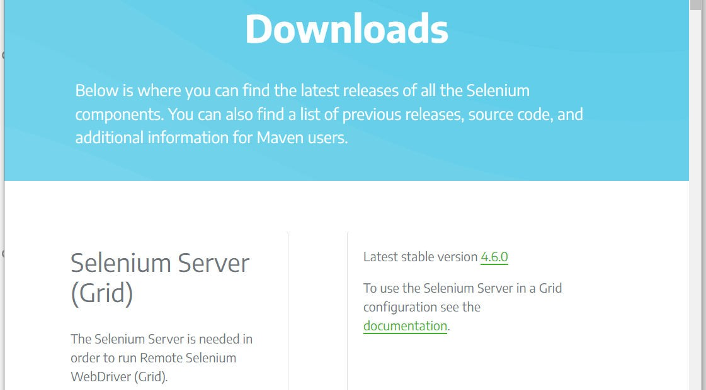

**Step 3 :** Scroll down a bit you will see java clients ,click on it to download .

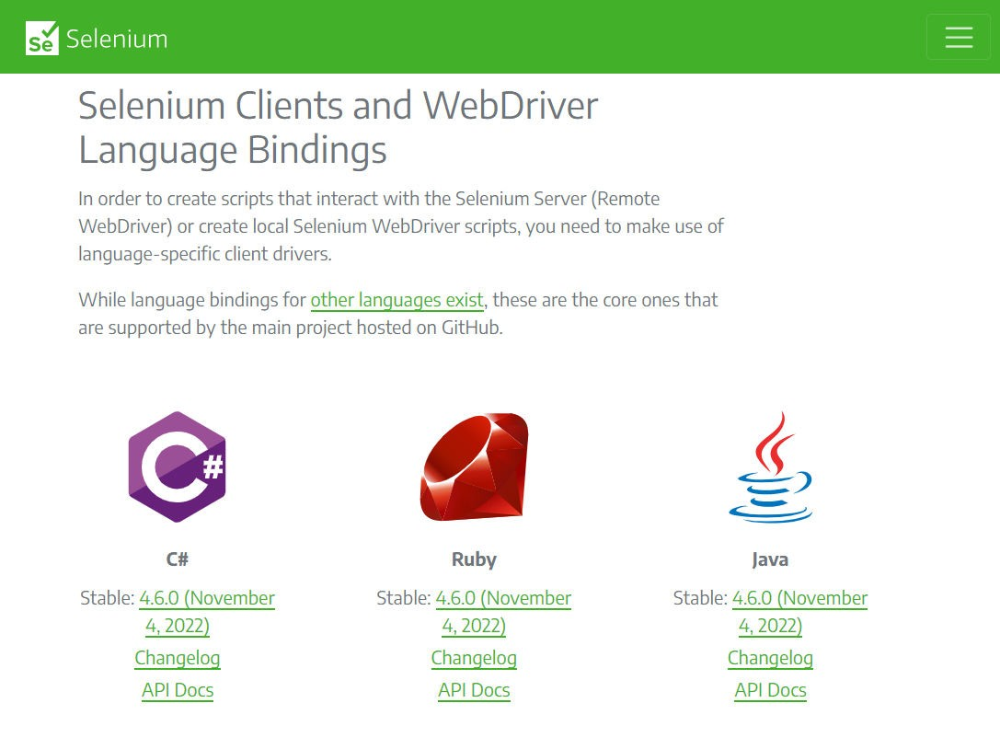

After download process files will look like this

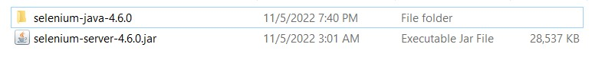

**Step 4 :** Move these two file into a new folder in c drive. I have name the folder as selenium web driver.

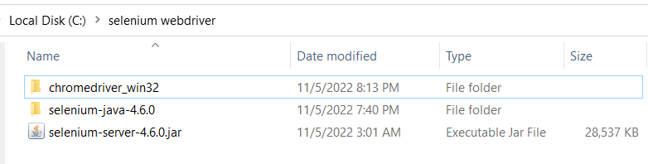

**Browser driver download:**

**Step 1 :** I am using Chrome browser so I will be installing Chrome driver. If you use other browser then you can download that respective browsers driver . Before that check your browsers version. Then click on download .

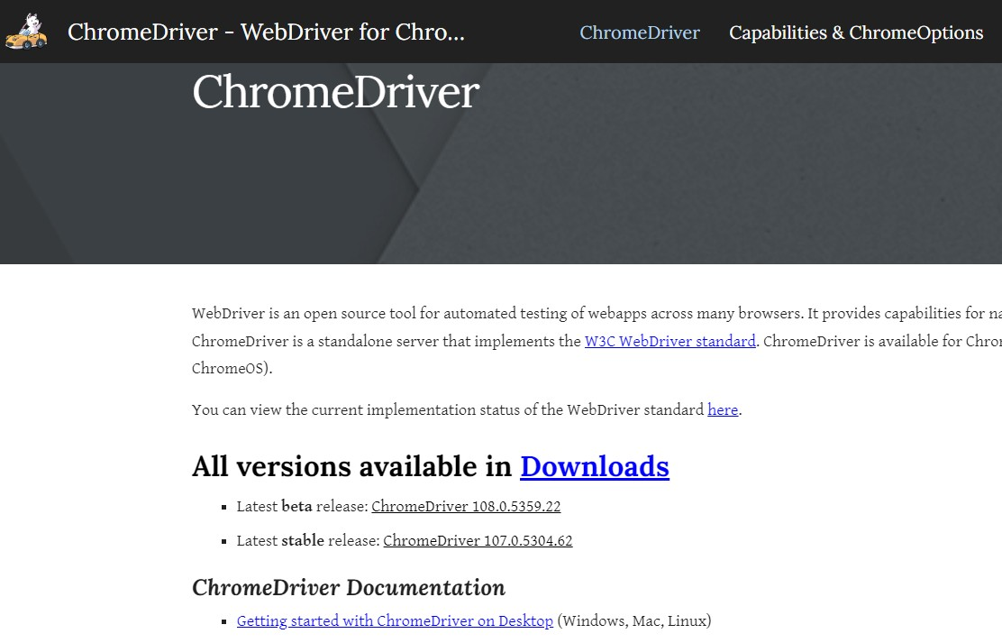

**How to check google chrome version ?**

Click on right corner 3 dots of your browser ->Click on **Help** -> About chrome. You will end up to the interface bellow.

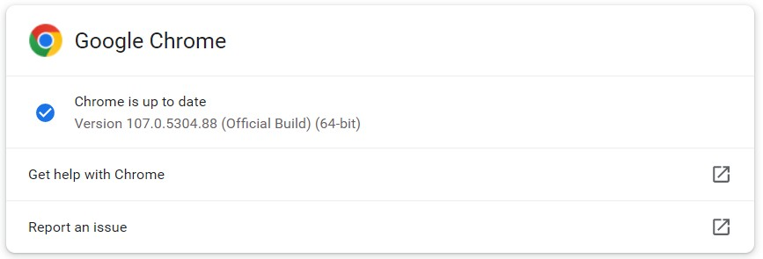

**Step 2 :** After checking that which version matches your browser click on it and download it according to your OS.

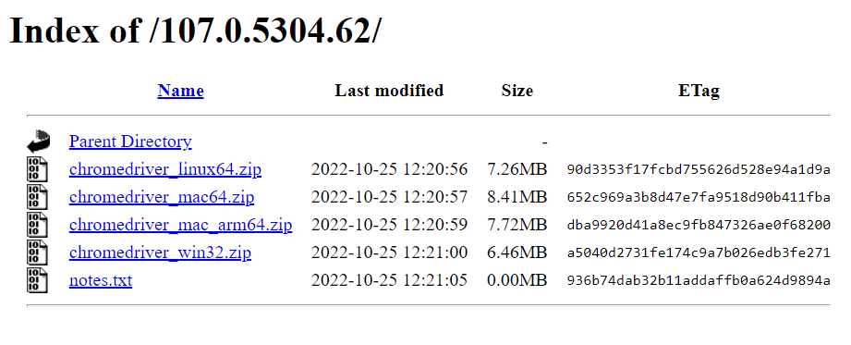

After downloading extract the zip file and move it into the c drive folder where your rest of the selenium files are.

**Configuring selenium:**

**Step 1 :** Open the eclipse IDE then click on file ->new ->java project. Now a new project will be created.

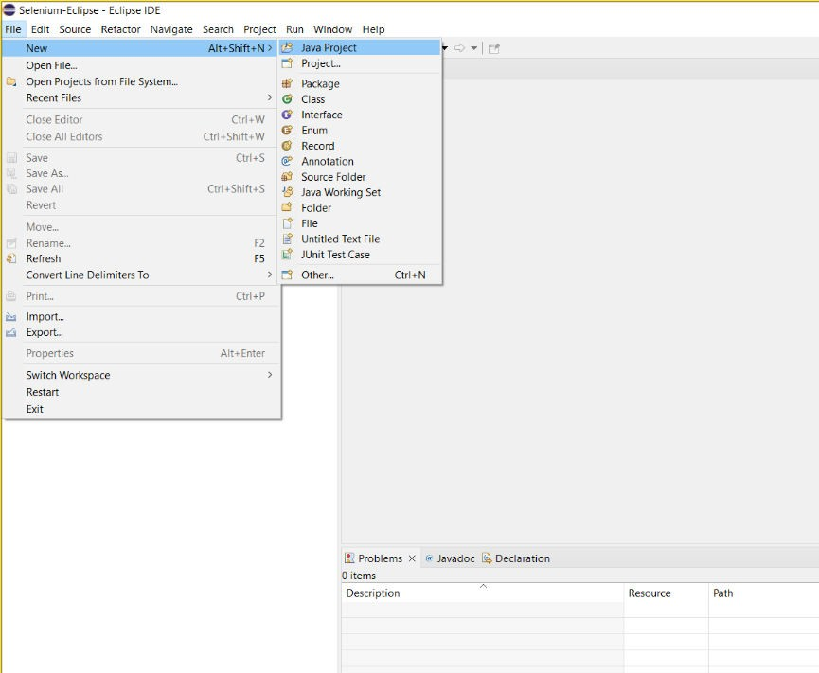

**Step 2 :** Give a project name starts with lower case . and click on finish .

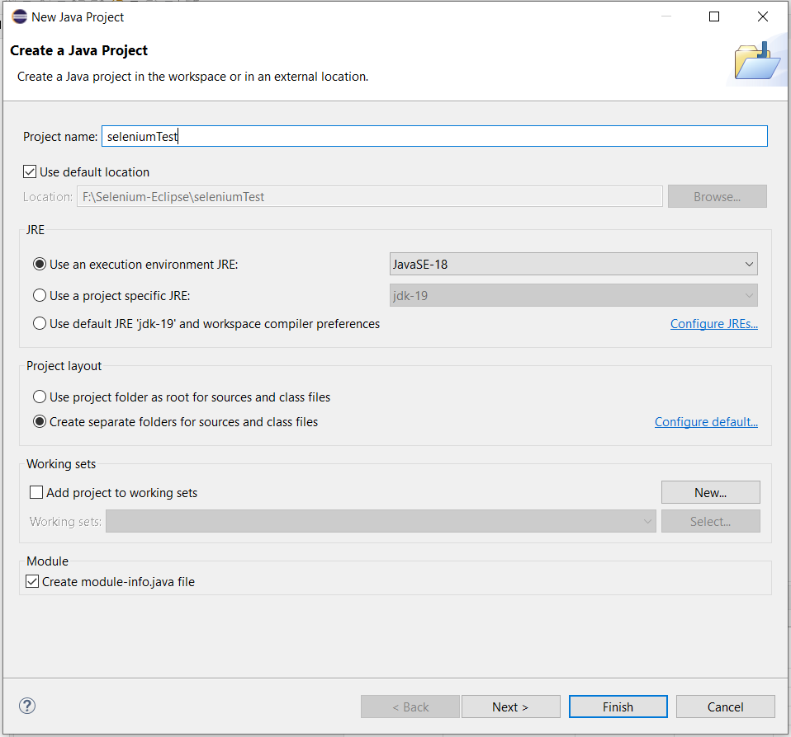

**Step 3 :** For creating a package click on the project file select New-> click on Package .

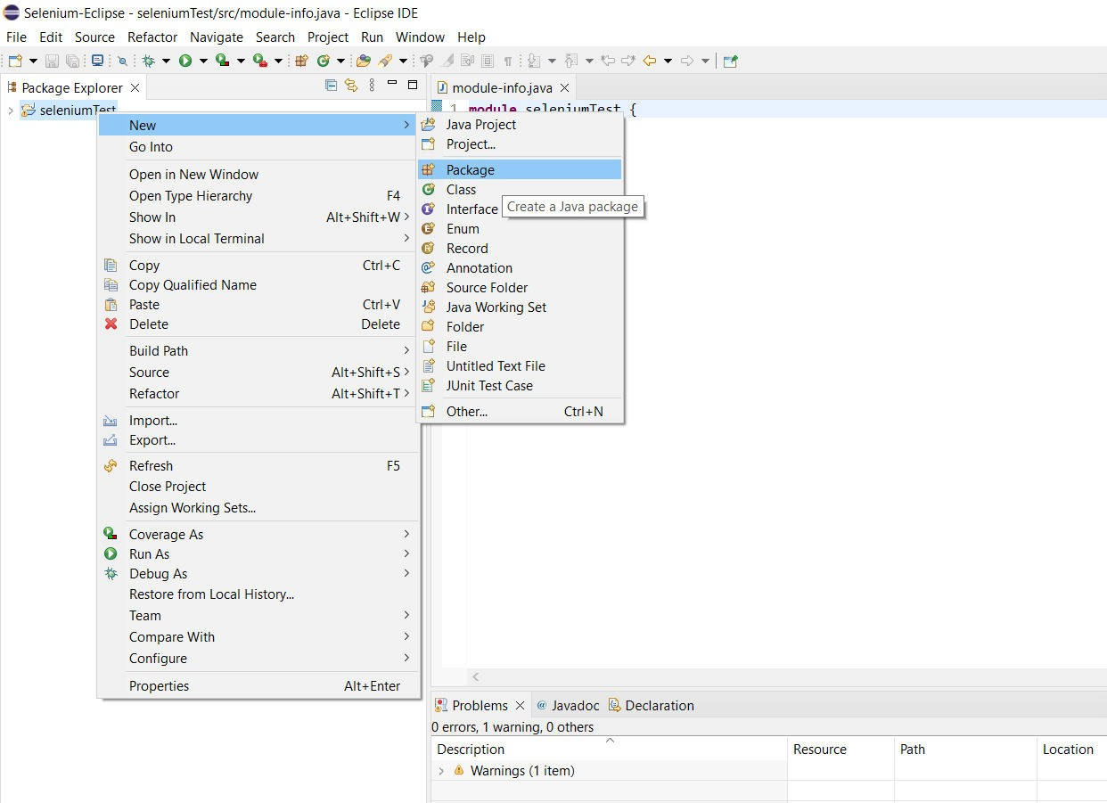

**Step 4 :** Give a name of the package and click on Finish .

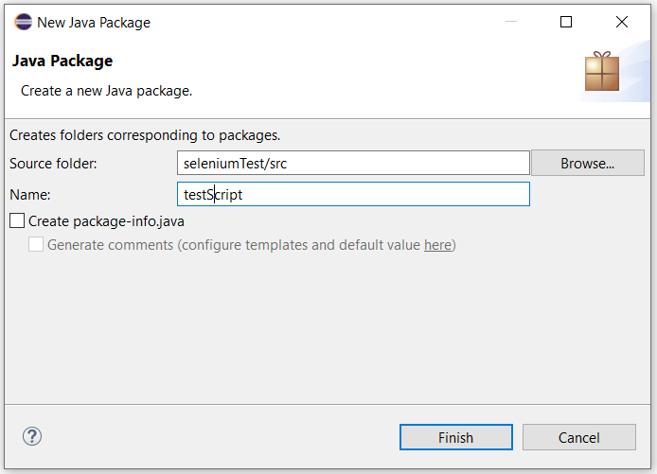

**Step 5 :** For creating a class click on the project file select New-> click on class.

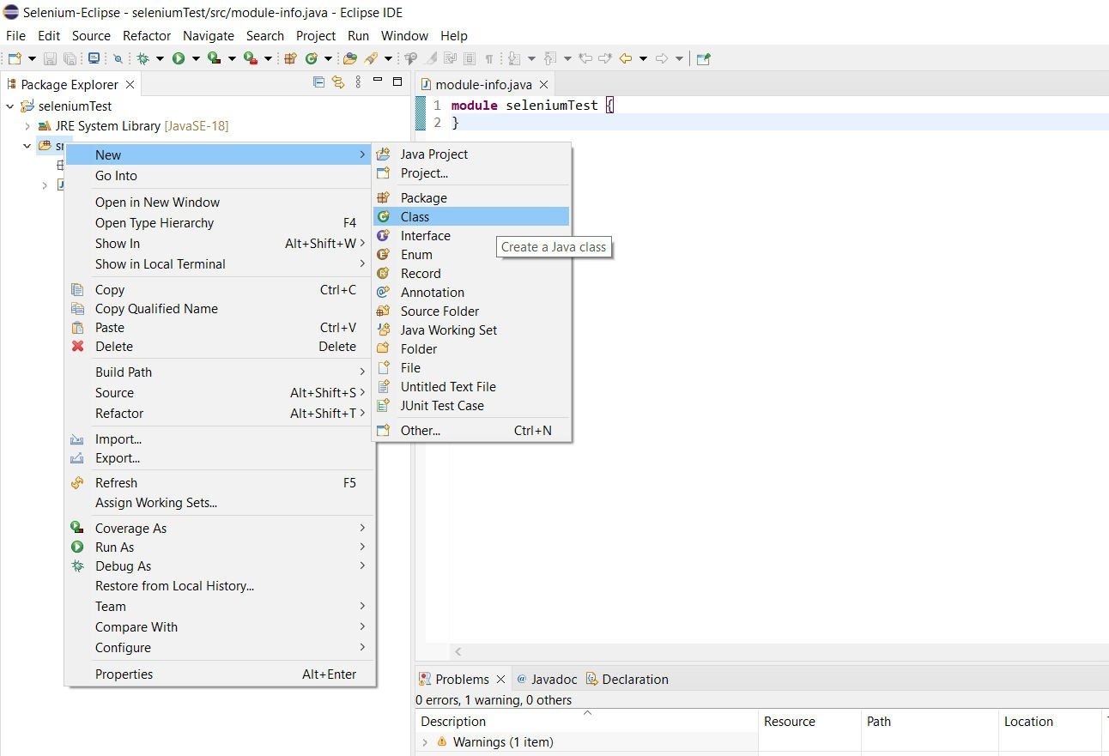

**Step 6 :** Give a name of the class ,select the check option “public static void main” and click on Finish

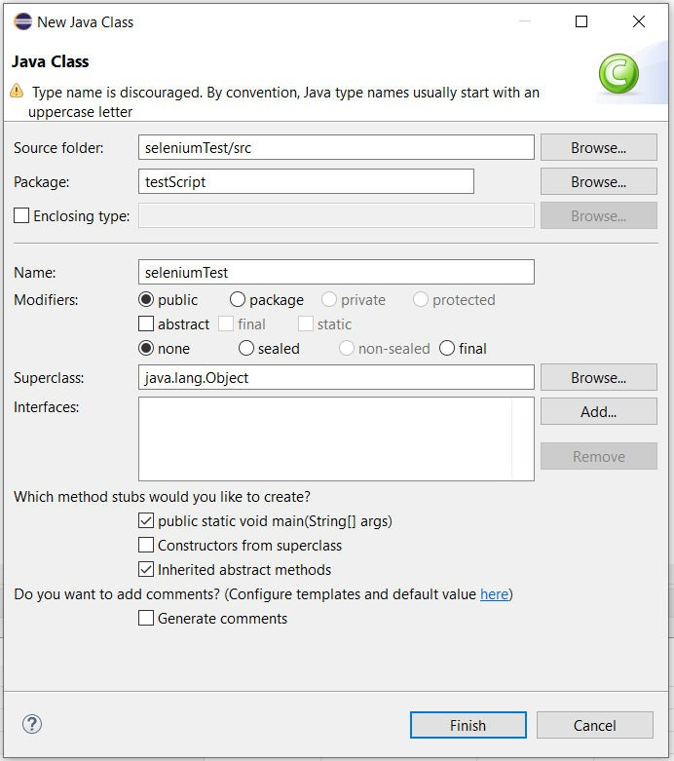

**Step 7 :**Then right click on the project name. Click on **Bulid Path → Configure Build Path**

option.

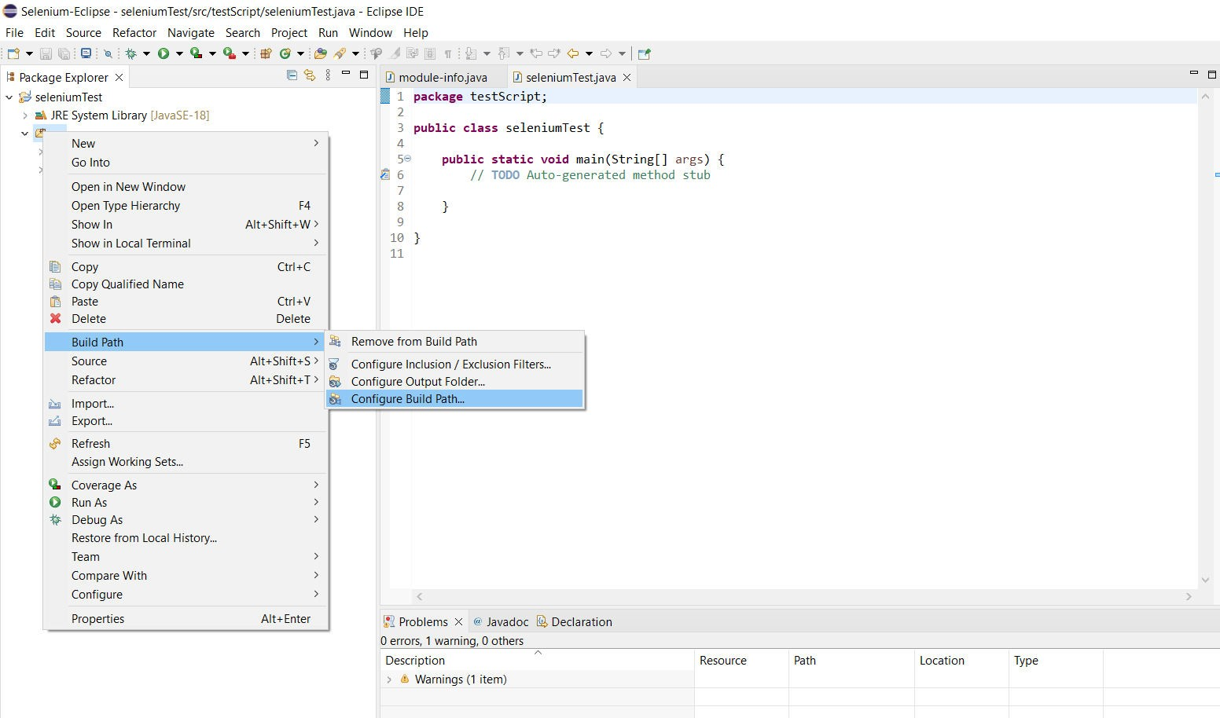

**Step 8 :** Then this tab will appear to us. Then go to **Libraries → Add External JARs…** option.

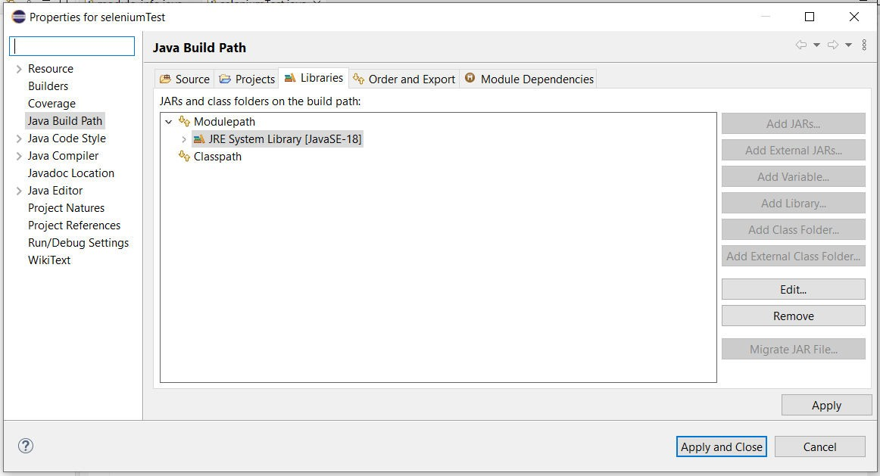

**Step 9 :** Then go to that path here we stored our Selenium file then select the file, click on **Open**

.

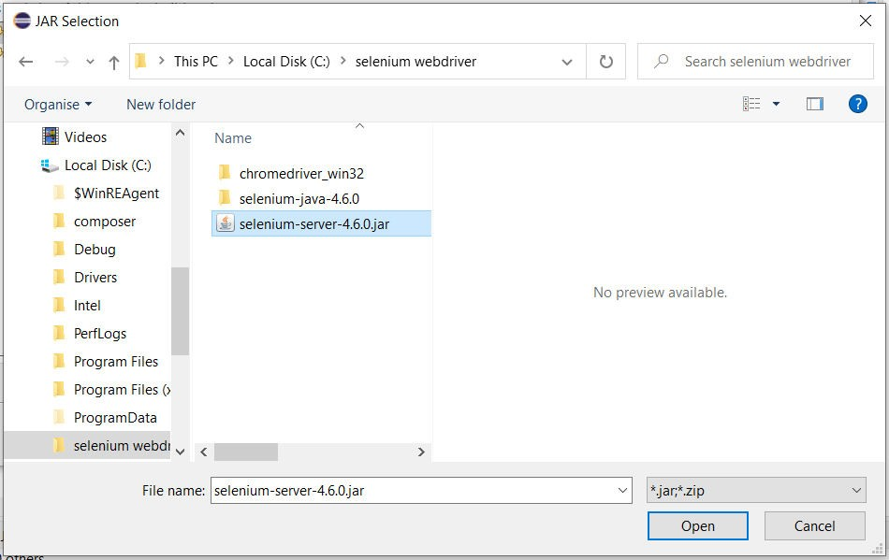

**Step 10 :** Then click on **Apply and Close**.

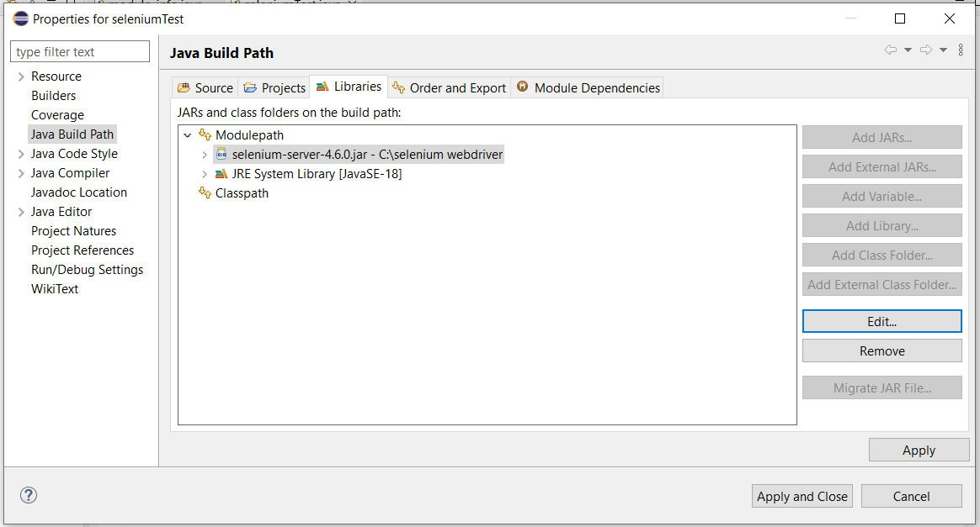

**Step 11 :** Then this screen will appear where you can write test codes.

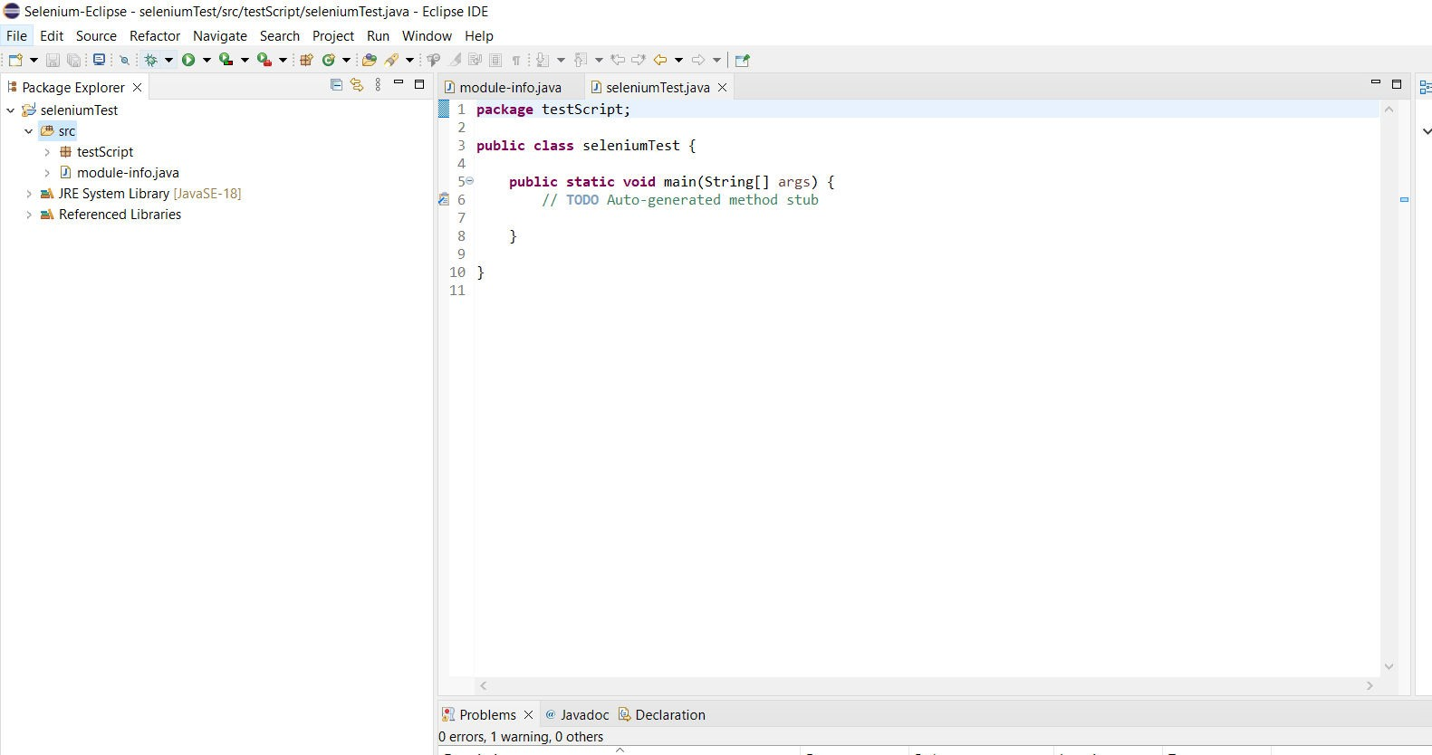

**Flowchart**

**Visual Representation and Description of Each Step of the Create a New Project in Eclipse IDE**

1. In Part-I, Configure Selenium on the Eclipse section’s already explained earlier in this file . Kindly look over that section then you can easily create a new project in Eclipse IDE.

**Select a Web Application Module Which Will be Tested**

1. For testing purposes, we select a web application module “social media admin panel ” that I did in my “Advance Web Technology ” course. We test the Login module of that application.

This is the log in module which I will be testing .

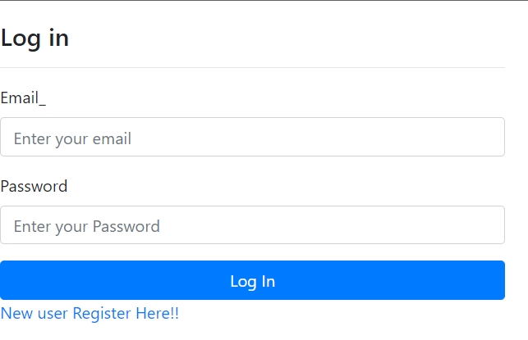

**Prepare a Test Case**

**Project Name:** Social Media application **Test Designed by:** Sreejan Roy

**Test Case ID:** 01 **Test Designed date:** 6. October. 2022

**Test Priority (Low, Medium, High):** Medium **Test Executed by:** Sahara Khan

**Module Name:** Login Session **Test Execution date:** 12. November. 2022

**Test Title:** Verify login with valid Email and password

**Description:** Test the website login page

**Precondition:** User has valid email and password

**Dependencies:** If any

**Test Steps Test Data Expected Results**

**Actual Results**

**Status (Pass/Fail)**

1. **Go to the site 2.Enter username 3.Enter password 4.Click submit**

Email : [bb@gmail.com](mailto:bb@gmail.com) Password: 12345

User should login

Into the application

As expected Pass

**Post Condition:** User is validated with database and successfully login to account. The account session details are logged in the database.

**Write Required Code**

* 1. In that stage, we write the required code for test execution. Each line of the Code's properly explained with comments.
  2. This is the code for login module automation testing.

package seleniumTestDemoPack; import org.openqa.selenium.By;

import org.openqa.selenium.WebDriver;

import org.openqa.selenium.chrome.ChromeDriver; public class seleniumClass {

public static void main(String[] args) {

// TODO Auto-generated method stub System.setProperty("webdriver.chrome.driver", "C:\\selenium

webdriver\\chromedriver_win32\\chromedriver.exe"); WebDriver driver =new ChromeDriver(); driver.get("http://127.0.0.1:8000/login/"); driver.manage().window().maximize();

//login module's Email field id driver.findElement(By.id("email_id")).sendKeys("[bb@gmail.com](mailto:bb@gmail.com)");

//login module's password field id driver.findElement(By.id("pass_id")).sendKeys("12345");

//path for login button driver.findElement(By.xpath("/html/body/div/div/div/form/div[3]/button")).click(); String expected_title = "Document";

String actual_title =driver.getTitle();

//checking condition if(expected_title.equals(actual_title))

{ System.out.println("Test Successfull"); } else

{ System.out.println("failure"); } driver.close();

}

}

Code on Eclipse window ..

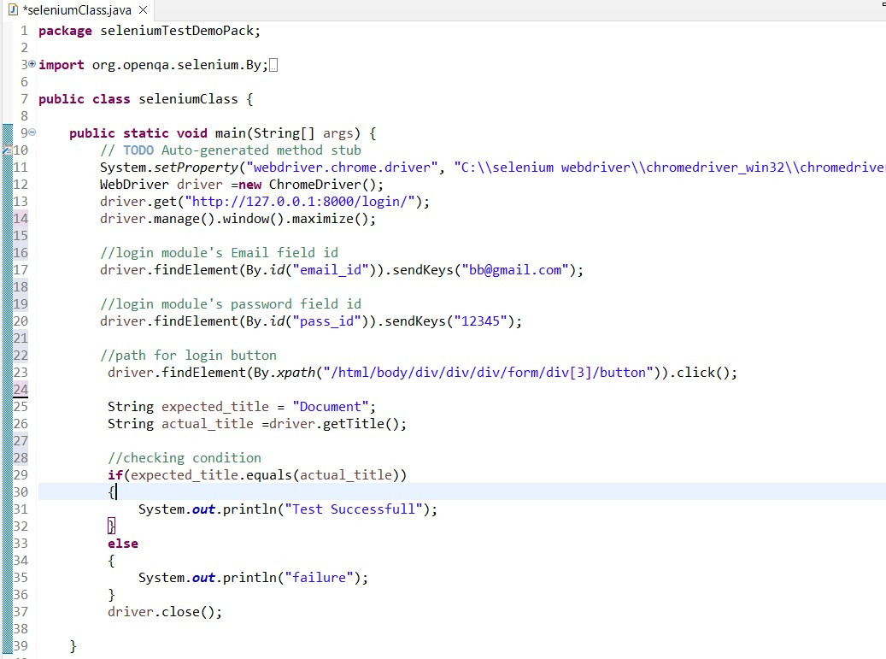

Note for finding X path for login button : First, we need to go to the web page. Then right click on the button and select Inspect option then right click on the marked code then click on copy ->click copy xpath**.**

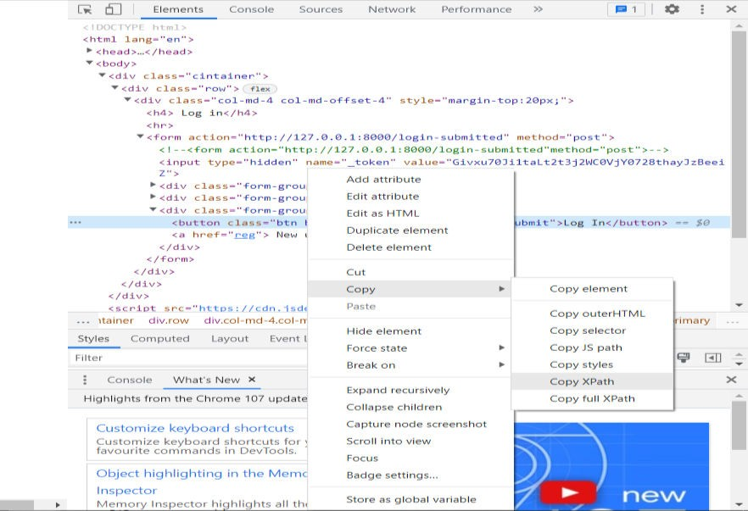

**How to run selenium :**

As code is written in previous steps now you need to save the file then you need to run the program .

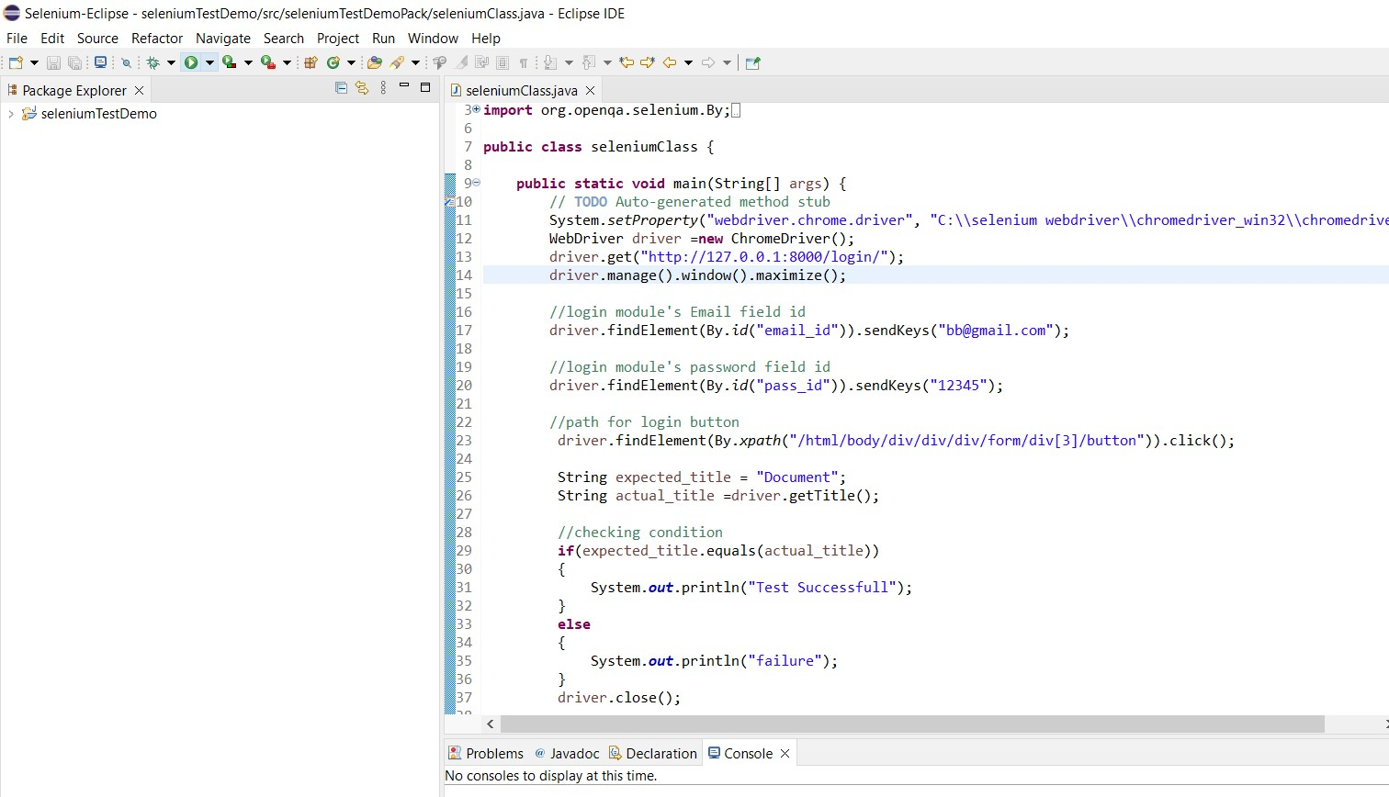

**I have give correct password and email so result come out is successful .**

