**Database Management System**

**CSE 303**

**Lankabangla Security Portal (LBSP)**

**Final Report**

**Group 19**

**DATACODERS**

|  |  |  |
| --- | --- | --- |
| **Student Name** |  | **ID** |

| Md. Omar Bin Sarwar | 2021237 |
| --- | --- |
| Shazneen Islam Akhi | 1920585 |
| Iftakhirul Mohaimin Alif | 1611001 |

Table of Contents

Chapter 1: Introduction 4

Background of the Organization 4

Background of the Project 4

Objective of the Project 4

Scope of the Project 5

Chapter 2: REQUIREMENTS ANALYSIS 6

Rich Picture - AS IS 6

Six Element Analysis - AS IS 7

Problem Analysis 7

Rich Picture – TO BE 7

Six Element Analysis - TO BE 7

Chapter 3: LOGICAL SYSTEM DESIGN 8

Business Rule 8

Entity Relationship Diagram 9

Relational Schema 10

Data Dictionary 11

Table 3.1: Client Table 11

Table 3.2: Joint Account Holder Table 12

Table 3.3: Corporate Account Table 13

Table 3.4: Relationship Manager Table 13

Table 3.5: Head Of Settlement Table 14

Table 3.6: Bank Table 14

Table 3.7: BO Account Table 15

Table 3.8: Power of Attorney Table 15

Table 3.9: Introducer Table 16

Table 3.10: Nominee Table 16

Table 3.11: Adult Nominee Table 17

Table 3.12: Minor Nominee Table 17

Table 3.13: Passport Information Table 17

Chapter 4: PHYSICAL SYSTEM DESIGN 18

INPUT FORMS 18

Log IN Page: 18

Employee Registration Page: 19

Client Registration and Bank information Page: 20

BO Account Opening Page: 21

Nominee/Heir Information Page: 22

Power Of Attorney Page: 23

OUTPUT FORMS 25

Client Dashboard 25

Admin Dashboard/Panel 26

Chapter 5: CONCLUSION 27

Problem And Solution 27

Additional Feature and Further Development 27

Conclusion and Recommendations 27

# Chapter 1: Introduction

## Background of the Organization

LankaBangla Finance Limited, founded in 1997 in Bangladesh, is a non-banking financial institution (NBFI) offering a diverse range of financial services, including consumer and SME loans, corporate finance, investments, and credit cards. It prioritizes customer-centric solutions while operating within Bangladesh Bank's regulatory framework, aiming to support individual and business financial goals.

## Background of the Project

The Online Registration and Verification Portal is a web-based application designed to streamline and enhance the financial services experience for clients, relationship managers, and the head of settlement. It offers convenient online registration, allowing clients to sign up for services effortlessly by providing essential information and uploading documents securely. The portal also features a robust online verification process, ensuring compliance with regulatory requirements and safeguarding client identities. This system enhances efficiency by reducing manual paperwork, improves accessibility, and strengthens security. Relationship managers benefit from easy access to verified client profiles, aiding them in providing efficient service. The head of settlement oversees compliance and security, ensuring a seamless and compliant process.

## Objective of the Project

## Scope of the Project

* Efficiency: Online registration saves time for clients and reduces manual data entry errors.
* Accessibility: Clients can register and verify their accounts from anywhere with an internet connection.
* Enhanced Security: Robust identity verification measures ensure the security of client information and accounts.
* Compliance: The portal helps ensure compliance with regulatory requirements, reducing the risk of non-compliance issues.
* Streamlined Processes: Relationship managers and the head of settlement can access verified client profiles seamlessly, enhancing their ability to provide efficient services.

# Chapter 2: REQUIREMENTS ANALYSIS

## Rich Picture - AS IS

Fig: Rich Picture – AS IS

## Six Element Analysis - AS IS

## Problem Analysis

## Rich Picture – TO BE

Fig: Rich Picture TO BE

## Six Element Analysis - TO BE

# Chapter 3: LOGICAL SYSTEM DESIGN

## Business Rule

We integrated a safer Identity verification system with which the organization’s officials will be able to verify the National Identity of an individual online. In this system the administrator can add clients and other employees.

## Entity Relationship Diagram

## A screenshot of a computer Description automatically generatedRelational Schema

## Data Dictionary

### Table 3.1: Client Table

Client_t

|  |  |  |  |
| --- | --- | --- | --- |
| **Attribute** | **Type** | **Size** | **Remarks** |
| client_code | CHAR | 20 | Client code (Primary Key) of the Table |
| name | VARCHAR | 255 | Full name of the client |
| id_create_date | DATE | “dd-mm-yy” | Date when the ID was created |
| email | VARCHAR | 255 | Email address |
| father_name | VARCHAR | 255 | Father's name |
| mother_name | VARCHAR | 255 | Mother's name |
| present_thana | VARCHAR | 50 | Present thana |
| present_post | VARCHAR | 50 | Present post |
| present_division | VARCHAR | 50 | Present division |
| present_country | VARCHAR | 50 | Present country |
| permanent_thana | VARCHAR | 50 | Permanent thana |
| permanent_post | VARCHAR | 50 | Permanent post |
| permanent_division | VARCHAR | 50 | Permanent division |
| permanent_country | VARCHAR | 50 | Permanent country |
| mobile | CHAR | 11 | Contact number (mobile) |
| tel | CHAR | 9 | Telephone number |
| dob | DATE | “dd-mm-yy” | Date of Birth |
| gender | VARCHAR | 6 | Gender (e.g., Male, Female) |
| tin | CHAR | 20 | Tax Identification Number |
| nationality | VARCHAR | 50 | Nationality |
| occupation | VARCHAR | 50 | Occupation |
| nid | CHAR | 10 | National ID number |
| photo | VARCHAR | 255 | Photo of the individual |
| signature | VARCHAR | 255 | Photo of a Signature of the individual |
| operation_type | VARCHAR | 10 | Type of operation (for BO_AC) eg: joint/corporate |
| bo_id | CHAR | 20 | Foreign Key to BO_AC (for CLIENT) |
| bank_ac_number | CHAR | 20 | Bank account number (for CLIENT) |
| manager_id | CHAR | 20 | Foreign Key to RELATIONSHIP MANAGER (for CLIENT) |
| pass | VARCHAR | 255 | Password for the user |

Table 3.2: Joint Account Holder Table  
jointacholder_t

|  |  |  |  |
| --- | --- | --- | --- |
| **Attribute** | **Type** | **Size** | **Remarks** |
| client_code | CHAR | 20 | Client code (Primary Key) which is also a foreign key of the Client Table |
| name | VARCHAR | 255 | Full name of the joint account holder |
| id_create_date | DATE | “dd-mm-yy” | Date when the ID was created |
| email | VARCHAR | 255 | Email address |
| father_name | VARCHAR | 255 | Father's name |
| mother_name | VARCHAR | 255 | Mother's name |
| present_address | TEXT |  | Present address |
| permanent_address | TEXT |  | Permanent address |
| mobile | CHAR | 11 | Contact number (mobile) |
| tel | CHAR | 9 | Telephone number |
| dob | DATE | “dd-mm-yy” | Date of Birth |
| gender | VARCHAR | 6 | Gender (e.g., Male, Female) |
| tin | CHAR | 20 | Tax Identification Number |
| nationality | VARCHAR | 50 | Nationality |
| occupation | VARCHAR | 50 | Occupation |
| nid | CHAR | 10 | National ID number |
| photo | VARCHAR | 255 | Photo of the individual |
| signature | VARCHAR | 255 | Photo of a Signature of the individual |

### Table 3.3: Corporate Account Table

corporate_t

|  |  |  |  |
| --- | --- | --- | --- |
| **Attribute** | **Type** | **Size** | **Remarks** |
| client_code | CHAR | 20 | Client code (Primary Key) which is also a foreign key of the Client Table |
| name | VARCHAR | 255 | Full name of the joint account holder |
| id_create_date | DATE | “dd-mm-yy” | Date when the ID was created |
| email | VARCHAR | 255 | Email address |
| father_name | VARCHAR | 255 | Father's name |
| present_address | TEXT |  | Present address |
| permanent_address | TEXT |  | Permanent address |
| mobile | CHAR | 11 | Contact number (mobile) |
| tel | CHAR | 9 | Telephone number |
| dob | DATE | “dd-mm-yy” | Date of Birth |
| gender | VARCHAR | 6 | Gender (e.g., Male, Female) |
| tin | CHAR | 20 | Tax Identification Number |
| nationality | VARCHAR | 50 | Nationality |
| occupation | VARCHAR | 50 | Occupation |
| nid | CHAR | 10 | National ID number |
| photo | VARCHAR | 255 | Photo of the individual |

### Table 3.4: Relationship Manager Table

relationshipmanager_t

|  |  |  |  |
| --- | --- | --- | --- |
| **Attribute** | **Type** | **Size** | **Remarks** |
| manager_id | CHAR | 20 | Primary Key |
| name | VARCHAR | 255 | Full name of the manager |
| email | VARCHAR | 255 | Email address |
| address | TEXT |  | Residential address |
| join_date | DATE | “dd-mm-yy” | Date of joining the company |
| photo | VARCHAR | 255 | Binary Large Object for storing photos |
| signature | VARCHAR | 255 | Binary Large Object for storing signatures |
| mobile | CHAR | 11 | Contact number |
| head_id | CHAR | 20 | Foreign Key to HEAD OF SETTLEMENT Table |
| pass | VARCHAR | 255 | Password of the user |

### Table 3.5: Head Of Settlement Table

headofsettlement_t

|  |  |  |  |
| --- | --- | --- | --- |
| **Attribute** | **Type** | **Size** | **Remarks** |
| head_id | CHAR | 20 | Primary Key |
| name | VARCHAR | 255 | Full name of the head of settlement |
| email | VARCHAR | 255 | Email address |
| address | TEXT |  | Residential address |
| join_date | DATE | “dd-mm-yy” | Date of joining the company |
| photo | VARCHAR | 255 | Binary Large Object for storing photos |
| signature | VARCHAR | 255 | Binary Large Object for storing signatures |
| mobile | CHAR | 11 | Contact number |
| pass | VARCHAR | 255 | Password of the user |

### Table 3.6: Bank Table

bank_t

|  |  |  |  |
| --- | --- | --- | --- |
| **Attribute** | **Type** | **Size** | **Remarks** |
| bank_ac_number | VARCHAR | 20 | Account number (Primary Key) |
| name | VARCHAR | 50 | Bank name |
| branch | VARCHAR | 50 | Branch name |
| routing_num | VARCHAR | 20 | Routing number |
| client_code | CHAR | 20 | Client code |

### Table 3.7: BO Account Table

boac_t

|  |  |  |  |
| --- | --- | --- | --- |
| **Attribute** | **Type** | **Size** | **Remarks** |
| bo_id | CHAR | 20 | Primary Key |
| open_date | DATE | “dd-mm-yy” | Date the account was opened |
| operation_type | VARCHAR | 10 | Type of operation  eg: individual/joint/corporate |
| ac_branch | VARCHAR | 50 | Branch for the Brokerage Operation eg: online/Uttara/Syhet branch |
| bo_status | VARCHAR | 10 | Status of the BO account, which indicates the activation of the BO account |
| introducer_id | CHAR | 20 | Foreign Key to Introducer Table |
| client_code | CHAR | 20 | Foreign Key to Client Table |
| passport_num | VARCHAR | 20 | Foreign key to Passport Table |
| poa_id | CHAR | 20 | Foreign Key to POA Table |

### Table 3.8: Power of Attorney Table

poa_t

|  |  |  |  |
| --- | --- | --- | --- |
| **Attribute** | **Type** | **Size** | **Remarks** |
| poa_id | CHAR | 20 | Primary Key |
| name | VARCHAR | 255 | Full name of the individual |
| mobile | CHAR | 11 | Contact number |
| tel | CHAR | 9 | Telephone number |
| email | VARCHAR | 255 | Email address |
| address | TEXT |  | Residential address |
| passport_num | VARCHAR | 20 | Foreign key to Passport Table |
| bo_id | CHAR | 20 | Foreign Key to BO_AC Table |

### Table 3.9: Introducer Table

introducer_t

|  |  |  |  |
| --- | --- | --- | --- |
| **Attribute** | **Type** | **Size** | **Remarks** |
| introducer_id | CHAR | 20 | Primary Key |
| client_code | CHAR | 20 | Client code |

### Table 3.10: Nominee Table

nominee_t

|  |  |  |  |
| --- | --- | --- | --- |
| **Attribute** | **Type** | **Size** | **Remarks** |
| nominee_id | CHAR | 20 | Primary Key |
| name | VARCHAR | 255 | Full name of the nominee |
| relationship | VARCHAR | 20 | Relationship with the account holder |
| percentage | DECIMAL | 4,2 | Nominee's percentage of ownership |
| residency | VARCHAR | 10 | Residency status |
| nationality | VARCHAR | 50 | Nationality |
| dob | DATE | “dd-mm-yy” | Date of Birth |
| nid | CHAR | 10 | National ID number of the individual |
| photo | VARCHAR | 255 | Photo of the individual |
| signature | VARCHAR | 255 | Photo of a Signature of the individual |
| age_status | CHAR | 5 | Age status (e.g., minor or adult) |
| passport_num | VARCHAR | 20 | Passport number |
| bo_id | CHAR | 20 | Foreign Key to BO_AC Table |

### Table 3.11: Adult Nominee Table

adult_t

|  |  |  |  |
| --- | --- | --- | --- |
| **Attribute** | **Type** | **Size** | **Remarks** |
| nominee_id | CHAR | 20 | Foreign Key to NOMINEE Table |
| mobile | CHAR | 11 | Contact number |
| email | VARCHAR | 255 | Email address |
| nid | CHAR | 10 | National ID number of the individual |

### Table 3.12: Minor Nominee Table

minor_t

|  |  |  |  |
| --- | --- | --- | --- |
| **Attribute** | **Type** | **Size** | **Remarks** |
| nominee_id | CHAR | 20 | Foreign Key to NOMINEE Table |
| guardian_name | VARCHAR | 255 | Full name of the guardian |
| relationship | VARCHAR | 20 | Relationship with the minor |
| address | VARCHAR | 50 | Residential address |
| g_mobile | CHAR | 11 | Guardian Contact number |
| g_email | VARCHAR | 255 | Guardian Email address |
| nid | CHAR | 10 | National ID number of the guardian |
| minor_maturity_date | DATE | “dd-mm-yy” | Date of the minor when they become mature |

### Table 3.13: Passport Information Table

passport_t

|  |  |  |  |
| --- | --- | --- | --- |
| **Attribute** | **Type** | **Size** | **Remarks** |
| passport_num | VARCHAR | 20 | Passport number (Primary Key) |
| issue_place | VARCHAR | 50 | Place of passport issuance |
| issue_date | DATE | “dd-mm-yy” | Date of passport issuance |
| expiry_date | DATE | “dd-mm-yy” | Date of passport expiry |
| poa_id | CHAR | 20 | Foreign Key to POA (Power of Attorney) Table |
| bo_id | CHAR | 20 | Foreign Key to BO_AC (Account Holder) |
| nominee_id | CHAR | 20 | Foreign Key to NOMINEE Table |

# Chapter 4: PHYSICAL SYSTEM DESIGN

## INPUT FORMS

### Log IN Page:

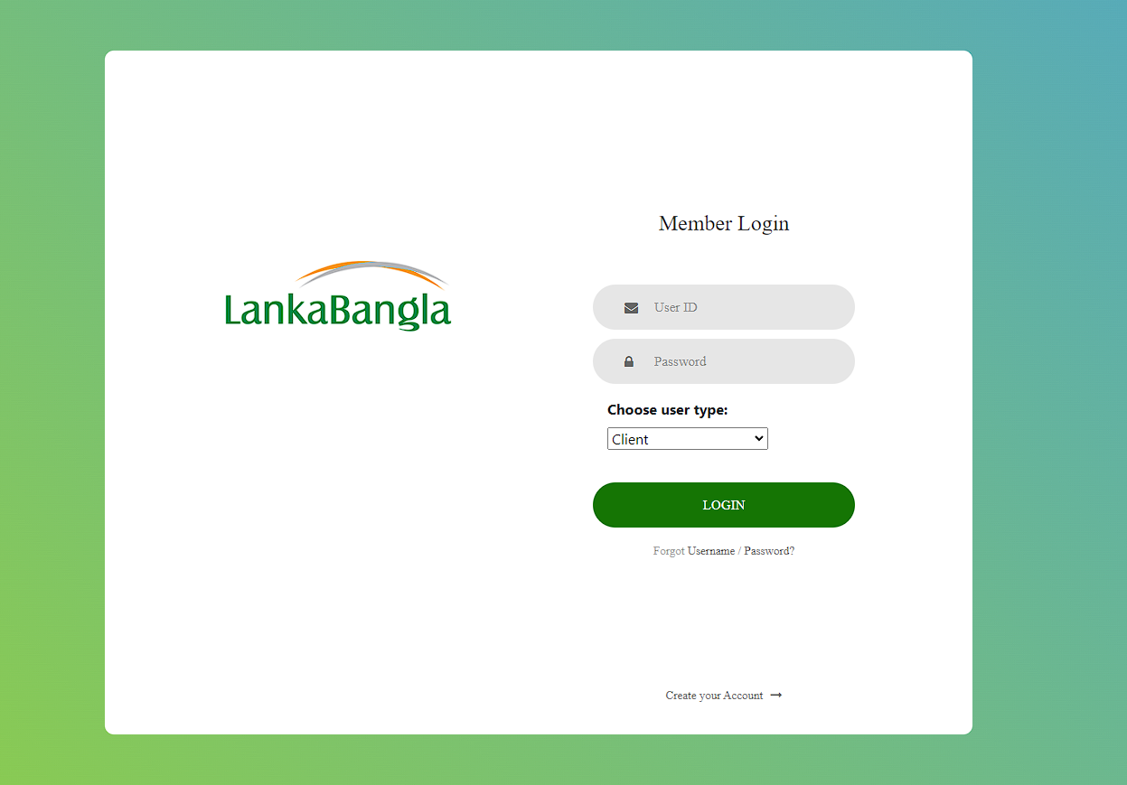This page is required for the users to log in to the application.

SQL:

### Employee Registration Page:

This page is required for the **ADMIN** to insert a new Relationship Manager and Head of Settlement.

SQL:

### Client Registration and Bank information Page:

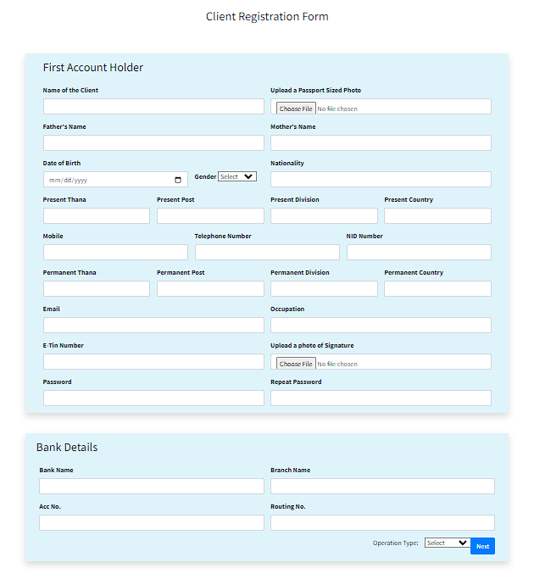This page is used by the clients to register into the system and input bank information.

SQL:

### BO Account Opening Page:

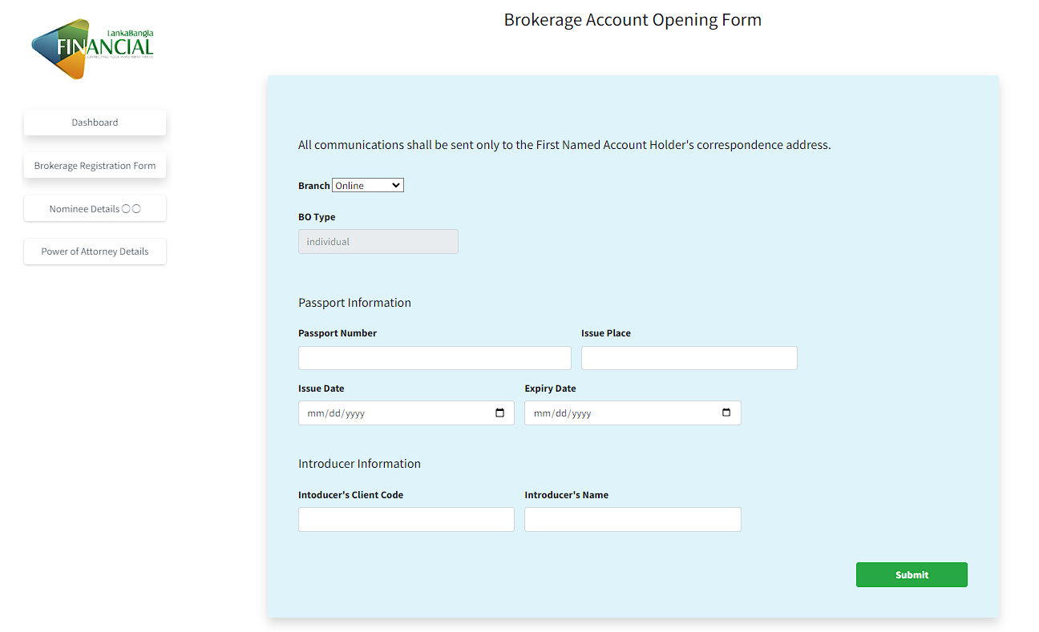This page is required to open a BO Account by an individual client:

SQL:

### Nominee/Heir Information Page:

This page is used by the client to provide information about the nominee/heir.

SQL:

### Power Of Attorney Page:

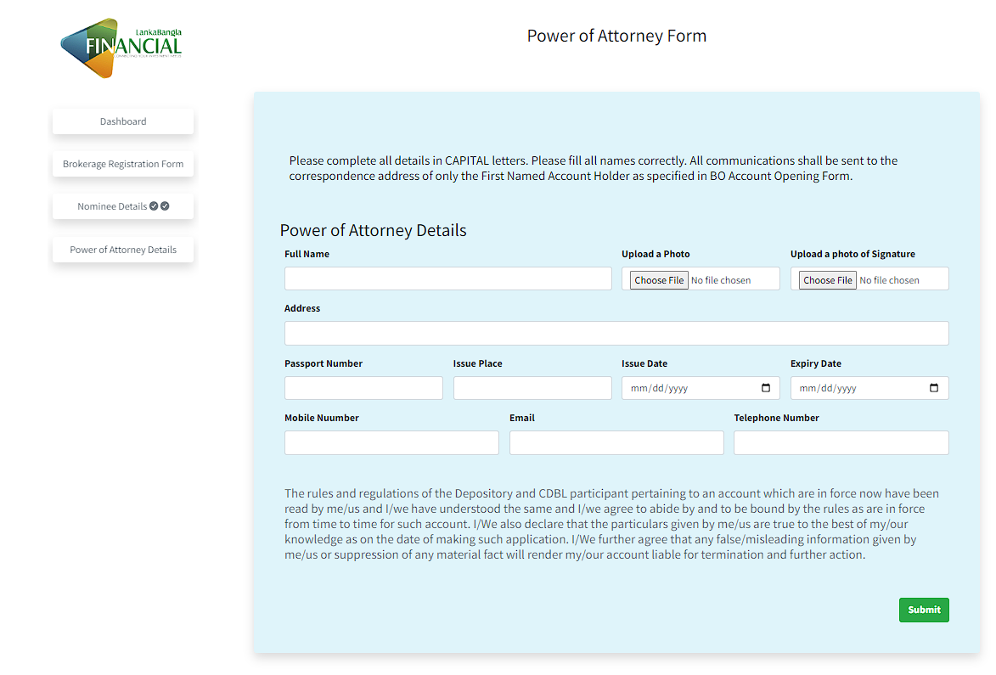This page is used by the client to provide information about the power of attorney.

SQL:

## OUTPUT FORMS

### Client Dashboard

This page is the interface of the client dashboard or panel, from where the client will be able to see all his information and change it.

SQL:

### Admin Dashboard/Panel

This page is the interface of the ADMIN panel, from where the admins will check data of the whole system and give access to more clients and employees such as Head of Settlement and Relationship Manager.

SQL:

# Chapter 5: CONCLUSION

## Problem And Solution

1. While working on this project we faced some challenges on collecting data and how the system works
2. As this is a huge company dealing with multiple systems, we were not able to make a system for the whole organization, rather we focused on the basic part of the organization, where we just make a system for the clients, relationship manager, head of settlement, and admin.

## Additional Feature and Further Development

1. A function can be integrated into the LBPS system which will create an automated excel sheet of data from the database, and the officials will be able to print a hard copy of the data.
2. An internal mailing portal can be integrated into the system with which the Relationship Manager and CDPL authorities can communicate easily and exchange BO Account data, which is required to open the account, this will lower the risk of losing or expose the data.
3. An AI assistant service can be integrated so that client can have seamless customer service without waiting for a receiver.

## Conclusion and Recommendations