RISK AVERSION COEFFICIENT  
&  
OPTIMAL CAPITAL ALLOCATION LINE

Prepared for

Ms. Shakila Yasmin  
Associate Professor  
Institute of Business Administration University of Dhaka  
Course Instructor  
Portfolio Management & Investment Analysis

Prepared by

Abul Kalam Faruk  
Roll: 42, MBA 59D

Institute of Business Administration University of Dhaka

29 September 2019

**Background**

Mr Abdur Rahman wants to create a diversified portfolio with two risky assets and risk free government T-Bills. He wants to invest his BDT 3,00,000 cash deposits in the portfolio. His investment horizon for this portfolio is 5 years. The Investment Policy Statement (IPS) shows the following requirements and constraints for the investor in the portfolio.

|  |  |
| --- | --- |
| Investment Amount | 3,00,000 Tk |
| Investment Horizon | 5 years |
| Required Rate of Return of Investor | 16.23% |
| Expected Rate of Return of the Portfolio | 29% |
| Risk Free Rate | 9.23% |
| Risk Aversion Co-efficient | 3.10 |
|  |  |

**Risk Free Rate**

Bangladesh Bank’s latest auction data shows the yield of 5 years T-Bonds to be 9.23% (Appendix A). We have taken the risk free rate of 9.23% for calculating risk premiums in our portfolio.

**Risk Aversion Co-efficient (A)**

Investors willingness to take risk is an important factor to consider when determining the portfolio for the investor. Mathematically it is determined by Risk Aversion Co-efficient (A). Which is calculated from the following formula:

$$A= \frac{E\left(r_{Q}\right)- r_{f}}{σ^{2}}$$

Here,

$r_{f}$ = Risk Free Rate

$E\left(r_{Q}\right)$ = Expected Return

$σ$ = Standard Deviation of the Portfolio

$E\left(r_{Q}\right)- r_{f}$ = Risk Premium

Investor was given a multiple sets of risk return choices (Appendix B). Chosen risk premiums were used to calculate A. The average 3.09 was taken as the investors Risk Aversion Co-efficient (A).

|  |  |  |  |
| --- | --- | --- | --- |
| **Picked Cards** | **Premium** | **Associated Risk** | **Risk Aversion Co-efficient** |
| Portfolio A | 10 | 18 | 3.09 |
| Portfolio B | 14 | 21 | 3.17 |
| Portfolio C | 22 | 26 | 3.25 |
| Portfolio D | 25 | 27 | 3.43 |
| Portfolio E | 38 | 34 | 3.29 |
| Portfolio F | 43 | 43 | 2.33 |
|  |  | **Average** | **3.10** |

**Risky Assets Selection:**

Selection procedures involves taking historical closing prices of the stocks trading in at least for five years and calculating annual return, annual standard deviation and sharpe ratio for each stock (Appendix C). Top 15 performing stocks chosen to calculate the correlation matrix (Appendix D). Considering their sharpe ratio and correlations for the purpose of diversification benefit, we have chosen two companies with following particulars.

|  |  |
| --- | --- |
| Companies | United Power Bangladesh ltd. (UPGDCL) |
|  | Monno Group (MONNOSTAF) |

Their risk adjusted returns and correlations are:

|  |  |  |  |  |
| --- | --- | --- | --- | --- |
| **Symbol** | **Annual Return** | **Standard Deviation** | **Sharpe Ratio** | **Correlation** |
| **UPGDCL** | 29% | 37% | 0.54 | 0.01 |
| **MONNOSTAF** | 43% | 61% | 0.56 |

**Portfolio of Risky Assets**

The expected rate of return on a portfolio is the weighted average of the expected returns on the component securities, with the portfolio proportions as weights.

page2image47316992

The variance of the rate of return on a two-risky-asset portfolio is-

page2image47318864

Where ρBS is the correlation coefficient between the returns on the two risk assets. As we can see the value is very close to zero, we can interpret that the stocks have no linear relationship or a very weak linear relationship.

For efficient frontier of the portfolio of two assets, we have calculated portfolio returns, risk and sharpe ratio for various weights (Appendix E).

Maximum sharpe ratio is found to be 0.78 for 60% United Power Bangladesh ltd and 40% Monno Group. Returns and Risk are as follows.

|  |  |
| --- | --- |
| **UPGDCL** | 60% |
| **MONNOSTAF** | 40% |
| **Portfolio Return** | 35% |
| **Portfolio Risk** | 33% |
| **Portfolio Sharpe Ratio** | 0.78 |
| **Risk Premium to VAR** | 2.37 |

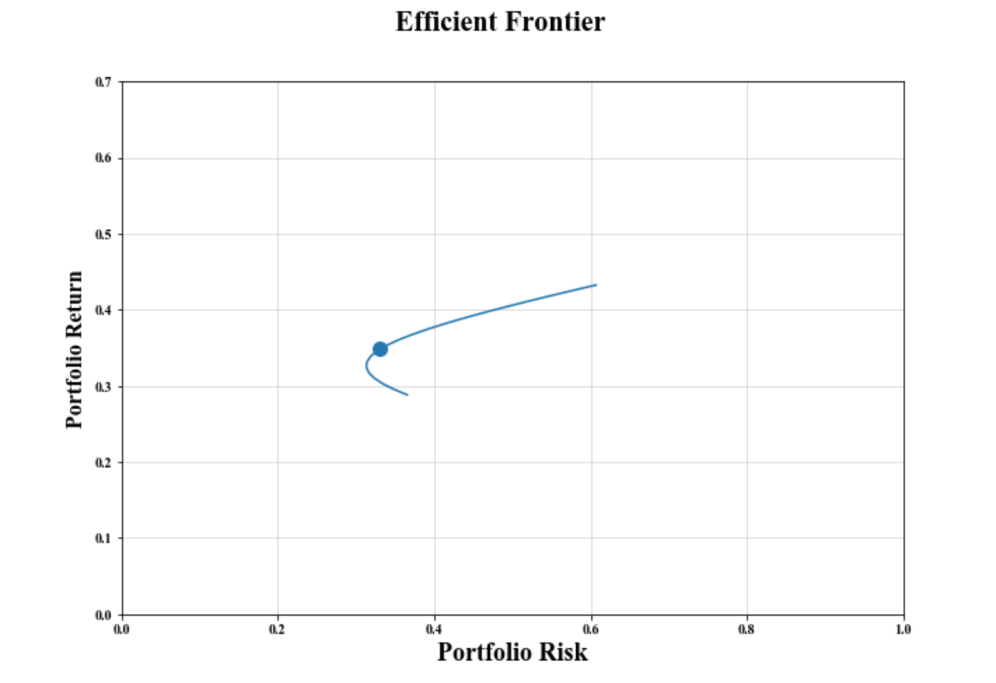

Figure: Risk and Return of the portfolio of two risky assets

**Risk Free and Risky Assets Portfolio:**

The compensation for risk demanded by the investor must be compared to the price of risk offered by the risky portfolio. We can find the investor’s preferred capital allocation, y, by dividing the risky portfolio’s price of risk by the investor’s risk aversion, her required price of risk:

page6image47323024

For risk free rate of 9% and investors risk aversion coefficient of 3.10, we can calculate the percentage of risky asset portfolio as 0.77 or 77% and risk free asset to be taken as 23% of the total investment.

|  |  |
| --- | --- |
| Risk Free Rate | 9% |
| Risk Aversion Coefficient | 3.10 |
| Portfolio Return | 35% |
| Portfolio Risk | 33% |
| Risk Premium | 26% |
| Weight of the Risky Portfolio | 77% |
| Weight of the Risk Free Asset | 23% |

The portfolio with risk free asset (Appendix F) would be as follows:

|  |  |
| --- | --- |
| **Risk Free Weight** | 23% |
| **Risky Portfolio** | 77% |
| **Portfolio Return** | 29% |
| **Portfolio Risk** | 25% |
| **Sharpe Ratio** | 0.78 |

The investment will allocated 23% to government T-Bonds and 46.2% in United Power Bangladesh ltd and 30.8% in Monno Group.

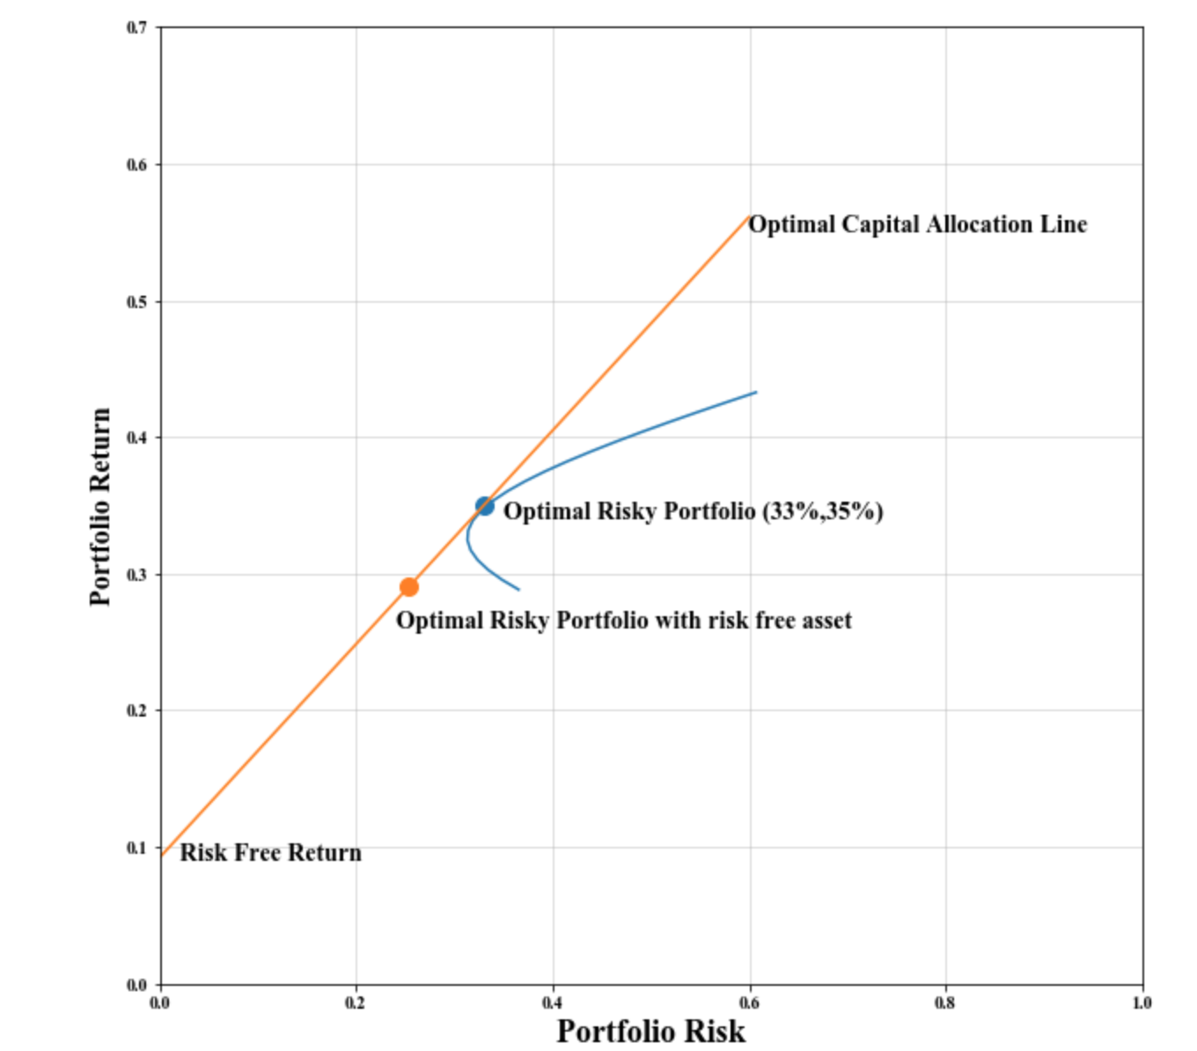

Figure: Capital Allocation Line of Optimal Risky Portfolio with Risk Free Asset

**Complete Portfolio**



**Reference:**

**[1]** [**www.dsebd.org**](http://www.dsebd.org)

**[2] Investment by Bodie, Kane and Marcus**

**Appendix**

1. **Cut-off and Standard Tenor Yield of T-Bonds on on 25 September, 2019**

|  |  |  |  |
| --- | --- | --- | --- |
| Auction Tenor & Yield | | Standard Tenor & Yield | |
| Year | Cut off yield (%) | Year | Yield (%) |
| 2.00 | 8.73 | 2 | 8.73 |
| 4.50 | 9.23 | **5** | **9.23** |
| 9.92 | 9.27 | 10 | 9.27 |
| 14.18 | 9.53 | 15 | 9.57 |
| 19.75 | 9.78 | 20 | 9.79 |

<https://bb.org.bd/monetaryactivity/treasury.php>

1. **Choice Cards**







1. **Top Performing Stocks**

|  |  |  |  |
| --- | --- | --- | --- |
| **Symbol** | Annual Return | Standard Deviation | Sharpe Ratio |
| KAY&QUE | 79% | 57% | 1.23 |
| STANCERAM | 66% | 51% | 1.11 |
| RENWICKJA | 55% | 46% | 1.01 |
| AZIZPIPES | 59% | 51% | 0.97 |
| BDAUTOCA | 64% | 61% | 0.88 |
| MONNOCERA | 55% | 57% | 0.80 |
| DAFODILCOM | 35% | 39% | 0.67 |
| RAHIMAFOOD | 41% | 48% | 0.66 |
| DULAMIACOT | 52% | 67% | 0.64 |
| SONALIANSH | 37% | 47% | 0.59 |
| AZIZPIPES | 53% | 74% | 0.59 |
| MONNOSTAF | 43% | 61% | 0.56 |
| UPGDCL | 29% | 37% | 0.54 |
| NORTHERN | 37% | 54% | 0.51 |
| RECKITTBEN | 25% | 31% | 0.51 |

1. **Correlations of Stocks**
2. **Portfolio Risk-Return of Risky Assets**

|  |  |  |  |  |
| --- | --- | --- | --- | --- |
| **UPGDCL** | **MONNOSTAF** | **Portfolio Return** | **Portfolio Std** | **Portfolio Sharpe Ratio** |
| 0% | 100% | 43% | 61% | 0.56 |
| 5% | 95% | 43% | 58% | 0.58 |
| 10% | 90% | 42% | 55% | 0.59 |
| 15% | 85% | 41% | 52% | 0.61 |
| 20% | 80% | 40% | 49% | 0.63 |
| 25% | 75% | 40% | 46% | 0.65 |
| 30% | 70% | 39% | 44% | 0.68 |
| 35% | 65% | 38% | 41% | 0.70 |
| 40% | 60% | 37% | 39% | 0.72 |
| 45% | 55% | 37% | 37% | 0.74 |
| 50% | 50% | 36% | 35% | 0.76 |
| 55% | 45% | 35% | 34% | 0.77 |
| **60%** | **40%** | **35%** | **33%** | **0.78** |
| 65% | 35% | 34% | 32% | 0.77 |
| 70% | 30% | 33% | 31% | 0.76 |
| 75% | 25% | 32% | 31% | 0.74 |
| 80% | 20% | 32% | 32% | 0.71 |
| 85% | 15% | 31% | 32% | 0.67 |
| 90% | 10% | 30% | 33% | 0.63 |
| 95% | 5% | 30% | 35% | 0.58 |
| 100% | 0% | 29% | 37% | 0.54 |

1. **Portfolio Risk Return with Risk Free Asset**

|  |  |  |  |
| --- | --- | --- | --- |
| **Risky Portfolio** | **Risk Free** | **Portfolio Return** | **Portfolio Risk** |
| 0% | 100% | 9% | 0% |
| 5% | 95% | 11% | 2% |
| 10% | 90% | 12% | 3% |
| 15% | 85% | 13% | 5% |
| 20% | 80% | 14% | 7% |
| 25% | 75% | 16% | 8% |
| 30% | 70% | 17% | 10% |
| 35% | 65% | 18% | 12% |
| 40% | 60% | 20% | 13% |
| 45% | 55% | 21% | 15% |
| 50% | 50% | 22% | 17% |
| 55% | 45% | 23% | 18% |
| 60% | 40% | 25% | 20% |
| 65% | 35% | 26% | 21% |
| 70% | 30% | 27% | 23% |
| 75% | 25% | 29% | 25% |
| 80% | 20% | 30% | 26% |
| 85% | 15% | 31% | 28% |
| 90% | 10% | 32% | 30% |
| 95% | 5% | 34% | 31% |
| 100% | 0% | 35% | 33% |
| 105% | -5% | 36% | 35% |
| 110% | -10% | 38% | 36% |
| 115% | -15% | 39% | 38% |
| 120% | -20% | 40% | 40% |
| 125% | -25% | 41% | 41% |
| 130% | -30% | 43% | 43% |
| 135% | -35% | 44% | 45% |
| 140% | -40% | 45% | 46% |
| 145% | -45% | 47% | 48% |
| 150% | -50% | 48% | 49% |
| 155% | -55% | 49% | 51% |