GWAS on Rice Traits
Genome wide Association Study is a technique being used in this project on the genome of Rice to identify single nucleotide polymorphisms associated with important rice traits. This particular technique looks for statistical correlations while comparing genetic makeup of individuals who have a particular trait with those who do not have the that particular trait. If the genetic variant is found significantly more often associated with that trait than it is considered to be associated with it. SNPs are the genetic variants being read in this project as it helps to read the formation of traits due a single nucleotide change.
Widely used in Agriculture, mainly to correct a genetic defect in the crop while maintaining its functionality. Evolutionary biology and personalized medicine are also amongst some applications.
1. Downloading Genotype and Phenotype Data
- Navigate to https://snp-seek.irri.org/download.zul
- Download 3K RG morpho-agronomic data file under the heading of “Full 3k RG Phenotype, SNP & indel Datasets release 1.2” 
- Scroll down to 3K RG 1M GWAS SNP Dataset, all chromosome
Download all the three bed, bim and fam file.
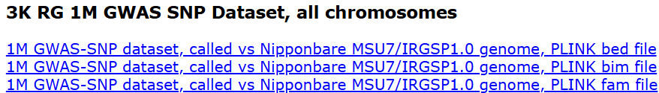
1. Downloading data
3K RG morpho-agronomic is the phenotypic dataset and the bed, bim and fam files make our entire genotypic dataset which are readable for the PLINK.
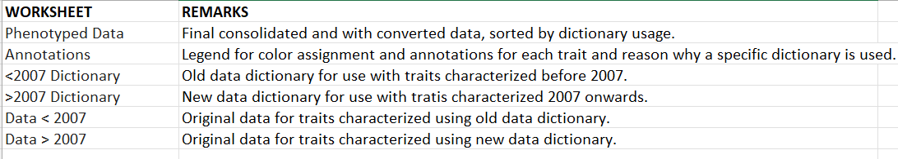
The image above depicts the phenotypic dataset, wherein the worksheets present in the file along with their respective descriptions has been given.
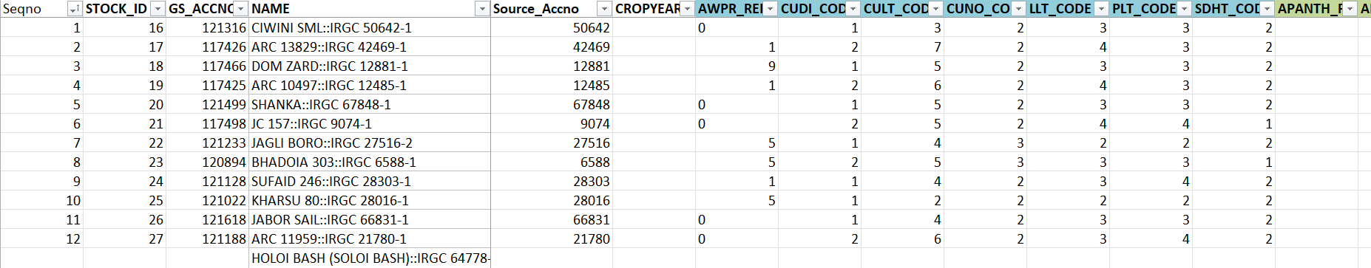
The image above depicts the data in “Phenotyped Data” sheet.

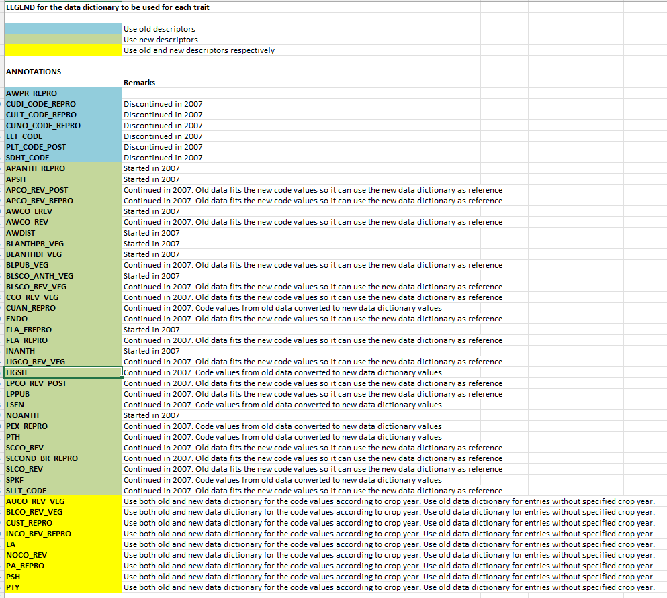
The image above shows the data present in the “Annotations” sheet.
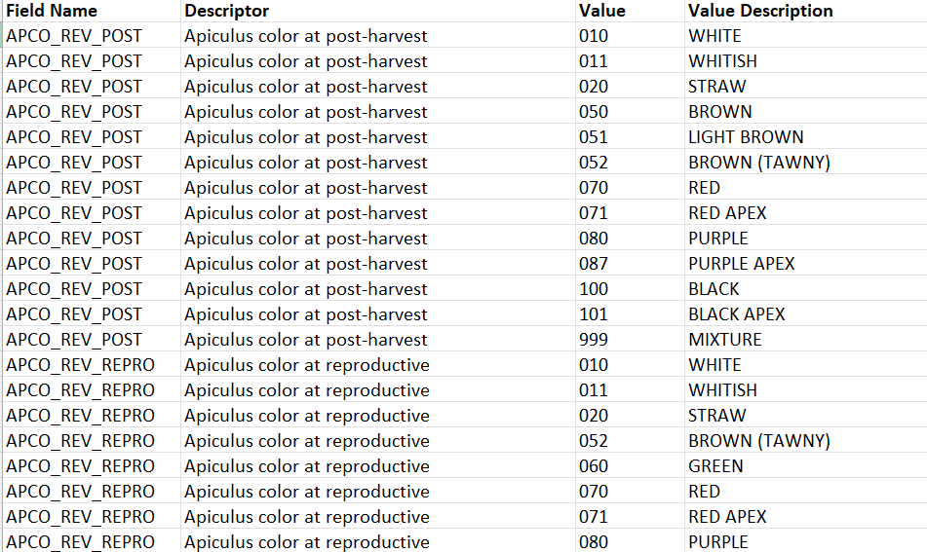The image above shows the data present in <2007 Dictionary sheet.
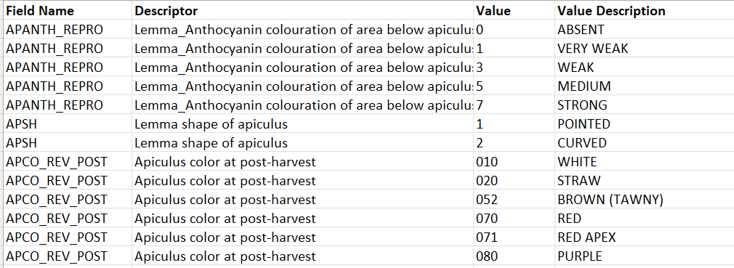
The image above shows values present in >2007 Dictionary sheet.
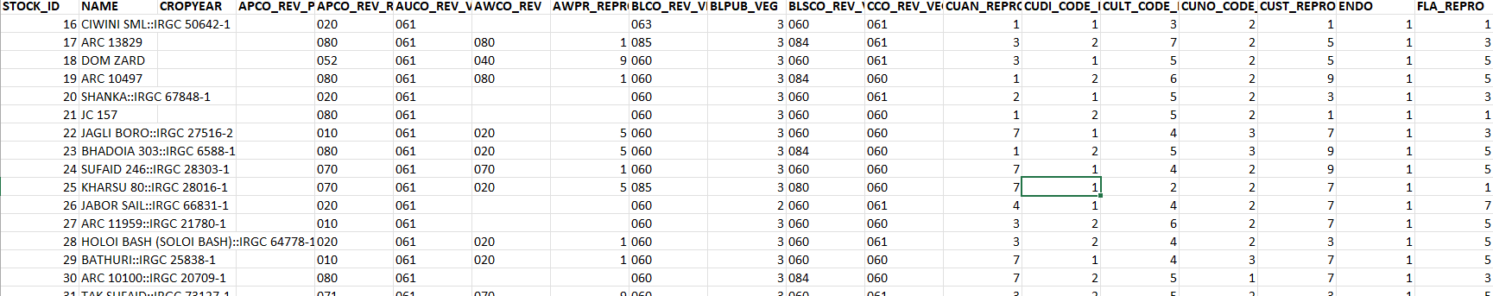
The image above shows data present in “Data <2007” sheet.
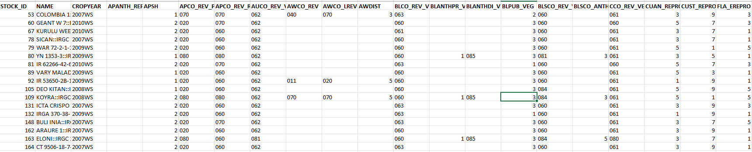
The image above shows data present in “Data >2007” sheet.

2. Download PLINK 1.9 and transfer it to a permanent but accessible file directory.
3. Running Quality Control (PLINK)
3.1 Filtering by Single Nucleotide Polymorphism
In this step we clean our raw input data files to improve accuracy and reliability. SNPs with a high percentage of missing genotype calls like for example we are not able to determine the genotype for more than 10% of individuals with specific SNPs then, removing them ensures the inclusion of reliable data.
a. Copy and paste the “plink.exe” in the folder containing the “.bed”, “.bim” and “.fam” files.
b. Run the following command from Terminal
.\plink.exe --bfile pruned_v2.1 --geno 0.1 --make-bed --out rice_qc1_snp_missing
Make sure that terminal’s executable path has been navigated to the data folder containing all the data files with the plink executable one.
4 well-structured files based on Single Nucleotide Polymorphism have been created.
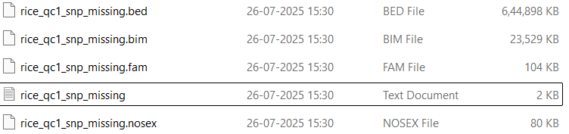
Results of Quality Control:
- 1011601 variants loaded from .bim file
- 3024 people (0 males, 0 females, 3024 ambiguous) loaded from .fam
- Ambiguous sex IDs written to rice_qc1_snp_missing.nosex
- Total genotyping rate is 0.962656.
- 138089 variants removed due to missing genotype data (--geno).
- 873512 high-quality variants and 3024 people pass filters and QC.
- Among remaining phenotypes, 0 are cases and 3024 are controls.
3.2 Filtering by individual Missingness
This step removes samples who have a high proportion of missing genotype calls across all SNPs. This ensures that all individuals included in the analysis have sufficient genotypic data as individuals with too much missing data indicates poor sample quality, DNA extraction issues or other problems that could affect downstream analysis.
Threshold: 10% Missingness (Above this, and samples are filtered out)
Run the following lines of code in Terminal: Make sure that the directory has been specified where all the “rice_qc1_snp_missing” in “.bed, .bim, .fam” are present
.\plink.exe --bfile rice_qc1_snp_missing --mind 0.1 --make-bed --out rice_qc2_ind_missing
--mind 0.1 : Missingness Filter with threshold 10%
- 873512 variants loaded from .bim file (generated in 2.1).
- 3024 people (0 males, 0 females, 3024 ambiguous) loaded from .fam.
- Ambiguous sex IDs written to rice_qc2_ind_missing.nosex
- 3024 phenotype values loaded from .fam
- 23 people removed due to missing genotype data (--mind)
- IDs written to rice_qc2_ind_missing.irem
- Total genotyping rate in remaining samples is 0.981442
- 873512 variants and 3001 people pass filters and QC
- Among remaining phenotypes, 0 are cases and 3001 are controls.
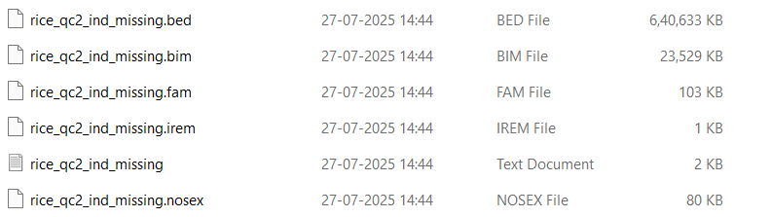
The above image depicts the files created after the completion of filtering by missingness.

3.3 Filtering by Allele frequency
This step removes Single Nucleotide Polymorphisms that are very rare in population, such rare variants can be difficult to work with statistically and including them leads to false positives or noise. SNPs with lower allele frequency have limited statistical power.
We have set a common threshold of 1% meaning those SNPs with allele frequency greater than 1% have been filtered out.
Following line of code need to be executed in the Terminal while simultaneously making sure that the directory chosen contains data files generate after Step 2.2
.\plink.exe --bfile rice_qc2_ind_missing --maf 0.01 --make-bed --out rice_qc3_maf_filter
--maf 0.01: Filters Allele Frequency with a threshold of 1%.
- 873512 variants loaded from .bim file (generated by 2.2).
- 3001 people (0 males, 0 females, 3001 ambiguous) loaded from .fam
- Ambiguous sex IDs written to rice_qc3_maf_filter.nosex
- 3001 phenotype values loaded from .fam
- Total genotyping rate is 0.981442
- 1710 variants removed due to minor allele threshold(s)
- 871802 variants and 3001 people pass filters and QC
- Among remaining phenotypes, 0 are cases and 3001 are controls.
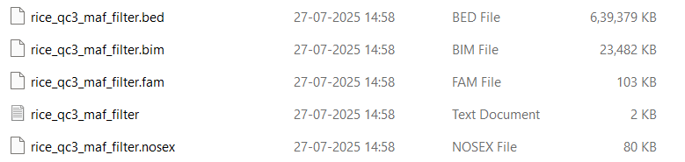
Output files generated after completion of this step.
3.4 Filtering by Hardy-Weinberg Equilibrium
This step removes SNPs that significantly deviate from Hardy-Weinberg Equilibrium. Deviations from this equilibrium denotes genotypic errors, population substructure or selection which affects the overall quality of the data. A strict threshold of 0.001 has been set so, that any sample exceeding above this percentage criteria has been removed.
Run the following lines of code from Terminal by making sure the files generated after Step 3.3 are served as input
.\plink.exe --bfile rice_qc3_maf_filter --hwe 0.001 --make-bed --out rice_qc4_hwe_filter
--hwe 0.0001: Hardy-Weinberg Equilibrium with threshold of 0.001
It states that Allele and genotypic frequency in an ideal population must always stay constant when there is no influence of evolution. The conditions are no mutation, no migration, no population diversity and no natural selection.
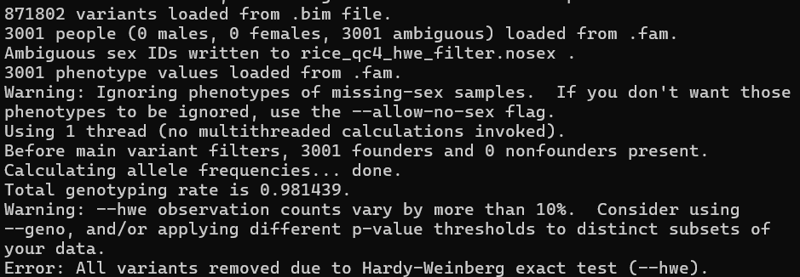
The error persists even after using extremely lenient threshold of 0.01 and 0.1 so, this suggests that our data exhibits Wahlund Effect.
Population Stratification or Wahlund Effect arises when the sample consists of individuals from two or more distinct subpopulations like different rice varieties in the same dataset. These subpopulations have different allele frequencies for many SNPs which leads to high-deviation. The deviation arises due to mixed genetic background rather than genotypic errors.
To solve this PCA and Relatedness filtering would be used later.
3.5 Filtering by High Relatedness
This step identifies and removes one individual from each pair of highly related individuals like parent-offspring, full siblings while still maintaining the threshold. This relatedness can inflate association statistics and lead to false positives.
The main logic behind this is that related individuals share a greater proportion of their genome and if they also share a phenotype it can create a spurious association.
a. To calculate relatedness, a separate “.genome” file by running the following code from Terminal, also the input files are those generated from 3.3:
.\plink.exe --bfile rice_qc3_maf_filter --genome --out rice_qc5_relatedness
.genome File
- 871802 variants loaded from .bim file.
- 3001 people (0 males, 0 females, 3001 ambiguous) loaded from .fam.
- Ambiguous sex IDs written to rice_qc5_relatedness.nosex
- 871802 variants and 3001 people pass filters and QC
- IBD calculations complete
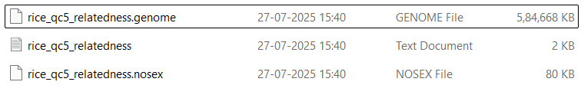
Files generated after the completion of this step.
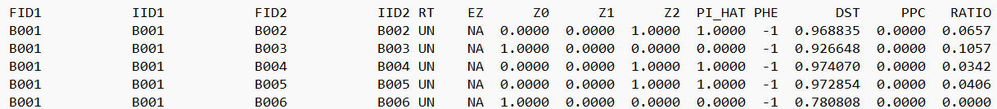
One of the many sample outputs in the “rice_qc5_relatedness.genome” file.
This .genome file provides pairwise identity-by-descent (IBD) estimates between all individuals in dataset.
- FID1: Family ID of first individual pair
- IID1: Individual ID of first individual pair
- FID2: Family ID of the second individual in pair
- IID2: Individual ID of the second individual in the pair
- RT: Relationship Type
a. UN- Unrelated
b. PO- Parent Offspring
c. FS- Full siblings
d. HS- Half Siblings
e. OT- Other
f. NA- Not available
- EZ: Empirical Z-scores
- Z0: Estimated proportion of the genome where two individuals share 0 alleles identical by descent
- Z1: Estimated proportion of the genome where the two individual share 1 allele identical by descent
- Z2: Estimated proportion of the genome where two individuals share 2 alleles identical by descent
- PI_HAT: Estimated proportion of the genome which is identical by descent. (Formula: 0.5 * Z1 + Z2)
a. Around 1.0- Identical individuals (Duplicates)
b. Around 0.5- Parent-offspring or full siblings
c. Around 0.25- Half-siblings, grandparent-grandchild
d. Around 0.125- First cousins
e. Around 0- Unrelated
- PHE: Phenotype value from “.fam” file for the second individual in the pair
- DST: Genetic distance
- PPC: P-value for close relationship
- RATIO: Relationship Interference quality
The goal of the succeeding steps is to filter out duplicates wherever possible or those with PI_HAT: 1.0000
b. Removing individuals with high relatedness
PLINK 1.9 has “–cluster” and “--rel-cutoff” which is typically used after generating a .genome file. The “--rel-cutoff 0.125” instructs PLINK to identify pairs of individuals with PI_HAT value greater than 0.125 and remove one individual from each pair. “--out rice_qc5_related_filtered” Sets the prefix for the output files (rice_qc5_related_filtered.bed, .bim, .fam).
Run the following code in Terminal while making sure that the file created in 3.3 is served as the input but also, the .genome file must be in the same directory:
.\plink.exe --bfile rice_qc3_maf_filter --rel-cutoff 0.125 --make-bed --out rice_qc5_related_filtered --allow-no-sex
- 871802 variants loaded from .bim file.
- 3001 people (0 males, 0 females, 3001 ambiguous) loaded from .fam.
- 871802 variants and 3001 people pass filters and QC (before --rel-cutoff).
- 2966 people excluded by --rel-cutoff.
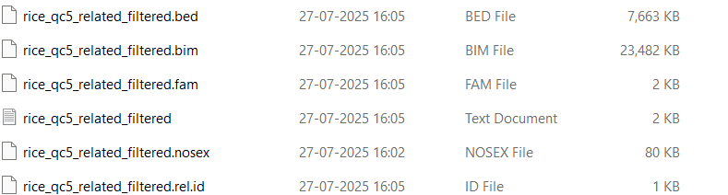
Output Files generated after execution of this step.
The exclusion of 2966 samples is extremely high for a robust analysis so, PCA has been employed on all the 3001 samples.
c. PCA:
Performing PCA on the largest possible sample of 3001 allows PLINK to capture the full spectrum of genetic variation and population structure present in your dataset more accurately. These principal components will be used as covariates in a Mixed Linear Model which combined with Kinship matrix is the most robust way of population stratification and relatedness without discarding valuable data.
Following line of code needs to be executed from terminal to perform PCA using PLINK while making sure that the data files created in Step 3.3 serve as input:
.\plink.exe --bfile rice_qc3_maf_filter --pca --out rice_pca --allow-no-sex
--pca: Specifies pca
--out rice_pca: Creates files named rice_pca with required formats like “.bam, .bed and .fam”
--bfile: Specifies input file
PCA Using Python:
1. The eigenvector file has been moved to an easily accessible directory.
2. Run the following code in Jupyter notebook:
import pandas as pd
import matplotlib.pyplot as plt
import seaborn as sns
eigenvec_file = 'C:/Users/mohak/Desktop/rice_pca.eigenvec'

try:
df_pca = pd.read_csv(eigenvec_file, sep='\s+', header=None)
df_pca.rename(columns={0: 'FID', 1: 'IID'}, inplace=True)
pc_cols = [f'PC{i}' for i in range(1, df_pca.shape[1] - 1)]
df_pca.columns = ['FID', 'IID'] + pc_cols

plt.figure(figsize=(10, 8))
sns.scatterplot(x='PC1', y='PC2', data=df_pca, alpha=0.7)
plt.title('PCA Plot: PC1 vs PC2')
plt.xlabel('Principal Component 1')
plt.ylabel('Principal Component 2')
plt.grid(True, linestyle='--', alpha=0.6)
plt.savefig('C:/Users/mohak/Desktop/pca_plot_pc1_vs_pc2.png')
plt.close()
print("PCA plot 'pca_plot_pc1_vs_pc2.png' generated.")
except FileNotFoundError:
print(f"Error: The file '{eigenvec_file}' was not found.")
except Exception as e:
print(f"An error occurred: {e}")
Two files with Eigenvalues and Eigenvectors post-PCA have been generated.
Eigenvalues:
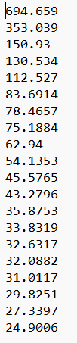
These explain the amount of variance explained by each corresponding principal component (PC). Higher eigenvalues mean that PC explains more of the genetic variation in the population.
Eigenvectors:
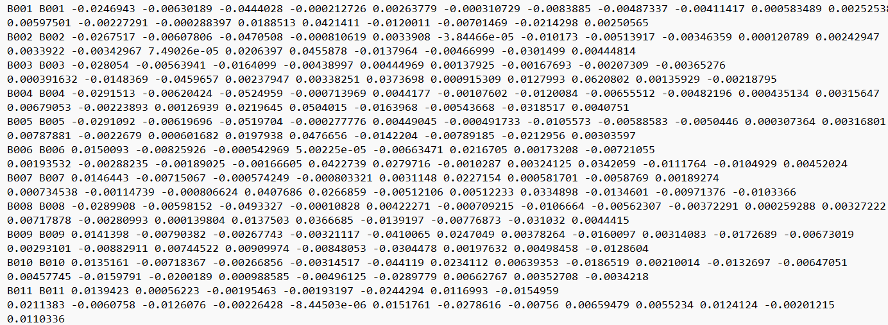
Few samples out of 3001 have been showcased.
Each row corresponds to an individual and column contain their scores for each principal component which will be used to visualize the population structure.
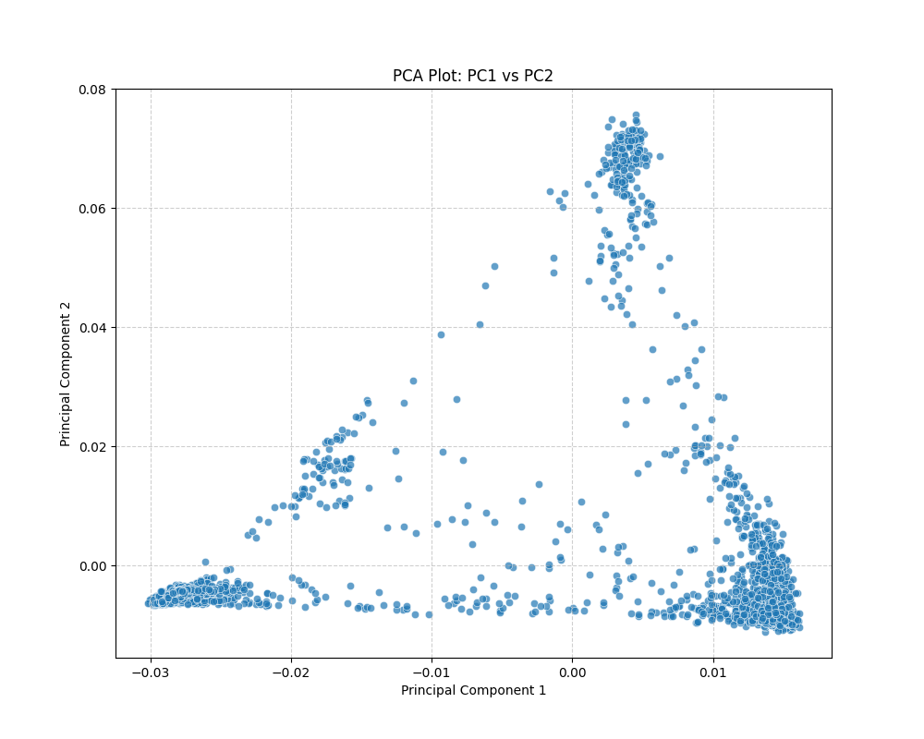
PCA plot generated post-execution of python code.
The distinct clusters represent genetically different subgroups or populations in our dataset like different subspecies.

d. Generating Kinship Matrix
This step generates a genetic relationship matrix or Kinship matrix which quantifies genetic relatedness between all pairs of individuals in our dataset when combined with Mixed Linear Model.
A genetic relationship matrix has been created after executing the following lines of code from Terminal by using data file generated in Step 3.3 as input:
.\plink.exe --bfile rice_qc3_maf_filter --make-grm-bin --out rice_grm_matrix --allow-no-sex
--make-grm-bin: Instructs PLINK to compute the Genetic Relationship Matrix (GRM) and output it in binary format. This is the format required by many MLM software packages.
- Relationship matrix written to rice_grm_matrix.grm.bin , and IDs written to rice_grm_matrix.grm.id.
- 871802 variants and 3001 people pass filters and QC
Quality Control using PLINK has been completed.
4. GWAS Analysis
In this Genome Wide Association analysis will be initiated wherein a trait AWPR_REPRO (Awn presence at reproductive phase) which is an quantitative one has been selected. Also, GEMMA has been selected as analysis software.
4.1 Preparing the Phenotype file for AWPR_REPRO
This step creates a phenotypic file for GEMMA to read simply meaning it creates a plain text file containing the Family ID (FID), Individual ID (IID) and the AWPR_REPRO values for each of the 3001 individuals.
To ensure the phenotype data correctly aligns with the genotype data we first extract the FIDs and IIDs of every individuals from the filtered “.fam” file which is later matched with AWPR_REPRO data.
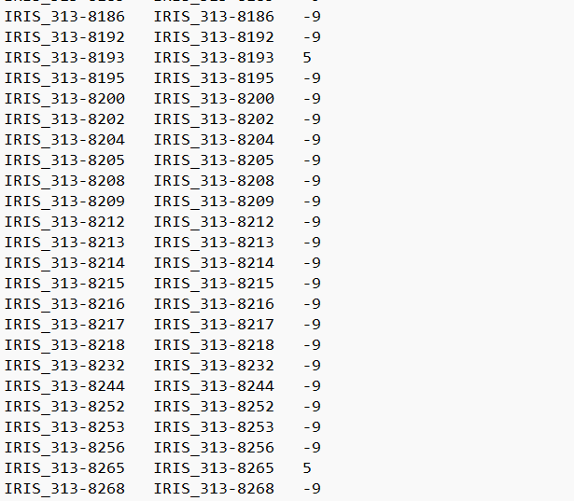
The image above depicts the output recorded in “awpr_repro_pheno.txt” file.
In this file we have mapped genotype data with the sample’s respective phenotype data and those which have been mapped have been designated a number like “0,1,5,7,9” which have been recorded by the organization itself.
Those samples with number “-9” are the ones which have not been mapped with their respective genotypes or simply act as noise in the data by inducing missing values (empty or NaN).

a. IDs from the genotype (.fam) and phenotype (excel) file have been mapped based on their core ID. For example:
In the genotype file “IRIS_313-9074-1” is an individual sample wherein the “9074” matches with “JC 157::IRGC 9074-1”. Based on this mapping appropriate file “awpr_repro_pheno.txt” has been created which houses the complete mapped data.
Code to do so:
import pandas as pd
import numpy as np
import re
#File paths
fam_file = 'C:/Users/mohak/Desktop/Data/2.3/rice_qc3_maf_filter.fam' # Path to .fam file
phenotype_excel_file = 'C:/Users/mohak/Desktop/Data/3kRG_PhenotypeData_v20170411.xlsx' # Path to phenotype Excel file
output_pheno_file = 'C:/Users/mohak/Desktop/awpr_repro_pheno.txt' # Name for the output phenotype file

# Function to extract a "core ID" for flexible matching (e.g., '67848' from 'IRIS_313-67848' or 'IRIS_313-67848-1')
def get_core_id(id_string):
if pd.isna(id_string):
return None
id_string = str(id_string).strip()
if '::' in id_string:
id_string = id_string.split('::')[-1].strip()

# Removes 'IRGC ' prefix if present
if id_string.startswith('IRGC '):
id_string = id_string[5:].strip()

# Removes 'IRIS_313-' prefix if present
if id_string.startswith('IRIS_313-'):
id_string = id_string[9:].strip()

# Attempt to strip any trailing '-digit' suffix (e.g., '-1' from '67848-1')
match = re.match(r'^(.*?)-\d+$', id_string)
if match:
return match.group(1)

return id_string

# Function to extract the mapped GWAS ID from the 'NAME' column (for Mapped_IID in phenotype data)
def extract_gwas_id(name_str):
if pd.isna(name_str):
return None
name_str = str(name_str).strip()
if '::' in name_str:
id_part = name_str.split('::')[-1].strip()
if id_part.startswith('IRGC '):
return 'IRIS_313-' + id_part[5:].strip()
else:
return id_part
return name_str.replace(' ', '_')

# Genotype IDs from .fam file
df_genotype_ids = pd.read_csv(fam_file, sep='\s+', header=None, usecols=[0, 1], names=['FID', 'IID_genotype'])
df_genotype_ids['Genotype_Core_ID'] = df_genotype_ids['IID_genotype'].apply(get_core_id)

# Phenotype data from Excel file
df_pheno = pd.read_excel(phenotype_excel_file, sheet_name='Phenotype Data')
df_pheno['Mapped_IID'] = df_pheno['NAME'].apply(extract_gwas_id) # Get the full mapped ID first
df_pheno['Phenotype_Core_ID'] = df_pheno['Mapped_IID'].apply(get_core_id) # Then derive core ID from mapped ID

# Filter phenotype data for non-missing AWPR_REPRO values
df_pheno_filtered = df_pheno[['Phenotype_Core_ID', 'AWPR_REPRO']].dropna(subset=['AWPR_REPRO']).copy()
df_pheno_filtered['AWPR_REPRO'] = df_pheno_filtered['AWPR_REPRO'].astype(int)

# Merge based on Core IDs
# Left merge to keep all individuals from the genotype file
df_merged = pd.merge(df_genotype_ids,
df_pheno_filtered,
left_on='Genotype_Core_ID',
right_on='Phenotype_Core_ID',
how='left')

#Preparing and saving the final phenotype file
# Filling NaN (missing) AWPR_REPRO values with -9
df_merged['AWPR_REPRO'] = df_merged['AWPR_REPRO'].fillna(-9).astype(int)

# Selecting and renaming columns for the final PLINK phenotype file format (FID IID PHENOTYPE)
df_final_pheno = df_merged[['FID', 'IID_genotype', 'AWPR_REPRO']].copy()
df_final_pheno.rename(columns={'IID_genotype': 'IID'}, inplace=True)

# Savinf the phenotype file to a tab-separated file without header or index
df_final_pheno.to_csv(output_pheno_file, sep='\t', index=False, header=False)

print(f"Successfully created phenotype file: '{output_pheno_file}'")
print("\nFirst 10 rows of the generated phenotype file (FID, IID, AWPR_REPRO):")
print(df_final_pheno.head(10))
print(f"\nTotal individuals in phenotype file: {len(df_final_pheno)}")
print(f"Individuals with assigned AWPR_REPRO data (not -9): {(df_final_pheno['AWPR_REPRO'] != -9).sum()}")

4.2 GWAS using PLINK
The command which when run from the terminal specifies PLINK to read our genotype data (rice_qc3_maf_filter), our labelled phenotype data (awpr_repro_pheno.txt), perform a linear regression association analysis for the trait (using rice_pca_covars.txt) and correct for population structure using PCA eigenvectors.
a. Before executing the PLINK code, we need a PCA covars text file and the python code given below helps to create one:
import pandas as pd

pca_eigenvec_file = 'C:/Users/mohak/Desktop/Data/2.3/rice_pca.eigenvec'
output_covar_file = 'C:/Users/mohak/Desktop/rice_pca_covars.txt'

try:

df_pca = pd.read_csv(pca_eigenvec_file, sep='\s+', header=None)

# Select FID (col 0), IID (col 1), and the first 5 PCs (cols 2 through 6)
# (assuming 0-indexed columns for Python)
# These correspond to PC1, PC2, PC3, PC4, PC5
df_covars = df_pca.iloc[:, [0, 1, 2, 3, 4, 5, 6]].copy()
df_covars.to_csv(output_covar_file, sep='\t', index=False, header=False)

print(f"Successfully created covariate file: '{output_covar_file}'")
print("\nFirst 5 rows of the new covariate file (FID, IID, PC1, PC2, PC3, PC4, PC5):")
print(df_covars.head())

except FileNotFoundError:
print(f"Error: The file '{pca_eigenvec_file}' was not found")
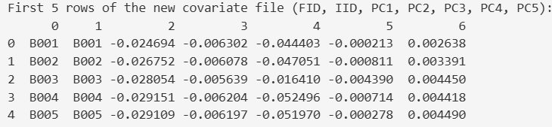
The image above depicts a PCA covariates text file created using python. This file is necessary for defining the principal components wherein each row defines the individual and each column defines the principal components scores achieved after PCA. All-in-all this particular text file helps to increase the overall accuracy of the analysis by identifying population stratification.

b. To reduce errors, all the phenotypic data for each individual sample has been embedded in a combined “.fam” file after executing the code given below:
import pandas as pd
import numpy as np
import re
try:
df_fam = pd.read_csv('C:/Users/mohak/Desktop/Data/2.3/rice_qc3_maf_filter.fam', sep=' ', header=None,
names=['FID', 'IID', 'PatID', 'MatID', 'Sex', 'Phenotype_original'])
except FileNotFoundError:
print("Error: rice_qc3_maf_filter.fam not found.
exit()
try:
df_pheno = pd.read_csv('C:/Users/mohak/Desktop/awpr_repro_pheno.txt', sep='\t')
except FileNotFoundError:
print("Error: awpr_repro_pheno.txt not found..")
exit()

def get_core_id(id_str):
if pd.isna(id_str):
return None
id_str = str(id_str).strip()
if '::' in id_str:
return id_str.split('::')[-1].strip().replace('IRGC ', 'IRIS_313-').replace(' ', '_')
return id_str.replace(' ', '_')

# Apply ID normalization to both dataframes
df_fam['Normalized_IID'] = df_fam['IID'].apply(get_core_id)
df_pheno['Normalized_IID'] = df_pheno['IID'].apply(get_core_id)

# Merge the dataframes on the normalized IID
# Use a left merge to keep all individuals from the FAM file
df_merged = pd.merge(df_fam, df_pheno[['Normalized_IID', 'AWPR_REPRO']],
on='Normalized_IID', how='left')

# Replace the original phenotype column (column 6, index 5) with the new AWPR_REPRO data
# Fill NaN values with -9 for missing phenotypes
df_merged['Phenotype_merged'] = df_merged['AWPR_REPRO'].fillna(-9).astype(int)

# Create the new FAM content with original FID/IID and updated phenotype
# Columns are FID, IID, PatID, MatID, Sex, Phenotype_merged
df_output_fam = df_merged[['FID', 'IID', 'PatID', 'MatID', 'Sex', 'Phenotype_merged']]
output_fam_filename = 'C:/Users/mohak/Desktop/rice_qc3_maf_filter_with_pheno.fam'
df_output_fam.to_csv(output_fam_filename, sep=' ', header=False, index=False)

print(f"Successfully created '{output_fam_filename}' with space delimiters and updated phenotypes.")
print("\nFirst 5 rows of the new FAM file (FID IID PatID MatID Sex Pheno):")
print(df_output_fam.head())
print(f"\nTotal individuals in new FAM file: {len(df_output_fam)}")

Terminal Command: Make sure the files mentioned in the image below are present in a single directory to which the Terminal’s execution path has been set to:
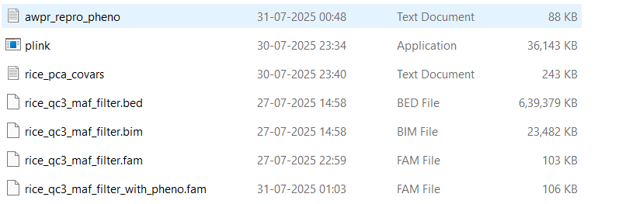
.\plink.exe --bfile rice_qc3_maf_filter --fam rice_qc3_maf_filter_with_pheno.fam --linear --covar rice_pca_covars.txt --out awpr_repro_gwas_results_v3 --allow-no-sex
*NOTE: PLINK requires all the input files to be in “space-delimited” format so, the above python code makes sure that all of them adhere to the requirements.
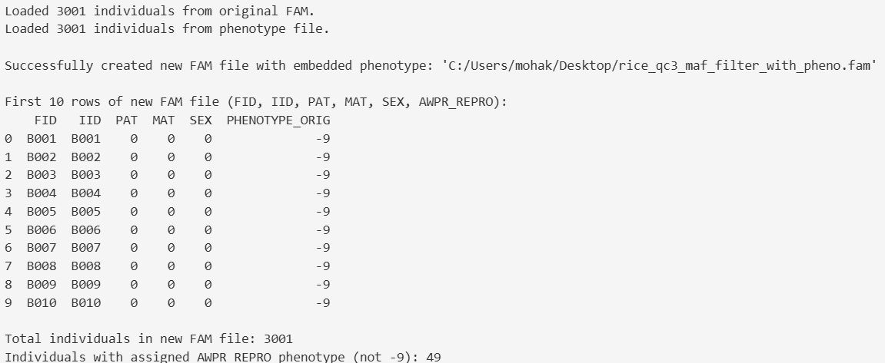
The image above depicts the results obtained after executing the code. The embedded file contains a new column titled “PHENOTYPE_ORIG” which is the column denoting each and every phenotypic value.
Linear Model Association
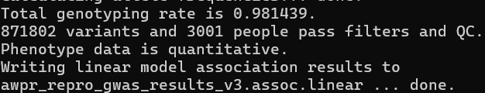
The image above depicts the results obtained post-execution of the code lines. A file named “awpr_repro_gwas_results_v3.assoc.linear” has been created in the working directory denoting the success of GWAS analysis.
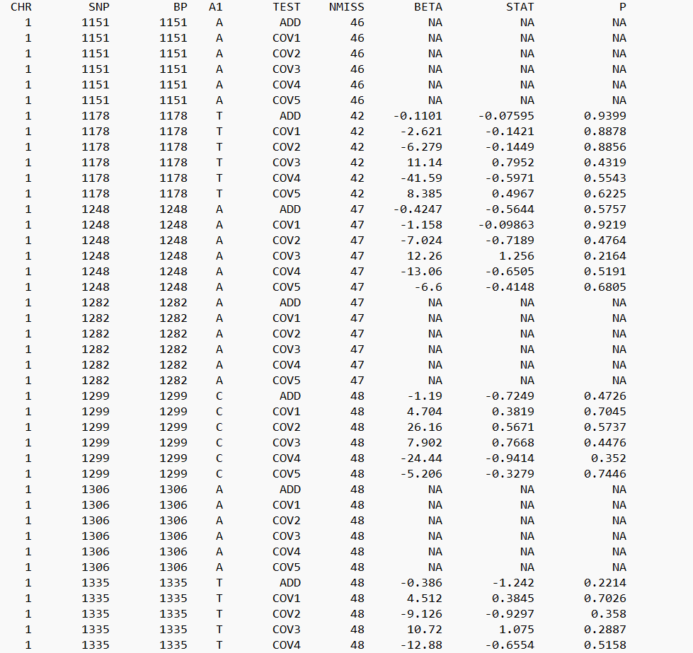
The image above depicts the linear regression association analysis which signifies the core output of our Genome Wide Association Study. This depicts the statistical association between each genetic variant (SNP) and the quantitative phenotype (AWPR_REPRO column) while still keeping the covariates.
Each column signifies:
1. CHR- The chromosome number where the genetic variant (SNP) is located.
2. SNP- The unique identifier for SNP.
3. BP- The base pair position of the SNP on the chromosome.
4. A1- The "coded allele" or "allele 1". For an additive model, this is usually the minor allele (the less common one), and the BETA value represents the change in phenotype for each additional copy of this allele.
5. TEST- This column indicates what the row's statistics represent:
a. ADD: It represents the association between the SNP’s genotype and the phenotype.
b. COV1, COV2, COV3, COV4, COV5: These rows represent the regression coefficients (BETA values) for each of covariates (from rice_pca_covars.txt) in the linear model . There are 5 because we loaded 5 covariates. These show the effect of each covariate on the phenotype.
6. NMISS: The number of individuals who had non-missing data for both the SNP genotype and the phenotype with covariates for that specific test.
7. BETA: The effect size or regression coefficient:
- For ADD rows: This is the estimated change in phenotype (AWPR_REPRO) for each additional copy of the A1 allele. A positive BETA means more A1 leads to a higher phenotype value, and a negative BETA means more A1 leads to a lower phenotype value.
- For COV rows: This is the estimated change in phenotype for a one-unit increase in that specific covariate.
8. STAT: This is the T-statistic for the association. It's calculated as BETA / SE (where SE is the standard error of BETA, which is often in a separate column or implied). A larger absolute value of STAT indicates a stronger association.
9. P: The p-value for the association test. This is the most crucial value in GWAS. It represents the probability of observing an association as strong as, or stronger than, the one found, assuming there is no true association between the SNP/covariate and the phenotype (the null hypothesis). Lower p-values indicate stronger statistical evidence against the null hypothesis, suggesting a more significant association.
*NOTE: NA (Not Applicable) values for BETA, STAT and P for SNPs occur when SNP is monomorphic meaning all individuals have the exact same genotype for that SNP. If there's no variation in the genetic predictor, a statistical association cannot be calculated.
5. Visualizing using Manhattan plots
R packages have been used to visualize the results while the packages used are: “qqman” and “data.table”.
The code below when executed in R-environment helps to install the required packages:
install.packages("qqman")
install.packages(“data.table”)
library(qqman)
library(data.table)

# Set your working directory (as you provided)
setwd("C:/Users/mohak/Desktop/1")
desktop_path <- "C:/Users/mohak/Desktop/"

# Read, name columns, filter, and convert data types in one block
gwasResults_ADD <- subset(
setNames(fread("awpr_repro_gwas_results_v3.assoc.linear", header = FALSE, data.table = FALSE, skip = 1),
c("CHR", "SNP", "BP", "A1", "TEST", "NMISS", "BETA", "STAT", "P")),
TEST == "ADD" & !is.na(P)
)
gwasResults_ADD$CHR <- as.numeric(gwasResults_ADD$CHR)
gwasResults_ADD$P <- as.numeric(gwasResults_ADD$P)

# Save and plot Manhattan plot
png(paste0(desktop_path, "Manhattan_AWPR_REPRO.png"), width = 1000, height = 600, res = 100)
manhattan(gwasResults_ADD, main = "Manhattan Plot for AWPR_REPRO GWAS", col = c("darkorchid", "maroon"), chrlabs = 1:12, genomewideline = -log10(5e-8))
dev.off()
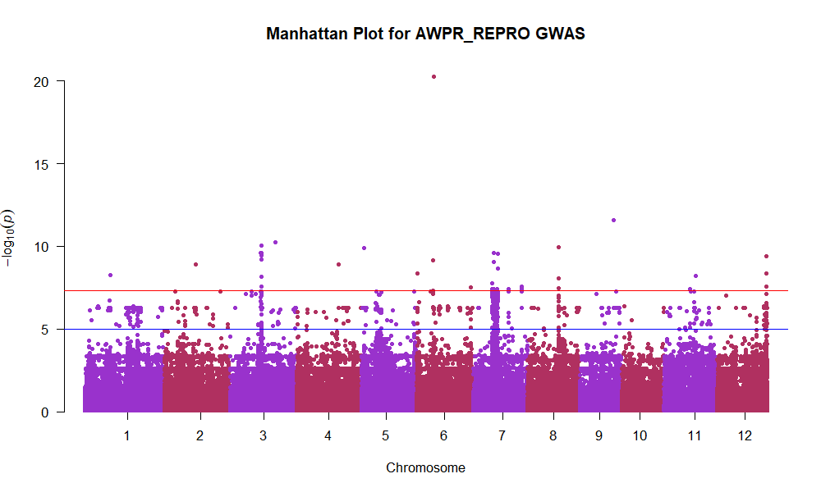
The image above depicts a Manhattan plot with the X-axis denoting the Chromosome number, with each chromosome points are ordered by their base pair position from start to end and the alternating colours help differentiate between adjacent chromosomes.
Y-axis denotes statistical significance wherein it plots the negative base-10 logarithm of the p-value (-log10(P)) for each SNP. Therefore, higher points on the Y-axis indicate a stronger, more statistically significant association between that SNP and the phenotype.
Every single dot on the plot is the genetic variation (SNP) that was tested in our GWAS. "Peaks" (clusters of dots rising high above the skyline) are the regions of interest. These represent SNPs that have a statistically strong association with the phenotype. Any point which rises above the red line is considered to be genome-wide significant.

6. Annotating the Significant SNP
In this step we record the most significant or statistically associated Single Nucleotide Polymorphism which occur in those genes influencing the resulting trait.
The R code below when executed creates a csv file housing all the significant SNPs:
library(data.table)

setwd("C:/Users/mohak/Desktop/1")

# Defining column names
plink_col_names=c("CHR", "SNP", "BP", "A1", "TEST", "NMISS", "BETA", "STAT", "P")

# Read the full results file
gwasResults=fread("awpr_repro_gwas_results_v3.assoc.linear", header = FALSE, data.table = FALSE, skip = 1)
colnames(gwasResults) =plink_col_names

# Filter for ADD test and numeric P-values
gwasResults_ADD= subset(gwasResults, TEST == "ADD" & !is.na(P))
gwasResults_ADD$P= as.numeric(gwasResults_ADD$P) # Ensure P is numeric

# Define your significance threshold
significance_threshold= 5e-8 # Genome-wide significance

# Filter for significant SNPs
significant_snps= subset(gwasResults_ADD, P < significance_threshold)

# Display the first few significant SNPs
print("Significant SNPs (P < 5e-8):")
print(head(significant_snps))
write.csv(significant_snps, "C:/Users/mohak/Desktop/significant_snps_awpr_repro.csv", row.names = FALSE)
print("Significant SNPs saved to 'significant_snps_awpr_repro.csv'")
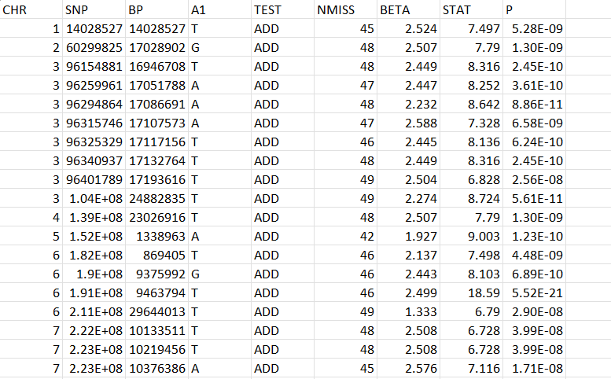
The image depicts the most significant SNPs in our GWAS analysis.

