Idea and documentation: MOHAMMAD Alqadri

Room Nest

### 1. A Brief Description of the System

The system is an online platform that facilitates shared housing rentals. It allows individuals to list and rent out rooms or spaces in their homes to tourists, students, or workers looking for short-term accommodation at affordable prices. The platform provides a secure and user-friendly environment where hosts and guests can connect, manage bookings, and handle payments seamlessly.

### 2. Functional Requirements in the System

* **User Registration and Authentication**: Users (hosts and guests) can create accounts, log in, and manage their profiles.
* **Listing Creation and Management**: Hosts can create and manage listings with descriptions, photos, pricing, and availability.
* **Search and Filtering**: Guests can search for available accommodations based on location, price, dates, and amenities.
* **Booking Management**: Guests can book accommodations, and hosts can approve or decline booking requests.
* **Payment Processing**: Secure online payment system to handle transactions between guests and hosts.
* **Review and Rating System**: Users can leave reviews and ratings for hosts and accommodations.
* **Messaging System**: In-platform messaging for communication between hosts and guests.
* **Notifications**: Email and in-app notifications for booking confirmations, messages, and updates.
* **Customer Support**: Support system for resolving issues and answering queries.

### 3. Non-Functional Requirements in the System

* **Security**: Ensure secure handling of user data and payment tranactions.
* **Scalability**: Ability to handle a growing number of users and listings.
* **Performance**: Fast response times for searches, bookings, and payments.
* **Usability**: Intuitive and easy-to-navigate user interface.
* **Reliability**: High availability and minimal downtime.
* **Compliance**: Adherence to legal and regulatory requirements for online transactions and data privacy.

### 4. Stakeholders

* **Hosts**: Individuals or property owners offering rooms or spaces for rent.
* **Guests**: Individuals seeking short-term accommodation.
* **Platform Admins**: System administrators managing the platform.
* **Payment Processors**: Third-party services handling payment transactions.
* **Customer Support Agents**: Personnel providing support to users.

### 5. System Goals

* **Provide a user-friendly platform for hosts to list and manage accommodations.**
* **Enable guests to find and book affordable short-term accommodations easily.**
* **Ensure secure and smooth transactions between hosts and guests.**
* **Foster a trusted community through reviews and ratings.**
* **Achieve financial returns by charging a commission on each booking.**

### 6. Process Sequence within the System

1. **User Registration**: Users sign up and create profiles.
2. **Listing Creation**: Hosts create and publish accommodation listings.
3. **Search and Filter**: Guests search for accommodations using filters.
4. **Booking Request**: Guests send booking requests to hosts.
5. **Booking Approval**: Hosts approve or decline booking requests.
6. **Payment Processing**: Guests make payments through the platform.
7. **Booking Confirmation**: Both parties receive booking confirmation.
8. **Stay Period**: Guests stay at the booked accommodation.
9. **Review and Rating**: Guests and hosts leave reviews and ratings post-stay.

### 7. Expected Risks in this Project

* **Data Security Breach**: Unauthorized access to user data.
* **Payment Fraud**: Risk of fraudulent transactions.
* **User Trust Issues**: Negative reviews or bad experiences affecting platform reputation.
* **Legal and Regulatory Compliance**: Challenges in adhering to local laws and regulations.
* **Technical Failures**: System outages or performance issues.

8.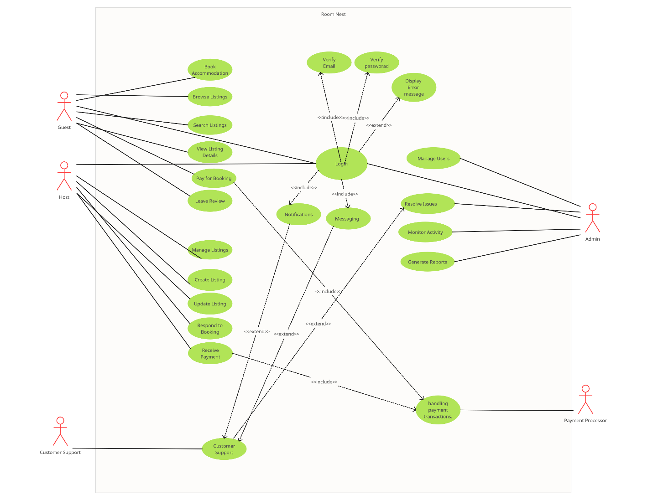 Use case diagram.