PROJECT DOCUMENTATION
Lebanese Home Rental Aggregator
A web platform that aggregates Lebanese rental listings into one place
Website name: Baytak Lebanon
Author
Mohamad Jawad Fakhreldine
Email: mohamad.jawad.fakhreldine.dev@gmail.com
GitHub: https://github.com/Mohamad-Fakhreldine
October 2026

Acknowledgment
This project would not have been possible without OLX Lebanon. Its publicly accessible listing data provided the foundation for the platform, and every listing shown links back to its original source on OLX. All listing content remains the property of its respective owners.
Abstract
Finding a rental home in Lebanon usually means scrolling through thousands of classified ads. Listing forms leave room for inconsistent data: details such as bedrooms or size often end up in the free-text description while the structured fields stay empty, and the same ad can appear more than once while a feed is being collected. The result is a slow, cluttered search.
This project addresses the problem with an automated scraper and data pipeline that collects rental listings from OLX Lebanon, cleans and structures the data, and stores it in a single unified database. A rule-based, bilingual (English and Arabic) parser recovers missing bedroom, bathroom, and size values from listing descriptions, and duplicate ads are prevented from being stored more than once within a source. The pipeline runs every night at midnight, builds a new database separately, validates it, and replaces the live one with an atomic swap so the website stays available. Each source is designed as an independent scraper feeding the same database, so new sources can be added without redesigning the system.
The results are presented through Baytak Lebanon, a website built with React and Flask. It offers paginated browsing, a filter by location, property type, price, size, and furnishing, a listing details popup with a link to the original post, and saved listings that live in the user’s browser with no account required. The database currently holds roughly 7,800 rental listings, which the site serves almost instantly. The system currently supports rental listings from OLX Lebanon only.
List of Tables
Table 1: Project scope 2
Table 2: Technology constraints and how they were handled 3
Table 3: Problems and their solutions 4
Table 4: Functional requirements: data collection and processing 5
Table 5: Functional requirements: website 5
Table 6: Non-functional requirements 6
Table 7: Actors 7
Table 8: Use case scenario: Browse Listings 8
Table 9: Use case scenario: Filter Listings 9
Table 10: Use case scenario: View Listing Details 10
Table 11: Use case scenario: Go to Source 10
Table 12: Use case scenario: Save or Remove Listing 11
Table 13: Use case scenario: View Saved Listings 11
Table 14: Use case scenario: View Information Pages 12
Table 15: Use case scenario: Run Nightly Scrape 12
Table 16: The listings table 14
Table 17: The images table 15
Table 18: Technology stack 20
Table 19: Mapping from OLX data to database fields 22
Table 20: Parser examples 23
Table 21: Safeguards in the refresh process 24
Table 22: API endpoints 25
Table 23: Frontend components 25
Table 24: Future work 27

List of Figures
Figure 1: Use case diagram 8
Figure 2: Entity-relationship diagram 14
Figure 3: System architecture 16
Figure 4: Navigation bar and hamburger menu 17
Figure 5: Home page 17
Figure 6: Home page filter popup 17
Figure 7: Listings page 18
Figure 8: Listing details popup 18
Figure 9: Saved page 18
Figure 10: Informational pages 19
Figure 11: The nightly data pipeline 21

Table of Contents
Chapter 1: Introduction 1
1.1 Introduction 1
1.2 Originality 1
1.3 Objective and Overview 2
Main objective 2
Specific objectives 2
Overview 2
1.4 Scope 2
Assumptions and limits 3
1.5 Technology Constraints 3
1.6 Problem 4
1.7 Solution 4
Chapter 2: Functional and Conceptual Study 5
2.1 Functional Requirements 5
Data collection and processing 5
Website (Baytak Lebanon) 5
2.2 Non-Functional Requirements 6
2.3 UML Use Case Diagram 7
2.4 Use Case Scenarios (User actor) 8
2.5 Use Case Scenarios (Scheduler actor) 12
Chapter 3: System Design 14
3.1 ER Diagram 14
3.2 Entity and Relationship Descriptions 14
3.3 System Architecture 15
Chapter 4: Implementation 17
4.1 Introduction 17
4.2 Navigation Bar 17
4.3 Home Page 17
4.4 Listings Page 18
4.5 Saved Page 18
4.6 Informational Pages 19
Chapter 5: Technical Implementation 20
5.1 Technology Stack 20
5.2 Project Structure and Data Pipeline 20
5.3 Data Collection 21
5.4 Listing Details Extraction 22
5.5 Data Processing 22
How the parser works 22
Known limitations 23
Preventing repeated entries 23
5.6 Database Implementation and Safe Refresh 23
5.7 Scheduling and Automation 24
5.8 Backend 24
5.9 Frontend 25
5.10 Containerization and Deployment 26
5.11 Adding a New Source 26
Chapter 6: Conclusion and Future Work 27
6.1 Conclusion 27
6.2 Future Work 27
References 29

Chapter 1: Introduction

1.1 Introduction
Online classifieds are one of the main ways people look for a home to rent in Lebanon. Platforms such as OLX Lebanon host thousands of rental ads at any given time, but the quality of each ad depends on how the person posting it filled in the form. Searching through them is slower and messier than it needs to be.
The Lebanese Home Rental Aggregator is a scraper and data pipeline that collects rental listings automatically, cleans and structures them, and stores them in one unified database. On top of that data sits Baytak Lebanon, a website that lets visitors browse, filter, and save listings, and follow a link to the original ad.
The project was built as a self-driven portfolio project. It was chosen because it tackles a real-world problem and because it required working with tools and techniques that were new to the author and outside his comfort zone, including browser automation, web scraping, containerization, and scheduled data pipelines.
The rest of this document is organized as follows. Chapter 2 presents the functional and non-functional requirements and the use cases. Chapter 3 describes the system design, including the database and the overall architecture. Chapter 4 walks through the website’s pages. Chapter 5 explains how the system was implemented. Chapter 6 concludes and outlines future work.

1.2 Originality
The project does not claim to offer new data or features that OLX does not already have. Its contribution lies in the scraper and the data pipeline behind the website, and in the cleaner browsing experience that results from their output.
- The core work: an automated scraper and pipeline that collects listings, recovers missing details from descriptions, prevents repeated ads from being stored more than once, and stores everything in a single structure.
- The result: because the data is structured and consistent, the website on top of it can offer a clean, organized, paginated view with a simple filter, instead of the cluttered feed of raw classifieds.
- The source: OLX Lebanon is the source of the data. It is treated as the source the scraper works on, not as a competitor.
- Design for growth: the system is built so that a new source means writing a new scraper and plugging it in. OLX is the only source today because other sources, such as Facebook Marketplace or sites that block scraping or render their data dynamically, are difficult to scrape, and each would be a project of its own.

1.3 Objective and Overview

Main objective
To build an automated scraper and data pipeline that collects rental listings from OLX Lebanon and turns them into clean, structured data, presented through a fast and easy-to-use website.

Specific objectives
- Build a scraper that automatically collects rental listings from OLX Lebanon.
- Clean and structure the scraped data, for example by recovering details left in descriptions.
- Prevent the same ad from being stored more than once within each source.
- Present the listings in a paginated website with a simple filter.
- Let users view a listing’s full details and follow a “View Listing” link to the original post.
- Let users save listings without creating an account.
- Keep the system extensible so that new sources can be added by writing a new scraper.

Overview
The system has four components. A scraper collects listings from the source. A pipeline cleans them, fills in missing details, and prevents repeated entries. A database stores the results. A website presents them with filtering and pagination. The whole process repeats automatically every night.

1.4 Scope
The project covers the rental listings available on OLX Lebanon. Table 1 summarizes what is inside and outside the scope. Rent only was a deliberate choice: the rental dataset is already large, and adding sale listings is a small extension (the same scraper pointed at a different source URL, plus one extra database field to distinguish rent from sale).
Table 1: Project scope
In scope | Out of scope
All rental listings available on OLX Lebanon, across all property categories and all regions OLX covers | Sale listings (a small extension: a different source URL plus one extra database field)
Automated scraping every day at midnight | Other sources such as Facebook Marketplace (each is a project of its own)
Cleaning, structuring, and prevention of repeated ads within a source | Detecting the same property across different sources, or reposted as separate ads
Safe data refresh: a new database is built, validated, and swapped in atomically | User accounts and authentication
Paginated browsing with filters covering all categories | Syncing saved listings across devices
Listing details popup with a “View Listing” link | Sorting of results
Saving listings in the browser (local storage) | Responsive and mobile layout

Assumptions and limits
- Coverage means everything OLX lists, not every rental in Lebanon. Many properties are never posted on OLX.
- Data is refreshed once a day, so a listing removed or edited on OLX can remain visible for up to about a day, since a full run takes about three hours to finish before the new database is swapped in.

1.5 Technology Constraints
Table 2 lists the technical limits the project had to work within and how each one was handled. The scraper depends on the structure of its source, but the system as a whole does not: each source is its own scraper feeding the same database.
Table 2: Technology constraints and how they were handled
Constraint | How the project handles it
Source scrapability. A scraper only works while its source stays publicly accessible and keeps a structure it understands. The only scraper today targets OLX Lebanon, so if OLX changes its pages, that scraper needs updating. | Each source is its own scraper feeding the same database, so a broken or new source never requires redesigning the system. A scrape that fails or ends unexpectedly never replaces the live data.
Data quality. Many listers leave structured fields empty and put details in the description. | A rule-based parser fills missing bedrooms, bathrooms, and size from the description text. Furnishing status comes from OLX’s own structured field.
Scraping time. A full run takes about 3 hours, because every listing page is fetched individually. | A nightly midnight schedule, and a new database that is built separately and swapped in atomically, keeping downtime minimal.
Data volume. The database holds roughly 7,800 listings. | Stored in a local SQLite database, which serves this volume quickly without special tuning. Only the automatic index on the unique key exists; additional indexes are future work if the dataset grows.
Repeated and reposted ads. The same ad can appear more than once while a feed is being collected. The same property reposted as a separate ad, or listed on another platform, is described differently and would need fuzzy comparison to detect. | Repeated ads are prevented by keeping one entry per source and external ID. Content-based and cross-source detection is left for future work.
Hard-to-scrape platforms. Sites such as Facebook Marketplace block scrapers or render data dynamically. | Left out of scope. Each would need its own dedicated scraper.
No accounts. Saved listings live in the browser. | A deliberate choice for accessibility. The trade-off is that saved listings do not sync across devices.
Desktop-oriented layout. The website is not responsive. | Documented as a limitation; a responsive layout is future work.

1.6 Problem
- Context: people in Lebanon search for rentals mostly through online classifieds, where thousands of listings are available at any time.
- Scattered data: rental listings are spread across many platforms, each with its own layout and filters. Searching means visiting several sites and repeating the same search on each.
- Inconsistent data: listing forms leave room for inconsistent input. Details such as price, bedrooms, or size often end up in the free-text description while the structured fields stay empty, so filters miss those listings.
- Repeated entries: the same ad can appear more than once while a feed is collected, which inflates results and wastes the searcher’s time.
- Volume and clutter: a full snapshot of OLX’s rental feed holds roughly 7,800 listings, spread across about 148 result pages. Scrolling through that raw feed to find a suitable place is slow and repetitive.
- Impact: searching takes longer than it should, and relevant listings are missed because they were never filled in properly.

1.7 Solution
Each problem above has a matching part of the solution, shown in Table 3.
Table 3: Problems and their solutions
Problem | Solution
Data is scattered across platforms | A scraper collects listings from a source and stores them in one unified database with a single structure. Each source is its own scraper feeding the same database, so new sources plug in without redesign. OLX Lebanon is the first source.
Listings are messy and details are buried in descriptions | A bilingual parser fills missing bedrooms, bathrooms, and size from the description text. Furnishing status is taken from OLX’s structured data.
Repeated entries of the same ad | One entry is kept per source and external ID, both in the scraper and through a unique constraint in the database.
Large, cluttered feed that is slow to browse | Cleaned data is stored in one database and shown in a paginated website with a filter bar covering all categories.
Data going stale | The scraper runs every night at midnight and swaps in a freshly built, validated database atomically, so downtime stays minimal.

Together, a scraper collects, a parser fills in the gaps, repeated entries are prevented, everything lands in one database, and a website presents it. Duplicate prevention works within a source; detecting the same property across sources is listed as future work.

Chapter 2: Functional and Conceptual Study
This chapter describes what the system does (functional requirements), how well it must do it (non-functional requirements), and how users and the system interact (use cases).

2.1 Functional Requirements
The requirements are grouped by the two parts of the project: the data pipeline and the website, Baytak Lebanon.

Data collection and processing
Table 4: Functional requirements: data collection and processing
ID | Requirement
FR1 | The system shall automatically scrape all rental listings from OLX Lebanon every day at midnight (Asia/Beirut time).
FR2 | The system shall fetch each listing’s details: title, description, price, location, property type, size, bedrooms, bathrooms, furnishing status, seller name, and images.
FR3 | The system shall fill missing bedroom, bathroom, and size values by parsing the listing description when OLX’s structured fields are empty.
FR4 | The system shall prevent the same ad from being stored more than once within the same source.
FR5 | The system shall store all listings in a single unified database structure that records each listing’s source and its ID on that source.
FR6 | The system shall retry a failed listing up to three times before counting it as failed.
FR7 | The system shall build each new dataset in a separate temporary database and replace the live database atomically once the build is validated.
FR8 | The system shall keep the existing live database unchanged if the scrape is incomplete, finds no listings, or exceeds a 5% failure rate.
FR9 | The system shall allow a new source to be added by writing a new scraper that feeds the same database.

Website (Baytak Lebanon)
Table 5: Functional requirements: website
ID | Requirement
FR10 | The system shall provide a navigation bar with links to Home, Listings, and Saved, and a hamburger menu that leads to the Contact Us, Privacy Policy, and About Baytak Lebanon pages.
FR11 | The system shall display listings in a paginated view.
FR12 | The system shall let users filter listings by location (text, with suggestions of up to three matching places), property type (dropdown), price range (minimum and maximum), size range (minimum and maximum), and furnishing (dropdown).
FR13 | The home page shall show location and property type as the main filters, plus a button that opens a popup containing the remaining filters (price, size, furnishing).
FR14 | The home page search action shall take the user to the listings page with the selected filters applied.
FR15 | The listings page shall display all filters in a visible filter bar.
FR16 | Each listing card shall show key parsed details, such as the number of bedrooms, as icons.
FR17 | The system shall show a listing’s full details in a popup when the user selects it.
FR18 | The popup shall include a “View Listing” button that opens the original listing.
FR19 | Each listing shall have a heart icon that saves it to the browser’s local storage when clicked and removes it when clicked again, with no account required.
FR20 | The system shall provide a Saved page that shows the user’s saved listings in the same card layout, with a count of how many are saved.
FR21 | The system shall provide informational pages: Contact Us, Privacy Policy, and About Baytak Lebanon.

2.2 Non-Functional Requirements
Table 6: Non-functional requirements
ID | Category | Requirement
NFR1 | Performance | The listings page shall load and filter a dataset of roughly 7,800 listings, typically near-instantly and within about 3 seconds at worst.
NFR2 | Availability | Refreshing the data shall cause minimal downtime, by building the new database separately and swapping it in atomically.
NFR3 | Reliability | A failed or incomplete scrape shall never replace or damage the live data.
NFR4 | Data freshness | The data shall be refreshed automatically every 24 hours.
NFR5 | Maintainability and extensibility | Each source shall be an independent scraper, so adding or fixing one does not affect the others or the website.
NFR6 | Usability | The website shall have a simple layout with a consistent navigation bar, so users can find and filter listings without instructions.
NFR7 | Accessibility | The website shall be usable without registration or login.
NFR8 | Data quality | Listings shall be structured consistently in the database, with missing fields recovered from descriptions where possible.
NFR9 | Privacy | No data about website visitors is collected or stored. Saved listings live only in the user’s browser.
NFR10 | Compatibility | The website is designed for desktop browsers. A responsive mobile layout is not part of the current version.
NFR11 | Portability | The system shall run as containers, so it can be started on any machine with Docker.

Note on NFR9: the database does hold the seller name shown on each OLX listing. This is public listing data, not data about visitors to the website.

2.3 UML Use Case Diagram
The use case diagram shows the following actors, which are all outside the system boundary. The scraper, the parser, and duplicate prevention are part of the system, so they appear as use cases, not as actors. Use cases drawn in blue belong to the User; use cases drawn in yellow belong to the nightly run.
Table 7: Actors
Actor | Type | Role
User | Primary | Browses, filters, views details, saves listings, and follows “View Listing”.
Scheduler (midnight timer) | Primary, time-based | Triggers the nightly scraping run.
OLX Lebanon | Secondary (external system) | The source the scraper reads from. It never initiates anything.

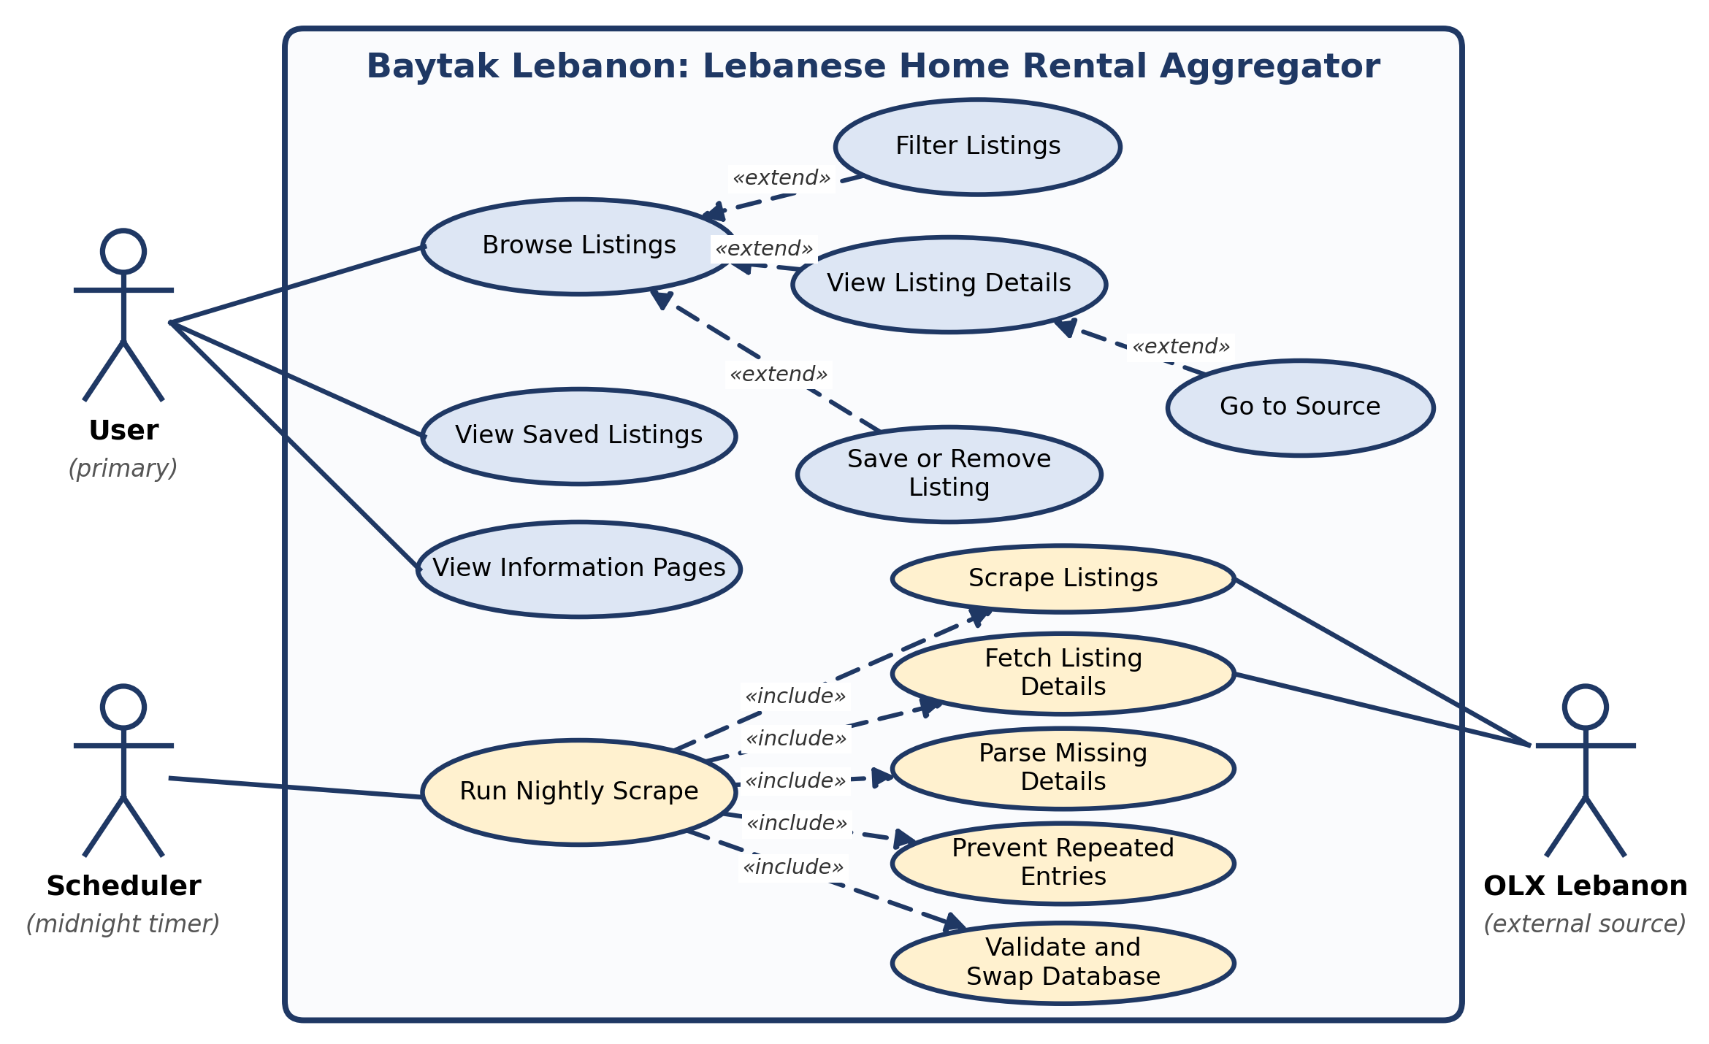
Figure 1: Use case diagram

2.4 Use Case Scenarios (User actor)
Each scenario below describes one use case of the User actor in the same format: name, ID, priority, actors, description, precondition, trigger, the typical course of events split between the actor and the system, alternative courses, and the conclusion. Step numbers run across both columns in the order they happen.
Table 8: Use case scenario: Browse Listings
Use case name | Browse Listings
Use case ID | UC-01
Priority | High
Primary actor | User
Other participating actors | None
Description | The user browses the rental listings page by page. This is the main use case of the website; filtering, viewing details, and saving extend it.
Precondition | The live database has been built.
Trigger | The user opens the Listings page, from the navigation bar, from a home page search, or from a link.
Typical course of events | Actor action | System action
Typical course of events | 1. The user opens the Listings page.  4. The user looks through the cards.  5. The user selects another page with the pagination controls or the arrows. | 2. The system requests the requested page from the API (page 1 by default).  3. The system shows the listing cards, each with its main image, title, price, bedroom count, furnishing icon, and heart icon, and a status line with the number of listings and sources.  6. The system loads that page of 50 listings, updates the page number in the address, and scrolls to the top.
Alternative courses | If the API cannot be reached, no cards are shown. If no listing matches, the grid stays empty and the status line shows zero listings.
Conclusion | The use case ends when the user selects a listing, changes the filters, or leaves the page.

Table 9: Use case scenario: Filter Listings
Use case name | Filter Listings
Use case ID | UC-02
Priority | High
Primary actor | User
Other participating actors | None
Description | The user narrows the results by location, property type, price range, size range, and furnishing.
Precondition | The user is on the home page or the Listings page.
Trigger | The user starts typing a location or opens a filter.
Typical course of events | Actor action | System action
Typical course of events | 1. The user types a location.  3. The user picks a suggestion, or keeps the typed text.  4. The user selects a property type, a price range, a size range, and a furnishing option. On the home page the price, size, and furnishing filters are in a popup opened with the filter button.  5. The user presses Apply (Listings page) or Search (home page). | 2. The system shows up to three matching city or area names, tolerating small spelling differences.  6. The system opens the Listings page with the filters and page 1 in the address.  7. The system returns only the listings that match every filter and updates the status line.
Alternative courses | If nothing matches the filters, the page shows zero listings. Clearing a field removes that filter. The filters are part of the address, so the result can be bookmarked or shared.
Conclusion | The use case ends when the filtered results are displayed.

Table 10: Use case scenario: View Listing Details
Use case name | View Listing Details
Use case ID | UC-03
Priority | High
Primary actor | User
Other participating actors | None
Description | The user opens a popup with the full details of one listing.
Precondition | Listing cards are displayed.
Trigger | The user selects a listing card.
Typical course of events | Actor action | System action
Typical course of events | 1. The user selects a card.  4. The user browses the photos and reads the details.  5. The user closes the popup. | 2. The system opens the popup and requests the listing by its ID.  3. The system shows an image carousel and the property type, title, location, price, bedrooms, bathrooms, size, furnishing, description, seller, and source. Missing values show as Unspecified.  6. The system closes the popup and returns to the page the user was on.
Alternative courses | If the listing cannot be loaded, the popup shows the message "Unable to load this listing." If a listing has no images, the popup says so.
Conclusion | The use case ends when the popup is closed or the user goes to the source.

Table 11: Use case scenario: Go to Source
Use case name | Go to Source
Use case ID | UC-04
Priority | High
Primary actor | User
Other participating actors | None
Description | The user follows the link from a listing to the original ad on the source platform.
Precondition | The listing details popup is open.
Trigger | The user presses the View Listing button.
Typical course of events | Actor action | System action
Typical course of events | 1. The user presses View Listing. | 2. The system opens the original OLX ad in a new browser tab.
Alternative courses | None.
Conclusion | The use case ends when the original ad is opened.

Table 12: Use case scenario: Save or Remove Listing
Use case name | Save or Remove Listing
Use case ID | UC-05
Priority | Medium
Primary actor | User
Other participating actors | None
Description | The user saves a listing with the heart icon, or removes it again. No account is needed.
Precondition | Listing cards are displayed.
Trigger | The user clicks the heart icon on a card.
Typical course of events | Actor action | System action
Typical course of events | 1. The user clicks the heart on a listing.  3. The user clicks the heart again to remove it. | 2. The system stores the listing in the browser's local storage and fills the heart.  4. The system deletes the listing from local storage and empties the heart.
Alternative courses | Saved listings stay on one browser and one device. Clearing the browser data removes them.
Conclusion | The use case ends when the heart reflects the new state.

Table 13: Use case scenario: View Saved Listings
Use case name | View Saved Listings
Use case ID | UC-06
Priority | Medium
Primary actor | User
Other participating actors | None
Description | The user reviews the listings saved earlier.
Precondition | None. The page works without saved listings.
Trigger | The user opens the Saved page from the navigation bar.
Typical course of events | Actor action | System action
Typical course of events | 1. The user opens the Saved page.  3. The user opens a saved listing for its details, or removes it with the heart. | 2. The system reads the saved listings from local storage and shows them as cards with a count, or shows a heart image if nothing is saved.  4. The system shows the details popup, or removes the card from the page.
Alternative courses | The saved cards are copies stored at the time of saving, so they are not refreshed by the nightly update.
Conclusion | The use case ends when the user leaves the page.

Table 14: Use case scenario: View Information Pages
Use case name | View Information Pages
Use case ID | UC-07
Priority | Low
Primary actor | User
Other participating actors | None
Description | The user reads the About, Contact Us, or Privacy Policy and Terms of Service page.
Precondition | None.
Trigger | The user opens the hamburger menu.
Typical course of events | Actor action | System action
Typical course of events | 1. The user opens the menu and chooses a page. | 2. The system shows the chosen static page.
Alternative courses | None.
Conclusion | The use case ends when the page is displayed.

2.5 Use Case Scenarios (Scheduler actor)
The nightly run is one use case that includes five steps: Scrape Listings, Fetch Listing Details, Parse Missing Details, Prevent Repeated Entries, and Validate and Swap Database. OLX Lebanon takes part as a supporting actor that only answers requests.
Table 15: Use case scenario: Run Nightly Scrape
Use case name | Run Nightly Scrape
Use case ID | UC-08
Priority | High
Primary actor | Scheduler (midnight timer)
Other participating actors | OLX Lebanon (external source)
Description | Every night the pipeline collects all rental ads from OLX, fills in missing details, builds a new database, validates it, and replaces the live database only if the checks pass.
Precondition | The automator container is running.
Trigger | The clock reaches midnight in the Asia/Beirut time zone.
Typical course of events | Actor action | System action
Typical course of events | 1. The scheduler reaches midnight and starts the scraper pipeline as a separate process.  4. OLX returns its result pages, one after another.  8. OLX returns the page of each listing. | 2. The system removes any leftover temporary database and creates a new, empty rental_temp.db with the schema.  3. Scrape Listings: the system loads the result pages in a headless browser, collects each ad's ID and URL, and pauses one second between pages until pagination ends.  5. Prevent Repeated Entries: the system keeps one entry per external ID.  6. Fetch Listing Details: for each ad the system reads the structured data embedded in the page and extracts the fields and the images, with up to three attempts per ad.  7. Parse Missing Details: if bedrooms, bathrooms, or size are empty, the system recovers them from the description in English or Arabic.  9. The system inserts each listing and its images into the temporary database.  10. Validate and Swap Database: the system checks that the scrape was complete, that at least one listing exists, and that no more than 5% of listings failed, then replaces rental.db with the new file in one atomic step.
Alternative courses | If a result page fails to load or pagination ends unexpectedly, the scrape is incomplete. If more than 5% of listings fail, or none are found, the same applies. In each case the temporary database is deleted and the live database is kept. An ad that fails three times is skipped and counted as failed. A database error rolls back and aborts the run.
Conclusion | The use case ends when the new database is live, or when the run is aborted and the live database is kept.

Chapter 3: System Design

3.1 ER Diagram
The data is stored in a SQLite database with two tables. The listings table holds one row per property ad. The images table holds the pictures of each listing, with a one-to-many relationship: one listing has many images. The foreign key is declared with ON DELETE CASCADE, so deleting a listing removes its images automatically.
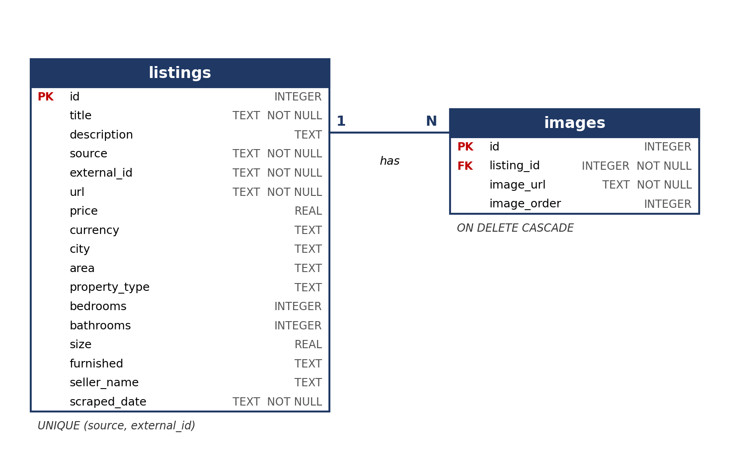
Figure 2: Entity-relationship diagram

3.2 Entity and Relationship Descriptions
The listings table is described below. The unique constraint on source and external_id identifies a listing by where it came from and its ID on that platform. This is what makes the structure independent of any one source, and it is the reason the same ad cannot be stored twice.
Table 16: The listings table
Field | Type | Description
id | INTEGER, primary key | Unique internal ID, generated automatically.
title | TEXT, not null | Listing title.
description | TEXT | Full description text from the ad.
source | TEXT, not null | Platform the listing came from (currently OLX).
external_id | TEXT, not null | The listing’s ID on the source platform. Unique together with source.
url | TEXT, not null | Link to the original ad, used by the “View Listing” button.
price | REAL | Rent price, taken from OLX’s price field.
currency | TEXT | Currency of the price. Always USD at present; the column allows other currencies to be added later.
city, area | TEXT | Location levels taken from OLX’s location data.
property_type | TEXT | Property category as defined by OLX.
bedrooms, bathrooms | INTEGER | Taken from OLX’s structured fields; filled by the description parser when missing.
size | REAL | Size in square meters; taken from OLX’s structured field and filled by the description parser when missing.
furnished | TEXT | Furnishing status, taken from OLX’s structured field.
seller_name | TEXT | Name shown on the ad.
scraped_date | TEXT, not null | When the listing was collected.

Table 17: The images table
Field | Type | Description
id | INTEGER, primary key | Unique internal ID, generated automatically.
listing_id | INTEGER, foreign key, not null | The listing the image belongs to. References listings(id) with cascade delete.
image_url | TEXT, not null | URL of the image on OLX’s servers. Images are stored as links, not as files, which keeps the database small.
image_order | INTEGER | Position of the image within the listing’s gallery.

The only index is the one SQLite creates automatically for the unique constraint on source and external_id. At the current size of roughly 7,800 listings, queries are fast without additional indexes.
There is no field distinguishing rent from sale, since the project covers rent only. Supporting sale listings would require one additional field.

3.3 System Architecture
The system runs as three containers. The automator container runs the scheduler and the scraper pipeline. The backend container runs the Flask API. The frontend container serves the React website. The automator and backend containers share the database folder, which is how a newly swapped database becomes visible to the website without any restart.
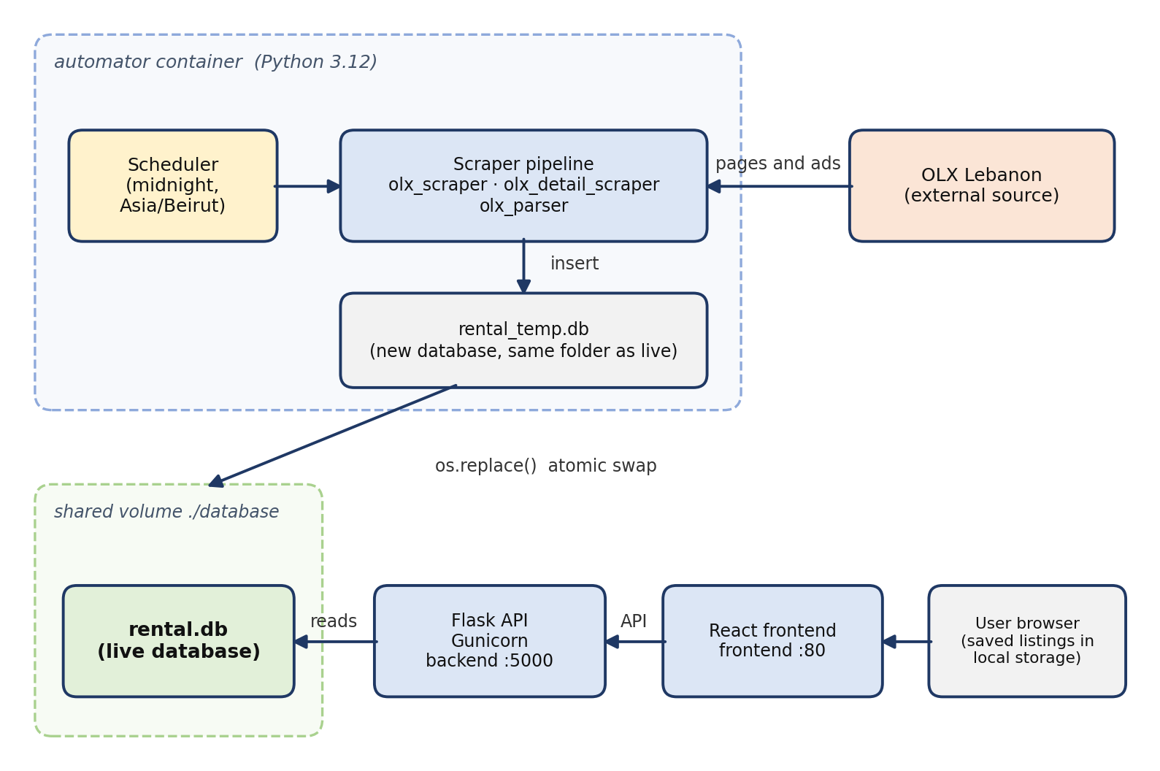
Figure 3: System architecture
The flow is as follows. At midnight the scheduler starts the pipeline, which reads OLX and writes into a temporary database in the same folder as the live one. When the build is validated, the temporary file replaces the live file in a single atomic operation. The Flask API reads the live database and serves it to the React frontend, which the user sees in the browser.

Chapter 4: Implementation

4.1 Introduction
This chapter walks through the pages of Baytak Lebanon, the website built on top of the scraper and the database. The site is a React application with six pages, reachable from a navigation bar that appears on every page. Screenshots are shown in the order a visitor would meet them.

4.2 Navigation Bar
The navigation bar shows links to the Home, Listings, and Saved pages. A hamburger menu leads to the three informational pages: Contact Us, Privacy Policy, and About Baytak Lebanon.
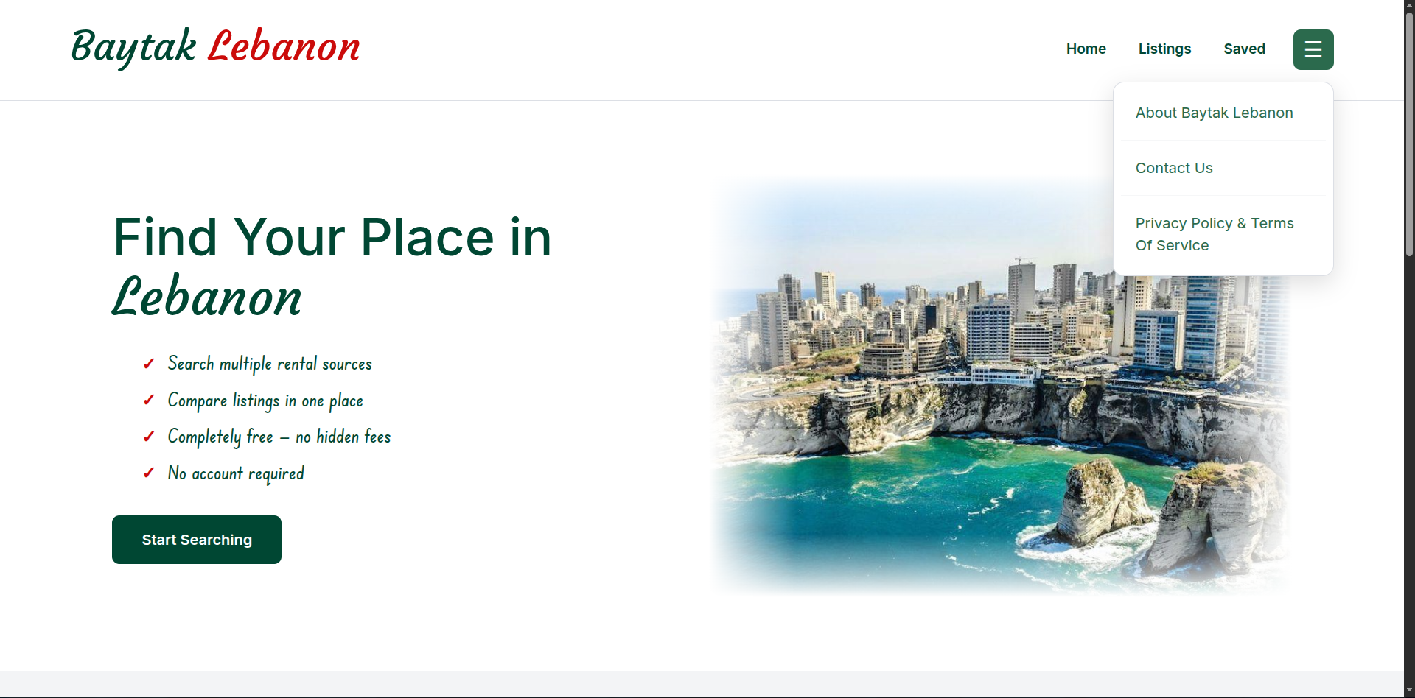
Figure 4: Navigation bar and hamburger menu

4.3 Home Page
The home page introduces the site with a short hero section and some introductory text. It contains a shortened search with two filters, location (a text box) and property type (a dropdown). A button opens a popup with the remaining filters: minimum and maximum price, minimum and maximum size, and furnishing. Pressing search takes the visitor to the listings page with the selected filters applied. A sources section lists the platforms the listings come from, which is currently OLX only.
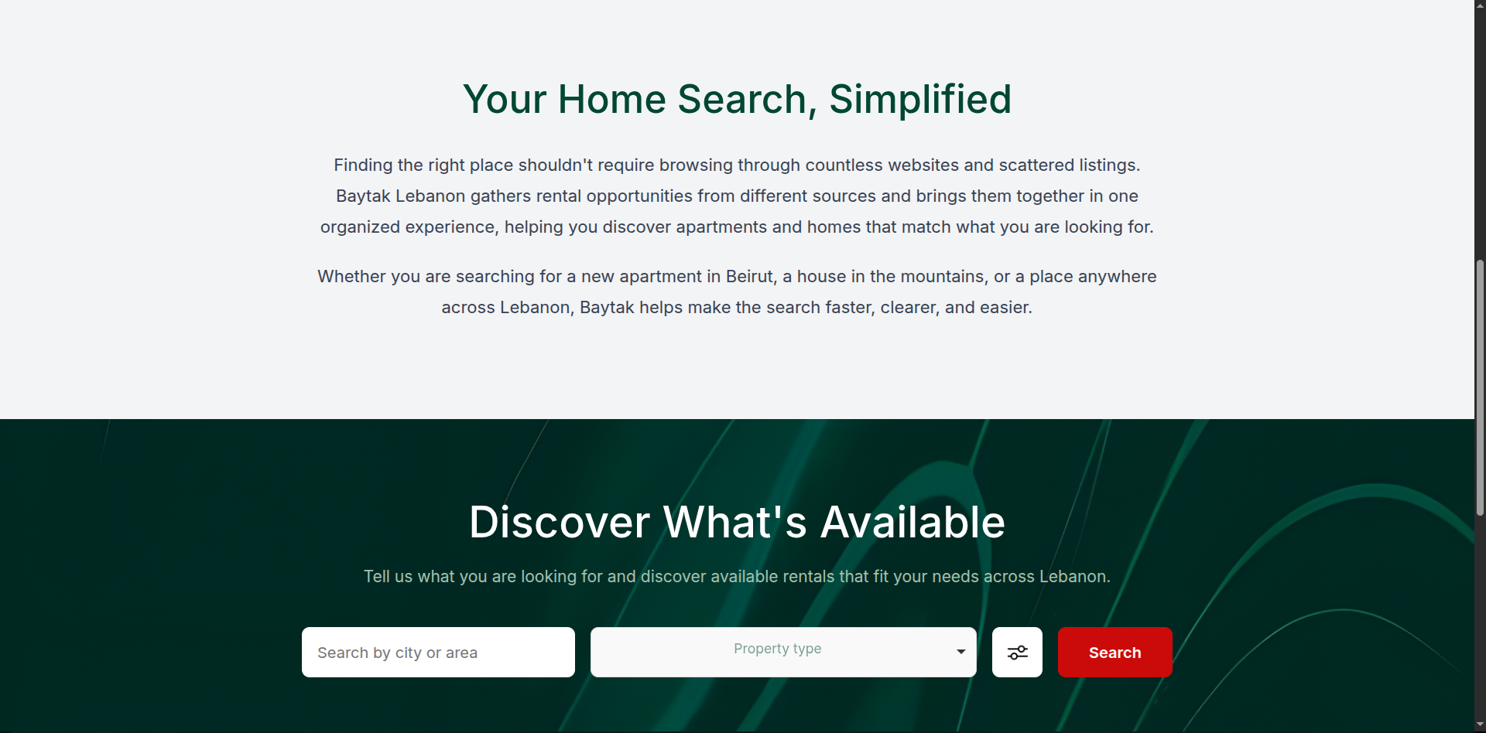
Figure 5: Home page
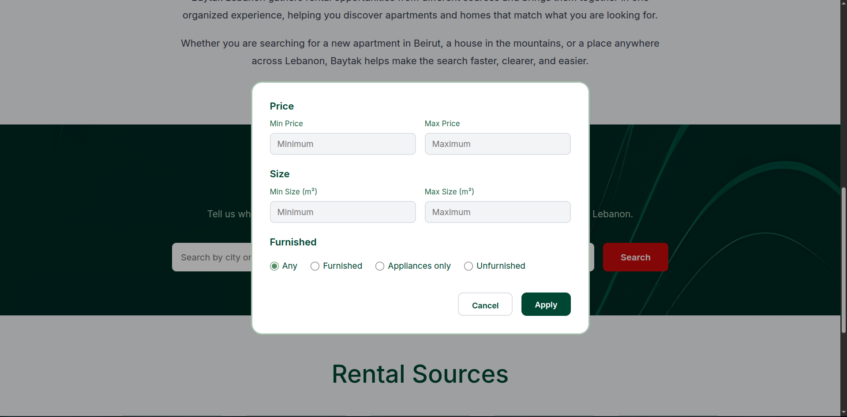
Figure 6: Home page filter popup

4.4 Listings Page
The listings page shows all filters in a visible filter bar: location, property type, price range, size range, and furnishing. Results appear as cards in a paginated view of 50 listings per page. While typing in the location box, up to three suggested city or area names appear; they tolerate small spelling differences. A status line above the cards shows how many listings are being browsed and from how many sources. Each card shows the main image, key details such as the number of bedrooms as icons, and a heart icon for saving the listing.
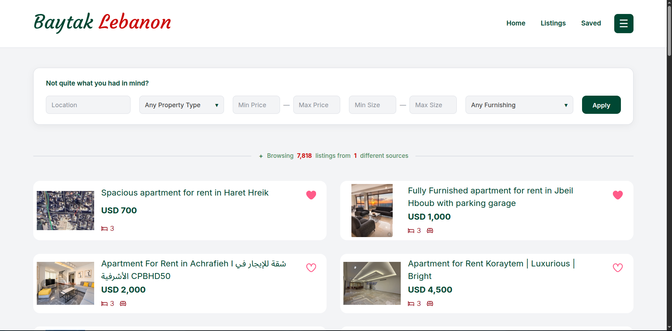
Figure 7: Listings page
Selecting a card opens a popup with the listing’s full details. The popup includes a “View Listing” button that opens the original ad on OLX.
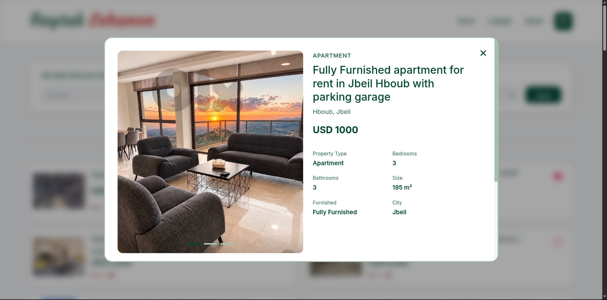
Figure 8: Listing details popup

4.5 Saved Page
Clicking the heart icon on a card saves the listing, and clicking it again removes it. Saved listings are kept in the browser’s local storage, so no account is needed. The Saved page shows the saved listings in the same card layout as the listings page, with a count at the top, and a heart image when nothing has been saved yet. Removing the heart on this page removes the listing from the page.
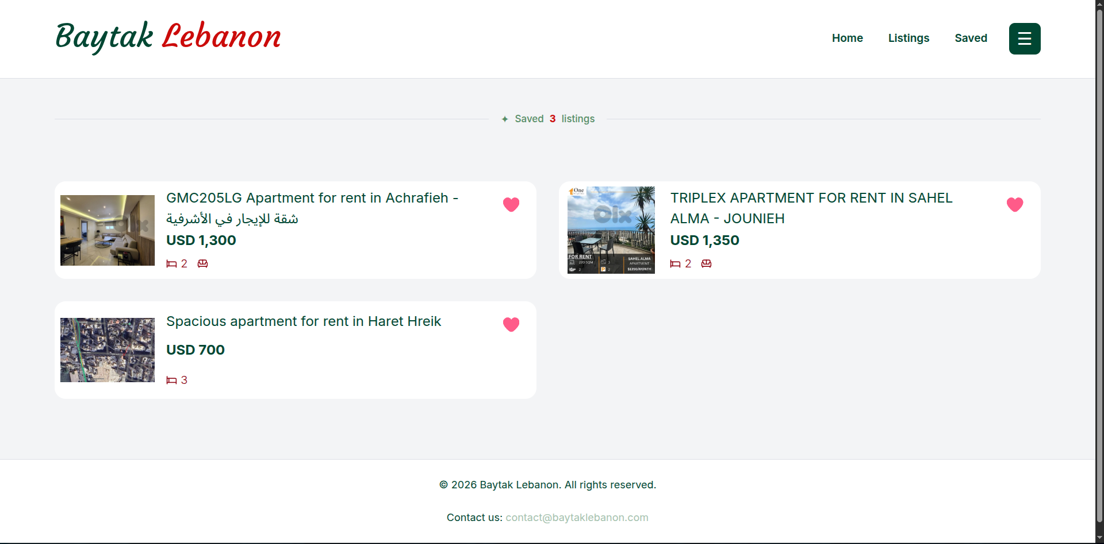
Figure 9: Saved page

4.6 Informational Pages
Three informational pages complete the site: Contact Us, Privacy Policy, and About Baytak Lebanon. They are static pages that do not collect any data from visitors.
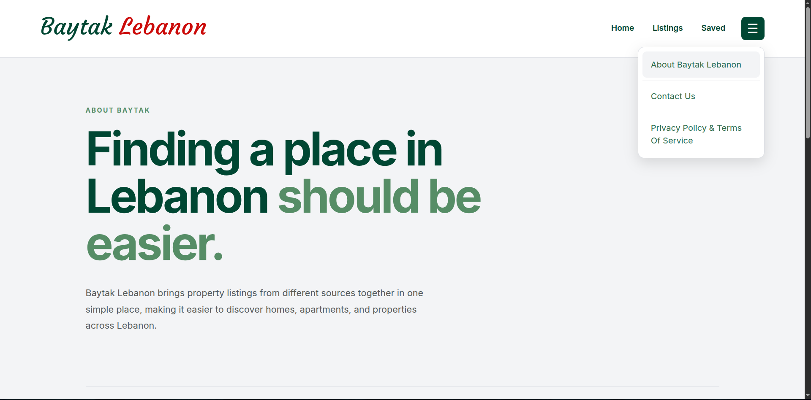
Figure 10: Informational pages

Chapter 5: Technical Implementation
This chapter describes how the scraper, the data pipeline, the database, and the website were implemented. The description parser is rule-based and does not use machine learning.

5.1 Technology Stack
Table 18: Technology stack
Layer | Technology | Used for
Language | Python 3.12 | Scraper, parser, pipeline, scheduler, and backend
Scraping | Playwright | Driving a headless browser to load OLX result pages
Scraping | Beautiful Soup (with lxml) | Reading HTML and extracting listing links and embedded data
Scraping | requests | Fetching each listing’s page over HTTP
Parsing | re (regular expressions) | The description parser for size, bedrooms, and bathrooms
Database | SQLite | Storing listings and images
Backend | Flask | Serving listing data to the website
Backend | Flask-SQLAlchemy | Database access from Flask
Backend | Flask-CORS | Allowing the React frontend to call the Flask API
Backend | Gunicorn | Production server for the Flask app
Frontend | React | The website’s interface, built from components
Frontend | Vite | Frontend build tool and development server
Frontend | HTML, CSS, JavaScript | Structure, styling, and logic
Frontend | Choices.js | Styled property-type dropdown on the home page
Tooling | Docker and Docker Compose | Packaging and running the three services
Tooling | Git | Version control

The scraper and pipeline also use Python standard-library modules, including time, json, pathlib, subprocess, and urllib.

5.2 Project Structure and Data Pipeline
The repository is divided by responsibility: a backend folder for the Flask API, a scraper folder for the scraping pipeline, a database folder for the SQLite files and schema scripts, an automator folder for the scheduler, and a frontend folder for the React application.
Each nightly run follows the flow in the figure below. The sections that follow describe each stage in turn.
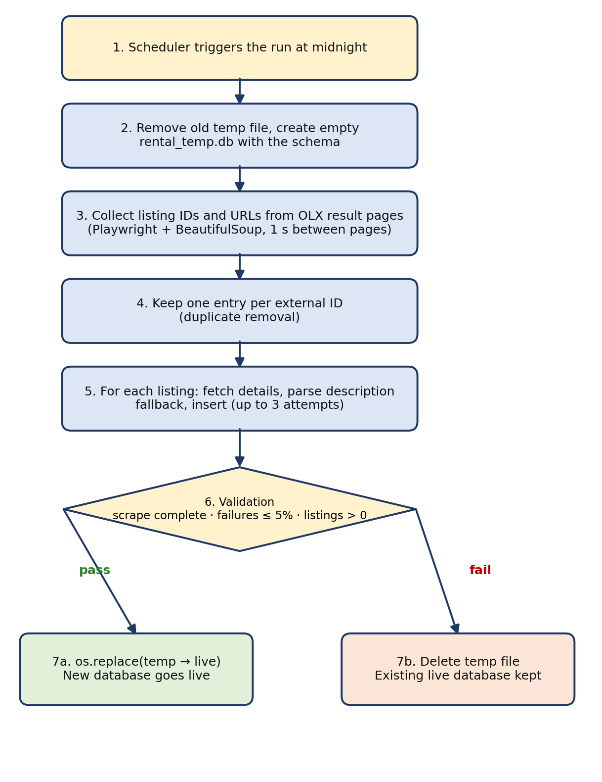
Figure 11: The nightly data pipeline

5.3 Data Collection
The first stage collects the address of every rental ad. OLX’s rental category is loaded page by page using Playwright, which drives a headless Chromium-based browser. This is needed because the result pages are rendered in the browser. After each page loads, the scraper waits three seconds and reads the HTML with Beautiful Soup. Links that match the ad URL pattern are collected, and the numeric ID at the end of each link becomes the listing’s external ID.
The scraper confirms it received the page it asked for by reading the page number from the page title. When OLX returns a different page than requested, the end of pagination has been reached and the scrape is marked complete. A one-second pause between pages keeps the load on OLX low. If a page fails to load, the scrape is marked incomplete and the pipeline will not replace the live data.
Within a collected feed, listings are stored in a dictionary keyed by external ID, so an ad that appears more than once is kept only once.

5.4 Listing Details Extraction
The second stage visits each listing individually. A plain HTTP request with a browser-like User-Agent header fetches the ad page, and the scraper reads the JSON data that OLX embeds in the page. This gives structured access to the ad’s fields without parsing the visible layout. The table below shows how OLX’s fields map to the database.
Table 19: Mapping from OLX data to database fields
Database field | Source in the OLX data | Processing
title, description, external_id | Ad data | Used as provided
price | price field | Thousands separators and the “USD” text removed; converted to a number
currency | Not read from OLX | Set to USD
property_type | property_type field | Used as provided
bedrooms, bathrooms | rooms and bathrooms fields | Converted to integers; filled by the description parser if missing
size | Size field | The “SQM” text removed; converted to a number; filled by the description parser if missing
furnished | furnished field | Used as provided
city, area | Location list | Second level becomes the city and third level the area
seller_name | Contact information | Name used as provided
images | Photo IDs and image tags on the page | See below

Images need extra care, because an ad page also contains pictures of other listings. The scraper first reads the photo IDs that belong to the current listing from the page data. It then collects only the image tags whose ID is in that set, prefers the WebP version of each image when one exists, falls back to JPEG, and removes repeated URLs. Only the image URLs are stored.

5.5 Data Processing
Many ads leave the bedroom, bathroom, or size field empty and write these details in the description instead. The description parser recovers them. It is applied as a fallback: a value is taken from the description only when OLX’s structured field is empty.

How the parser works
- Normalization. The text is lowercased and whitespace is collapsed. The superscript in “m²” is converted to “m2”, and Arabic punctuation marks are mapped to their Latin equivalents.
- Regular expressions. For each field, an ordered list of patterns is tried and the first match wins. The patterns cover forms such as “3 bedrooms”, “Bedrooms: 3”, “2 BR”, “150 sqm”, “sq m”, “m2”, and “Total area: 210”.
- Bilingual support. The same fields are recognized in Arabic, including the Arabic words for bedroom, bathroom, area, and square meter, and written-out room counts such as “ثلاث غرف” (three rooms).
- Safe failure. If nothing matches, the value stays empty instead of being guessed.
Table 20: Parser examples
Description | Size | Bedrooms | Bathrooms
Beautiful apartment with 3 bedrooms and 2 bathrooms. Total area: 220 sqm. | 220 | 3 | 2
Spacious 2 BR / 2 BA apartment, 150 sq m. | 150 | 2 | 2
شقة بمساحة 180 متر مربع مؤلفة من 3 غرف نوم و 2 حمام | 180 | 3 | 2

Known limitations
- The parser is a set of rules, so unusual phrasing is missed. Missed values stay empty.
- In Arabic, a count of rooms is read as a bedroom count, so a description of an office or a living room can be misread.
- Only the first match is used, so a description with conflicting numbers can give a wrong value.
- The parser ships with a self-test of 13 sample descriptions in English, Arabic, and mixed language, each with its expected result, which reports a pass or fail for every case. It is run by hand and is not part of an automated test suite.

Preventing repeated entries
Repeated entries are prevented in two places. The scraper keeps one entry per external ID. The database adds a second line of defense through a unique constraint on source and external ID. Both work within a single source. Detecting the same property posted as separate ads, or on different platforms, is not implemented.

5.6 Database Implementation and Safe Refresh
The database is SQLite, accessed with Python’s sqlite3 module during the build and with Flask-SQLAlchemy in the backend. Foreign keys are enabled when the schema is created.
The refresh is designed so that a failed run can never hurt the live site. Each run builds a complete new database in a separate file, rental_temp.db, in the same folder as the live file, rental.db. Only after the build passes validation does the pipeline replace the live file with the new one using os.replace, which is an atomic operation: the website sees either the old database or the new one, never a half-built one. Because the swap is a rename, the downtime is negligible even though a full run takes about three hours.
Table 21: Safeguards in the refresh process
Situation | What the pipeline does
A result page fails to load, or pagination ends unexpectedly | Marks the scrape incomplete, aborts, and deletes the temporary database
A listing fails to scrape | Retries up to three times, two seconds apart; counted as failed only after the third attempt
More than 5% of listings fail | Keeps the existing live database and deletes the temporary one
No listings are found | Keeps the existing live database and deletes the temporary one
A database or system error occurs while building | Rolls back the transaction and aborts the rebuild
All checks pass | Replaces the live database with the new one atomically

5.7 Scheduling and Automation
The nightly run is triggered by a small scheduler script, the automator, which runs in its own container. It calculates the next midnight in the Asia/Beirut timezone, sleeps until then, and starts the scraper pipeline as a separate process. Running the pipeline as a subprocess means a crash in one run does not stop the scheduler, which logs the exit code and waits for the next midnight. The container is configured to restart automatically. The first run takes place at the next midnight after the container starts, not at startup.

5.8 Backend
The backend is a Flask application. It configures Flask-SQLAlchemy with the path to the live SQLite database and registers two blueprints: one for listings and one for images. Flask-CORS allows the React frontend to call the API. In production, the app is served by Gunicorn on port 5000.
Filtering and pagination are done on the server. The listings page sends the filters and the page number to the API as query-string parameters, and the API replies with the listings of that page and a pagination object holding the number of pages, the total number of listings, and the number of sources.
Table 22: API endpoints
Route | Method | Parameters | Returns
/api/listings/ | GET | page (default 1, 50 per page); location (city or area name); property_type; furnished (furnished, appliances_only, or unfurnished); min_price, max_price; min_size, max_size; bedrooms, bathrooms, min_bedrooms, min_bathrooms; and exact-match fields such as source or external_id | The listings of the requested page, each with its images, plus a pagination object (page, per_page, total, pages, sources)
/api/listings/<id> | GET | The listing's internal ID in the path | One listing with its images, or a 404 error if it does not exist
/api/listings/locations | GET | q: the text typed so far (at least two characters) | Up to three city or area names that best match, tolerant of spelling differences
/api/listings/property-types | GET | None | The distinct property types in the database, sorted
/api/images/ | GET | Optional exact-match filters: id, listing_id, image_url, image_order | A list of image records

The website uses the first four routes. The images route is available for querying image records directly, since the listing routes already return each listing with its images. Filter parameters can be combined; a parameter that is left out is simply not applied.

5.9 Frontend
The frontend is a React application built with Vite. It is divided into components, listed below. The property-type dropdown on the home page is styled with Choices.js, while the listings page uses its own React dropdowns. The current page number and the filters are kept in the page address, so a search can be bookmarked or shared as a link. Saving a listing writes to the browser’s local storage, which is why the site needs no accounts and why saved listings stay on one device.
Table 23: Frontend components
Component | Purpose
Header | Navigation bar and hamburger menu
Hero and Intro | Opening section and introductory text on the home page
SearchSection | Shortened search on the home page (location and property type)
FilterPopup | Popup with the remaining filters (price, size, furnishing)
ListingsFilters | Full filter bar on the listings page, including location suggestions
ListingCard | A listing in the results, with its main image, icon details, and heart icon
ListingPopup | Full listing details and the “View Listing” button
Pagination | Page controls for the results
SourcesSection | List of the platforms the listings come from (static, currently OLX only)
Footer | Footer shown on every page

5.10 Containerization and Deployment
The project runs with Docker Compose as three services. The backend and automator services are built from the same Python image. It is based on python:3.12-slim, installs the dependencies from requirements.txt, installs Playwright’s Chromium browser with its system dependencies, and copies in the backend, scraper, database, and automator folders. The backend service starts Gunicorn; the automator service overrides the command to run the scheduler. The frontend service is built from the frontend folder and publishes port 80.
- The backend service is only exposed to the other containers, not published to the host.
- The backend and automator services mount the same database folder. This shared volume is how a database swapped in by the automator becomes visible to the backend.
- All services restart automatically unless stopped.

5.11 Adding a New Source
Extensibility is a core objective, so adding a source is intentionally simple. A new source needs a scraper that does the following:
- Collects the listing addresses and IDs from the new platform.
- Fetches each listing’s details and returns them in the same structure the database already uses (title, description, source, external ID, URL, price, currency, city, area, property type, bedrooms, bathrooms, size, furnished, seller name, and image URLs).
- Uses its own value in the source field, so the unique constraint keeps its listings separate from those of other sources.
- Is called from the pipeline so its listings are inserted into the same temporary database before the swap.
The website needs no changes to display the new listings. The one exception is the Sources section, which is currently a static list.

Chapter 6: Conclusion and Future Work

6.1 Conclusion
The Lebanese Home Rental Aggregator turns the cluttered feed of rental classifieds into clean, structured, browsable data. Its core is an automated pipeline: a scraper collects every rental ad from OLX Lebanon, a bilingual parser recovers details that listers left in descriptions, repeated ads are prevented, and everything is stored in one unified database. The pipeline runs every night, validates its own output, and swaps the new database in atomically, so the site stays available and a failed run never damages the live data.
On top of the data, Baytak Lebanon offers a straightforward experience: paginated browsing, a five-field filter, a details popup with a link to the original ad, and saved listings without any account. With roughly 7,800 listings, the site responds almost instantly.
The project also met its personal goal. It required working with tools and ideas outside the author’s comfort zone, including browser automation, scraping, containers, and scheduled pipelines, and it produced a complete system, not a prototype. Its limits are clear and documented: it covers rentals from one source, repeated ads are detected only within a source, and the site is built for desktop screens.

6.2 Future Work
Table 24: Future work
Improvement | Notes
Sale listings | The same scraper with a different source URL, plus one extra database field to distinguish rent from sale.
More sources | Write additional scrapers, for example for other classified sites. Platforms that block scraping or render data dynamically need dedicated effort.
Cross-source and content-based duplicate detection | Detect the same property posted as separate ads or on different platforms. This needs fuzzy comparison of title, price, and location, and becomes relevant once a second source exists.
Database indexes | Add indexes on the filtered columns (city, property type, price, size) and on images.listing_id if the dataset grows.
Bedrooms filter and sorting | The bedroom and bathroom data is already parsed and stored, and the API already accepts bedroom and bathroom filters, so adding them to the interface is a small addition. Sorting by price or date would complete the browsing experience.
Responsive design | A mobile-friendly layout for phones and tablets.
Dynamic Sources section | Generate the list of sources from the data instead of keeping it static.
Syncing saved listings | Optional accounts so that saved listings follow the user across devices.
Parser improvements | Tell bedrooms apart from other rooms, handle conflicting numbers, and add an automated test suite with expected outputs.
Monitoring | Alerts when a nightly run fails or when the source’s page structure changes.
Incremental updates | Update only new, changed, and removed listings instead of rebuilding the whole database each night.

References
- OLX Lebanon. https://www.olx.com.lb. Source of the listing data.
- Playwright for Python documentation. https://playwright.dev/python/
- Beautiful Soup documentation. https://www.crummy.com/software/BeautifulSoup/bs4/doc/
- Requests documentation. https://requests.readthedocs.io
- Python re module documentation. https://docs.python.org/3/library/re.html
- SQLite documentation. https://www.sqlite.org/docs.html
- Flask documentation. https://flask.palletsprojects.com
- Flask-SQLAlchemy documentation. https://flask-sqlalchemy.palletsprojects.com
- Gunicorn documentation. https://gunicorn.org
- React documentation. https://react.dev
- Vite documentation. https://vite.dev
- Choices.js. https://github.com/Choices-js/Choices
- Docker and Docker Compose documentation. https://docs.docker.com

