Benchmark Results — Lebanese Legal AI
Evaluated on 196 grounded legal questions · June 30, 2026
Arabic retrieval: 72% hit-rate in top 5 · 81% in top 10 | Answer quality: 4.6 / 5

How the benchmark works
- 196 questions generated directly from the real corpus (Penal Code articles + court rulings), each stored with its correct article number(s) — the 'gold answer' — and validated automatically.
- Trilingual (≈69 Arabic, 65 English, 62 French); covers 204 distinct articles; mixes general questions and case scenarios.
- Scored automatically: an answer is correct if it retrieves the right article number — so an English query that finds the Arabic article still counts (fair cross-lingual test).

Result 1 — accuracy by language
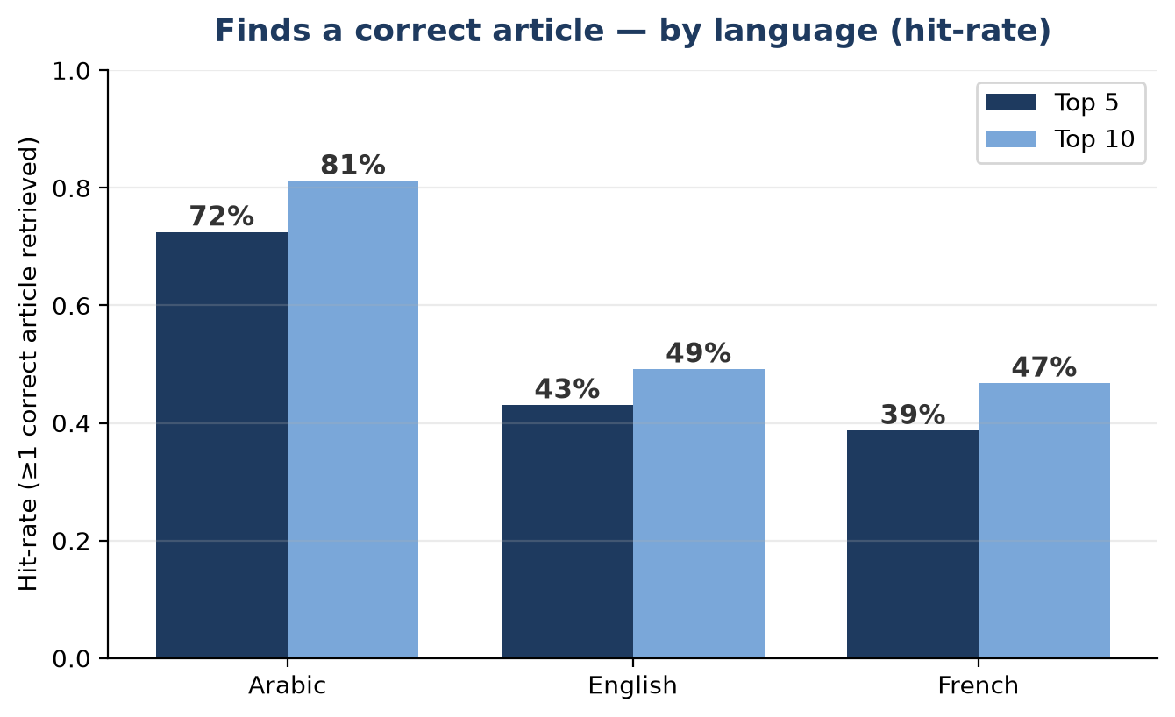
On Arabic — the official language of Lebanese law — the system surfaces a correct article 72% of the time within the top 5 results, and 81% within the top 10. English and French are lower because the corpus is Arabic-primary; closing this cross-lingual gap is the main next step (the translation feature is already built and ready to evaluate).

Result 2 — which search method is best
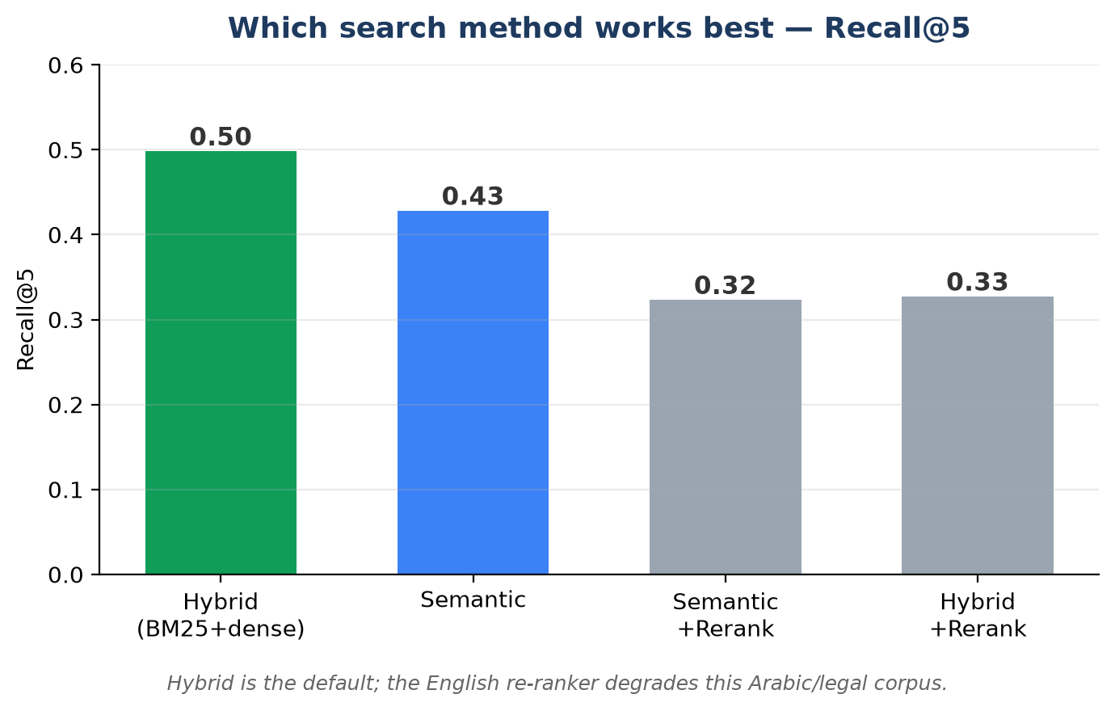
Method | Recall@5 | Precision@5 | MRR | nDCG@5
Hybrid (BM25+dense) | 0.498 | 0.112 | 0.360 | 0.407
Semantic | 0.428 | 0.100 | 0.324 | 0.359
Semantic +Rerank | 0.323 | 0.074 | 0.187 | 0.222
Hybrid +Rerank | 0.327 | 0.070 | 0.181 | 0.219

Result 3 — answer quality
On a judged sample, the final memoranda scored ≈4.6/5 for legal quality (an AI judge rated correctness, citations, completeness, and clarity). The memoranda are written entirely in the question's language and cite verified articles.

Key takeaways
- Strong on Arabic. 72% / 81% hit-rate (top 5 / top 10) on the primary legal language.
- Evidence-based design. Hybrid search was chosen by data; a popular English re-ranker was rejected because the benchmark showed it hurt this corpus.
- Clear roadmap. Cross-lingual retrieval (already implemented) targets the English/French gap; citation precision is the next quality target.

