Lebanese Legal AI
Project Update & Benchmark Report
Multi-Agent Retrieval-Augmented System for Lebanese Penal Law · June 30, 2026

1. Executive Summary
This report describes the Lebanese Legal AI system, the improvements made in this phase, and a rigorous benchmark built to measure its accuracy. The system answers legal questions in Arabic, English, and French by retrieving the relevant Lebanese Penal Code articles and court rulings, then writing a structured legal memorandum through a pipeline of specialised AI agents.
Arabic retrieval: 72% hit-rate (top 5) · 81% (top 10) | Answer quality: 4.6 / 5
In short: on Arabic — the official language of Lebanese law — the system finds a correct article about three-quarters of the time in its top 5 results, and the memoranda it writes are rated high quality. The main area to improve is English/French retrieval, for which a fix is already built.

2. How the System Works
A user asks a legal question. The question passes through a pipeline of specialised agents, each doing one job. This 'multi-agent' design is the core idea of the thesis: dividing the work makes each step more accurate and transparent than a single AI call.
Step | Agent | What it does
0 | Orchestrator | Reads the question and decides the type (general legal question vs. a case to assess).
1 | Query Understanding | Detects the language and legal domain, and extracts the key facts.
2 | Research (RAG) | Searches the corpus and retrieves the most relevant articles and rulings.
3 | Analysis | Extracts the applicable provisions and checks each one against the retrieved text.
4 | Reasoning | Applies the law to the facts (legal argument).
5 | Citation | Formats citations and verifies each article number exists in the corpus.
6 | Writing | Produces the final memorandum, in the language of the question.

A trust layer runs across the pipeline: it flags any legal point not found in the sources and reports a 'hallucination rate', so the system's claims are traceable to real law.

3. What Was Updated in This Phase

3.1 Models
- Up-to-date models. Standardised on Claude Sonnet 4.5, with a selector to also run Sonnet 4.6, Opus 4.6, or Haiku 4.5 — useful for model comparisons in the thesis.

3.2 Data & corpus
- Bilingual corpus. Added the English Penal Code (242 articles) to the Arabic one — 713 searchable documents in total (417 Arabic + 242 English articles + 54 court rulings).
- Reproducible ingestion. A one-command pipeline rebuilds the searchable index from the source files and records exactly what was indexed; new sources can be added automatically.

3.3 Accuracy & trust
- Grounding (anti-hallucination). Every legal point is checked against the sources; unsupported claims are flagged and a hallucination rate is reported.
- Citation verification. Every cited article number is verified against a master list of real articles.
- Correctness fixes. Repaired internal bugs where agents were working on empty input, which previously weakened the reasoning.

3.4 Retrieval quality
- Evidence-based search. Hybrid search (keyword + meaning) was adopted as the default because the benchmark showed it works best; a popular re-ranking model was removed because it made results worse on this Arabic/legal corpus.

3.5 User experience
- Language-matched output. The memorandum is written entirely in the question's language; Arabic is shown right-to-left in a clean document layout.
- Transparency. Each answer shows its sources, verified citations, and a cost/time breakdown.

3.6 Engineering
- Reliability. Added an automated test suite, continuous integration, and per-answer cost/speed/token tracking, so the system is reproducible and monitored.

4. The Benchmark — How It Was Done

4.1 Why a benchmark
A legal AI is only credible if its accuracy can be measured. The benchmark turns 'the answers look good' into objective, repeatable numbers: how often the system finds the correct law, how accurate its citations are, and whether the multi-agent design beats a simple single-AI baseline. It also lets every design choice be tested with evidence.

4.2 The dataset
- Grounded in real law. 196 questions were generated directly from the actual Penal Code articles and court rulings — not invented — so each reflects real legal content.
- Verified gold answers. Each question is stored with the correct article number(s) it should rely on. Every gold label was automatically validated against the corpus.
- Trilingual. ≈69 Arabic, 65 English, 62 French.
- Two question types. General legal questions ('what does the law say?') and case scenarios ('here are the facts — assess them').
- Broad coverage. The questions cover 204 distinct articles.

4.3 What is measured
Layer | Metrics | Meaning (plain language)
Retrieval | Hit-rate@k, Recall@k, MRR, nDCG@k | Does the system find the correct article, and how highly is it ranked?
Citations | Precision, Recall, F1 | Does the final answer cite the correct article numbers?
Answer quality | AI-judge score 1–5 | Is the memorandum legally correct, complete, and clear?
Efficiency | Latency, tokens, cost | Is it practical to run?
Rigour | Mean ± 95% CI, significance tests | Are differences real, not chance?

4.4 Why it was designed this way
- Article-level gold answers. Because legal answers must cite specific articles, the correct answer is a set of article numbers — making scoring objective and fully automatic.
- Grounded generation. Generating questions from the real corpus guarantees every question has a known, checkable answer (no invented questions with no verifiable answer).
- Language-independent scoring. An article counts as found by its number, so an English question that retrieves the Arabic article still scores — a fair cross-lingual test.
- Baselines & statistics. Comparing against single-AI baselines tests the multi-agent claim; confidence intervals make conclusions scientifically defensible.

5. The Benchmark — Results
All numbers are on the 196-question benchmark. Retrieval is fully measured; answer-quality is from a judged sample.

5.1 Accuracy by language
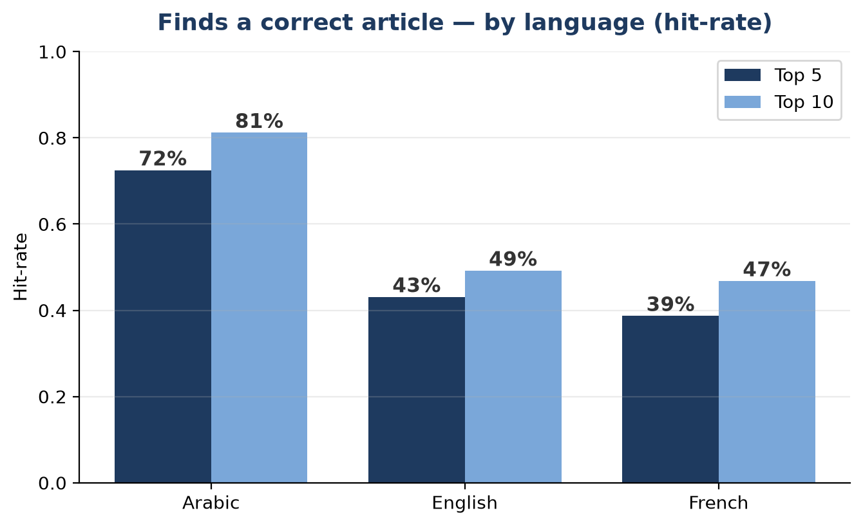
Language | Hit-rate (top 5) | Hit-rate (top 10)
Arabic | 72% | 81%
English | 43% | 49%
French | 39% | 47%

On Arabic, the system surfaces a correct article 72% of the time in the top 5 and 81% in the top 10. English and French are lower because the corpus is Arabic-primary — closing this gap is the main next step (a cross-lingual translation feature is already implemented and ready to evaluate).

5.2 Which search method is best
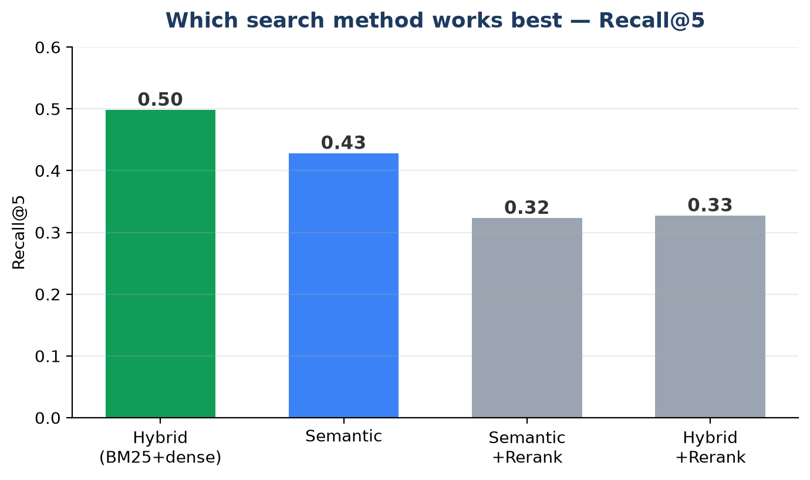
Method | Recall@5 | Precision@5 | MRR | nDCG@5
Hybrid (BM25+dense) | 0.498 | 0.112 | 0.360 | 0.407
Semantic | 0.428 | 0.100 | 0.324 | 0.359
Semantic +Rerank | 0.323 | 0.074 | 0.187 | 0.222
Hybrid +Rerank | 0.327 | 0.070 | 0.181 | 0.219

Hybrid search wins. The English re-ranker actually lowered accuracy on this corpus, so it was disabled — a decision the benchmark made for us, against common intuition.

5.3 Overall retrieval & answer quality
Metric | Result | Reading
Hit-rate@5 (overall) | 52% | Finds a correct article in the top 5.
Recall@5 / @10 | 0.50 / 0.57 | Share of correct articles found.
MRR | 0.37 | How highly the first correct article is ranked.
Answer quality (judge) | 4.6 / 5 | Legal correctness, citations, completeness, clarity.
Speed / cost | ~3 min · ~$0.12 | Per full memorandum — practical for research use.

6. Key Findings
- Strong on Arabic. 72% / 81% hit-rate (top 5 / top 10) on Lebanon's primary legal language.
- Writes well. Memoranda rated ~4.6/5; output is single-language and cites verified articles.
- Evidence over intuition. Hybrid search adopted and the re-ranker rejected — both decided by data.
- Honest limitation. Exact-citation precision and English/French retrieval are the weak points, both with a clear, already-scoped fix.

7. Limitations & Next Steps
- Raise English/French retrieval. Evaluate the built-in cross-lingual translation; test stronger multilingual embedding models.
- Improve citation precision. Make the writer cite only the directly-applicable articles.
- Full evaluation run. Produce final, statistically-backed multi-agent vs. baseline numbers.
- Broaden the corpus. Add contract law and French legal texts (the pipeline already supports it).

8. Glossary (Plain Language)
Term | Meaning
RAG (Retrieval-Augmented Generation) | The AI first retrieves real legal documents, then writes its answer from them — so answers are based on actual law, not memory.
Hit-rate@k | How often at least one correct article appears in the top k results.
Recall@k | The share of all correct articles that appear in the top k.
Precision@k | Of the articles returned, how many are correct.
MRR | Mean Reciprocal Rank — rewards putting the first correct article near the top.
nDCG@k | A ranking score that rewards correct articles appearing higher in the list.
Gold answer | The known-correct article number(s) for a question, used to score the system.
Hallucination rate | How often the system states something not supported by the sources.
LLM-as-judge | Using a strong AI model to rate answer quality on a 1–5 scale.
Hybrid search | Combines keyword matching (BM25) with meaning-based search (embeddings).

All results are reproducible from the project's evaluation scripts.

