Demo: Parallel Heat Equation Solver using MPI

Grp : Ali Azzan, Jaafar el Khatib, Mohamad Rachid, Rafic dergham

1. Project Overview
This project demonstrates the parallel solution of the 2D heat equation using MPI (Message Passing Interface) on a virtual cluster of Ubuntu machines.
The objective is to:
- Build a small MPI cluster
- Run a sequential solver and a parallel solver
- Validate correctness
- Demonstrate distributed execution and communication
- Visualize the final temperature field

2. Cluster Architecture and Network Connectivity
Our cluster consists of one master node and three worker nodes, all connected on the same private network.
Before running MPI jobs, we verify that all nodes are reachable.
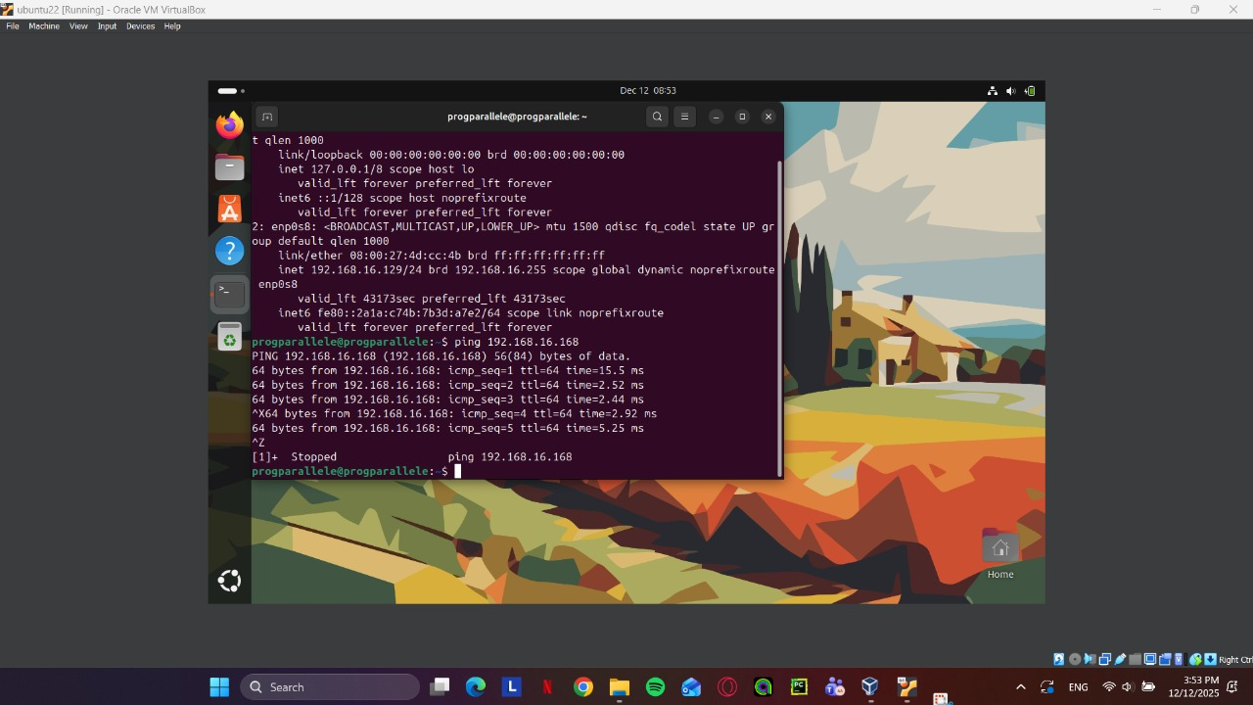
Figure 1- Worker Ping to Master (Ali to Rachid)
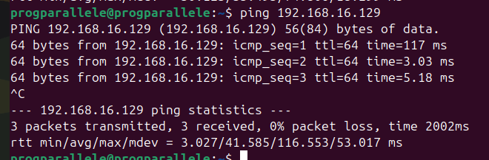
Figure 2 - PING_to_W1
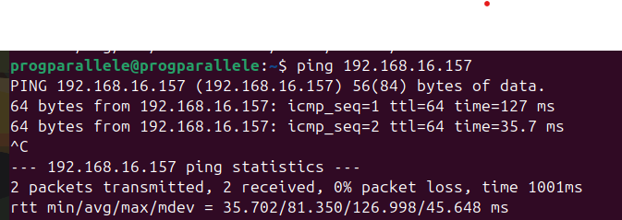
Figure 3 - PING_to_W2
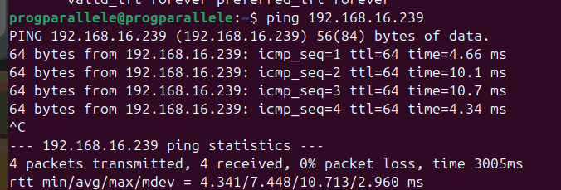
Figure 4 - PING_to_W3
These screenshots confirm:
- No packet loss
- Stable RTT
- Proper network configuration between nodes

3. Secure Communication Between Nodes (SSH)
MPI relies on passwordless SSH to start processes on remote nodes.
3.1 First SSH Connection (Host Key Registration)
We manually connect to each worker once to accept its SSH fingerprint.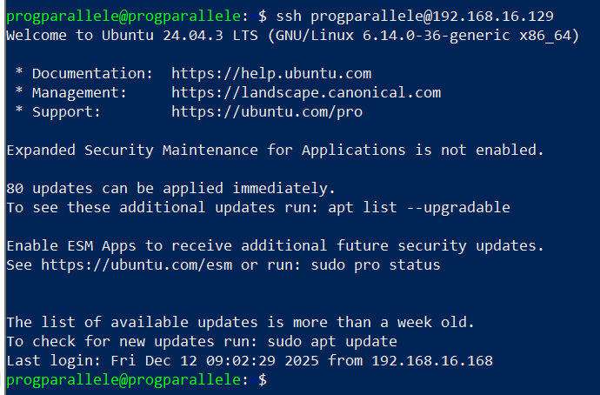
Figure 5 - SSH_TO_W1
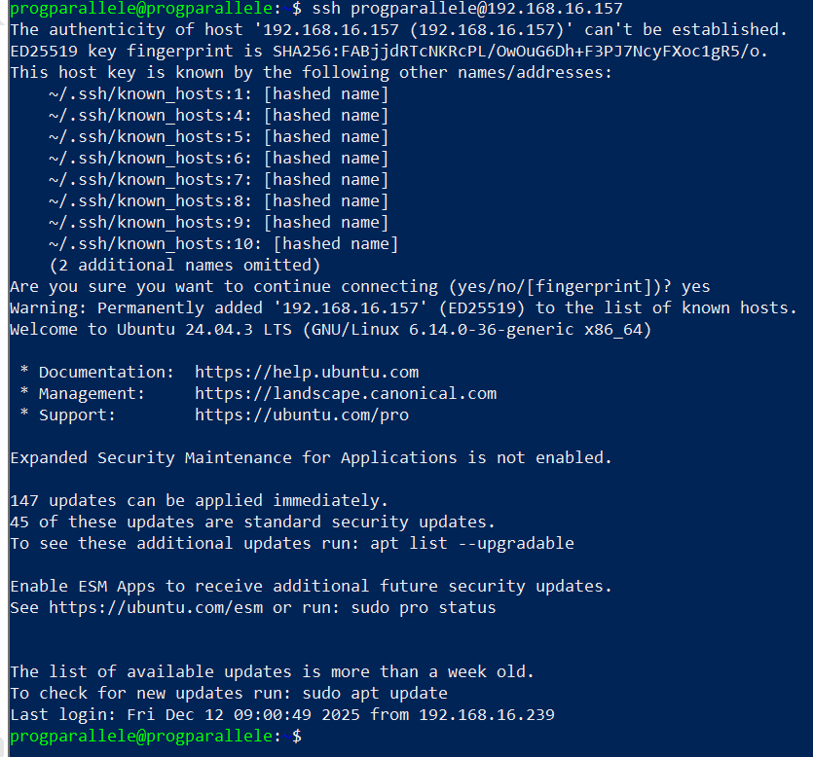
Figure 6 - SSH_TO_W2
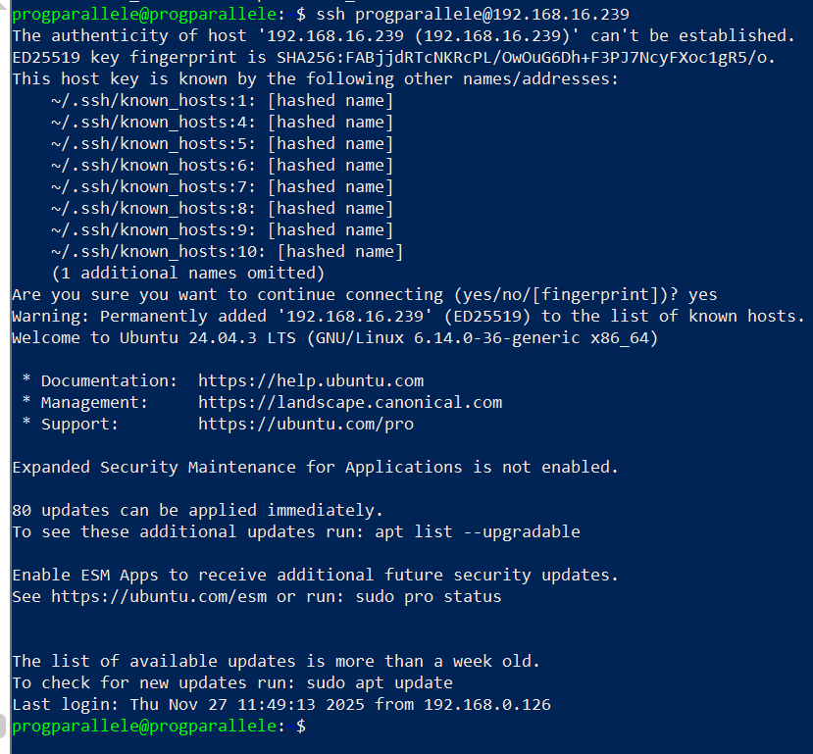
Figure 7 - SSH_TO_W3
This step ensures all worker nodes are trusted by the master.

3.2 SSH Key Distribution
To enable passwordless execution, we copy the public SSH key from the master to each worker.
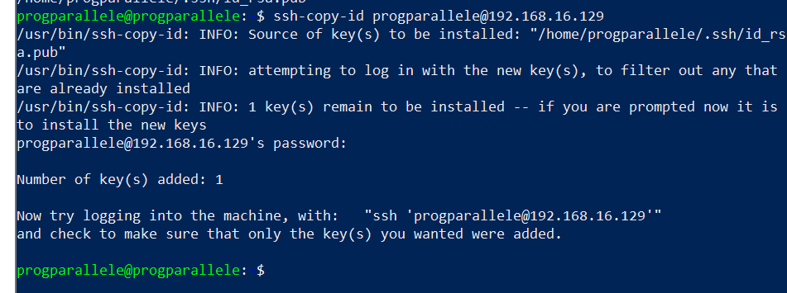
Figure 8 - COPYING_SSH_KEYS_TO_WORKERSpng
After this step:
- ssh worker works without password
- MPI can launch processes remotely

4. MPI Hostfile Configuration
MPI uses a hostfile to know:
- Which machines participate
- How many processes (slots) per machine

4.1 Hostfile with 4 Slots per Node
This configuration allows higher parallelism for performance testing.
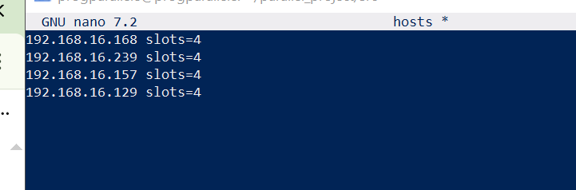
Figure 9 - 4_SLOTS_HOSTS

4.2 Hostfile with 2 Slots per Node (Final Demo Setup)
For the demo, we run 8 MPI processes total (2 per node × 4 nodes).
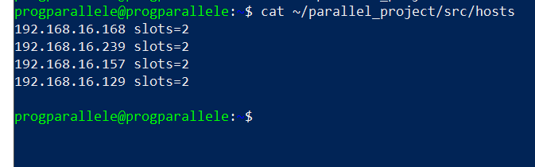
Figure 10 - HOSTS_FILE_SLOTS_2
This setup is ideal for:
- Clear load distribution
- Stable execution
- Easy explanation during presentation

5. Sequential Execution (Reference Solution)
Before running MPI, we execute the sequential version on the master node.
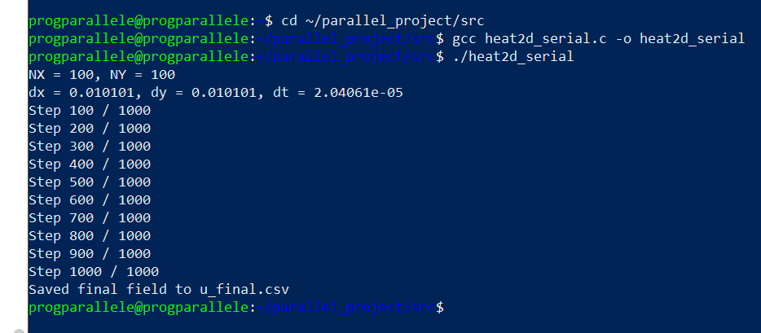
Figure 11 - SEQ_RUN
This run:
- Solves the same problem (NX = NY = 100)
- Produces u_final.csv
- Serves as a reference solution for correctness

6. Parallel MPI Execution
We now run the MPI solver using the hostfile.
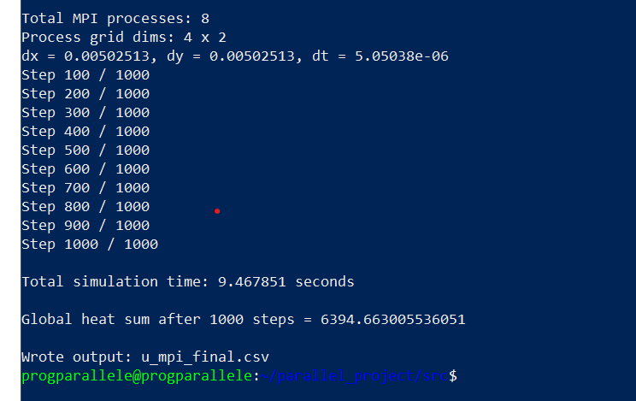
Figure 12 - MPI_Parall_RUN

During execution, MPI:
- Launches 8 processes across 4 machines
- Decomposes the domain
- Exchanges ghost cells
- Synchronizes at each time step
At the end:
- The global solution is gathered
- Output file u_mpi_final.csv is generated

7. Numerical Validation (Sequential vs MPI)
To ensure correctness, we compare the sequential and MPI results using Python (NumPy).
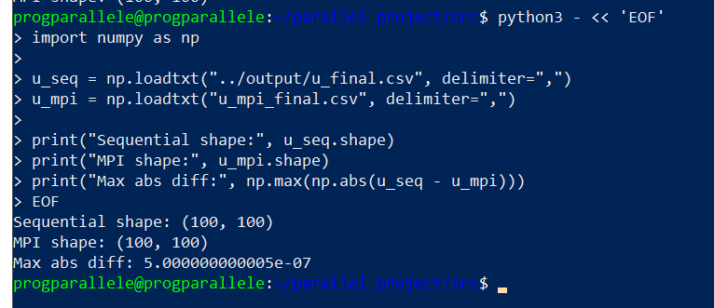
Figure 13 - NUMERICAL_VALIDATION_SEQ_VS_MPI_RESULTS
Validation Results:
- Sequential shape: (100, 100)
- MPI shape: (100, 100)
- Maximum absolute difference:
≈ 5 × 10⁻⁷
This confirms that:
- The MPI implementation is numerically correct
- Differences are only due to floating-point rounding

8. Visualization of Final Temperature Field
Finally, we visualize the final temperature distribution as a heatmap.
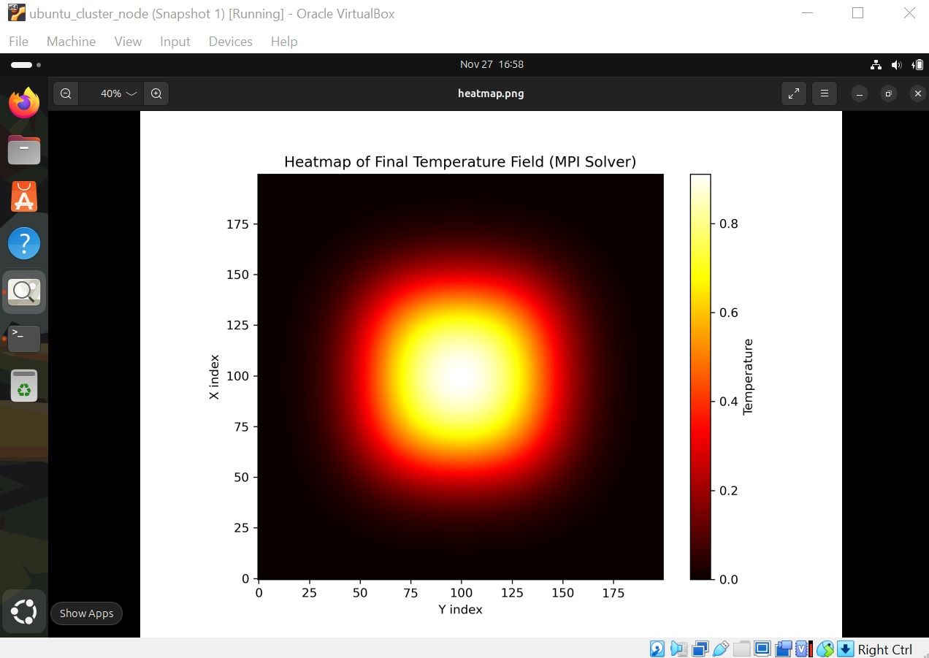
Figure 14 - heatmap
The plot clearly shows:
- A hot region at the center
- Smooth heat diffusion
- Symmetry preserved across the domain
This confirms both physical correctness and proper parallel assembly.

9. Conclusion
Through this demo, we successfully demonstrated:
- MPI cluster setup using VirtualBox
- Secure SSH-based communication
- Domain decomposition and parallel execution
- Numerical validation against a sequential solver
- Visualization of scientific results
This project illustrates how MPI enables scalable scientific computing across distributed systems while preserving accuracy.

