Project Documentation
SmartSDLC Project - Eco Assistant & Policy Analyzer

1. Introduction
- Project Title : SmartSDLC - Eco Assistant & Policy Analyzer
- Team Member : LOGESH V
- Team Member : MANIKANDAN K
- Team Member : MOHAMADU HASSAN S
- Team Member : MUTHU KUMAR C

2. Project Overview
- Purpose :
The purpose of this SmartSDLC project is to provide a sustainable digital assistant that empowers users to generate eco-friendly tips and analyze policy documents. By leveraging IBM Granite LLM and Gradio interface, it demonstrates how artificial intelligence can support both citizens and city officials in promoting eco-conscious decisions.
- Features:
Conversational Interface – Natural language interaction to ask questions and get updates.
Policy Summarization – Summarizes lengthy policy documents into concise points.
Eco-Tip Generator – Provides personalized sustainability advice.
PDF Text Extraction – Reads and extracts text from uploaded PDF documents.
Gradio UI – User-friendly interface with multiple tabs for easy interaction.

3. Architecture
Frontend (Gradio): Provides an interactive web UI with tabs for Eco Tips and Policy Summarization.
Backend (Python & IBM Granite LLM): Powers natural language understanding and response generation.
Libraries Used: Transformers, Torch, Gradio, PyPDF2.

4. Setup Instructions
Prerequisites:
o Python 3.9 or later
o pip and virtual environment tools
o Internet access to install dependencies and run the app
Installation Process:
o Install dependencies using pip
o Load the IBM Granite model and tokenizer
o Run the Gradio application

5. Folder Structure
SmartSDLC.ipynb – Jupyter notebook containing full implementation.
Functions included: generate_response, extract_text_from_pdf, eco_tips_generator, policy_summarization.
Gradio interface – Includes tabs for Eco Tips Generator and Policy Summarization.

6. Running the Application
- Install the required libraries.
- Load the model and tokenizer.
- Run the Gradio Blocks interface.
- Use Eco Tips Generator to get sustainability tips.
- Use Policy Summarization to upload PDFs or input text for summarization.

7. API Documentation
Functions:
generate_response(prompt) – Returns AI-generated text response.
extract_text_from_pdf(pdf_file) – Extracts text content from uploaded PDF.
eco_tips_generator(problem_keywords) – Provides eco-friendly tips based on keywords.
policy_summarization(pdf_file, policy_text) – Summarizes uploaded or pasted policy documents.

8. Authentication
This demo version runs in an open environment without authentication. For secure deployment, token-based authentication or OAuth can be integrated.

9. User Interface
The interface is built using Gradio with:
Sidebar navigation
Tabbed layouts for Eco Tips and Policy Summarization
Real-time interaction with AI model
Output display for tips and policy summaries

10. Testing
Testing Phases:
Unit Testing – For model functions and PDF extraction.
Manual Testing – For Gradio UI, eco tips generation, and policy summarization.
Edge Case Handling – For empty inputs, invalid PDFs, and large text.

11. Screenshots
Screenshots of the Gradio interface should be added here.

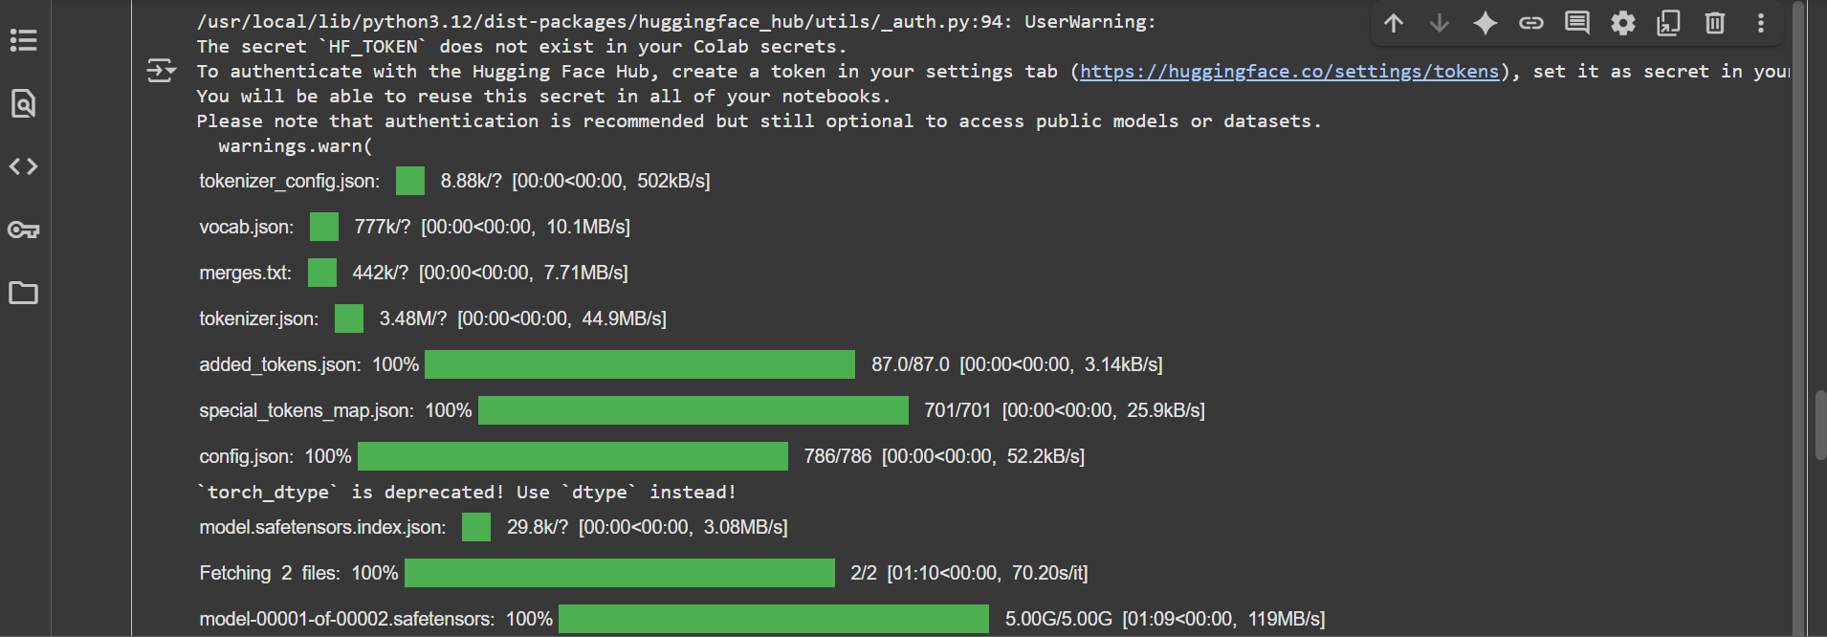

OUTPUT :
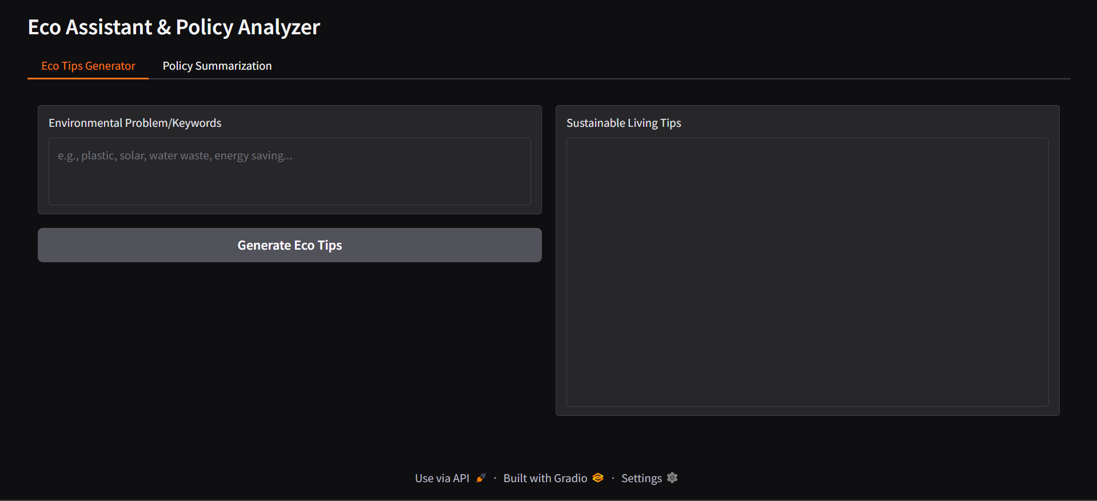

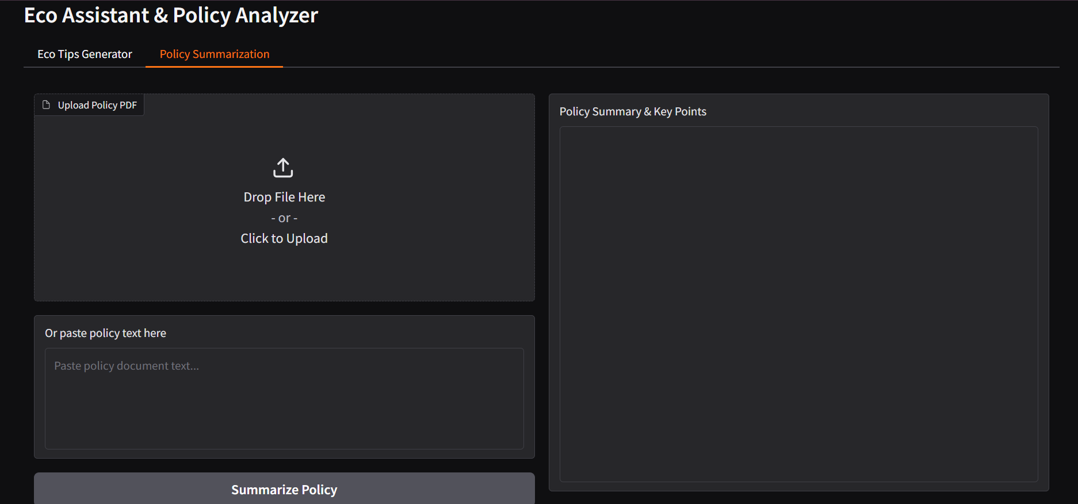

12. Known Issues
• Large PDF documents may take time to process.
• Summarization depends on the model’s performance.
• Limited customization of Gradio UI.

13. Future Enhancements
• Add secure authentication with user roles.
• Extend functionality with forecasting and anomaly detection.
• Improve UI with additional visualization features.
• Enhance summarization accuracy with fine-tuned models.

