8/16/2025
Data Pill

Team 2

full analysis for wide world importers dw.

Pipelines:
- Customer Behavior & Sales Analysis Flow
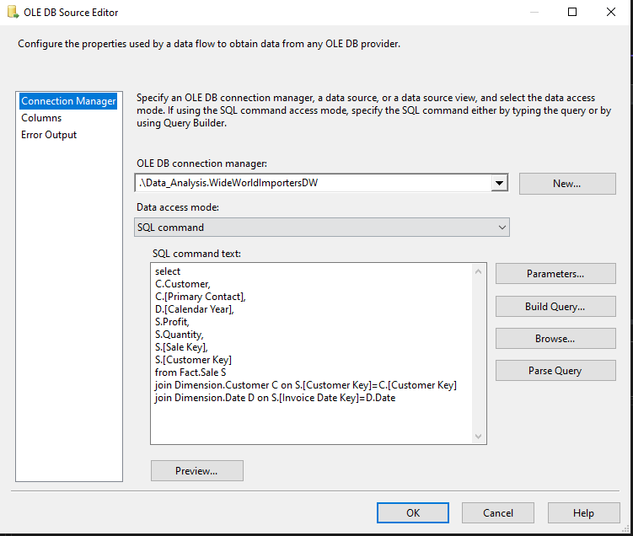
- Customer Behavior & Sales Analysis Flow Source

- Multicast: Only for Splitting date into 2 Paths.

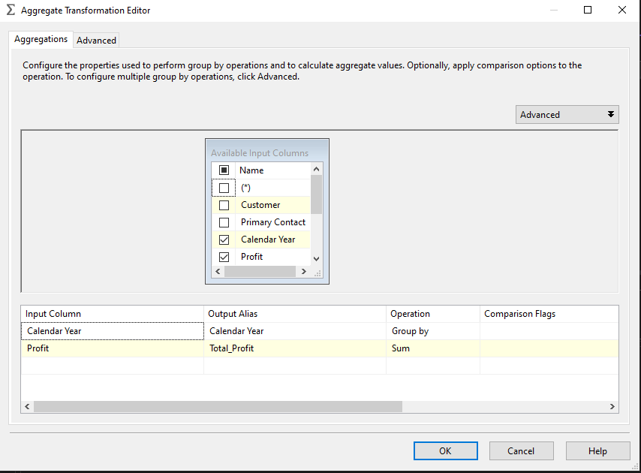
- Aggregate: Group the data by Calendar Year and Calculate the total profit for each year using the SUM operation.

- Aggregate 1: Groups the data by Customer Key, Customer, and Calendar Year, then Calculate the total profit and total quantity for each group.
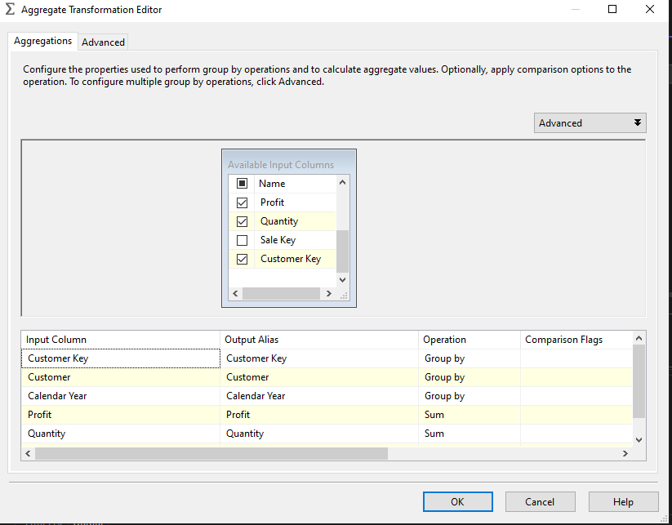

- Sort & Sort 1: Sort the data after the aggregation operations.
- Merge Join: Merge the data again to complete process.

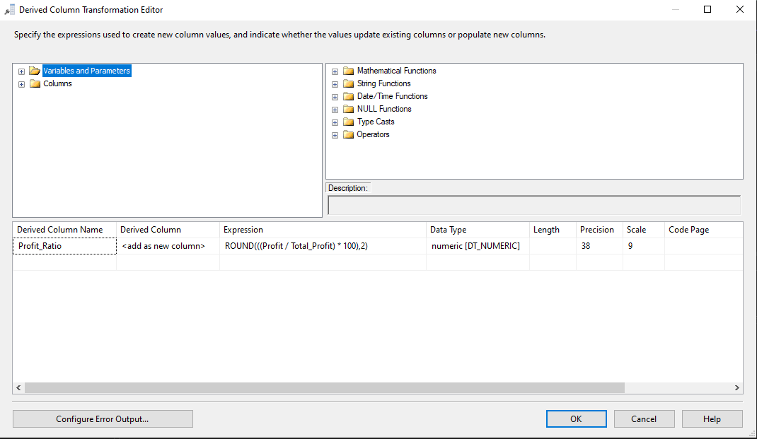
- Derived Column: Create a new column Profit_Ratio by calculating the percentage of each profit value compared to the total profit, rounded to two decimal places.

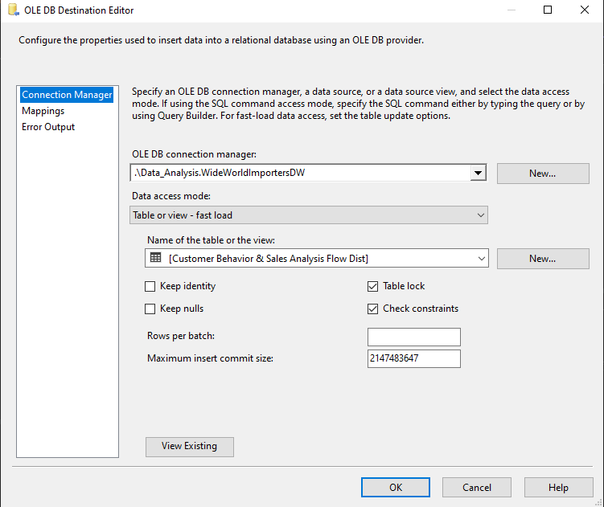
- Customer Behavior & Sales Analysis Flow Dist

- City Sales Analytics Flow
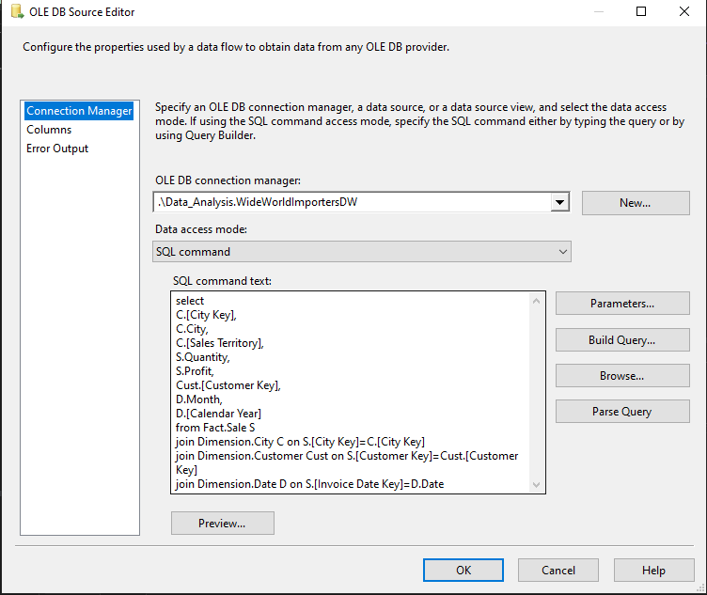
- City Sales Analytics Flow Source

- Multicast: Only for Splitting date into 2 Paths.

- Aggregate: Group the data by City, Sales Territory, and Calendar Year, then Calculate the total profit and total quantity for each group.
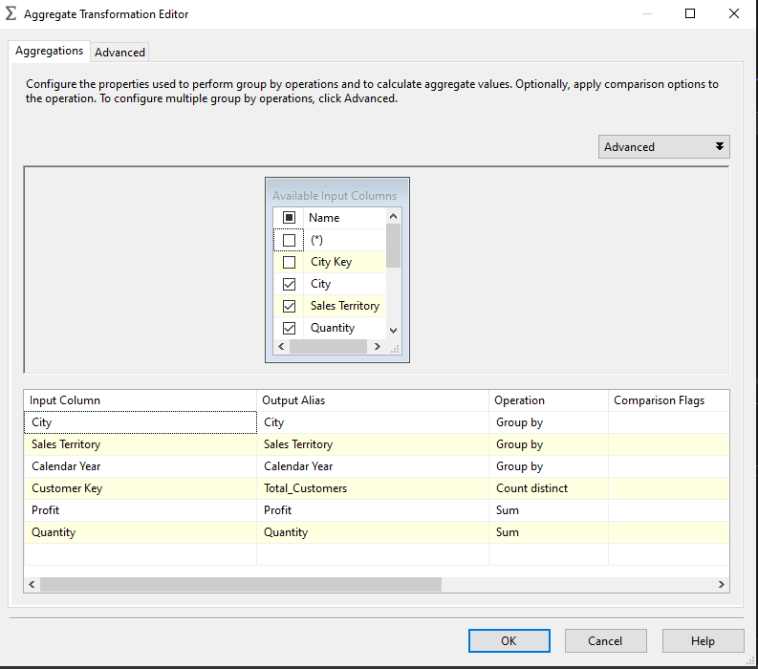

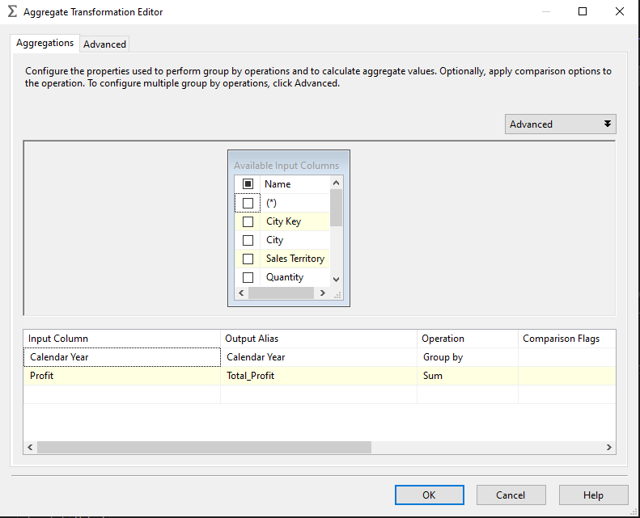
- Aggregate 1: Group the data by Calendar Year and Calculate the total profit for each year using the SUM operation.

- Sort & Sort 1: Sort the data after the aggregation operations.
- Merge Join: Merge the data again to complete process.
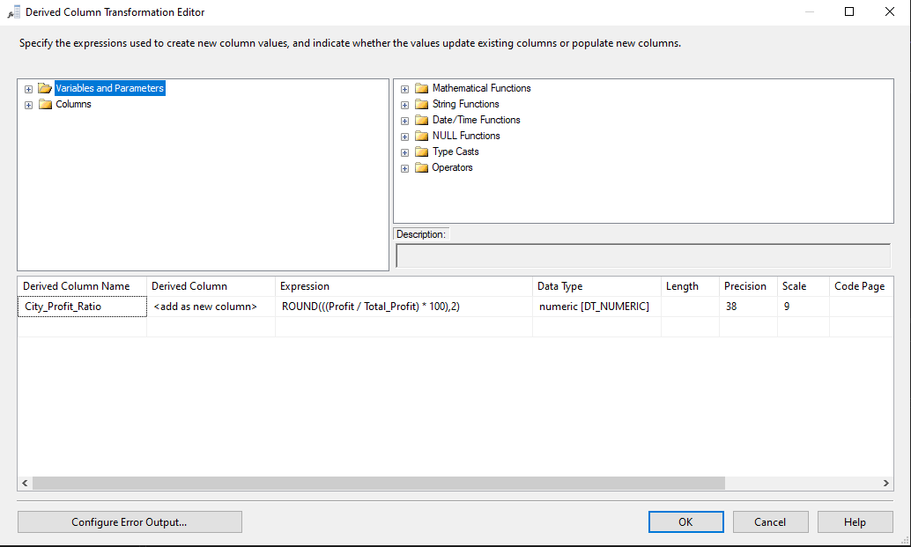
- Derived Column: Create a new column City_Profit_Ratio by calculating the percentage of each profit value compared to the total profit, rounded to two decimal places.

- City Sales Analytics Flow Dist.

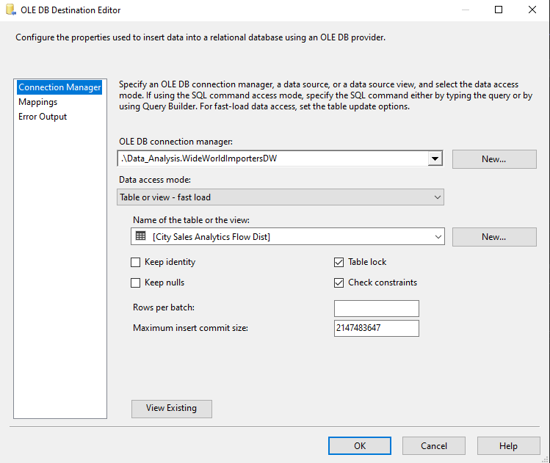

- Trends Overtime Flow
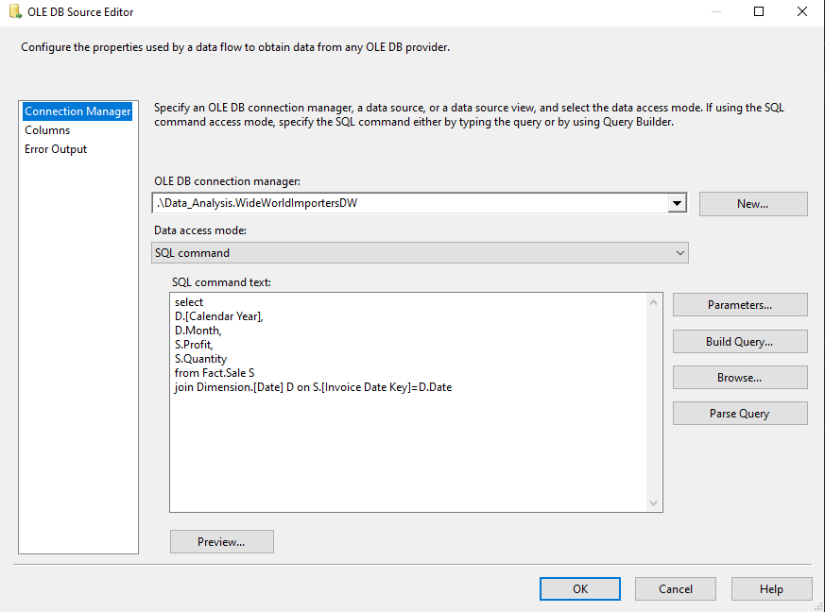
- Trends Overtime Flow Source:
- Multicast: Only for Splitting date into 2 Paths.
- Aggregate: Group the data by month and Calendar Year, then Calculate the total profit and total quantity for each group.
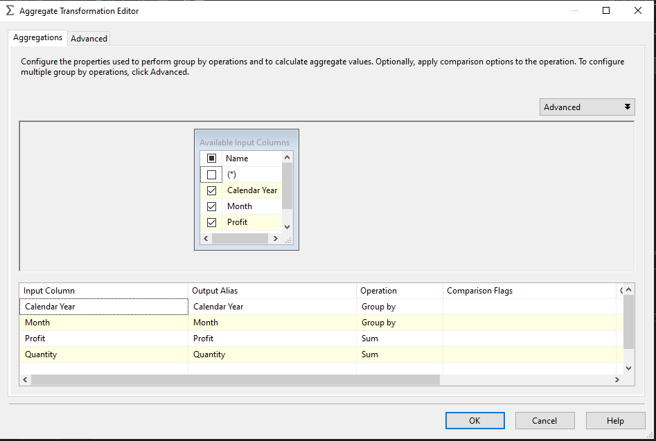
- Aggregate 1: Group the data by Calendar Year and Calculate the total profit for each year using the SUM operation.
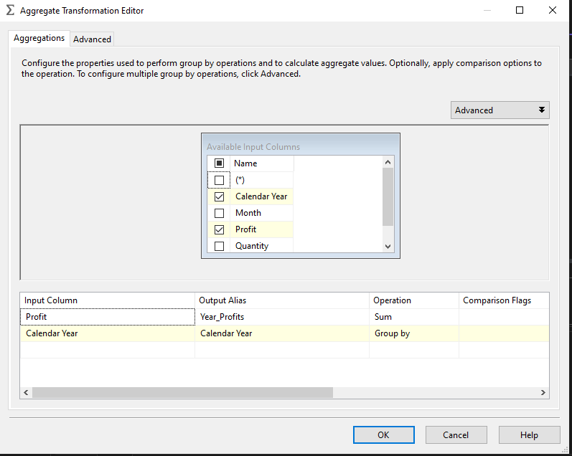

- Sort & Sort 1: Sort the data after the aggregation operations.
- Merge Join: Merge the data again to complete process.
- Derived Column: Create a new column Monthly_Profit_Ratio by calculating the percentage of each profit value compared to the year profits.
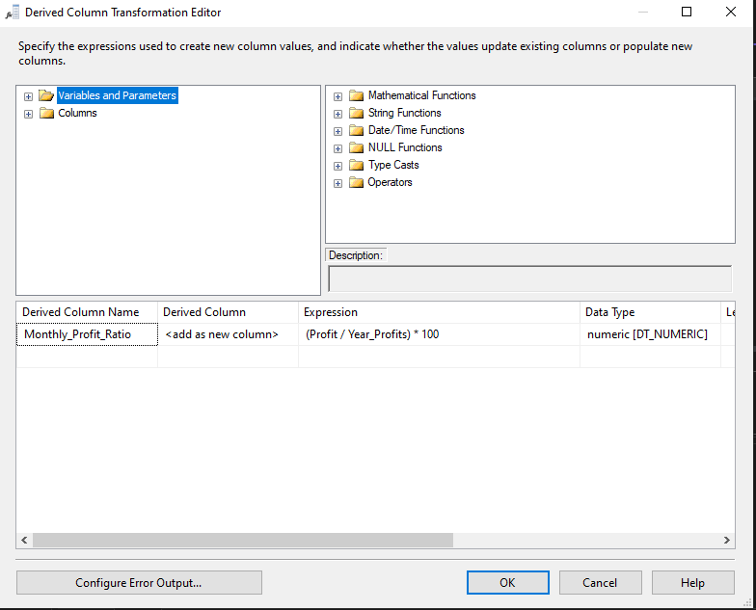

- Trends Overtime Flow Dist.

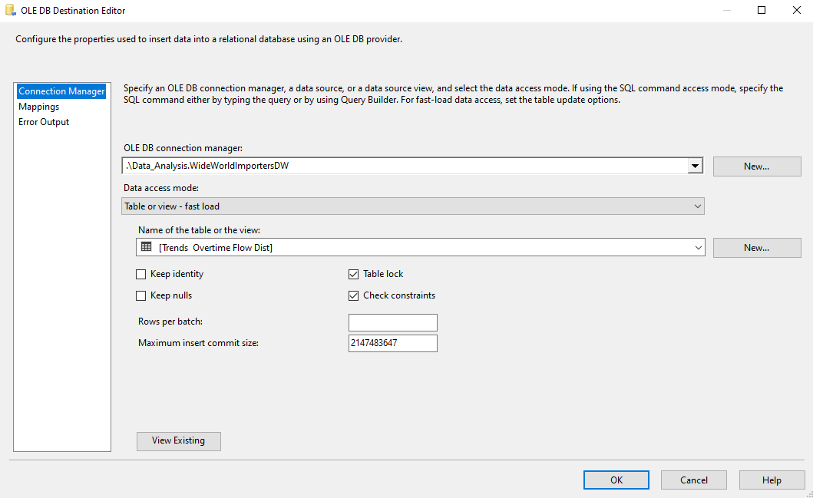
- Sales Person Performance Flow

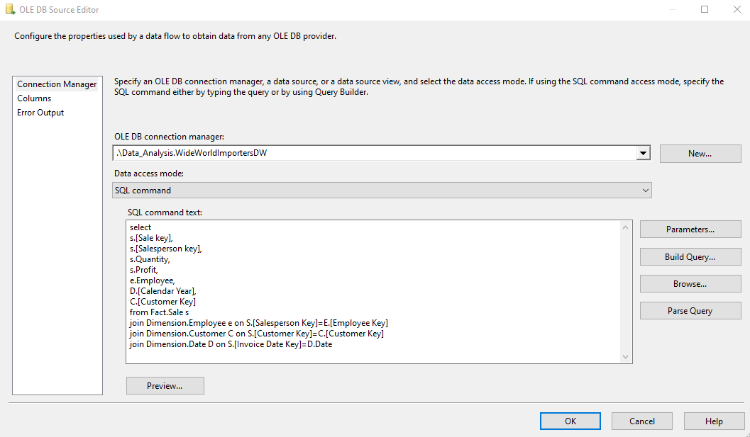
- Sales Person Performance Flow Source
- Multicast: Only for Splitting date into 2 Paths.

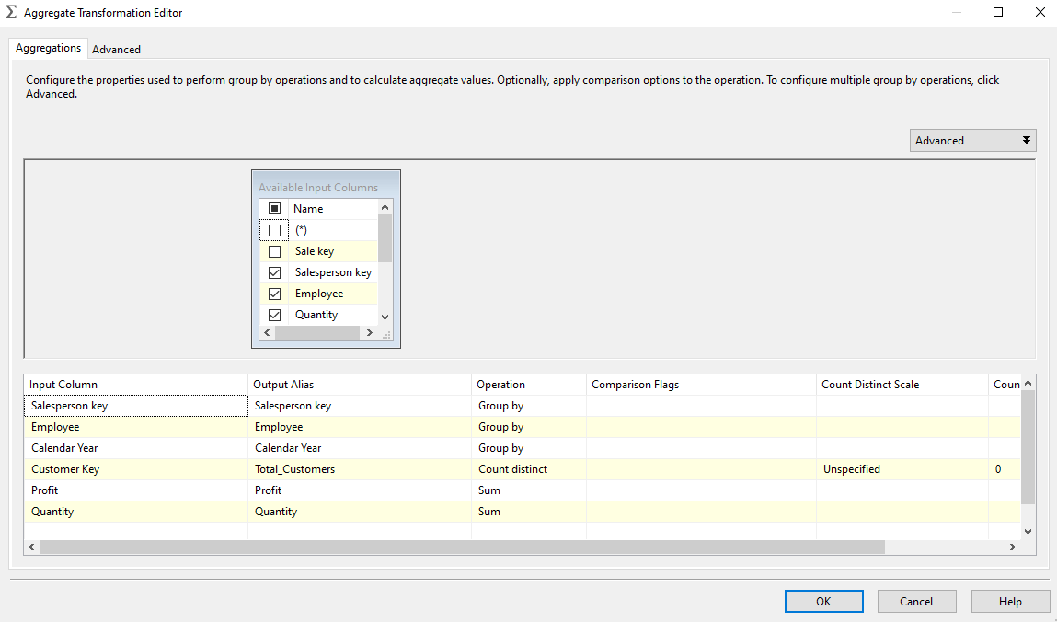
- Aggregate: Group the data by salesperson key, Employee and Calendar Year, then Calculate the total profit and total quantity for each group.

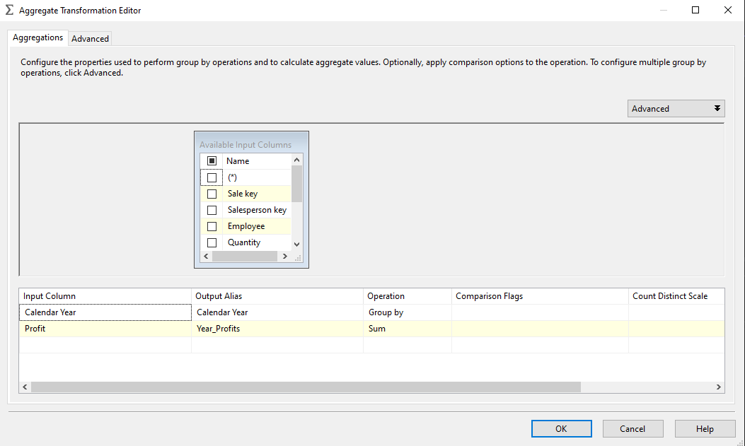
- Aggregate 1: Group the data by Calendar Year and Calculate the total profit for each year using the SUM operation.
- Sort & Sort 1: Sort the data after the aggregation operations.
- Merge Join: Merge the data again to complete process.

- Derived Column: Create a new column Profit_Contribution by calculating the percentage of each profit value compared to the year profits.
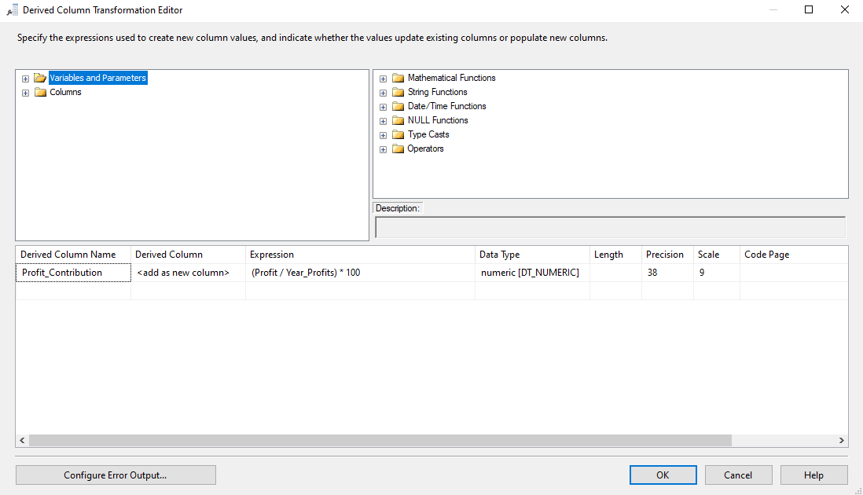
- Sales Person Performance Flow Dist.
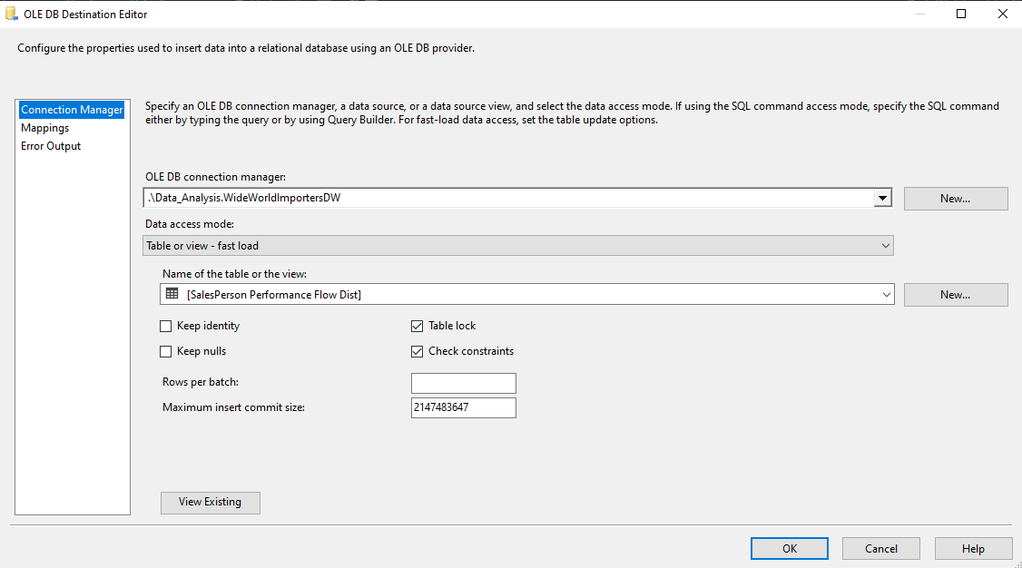

- Supplier Performance Flow

- Supplier Performance Flow Source
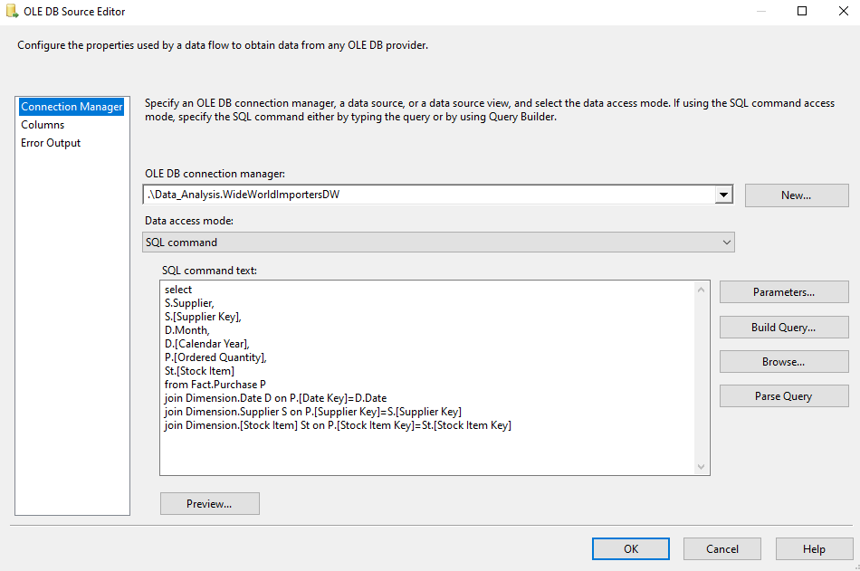
- Aggregate: Group the data by supplier key, supplier, month and Calendar Year, then Calculate the ordered quantity.
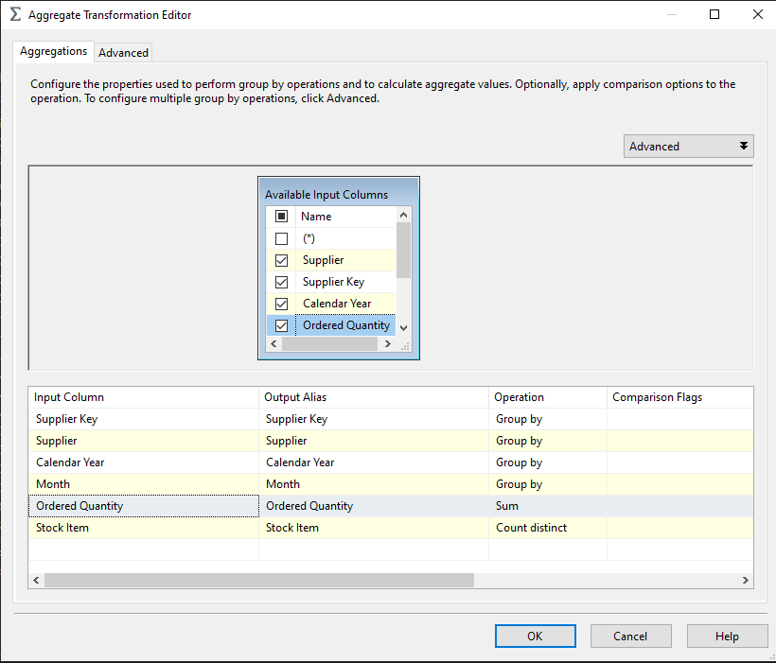

- Sort: Sort the data after the aggregation operations.
- Supplier Performance Flow Dist

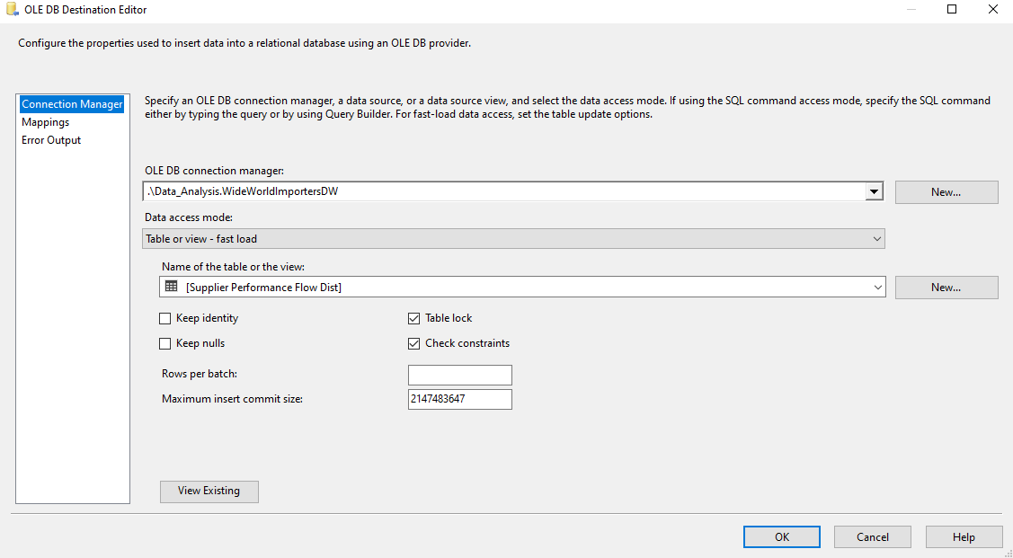
- Stock Item Performance Flow

- Stock Item Performance Flow Source
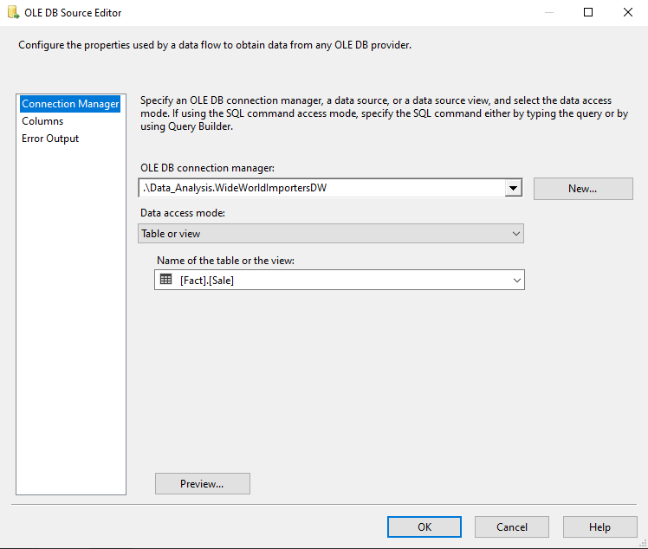
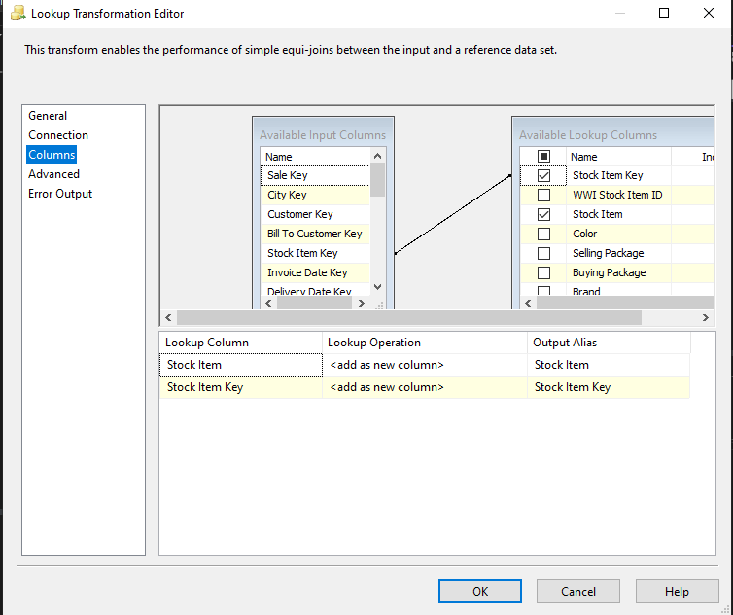
- Lookup: It matches data from the Fact Sale input with the Stock Item table based on the Stock Item Key, and retrieves related columns from the lookup table.

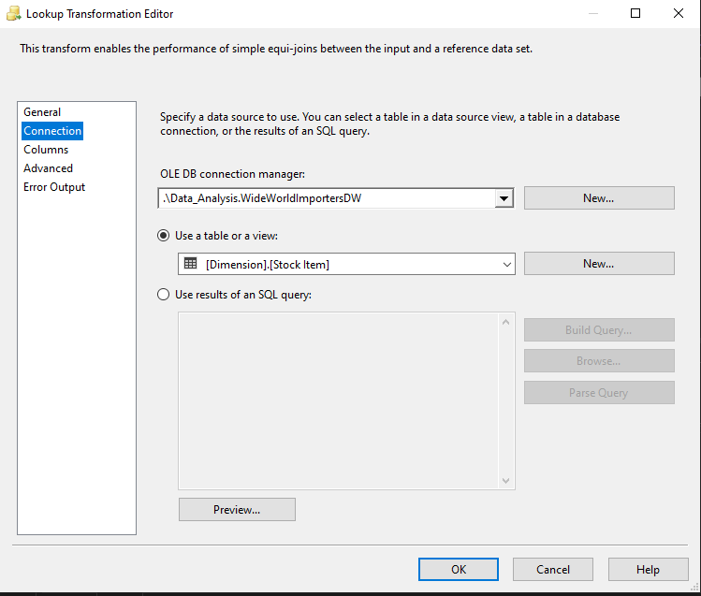
- Multicast: Only for Splitting date into 2 Paths.

- Aggregate: Group the data by stock item key and stock item, then Calculate the total profit and total quantity for each group.
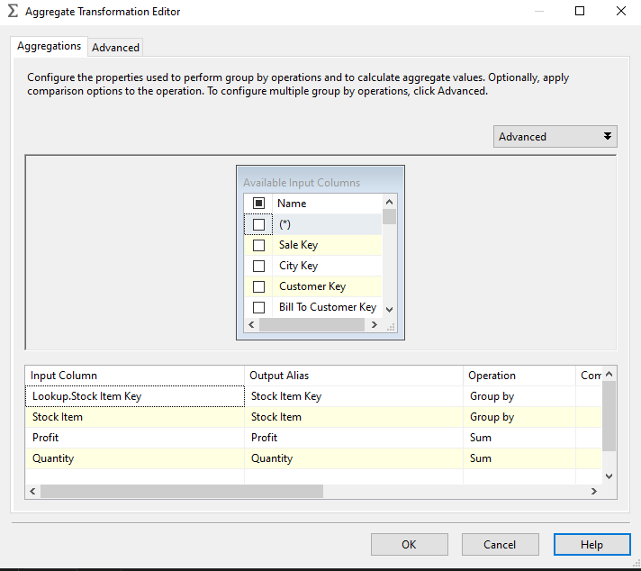

- Derived Column & Derived Column 1: Creates a new column join_key with a constant value to be used for sorting the data before a Merge Join, as SSIS requires both inputs to be sorted on the join key.
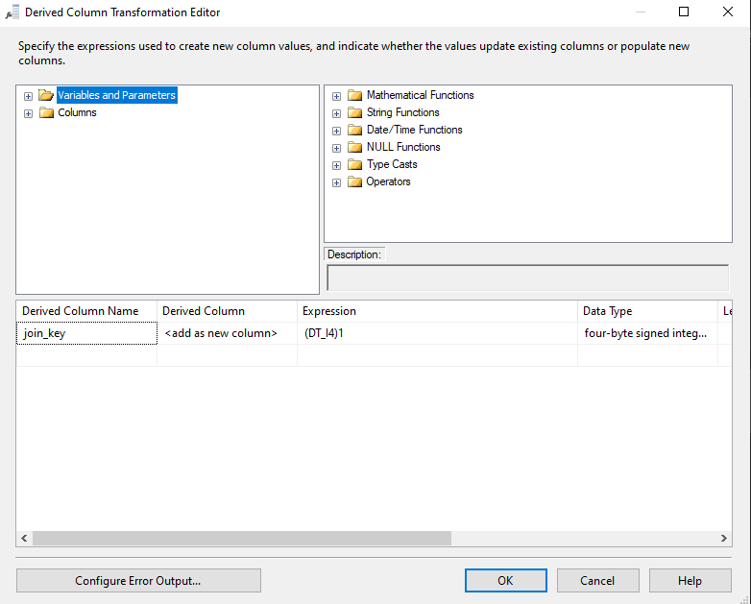

- Aggregate 1: Calculate the total profit using the SUM operation.
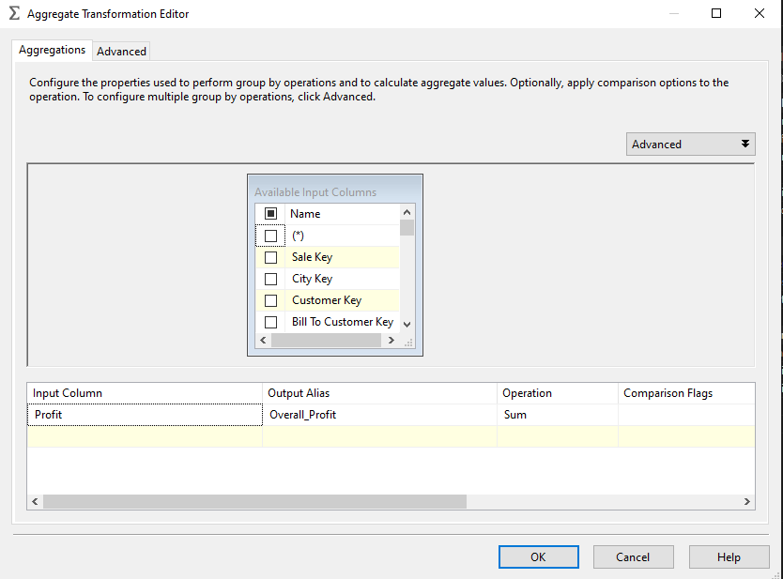

- Sort & Sort 1: Sort the data after the aggregation operations.
- Merge Join: Merge the data again to complete process.

- Derived Column 2: Create a new column Stock item profit percent by calculating the percentage of each profit value compared to the overall profits rounded to two decimal places.

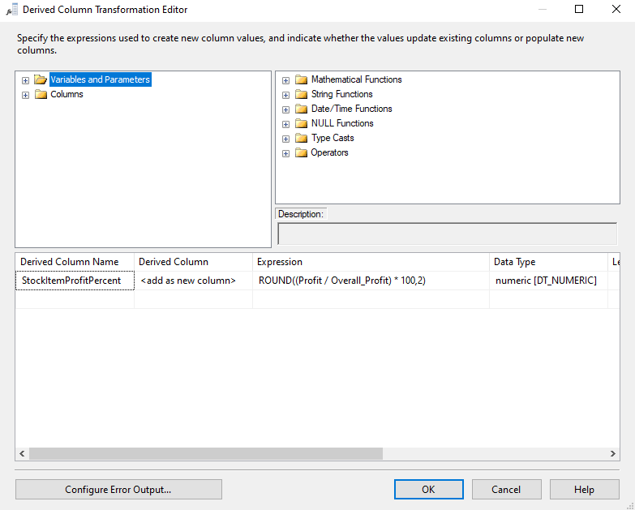

- Stock Item Performance Flow Dist
