# Research objective

Today we looked for improper integration, which is a type of definite integration, but there is some difference between them. Improper integration is used to find the value of the area between the x-axis and the curve if one of the end points of the curve is $∞$ or $-∞$ and is used to find the value of the area between the discontinuous curve and the x-axis. In the improper integration, we use limits to find its value.

# Introduction:

The integration was discovered by Italian mathematician called **Cavalieri** in **1635,** the beginning of the integration is to calculate the area under the curve. **Cavalieri** viewed that the curve is sum of infinite number of points and the area under the curve is infinite number of lines. He considered that the area of the triangle is $\frac{1}{2}$ area of the rectangle has the same base and height.

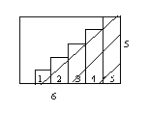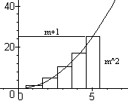

**Figure 1 the area under the curve**

$\frac{Area of shawded region}{Area of the rectangle}= \frac{0+1+2+3+4+5}{5*6}$ = $\frac{1}{2}$

**Therefore:**

$$\frac{Area of shaded region}{Area of the rectangle} = \frac{\sum_{i=0}^{n}{i}}{n(n+1)}= \frac{\frac{1}{2}n(n+1)}{n(n+1)}= \frac{1}{2}$$

The integration has several types one of them is the definite integral. The definite integral is used to calculate the area between the curve and x-axis in specified interval. **The improper integral** is one of the types of definite integral, in this type of the integration we use the limit to find its value.

In this research, we are going to discuss only the **Improper Integration**.

The **Improper Integration** consists of two types:

1. **Improper Integrals with infinite limits of Integration.**
2. **Improper Integrals with infinite discontinuities.**

# Infinite Integration:

An infinite integration is integral whose integration length is infinite. This means that integration limits include $∞$ or $-∞$ or both. Remember that $∞$ is a process (keep going, never stop), not a number. We make the integration limit a number, and take the limit as it goes to infinity or negative

General form of infinite limits integration:

$\int_{-∞}^{a}{f\left(x\right)dx}$ $\lim_{n→∞}{\int_{n}^{a}{f(x)dx}}$

$\int_{a}^{∞}{f\left(x\right)dx}$ $\lim_{n→∞}{\int_{a}^{n}{f(x)dx}}$

**Where f(x) is continuous**

**Example 1**

$\int_{3}^{9}{e^{-x}dx}$

**Sol.**

$\int_{3}^{9}{e^{-x}dx}$

**I= $\left[{-e}^{-x}\right]{9 \atop 3}$**

In this case we can solve this problem as definite integral because there is no infinity in its interval

**I= ${-e}^{-9}-{(-e}^{-3})$**

**Example 2**

$\int_{3}^{∞}{e^{-x}dx}$

**Sol.**

In this case we can’t use infinity as a limit because we can’t evaluate the definite integral as we have previouslydone**.**

$\lim_{n→∞}{\int_{3}^{n}{e^{-x}}}dx$

**I= $\lim_{n→∞}{{-e}^{-n}-({-e}^{-3})}$**

**I= ${-e}^{-∞}+e^{-3}$**

**I= 0+ $e^{-3}$ = $e^{-3}$**

**Integrals with Infinite Discontinuities:**

Now let's discuss integrals of functions that contain an infinite discontinuity in the interval that the integration takes place over. Find an f(x) dx form integral, where f(x) is continuous over [a, b) and discontinuous over b. Since the function f(x) is continuous over [a, t] for all t values, the values of x) dx should be considered as it approaches b for a

# General Form of infinite discontinuities:

$\int_{a}^{b}{f\left(x\right)dx}$ $\lim_{t→b-}{\int_{a}^{t}{f(x)dx}}$

$\int_{a}^{b}{f\left(x\right)dx}$ $\int_{a}^{c}{f(x)dx}+\int_{c}^{b}{f(x)dx}$

**Example 1**

* **Determine whether the following improper integral converges or diverges:**



$\int_{0}^{8}{\frac{3x}{\sqrt[3]{64-x^{2}}}dx}$

**Sol.**

$\int_{0}^{8}{\frac{3x}{\sqrt[3]{64-x^{2}}}dx}$**= $\lim_{t→8-}{\int_{0}^{t}{\frac{3x}{\sqrt[3]{64-x^{2}}}dx}}$ = $\lim_{t→8-}\left[\frac{-9}{4}{(64-x^{2})}^{2/3}\right]{t \atop 0}$**

Thus,

**= $\frac{-9}{4}\lim_{t→8}\left[{(64-t^{2})}^{2/3}-{64}^{2/3}\right]=\frac{-9}{4}\lim_{t→8}\left[{(64-t^{2})}^{2/3}-16\right]$**

**= $\frac{-9}{4}(0-16)$ = 36**

This integrand is continuous on the interval $\left[0 , 8\right].$

Thus, we will substitute the number **8** with the symbol **t**, because the fundamental theorem is not applied on this interval.

**Example 2**

$\int_{-3}^{3/{\sqrt{2}}}{\frac{dx}{\sqrt{9-x^{2}}}}$

**Sol**

$\int_{-3}^{3/{\sqrt{2}}}{\frac{dx}{\sqrt{9-x^{2}}}}$***= $\lim_{t→-3}{\int_{t}^{3/{\sqrt{2}}}{\frac{dx}{\sqrt{9-x^{2}}}}}$***

**The curve is discontinuous at x=3**

Thus,

$\int_{-3}^{3/{\sqrt{2}}}{\frac{dx}{\sqrt{9-x^{2}}}}= \sin^{-1}{\frac{x}{3}+c}$

Thus,

$\int_{-3}^{3/{\sqrt{2}}}{\frac{dx}{\sqrt{9-x^{2}}}}= \lim_{t→-3}{\int_{t}^{3/{\sqrt{2}}}{\frac{dx}{\sqrt{9-x^{2}}}}}= \lim_{t→-3}\left[\sin^{-1}{\frac{x}{3}}\right]{3/{\sqrt{2}} \atop t}$

**= $\lim_{t→-3}\left(\sin^{-1}{\frac{1}{\sqrt{2}}}-\sin^{-1}{\frac{t}{3}}\right)=\lim_{t→-3}\left(\frac{π}{4}-\sin^{-1}{\frac{t}{3}}\right)=\frac{π}{4}-\sin^{-1}\left(-1\right)=\frac{π}{4}$ + $\frac{π}{2}=\frac{3π}{4}$,** converges.

# 

# Solved Problems on infinite integration:

1. Determine if the integral $\int_{3}^{∞}{\frac{1}{{(x-2)}^{2}}}dx$ converges or diverges.

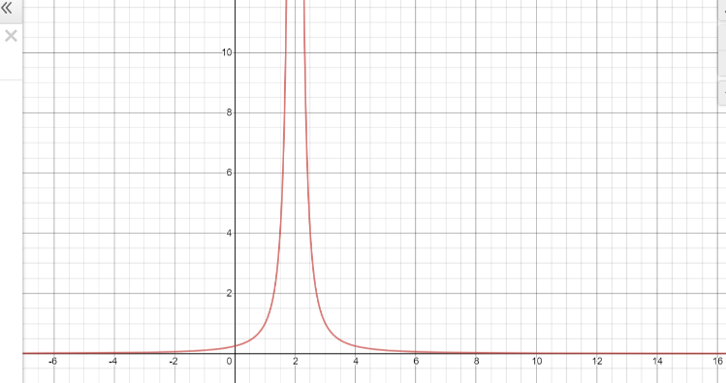**Sol.**

Figure 2 problem 1

**I= $\lim_{n→∞}{\int_{3}^{n}{\frac{1}{{(x-2)}^{2}}dx}}$**

**I= $\lim_{n→∞}\left[\frac{-1}{x-2}\right]{n \atop 3}$**

**I= $\lim_{n→∞}\left(-1+\frac{1}{n-2}\right)$**

**I= -1 + 0 = -1**

1. Determine the area (if it exist) of the region that is bounded by $y=e^{-x}$,***y=0*** , to the left of ***x=1***
2. 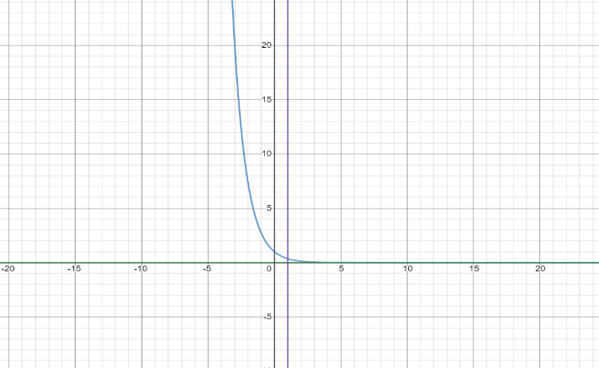**Sol.**

Figure 3 problem 2

$\int_{-∞}^{1}{e^{2x}dx}$**= $\lim_{n→-∞}{\int_{n}^{1}{e^{2x}}}$**

**I= $\lim_{n→-∞}\left[\frac{1}{2}e^{2x}\right]{1 \atop n}$**

**I= $\lim_{n→-∞}{\frac{1}{2}e^{2n}-\frac{1}{2}e^{2}}$**

**I= 0 - $\frac{1}{2}e^{2}= e^{2}$**

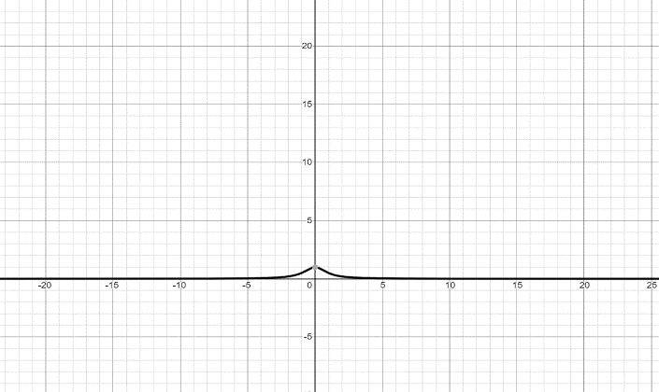

Figure 4 problem 3

$\int_{-∞}^{∞}{\frac{1}{1+x^{2}}dx}$

**I= $\int_{-∞}^{0}{\frac{1}{1+x^{2}}dx+ \int_{0}^{∞}{\frac{1}{1+x^{2}}dx}}$**

**I= $\lim_{n→-∞}{\int_{n}^{0}{\frac{1}{1+x^{2}}dx}}+ \lim_{n→∞}{\int_{0}^{∞}{\frac{1}{1+x^{2}}dx}}$**

**I= $\lim_{n→-∞}\left[arctan⁡(x)\right]{0 \atop n}$ + $\lim_{n→∞}\left[arctan⁡(x)\right]{n \atop 0}$**

**I= $π$**

**Solved Problems on discontinuous:**

1. $\int_{0}^{3}{\frac{x}{\sqrt{9-x^{2}}}}$***dx***

**Sol.**

$$\lim_{t→3}{\int_{0}^{t}{\frac{x}{\sqrt{9-x^{2}}}}dx }=\lim_{t→3}\left[-\sqrt{9-x^{2}} \right]{t \atop 0}=\lim_{t→3}\left[-\sqrt{9-t^{2}}+3\right]=3$$

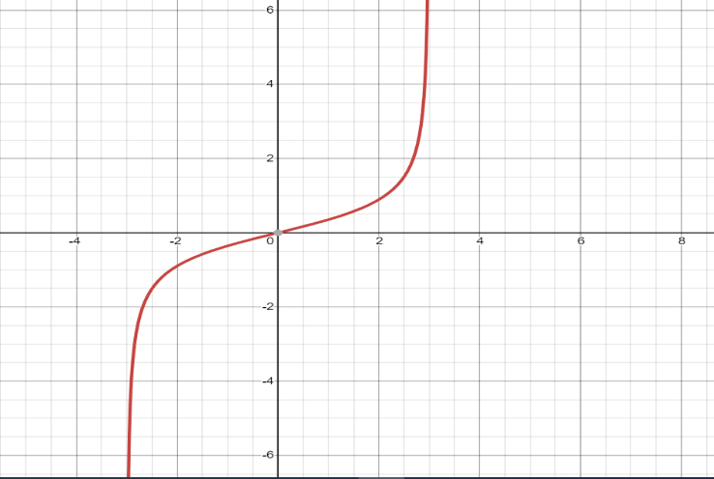



$\int_{-3}^{1}{\frac{1}{{(x+2)}^{2}}dx}$

Domain R- $\left\{-2\right\}$

**Therefore**

$\int_{-3}^{1}{\frac{1}{{(x+2)}^{2}}dx}$**= $\int_{-3}^{-2}{\frac{1}{{(x+2)}^{2}}dx}$ + $\int_{-2}^{1}{\frac{1}{{(x+2)}^{2}}}dx$**

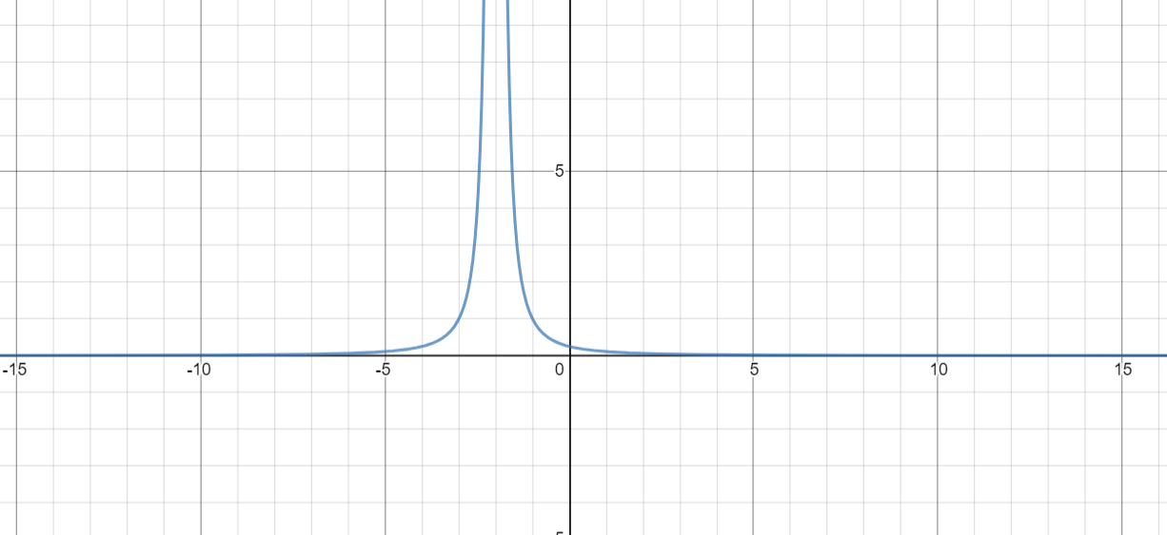**= $\lim_{t→-2}{\int_{-3}^{t}{\frac{1}{{(x+2)}^{2}}dx}}$ = $\left[\frac{-1}{x+1}\right]{t \atop -3}$**

**= $\lim_{t→-2}{ \frac{-1}{t+1}- \frac{1}{2}}$ = $1-\frac{1}{2}$ = $\frac{1}{2}$**

$\lim_{t→-2}{\int_{t}^{1}{\frac{1}{{(x+2)}^{2}}dx}}$**= $\left[\frac{-1}{x+1}\right]{1 \atop t}$**

**= $\lim_{t→-2}{ \frac{-1}{2}+ \frac{1}{t+1}}$ = $\frac{-1}{2}-1$ = $\frac{-3}{2}$**

**Therefore**

$\int_{-3}^{1}{\frac{1}{{(x+2)}^{2}}dx}$**= $\frac{1}{2}- \frac{3}{2}$ = $-1$**

# Application of improper integral

1. The most common application of such integrals is in probability and statistics (or their applications, such as in quantum physics, economics, etc.), in which some quantity is modeled on a distribution of probability that is supported in the real line, such as the normal distribution ("bell curve").
2. Will a very simple application be measuring the velocity of escape or having the work performed in lifting a 3 kilogram mass from the earth's surface to a distance D from the earth's center? If value D isn't specified. After a clear answer to integration it turns out to be $W=-\frac{k}{D}+c$; where K and C are a few constants. W increases as D increases or $C= \lim_{D→∞}{W}$ which calculates the work required to lift the object to a certain extent. I.e.

$\lim_{D→∞}{\int_{r0}^{D}{\frac{k}{x^{2}}dx}}$ = $\int_{r0}^{D}{\frac{k}{x^{2}}dx}$ The ro is avg here. Planet radius & RHS is incomplete integral. To do so is not necessarily "improper," nor is it necessarily "an integral'.' In fact, a limit is shorthand. Be mindful that a finite amount of work is enough to lift an object to "infinity’ ‘this is like saying that area under infinite curve is finite.  
It so happens, when the integral converges.

1. The definite integral can be used in a variety of commercial and economic applications. For instance, the definite integral may be used to find the total revenue from a continuous income stream for a defined number of years. It is also possible to use the definite integral to find the present value-the value today of a continuous income stream that will provide income in future. The present value is useful when determining which machinery to repair or which new equipment to choose. When the notion of the present value is extended to an infinite time interval, the result is called the income stream's capital value and given by

$$Capital Value= \int_{0}^{∞}{f(t)e^{-rt}dt}$$

# Conclusion

Cavalieri is the one who discovered the improper integral in 1635.

What are improper integrals?

* Improper integrals are definite elements covering an unbounded area..

*An Improper integral is a definite integral which has either or both infinite limits or an integral which approaches infinity at one or more points in the integration range.

-One type of improper integrals is integrals in which at least one endpoint is extended to infinity.

**Infinite Interval**

In this type of integral infinity is one or both of the limits of integration are infinity. In such cases, the integration interval is said to be over an infinite interval.

**Discontinuous Integrand**

The second category of improper are integrals with discontinuous integrands. Only one small difference the procedure here is exactly the same.