1. Data Collection & Importing
1.1. Import Necessary Libraries
import pandas as pd # Importing pandas for data manipulation
import matplotlib.pyplot as plt # Importing Matplotlib for
visualization
import seaborn as sns # Importing Seaborn for advanced visualizations
1.2. Load the Dataset
# Load CSV file
df = pd.read_csv("Superstore Sales Dataset.csv")
# Display first 5 rows
print(df.head())
Row ID Order ID Order Date Ship Date Ship Mode Customer ID \
0 1 CA-2017-152156 08/11/2017 11/11/2017 Second ClassCG-12520
1 2 CA-2017-152156 08/11/2017 11/11/2017 Second ClassCG-12520
2 3 CA-2017-138688 12/06/2017 16/06/2017 Second ClassDV-13045
3 4 US-2016-108966 11/10/2016 18/10/2016 Standard ClassSO-20335
4 5 US-2016-108966 11/10/2016 18/10/2016 Standard ClassSO-20335
Customer Name Segment Country CityState \
0 Claire Gute Consumer United States HendersonKentucky
1 Claire Gute Consumer United States HendersonKentucky
2 Darrin Van Huff Corporate United States Los AngelesCalifornia
3 Sean O'Donnell Consumer United States Fort LauderdaleFlorida
4 Sean O'Donnell Consumer United States Fort LauderdaleFlorida
Postal Code Region Product ID Category Sub-
Category \
0 42420.0 South FUR-BO-10001798 Furniture Bookcases

1 42420.0 South FUR-CH-10000454 Furniture Chairs
2 90036.0 West OFF-LA-10000240 Office Supplies Labels
3 33311.0 South FUR-TA-10000577 Furniture Tables
4 33311.0 South OFF-ST-10000760 Office Supplies Storage
Product Name Sales 0 Bush Somerset Collection Bookcase 261.9600 1 Hon Deluxe Fabric Upholstered Stacking Chairs,... 731.9400 2 Self-Adhesive Address Labels for Typewriters b... 14.6200 3 Bretford CR4500 Series Slim Rectangular Table 957.5775 4 Eldon Fold 'N Roll Cart System 22.3680
1.3. Inspect the Dataset
df.drop('Row ID', axis=1, inplace=True)
# Get a summary of dataset columns, data types, and non-null values df.info()
<class 'pandas.core.frame.DataFrame'>
RangeIndex: 9800 entries, 0 to 9799
Data columns (total 17 columns):
# Column Non-Null Count Dtype--- ------ -------------- ----- 0 Order ID 9800 non-null object 1 Order Date 9800 non-null object 2 Ship Date 9800 non-null object 3 Ship Mode 9800 non-null object 4 Customer ID 9800 non-null object 5 Customer Name 9800 non-null object 6 Segment 9800 non-null object 7 Country 9800 non-null object 8 City 9800 non-null object 9 State 9800 non-null object 10 Postal Code 9789 non-null float64 11 Region 9800 non-null object 12 Product ID 9800 non-null object 13 Category 9800 non-null object 14 Sub-Category 9800 non-null object 15 Product Name 9800 non-null object 16 Sales 9800 non-null float64 dtypes: float64(2), object(15)
memory usage: 1.3+ MB
# Get statistical summary of numerical columns df.describe()

Postal Code Sales count 9789.000000 9800.000000 mean 55273.322403 230.769059 std 32041.223413 626.651875 min 1040.000000 0.444000 25% 23223.000000 17.248000 50% 58103.000000 54.490000 75% 90008.000000 210.605000 max 99301.000000 22638.480000

1.4. Check for Missing Values
# Count missing values in each column missing_values = df.isnull().sum() print(missing_values)
Order ID 0 Order Date 0 Ship Date 0 Ship Mode 0 Customer ID 0 Customer Name 0 Segment 0 Country 0 City 0 State 0 Postal Code 11 Region 0 Product ID 0 Category 0 Sub-Category 0 Product Name 0 Sales 0 dtype: int64

2. Data Preparation
2.1. Convert Columns Data Type Format
# Convert 'Order Date' and 'Ship Date' columns to datetime format df['Order Date'] = pd.to_datetime(df['Order Date'], dayfirst=True) df['Ship Date'] = pd.to_datetime(df['Ship Date'], dayfirst=True)
# Convert 'Category' column to categorical data type df['Category'] = df['Category'].astype('category')

2.2. Handle Missing Values
# Show missing values
print(df[df['Postal Code'].isnull()])
  \
  Order ID Order Date Ship Date Ship Mode Customer ID
2234 CA-2018-104066 2018-12-05 2018-12-10 Standard Class QJ-19255
5274 CA-2016-162887 2016-11-07 2016-11-09 Second Class SV-20785
8798 US-2017-150140 2017-04-06 2017-04-10 Standard Class VM-21685
9146 US-2017-165505 2017-01-23 2017-01-27 Standard Class CB-12535
9147 US-2017-165505 2017-01-23 2017-01-27 Standard Class CB-12535
9148 US-2017-165505 2017-01-23 2017-01-27 Standard Class CB-12535
9386 US-2018-127292 2018-01-19 2018-01-23 Standard Class RM-19375
9387 US-2018-127292 2018-01-19 2018-01-23 Standard Class RM-19375
9388 US-2018-127292 2018-01-19 2018-01-23 Standard Class RM-19375
9389 US-2018-127292 2018-01-19 2018-01-23 Standard Class RM-19375
9741 CA-2016-117086 2016-11-08 2016-11-12 Standard Class QJ-19255
Customer Name Segment Country City State \
2234 Quincy Jones Corporate United States BurlingtonVermont
5274 Stewart Visinsky Consumer United States BurlingtonVermont
8798 Valerie Mitchum Home Office United States BurlingtonVermont
9146 Claudia Bergmann Corporate United States BurlingtonVermont
9147 Claudia Bergmann Corporate United States BurlingtonVermont
9148 Claudia Bergmann Corporate United States BurlingtonVermont
9386 Raymond Messe Consumer United States BurlingtonVermont
9387 Raymond Messe Consumer United States BurlingtonVermont
9388 Raymond Messe Consumer United States BurlingtonVermont
9389 Raymond Messe Consumer United States Burlington

Vermont
9741 Quincy Jones Corporate United States BurlingtonVermont
Postal Code Region Product ID Category Sub-
Category \
2234 NaN East TEC-AC-10001013 TechnologyAccessories
5274 NaN East FUR-CH-10000595 FurnitureChairs
8798 NaN East TEC-PH-10002555 TechnologyPhones
9146 NaN East TEC-AC-10002926 TechnologyAccessories
9147 NaN East OFF-AR-10003477 Office SuppliesArt
9148 NaN East OFF-ST-10001526 Office SuppliesStorage
9386 NaN East OFF-PA-10000157 Office SuppliesPaper
9387 NaN East OFF-PA-10001970 Office SuppliesPaper
9388 NaN East OFF-AP-10000828 Office SuppliesAppliances
9389 NaN East OFF-EN-10001509 Office SuppliesEnvelopes
9741 NaN East FUR-BO-10004834 FurnitureBookcases
Product Name Sales 2234 Logitech ClearChat Comfort/USB Headset H390 205.03 5274 Safco Contoured Stacking Chairs 715.20 8798 Nortel Meridian M5316 Digital phone 1294.75 9146 Logitech Wireless Marathon Mouse M705 99.98 9147 4009 Highlighters 8.04 9148 Iceberg Mobile Mega Data/Printer Cart 1564.29 9386 Xerox 191 79.92 9387 Xerox 1881 12.28 9388 Avanti 4.4 Cu. Ft. Refrigerator 542.94 9389 Poly String Tie Envelopes 2.04 9741 Riverside Palais Royal Lawyers Bookcase, Royal... 4404.90
# Alternatively, fill missing Postal Code values with 5001 df['Postal Code'] = df['Postal Code'].fillna(5001)

2.3. Standardize Text
2.3.1. Standardize Column Names
# Convert column names to lowercase and replace spaces with
underscores
df.columns = df.columns.str.strip().str.lower().str.replace(' ', '_')
2.3.2. Standardize Text Columns
# Function to standardize and format text columns
def standardize_text(text):
ifisinstance(text, str):
return'_'.join(text.strip().lower().split()) # Convert to lowercase, remove extra spaces, replace spaces with "_"
return text
# Apply standardization to all string columns
string_columns = df.select_dtypes(include=['object']).columns df[string_columns] = df[string_columns].applymap(standardize_text)
C:\Users\Aboelyazzed\AppData\Local\Temp\
ipykernel_7360\3450330121.py:9: FutureWarning: DataFrame.applymap hasbeen deprecated. Use DataFrame.map instead.
df[string_columns] = df[string_columns].applymap(standardize_text)
# Print Columns names After Standardize print (df.columns)
Index(['order_id', 'order_date', 'ship_date', 'ship_mode','customer_id',
'customer_name', 'segment', 'country', 'city', 'state',
'postal_code',
'region', 'product_id', 'category', 'sub-category',
'product_name',
'sales'],

dtype='object')

2.3.3. Use fuzzy matching to find similar product names
from rapidfuzz import process, fuzz
# Convert product names to lowercase and strip extra spaces for consistency
df['product_name'] = df['product_name'].str.strip().str.lower()
# Count unique Product IDs for each Product Name product_name_check = df.groupby('product_name') ['product_id'].nunique()

# Filter Product Names that have multiple Product IDs
potential_issues = product_name_check[product_name_check > 1].index.tolist()
# Use fuzzy matching to find similar product names with different IDs similar_names = {}
for name in potential_issues:
matches = process.extract(name, df['product_name'].unique(), limit=5, scorer=fuzz.partial_ratio)
similar_names[name] = [match[0] for match in matches if match[0] !
= name and match[1] > 85] # Threshold set to 85
# Display Results
ifany(similar_names.values()): # Check if there are matches
for name, matches in similar_names.items():
if matches:
print(f"⚠️ Possible duplicate product names for '{name}': {matches}")
else:
print("✅ No similar product names with different IDs were found.")
⚠️ Possible duplicate product names for '#10-
_4_1/8"_x_9_1/2"_recycled_envelopes': ['colored_envelopes']
⚠️ Possible duplicate product names for 'avery_non-stick_binders':['avery_5', 'avery_51', 'avery_48', 'avery_52']
⚠️ Possible duplicate product names for 'easy-staple_paper':
['staples']
⚠️ Possible duplicate product names for 'okidata_c610n_printer':['okidata_c331dn_printer', 'okidata_mb760_printer']
⚠️ Possible duplicate product names for 'staple-based_wall_hangings':['staples']
⚠️ Possible duplicate product names for 'staple_envelope': ['staples']⚠️ Possible duplicate product names for 'staple_holder': ['staples']⚠️ Possible duplicate product names for 'staple_magnet': ['staples']⚠️ Possible duplicate product names for 'staple_remover': ['staples']⚠️ Possible duplicate product names for 'staples':
['staples_in_misc._colors', 'staple_envelope', 'staple-
based_wall_hangings', 'staple_remover']
⚠️ Possible duplicate product names for 'staples_in_misc._colors': ['staples']
8. Remove Duplicate Rows
1. Check if Each Product Name Has One Product ID
# Step 1: Count the number of unique Product IDs for each Product Name product_name_check = df.groupby('product_name')
['product_id'].nunique()

# Step 2: Find product names that have more than one unique Product ID multiple_ids = product_name_check[product_name_check > 1]
# Step 3: Display results of the initial check
if multiple_ids.empty:
print("✅ Each Product Name has only one Product ID.") else:
print("⚠️ Some Product Names have multiple Product IDs:") print(multiple_ids)
⚠️ Some Product Names have multiple Product IDs: product_name
#10-_4_1/8"_x_9_1/2"_recycled_envelopes 2 avery_non-stick_binders 2 easy-staple_paper 8 eldon_wave_desk_accessories 2 ki_adjustable-height_table 2 okidata_c610n_printer 2 peel_&_seel_recycled_catalog_envelopes,_brown 2 prang_drawing_pencil_set 2 staple-based_wall_hangings 2 staple_envelope 9 staple_holder 3 staple_magnet 2 staple_remover 3 staples 10 staples_in_misc._colors 7 storex_dura_pro_binders 2 Name: product_id, dtype: int64
# Step 1: Get the most frequent Product ID for each Product Name most_frequent_ids = (
df.groupby('product_name')['product_id']
.agg(lambda x: x.value_counts().idxmax()) # Select the most common Product ID
)
# Step 2: Map the most frequent Product ID to a new column df['most_frequent_product_id'] =
df['product_name'].map(most_frequent_ids)
# Step 3: Investigate problematic products
ifnot multiple_ids.empty:
print("\nInvestigating problematic products...")
# Ensure required columns exist; add placeholders if necessary if'category'notin df.columns:
df['category'] = "Unknown"
if'sub_category'notin df.columns:

df['sub_category'] = "Unknown"
problematic_products = df[
df['product_name'].isin(multiple_ids.index)
][['product_name', 'product_id', 'category', 'sub_category']] # Include relevant columns for context
# Save problematic products to a CSV file for review
problematic_products.to_csv("problematic_products.csv",
index=False)
print("Problematic products saved to 'problematic_products.csv'.")
# Step 4: Resolve inconsistencies (merge IDs using the most frequent ID)
print("\nResolving inconsistencies by merging IDs...")
df['product_id'] = df['product_name'].map(most_frequent_ids)
# Step 5: Re-check the number of unique Product IDs for each Product Name
product_name_check_after = df.groupby('product_name')
['product_id'].nunique()
multiple_ids_after = product_name_check_after[product_name_check_after > 1]
# Step 6: Display final results
if multiple_ids_after.empty:
print("\n✅ All inconsistencies resolved. Each Product Name now has only one Product ID.")
else:
print("\n⚠️ Some Product Names still have multiple Product IDs after resolution:")
print(multiple_ids_after)
Investigating problematic products...
Problematic products saved to 'problematic_products.csv'.
Resolving inconsistencies by merging IDs...
✅ All inconsistencies resolved. Each Product Name now has only oneProduct ID.
print(df.info()) # Verify column names and non-null counts print(df.head()) # Inspect the first few rows of the DataFrame print(df['most_frequent_product_id'].isna().sum()) # Check for missing values in the new column
<class 'pandas.core.frame.DataFrame'>
RangeIndex: 9800 entries, 0 to 9799
Data columns (total 19 columns):
# Column Non-Null Count Dtype

--- ------ -------------- -----
0 order_id 9800 non-null object
1 order_date 9800 non-null datetime64[ns] 2 ship_date 9800 non-null datetime64[ns] 3 ship_mode 9800 non-null object
4 customer_id 9800 non-null object
5 customer_name 9800 non-null object
6 segment 9800 non-null object
7 country 9800 non-null object
8 city 9800 non-null object
9 state 9800 non-null object
10 postal_code 9800 non-null float64
11 region 9800 non-null object
12 product_id 9800 non-null object
13 category 9800 non-null category 14 sub-category 9800 non-null object
15 product_name 9800 non-null object
16 sales 9800 non-null float64
17 most_frequent_product_id 9800 non-null object
18 sub_category 9800 non-null object
dtypes: category(1), datetime64[ns](2), float64(2), object(14) memory usage: 1.4+ MB
None
order_id order_date ship_date ship_mode customer_id \
0 ca-2017-152156 2017-11-08 2017-11-11 second_class cg-125201 ca-2017-152156 2017-11-08 2017-11-11 second_class cg-125202 ca-2017-138688 2017-06-12 2017-06-16 second_class dv-130453 us-2016-108966 2016-10-11 2016-10-18 standard_class so-203354 us-2016-108966 2016-10-11 2016-10-18 standard_class so-20335
customer_name segment country citystate \
0 claire_gute consumer united_states hendersonkentucky
1 claire_gute consumer united_states hendersonkentucky
2 darrin_van_huff corporate united_states los_angelescalifornia
3 sean_o'donnell consumer united_states fort_lauderdaleflorida
4 sean_o'donnell consumer united_states fort_lauderdaleflorida
postal_code region product_id category sub-
category \
0 42420.0 south fur-bo-10001798 Furniture bookcases
1 42420.0 south fur-ch-10000454 Furniture chairs
2 90036.0 west off-la-10000240 Office Supplies labels

3 33311.0 south fur-ta-10000577 Furniture tables
4 33311.0 south off-st-10000760 Office Supplies storage
product_name sales \ 0 bush_somerset_collection_bookcase 261.9600 1 hon_deluxe_fabric_upholstered_stacking_chairs,... 731.9400 2 self-adhesive_address_labels_for_typewriters_b... 14.6200 3 bretford_cr4500_series_slim_rectangular_table 957.5775 4 eldon_fold_'n_roll_cart_system 22.3680
most_frequent_product_id sub_category0 fur-bo-10001798 Unknown1 fur-ch-10000454 Unknown2 off-la-10000240 Unknown3 fur-ta-10000577 Unknown4 off-st-10000760 Unknown
0
# Replace 'product_id' with 'most_frequent_product_id' df['product_id'] = df['most_frequent_product_id']
# Drop the 'most_frequent_product_id' column if no longer needed df.drop(columns=['most_frequent_product_id'], inplace=True)
# Verify the change
print(df[['product_name', 'product_id']].head())
product_name product_id 0 bush_somerset_collection_bookcase fur-bo-10001798 1 hon_deluxe_fabric_upholstered_stacking_chairs,... fur-ch-10000454 2 self-adhesive_address_labels_for_typewriters_b... off-la-10000240 3 bretford_cr4500_series_slim_rectangular_table fur-ta-10000577 4 eldon_fold_'n_roll_cart_system off-st-10000760

2.4.2 Check if Each Product ID is Assigned to Only One Product Name
# Count the number of unique Product Names for each Product ID
product_id_check = df.groupby('product_id')['product_name'].nunique()
# Find Product IDs that have more than one unique Product Name multiple_names = product_id_check[product_id_check > 1]
# Display results
if multiple_names.empty:
print("✅ Each Product ID is linked to only one Product Name.") else:
print("⚠️ Some Product IDs are assigned to multiple Product

Names:")
print(multiple_names)
⚠️ Some Product IDs are assigned to multiple Product Names: product_id
fur-bo-10002213 2
fur-ch-10001146 2
fur-fu-10001473 2
fur-fu-10004017 2
fur-fu-10004091 2
fur-fu-10004270 2
fur-fu-10004848 2
fur-fu-10004864 2
off-ap-10000576 2
off-ar-10001149 2
off-bi-10002026 2
off-bi-10004632 2
off-bi-10004654 2
off-pa-10000357 2
off-pa-10000477 2
off-pa-10000659 2
off-pa-10001166 2
off-pa-10001970 2
off-pa-10002195 2
off-pa-10002377 2
off-pa-10003022 2
off-st-10001228 2
off-st-10004950 2
tec-ac-10002049 2
tec-ac-10002550 2
tec-ac-10003832 2
tec-ma-10001148 2
tec-ph-10001530 2
tec-ph-10001795 2
tec-ph-10002200 2
tec-ph-10002310 2
tec-ph-10004531 2
Name: product_name, dtype: int64
# Step 1: Identify Product IDs assigned to multiple Product Names product_id_check = df.groupby('product_id')['product_name'].nunique() multiple_names = product_id_check[product_id_check > 1]
# Step 2: Display initial results
if multiple_names.empty:
print("✅ Each Product ID is Assigned to Only One Product Name.") else:
print("⚠️ Some Product IDs are Assigned to Multiple Product Names:")
print(multiple_names)

# Step 3: Investigate problematic Product IDs
ifnot multiple_names.empty:
print("\nInvestigating problematic Product IDs...")
# Ensure required columns exist; add placeholders if necessary if'category'notin df.columns:
df['category'] = "Unknown"
if'sub_category'notin df.columns:
df['sub_category'] = "Unknown"
problematic_products = df[
df['product_id'].isin(multiple_names.index)
][['product_id', 'product_name', 'category', 'sub_category']] # Include relevant columns for context
# Save problematic products to a CSV file for review
problematic_products.to_csv("problematic_product_ids.csv", index=False)
print("Problematic Product IDs saved to
'problematic_product_ids.csv'.")
# Step 4: Resolve inconsistencies (merge names using the most frequent name)
print("\nResolving inconsistencies by merging Product Names...")
# Get the most frequent Product Name for each Product ID
most_frequent_names = (
df.groupby('product_id')['product_name']
.agg(lambda x: x.value_counts().idxmax()) # Select the most common Product Name
)
# Map the most frequent Product Name back to the DataFrame df['product_name'] = df['product_id'].map(most_frequent_names)
# Step 5: Re-check the number of unique Product Names for each Product ID
product_id_check_after = df.groupby('product_id')
['product_name'].nunique()
multiple_names_after = product_id_check_after[product_id_check_after > 1]
# Step 6: Display final results
if multiple_names_after.empty:
print("\n✅ All inconsistencies resolved. Each Product ID is Assigned to Only One Product Name.")
else:
print("\n⚠️ Some Product IDs are still Assigned to Multiple Product

Names:")
print(multiple_names_after)
⚠️ Some Product IDs are Assigned to Multiple Product Names: product_id
fur-bo-10002213 2
fur-ch-10001146 2
fur-fu-10001473 2
fur-fu-10004017 2
fur-fu-10004091 2
fur-fu-10004270 2
fur-fu-10004848 2
fur-fu-10004864 2
off-ap-10000576 2
off-ar-10001149 2
off-bi-10002026 2
off-bi-10004632 2
off-bi-10004654 2
off-pa-10000357 2
off-pa-10000477 2
off-pa-10000659 2
off-pa-10001166 2
off-pa-10001970 2
off-pa-10002195 2
off-pa-10002377 2
off-pa-10003022 2
off-st-10001228 2
off-st-10004950 2
tec-ac-10002049 2
tec-ac-10002550 2
tec-ac-10003832 2
tec-ma-10001148 2
tec-ph-10001530 2
tec-ph-10001795 2
tec-ph-10002200 2
tec-ph-10002310 2
tec-ph-10004531 2
Name: product_name, dtype: int64
Investigating problematic Product IDs...
Problematic Product IDs saved to 'problematic_product_ids.csv'.
Resolving inconsistencies by merging Product Names...
✅ All inconsistencies resolved. Each Product ID is Assigned to OnlyOne Product Name.
print(df.info()) # Verify column names and non-null counts print(df.head()) # Inspect the first few rows of the DataFrame

print(df['product_id'].isna().sum()) # Check for missing values in the new column
<class 'pandas.core.frame.DataFrame'>
RangeIndex: 9800 entries, 0 to 9799
Data columns (total 18 columns):
# Column Non-Null Count Dtype
--- ------ -------------- -----
0 order_id 9800 non-null object
1 order_date 9800 non-null datetime64[ns]
2 ship_date 9800 non-null datetime64[ns]
3 ship_mode 9800 non-null object
4 customer_id 9800 non-null object
5 customer_name 9800 non-null object
6 segment 9800 non-null object
7 country 9800 non-null object
8 city 9800 non-null object
9 state 9800 non-null object
10 postal_code 9800 non-null float64
11 region 9800 non-null object
12 product_id 9800 non-null object
13 category 9800 non-null category
14 sub-category 9800 non-null object
15 product_name 9800 non-null object
16 sales 9800 non-null float64
17 sub_category 9800 non-null object
dtypes: category(1), datetime64[ns](2), float64(2), object(13) memory usage: 1.3+ MB
None
order_id order_date ship_date ship_mode customer_id \
0 ca-2017-152156 2017-11-08 2017-11-11 second_class cg-125201 ca-2017-152156 2017-11-08 2017-11-11 second_class cg-125202 ca-2017-138688 2017-06-12 2017-06-16 second_class dv-130453 us-2016-108966 2016-10-11 2016-10-18 standard_class so-203354 us-2016-108966 2016-10-11 2016-10-18 standard_class so-20335
customer_name segment country citystate \
0 claire_gute consumer united_states hendersonkentucky
1 claire_gute consumer united_states hendersonkentucky
2 darrin_van_huff corporate united_states los_angelescalifornia
3 sean_o'donnell consumer united_states fort_lauderdaleflorida
4 sean_o'donnell consumer united_states fort_lauderdaleflorida
postal_code region product_id category sub-

category \
0 42420.0 south fur-bo-10001798 Furniture bookcases1 42420.0 south fur-ch-10000454 Furniture chairs2 90036.0 west off-la-10000240 Office Supplies labels3 33311.0 south fur-ta-10000577 Furniture tables4 33311.0 south off-st-10000760 Office Supplies storage
s 0 U 1 U 2 U 3 U 4 U | s ub_category  0 bush_somerset_collection_bookcase 261.9600 U nknown  1 hon_deluxe_fabric_upholstered_stacking_chairs,... 731.9400 U nknown  2 self-adhesive_address_labels_for_typewriters_b... 14.6200 U nknown  3 bretford_cr4500_series_slim_rectangular_table 957.5775 U nknown  4 eldon_fold_'n_roll_cart_system 22.3680 Unknown
  0
  product_name sales

2.4.3 Check Row Duplicate
# Check for duplicate rows
duplicates = df.duplicated().sum()
print(f"Number of duplicate rows: {duplicates}")
if duplicates > 0:
print("Aggregating duplicate rows...")
# Identify all duplicate rows (including the original and copies) duplicated_rows = df[df.duplicated(keep=False)]
# Define aggregation rules for each column
aggregation_rules = {
'order_date': 'first', # Keep the first order date 'ship_date': 'last', # Keep the last ship date
'ship_mode': 'first', # Keep the first shipping mode 'customer_name': 'first', # Keep the first customer name 'segment': 'first', # Keep the first segment
'country': 'first', # Keep the first country
'city': 'first', # Keep the first city
'state': 'first', # Keep the first state
'postal_code': 'first', # Keep the first postal code 'region': 'first', # Keep the first region

'category': 'first', # Keep the first category
'sub-category': 'first', # Keep the first sub-category 'product_name': lambda x: ', '.join(x.unique()), # Concatenate unique product names
'sales': 'sum', # Sum up sales for duplicate rows }
# Group by unique identifiers and apply aggregation only on duplicate rows
aggregated_duplicates = duplicated_rows.groupby(['order_id', 'customer_id', 'product_id'], as_index=False).agg(aggregation_rules)
# Remove all duplicate rows from the original DataFrame df_cleaned = df.drop_duplicates(keep=False)
# Concatenate the cleaned DataFrame with the aggregated duplicates df = pd.concat([df_cleaned, aggregated_duplicates],
ignore_index=True)
print(f"Duplicate rows aggregated. New DataFrame shape: {df.shape}")
else:
print("No duplicate rows found.")
Number of duplicate rows: 1
Aggregating duplicate rows...
Duplicate rows aggregated. New DataFrame shape: (9799, 18)
print(df.info())
<class 'pandas.core.frame.DataFrame'>
RangeIndex: 9799 entries, 0 to 9798
Data columns (total 18 columns):
# Column Non-Null Count Dtype
--- ------ -------------- -----
0 order_id 9799 non-null object
1 order_date 9799 non-null datetime64[ns] 2 ship_date 9799 non-null datetime64[ns] 3 ship_mode 9799 non-null object
4 customer_id 9799 non-null object
5 customer_name 9799 non-null object
6 segment 9799 non-null object
7 country 9799 non-null object
8 city 9799 non-null object
9 state 9799 non-null object
10 postal_code 9799 non-null float64
11 region 9799 non-null object
12 product_id 9799 non-null object
13 category 9799 non-null category 14 sub-category 9799 non-null object

15 product_name 9799 non-null object
16 sales 9799 non-null float64
17 sub_category 9798 non-null object
dtypes: category(1), datetime64[ns](2), float64(2), object(13) memory usage: 1.3+ MB
None
2.5 Filter out outliers
# Define a function to remove outliers using IQR def remove_outliers_iqr(df, column):
Q1 = df[column].quantile(0.25) # First quartile Q3 = df[column].quantile(0.75) # Third quartile IQR = Q3 - Q1 # Interquartile range
lower_bound = Q1 - 1.5 * IQR # Lower limit upper_bound = Q3 + 1.5 * IQR # Upper limit
# Filter out rows with outliers
df_cleaned = df[(df[column] >= lower_bound) & (df[column] <= upper_bound)]
return df_cleaned
# Apply the function to the 'sales' column df_cleaned = remove_outliers_iqr(df, 'sales')
# Check summary statistics before applying outlier removal print("Before Outlier Removal:")
print(df['sales'].describe())
# Check summary statistics after applying outlier removal print("\nAfter Outlier Removal:")
print(df_cleaned['sales'].describe())
Before Outlier Removal:
count 9799.000000
mean 230.792610
std 626.692409
min 0.444000
25% 17.248000
50% 54.480000
75% 210.572000
max 22638.480000
Name: sales, dtype: float64
After Outlier Removal:
count 8653.000000
mean 93.169840
std 114.670861
min 0.444000

25% 15.008000
50% 40.784000
75% 124.360000
max 500.240000
Name: sales, dtype: float64
# Function to calculate the IQR for each category and filter products exceeding the upper bound
def identify_outliers_by_category(df):
# Group by category and calculate Q1, Q3, and IQR for each category
outliers = []
for category, group in df.groupby('category'):
Q1 = group['sales'].quantile(0.25)
Q3 = group['sales'].quantile(0.75)
IQR = Q3 - Q1
upper_bound = Q3 + 1.5 * IQR
# Identify products with sales above the upper bound for each category
outliers_in_category = group[group['sales'] > upper_bound] outliers_in_category = outliers_in_category[['product_name', 'sales', 'category']]
# Remove rows with NaN in product_name
outliers_in_category =
outliers_in_category.dropna(subset=['product_name'])
# Append the results
outliers.append(outliers_in_category)
# Concatenate the results for all categories return pd.concat(outliers)
# Apply the function to find outliers
outliers = identify_outliers_by_category(df)
# Check if there are outliers
if outliers.empty:
print("✅ No products exceed the upper bound in any category.") else:
# Sort outliers by sales in descending order
outliers_sorted = outliers.sort_values(by='sales',
ascending=False)
print("⚠️ Products with sales higher than the upper bound in their respective categories:")
print(outliers_sorted)

⚠️ Products with sales higher than the upper bound in their respective categories:
product_name sales \
2697 cisco_telepresence_system_ex90_videoconferenci... 22638.4806824 canon_imageclass_2200_advanced_copier 17499.9508151 canon_imageclass_2200_advanced_copier 13999.9602623 canon_imageclass_2200_advanced_copier 11199.9684188 canon_imageclass_2200_advanced_copier 10499.970... ... ...3419 xerox_1991 182.7205289 snap-a-way_black_print_carbonless_ruled_speed_... 182.1127262 boston_1799_powerhouse_electric_pencil_sharpener 181.8603174 boston_1799_powerhouse_electric_pencil_sharpener 181.8603317 boston_19500_mighty_mite_electric_pencil_sharp... 181.350
category
2697 Technology
6824 Technology
8151 Technology
2623 Technology
4188 Technology
... ...
3419 Office Supplies
5289 Office Supplies
7262 Office Supplies
3174 Office Supplies
3317 Office Supplies
[1134 rows x 3 columns]
C:\Users\Aboelyazzed\AppData\Local\Temp\
ipykernel_7360\1535412655.py:5: FutureWarning: The default of
observed=False is deprecated and will be changed to True in a futureversion of pandas. Pass observed=False to retain current behavior orobserved=True to adopt the future default and silence this warning.
for category, group in df.groupby('category'):

2.6. Normalize
# Assuming 'df' is your original DataFrame
# 1. Creating the Customers DataFrame
customers = df[['customer_id', 'customer_name', 'segment']].drop_duplicates()
# 2. Creating the Branches DataFrame
Location = df[['country', 'city', 'state', 'postal_code',
'region']].drop_duplicates()
Location['loc_id'] = range(1, len(Location) + 1) # Automatically assigning branch_id

# Reorder columns to move 'branch_id' to the first position Location = Location[['loc_id', 'country', 'city', 'state', 'postal_code', 'region']]
# 3. Creating the Products DataFrame
# Standardize column names (replace hyphens with underscores) products = df[['product_id', 'product_name', 'category', 'sub-category']].drop_duplicates()
products.rename(columns={'sub-category': 'sub_category'}, inplace=True) # Replace hyphen with underscore
# 4. Creating the Orders DataFrame
orders = df[['order_id', 'order_date', 'ship_date', 'ship_mode', 'customer_id', 'country', 'city', 'state',
'postal_code']].drop_duplicates()
# Merge with branches to assign branch_id
orders = orders.merge(Location, on=['country', 'city', 'state', 'postal_code'], how='left')
# Reorder columns to move 'branch_id' after 'customer_id'
orders = orders[['order_id', 'order_date', 'ship_date', 'ship_mode', 'customer_id', 'loc_id', 'country', 'city', 'state', 'postal_code']]
# 5. Creating the OrderDetails DataFrame (Bridge Table) order_details = df[['order_id', 'product_id',
'sales']].drop_duplicates()
# Drop unnecessary columns from the 'orders' DataFrame orders = orders.drop(columns=['country', 'city', 'state', 'postal_code'])
# Verify the updated columns in the 'orders' DataFrame print("Updated Columns in Orders DataFrame:")
print(orders.columns.tolist())
Updated Columns in Orders DataFrame:
['order_id', 'order_date', 'ship_date', 'ship_mode', 'customer_id','loc_id']
# Display first 5 rows
print(customers.head())
print(Location.head())
print(products.head())
print(orders.head())
print(order_details.head())
customer_id customer_name segment 0 cg-12520 claire_gute consumer

2 dv-13045 darrin_van_huff corporate 3 so-20335 sean_o'donnell consumer 5 bh-11710 brosina_hoffman consumer 12 aa-10480 andrew_allen consumer
 | loc_id country city state
p 0 4 2 9 3 3 5 9 1 2 | p ostal_code region  0 1 united_states henderson kentucky 4 2420.0 south  2 2 united_states los_angeles california 9 0036.0 west  3 3 united_states fort_lauderdale florida 3 3311.0 south  5 4 united_states los_angeles california 9 0032.0 west  1 2 5 united_states concord north_carolina 28027.0 south
  \
  product_id product_name
0 fur-bo-10001798 bush_somerset_collection_bookcase
1 fur-ch-10000454 hon_deluxe_fabric_upholstered_stacking_chairs,...
2 off-la-10000240 self-adhesive_address_labels_for_typewriters_b...
3 fur-ta-10000577 bretford_cr4500_series_slim_rectangular_table
4 off-st-10000760 eldon_fold_'n_roll_cart_system
 | category sub_category
0 1 2 3 4 | 0 Furniture bookcases  1 Furniture chairs  2 Office Supplies labels  3 Furniture tables  4 Office Supplies storage
  order_id order_date ship_date ship_mode customer_id
l 0 | l oc_id  0 ca-2017-152156 2017-11-08 2017-11-11 second_class cg-12520
  1
1 | 1 ca-2017-138688 2017-06-12 2017-06-16 second_class dv-13045
  2
2 | 2 us-2016-108966 2016-10-11 2016-10-18 standard_class so-20335
  3
3 | 3 ca-2015-115812 2015-06-09 2015-06-14 standard_class bh-11710
  4
4 | 4 ca-2018-114412 2018-04-15 2018-04-20 standard_class aa-10480
  5
  order_id product_id sales
0 ca-2017-152156 fur-bo-10001798 261.9600 1 ca-2017-152156 fur-ch-10000454 731.9400

2 ca-2017-138688 off-la-10000240 14.6200 3 us-2016-108966 fur-ta-10000577 957.5775 4 us-2016-108966 off-st-10000760 22.3680
# 1. Export Customers DataFrame to CSV
customers.to_csv("customers.csv", index=False) print("Customers data saved to 'customers.csv'.")
# 2. Export Branches DataFrame to CSV
Location.to_csv("branches.csv", index=False) print("Branches data saved to 'branches.csv'.")
# 3. Export Products DataFrame to CSV
products.to_csv("products.csv", index=False) print("Products data saved to 'products.csv'.")
# 4. Export Orders DataFrame to CSV
orders.to_csv("orders.csv", index=False) print("Orders data saved to 'orders.csv'.")
# 5. Export OrderDetails DataFrame to CSV
order_details.to_csv("order_details.csv", index=False) print("OrderDetails data saved to 'order_details.csv'.")
Customers data saved to 'customers.csv'.
Branches data saved to 'branches.csv'.
Products data saved to 'products.csv'.
Orders data saved to 'orders.csv'.
OrderDetails data saved to 'order_details.csv'.
# Define the base directory where you want to save the files
base_directory = r"D:\sales project\Analysis\Python Analysis\Sales Project By Python"
# 1. Export Customers DataFrame to CSV
customers.to_csv(f"{base_directory}\\customers.csv", index=False) print("Customers data saved to 'customers.csv'.")
# 2. Export Branches DataFrame to CSV
Location.to_csv(f"{base_directory}\\branches.csv", index=False) print("Location data saved to 'branches.csv'.")
# 3. Export Products DataFrame to CSV
products.to_csv(f"{base_directory}\\products.csv", index=False) print("Products data saved to 'products.csv'.")
# 4. Export Orders DataFrame to CSV
orders.to_csv(f"{base_directory}\\orders.csv", index=False) print("Orders data saved to 'orders.csv'.")
# 5. Export OrderDetails DataFrame to CSV

order_details.to_csv(f"{base_directory}\\order_details.csv", index=False)
print("OrderDetails data saved to 'order_details.csv'.")
Customers data saved to 'customers.csv'.
Branches data saved to 'branches.csv'.
Products data saved to 'products.csv'.
Orders data saved to 'orders.csv'.
OrderDetails data saved to 'order_details.csv'.
3. Exploratory Data Analysis (EDA)
3.1. Summary Statistics
# Sales distribution by category
print(df.groupby('category')['sales'].describe())
50% \  category | count mean std min 25%
Furniture 2077.0 350.822617 501.626947 1.892 47.12182.550
Office Supplies 5909.0 119.381001 383.761427 0.444 11.7627.360
Technology 1813.0 456.401474 1116.818701 0.990 67.98167.944
75% max category
Furniture 435.999 4416.174Office Supplies 79.470 9892.740Technology 453.576 22638.480
C:\Users\Aboelyazzed\AppData\Local\Temp\ipykernel_7360\656462362.py:2:FutureWarning: The default of observed=False is deprecated and will bechanged to True in a future version of pandas. Pass observed=False to retain current behavior or observed=True to adopt the future defaultand silence this warning.
print(df.groupby('category')['sales'].describe())

3.2. Visualize Outliers
# Boxplot (fixed syntax for Seaborn v0.14.0+)
plt.figure(figsize=(12, 6))
sns.boxplot(x='category', y='sales', data=df, palette="Set2", hue='category', legend=False)
plt.title("Sales Distribution by Category")

plt.xticks(rotation=45)
plt.show()
# Violin plot (fixed syntax for Seaborn v0.14.0+)
plt.figure(figsize=(12, 6))
sns.violinplot(x='category', y='sales', data=df, palette="Set2", hue='category', legend=False)
plt.title("Sales Distribution by Category (Violin Plot)")
plt.xticks(rotation=45)
plt.show()
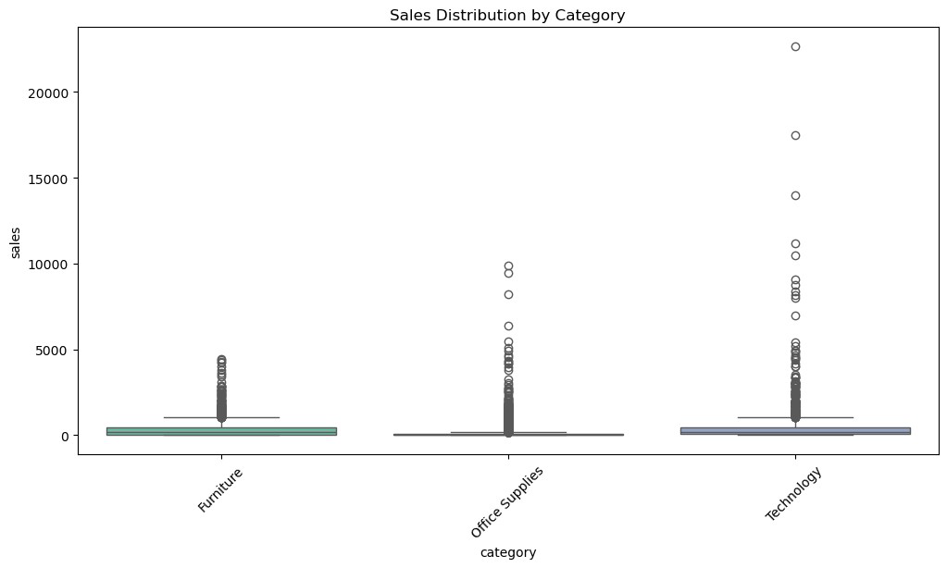

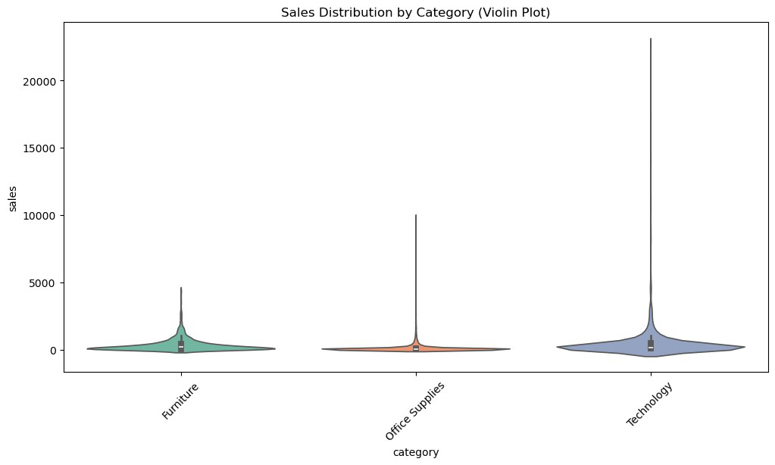
3.3. Deeper Insights
# Summary statistics for sales
print(df['sales'].describe())
# Total and average sales
total_sales = df['sales'].sum()
average_sales = df['sales'].mean()
print(f"Total Sales: ${total_sales:,.2f}") print(f"Average Sales: ${average_sales:,.2f}")
count 9799.000000
mean 230.792610
std 626.692409
min 0.444000
25% 17.248000
50% 54.480000
75% 210.572000
max 22638.480000
Name: sales, dtype: float64
Total Sales: $2,261,536.78
Average Sales: $230.79
# Sales by region (replace 'region' with 'state' if available) regional_sales = df.groupby('region')
['sales'].sum().sort_values(ascending=False)
print(regional_sales)

region
west 710219.6845
east 669518.7260
central 492646.9132
south 389151.4590
Name: sales, dtype: float64
# Sales by product category
category_sales = df.groupby('category')
['sales'].sum().sort_values(ascending=False) print(category_sales)
category
Technology 827455.8730
Furniture 728658.5757
Office Supplies 705422.3340
Name: sales, dtype: float64
C:\Users\Aboelyazzed\AppData\Local\Temp\
ipykernel_7360\3352670558.py:2: FutureWarning: The default of
observed=False is deprecated and will be changed to True in a futureversion of pandas. Pass observed=False to retain current behavior orobserved=True to adopt the future default and silence this warning.
category_sales = df.groupby('category')
['sales'].sum().sort_values(ascending=False)
3.4. visualizations
import plotly.express as px
# Mapping of standardized state names to abbreviations
state_abbreviations = {
'alabama': 'AL', 'alaska': 'AK', 'arizona': 'AZ', 'arkansas': 'AR',
'california': 'CA', 'colorado': 'CO', 'connecticut': 'CT', 'delaware': 'DE',
'florida': 'FL', 'georgia': 'GA', 'hawaii': 'HI', 'idaho': 'ID', 'illinois': 'IL',
'indiana': 'IN', 'iowa': 'IA', 'kansas': 'KS', 'kentucky': 'KY', 'louisiana': 'LA',
'maine': 'ME', 'maryland': 'MD', 'massachusetts': 'MA',
'michigan': 'MI',
'minnesota': 'MN', 'mississippi': 'MS', 'missouri': 'MO',
'montana': 'MT',
'nebraska': 'NE', 'nevada': 'NV', 'new_hampshire': 'NH',
'new_jersey': 'NJ',
'new_mexico': 'NM', 'new_york': 'NY', 'north_carolina': 'NC', 'north_dakota': 'ND',
'ohio': 'OH', 'oklahoma': 'OK', 'oregon': 'OR', 'pennsylvania': 'PA', 'rhode_island': 'RI',
'south_carolina': 'SC', 'south_dakota': 'SD', 'tennessee': 'TN',

'texas': 'TX',
'utah': 'UT', 'vermont': 'VT', 'virginia': 'VA', 'washington': 'WA', 'west_virginia': 'WV',
'wisconsin': 'WI', 'wyoming': 'WY', 'district_of_columbia': 'DC' }
# Convert full state names to abbreviations
df['state'] = df['state'].map(state_abbreviations)
# Ensure all states are present
all_states = pd.DataFrame({'state': ['AL', 'AK', 'AZ', 'AR', 'CA', 'CO', 'CT', 'DE', 'FL', 'GA', 'HI', 'ID', 'IL', 'IN', 'IA', 'KS', 'KY', 'LA', 'ME', 'MD', 'MA', 'MI', 'MN', 'MS', 'MO', 'MT', 'NE', 'NV', 'NH', 'NJ', 'NM', 'NY', 'NC', 'ND', 'OH', 'OK', 'OR', 'PA', 'RI', 'SC', 'SD', 'TN', 'TX', 'UT', 'VT', 'VA', 'WA', 'WV', 'WI', 'WY']})
# Aggregate sales by state
state_sales = df.groupby('state')['sales'].sum().reset_index()
# Merge to include all states, filling missing values with 0 state_sales = all_states.merge(state_sales, on='state', how='left').fillna(0)
# Create the choropleth map
fig = px.choropleth(
state_sales,
locations='state',
locationmode='USA-states',
color='sales',
scope="usa",
title='Sales Distribution by State (USA)',
color_continuous_scale="Viridis"
)
fig.update_geos(showland=True, landcolor="lightgray", showlakes=True, lakecolor="blue")
fig.show()
{"config":{"plotlyServerURL":"https://plot.ly"},"data":
[{"coloraxis":"coloraxis","geo":"geo","hovertemplate":"state=%
{location}<br>sales=%{z}<extra></extra>","locationmode":"USA-
states","locations":
["AL","AK","AZ","AR","CA","CO","CT","DE","FL","GA","HI","ID","IL","IN" ,"IA","KS","KY","LA","ME","MD","MA","MI","MN","MS","MO","MT","NE","NV" ,"NH","NJ","NM","NY","NC","ND","OH","OK","OR","PA","RI","SC","SD","TN" ,"TX","UT","VT","VA","WA","WV","WI","WY"],"name":"","type":"choropleth ","z":
[19510.64,0,35272.657,11678.13,446306.4635,31841.597999999998,13384.35 7,27322.999,88436.532,48219.11,0,4382.486,79236.517,48718.4,4443.56,29 14.31,36458.39,9131.05,1270.53,23705.523,28634.434,76136.074,29863.15,

10771.34,22205.15,5589.352,7464.93,16729.102,7292.524,34610.972,4783.5 22,306361.147,55165.964,919.91,75130.35,19683.39,17284.462,116276.65,2 2525.026,8481.71,1315.56,30661.873,168572.5322,11220.056,8929.36999999 9999,70636.72,135206.85,1209.824,31173.43,1603.136]}],"layout":
{"autosize":true,"coloraxis":{"colorbar":{"title":
{"text":"sales"}},"colorscale":[[0,"#440154"],
[0.1111111111111111,"#482878"],[0.2222222222222222,"#3e4989"],
[0.3333333333333333,"#31688e"],[0.4444444444444444,"#26828e"],
[0.5555555555555556,"#1f9e89"],[0.6666666666666666,"#35b779"],
[0.7777777777777778,"#6ece58"],[0.8888888888888888,"#b5de2b"],
[1,"#fde725"]]},"geo":{"center":{},"domain":{"x":[0,1],"y":
[0,1]},"lakecolor":"blue","landcolor":"lightgray","scope":"usa","showl akes":true,"showland":true},"legend":{"tracegroupgap":0},"template": {"data":{"bar":[{"error_x":{"color":"#2a3f5f"},"error_y":
{"color":"#2a3f5f"},"marker":{"line":
{"color":"#E5ECF6","width":0.5},"pattern":
{"fillmode":"overlay","size":10,"solidity":0.2}},"type":"bar"}],"barpo lar":[{"marker":{"line":{"color":"#E5ECF6","width":0.5},"pattern": {"fillmode":"overlay","size":10,"solidity":0.2}},"type":"barpolar"}]," carpet":[{"aaxis":
{"endlinecolor":"#2a3f5f","gridcolor":"white","linecolor":"white","min orgridcolor":"white","startlinecolor":"#2a3f5f"},"baxis":
{"endlinecolor":"#2a3f5f","gridcolor":"white","linecolor":"white","min orgridcolor":"white","startlinecolor":"#2a3f5f"},"type":"carpet"}],"ch oropleth":[{"colorbar":
{"outlinewidth":0,"ticks":""},"type":"choropleth"}],"contour":
[{"colorbar":{"outlinewidth":0,"ticks":""},"colorscale":
[[0,"#0d0887"],[0.1111111111111111,"#46039f"],
[0.2222222222222222,"#7201a8"],[0.3333333333333333,"#9c179e"],
[0.4444444444444444,"#bd3786"],[0.5555555555555556,"#d8576b"],
[0.6666666666666666,"#ed7953"],[0.7777777777777778,"#fb9f3a"],
[0.8888888888888888,"#fdca26"],
[1,"#f0f921"]],"type":"contour"}],"contourcarpet":[{"colorbar": {"outlinewidth":0,"ticks":""},"type":"contourcarpet"}],"heatmap": [{"colorbar":{"outlinewidth":0,"ticks":""},"colorscale":
[[0,"#0d0887"],[0.1111111111111111,"#46039f"],
[0.2222222222222222,"#7201a8"],[0.3333333333333333,"#9c179e"],
[0.4444444444444444,"#bd3786"],[0.5555555555555556,"#d8576b"],
[0.6666666666666666,"#ed7953"],[0.7777777777777778,"#fb9f3a"],
[0.8888888888888888,"#fdca26"],
[1,"#f0f921"]],"type":"heatmap"}],"heatmapgl":[{"colorbar":
{"outlinewidth":0,"ticks":""},"colorscale":[[0,"#0d0887"],
[0.1111111111111111,"#46039f"],[0.2222222222222222,"#7201a8"],
[0.3333333333333333,"#9c179e"],[0.4444444444444444,"#bd3786"],
[0.5555555555555556,"#d8576b"],[0.6666666666666666,"#ed7953"],
[0.7777777777777778,"#fb9f3a"],[0.8888888888888888,"#fdca26"],
[1,"#f0f921"]],"type":"heatmapgl"}],"histogram":[{"marker":{"pattern": {"fillmode":"overlay","size":10,"solidity":0.2}},"type":"histogram"}], "histogram2d":[{"colorbar":{"outlinewidth":0,"ticks":""},"colorscale":

[[0,"#0d0887"],[0.1111111111111111,"#46039f"],
[0.2222222222222222,"#7201a8"],[0.3333333333333333,"#9c179e"],
[0.4444444444444444,"#bd3786"],[0.5555555555555556,"#d8576b"],
[0.6666666666666666,"#ed7953"],[0.7777777777777778,"#fb9f3a"],
[0.8888888888888888,"#fdca26"],
[1,"#f0f921"]],"type":"histogram2d"}],"histogram2dcontour":
[{"colorbar":{"outlinewidth":0,"ticks":""},"colorscale":
[[0,"#0d0887"],[0.1111111111111111,"#46039f"],
[0.2222222222222222,"#7201a8"],[0.3333333333333333,"#9c179e"],
[0.4444444444444444,"#bd3786"],[0.5555555555555556,"#d8576b"],
[0.6666666666666666,"#ed7953"],[0.7777777777777778,"#fb9f3a"],
[0.8888888888888888,"#fdca26"],
[1,"#f0f921"]],"type":"histogram2dcontour"}],"mesh3d":[{"colorbar": {"outlinewidth":0,"ticks":""},"type":"mesh3d"}],"parcoords":[{"line": {"colorbar":{"outlinewidth":0,"ticks":""}},"type":"parcoords"}],"pie": [{"automargin":true,"type":"pie"}],"scatter":[{"fillpattern":
{"fillmode":"overlay","size":10,"solidity":0.2},"type":"scatter"}],"sc atter3d":[{"line":{"colorbar":{"outlinewidth":0,"ticks":""}},"marker": {"colorbar":
{"outlinewidth":0,"ticks":""}},"type":"scatter3d"}],"scattercarpet": [{"marker":{"colorbar":
{"outlinewidth":0,"ticks":""}},"type":"scattercarpet"}],"scattergeo": [{"marker":{"colorbar":
{"outlinewidth":0,"ticks":""}},"type":"scattergeo"}],"scattergl": [{"marker":{"colorbar":
{"outlinewidth":0,"ticks":""}},"type":"scattergl"}],"scattermapbox": [{"marker":{"colorbar":
{"outlinewidth":0,"ticks":""}},"type":"scattermapbox"}],"scatterpolar" :[{"marker":{"colorbar":
{"outlinewidth":0,"ticks":""}},"type":"scatterpolar"}],"scatterpolargl ":[{"marker":{"colorbar":
{"outlinewidth":0,"ticks":""}},"type":"scatterpolargl"}],"scatterterna ry":[{"marker":{"colorbar":
{"outlinewidth":0,"ticks":""}},"type":"scatterternary"}],"surface": [{"colorbar":{"outlinewidth":0,"ticks":""},"colorscale":
[[0,"#0d0887"],[0.1111111111111111,"#46039f"],
[0.2222222222222222,"#7201a8"],[0.3333333333333333,"#9c179e"],
[0.4444444444444444,"#bd3786"],[0.5555555555555556,"#d8576b"],
[0.6666666666666666,"#ed7953"],[0.7777777777777778,"#fb9f3a"],
[0.8888888888888888,"#fdca26"],
[1,"#f0f921"]],"type":"surface"}],"table":[{"cells":{"fill":
{"color":"#EBF0F8"},"line":{"color":"white"}},"header":{"fill":
{"color":"#C8D4E3"},"line":
{"color":"white"}},"type":"table"}]},"layout":{"annotationdefaults": {"arrowcolor":"#2a3f5f","arrowhead":0,"arrowwidth":1},"autotypenumbers ":"strict","coloraxis":{"colorbar":
{"outlinewidth":0,"ticks":""}},"colorscale":{"diverging":
[[0,"#8e0152"],[0.1,"#c51b7d"],[0.2,"#de77ae"],[0.3,"#f1b6da"], [0.4,"#fde0ef"],[0.5,"#f7f7f7"],[0.6,"#e6f5d0"],[0.7,"#b8e186"],

[0.8,"#7fbc41"],[0.9,"#4d9221"],[1,"#276419"]],"sequential":
[[0,"#0d0887"],[0.1111111111111111,"#46039f"],
[0.2222222222222222,"#7201a8"],[0.3333333333333333,"#9c179e"],
[0.4444444444444444,"#bd3786"],[0.5555555555555556,"#d8576b"],
[0.6666666666666666,"#ed7953"],[0.7777777777777778,"#fb9f3a"],
[0.8888888888888888,"#fdca26"],[1,"#f0f921"]],"sequentialminus": [[0,"#0d0887"],[0.1111111111111111,"#46039f"],
[0.2222222222222222,"#7201a8"],[0.3333333333333333,"#9c179e"],
[0.4444444444444444,"#bd3786"],[0.5555555555555556,"#d8576b"],
[0.6666666666666666,"#ed7953"],[0.7777777777777778,"#fb9f3a"],
[0.8888888888888888,"#fdca26"],[1,"#f0f921"]]},"colorway":
["#636efa","#EF553B","#00cc96","#ab63fa","#FFA15A","#19d3f3","#FF6692" ,"#B6E880","#FF97FF","#FECB52"],"font":{"color":"#2a3f5f"},"geo": {"bgcolor":"white","lakecolor":"white","landcolor":"#E5ECF6","showlake s":true,"showland":true,"subunitcolor":"white"},"hoverlabel":
{"align":"left"},"hovermode":"closest","mapbox":
{"style":"light"},"paper_bgcolor":"white","plot_bgcolor":"#E5ECF6","po lar":{"angularaxis":
{"gridcolor":"white","linecolor":"white","ticks":""},"bgcolor":"#E5ECF 6","radialaxis":
{"gridcolor":"white","linecolor":"white","ticks":""}},"scene":
{"xaxis":
{"backgroundcolor":"#E5ECF6","gridcolor":"white","gridwidth":2,"lineco lor":"white","showbackground":true,"ticks":"","zerolinecolor":"white"} ,"yaxis":
{"backgroundcolor":"#E5ECF6","gridcolor":"white","gridwidth":2,"lineco lor":"white","showbackground":true,"ticks":"","zerolinecolor":"white"} ,"zaxis":
{"backgroundcolor":"#E5ECF6","gridcolor":"white","gridwidth":2,"lineco lor":"white","showbackground":true,"ticks":"","zerolinecolor":"white"} },"shapedefaults":{"line":{"color":"#2a3f5f"}},"ternary":{"aaxis": {"gridcolor":"white","linecolor":"white","ticks":""},"baxis":
{"gridcolor":"white","linecolor":"white","ticks":""},"bgcolor":"#E5ECF 6","caxis":
{"gridcolor":"white","linecolor":"white","ticks":""}},"title":
{"x":5.0e-2},"xaxis":
{"automargin":true,"gridcolor":"white","linecolor":"white","ticks":"", "title":
{"standoff":15},"zerolinecolor":"white","zerolinewidth":2},"yaxis": {"automargin":true,"gridcolor":"white","linecolor":"white","ticks":"", "title":
{"standoff":15},"zerolinecolor":"white","zerolinewidth":2}}},"title": {"text":"Sales Distribution by State (USA)"}}}
df['shipping_time_days'] = (df['ship_date'] -
df['order_date']).dt.days
# Scatter plot
plt.figure(figsize=(10, 6))
sns.scatterplot(x='shipping_time_days', y='sales', data=df, alpha=0.5) plt.title("Sales vs. Shipping Time (Days)")

plt.xlabel("Shipping Time (Days)")
plt.ylabel("Sales")
plt.show()
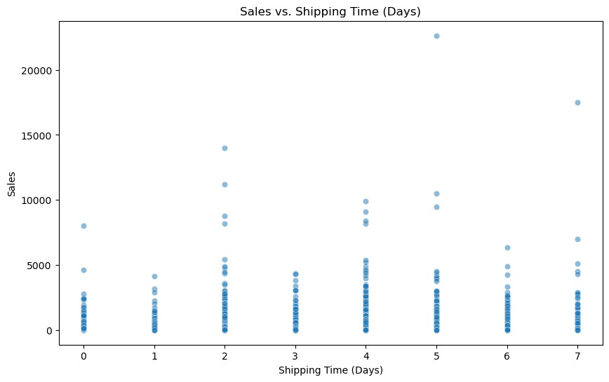
# Scatter plot for shipping_time_days vs sales
plt.figure(figsize=(10, 6))
sns.scatterplot(x='shipping_time_days', y='sales', data=df, hue='category')
plt.title("Shipping Time vs Sales")
plt.xlabel("Shipping Time (Days)")
plt.ylabel("Sales")
plt.show()
# Box plot for shipping_time_days vs sales by region
plt.figure(figsize=(12, 6))
sns.boxplot(x='region', y='sales', hue='shipping_time_days', data=df) plt.title("Sales Distribution by Region and Shipping Time")
plt.xticks(rotation=45)
plt.show()

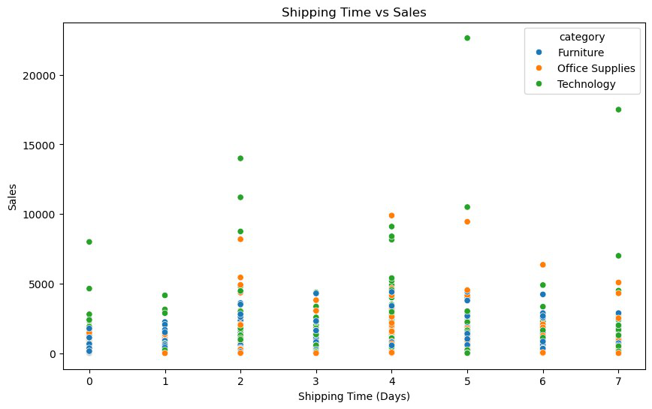
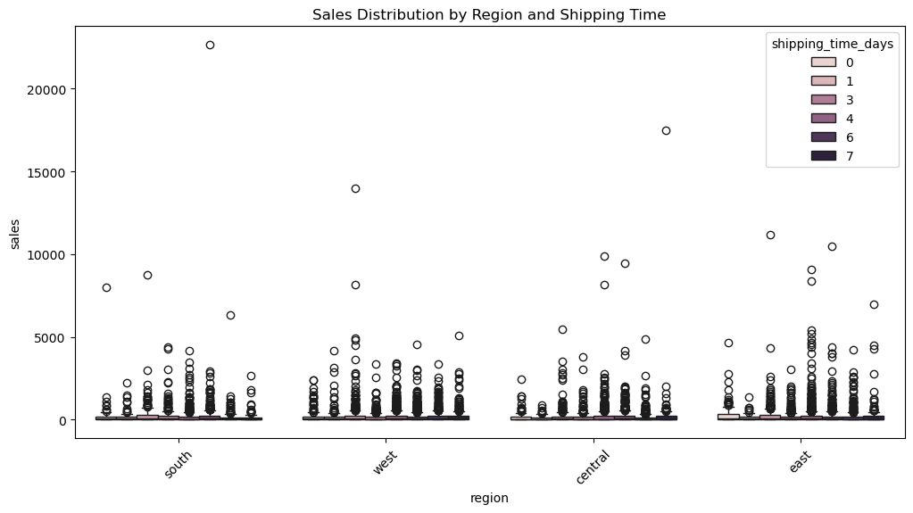

4.Data Transformation & Feature Engineering
4.1. Extract Date Features
# Extract year, month, and day from order_date df['order_year'] = df['order_date'].dt.year df['order_month'] = df['order_date'].dt.month df['order_day'] = df['order_date'].dt.day
# Calculate shipping time (in days)
df['shipping_time_days'] = (df['ship_date'] - df['order_date']).dt.days
# Display the new features
print(df[['order_date', 'ship_date', 'shipping_time_days', 'order_year', 'order_month','order_day']].head())
order_date ship_date shipping_time_days order_year
order_month \
0 2017-11-08 2017-11-11 3 2017 11
1 2017-11-08 2017-11-11 3 2017 11
2 2017-06-12 2017-06-16 4 2017 6
3 2016-10-11 2016-10-18 7 2016 10
4 2016-10-11 2016-10-18 7 2016 10
order_day
0 8
1 8
2 12
3 11
4 11
4.2. Create Calculated Columns
# Example: Calculate total sales per customer
customer_sales = df.groupby('customer_id')
['sales'].sum().reset_index()
customer_sales.rename(columns={'sales': 'total_customer_sales'}, inplace=True)
# Merge back into the main DataFrame
df = df.merge(customer_sales, on='customer_id', how='left')
# Display the new feature
print(df[['customer_id', 'total_customer_sales']].head())

customer_id total_customer_sales 0 cg-12520 1148.7800 1 cg-12520 1148.7800 2 dv-13045 1119.4830 3 so-20335 2602.5755 4 so-20335 2602.5755

4.3. Normalize or Standardize Numeric Columns
from sklearn.preprocessing import MinMaxScaler
# Initialize the scaler
scaler = MinMaxScaler()
# Normalize the 'sales' column
df['sales_normalized'] = scaler.fit_transform(df[['sales']])
# Display the normalized values
print(df[['sales', 'sales_normalized']].head())
sales sales_normalized 0 261.9600 0.011552 1 731.9400 0.032313 2 14.6200 0.000626 3 957.5775 0.042280 4 22.3680 0.000968

4.4. Encode Categorical Variables
# One-hot encode categorical columns
df_encoded = pd.get_dummies(df, columns=['category', 'sub-category', 'region'], drop_first=True)
# Display the encoded DataFrame
print(df_encoded.head())
order_id order_date ship_date ship_mode customer_id \ 0 ca-2017-152156 2017-11-08 2017-11-11 second_class cg-12520 1 ca-2017-152156 2017-11-08 2017-11-11 second_class cg-12520 2 ca-2017-138688 2017-06-12 2017-06-16 second_class dv-13045 3 us-2016-108966 2016-10-11 2016-10-18 standard_class so-20335 4 us-2016-108966 2016-10-11 2016-10-18 standard_class so-20335
customer_name segment country city state ... \
0 claire_gute consumer united_states hendersonKY ...
1 claire_gute consumer united_states hendersonKY ...
2 darrin_van_huff corporate united_states los_angeles

CA ...
3 sean_o'donnell consumer united_states fort_lauderdaleFL ...
4 sean_o'donnell consumer united_states fort_lauderdaleFL ...
sub-category_labels sub-category_machines sub-category_paper \ 0 False False False 1 False False False 2 True False False 3 False False False 4 False False False

sub-category_phones sub-category_storage sub-category_supplies \ 0 False False False 1 False False False 2 False False False 3 False False False 4 False True False
sub-category_tables region_east region_south region_west0 False False True False1 False False True False2 False False False True3 True False True False4 False False True False
[5 rows x 42 columns]
from sklearn.preprocessing import LabelEncoder
# Initialize the encoder
encoder = LabelEncoder()
# Encode the 'segment' column
df['segment_encoded'] = encoder.fit_transform(df['segment'])
# Display the encoded column
print(df[['segment', 'segment_encoded']].head())
segment segment_encoded 0 consumer 0 1 consumer 0 2 corporate 1 3 consumer 0 4 consumer 0

4.5. Aggregate Data for Insights
# Total sales by category
category_sales = df.groupby('category')['sales'].sum().reset_index() category_sales.rename(columns={'sales': 'total_category_sales'}, inplace=True)
# Total sales by region
region_sales = df.groupby('region')['sales'].sum().reset_index() region_sales.rename(columns={'sales': 'total_region_sales'}, inplace=True)
# Merge aggregated features back into the main DataFrame df = df.merge(category_sales, on='category', how='left') df = df.merge(region_sales, on='region', how='left')
# Display the new aggregated features
print(df[['category', 'total_category_sales', 'region', 'total_region_sales']].head())
category total_category_sales region total_region_sales 0 Furniture 728658.5757 south 389151.4590 1 Furniture 728658.5757 south 389151.4590 2 Office Supplies 705422.3340 west 710219.6845 3 Furniture 728658.5757 south 389151.4590 4 Office Supplies 705422.3340 south 389151.4590
C:\Users\Aboelyazzed\AppData\Local\Temp\
ipykernel_7360\2394340360.py:2: FutureWarning:
The default of observed=False is deprecated and will be changed toTrue in a future version of pandas. Pass observed=False to retain current behavior or observed=True to adopt the future default andsilence this warning.
4.6. Handle Outliers
def remove_outliers_iqr(df, column):
Q1 = df[column].quantile(0.25)
Q3 = df[column].quantile(0.75)
IQR = Q3 - Q1
lower_bound = Q1 - 1.5 * IQR
upper_bound = Q3 + 1.5 * IQR
return df[(df[column] >= lower_bound) & (df[column] <= upper_bound)]
# Remove outliers from 'shipping_time_days'
df_cleaned = remove_outliers_iqr(df, 'shipping_time_days')

# Compare before and after outlier removal
print("Before Outlier Removal:")
print(df['shipping_time_days'].describe())
print("\nAfter Outlier Removal:")
print(df_cleaned['shipping_time_days'].describe())
Before Outlier Removal:
count 9799.000000
mean 3.961118
std 1.749703
min 0.000000
25% 3.000000
50% 4.000000
75% 5.000000
max 7.000000
Name: shipping_time_days, dtype: float64
After Outlier Removal:
count 9799.000000
mean 3.961118
std 1.749703
min 0.000000
25% 3.000000
50% 4.000000
75% 5.000000
max 7.000000
Name: shipping_time_days, dtype: float64
4.7. Split Data into Training and Testing Sets
from sklearn.model_selection import train_test_split
# Define features (X) and target variable (y)
X = df[['order_year', 'order_month', 'shipping_time_days', 'total_customer_sales']]
y = df['sales']
# Split into training and testing sets (80% train, 20% test) X_train, X_test, y_train, y_test = train_test_split(X, y, test_size=0.2, random_state=42)
# Display shapes of the splits
print(f"Training set size: {X_train.shape}") print(f"Testing set size: {X_test.shape}")
Training set size: (7839, 4)
Testing set size: (1960, 4)

5.Data Analysis & Insights Extraction 5.1. Key Performance Indicators (KPIs)
5.1.1. Total Sales
total_sales = df['sales'].sum()
print(f"Total Sales: ${total_sales:,.2f}")
Total Sales: $2,261,536.78
5.1.2. Average Sales
average_sales = df['sales'].mean()
print(f"Average Sales: ${average_sales:,.2f}")
Average Sales: $230.79
5.1.3. Top-Selling Products
top_products = df.groupby('product_name')
['sales'].sum().sort_values(ascending=False).head(10) print("Top 10 Products by Sales:")
print(top_products)
Top 10 Products by Sales:
product_name
canon_imageclass_2200_advanced_copier
61599.824
fellowes_pb500_electric_punch_plastic_comb_binding_machine_with_manual _bind 27453.384
cisco_telepresence_system_ex90_videoconferencing_unit
22638.480
hon_5400_series_task_chairs_for_big_and_tall
21870.576
gbc_docubind_tl300_electric_binding_system
19823.479
gbc_ibimaster_500_manual_proclick_binding_system
19024.500
hewlett_packard_laserjet_3310_copier
18839.686
hp_designjet_t520_inkjet_large_format_printer_-_24"_color
18374.895
gbc_docubind_p400_electric_binding_system
17965.068
high_speed_automatic_electric_letter_opener
17030.312
Name: sales, dtype: float64

5.1.4. Regional Sales Breakdown
region_sales = df.groupby('region')
['sales'].sum().sort_values(ascending=False) print("Sales by Region:")
print(region_sales)
Sales by Region:
region
west 710219.6845
east 669518.7260
central 492646.9132
south 389151.4590
Name: sales, dtype: float64
5.1.5. Customer Segment Analysis
segment_sales = df.groupby('segment')
['sales'].sum().sort_values(ascending=False) print("Sales by Customer Segment:")
print(segment_sales)
Sales by Customer Segment:
segment
consumer 1.148061e+06
corporate 6.884941e+05
home_office 4.249822e+05
Name: sales, dtype: float64
2. Trend Analysis
2.2.1. Sales Over Time
# Ensure 'order_date' is in datetime format
df['order_date'] = pd.to_datetime(df['order_date'])
# Extract year and month
df['order_year'] = df['order_date'].dt.year df['order_month'] = df['order_date'].dt.month
# Monthly sales trend
monthly_sales = df.groupby(['order_year', 'order_month']) ['sales'].sum().reset_index()
print(monthly_sales)
# Visualize monthly sales trend
import plotly.express as px
fig = px.line(monthly_sales, x='order_month', y='sales', color='order_year', title="Monthly Sales Trend")
fig.show()

order_year order_month sales 0 2015 1 14205.7070 1 2015 2 4519.8920 2 2015 3 55205.7970 3 2015 4 27906.8550 4 2015 5 23644.3030 5 2015 6 34322.9356 6 2015 7 33781.5430 7 2015 8 27117.5365 8 2015 9 81623.5268 9 2015 10 31453.3930 10 2015 11 77907.6607 11 2015 12 68167.0585 12 2016 1 18066.9576 13 2016 2 11951.4110 14 2016 3 32339.3184 15 2016 4 34154.4685 16 2016 5 29959.5305 17 2016 6 23599.3740 18 2016 7 28608.2590 19 2016 8 36818.3422 20 2016 9 63133.6060 21 2016 10 31011.7375 22 2016 11 75249.3995 23 2016 12 74543.6012 24 2017 1 18542.4910 25 2017 2 22978.8150 26 2017 3 51165.0590 27 2017 4 38679.7670 28 2017 5 56656.9080 29 2017 6 39724.4860 30 2017 7 38320.7830 31 2017 8 30542.2003 32 2017 9 69193.3909 33 2017 10 59583.0330 34 2017 11 79066.4958 35 2017 12 95739.1210 36 2018 1 43476.4740 37 2018 2 19920.9974 38 2018 3 58863.4128 39 2018 4 35541.9101 40 2018 5 43825.9822 41 2018 6 48190.7277 42 2018 7 44825.1040 43 2018 8 62837.8480 44 2018 9 86152.8880 45 2018 10 77448.1312 46 2018 11 117938.1550 47 2018 12 83030.3888

{"config":{"plotlyServerURL":"https://plot.ly"},"data":
[{"hovertemplate":"order_year=2015<br>order_month=%{x}<br>sales=% {y}<extra></extra>","legendgroup":"2015","line":
{"color":"#636efa","dash":"solid"},"marker":
{"symbol":"circle"},"mode":"lines","name":"2015","orientation":"v","sh owlegend":true,"type":"scatter","x":
[1,2,3,4,5,6,7,8,9,10,11,12],"xaxis":"x","y":
[14205.707,4519.892,55205.797,27906.855,23644.303,34322.9356,33781.543 ,27117.5365,81623.5268,31453.393,77907.66070000001,68167.0585],"yaxis" :"y"},{"hovertemplate":"order_year=2016<br>order_month=%{x}<br>sales=% {y}<extra></extra>","legendgroup":"2016","line":
{"color":"#EF553B","dash":"solid"},"marker":
{"symbol":"circle"},"mode":"lines","name":"2016","orientation":"v","sh owlegend":true,"type":"scatter","x":
[1,2,3,4,5,6,7,8,9,10,11,12],"xaxis":"x","y":
[18066.9576,11951.411,32339.3184,34154.4685,29959.5305,23599.374,28608 .259000000002,36818.3422,63133.606,31011.7375,75249.3995,74543.6012]," yaxis":"y"},{"hovertemplate":"order_year=2017<br>order_month=%
{x}<br>sales=%{y}<extra></extra>","legendgroup":"2017","line":
{"color":"#00cc96","dash":"solid"},"marker":
{"symbol":"circle"},"mode":"lines","name":"2017","orientation":"v","sh owlegend":true,"type":"scatter","x":
[1,2,3,4,5,6,7,8,9,10,11,12],"xaxis":"x","y":
[18542.490999999998,22978.815,51165.059,38679.767,56656.908,39724.486, 38320.783,30542.2003,69193.3909,59583.033,79066.4958,95739.121],"yaxis ":"y"},{"hovertemplate":"order_year=2018<br>order_month=%{x}<br>sales= %{y}<extra></extra>","legendgroup":"2018","line":
{"color":"#ab63fa","dash":"solid"},"marker":
{"symbol":"circle"},"mode":"lines","name":"2018","orientation":"v","sh owlegend":true,"type":"scatter","x":
[1,2,3,4,5,6,7,8,9,10,11,12],"xaxis":"x","y":
[43476.474,19920.9974,58863.4128,35541.9101,43825.9822,48190.7277,4482 5.104,62837.848,86152.888,77448.1312,117938.155,83030.3888],"yaxis":"y "}],"layout":{"autosize":true,"legend":{"title":
{"text":"order_year"},"tracegroupgap":0},"template":{"data":{"bar": [{"error_x":{"color":"#2a3f5f"},"error_y":
{"color":"#2a3f5f"},"marker":{"line":
{"color":"#E5ECF6","width":0.5},"pattern":
{"fillmode":"overlay","size":10,"solidity":0.2}},"type":"bar"}],"barpo lar":[{"marker":{"line":{"color":"#E5ECF6","width":0.5},"pattern": {"fillmode":"overlay","size":10,"solidity":0.2}},"type":"barpolar"}]," carpet":[{"aaxis":
{"endlinecolor":"#2a3f5f","gridcolor":"white","linecolor":"white","min orgridcolor":"white","startlinecolor":"#2a3f5f"},"baxis":
{"endlinecolor":"#2a3f5f","gridcolor":"white","linecolor":"white","min orgridcolor":"white","startlinecolor":"#2a3f5f"},"type":"carpet"}],"ch oropleth":[{"colorbar":
{"outlinewidth":0,"ticks":""},"type":"choropleth"}],"contour":
[{"colorbar":{"outlinewidth":0,"ticks":""},"colorscale":
[[0,"#0d0887"],[0.1111111111111111,"#46039f"],

[0.2222222222222222,"#7201a8"],[0.3333333333333333,"#9c179e"],
[0.4444444444444444,"#bd3786"],[0.5555555555555556,"#d8576b"],
[0.6666666666666666,"#ed7953"],[0.7777777777777778,"#fb9f3a"],
[0.8888888888888888,"#fdca26"],
[1,"#f0f921"]],"type":"contour"}],"contourcarpet":[{"colorbar": {"outlinewidth":0,"ticks":""},"type":"contourcarpet"}],"heatmap": [{"colorbar":{"outlinewidth":0,"ticks":""},"colorscale":
[[0,"#0d0887"],[0.1111111111111111,"#46039f"],
[0.2222222222222222,"#7201a8"],[0.3333333333333333,"#9c179e"],
[0.4444444444444444,"#bd3786"],[0.5555555555555556,"#d8576b"],
[0.6666666666666666,"#ed7953"],[0.7777777777777778,"#fb9f3a"],
[0.8888888888888888,"#fdca26"],
[1,"#f0f921"]],"type":"heatmap"}],"heatmapgl":[{"colorbar":
{"outlinewidth":0,"ticks":""},"colorscale":[[0,"#0d0887"],
[0.1111111111111111,"#46039f"],[0.2222222222222222,"#7201a8"],
[0.3333333333333333,"#9c179e"],[0.4444444444444444,"#bd3786"],
[0.5555555555555556,"#d8576b"],[0.6666666666666666,"#ed7953"],
[0.7777777777777778,"#fb9f3a"],[0.8888888888888888,"#fdca26"],
[1,"#f0f921"]],"type":"heatmapgl"}],"histogram":[{"marker":{"pattern": {"fillmode":"overlay","size":10,"solidity":0.2}},"type":"histogram"}], "histogram2d":[{"colorbar":{"outlinewidth":0,"ticks":""},"colorscale": [[0,"#0d0887"],[0.1111111111111111,"#46039f"],
[0.2222222222222222,"#7201a8"],[0.3333333333333333,"#9c179e"],
[0.4444444444444444,"#bd3786"],[0.5555555555555556,"#d8576b"],
[0.6666666666666666,"#ed7953"],[0.7777777777777778,"#fb9f3a"],
[0.8888888888888888,"#fdca26"],
[1,"#f0f921"]],"type":"histogram2d"}],"histogram2dcontour":
[{"colorbar":{"outlinewidth":0,"ticks":""},"colorscale":
[[0,"#0d0887"],[0.1111111111111111,"#46039f"],
[0.2222222222222222,"#7201a8"],[0.3333333333333333,"#9c179e"],
[0.4444444444444444,"#bd3786"],[0.5555555555555556,"#d8576b"],
[0.6666666666666666,"#ed7953"],[0.7777777777777778,"#fb9f3a"],
[0.8888888888888888,"#fdca26"],
[1,"#f0f921"]],"type":"histogram2dcontour"}],"mesh3d":[{"colorbar": {"outlinewidth":0,"ticks":""},"type":"mesh3d"}],"parcoords":[{"line": {"colorbar":{"outlinewidth":0,"ticks":""}},"type":"parcoords"}],"pie": [{"automargin":true,"type":"pie"}],"scatter":[{"fillpattern":
{"fillmode":"overlay","size":10,"solidity":0.2},"type":"scatter"}],"sc atter3d":[{"line":{"colorbar":{"outlinewidth":0,"ticks":""}},"marker": {"colorbar":
{"outlinewidth":0,"ticks":""}},"type":"scatter3d"}],"scattercarpet": [{"marker":{"colorbar":
{"outlinewidth":0,"ticks":""}},"type":"scattercarpet"}],"scattergeo": [{"marker":{"colorbar":
{"outlinewidth":0,"ticks":""}},"type":"scattergeo"}],"scattergl": [{"marker":{"colorbar":
{"outlinewidth":0,"ticks":""}},"type":"scattergl"}],"scattermapbox": [{"marker":{"colorbar":
{"outlinewidth":0,"ticks":""}},"type":"scattermapbox"}],"scatterpolar" :[{"marker":{"colorbar":

{"outlinewidth":0,"ticks":""}},"type":"scatterpolar"}],"scatterpolargl ":[{"marker":{"colorbar":
{"outlinewidth":0,"ticks":""}},"type":"scatterpolargl"}],"scatterterna ry":[{"marker":{"colorbar":
{"outlinewidth":0,"ticks":""}},"type":"scatterternary"}],"surface": [{"colorbar":{"outlinewidth":0,"ticks":""},"colorscale":
[[0,"#0d0887"],[0.1111111111111111,"#46039f"],
[0.2222222222222222,"#7201a8"],[0.3333333333333333,"#9c179e"],
[0.4444444444444444,"#bd3786"],[0.5555555555555556,"#d8576b"],
[0.6666666666666666,"#ed7953"],[0.7777777777777778,"#fb9f3a"],
[0.8888888888888888,"#fdca26"],
[1,"#f0f921"]],"type":"surface"}],"table":[{"cells":{"fill":
{"color":"#EBF0F8"},"line":{"color":"white"}},"header":{"fill":
{"color":"#C8D4E3"},"line":
{"color":"white"}},"type":"table"}]},"layout":{"annotationdefaults": {"arrowcolor":"#2a3f5f","arrowhead":0,"arrowwidth":1},"autotypenumbers ":"strict","coloraxis":{"colorbar":
{"outlinewidth":0,"ticks":""}},"colorscale":{"diverging":
[[0,"#8e0152"],[0.1,"#c51b7d"],[0.2,"#de77ae"],[0.3,"#f1b6da"], [0.4,"#fde0ef"],[0.5,"#f7f7f7"],[0.6,"#e6f5d0"],[0.7,"#b8e186"], [0.8,"#7fbc41"],[0.9,"#4d9221"],[1,"#276419"]],"sequential":
[[0,"#0d0887"],[0.1111111111111111,"#46039f"],
[0.2222222222222222,"#7201a8"],[0.3333333333333333,"#9c179e"],
[0.4444444444444444,"#bd3786"],[0.5555555555555556,"#d8576b"],
[0.6666666666666666,"#ed7953"],[0.7777777777777778,"#fb9f3a"],
[0.8888888888888888,"#fdca26"],[1,"#f0f921"]],"sequentialminus": [[0,"#0d0887"],[0.1111111111111111,"#46039f"],
[0.2222222222222222,"#7201a8"],[0.3333333333333333,"#9c179e"],
[0.4444444444444444,"#bd3786"],[0.5555555555555556,"#d8576b"],
[0.6666666666666666,"#ed7953"],[0.7777777777777778,"#fb9f3a"],
[0.8888888888888888,"#fdca26"],[1,"#f0f921"]]},"colorway":
["#636efa","#EF553B","#00cc96","#ab63fa","#FFA15A","#19d3f3","#FF6692" ,"#B6E880","#FF97FF","#FECB52"],"font":{"color":"#2a3f5f"},"geo": {"bgcolor":"white","lakecolor":"white","landcolor":"#E5ECF6","showlake s":true,"showland":true,"subunitcolor":"white"},"hoverlabel":
{"align":"left"},"hovermode":"closest","mapbox":
{"style":"light"},"paper_bgcolor":"white","plot_bgcolor":"#E5ECF6","po lar":{"angularaxis":
{"gridcolor":"white","linecolor":"white","ticks":""},"bgcolor":"#E5ECF 6","radialaxis":
{"gridcolor":"white","linecolor":"white","ticks":""}},"scene":
{"xaxis":
{"backgroundcolor":"#E5ECF6","gridcolor":"white","gridwidth":2,"lineco lor":"white","showbackground":true,"ticks":"","zerolinecolor":"white"} ,"yaxis":
{"backgroundcolor":"#E5ECF6","gridcolor":"white","gridwidth":2,"lineco lor":"white","showbackground":true,"ticks":"","zerolinecolor":"white"} ,"zaxis":
{"backgroundcolor":"#E5ECF6","gridcolor":"white","gridwidth":2,"lineco lor":"white","showbackground":true,"ticks":"","zerolinecolor":"white"}

},"shapedefaults":{"line":{"color":"#2a3f5f"}},"ternary":{"aaxis": {"gridcolor":"white","linecolor":"white","ticks":""},"baxis":
{"gridcolor":"white","linecolor":"white","ticks":""},"bgcolor":"#E5ECF 6","caxis":
{"gridcolor":"white","linecolor":"white","ticks":""}},"title":
{"x":5.0e-2},"xaxis":
{"automargin":true,"gridcolor":"white","linecolor":"white","ticks":"", "title":
{"standoff":15},"zerolinecolor":"white","zerolinewidth":2},"yaxis": {"automargin":true,"gridcolor":"white","linecolor":"white","ticks":"", "title":
{"standoff":15},"zerolinecolor":"white","zerolinewidth":2}}},"title": {"text":"Monthly Sales Trend"},"xaxis":
{"anchor":"y","autorange":true,"domain":[0,1],"range":[1,12],"title": {"text":"order_month"},"type":"linear"},"yaxis":
{"anchor":"x","autorange":true,"domain":[0,1],"range":[-
1781.1226111111118,124239.16961111111],"title":
{"text":"sales"},"type":"linear"}}}
5.2.2. Product Category Trends
category_trends = df.groupby(['category', 'order_year']) ['sales'].sum().reset_index()
print(category_trends)
# Visualize category trends
fig = px.bar(category_trends, x='order_year', y='sales', color='category', title="Sales Trends by Category")
fig.show()
category order_year sales 0 Furniture 2015 156477.8811 1 Furniture 2016 164053.8674 2 Furniture 2017 195813.0400 3 Furniture 2018 212313.7872 4 Office Supplies 2015 149512.8200 5 Office Supplies 2016 133124.4070 6 Office Supplies 2017 182417.5660 7 Office Supplies 2018 240367.5410 8 Technology 2015 173865.5070 9 Technology 2016 162257.7310 10 Technology 2017 221961.9440 11 Technology 2018 269370.6910
C:\Users\Aboelyazzed\AppData\Local\Temp\ipykernel_7360\843351102.py:1:FutureWarning:
The default of observed=False is deprecated and will be changed toTrue in a future version of pandas. Pass observed=False to retain current behavior or observed=True to adopt the future default and

silence this warning.
{"config":{"plotlyServerURL":"https://plot.ly"},"data":
[{"alignmentgroup":"True","hovertemplate":"category=Furniture<br>order _year=%{x}<br>sales=%{y}<extra></
extra>","legendgroup":"Furniture","marker":
{"color":"#636efa","pattern":
{"shape":""}},"name":"Furniture","offsetgroup":"Furniture","orientatio n":"v","showlegend":true,"textposition":"auto","type":"bar","x": [2015,2016,2017,2018],"xaxis":"x","y":
[156477.8811,164053.8674,195813.04,212313.7872],"yaxis":"y"},
{"alignmentgroup":"True","hovertemplate":"category=Office
Supplies<br>order_year=%{x}<br>sales=%{y}<extra></extra>","legendgroup ":"Office Supplies","marker":{"color":"#EF553B","pattern":
{"shape":""}},"name":"Office Supplies","offsetgroup":"Office
Supplies","orientation":"v","showlegend":true,"textposition":"auto","t ype":"bar","x":[2015,2016,2017,2018],"xaxis":"x","y":
[149512.82,133124.407,182417.566,240367.541],"yaxis":"y"},
{"alignmentgroup":"True","hovertemplate":"category=Technology<br>order _year=%{x}<br>sales=%{y}<extra></
extra>","legendgroup":"Technology","marker":
{"color":"#00cc96","pattern":
{"shape":""}},"name":"Technology","offsetgroup":"Technology","orientat ion":"v","showlegend":true,"textposition":"auto","type":"bar","x": [2015,2016,2017,2018],"xaxis":"x","y":
[173865.507,162257.731,221961.94400000002,269370.691],"yaxis":"y"}],"l ayout":{"autosize":true,"barmode":"relative","legend":{"title":
{"text":"category"},"tracegroupgap":0},"template":{"data":{"bar": [{"error_x":{"color":"#2a3f5f"},"error_y":
{"color":"#2a3f5f"},"marker":{"line":
{"color":"#E5ECF6","width":0.5},"pattern":
{"fillmode":"overlay","size":10,"solidity":0.2}},"type":"bar"}],"barpo lar":[{"marker":{"line":{"color":"#E5ECF6","width":0.5},"pattern": {"fillmode":"overlay","size":10,"solidity":0.2}},"type":"barpolar"}]," carpet":[{"aaxis":
{"endlinecolor":"#2a3f5f","gridcolor":"white","linecolor":"white","min orgridcolor":"white","startlinecolor":"#2a3f5f"},"baxis":
{"endlinecolor":"#2a3f5f","gridcolor":"white","linecolor":"white","min orgridcolor":"white","startlinecolor":"#2a3f5f"},"type":"carpet"}],"ch oropleth":[{"colorbar":
{"outlinewidth":0,"ticks":""},"type":"choropleth"}],"contour":
[{"colorbar":{"outlinewidth":0,"ticks":""},"colorscale":
[[0,"#0d0887"],[0.1111111111111111,"#46039f"],
[0.2222222222222222,"#7201a8"],[0.3333333333333333,"#9c179e"],
[0.4444444444444444,"#bd3786"],[0.5555555555555556,"#d8576b"],
[0.6666666666666666,"#ed7953"],[0.7777777777777778,"#fb9f3a"],
[0.8888888888888888,"#fdca26"],
[1,"#f0f921"]],"type":"contour"}],"contourcarpet":[{"colorbar": {"outlinewidth":0,"ticks":""},"type":"contourcarpet"}],"heatmap":

[{"colorbar":{"outlinewidth":0,"ticks":""},"colorscale":
[[0,"#0d0887"],[0.1111111111111111,"#46039f"],
[0.2222222222222222,"#7201a8"],[0.3333333333333333,"#9c179e"],
[0.4444444444444444,"#bd3786"],[0.5555555555555556,"#d8576b"],
[0.6666666666666666,"#ed7953"],[0.7777777777777778,"#fb9f3a"],
[0.8888888888888888,"#fdca26"],
[1,"#f0f921"]],"type":"heatmap"}],"heatmapgl":[{"colorbar":
{"outlinewidth":0,"ticks":""},"colorscale":[[0,"#0d0887"],
[0.1111111111111111,"#46039f"],[0.2222222222222222,"#7201a8"],
[0.3333333333333333,"#9c179e"],[0.4444444444444444,"#bd3786"],
[0.5555555555555556,"#d8576b"],[0.6666666666666666,"#ed7953"],
[0.7777777777777778,"#fb9f3a"],[0.8888888888888888,"#fdca26"],
[1,"#f0f921"]],"type":"heatmapgl"}],"histogram":[{"marker":{"pattern": {"fillmode":"overlay","size":10,"solidity":0.2}},"type":"histogram"}], "histogram2d":[{"colorbar":{"outlinewidth":0,"ticks":""},"colorscale": [[0,"#0d0887"],[0.1111111111111111,"#46039f"],
[0.2222222222222222,"#7201a8"],[0.3333333333333333,"#9c179e"],
[0.4444444444444444,"#bd3786"],[0.5555555555555556,"#d8576b"],
[0.6666666666666666,"#ed7953"],[0.7777777777777778,"#fb9f3a"],
[0.8888888888888888,"#fdca26"],
[1,"#f0f921"]],"type":"histogram2d"}],"histogram2dcontour":
[{"colorbar":{"outlinewidth":0,"ticks":""},"colorscale":
[[0,"#0d0887"],[0.1111111111111111,"#46039f"],
[0.2222222222222222,"#7201a8"],[0.3333333333333333,"#9c179e"],
[0.4444444444444444,"#bd3786"],[0.5555555555555556,"#d8576b"],
[0.6666666666666666,"#ed7953"],[0.7777777777777778,"#fb9f3a"],
[0.8888888888888888,"#fdca26"],
[1,"#f0f921"]],"type":"histogram2dcontour"}],"mesh3d":[{"colorbar": {"outlinewidth":0,"ticks":""},"type":"mesh3d"}],"parcoords":[{"line": {"colorbar":{"outlinewidth":0,"ticks":""}},"type":"parcoords"}],"pie": [{"automargin":true,"type":"pie"}],"scatter":[{"fillpattern":
{"fillmode":"overlay","size":10,"solidity":0.2},"type":"scatter"}],"sc atter3d":[{"line":{"colorbar":{"outlinewidth":0,"ticks":""}},"marker": {"colorbar":
{"outlinewidth":0,"ticks":""}},"type":"scatter3d"}],"scattercarpet": [{"marker":{"colorbar":
{"outlinewidth":0,"ticks":""}},"type":"scattercarpet"}],"scattergeo": [{"marker":{"colorbar":
{"outlinewidth":0,"ticks":""}},"type":"scattergeo"}],"scattergl": [{"marker":{"colorbar":
{"outlinewidth":0,"ticks":""}},"type":"scattergl"}],"scattermapbox": [{"marker":{"colorbar":
{"outlinewidth":0,"ticks":""}},"type":"scattermapbox"}],"scatterpolar" :[{"marker":{"colorbar":
{"outlinewidth":0,"ticks":""}},"type":"scatterpolar"}],"scatterpolargl ":[{"marker":{"colorbar":
{"outlinewidth":0,"ticks":""}},"type":"scatterpolargl"}],"scatterterna ry":[{"marker":{"colorbar":
{"outlinewidth":0,"ticks":""}},"type":"scatterternary"}],"surface":

[{"colorbar":{"outlinewidth":0,"ticks":""},"colorscale":
[[0,"#0d0887"],[0.1111111111111111,"#46039f"],
[0.2222222222222222,"#7201a8"],[0.3333333333333333,"#9c179e"],
[0.4444444444444444,"#bd3786"],[0.5555555555555556,"#d8576b"],
[0.6666666666666666,"#ed7953"],[0.7777777777777778,"#fb9f3a"],
[0.8888888888888888,"#fdca26"],
[1,"#f0f921"]],"type":"surface"}],"table":[{"cells":{"fill":
{"color":"#EBF0F8"},"line":{"color":"white"}},"header":{"fill":
{"color":"#C8D4E3"},"line":
{"color":"white"}},"type":"table"}]},"layout":{"annotationdefaults": {"arrowcolor":"#2a3f5f","arrowhead":0,"arrowwidth":1},"autotypenumbers ":"strict","coloraxis":{"colorbar":
{"outlinewidth":0,"ticks":""}},"colorscale":{"diverging":
[[0,"#8e0152"],[0.1,"#c51b7d"],[0.2,"#de77ae"],[0.3,"#f1b6da"], [0.4,"#fde0ef"],[0.5,"#f7f7f7"],[0.6,"#e6f5d0"],[0.7,"#b8e186"], [0.8,"#7fbc41"],[0.9,"#4d9221"],[1,"#276419"]],"sequential":
[[0,"#0d0887"],[0.1111111111111111,"#46039f"],
[0.2222222222222222,"#7201a8"],[0.3333333333333333,"#9c179e"],
[0.4444444444444444,"#bd3786"],[0.5555555555555556,"#d8576b"],
[0.6666666666666666,"#ed7953"],[0.7777777777777778,"#fb9f3a"],
[0.8888888888888888,"#fdca26"],[1,"#f0f921"]],"sequentialminus": [[0,"#0d0887"],[0.1111111111111111,"#46039f"],
[0.2222222222222222,"#7201a8"],[0.3333333333333333,"#9c179e"],
[0.4444444444444444,"#bd3786"],[0.5555555555555556,"#d8576b"],
[0.6666666666666666,"#ed7953"],[0.7777777777777778,"#fb9f3a"],
[0.8888888888888888,"#fdca26"],[1,"#f0f921"]]},"colorway":
["#636efa","#EF553B","#00cc96","#ab63fa","#FFA15A","#19d3f3","#FF6692" ,"#B6E880","#FF97FF","#FECB52"],"font":{"color":"#2a3f5f"},"geo": {"bgcolor":"white","lakecolor":"white","landcolor":"#E5ECF6","showlake s":true,"showland":true,"subunitcolor":"white"},"hoverlabel":
{"align":"left"},"hovermode":"closest","mapbox":
{"style":"light"},"paper_bgcolor":"white","plot_bgcolor":"#E5ECF6","po lar":{"angularaxis":
{"gridcolor":"white","linecolor":"white","ticks":""},"bgcolor":"#E5ECF 6","radialaxis":
{"gridcolor":"white","linecolor":"white","ticks":""}},"scene":
{"xaxis":
{"backgroundcolor":"#E5ECF6","gridcolor":"white","gridwidth":2,"lineco lor":"white","showbackground":true,"ticks":"","zerolinecolor":"white"} ,"yaxis":
{"backgroundcolor":"#E5ECF6","gridcolor":"white","gridwidth":2,"lineco lor":"white","showbackground":true,"ticks":"","zerolinecolor":"white"} ,"zaxis":
{"backgroundcolor":"#E5ECF6","gridcolor":"white","gridwidth":2,"lineco lor":"white","showbackground":true,"ticks":"","zerolinecolor":"white"} },"shapedefaults":{"line":{"color":"#2a3f5f"}},"ternary":{"aaxis": {"gridcolor":"white","linecolor":"white","ticks":""},"baxis":
{"gridcolor":"white","linecolor":"white","ticks":""},"bgcolor":"#E5ECF 6","caxis":

{"gridcolor":"white","linecolor":"white","ticks":""}},"title":
{"x":5.0e-2},"xaxis":
{"automargin":true,"gridcolor":"white","linecolor":"white","ticks":"", "title":
{"standoff":15},"zerolinecolor":"white","zerolinewidth":2},"yaxis": {"automargin":true,"gridcolor":"white","linecolor":"white","ticks":"", "title":
{"standoff":15},"zerolinecolor":"white","zerolinewidth":2}}},"title": {"text":"Sales Trends by Category"},"xaxis":
{"anchor":"y","autorange":true,"domain":[0,1],"range":
[2014.5,2018.5],"title":
{"text":"order_year"},"type":"linear"},"yaxis":
{"anchor":"x","autorange":true,"domain":[0,1],"range":
[0,760054.7570526316],"title":{"text":"sales"},"type":"linear"}}}
5.3. Statistical Analysis
5.3.1. Correlation Matrix
numeric_columns = ['sales', 'shipping_time_days', 'postal_code'] if'profit'in df.columns:
numeric_columns.append('profit')
if'quantity'in df.columns:
numeric_columns.append('quantity')
corr_matrix = df[numeric_columns].corr() print(corr_matrix)
sales shipping_time_days postal_code sales 1.000000 -0.005711 -0.025615 shipping_time_days -0.005711 1.000000 -0.009376 postal_code -0.025615 -0.009376 1.000000

5.3.2. Hypothesis Testing
from scipy.stats import f_oneway
# Perform ANOVA test
regions = df['region'].unique()
sales_by_region = [df[df['region'] == region]['sales'] for region in regions]
f_stat, p_value = f_oneway(*sales_by_region)
print(f"F-statistic: {f_stat}, p-value: {p_value}")
if p_value < 0.05:
print("There is a significant difference in sales between regions.")
else:
print("No significant difference in sales between regions.")

F-statistic: 0.9011821229386157, p-value: 0.4396648653568087 No significant difference in sales between regions.
5.4. Outlier Analysis
5.4.1. Identify High-Value Transactions
high_value_sales = df[df['sales'] > df['sales'].quantile(0.99)] print("High-Value Transactions:")
print(high_value_sales[['product_name', 'sales', 'region']])
High-Value Transactions:
product_name sales region
27 riverside_palais_royal_lawyers_bookcase,_royal... 3083.430east
165 lexmark_mx611dhe_monochrome_laser_printer 8159.952central
251 logitech_p710e_mobile_speakerphone 3347.370west
262 lexmark_mx611dhe_monochrome_laser_printer 3059.982central
263 xerox_workcentre_6505dn_laser_multifunction_pr... 2519.958central
... ... ......
9423 hon_5400_series_task_chairs_for_big_and_tall 3785.292east
9637 chromcraft_bull-nose_wood_oval_conference_tabl... 4297.644south
9647 dmi_eclipse_executive_suite_bookcases 3406.664west
9658 samsung_galaxy_mega_6.3 3023.928west
9739 riverside_palais_royal_lawyers_bookcase,_royal... 4404.900east
[98 rows x 3 columns]
5.4.2. Analyze Shipping Times
shipping_time_analysis = df.groupby('shipping_time_days') ['sales'].mean().reset_index()
print(shipping_time_analysis)
# Visualize relationship
plt.figure(figsize=(10, 6))
sns.scatterplot(x='shipping_time_days', y='sales', data=df, alpha=0.5) plt.title("Sales vs. Shipping Time")

plt.xlabel("Shipping Time (Days)")
plt.ylabel("Sales")
plt.show()
shipping_time_days sales 0 0 236.894173 1 1 183.746874 2 2 277.107123 3 3 205.097288 4 4 228.759576 5 5 229.254844 6 6 201.461437 7 7 266.950228

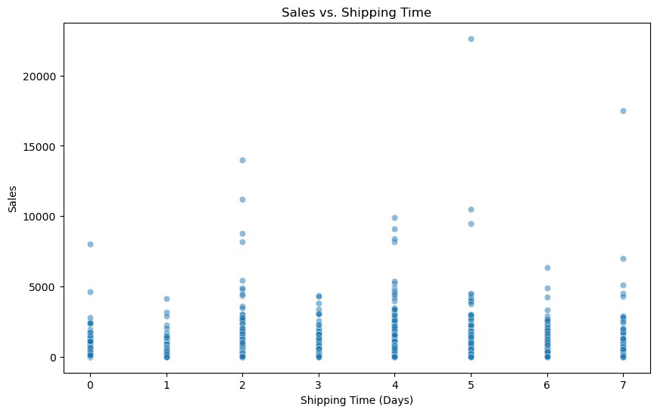
5.5. Geographic Insights
5.5.1. Sales by State
state_sales = df.groupby('state')
['sales'].sum().sort_values(ascending=False) print("Sales by State:")
print(state_sales)
# Visualize using a choropleth map
fig = px.choropleth(state_sales.reset_index(),

fig.show() | locations='state',  locationmode='USA-states',  color='sales',  scope="usa",  title='Sales Distribution by State (USA)')

Sales by State:
state
CA 446306.4635 NY 306361.1470 TX 168572.5322 WA 135206.8500 PA 116276.6500 FL 88436.5320 IL 79236.5170 MI 76136.0740 OH 75130.3500 VA 70636.7200 NC 55165.9640 IN 48718.4000 GA 48219.1100 KY 36458.3900 AZ 35272.6570 NJ 34610.9720 CO 31841.5980 WI 31173.4300 TN 30661.8730 MN 29863.1500 MA 28634.4340 DE 27322.9990 MD 23705.5230 RI 22525.0260 MO 22205.1500 OK 19683.3900 AL 19510.6400 OR 17284.4620 NV 16729.1020 CT 13384.3570 AR 11678.1300 UT 11220.0560 MS 10771.3400 LA 9131.0500 VT 8929.3700 SC 8481.7100 NE 7464.9300 NH 7292.5240 MT 5589.3520 NM 4783.5220 IA 4443.5600

ID 4382.4860
KS 2914.3100
DC 2865.0200
WY 1603.1360
SD 1315.5600
ME 1270.5300
WV 1209.8240
ND 919.9100
Name: sales, dtype: float64
{"config":{"plotlyServerURL":"https://plot.ly"},"data":
[{"coloraxis":"coloraxis","geo":"geo","hovertemplate":"state=%
{location}<br>sales=%{z}<extra></extra>","locationmode":"USA-
states","locations":
["CA","NY","TX","WA","PA","FL","IL","MI","OH","VA","NC","IN","GA","KY" ,"AZ","NJ","CO","WI","TN","MN","MA","DE","MD","RI","MO","OK","AL","OR" ,"NV","CT","AR","UT","MS","LA","VT","SC","NE","NH","MT","NM","IA","ID" ,"KS","DC","WY","SD","ME","WV","ND"],"name":"","type":"choropleth","z" :
[446306.4635,306361.147,168572.5322,135206.85,116276.65,88436.532,7923 6.517,76136.074,75130.35,70636.72,55165.964,48718.4,48219.11,36458.39, 35272.657,34610.972,31841.597999999998,31173.43,30661.873,29863.15,286 34.434,27322.999,23705.523,22525.026,22205.15,19683.39,19510.64,17284. 462,16729.102,13384.357,11678.13,11220.056,10771.34,9131.05,8929.36999 9999999,8481.71,7464.93,7292.524,5589.352,4783.522,4443.56,4382.486,29 14.31,2865.02,1603.136,1315.56,1270.53,1209.824,919.91]}],"layout": {"autosize":true,"coloraxis":{"colorbar":{"title":
{"text":"sales"}},"colorscale":[[0,"#0d0887"],
[0.1111111111111111,"#46039f"],[0.2222222222222222,"#7201a8"],
[0.3333333333333333,"#9c179e"],[0.4444444444444444,"#bd3786"],
[0.5555555555555556,"#d8576b"],[0.6666666666666666,"#ed7953"],
[0.7777777777777778,"#fb9f3a"],[0.8888888888888888,"#fdca26"],
[1,"#f0f921"]]},"geo":{"center":{"lat":74.42757131926979,"lon":-138.27891032690619},"domain":{"x":[0,1],"y":[0,1]},"projection": {"scale":0.4358791197685311},"scope":"usa"},"legend":
{"tracegroupgap":0},"template":{"data":{"bar":[{"error_x":
{"color":"#2a3f5f"},"error_y":{"color":"#2a3f5f"},"marker":{"line": {"color":"#E5ECF6","width":0.5},"pattern":
{"fillmode":"overlay","size":10,"solidity":0.2}},"type":"bar"}],"barpo lar":[{"marker":{"line":{"color":"#E5ECF6","width":0.5},"pattern": {"fillmode":"overlay","size":10,"solidity":0.2}},"type":"barpolar"}]," carpet":[{"aaxis":
{"endlinecolor":"#2a3f5f","gridcolor":"white","linecolor":"white","min orgridcolor":"white","startlinecolor":"#2a3f5f"},"baxis":
{"endlinecolor":"#2a3f5f","gridcolor":"white","linecolor":"white","min orgridcolor":"white","startlinecolor":"#2a3f5f"},"type":"carpet"}],"ch oropleth":[{"colorbar":
{"outlinewidth":0,"ticks":""},"type":"choropleth"}],"contour":
[{"colorbar":{"outlinewidth":0,"ticks":""},"colorscale":
[[0,"#0d0887"],[0.1111111111111111,"#46039f"],

[0.2222222222222222,"#7201a8"],[0.3333333333333333,"#9c179e"],
[0.4444444444444444,"#bd3786"],[0.5555555555555556,"#d8576b"],
[0.6666666666666666,"#ed7953"],[0.7777777777777778,"#fb9f3a"],
[0.8888888888888888,"#fdca26"],
[1,"#f0f921"]],"type":"contour"}],"contourcarpet":[{"colorbar": {"outlinewidth":0,"ticks":""},"type":"contourcarpet"}],"heatmap": [{"colorbar":{"outlinewidth":0,"ticks":""},"colorscale":
[[0,"#0d0887"],[0.1111111111111111,"#46039f"],
[0.2222222222222222,"#7201a8"],[0.3333333333333333,"#9c179e"],
[0.4444444444444444,"#bd3786"],[0.5555555555555556,"#d8576b"],
[0.6666666666666666,"#ed7953"],[0.7777777777777778,"#fb9f3a"],
[0.8888888888888888,"#fdca26"],
[1,"#f0f921"]],"type":"heatmap"}],"heatmapgl":[{"colorbar":
{"outlinewidth":0,"ticks":""},"colorscale":[[0,"#0d0887"],
[0.1111111111111111,"#46039f"],[0.2222222222222222,"#7201a8"],
[0.3333333333333333,"#9c179e"],[0.4444444444444444,"#bd3786"],
[0.5555555555555556,"#d8576b"],[0.6666666666666666,"#ed7953"],
[0.7777777777777778,"#fb9f3a"],[0.8888888888888888,"#fdca26"],
[1,"#f0f921"]],"type":"heatmapgl"}],"histogram":[{"marker":{"pattern": {"fillmode":"overlay","size":10,"solidity":0.2}},"type":"histogram"}], "histogram2d":[{"colorbar":{"outlinewidth":0,"ticks":""},"colorscale": [[0,"#0d0887"],[0.1111111111111111,"#46039f"],
[0.2222222222222222,"#7201a8"],[0.3333333333333333,"#9c179e"],
[0.4444444444444444,"#bd3786"],[0.5555555555555556,"#d8576b"],
[0.6666666666666666,"#ed7953"],[0.7777777777777778,"#fb9f3a"],
[0.8888888888888888,"#fdca26"],
[1,"#f0f921"]],"type":"histogram2d"}],"histogram2dcontour":
[{"colorbar":{"outlinewidth":0,"ticks":""},"colorscale":
[[0,"#0d0887"],[0.1111111111111111,"#46039f"],
[0.2222222222222222,"#7201a8"],[0.3333333333333333,"#9c179e"],
[0.4444444444444444,"#bd3786"],[0.5555555555555556,"#d8576b"],
[0.6666666666666666,"#ed7953"],[0.7777777777777778,"#fb9f3a"],
[0.8888888888888888,"#fdca26"],
[1,"#f0f921"]],"type":"histogram2dcontour"}],"mesh3d":[{"colorbar": {"outlinewidth":0,"ticks":""},"type":"mesh3d"}],"parcoords":[{"line": {"colorbar":{"outlinewidth":0,"ticks":""}},"type":"parcoords"}],"pie": [{"automargin":true,"type":"pie"}],"scatter":[{"fillpattern":
{"fillmode":"overlay","size":10,"solidity":0.2},"type":"scatter"}],"sc atter3d":[{"line":{"colorbar":{"outlinewidth":0,"ticks":""}},"marker": {"colorbar":
{"outlinewidth":0,"ticks":""}},"type":"scatter3d"}],"scattercarpet": [{"marker":{"colorbar":
{"outlinewidth":0,"ticks":""}},"type":"scattercarpet"}],"scattergeo": [{"marker":{"colorbar":
{"outlinewidth":0,"ticks":""}},"type":"scattergeo"}],"scattergl": [{"marker":{"colorbar":
{"outlinewidth":0,"ticks":""}},"type":"scattergl"}],"scattermapbox": [{"marker":{"colorbar":
{"outlinewidth":0,"ticks":""}},"type":"scattermapbox"}],"scatterpolar"

:[{"marker":{"colorbar":
{"outlinewidth":0,"ticks":""}},"type":"scatterpolar"}],"scatterpolargl ":[{"marker":{"colorbar":
{"outlinewidth":0,"ticks":""}},"type":"scatterpolargl"}],"scatterterna ry":[{"marker":{"colorbar":
{"outlinewidth":0,"ticks":""}},"type":"scatterternary"}],"surface": [{"colorbar":{"outlinewidth":0,"ticks":""},"colorscale":
[[0,"#0d0887"],[0.1111111111111111,"#46039f"],
[0.2222222222222222,"#7201a8"],[0.3333333333333333,"#9c179e"],
[0.4444444444444444,"#bd3786"],[0.5555555555555556,"#d8576b"],
[0.6666666666666666,"#ed7953"],[0.7777777777777778,"#fb9f3a"],
[0.8888888888888888,"#fdca26"],
[1,"#f0f921"]],"type":"surface"}],"table":[{"cells":{"fill":
{"color":"#EBF0F8"},"line":{"color":"white"}},"header":{"fill":
{"color":"#C8D4E3"},"line":
{"color":"white"}},"type":"table"}]},"layout":{"annotationdefaults": {"arrowcolor":"#2a3f5f","arrowhead":0,"arrowwidth":1},"autotypenumbers ":"strict","coloraxis":{"colorbar":
{"outlinewidth":0,"ticks":""}},"colorscale":{"diverging":
[[0,"#8e0152"],[0.1,"#c51b7d"],[0.2,"#de77ae"],[0.3,"#f1b6da"], [0.4,"#fde0ef"],[0.5,"#f7f7f7"],[0.6,"#e6f5d0"],[0.7,"#b8e186"], [0.8,"#7fbc41"],[0.9,"#4d9221"],[1,"#276419"]],"sequential":
[[0,"#0d0887"],[0.1111111111111111,"#46039f"],
[0.2222222222222222,"#7201a8"],[0.3333333333333333,"#9c179e"],
[0.4444444444444444,"#bd3786"],[0.5555555555555556,"#d8576b"],
[0.6666666666666666,"#ed7953"],[0.7777777777777778,"#fb9f3a"],
[0.8888888888888888,"#fdca26"],[1,"#f0f921"]],"sequentialminus": [[0,"#0d0887"],[0.1111111111111111,"#46039f"],
[0.2222222222222222,"#7201a8"],[0.3333333333333333,"#9c179e"],
[0.4444444444444444,"#bd3786"],[0.5555555555555556,"#d8576b"],
[0.6666666666666666,"#ed7953"],[0.7777777777777778,"#fb9f3a"],
[0.8888888888888888,"#fdca26"],[1,"#f0f921"]]},"colorway":
["#636efa","#EF553B","#00cc96","#ab63fa","#FFA15A","#19d3f3","#FF6692" ,"#B6E880","#FF97FF","#FECB52"],"font":{"color":"#2a3f5f"},"geo": {"bgcolor":"white","lakecolor":"white","landcolor":"#E5ECF6","showlake s":true,"showland":true,"subunitcolor":"white"},"hoverlabel":
{"align":"left"},"hovermode":"closest","mapbox":
{"style":"light"},"paper_bgcolor":"white","plot_bgcolor":"#E5ECF6","po lar":{"angularaxis":
{"gridcolor":"white","linecolor":"white","ticks":""},"bgcolor":"#E5ECF 6","radialaxis":
{"gridcolor":"white","linecolor":"white","ticks":""}},"scene":
{"xaxis":
{"backgroundcolor":"#E5ECF6","gridcolor":"white","gridwidth":2,"lineco lor":"white","showbackground":true,"ticks":"","zerolinecolor":"white"} ,"yaxis":
{"backgroundcolor":"#E5ECF6","gridcolor":"white","gridwidth":2,"lineco lor":"white","showbackground":true,"ticks":"","zerolinecolor":"white"} ,"zaxis":

{"backgroundcolor":"#E5ECF6","gridcolor":"white","gridwidth":2,"lineco lor":"white","showbackground":true,"ticks":"","zerolinecolor":"white"} },"shapedefaults":{"line":{"color":"#2a3f5f"}},"ternary":{"aaxis": {"gridcolor":"white","linecolor":"white","ticks":""},"baxis":
{"gridcolor":"white","linecolor":"white","ticks":""},"bgcolor":"#E5ECF 6","caxis":
{"gridcolor":"white","linecolor":"white","ticks":""}},"title":
{"x":5.0e-2},"xaxis":
{"automargin":true,"gridcolor":"white","linecolor":"white","ticks":"", "title":
{"standoff":15},"zerolinecolor":"white","zerolinewidth":2},"yaxis": {"automargin":true,"gridcolor":"white","linecolor":"white","ticks":"", "title":
{"standoff":15},"zerolinecolor":"white","zerolinewidth":2}}},"title": {"text":"Sales Distribution by State (USA)"}}}
5.6. Insights
5.6.1. Interactive Dashboard
# Example: Streamlit Dashboard (save as app.py) import streamlit as st
import pandas as pd
st.title("Sales Analysis Dashboard")
st.write("## Monthly Sales Trend")
st.line_chart(monthly_sales)
st.write("## Regional Sales Performance") st.bar_chart(region_sales)
2025-04-05 07:58:16.584
Warning: to view this Streamlit app on a browser, run it with thefollowing
command:

streamlit run C:\Users\Aboelyazzed\anaconda3\Lib\site-packages\
ipykernel_launcher.py [ARGUMENTS]
DeltaGenerator()
class DeltaGenerator:
def__init__(self, data, date_column, value_column): self.data = data
self.date_column = date_column
self.value_column = value_column
def calculate_deltas(self):
# Sort data by date
self.data = self.data.sort_values(by=self.date_column)

# Calculate the difference between consecutive rows self.data['delta'] = self.data[self.value_column].diff() returnself.data
def plot_deltas(self):
import matplotlib.pyplot as plt
plt.figure(figsize=(10, 6))
plt.plot(self.data[self.date_column], self.data['delta'], marker='o')
plt.title("Change in Sales Over Time")
plt.xlabel("Date")
plt.ylabel("Delta (Change in Sales)")
plt.grid(True)
plt.show()
# Example usage
df['order_date'] = pd.to_datetime(df['order_date'])
delta_gen = DeltaGenerator(df, date_column='order_date', value_column='sales')
df_with_deltas = delta_gen.calculate_deltas()
delta_gen.plot_deltas()
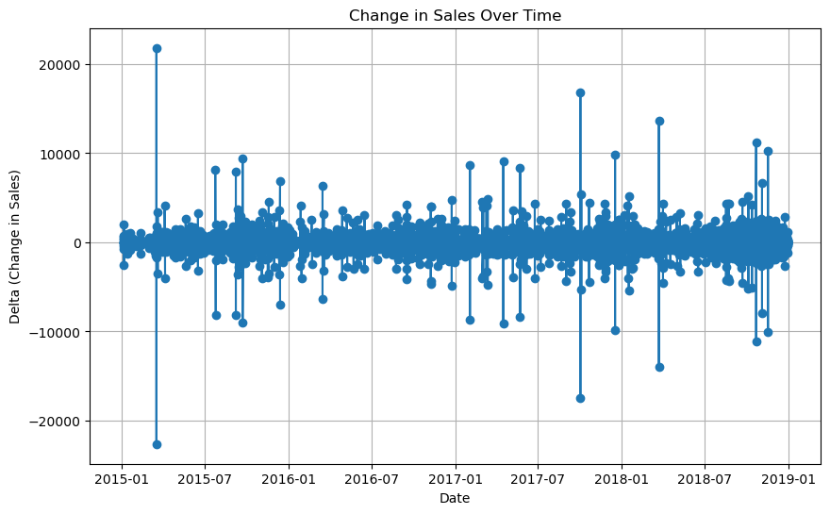

6.Forecasting
6.1.Prepare the Data for Forecasting
# Ensure 'order_date' is in datetime format
df['order_date'] = pd.to_datetime(df['order_date'])
# Aggregate sales by month
monthly_sales = df.groupby(df['order_date'].dt.to_period('M')) ['sales'].sum().reset_index()
monthly_sales['order_date'] =
monthly_sales['order_date'].dt.to_timestamp()
# Display the aggregated data
print(monthly_sales.head())
order_date sales 0 2015-01-01 14205.707 1 2015-02-01 4519.892 2 2015-03-01 55205.797 3 2015-04-01 27906.855 4 2015-05-01 23644.303

6.2. Visualize the Time Series
# Plot monthly sales
plt.figure(figsize=(12, 6))
plt.plot(monthly_sales['order_date'], monthly_sales['sales'], marker='o')
plt.title("Monthly Sales Over Time")
plt.xlabel("Date")
plt.ylabel("Sales")
plt.grid(True)
plt.show()

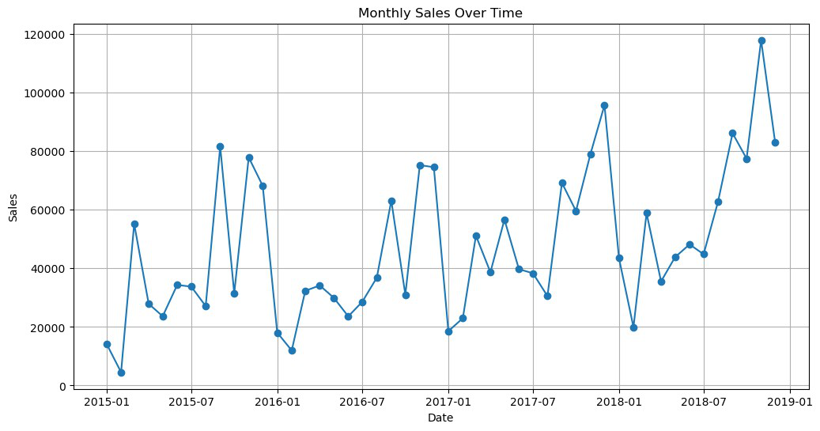
6.3. Decompose the Time Series
from statsmodels.tsa.seasonal import seasonal_decompose
# Decompose the time series
result = seasonal_decompose(monthly_sales.set_index('order_date') ['sales'], model='additive', period=12)
# Plot the decomposed components
result.plot()
plt.show()

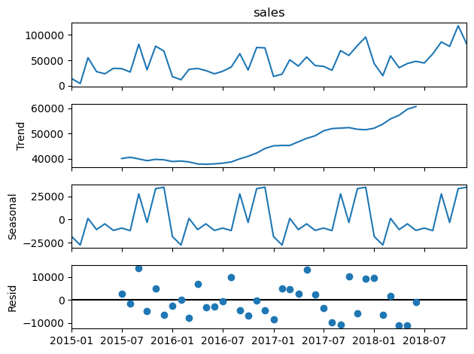
6.4. Choose a Forecasting Model 6.4.1: ARIMA
from statsmodels.tsa.arima.model import ARIMA import numpy as np
# Fit ARIMA model
model = ARIMA(monthly_sales['sales'], order=(5, 1, 0)) # (p, d, q) parameters
model_fit = model.fit()
# Forecast next 12 months
forecast = model_fit.forecast(steps=12) print(forecast)
48 77882.535842
49 82080.050366
50 78363.673696
51 77562.297662
52 90178.601100
53 84479.482539

54 83175.392773
55 85201.846388
56 82194.773321
57 81241.336983
58 84496.723791
59 83333.201659
Name: predicted_mean, dtype: float64
6.4.2: Prophet
from prophet import Prophet
# Prepare data for Prophet
prophet_data = monthly_sales.rename(columns={'order_date': 'ds', 'sales': 'y'})
# Initialize and fit the Prophet model model = Prophet()
model.fit(prophet_data)
# Create a dataframe for future dates
future = model.make_future_dataframe(periods=12, freq='ME') # Use 'ME' instead of 'M'
# Make predictions
forecast = model.predict(future)
print(forecast[['ds', 'yhat', 'yhat_lower', 'yhat_upper']].tail(12))
# Plot the forecast
model.plot(forecast)
plt.show()
07:58:24 - cmdstanpy - INFO - Chain [1] start processing 07:58:25 - cmdstanpy - INFO - Chain [1] done processing
ds yhat yhat_lower yhat_upper 48 2018-12-31 40916.277906 32079.723155 50033.914281 49 2019-01-31 27223.271177 18306.841836 37270.438986 50 2019-02-28 109599.772422 100221.641002 119031.926127 51 2019-03-31 37759.849273 28000.883626 47374.827107 52 2019-04-30 35918.504583 27079.151967 45935.890115 53 2019-05-31 69053.588624 59629.554166 79021.447420 54 2019-06-30 54169.807315 43813.193148 63948.371269 55 2019-07-31 46565.572090 37846.939554 56136.125441 56 2019-08-31 118629.732794 109226.249615 128112.005297 57 2019-09-30 65062.450646 56047.978340 75024.356860 58 2019-10-31 120758.788312 111499.504837 130341.695175 59 2019-11-30 76224.267374 66927.449033 85521.442275

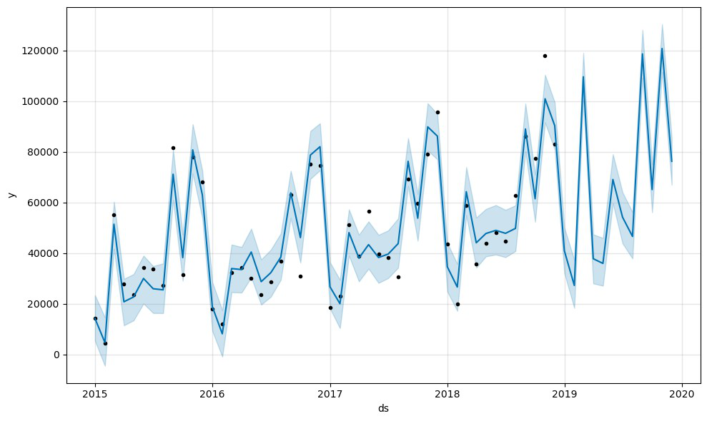
6.5. Evaluate the Model
from sklearn.metrics import mean_absolute_error
# Split data into train and test sets
train_size = int(len(monthly_sales) * 0.8)
train, test = monthly_sales[:train_size], monthly_sales[train_size:]
# Fit ARIMA on training data
model = ARIMA(train['sales'], order=(5, 1, 0)) model_fit = model.fit()
# Forecast on test data
predictions = model_fit.forecast(steps=len(test))
# Calculate MAE
mae = mean_absolute_error(test['sales'], predictions) print(f"Mean Absolute Error: {mae}")
Mean Absolute Error: 24071.07181000625

