Breem Ads Screens System Guide

Full Story from Four Perspectives (Backend • Dashboard • Android App • Device)

Version 1.0 • 2025-09-27

Table of Contents
— Update the TOC in Word to refresh —

Executive Summary
This guide narrates the operational lifecycle of the Breem Ads Screens system—backend, admin dashboard, and Android TV player—with an auto-generated TOC and sequence diagrams to visualize data flow.

Backend (Laravel) Perspective
• Models: Ad, AdSchedule, Screen, Place, PlaybackLog, ScreenLog.
• Services: AdSchedulerService (Playlist + Fallback + ETag + Cache), ScreenApiService/HeartbeatService, DeviceConfigService, PlaybackService.
• Observers: Flush per-screen playlist cache on impactful changes.
• ffprobe: Auto-detect video duration on upload; otherwise require manual input.
• Jobs: Screen health (offline) notifications; expiring ads checker.
• Permissions: ads.*, screens.*, places.*, reports.*, settings.*

Device API v1 Sequence
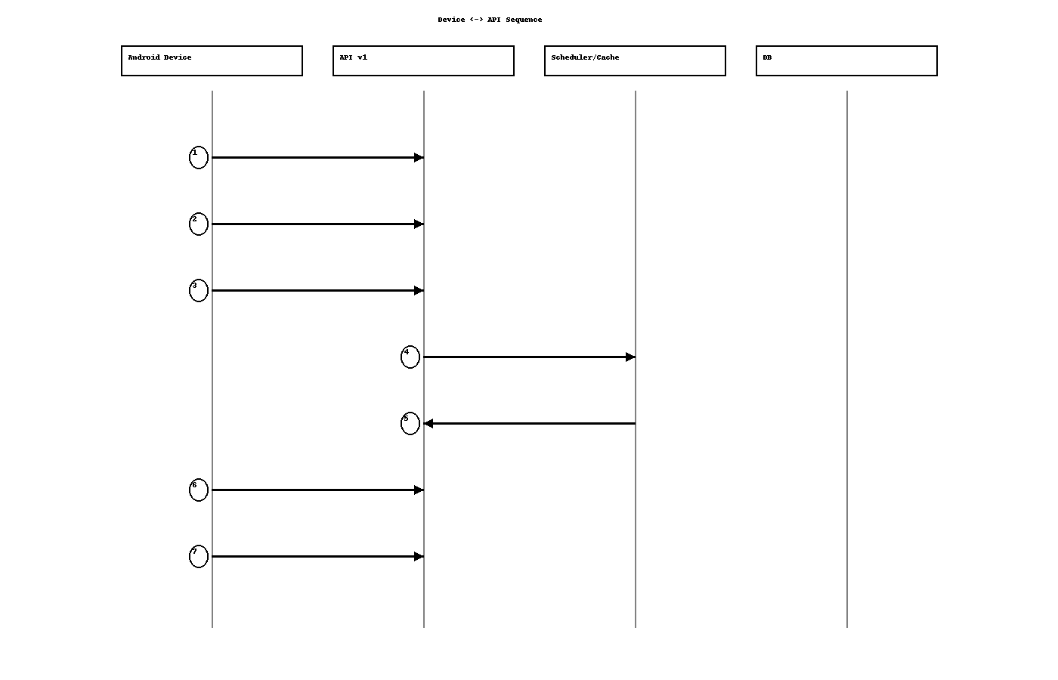
Legend:
- 1) Handshake: bind device, receive screen_id and config.
- 2) Config: fetch with ETag.
- 3) Playlist: GET with If-None-Match (may return 304).
- 4–5) Scheduler builds playlist and returns ETag and items.
- 6) Playbacks: proof-of-play (single or batch).
- 7) Heartbeat: periodic health update and logging.

Admin Dashboard Perspective
Upload creatives (video/image) with AR/EN titles & descriptions, submit for approval, approve/reject, activate/deactivate, assign ads to screens with play order, and define schedules. Monitor online/offline status and export performance/uptime reports.

Admin Actions -> Device Refresh
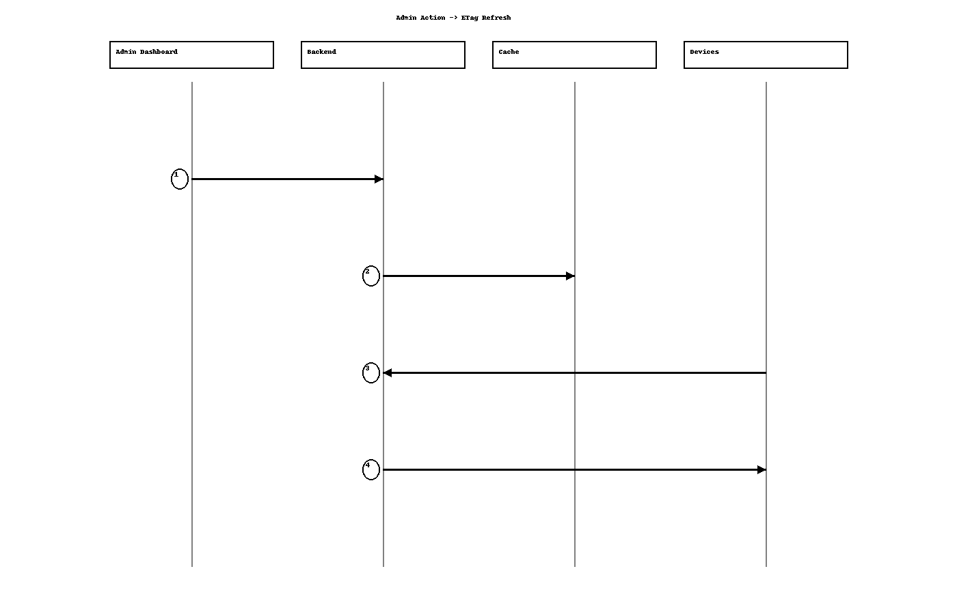
Legend:
- 1) Approve/assign/schedule from dashboard.
- 2) Invalidate per-screen cache (ETag refresh).
- 3) Devices poll playlist with If-None-Match.
- 4) Backend responds with new ETag/items.

Android Developer Perspective
- Stable device_uid + OkHttp interceptor adding X-Device-UID.
- Room for Config/Playlist/PlaybackQueue.
- ExoPlayer + SimpleCache; prefetch heavy items.
- ETag/304 for playlist/config efficiency.
- Offline: keep playing from cache, queue playbacks, flush later.
- Backoff for 5xx/429; re-handshake on 401/403.

Device User Perspective
- Seamless playback with or without connectivity.
- Dashboard changes appear promptly without manual intervention.
- Fallback ensures no blank screen.

Quick Checklists

Backend
- ETag refreshes on impactful changes.
- Fallback always present.
- ffprobe configured or validation enforced.
- Jobs healthy; Slack optional.

Dashboard
- Create/approve/assign/schedule without errors.
- Monitoring updates statuses; alerts can be acknowledged.
- Reports export to CSV.
- Bilingual UI + RTL for Arabic.

Android
- X-Device-UID on every call.
- ETag/304 handling implemented.
- Prefetch + SimpleCache enabled.
- Playback queue + reliable flush.
- Stable heartbeat; backoff; UTC time.

