Project Documentation
Multi-Tier Laravel Application on Bare-Metal Kubernetes
Deployed with kubeadm • Namespace: production

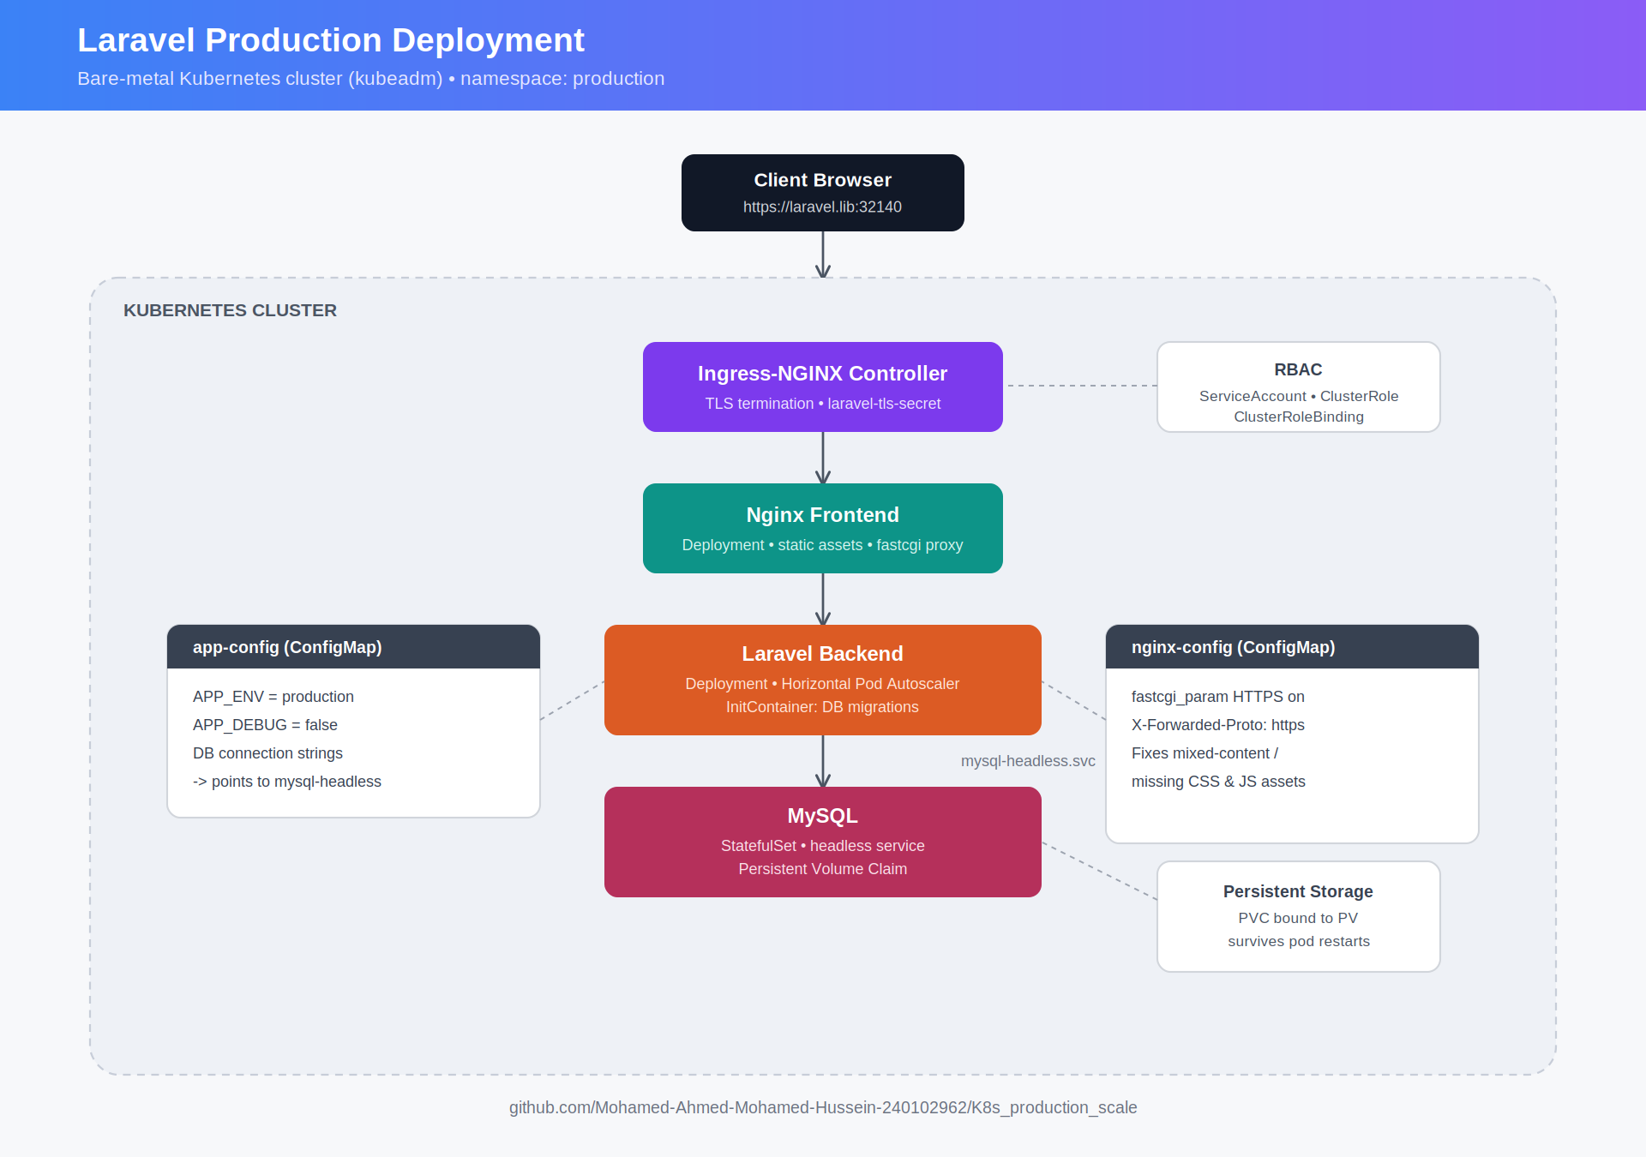

Repository: github.com/Mohamed-Ahmed-Mohamed-Hussein-240102962/K8s_production_scale

1. Project Overview & Architecture
Application type: Multi-tier web application — Laravel (backend API/app), Nginx (reverse proxy & web server), MySQL (database)
Environment: Bare-metal Kubernetes cluster managed via kubeadm
Namespace: production
Local domain: laravel.lib, mapped via /etc/hosts to the cluster node IP
Ingress controller: ingress-nginx, deployed from the official bare-metal static manifest with full RBAC

Architecture diagram
Traffic enters through the ingress-nginx controller, which terminates TLS and routes requests to the Nginx frontend. Nginx serves static assets directly and proxies PHP requests to the Laravel backend over FastCGI. The backend runs its database migrations through an init container before serving traffic, and reads and writes to MySQL through the internal headless service. Configuration for both tiers is supplied through ConfigMaps rather than being baked into images.

2. Component Specifications & Manifest Structure

A. Database tier (MySQL)
- Resource type: StatefulSet (mysql)
- Service: headless service (mysql-headless) for stable internal DNS resolution — mysql-headless.production.svc.cluster.local
- Persistence: a PersistentVolumeClaim ensures data survives pod restarts

B. Backend tier (Laravel backend)
- Resource type: Deployment (laravel-backend) with a Horizontal Pod Autoscaler (HPA)
- Initialization: an InitContainer runs database migrations before the app container starts
- The --seed flag was intentionally omitted from migration commands to avoid conflict errors or duplicate-entry exceptions on pod restarts
Environment configuration — app-config ConfigMap:
- APP_ENV: production
- APP_DEBUG: false
- APP_URL: https://laravel.lib:32140
- Database connection strings pointing to the internal MySQL headless service

C. Frontend tier (Nginx frontend)
- Resource type: Deployment (nginx-frontend) serving static assets and proxying PHP requests to the backend service
Nginx configuration — nginx-config ConfigMap:
- Listens on port 80, serving root /var/www/html/public
- Passes .php requests to laravel-backend-service:80
- Critical HTTPS/proxy fixes: fastcgi_param HTTPS on; and fastcgi_param HTTP_X_FORWARDED_PROTO https; so Laravel generates secure https:// asset links behind the ingress proxy, preventing mixed-content errors and missing CSS/JS (404) issues

D. Networking & ingress tier
- Ingress controller: the official ingress-nginx controller, deployed in the ingress-nginx namespace with automated RBAC (ServiceAccount, ClusterRole, ClusterRoleBinding)
- Exposure: NodePort type exposing HTTP/HTTPS traffic through cluster node ports (e.g. 32719 for HTTP and 32140 for HTTPS)
Ingress resource — laravel-production-ingress:
- Host: laravel.lib
- TLS termination configured with a secret (laravel-tls-secret) for laravel.lib
- Annotations: nginx.ingress.kubernetes.io/ssl-redirect: "true" and proxy body size limits

3. Resolved Technical Challenges & Fixes
InitContainer migration crash (Init:Error) | Resolved by cleaning up redundant seed commands in the startup script.
Ingress controller RBAC & permissions | Fixed missing POD_NAME errors by deploying the complete official bare-metal static manifest instead of isolated or manual definitions.
Missing GUI / unstyled CSS (mixed-content error) | Fixed by updating Nginx FastCGI parameters (HTTPS on and X-Forwarded-Proto) so the backend recognizes the secure proxy and outputs https:// asset URLs correctly.
Port mismatch & protocol errors (400 Bad Request) | Aligned browser requests with the correct NodePort and protocol (https://laravel.lib:32140).

4. Next Phase / Future Objectives
- Helm chart migration: packaging all raw Kubernetes manifests (namespaces, deployments, statefulsets, services, configmaps, ingress, hpa) into a structured, parameterizable Helm chart
- A flexible values.yaml file for effortless, repeatable deployment management

5. Kubernetes Concepts Covered
This project exercises a large share of the practical skills tested by the CKA and CKAD certifications:
- Workloads: Deployments, StatefulSets, InitContainers, Horizontal Pod Autoscaler
- Networking: Services (ClusterIP, Headless, NodePort), Ingress, TLS secrets
- Configuration: ConfigMaps, environment variable injection
- Storage: PersistentVolumeClaims and stable pod identity for stateful workloads
- Cluster administration: RBAC (ServiceAccount, ClusterRole, ClusterRoleBinding), troubleshooting pod and ingress failures on a bare-metal kubeadm cluster

Repository: github.com/Mohamed-Ahmed-Mohamed-Hussein-240102962/K8s_production_scale

